Logical Trees

UI Structure

Nodes with more than one child

Source code



Logical tree

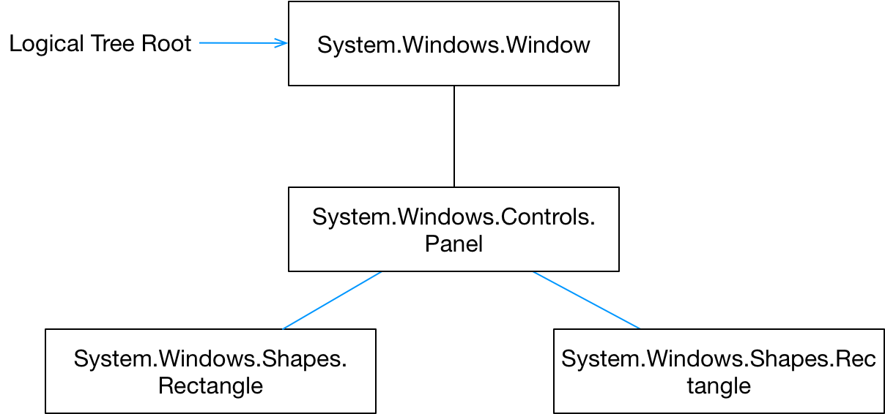

Questions

Compare and contrast the logic and visual trees

The logical tree is typically defined by the XAML. A node in the logical tree is often a FrameworkElement or Control. Each node in the logical tree can map to many nodes in the visual tree. For example, a single ListBox in the logical tree is composed of many visual elements such as scrollbars, borders etc

ContentControls have a single child. How can we add more than one child to such an object?

By using a Panel

Write code to create a single window with two rectangle children; one blue and one red.

public class Answer

{

public static void CreateLogicalTree()

{

// Write code to create a logical tree consisting of a single

// window with two rectangles

Window mainWindow = new Window() {Height = 200, Width = 200};

var p = new StackPanel()

{

HorizontalAlignment = HorizontalAlignment.Center,

VerticalAlignment = VerticalAlignment.Center

};

var r = new Rectangle {Height = 200, Width = 200, Fill = Brushes.Red};

var b = new Rectangle {Height = 200, Width = 200, Fill = Brushes.Blue};

p.Children.Add(r);

p.Children.Add(b);

mainWindow.Content = p;

Application mainApp = new Application();

mainApp.Run(mainWindow);

}

}

Sketch the visual and logical trees for the previous code

