Rendering

Painting WPF interfaces onto the screen

# Visual

From a high level, any UI technology is about processing user input from the mouse or keyboard and rendering the resultant state to the screen. Rendering in WPF is supported via the abstract base class Visual. Visual is a lightweight implementation that supports

* Specifying and rendering drawing content
* Hit Testing
* Bounding box calculations
* Transformations
* Clipping

### The Visual Tree

A Visual can have zero or more child visuals arranged into a hierarchical structure known as the visual tree. The hierarchical aspect of Visual is supported by one property and one method

* VisualChildCount
* GetVisualChild

UIElement extends Visual and FrameworkElement extends UIElement meaning all WPF Framework Elements can be rendered to the screen.

### Visual Tree Examples

The following sections contain code that highlight how visual trees are constructed and rendered.

#### Single node visual tree

Because FrameworkElement extends Visual all framework elements can be rendered. The root element in any visual tree is Window. We can create a one node visual tree by sub classing Window and overriding the VisualChildCount property to return zero. This informs the rendering engine not to look for children of this node.

Window is a complex subclass of ContentControl which supports layout and other more advanced topics which I don’t want to cover here. By overriding OnRender with a no-op we effectively prevent the window from doing any rendering of itself as part of layout.

As our single node has no rendering instructions our window shows just as a black box on the screen.



Listing Single node tree



#### Adding a node

A window with no visual representation is fairly useless. If we add a single child visual, we can render our window as a single red circle with the same diameter as the window itself. We do this by overriding VisualChildrenCount to be one. We then create a DrawingVisual which we return from the GetVisualChild method. Our window then renders as follows.



And the source code is as follows.

Visuals must have at least one FrameworkElement ancestor

Visuals are lightweight objects. As we have mentioned they can be arranged into arbitrarily deep hierarchies in order to efficiently render complex content. One proviso is that a hierarchy of visuals and sub visuals must at some stage be added to at least one Framework Element in order to render. As Window is a FrameworkElement this requirement is met by all the samples in this document.



#### Visual Trees render depth first

The nodes in a tree are rendering by walking down the tree in a depth first traversal. The z-order is specified by the order of rendering, so visuals rendered later are in the pass are rendered in front of visuals rendered earlier in the pass. The screenshot below shows how the given code listing renders

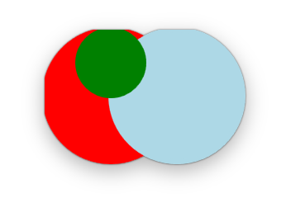

From a visual tree as follows. Note the window and the internal node do not render anything.

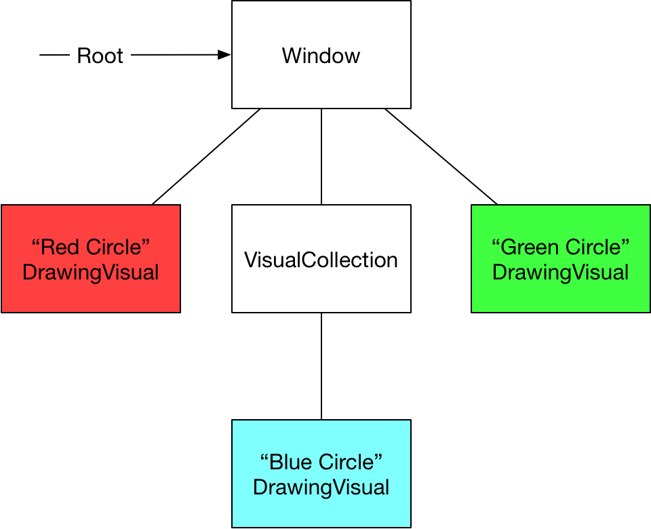



### Hit Testing

Questions - Rendering

Visual

What type supports rendering in WPF?

The abstract base class Visual

What does visual support?

Visual is a lightweight implementation that supports

Specifying and rendering drawing content

Hit Testing

Bounding box calculations

Transformations

Clipping

What is the visual tree?

The tree of rendered Visual objects

Which two methods control the children of a visual in the visual tree?

1. Visual.VisualChildrenCount
2. Visual.GetVisualChild(int)

UIElements are lightweight elements that can be arranged in deep hierarchies. What condition must be met for a hierarchy of Visual to be rendered?

They must have at least one FrameworkElement in the visual tree.

In what order are nodes in a tree rendered?

Depth first traversal of the visual tree

Given a visual object how would you render vector graphic geometries onto it?

Get its DrawingContext and invoke DrawGeometry on the context

How does rendering in WPF differ from rendering in Win32

Retained mode rendering system.

Controls

What defines a control’s visual tree?

Its Template property of type ControlTemplate

What are three ways you can affect a controls appearance

1. Directly set properties
2. Styles
3. Control Templates

If you create a new ControlTemplate can you just put anything you want in there or are there any restrictions? How does a control indicate what a control template needs to provide in order to be valid?

TemplatePart attributes on the Control class definition

If you were creating you own custom control how would you create state that could be bound to a View Model

By creating DependencyProperties

Layout

Describe how layout is performed in WPF?

Two pass traversal known as the Measure Arrange pass

Describe the measure arrange interaction between a parent and it child?

1. Parent asks child how much space it wants by invoking Measure
2. Parent calculates how much space to allocate to the child and passes this to the child’s arrange method
3. Child can use a subset of the space passed to it if necessary

How is margin dealt with in the measure arrange pass?

When a parent invokes Measure on a child and passes in the amount of available space. The internals of Measure subtract the child’s margins before invoking its MeasureOverride method

How does a parent specify the size of the layout slot for the child?

By passing a rectangle to the child’s measure method

Which classes expose padding?

Block, Border, Control, TextBlock

What ate the main panels in WPF

StackPanel

GridPanel

Canvas

WrapPanel

DockPanel

Which properties control how a control deals with the situation where it is given more space than it needs to show its content?

Horizontal and Vertical alignment