XAML From the Ground up

Instantiating object graphs using XML

This document covers

Instantiating object graphs using XML

Different Kinds of Element and Attribute

XAML is an XML-based declarative language which provides a concise way to construct and initialise object graphs. The best-known use of XAML is to specify the logical tree of controls and other user interface elements that constitute a user interface in WPF. There is, however, no reason why XAML cannot be used to construct object graphs in other situations. In this introductory article I will show how to initialise object graphs in XAML. We will start from something very simple and gradually add in more complexity to show how XAML supports very basic use cases while also enabling more complex scenarios.

## Basic Object Graphs

### How to add a simple object to the object graph

We define a type that has a single string property called Id.

Listing 1C# Option Type

namespace Example1

{

public class Option

{

public string Id {get; set;}

}

}

We then use XAML to declare that we want to instantiate an instance of Option as the root of an object graph and that we want to set the value of its Id property to the string “MyIdentity”

Listing 2 Declarative XAML

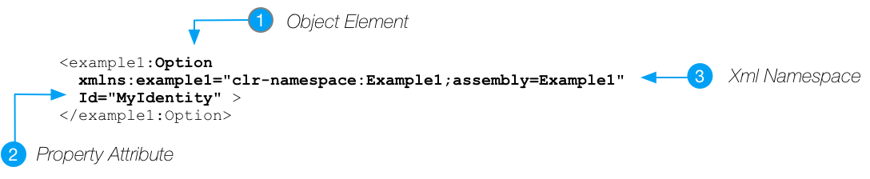

Finally, we use the XamlReadertype from the System.Windows.Markup namespace to parse our XAML and instantiate the object graph as declared.

Listing 3 Parsing the XAML

private static void Main(string[] args)

{

using (var fs = new FileStream("./ObjectGraph.xaml",

FileMode.Open, FileAccess.Read))

{

Option option = (Option) XamlReader.Load(fs);

Console.WriteLine(option.Id);

}

}

Our runtime object graph is then as follows

Figure 1 Resulting Object Graph

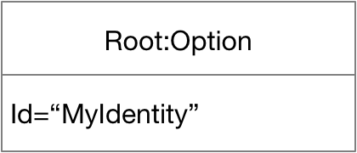

### How to set non-string properties via type converters

In the previous example our Id property was of type String, so it was easy to see how a string value in the XAML could be used to set a string property on the Option instance. What happens however if the property is on a non-string type? To highlight how this works we add a double property called Strike to our Option type

public class Option

{

public string Id { get; set; }

public double Strike { get; set; }

}

Our Xaml then becomes

<example1:Option

xmlns:example1="clr-namespace:Example2;assembly=Example2"

Id="MyIdentity" Strike="0.5">

</example1:Option>

The XAML parser now needs to convert the string “0.5” into the double 0.5. It does this via a subclass of the **TypeConverter**.The call sequence to instantiate and set our strike property is as follows.

Figure 2 Xaml Parsing with Type Conversion

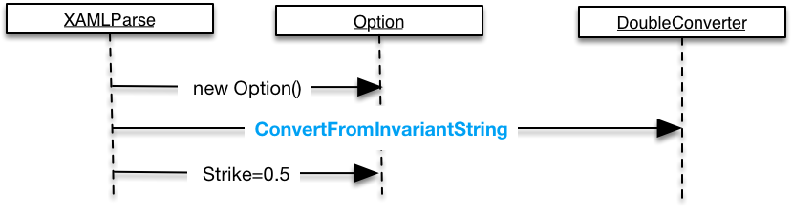

Our final object graph then looks as follows

Figure 3Object Graph with Double Property

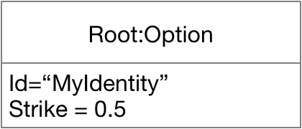

ValueConverter versus TypeConverter

It is important to distinguish the System.Windows.Data.IValueConverter interface from the Sytem.ComponentModel.TypeConverter type. Instances of TypeConverter convert values to/from XAML strings. Instances of the IValueConverter interface are used in data-binding scenarios to allow properties of differing types to be bound together.

### How to set complex objects as property values

Setting simple properties such as doubles from XAML can be achieved easily via instances of TypeConverter as described in the previous section. Consider the scenario where the property we want to set is of a complex type consisting of multiple public properties which need to be set. To show how this works let us add a new non-primitive property to our Option type called Expiry of type Expiry. The Expiry type defines a simple single integer property called Days.

public class Option

{

public string Id { get; set; }

public double Strike { get; set; }

public Expiry Expiry { get; set; }

}

public class Expiry

{

public int Days { get; set; }

}

The way that XAML supports this is via **property elements.** Property elements are child elements that specify how to populate a property of an object element. The following XAML shows how this works

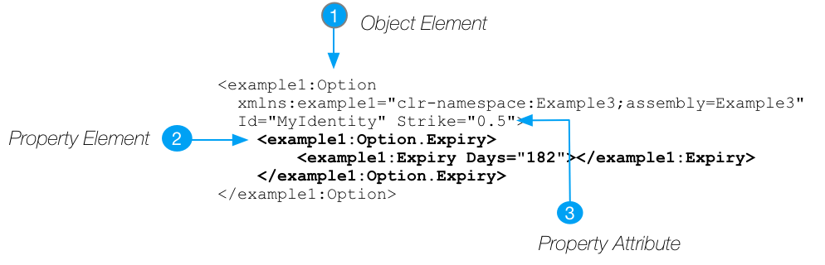

The XAML parser will then construct an instance of Expiry, set its Days property (using a IntegerConverter) and then set this as the value of the Options Expiry property.

### How to create custom typeconverters

We might want to define our own type converters that can convert from a string to an instance of the Expiry type. If we do this, we can contract our xaml to the following.

<example1:Option

xmlns:example1="clr-namespace:Example4;assembly=Example4"

Id="MyIdentity" Strike="0.5" Expiry="180">

</example1:Option>

In this case we write a class that can take a string representation of an expiry and use it to create a new instance of the **Expiry** type.

Listing 4Custom TypeConverter

public class ExpiryConverter : TypeConverter

{

public override object ConvertFrom(ITypeDescriptorContext context, CultureInfo culture, object value)

{

var exp = new Expiry();

var daysToExpiry = 0;

if (!string.IsNullOrEmpty(value as string) &&

int.TryParse(value as string, out daysToExpiry))

{

exp.Days = daysToExpiry;

}

return exp;

}

public override object ConvertTo(ITypeDescriptorContext context, CultureInfo culture, object value, destinationType)

{

Expiry exp = value as Expiry;

if (exp != null)

return exp.Days.ToString();

return string.Empty;

}

public override bool CanConvertFrom(ITypeDescriptorContext context, sourceType)

{

return sourceType == typeof (string);

}

public override bool CanConvertTo(ITypeDescriptorContext context, Type destinationType)

{

return destinationType == typeof (string);

}

}

Finally, we need to mark the Expiry type with our newly created ExpiryConverter type thereby instructing the XAML parser to use it to map from instances of string to Expiry objects.

[TypeConverter(typeof(ExpiryConverter))]

public class Expiry

{

public int Days { get; set; }

}

TypeConverter and IValueConverter

We need to be clear on when we would use System.ComponentModel.TypeConverter and when we would use System.Windows.Data.IvalueConverter. TypeConverter is used when mapping a string property value in XAML into a typed property value on the actual object. IvalueConverter is typically used when we are binding one value to another and need a conversion between them

## Mark-up Extensions

If we extend our model types to include a compound object that has two Option object properties as follows.



We could create our object graph as follows.



But this starts to get a little unwieldy. We ant to make the legs a bit more compact. To do this we use a markup extension. We do this as follows.



How do these magic markup extensions work? We need to create a subclass of the type MarkupExtension. This type will have a default constructor and also a constructor which takes one argument for each positional parameter that can be specified ="{OptionMarkupExtension firstLeg,90,0.5} In this case a string id, integer number of days to expiry and a double strike.



We also need a method called ProvideValue which is the factory method that takes our MarkupExtension object and constructs an instance of the Option type.



Notice that in this case the Expiry field is of type Expiry, so the string in the XAML file must first be converted to an Expiry type using the ExpiryConverter and the string for the strike must be converted to a double using the DoubleConverter before the OptionMarkupExtension constructor is invoked.

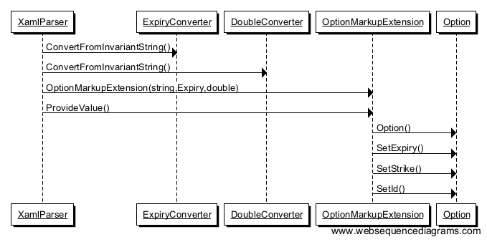

We can also specify named parameters in our Xaml file in which case the OptionMarkupExtension’s default constructor will be invoked followed by the named properties and then finally the ProvideValue method will be invoked.



Our Xaml then becomes



Because markup extensions are classes with default constructors we can use then as normal property element syntax. In the following the first leg is constructed using markup syntax and the second uses property element syntax.



## Child Items – building the object graph

We need to make the distinction between a property element and an object’s child elements. The distinction can be made as follows.

* A child element specifies a node’s child node in the object graph
* A property element specified the value of a particular property on a given node.

The green highlighted Rectangle element specifies a child node of the StackPanel. The blue highlighted Rectangle.Height and Rectangle.Width nodes specify how to construct objects that are set as the values of properties on a given node

## Backing XAML with executable code

So far we have used XAML to define object graphs. Every such object graph has a single instance at the root of the XAML and the root of the object graph. We can provide executable code to back the object graph by creating a separate partial class which extends the type of the root element.





MyOption

MyOption (Code Behind)

MyOption (XAML)

Option

## Namespaces

The WPF assemblies map all the core .NET namespaces such as System.Windows, System.Windows.Controls etc to the xml namespace <https://schemas.microsoft.com/winfx/xaml/presentation> using a number of hardcoded XmlnsDefinitionAttribute custom attributes. As multiple .NET namespaces are mapping to a single xml namespace Microsoft have to be careful to ensure there are no name clashes in any of the relevant WPF namespaces.

The root element in any XAML file must contain at least one namespace. Consider the following simplest piece of XAML imaginable. It consists of one single element which is also the root element. Note in this case we have given this namespace a prefix of wpf that is then used on the identifiers from this namespace.



Each XAML file can have a single primary namespace which has no prefix and that implicitly qualifies any identifiers not explicitly prefixed with another namespace



In addition to xmlns:wpf=<http://schemas.microsoft.com/winfx/2006/xaml/presentation> most XAML files also contain the XAML language namespace <http://schemas.microsoft.com/winfx/2006/xaml>

|  |  |
| --- | --- |
| Construct | Use |
| Object Element | Instantiate object note in graph |
| Property Attribute | Set object property using property value |
| Property Element | Set object property using element value |
| XML Namespace | Specify namespace of type to be instantiated |

## Mapping .NET types to XAML

Questions

Important

What is XAML?

A declarative language for constructing and initializing .NET object graphs

A precise way of describing object hierarchies

Why is XAML useful for building user interfaces?

A UI is a tree of elements

Compare the use of the interface IValueConverter and the type TypeConverter

TypeConverter converts between strings and other types in XAML

IValueConverter converts between values of different types on binding source/target

If a child property is too complex to be converted using an instance of TypeConverter how would we set the property value?

By using a property element.

Compare and contrast object elements and property node elements?

An object element specifies a node in the object graph

A property element specifies properties of a node in the graph

How can we distinguish between property elements and object elements?

Property elements always contained inside a TypeName object element

They can never have attributes of their own

There element name is always of the form TyepName.PropertyName

What is a Markup extension?

Enables one to create an object using shorthand

What must a type provide to be useable from XAML?

Public default constructor and useful instance properties

How do we create one?

Subclass System.Windows.Markup.MarkupExtention

Consider the following object and XAML. How is a string property value in XAML converted to the double Strike property?

public class Option

{

public string Id { get; set; }

public double Strike { get; set; }

}

<example1:Option

xmlns:example1="clr-namespace:Example2;assembly=Example2"

Id="MyIdentity" Strike="0.5">

</example1:Option>

By using an instance of a type converter (System.ComponentModel.TypeConverter) In this case WPF already has a subclass of TypeConverter that can convert from string to double called DoubleConverter

Give an example of TypeConverter

For instance, a piece of XAML might specify a property attribute such as Strike=”0.5” and then the XAML parser will use a DoubleConverter to convert from the string “0.5” to the double 0.5

Write XAML to create an instance of Option (specified below) and set its Expiry property?

public class Option

{

public string Id { get; set; }

public double Strike { get; set; }

public Expiry Expiry { get; set; }

}

public class Expiry

{

public int Days { get; set; }

}



What is the purpose of the x:Class in a xaml file?

Associates the xaml with the code-behind file

What is <http://schemas.microsoft.com/winfx/xaml/presentation>

The main WPF namespace

Contains types from many .NET namespaces such as System.Windows

What is <http://schemas/microsoft.com/winfx/xaml/2006/xaml>

The XAML language namespace

Maps types in System.Windows.Markup language

Defines some special directives for the XAML compiler or parser

How are the core WPF types mapped to <https://schemas.microsoft.com/winfx/xaml/presentation>?

By hardcoded XmlnsDefinition attribute in the .NET assemblies