Bits, Bytes and Numbers

This document covers

Bit Operators

## Bits

### Bit Operators

|  |  |
| --- | --- |
| << | a **11**010101  a << 2 010101**00** |
| >> (Signed Integers) | a 110101**01**  a >> 2 **11**110101  a 010101**01**  a >> 2 **00**010101 |
| ~ | a 00001101  ~a 11110010 |
| & | a 00001101  b 11101011  a&b 00001001 |
| | | a 00001101  b 11101011  a|b 11101111 |
| ^ | a 00001101  b 11101011  a^b 11100110 |

<< Left Shift

A left shift moves everything n place to the left. The left most n bits are dropped and the rightmost n bits are filled with zeros.

byte c = byte.MaxValue;

byte d = (byte)(a >> 2);

Figure 1 Left Shift

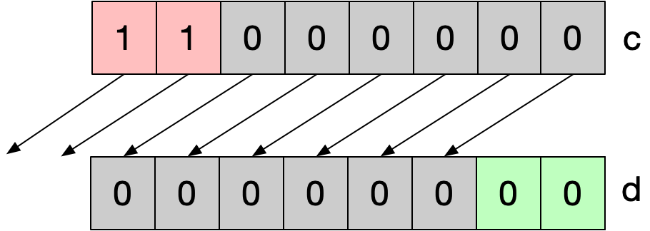

>> Right Shift

The right shift operator shifts all bits n places to the right. The rightmost n digits are dropped and the leftmost n digits are filled as follows. If the operand is unsigned the left n bits are filled with zeros

byte c = 128+64;

byte d = (byte)(c >> 2);

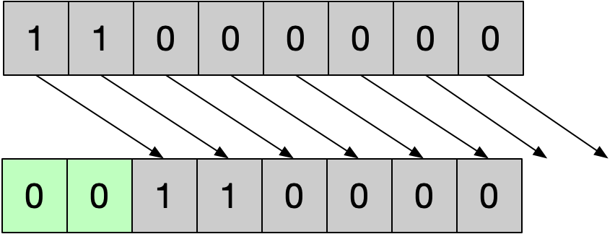

If the operand is signed the sign of the bits filled on the left matches the sign bit in the most significant position.

sbyte a = -96;

sbyte b = (sbyte)(a >> 2);

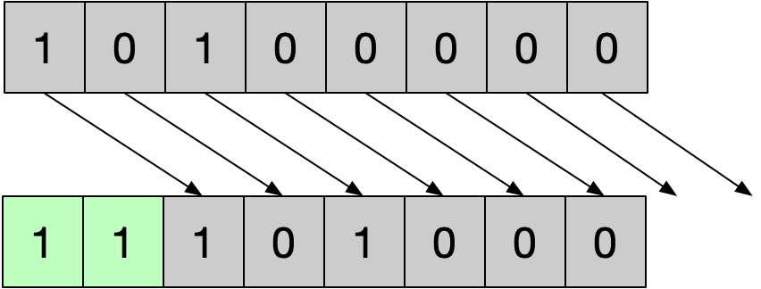

This extra complexity ensures that shifting right 1 place is equivalent to divinding by two when the operand is negative.

~ bitwise complement

Inverts all the bits

a 00001101

~a 11110010

& bitwise and

Copies a 1 into the result if the corresponding bits in each operand are 1

a 00001101

b 11101011

a&b 00001001

| bitwise or

a 00001101

b 11101011

a|b 11101111

^ exclusive or

a 00001101

b 11101011

a^b 11100110

### Bit Manipulation

|  |  |  |  |
| --- | --- | --- | --- |
| 1 << i | 1 << 3 | 0001000 | Create a mask with all zeros except a single 1 at bit location i |
| ~(1 << i) | ~(1 << 3) | 11110111 | Create a mask with all ones except a single 0 at bit location i |
| ~0 << n | ~0 << 3 | 11111000 | Create a mask of all 1s except for 0s in the n least significant digits |
| (1 << i)-1 | (1 << 3)-1 | 00000111 | Create a mask of all 0s except for 1s in the n least significant digits |
| (1 << j-i+1)-1)<<i | (1 << 4-2+1)-1)<<2 | 00011100 | Create a mask of all 0s except for digits i through j which contain 1s |
| ~(((1 << i - j + 1) - 1) << i)) | ~(((1 << i - j + 1) - 1) << i)) | 111000111 | Create a mask of all 1s except for digits i through j which contain 0s |
| a+(~b+1) | 5 + (~3+1) | 2 | Perform subtraction without using the - key |

### Bit Properties

|  |  |
| --- | --- |
| a ^ 0s = a | a 00001101  0s 00000000  a ^ 0s 00001101 |
| a ^ 1s = ~a | a 00001101  1s 11111111  a ^ 1s 11110010 |
| a ^ a = 0 | a 00001101  0s 00000000  a & 0s 00000000 |
| a & 0s = 0 | a 00001101  0s 00000000  a & 0s 00000000 |
| a & 1s = a | a 00001101  1s 11111111  a & 1s 00001101 |
| a & a = a | a 00001101  a 00001101  a & a 00001101 |
| a | 1s = 1s | a 00001101  1s 11111111  a | 1s 11111111 |
| a | a = a | a 00001101  a 00001101  a | 1s 00001101 |
| a ^ ~a = 1s | a 00001101  ~a 11110010  a^~a 11111111 |

### Getting/Setting Bits

|  |  |  |  |
| --- | --- | --- | --- |
| (1 << i) | a | (1 << 2) | 0b00101000 | 00101100 | Set bit i to 1 |
| ~(1 << i) & a | ~(1 << 2) & 0b00101100 | 00101000 | Set bit i to 0 |
| (a >> i) & 1 | (0b00101100 >> 3) & 1 | 1 | Get the value of bit i |
| (~0 << i) & a | (~0 << 3) & 0b10101111 | 10101000 | Clear i least significant bits |
| ((1 << i)-1) | a | ((1 << 3)-1) | 0b10100000 |  | Set i least signifcant bits |
| a & (a-1) | a 00111100 a-1 00111011 a&(a-1) 00111000 |  | Clear the rightmost (least significant) 1 digit |

### Endianness

Most numeric types consist of multiple bytes. The order in which the bytes are arranged in memory is known as endianness. On a little-endian system, a numeric object’s least to most significant bytes are arranged in order from lower memory addresses to higher memory addresses. Consider a .NET unsigned short which occupies 2 bytes or 16 bits

ushort a = 0x0102;

Figure 2 Endianness

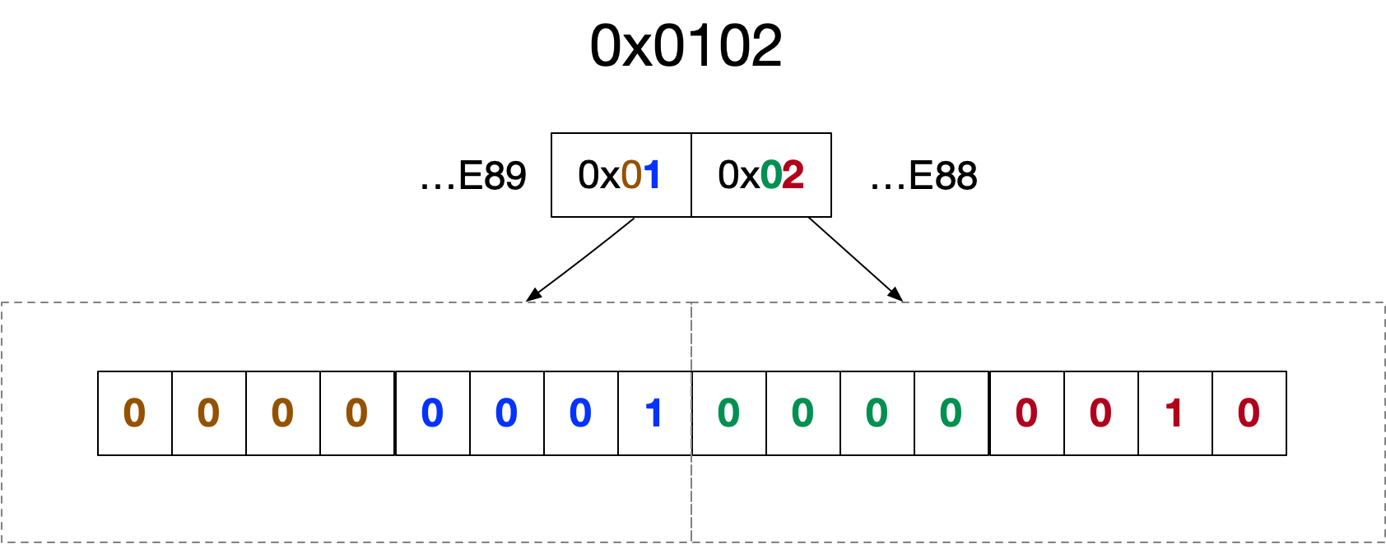

### Manipulating Binary

#### Tricks

Adding the same number

Performing integer addition where both operands are the same equal to multiplying by two which is equal to shifting left one place.

0000**1101**

+ 0000**1101**

000**1101**0

Multiplication

In binary multiplication is simply shiting the multiplicand left by a number of digits equal to the multiplier.

0000**1101**

* 00000011

0**1101**000

Bits – Questions

Bit Manipulation

…\linqpad\Queries\InterviewQuestions\Bits\2. Bit Manipulation

Implement this function to return a mask of all 0s except a single 1 in bit location i

The following shows how this works with i=3

idx 7654**3**210

1 00000001

1 << 3 0000**1**000

public static sbyte MaskOne(int i) => (sbyte)(1 << i);

Implement this function to return a mask of all 1s except a single 0 in bit location i

The following shows how this works with i=3

idx 7654**3**210

1 00000001

1 << 3 0000**1**000

~(1 << 3) 1111**0**111

public static sbyte MaskTwo(int i) => (sbyte)(~(1 << i));

Implement this function to return a mask of all ones except for zeros in the i least significant bits from 0 to (i-1)

The following shows how this works with i=3

idx 76543**210**

~0 11111111

~0 << 3 11111**000**

public static sbyte MaskThree(int n) => (sbyte)(~0 << n);

Implement this function to return a mask of all zeroes except for ones in the n least significant bits

The following shows how this works with i=3

idx 76543**210**

1 << 3 00001000

(1 << 3)-1 00000**111**

public static sbyte MaskFour(int n) => (sbyte)((1 << n)-1);

Implement this function to return a mask of all 0s except for digits i through j which

The following shows how this works with i=3, j=6

idx 7**6543**210

(1 << 6-3+1) 00010000

(1 << 6-3+1)-1 00001111

((1 << 6-3)-1)<< 3 0**1111**000

public static sbyte MaskFive(int i, int j) =>

(sbyte)(((1 << j-i+1) - 1) << i);

Implement this function to return a mask of all 1s except for digits i through j which contain 0s.

The following shows how this works with i=3, j=6

idx 7**6543**210

(1 << 6-3+1) 00010000

(1 << 6-3+1)-1 00001111

((1 << 6-3)-1)<< 3 01111000

~(((1 << 6-3)-1)<< 3) 1**0000**111

public static sbyte MaskSix(int i, int j)

=> (sbyte)~(((1 << j – i+1) - 1) << i);

Bit Properties

…\linqpad\Queries\InterviewQuestions\Bits\1. Properties of Bit Operators

What is the result of a ^ 0s?

a 00001101

0s 00000000

a ^ 0s 00001101

The result is a

What is the result of a ^ 1s?

a 00001101

1s 11111111

a ^ 1s 11110010

The result is ~a

What is the result of a^a?

a 00001101

0s 00000000

a & 0s 00000000

The result is 0s

What is the result of a&0s?

a 00001101

0s 00000000

a & 0s 00000000

The result is 0s

What is the result of a&1s?

a 00001101

1s 11111111

a & 1s 00001101

The result is a

What is the result of a | a?

a 00001101

a 00001101

a | 1s 00001101

The result is a

What is the result of a ^ ~a ?

a 00001101

~a 11110010

a^~a 11111111

The result is 1s

Perform bitwise negation without using the ~ operator?

a ^ 1s = ~0

### Getting/Setting bits

…\linqpad\Queries\InterviewQuestions\Bits\3. Getting and Setting

Write a function that returns true or false, reflecting whether or not the bit at index i is 1 or 0 respectively

Consider the specific case where n = 5 and i=2

idx 76543**2**10

n 00000**1**01

n >> 2 0000000**1**

1 00000001

(n >> 2)&1 00000001

((n >> 2)&1)>0 **true**

public bool GetBit(int n, int i) => ((n >> i) & 1) > 0;

Write a function set the bit at index i to 1

public int SetBit(int n, int i) => (1 << i) | n;

Write a function clear the bit at index i to 0

public int ClearBit(int n, int i) => ~(1 << i ) & n;

Write a function that clears all bits from msb through to i inclusive

public int ClearFromMsbToI(int n, int i)

{

return ((1 << i )-1) & n;

}

Write a function that sets all bits from msb through to i inclusive

public int SetFromMsbToI(int n, int i)

{

return (~0 << i) | n;

}

Write a function that clears all bits from 0 through to i inclusive

public int ClearFromLsbToI(int n, int i)

{

return (~0 << i+1) & n;

}

Write a function that sets all bits from 0 through to i inclusive

public int SetFromLsbToI(int n, int i)

{

return ((1 << i+1)-1) | n;

}

Bit Based Interview Questions

#### Unset Least Significant Set Bit

Write an expression to unset the least significant/rightmost set bit

We make use of the fact that subtracting one from a binary number has the effect of unsetting the least significant set bit and setting all bits to the right of that bit.

|  |  |
| --- | --- |
|  | 000010**10** |
|  | 000010**01** |

If we then & the result of this operation with the original number the effect is to unset the least significant(rightmost) set bit

|  |  |
| --- | --- |
|  | 000010**1**0 |
|  | 00001001 |
|  | 000010**0**0 |

#### Set all bits to Right of Rightmost Set Bit

Write an expression to set all bits to the right of the least significant set bit

We make use of the fact that subtracting one from a binary number has the effect of unsetting the least significant set bit and setting all bits to the right of that bit.

|  |  |
| --- | --- |
|  | 000010**10** |
|  | 000010**01** |

If we then | the result of this operation with the original number the effect is to set all bits to the right of the least sinificant set bit to 1.

|  |  |
| --- | --- |
|  | 00001100 |
|  | 00001011 |
|  | 00001111 |

#### Calculate Number of Set Bits

Write a function to calculate the number of 1s in an integers binary representation

We can use a simple linear traversal of the integers bits counting the 1s as we go. Such as algorithm is constant time and always takes O(sizeof(int)*8).

public int BitCount(int a)

{

int numBits = sizeof(int) * 8;

int bitCount = 0;

for (int i=0; i < numBits;i++)

{

if (((a >> i) & 1) > 0)

bitCount++;

}

return bitCount;

}

But actually we can do better. The following describes a clever algorithm invented by Brian Kernigan. It key idea is that if we subtract 1 from any integer then the result is that ever bit from the lsb up to a and including the least significant 1 is flipped. If we then perform an & operation we are effectively removing the least 1.

|  |  |
| --- | --- |
|  | **00000101**  **00000100**  **00000100** |

#### Count Number Of Differing Bits

Given two integers a and b find the number of bits you would need to change to modify x to be y?

A simple XOR is enough to give us the bit that differ between a and b. We can then use Kernighan’s algorithm to count the number of bits

public int CountDifference(byte a, byte b)

{

byte diff = (byte)(a ^ b);

int count = 0;

while (diff != 0)

{

diff = (byte)(diff & (diff-1));

count++;

}

return count;

}

#### Set All Bits To Right of Most Significant Bit

Write an expression to set all bits to the right of the most significant set bit

|  |  |
| --- | --- |
|  | 01000000 |
|  | 01100000 |
|  | 01111000 |
|  | 01111111 |

#### MSB > n

Write code to calculate if msb if is in location > n

idx 76543210

x0 00010000

((1 << 5)-1) 00011111

~((1 << 5)-1) 11100000

x & ~((1 << 5)-1) |= 0 true

#### Next Int Same 1 Count

Given an integer find the next largest integer that has the same number of 1s in its binary representation.

public byte NextLargestSame1Count(byte x)

{

int onesCount = 0;

for (int i = 0; i < sizeof(byte) * 8; i++)

{

// We have found the first non-trailing zero

if (((x >> i) & 1) == 0)

{

if (onesCount > 0)

{

// Flip first non-trailing zero to 1

x |= (byte)(1 << i);

// Zero locations right of flipped digit

x &= (byte)(~1 << (i-1));

// add back in onesCount-1 1s in lsb locations

x |= (byte)((1 << onesCount-1)-1);

break;

}

}

else

{

onesCount++;

}

}

return x;

}

#### Previous Int Same 1 Count

Given an integer find the next smallest integer that has the same number of 1s in its binary representation.

The key idea is that we need to swap a set bit with an unset bit. If the bit we unset is to the left (more significant) than the bit we set we have decreased the number. Consider the specific input of 62. The first step is to find the 1 that we will flip to a zero. In order to be valid the 1 bit must have a 0 bit to the right of it (less significant) We are hence looking for the first non-trailing 1. We walk from least significant bits to most significant counting zeroes on the way and stopping when we reach the first non trailing 1.

idx 7**6**543210

x0 0**1**001111

i 6

The index of the non-trailing 1 is , the number of zeroes is and the number of ones is In order to unset the first non-trailing 1 which is at index 6 we create a mask

idx 7**6**543210

x0 0**1**001111

mask1 10111111

x1= x0&mask1 00001111

Rather than look for a single bit to set to the right of i, we instead clear all bits to the right of i and insert ones imediately to the right of. First we create a mask for the zeroing

idx 7**6**543210

x1 00001111

mask2 11000000

x2= x1 & mask2 00000000

Now we put the ones immediately to the right of i. Our mask is

idx 7**6**543210

x2 00000000

mask3 00111110

x3= x2 | mask3 00111110

The source code is then

public byte NextSmallestSame1Count(byte x)

{

Console.WriteLine($"x {Convert.ToString(x, 2).PadLeft(8, '0')}");

int zeroCount = 0;

for (int i = 0; i < sizeof(byte) * 8; i++)

{

if (((x >> i) & 1) != 0)

{

// If this condition is true the bit at the

// current index is set and there exists

// unset bits to the right of it.

// We can do a switch

if (zeroCount > 0)

{

// 1. Unset the bit at the current index.

// To do this we form a mask of all 1s

// except at index i where it has a zero.

// The mask is anded with x to unset bit i

byte mask1 =(byte)~(1 << i);

x &= mask1;

// 2. The index of the unset bit is i. We want to

// clear all bits to the right of i. That is

// we want to clear bits 0 through i-1 or

// the leftmost i bits. We define a mask that

// consists of i 0s in positions 0 through i-1

// and the rest 1s. We and the mask with x to clear

byte mask2 =(byte)(~0 << i);

x &= mask2;

// 4. We originally had (i+1-zeroCount) 1 digits.

// We need to these back in location i-1

// i-1-(i+1-zeroCount)

int oneCount = i +1 - zeroCount;

byte mask3 = (byte)((1 << oneCount) -1);

// 5. Shift the mask into position

mask3 = (byte)(mask3 << (i-oneCount));

// 6. Apply the mask

x |= mask2;

break;

}

}

else

{

zeroCount++;

}

}

return x;

}

#### Missing Int In Array

An array holds all the values from 0 to n inclusive with the exception of one number in the range which is missing. Write code to find which one

The simplest solutions makes use of the fact that we know that We can then just walk the array summing as we go and then subtract the result from the know value. This technique is

public int FindMissing(int[] a)

{

int n = a.Length;

int expected = (n*(n+1))/2 ;

int actual = a.Aggregate ((x, y) => x+y);

return expected - actual;

}

If the array is sorted we can use the relationship between each array element and its index to perform a binary search from O(logn)

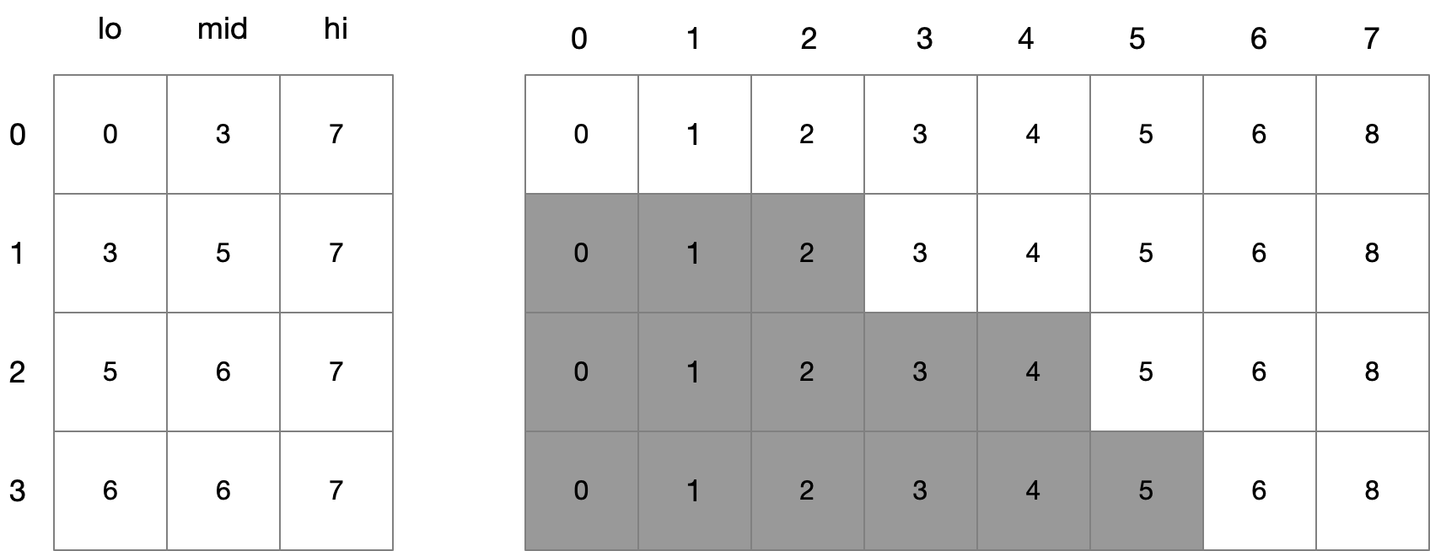

public int SearchIterative(int[] ar)

{

int lo = 0;

int hi = ar.Length-1;

int mi =0;

// Special cases for off the front and back off the

// sequence

if (ar[lo] != 0) return 0;

if (ar[hi] == hi) return hi +1;

while ((hi-lo)>1)

{

mi = (lo+hi)/2;

if ((ar[mi]-mi) != 0)

hi = mi;

else

lo = mi;

}

return lo+1;

}

Finally if the array is not sorted we can use the relationship between the number of 1s and 0s at each bit position to work out which number is missing. This is by far the most complex technique but it does yield O(logn) on an unsorted array.

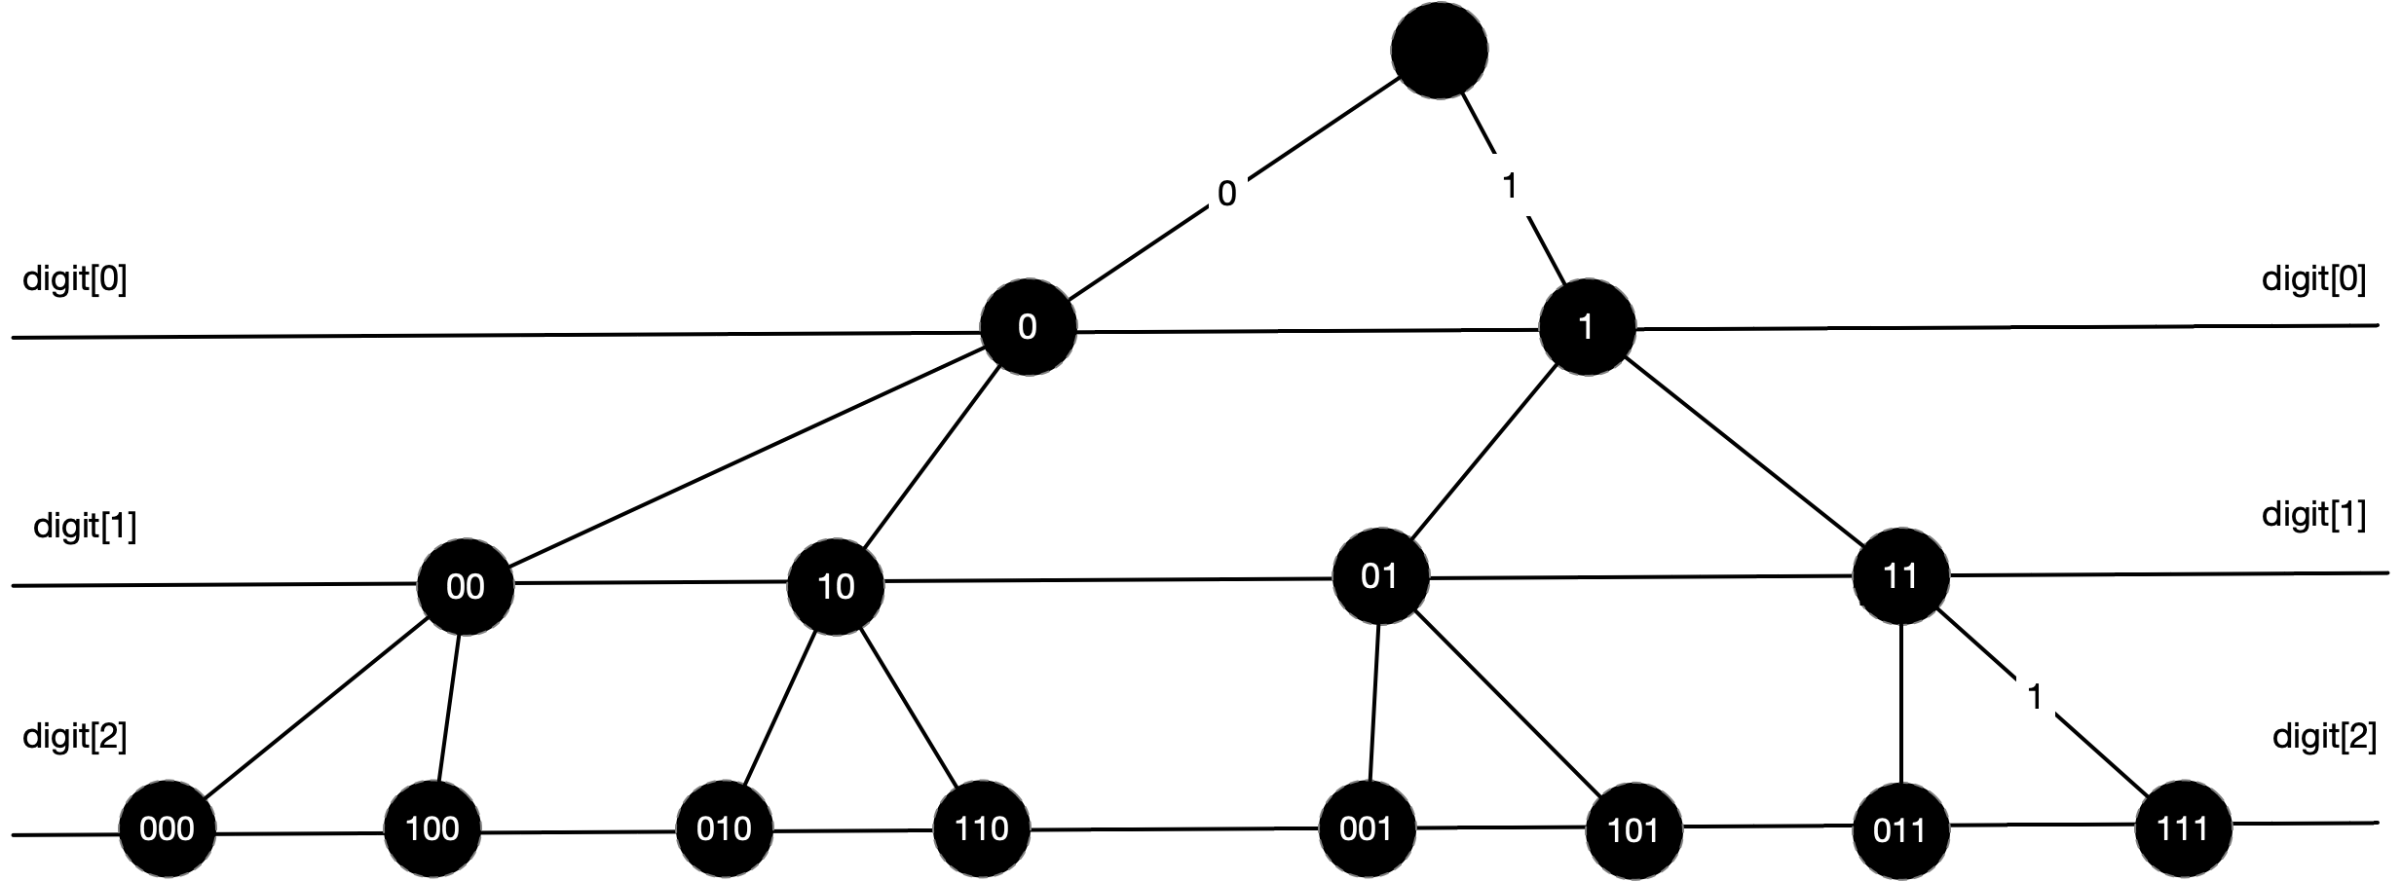

public int SearchIterative(int[] ar)

{

int numBits = (int)Math.Ceiling(Math.Log(ar.Count() + 2) / Math.Log(2));

int result = 0;

List<int> searchArray = new List<int>(ar);

for (int i = 0; i < numBits; i++)

{

List<int> ones = new List<int>();

List<int> zeroes = new List<int>();

for (int j = 0; j < searchArray.Count; j++)

{

if ((searchArray[j] >> i & 1) == 0)

zeroes.Add(searchArray[j]);

else

ones.Add(searchArray[j]);

}

if (ones.Count >= zeroes.Count)

{

searchArray = zeroes;

}

else

{

searchArray = ones;

result |= 1 << i;

}

}

return result;

}

#### Maximum XOR

Given an array of integers called ints and and an array of elements called elements that returns the maxium xor value of each value in elements against the elements in integers.

This is a tricky one and we need to use a data structure called a trie to solve it. Consider the case where our

#### Swap Even and Odd Bits

Write code to swap the even and odd bits of a given integer

The first stage is to separate out the even and odd digits. We use masks . Consider the specific example

*idx 76543210*

x 10111101

mask odd (0xaa) 10101010

mask even (0x55) 01010101

We apply the masks

*idx 76543210*

x 10111101

maskodd  10101010

xodd = x & maskodd 10101000

idx 76543210

x 10111101

maskeven 01010101

xeven = x & maskeven 00010101

We shift the odd bits into even positions and even bits into odd positions

idx 76543210

xeven =  xeven <<< 1 00101010

xodd = xodd >>> 101010100

result = xeven |xodd 01111110

The code is then

sbyte SwapEvenAndOdd(sbyte x)

{

// 1. Define the masks

sbyte oddMask = unchecked((sbyte)0xaa);

sbyte evenMask = unchecked((sbyte)0b01010101);

// 2. Separate out the even and odd bits

sbyte xEven = (sbyte)(x & evenMask);

sbyte xOdd = (sbyte)(x & oddMask);

// 3. Move odd bits into even positions and

// even bits into odd bit. Notice the cast to int

// to compensate fro C# having only arithmetic shift

// operators.

xEven = (sbyte)(xEven << 1);

xOdd = (sbyte)(((byte)xOdd) >> 1);

return (sbyte)(xEven | xOdd);

}

#### Longest Sequence Of 1s

Given an integer find the longest sequence of 1s you can form if you are allowed to flip one zero to a 1.

#### Copy Subsection

#### Position Of Rightmost Set Bit

#### Position Of Single Set Bit

#### Swap Variables

## Positional Number Systems

A positional number system represents any real number as a polynomial in the base of the number system.

When writing polynomial representations of numbers, we use a radix point to separate the whole and fractional parts. We can then drop the powers of the base as the exponent is implicit in the position of the digit. If a power has no value, we still need to mark it with a co-efficient of zero. Our form becomes.

The following are some examples

## Integers

If we drop the fractional part of the representation and consider only positive values, we have what programming languages refer to as the ‘unsigned integers

Note:

Mathematicians usually assume the natural numbers exclude zero. We use the standard computer science convention that the set includes zero.

Such a representation can distinguish between different values which we can use to represent positive integers in the range To highlight the approach consider the specific case of

00 0000

01 0001

02 0010

03 0011

04 0100

05 0101

06 0110

07 0111

08 1000

09 1001

10 1010

11 1011

12 1100

13 1101

14 1110

15 1111

It is useful to visualize such a system as a circle

Figure 3 Unsigned Integers

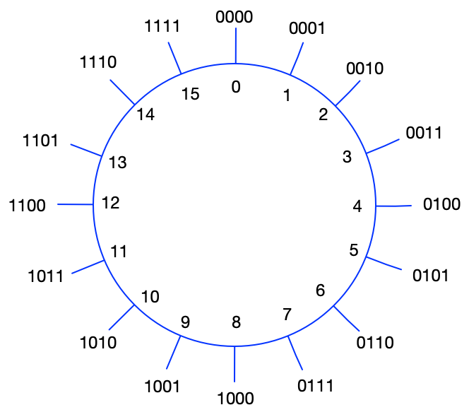

### 2s Complement Signed Integers

In the previous section we showed that an unsigned integer can be specified as the polynomial and that in this system the three-bit binary number represents the decimal value .

If we allow both positive and negative values we obtain the set of integers . In programming languages these are known as the signed integers.

In order to provide support for signed integers most systems use a 2’s complement notation. Twos complement is a way of encoding negative numbers into ordinary binary such that addition still works. In a 2’s complement signed representation we change our most significant digits weighting to giving us

A n bit 2s complement representation supports the values from … In this system the three-bit binary number is interpreted as the decimal value If all the coefficients are set to 1, i.e. () the value is interpreted as -1. The following shows the values of a 4-bit 2’s complement integer representation.

+00 0000

+01 0001

+02 0010

+03 0011

+04 0100

+05 0101

+06 0110

+07 0111

-08 1000

-07 1001

-06 1010

-05 1011

-04 1100

-03 1101

-02 1110

-01 1111

In the previous section on unsigned integers we saw that the maximum value than can be represented with a n-bit unsigned integer is .We also proved that subtracting a value from is every bit is the same as flipping the bits

In our twos complement notation the binary value with a one in every bit is no longer but instead is -1. Our equation then becomes

In order to negate a positive 2’s complement number we flip its bits and add one. We complement it and add one When adding a pair of twos complement numbers where one of them is negative we simply move around the wheel the number of places in the positive direction of the twos complement binary representation.

Figure 4 Addition of negative unsigned integers

short Negate( short x )

{

short neg = binaryAdd(~x, 1);

return neg;

}

short binarySubtract( short x, short y )

{

short minusY = Negate(y);

return binaryAdd( x, minusY);

}

#### Why twos complement is powerful

The most powerful aspect of 2’s complement notation is that we can add positive and negative numbers. If we have n bits, we can represent values. If we move points around our modular system, we get back to the same number (overflow).

The algorithm to multiply a 2’s complement number by -1 is to flip all its bits using the logical negation operator ~ and then add one. This is beautiful because we can use the same bitwise addition to perform addition and subtraction. To do subtraction just form the ones complement and then do normal addition

#### Summary

* The most significant bit represents the sign
* Negating a value requires switching all its bits and then adding one
* 1 is represented by 001 and -1 is represented by 111
* N-bit implementation can represent numbers from to

### Arithmetic Operators

#### Unsigned Addition

Addition is achieved by starting at a and moving b places clockwise around the wheel. Consider the specific case of We visualize this as follows

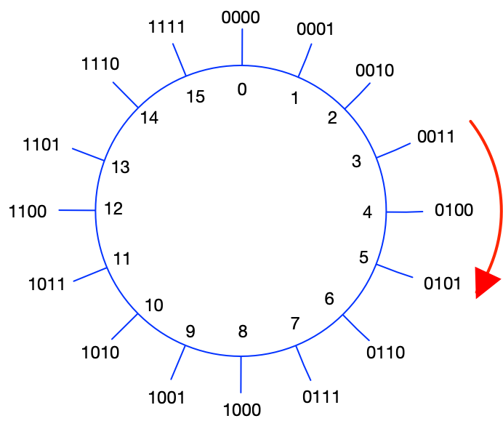

This is very simple binary addition

0011

+ 0010

0101

The following C# code shows how we might achieve such addition

Figure 5 Adding Unsigned Integers



Notice in our add method we do not deal with the overflow from the most significant bit. When we add one to the largest representable binary digit which consists of all ones the result is the smallest binary digit consisting of all zeros. In a four bit unsigned integer we would have as follows. Note the bold red overflow is discarded.

1111

+ 0001

**1**0000

By implementing add in this way we have created a modulo number system. If there are n bits in our unsigned integer, then addition is . For any unsigned integers a and m we have

=

=for

In our case adding to any value gets back to the same value. We show 4

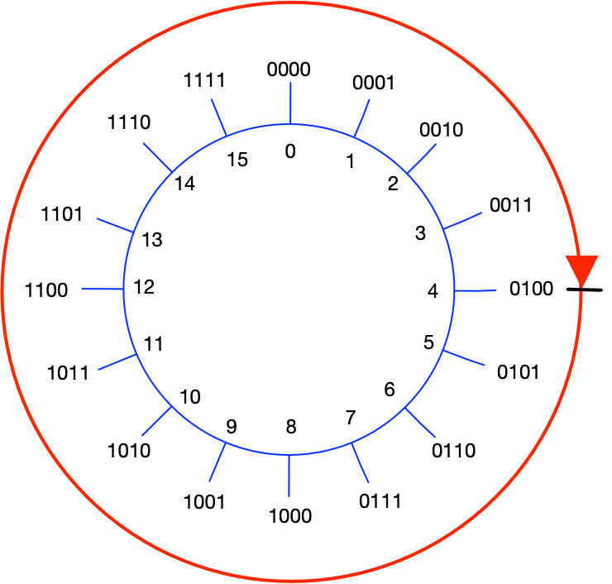

#### Unsigned subtraction

In our 4-bit integer notice what happens if we add to 4. We only rotate to 3. So, adding is the same as adding -1.

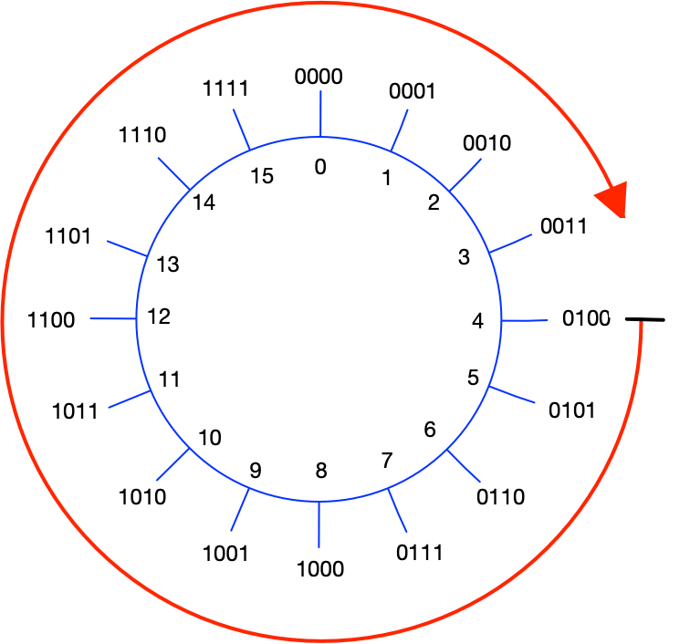

Similarly, adding is the same as subtracting 2 and adding is the same as subtracting b. We noted in the previous section that = and so it is self-evident that

This is a very useful result if we combine it with the following observation. Adding any binary number to its complement gives a number consisting solely of 1s.

In our representation we have that hence it follows that

If we substitute this into the expression

We get

This means we can use our method for addition of unsigned integers to perform subtraction of unsigned integers. The following shows the simple C# code

public uint Subtract(uint a, uint b) => Add(a, Add(~b, 1));

|  |  |  |  |  |
| --- | --- | --- | --- | --- |
| b  (Decimal) | B  (Binary) | ~b  (Binary) | Adding  (Clockwise) | Subtraction  (Anticlockwise) |
| 0 | 0000 | 1111 | 15 |  |
| 1 | 0001 | 1110 | 14 |  |
| 2 | 0010 | 1101 | 13 |  |
| 3 | 0011 | 1100 | 12 |  |

Proof that =

From properties of modulo numbers we know that

= and hence

= rearranging

= adding and subtracting 1

=

#### Division

Division is nothing but repeated subtraction. Integer division is defined using the following terms.

Division Example

##### Euclid’s Division Algorithm

The simplest algorithm to perform integer division is to repeatedly subtract. The runtime of this operation is very slow O(q) where q is the quotient

private (int q, int r) UnsignedDivide(int dividend, int divisor)

{

int quotient = 0;

int remainder = dividend;

while (remainder >= divisor)

{

remainder -= divisor;

quotient++;

}

return (quotient, remainder);

}

Signed divide is nothing more than a decorator of the unsigned divide method

public (int q, int r) Divide(int dividend, int divisor)

{

if (divisor == 0) throw new DivideByZeroException();

if ( dividend < 0 && divisor < 0 )

return UnsignedDivide(-dividend,-divisor);

if (dividend < 0)

{

(int q, int r) =UnsignedDivide(-dividend, divisor);

return (-q,r);

}

if (divisor < 0)

{

(int q, int r) = UnsignedDivide(dividend, -divisor);

return (-q, r);

}

return UnsignedDivide(dividend,divisor);

}

##### Long Division Algorithm (Any Base)

Consider

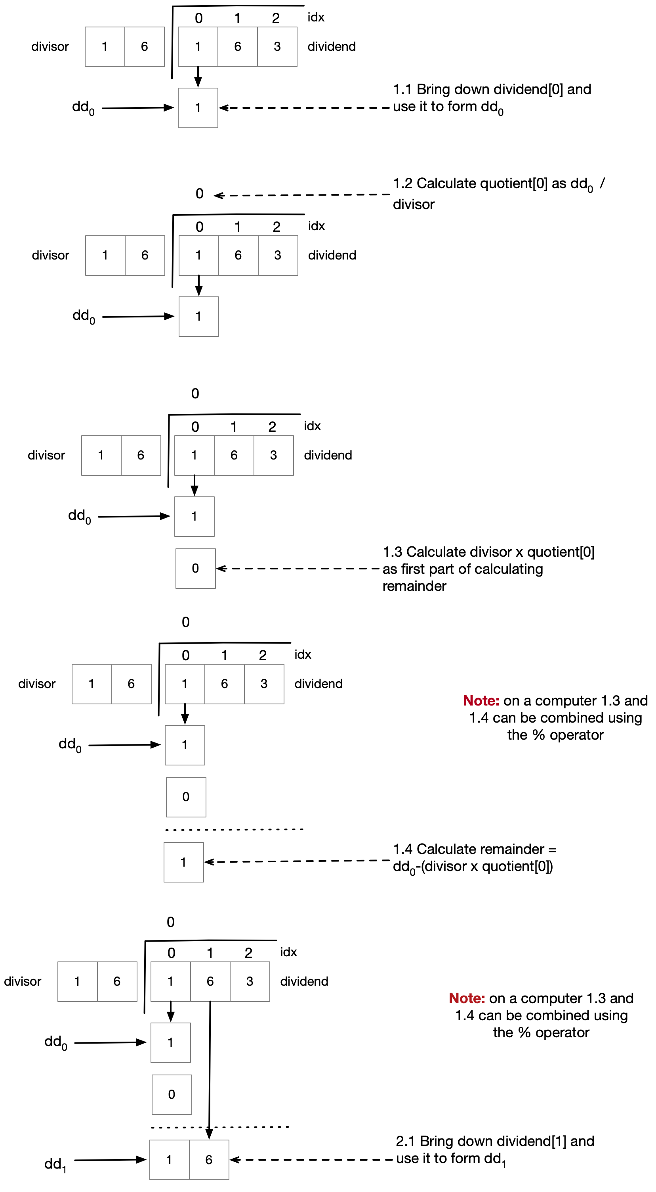

The following algorithm performs long division in any base.

public (string quotient, string remainder) IntegerLongDivision(string dividend, int divisor,

int b = 10)

{

StringBuilder quotient = new StringBuilder();

int remainder = 0;

int dd = 0;

for (int idx = 0; idx < dividend.Length; idx++)

{

// idx.1 copy in next digit into temporary dividend dd

dd = (dd * b) + dividend[idx].ToIntDigit();

// idx.2 calculate partial quotient and set into quotient[idx]

int partialQuotient = dd / divisor;

quotient.Append(partialQuotient.ToChar());

// idx.3 calculate this temporary as part of calculating the remainder

int temp = partialQuotient * divisor;

// idx.4 Calculate the remainder

remainder = dd % divisor;

// the remainder will form the basis of dd[idx+1]

dd = remainder;

}

return (quotient.ToString(), remainder.ToChar().ToString());

}

public static class Extensions

{

public static int ToIntDigit(this char c)

{

if (char.IsNumber(c)) return (int)char.GetNumericValue(c);

return char.ToLower(c) - 'a' + 10;

}

public static char ToChar(this int i)

{

if (i >= 0 && i < 10)

return (char)(i + '0');

return (char)(i + 'a' - 10);

}

}

##### Long Division Algorithm Binary

If we want to do long division in binary the algorithm is very simple

public (int quotient, int remainder) UnsignedDivide(int dividend, int divisor)

{

int numBits = sizeof(byte) * 8;

int quotient = 0;

int remainder = 0;

for (int i = numBits-1; i >= 0; i--)

{

// Get the value of the dividend's bit index i

byte d_i = (byte)((dividend >> i) & 1);

// Shift the remainder left by 1 bit and add in the

// bit i from the dividend

remainder = ((remainder << 1) | d_i);

// The value of the quotient at index i can only be 1 or 0.

// It is 1 if the divisor is greater than or equal to

// remainder, otherwise it is zero

int q_i = (((remainder >= divisor) ? 1 : 0) << i);

// copy q_i into the quotient

quotient |= q_i;

// If the quotient digit q_i is non zero we subtract the

// divisor fro, the dividendTemp

if ( q_i > 0 )

remainder -= divisor;

}

return (quotient,remainder);

}

##### Integer Long Division Algorithm Floating Point Result

public string IntegerDivisionWithFloatingPointResult(string dividend, int divisor,

int b = 10, int maxDigits = 8)

{

StringBuilder quotient = new StringBuilder();

int remainder = 1;

int dd = 0;

for (int idx = 0; (idx < dividend.Length || remainder > 0)

&& idx < maxDigits; idx++)

{

// Add in a decimal point

if (idx == dividend.Length)

quotient.Append(".");

// idx.1 copy in next digit into temporary dividend dd

if (idx < dividend.Length)

dd = (dd * b) + dividend[idx].ToIntDigit();

else

// The integer dividend has no more digits so we just increase

// by a factor of b as we move to the right side of the point

// point

dd = (dd * b);

// idx.2 calculate partial quotient and set into quotient[idx]

int partialQuotient = dd / divisor;

quotient.Append(partialQuotient.ToChar());

// idx.3 calculate this temporary as part of calculating remainder

int temp = partialQuotient * divisor;

// idx.4 Calculate the remainder

remainder = dd % divisor;

// the remainder will form the basis of dd[idx+1]

dd = remainder;

}

return quotient.ToString();

}

Integers – Questions

#### Addition

Write a function to add two signed integers. Do not use the + operator?

**Note:** Make sure you work through an example like this before writing the code

1111

+ 0001

**1**0000

public int Add(int a, int b)

{

int numDigits = (sizeof(int) * 4)-1;

int carry=0;

int result = 0;

for(int i=0; i < numDigits; i++)

{

int ai = (a >> i) & 1;

int bi = (b >> i) & 1;

// ri is a 1 if one or three of the

// variables {ai,bi, carry} is a 1 otherwise

// it is a zero. We use XOR

int ri = ai ^ bi ^ carry;

// the carry if any two of the three input are 1

carry = (carry & ai) | (carry & bi) | (ai & bi);

// Shift ri into position i and add to result

result |= (ri << i);

}

return result;

}

Why does it work for negative integers?

Our addition is working on a modulo system where and so

The following diagram shows how signed integers are represented in twos complement notation. Notice that so subtracting b is the same as adding if the binary is treated as an unsigned number.

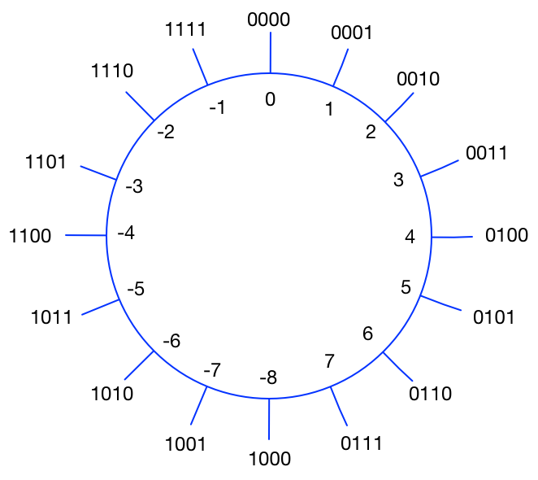

#### Subtraction

User your function to write unsigned subtraction?

We make use of the fact that a – b = a + ~b +1

public int Subtract(int a, int b) => a + ~b +1;

Why does this work?

#### Negation

Write code to calculate a numbers twos complement



In binary as unsigned

And we know

Inserting 2 into 1

Simplify

#### Multiplication

Write code to do simple binary multiplication?

In binary multiplication is simply shifting the multiplicand left by a number of digits equal to the multiplier.

0000**1101**

* 00000011

0**1101**000

public int UnsignedMultiply(int multiplicant, int multiplier)

{

int result =0;

int numBits = sizeof(int)*8;

for (int i = 0; i < numBits; i++)

{

if ( ((multiplier >> i ) & 1) > 0)

result |= (multiplicant << i);

}

return result;

}

#### Division By Repeated Subtraction

Write code to do very simple division?

private (int q, int r) UnsignedDivide(int dividend, int divisor)

{

int quotient = 0;

int remainder = dividend;

while (remainder >= divisor)

{

remainder -= divisor;

quotient++;

}

return (quotient, remainder);

}

What is the performance of your algorithm?

This is very inefficient. O(q) where q is the quotient

It is very slow

Use your function to do signed division?

public (int q, int r) Divide(int dividend, int divisor)

{

if (divisor == 0) throw new DivideByZeroException();

if ( dividend < 0 && divisor < 0 )

return UnsignedDivide(-dividend,-divisor);

if (dividend < 0)

{

(int q, int r) =UnsignedDivide(-dividend, divisor);

return (-q,r);

}

if (divisor < 0)

{

(int q, int r) = UnsignedDivide(dividend, -divisor);

return (-q, r);

}

return UnsignedDivide(dividend,divisor);

}

#### Division By Binary Long Division

Write code to perform binary long division unsigned

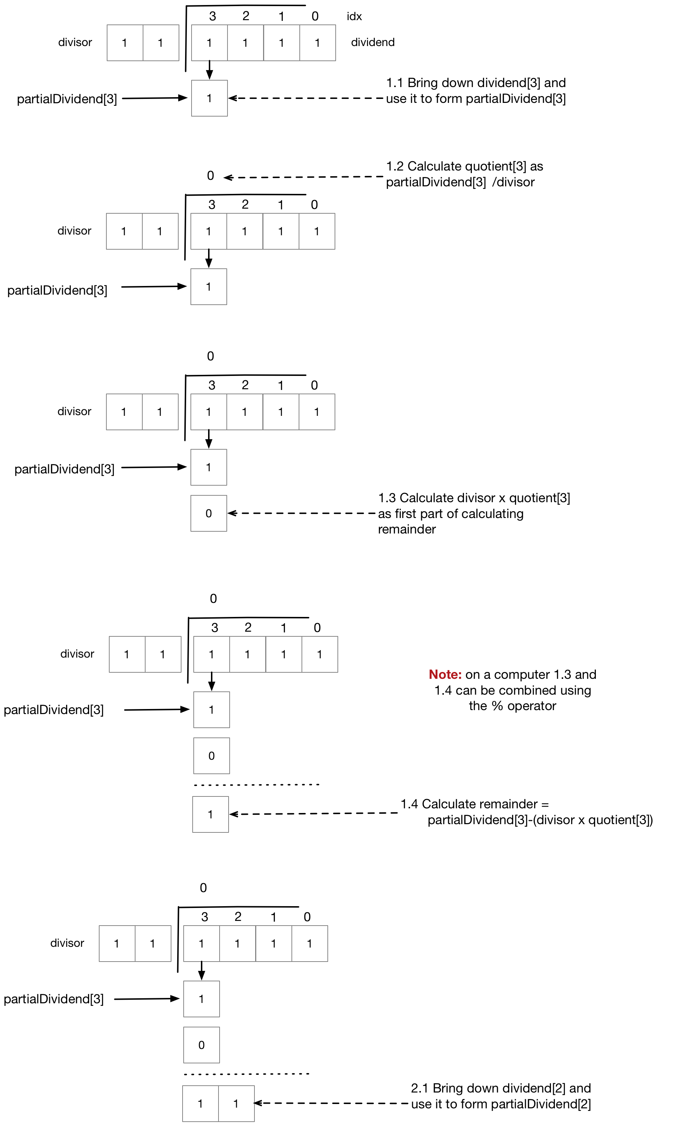

public (int quotient, int remainder) UnsignedDivide(int dividend, int divisor)

{

int numBits = sizeof(int) * 8;

int quotient = 0;

int remainder = 0;

for (int i = numBits-1; i >= 0; i--)

{

// Get the value of the dividend's bit at index i

int dividend_i = (int)((dividend >> i) & 1);

// Form the partial dividend for this iteration

// (partialDividend[i]) by combining the bit

// at index i in the dividend (dividend[i])

// the remainder from the previous iteration

// shifted one bit left

int partialDividend_i = (remainder << 1) | dividend_i;

// The value of the quotient at index i (quotient[i])

// can only be 1 or 0. It is 1 if the divisor is

// greater than or equal to partialDividend[i],

//otherwise it is zero

int quotient_i = ((partialDividend_i >= divisor) ? 1 : 0);

// copy quotient[i] into the quotient

quotient |= quotient_i <<i;

// Calculate the product of quotient[i] and the divisor

// as a part of calculating the remainder

int productTemp = quotient_i * divisor;

// The remainder from this iteration is then the

// partialDividend[i] - (quotient_i * divisor) =

// partialDividend[i] % divisor

remainder = partialDividend_i - productTemp;

// Note the previous two statements can be much

// simplified in the case of binary

// which we do in Answer2

}

return (quotient,remainder);

}

We note however that the final two statements of the method that carry our the remainder can be greatly simplified because we are dealing with binary. The code becomes

public (int quotient, int remainder) UnsignedDivide(int dividend, int divisor)

{

int numBits = sizeof(int) * 8;

int quotient = 0;

int remainder = 0;

for (int i = numBits-1; i >= 0; i--)

{

// Get the value of the dividend's bit at index i

int dividend_i = (int)((dividend >> i) & 1);

// Form the partial dividend for this iteration

// (partialDividend[i]) by combining the bit

// at index i in the dividend (dividend[i])

// the remainder from the previous iteration

// shifted one bit left

int partialDividend_i = (remainder << 1) | dividend_i;

// The value of the quotient at index i (quotient[i])

// can only be 1 or 0. It is 1 if the divisor is

// greater than or equal to partialDividend[i],

//otherwise it is zero

int quotient_i = ((partialDividend_i >= divisor) ? 1 : 0);

// copy quotient[i] into the quotient

quotient |= quotient_i <<i;

// Calculate the product of quotient[i] and the divisor

// as a part of calculating the remainder

int productTemp = quotient_i * divisor;

**remainder = partialDividend_i;**

// If the quotient digit q_i is non zero we subtract the

// divisor fro, the dividendTemp

**if ( quotient_i > 0 )**

**remainder -= divisor;**

}

return (quotient, remainder);

}

#### Long Division Any Base

Write code to perform integer division using a long division algorithm. The dividend is specified using a string. The base of the dividend and the divisor are given as simple ints?

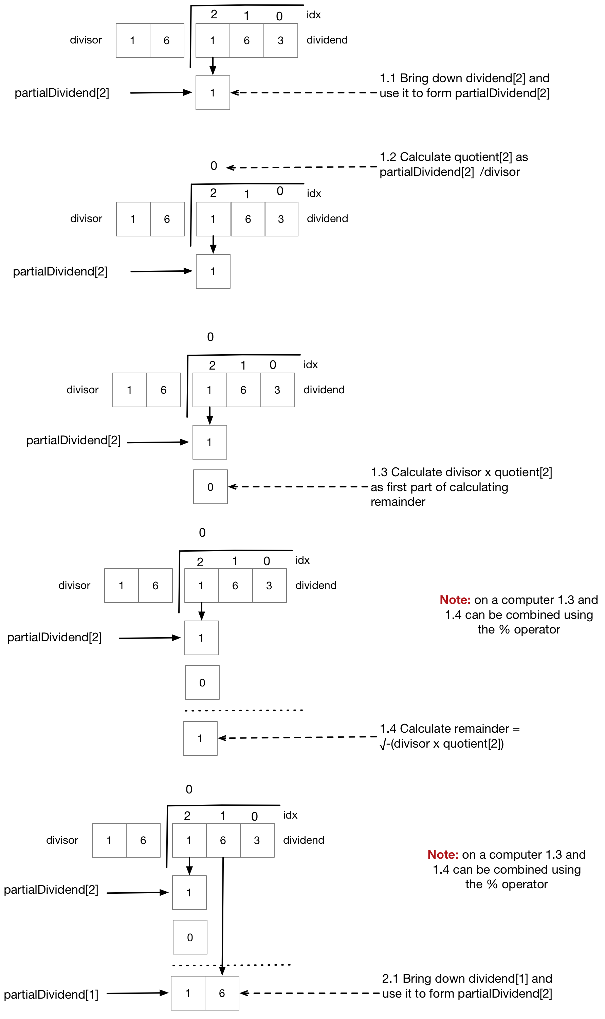

public (string quotient, string remainder) IntegerLongDivision(string dividend, int divisor,

int b = 10)

{

StringBuilder quotient = new StringBuilder();

int remainder = 0;

int dd = 0;

for (int idx = 0; idx < dividend.Length; idx++)

{

// Get the value of the character at index i and

// convert it to an integer. This gives us a single

// digit of the dividend

int dividend_i = dividend[idx].ToIntDigit();

// Form the partial dividend for this iteration my

// shifting the remainder from the previous iteration

// one position left and adding the dividend[i]

int partialDividend_i = (remainder * b) + dividend_i;

// Calculate partial quotient and set into quotient[idx]

int quotient_i = partialDividend_i / divisor;

quotient.Append(quotient_i.ToChar());

// Calculate the remainder

remainder = partialDividend_i % divisor;

}

return (quotient.ToString(), remainder.ToChar().ToString());

}

public static class Extensions

{

public static int ToIntDigit(this char c)

{

if (char.IsNumber(c)) return (int)char.GetNumericValue(c);

return char.ToLower(c) - 'a' + 10;

}

public static char ToChar(this int i)

{

if (i >= 0 && i < 10)

return (char)(i + '0');

return (char)(i + 'a' - 10);

}

}

#### Parse Int

Write code to parse an Integer

public int ParseInteger(string s)

{

int sign = 1;

if (s[0] == '-')

{

s = s.Substring(1);

sign = -1;

}

int x = 0;

foreach (var c in s) x = (x*10) + c - '0';

return x * sign;

}

#### Change of Base

Given a string representation of an integer N in base convert it to a string representation of an integer in base . For example given the input “10” with and it would return “1010”

Let then we want to find the coefficients  such that

We have a number N

That we want to convert to base such that

We can rewrite this as

If we divide it by then the remainder is clearly and the quotient is

If we repeat this until the quotient is zero we can read off the value of to giving us the required number in the new base

Integer change of base

private string ConvertIntegralPart(string input, int l, int b)

{

var result = new StringBuilder();

// Calculate the decimal equivalent

var idx =0;

var d = input[idx].ToIntDigit();

while(++idx < input.Length) d = (d * l) + input[idx].ToIntDigit();

var quotient = d;

do

{

var r = quotient % b ;

quotient = quotient / b;

result.Append(r.ToChar());

}

while (quotient > 0 );

var chars = result.ToString().ToCharArray().Reverse().ToArray();

return new string(chars);

}

#### Log Any Base

Write a function Log(double x, double b) that takes a double value and a double base and returns It should work for any valid real base.

We only have natural logarithm and logarithm base 10 in the mathematics package but we can make use of the following to calculate any base from the natural logarithm or the base 10 logarithm

Proof

Let and hence

The C# source code is then given by

Logarithm any base

public double Log(double x, double b)

{

return Math.Log(x) / Math.Log(b);

}

#### Digits Required To Represent Integer In Base B

Given an integer value calculate the number of digits d required to represent that integer in base b nuber system

A number n represented in a base b number system will consist of k digits if and only if . In other words is the smallest number that requires k digits. Based on these facts we can derive expressions that calculate the number of digits k required to represent n in base b.

Expression using the floor function

Taking logarithms our inequality becomes.

.

From the properties of the floor function we know that and hence in our case

Expression using the ceiling function

We can achive a similar result that uses the ceiling function by adding one to the inequality . so we get

and taking logarithms we get

From the properties of the ceiling function we know that and hence that

Number of digits code

The following code uses the ceiling function approach. It requires a function that gives the logarithm of any base.

public double DigitsRequired(int x, int b)

=> Math.Ceiling(Log(x+1,b));

public double Log(double x, double b)

=> Math.Log(x) / Math.Log(b);

#### Log Base 2 Floor (Integer)

Write a function to calculate

The brute force algorithm simply shifts right one digit at a time until we reach zero. The number of ties we can do this gives us the position of the most significant set bit and hence the number we are looking for

public byte IntLog(byte x)

{

if (x<=0) throw new ArgumentException();

byte shiftCount =0;

while (x >0)

{

x >>=1;

shiftCount++;

}

return (byte)(shiftCount -1);

}

More efficient log2(n)

public int LogOpt(int x)

{

int e = 0;

if ((x &(~((1<<16)-1))) != 0)

{

// We have set digits in location 16-31 so we don't

// care about the digits in locations 0-15. Add 16

// and shift right to home in on exact location

x >>= 16; e += 16;

}

if ((x &(~((1<<8)-1))) != 0)

{

// We have set digits in location 8-15 so we don't

// care about the digits in locations 0-7. Add 8

// and shift right to home in on exact location

x >>= 8; e += 8;

}

if ((x &(~((1<<4)-1))) != 0)

{

// We have set digits in location 4-7 so we don't

// care about the digits in locations 0-3. Add 4

// and shift right to home in on exact location

x >>= 4; e += 4;

}

if ((x &(~((1<<2)-1))) != 0)

{

// We have set digits in location 2-3 so we don't

// care about the digits in locations 0-1. Add 2

// and shift right to home in on exact location

x >>= 2; e += 2;

}

if ((x &(~((1<<1)-1))) != 0)

{

// Finally is the digit in slot index 0 or 1

e += 1;

}

return e;

}

#### Minimum of Two Integers No Branching

Write code to find the minimum of two signed integers. You may not use Math.min or branching constructs.

Consider the case where we have two signed 8 bit integers a and b. If we take their difference (a-b) then the result can be classified as

* 0xxxxxxxx If a >= b or 1xxxxxxxx If a < b

If we perform a right arithmetic shift of 7 bits (sizeof the int -1) we get either

* 00000000 If a >= b
* 11111111 If a < b

Now if we & the result of this shift with the original difference. ((a-b) >> 7) & a-b

* 0 If a >= b
* a-b If a < b

Now we add in b

* 0+b=b If a >= b
* a-b+b =a If a < b

So we have returned b if a>=b and a if a < b which was the original aim

public sbyte Min(sbyte a, sbyte b)

{

// Take the differnce a-b. The result is one of two forms

// a) 0xxxxxxx if a >= b

// b) 1xxxxxxx if a < b

sbyte difference = (sbyte)(a-b);

// The result of the right shift is then one of two things

// a) 00000000 if a >= b

// b) 11111111 if a < b

sbyte mask = (sbyte)(difference >> (sizeof(sbyte)*8-1));

// Now if we & the mask and (a-b) we get one of of two things

// a) 00000000 if a >= b

// b) a-b if a < b

sbyte temp = (sbyte)(mask & difference);

// If we add b to this temp variable we get one of two things which

// is what we wanted

// a) 0+b=b if a >= b

// b) a-b+b=a if a < b

return (sbyte)(temp + b);}

#### Maximum of Two Integers No Branching

Write code to find the maximum of two signed integers. You may not use Math.min or branching constructs.

This is the same as the previous code except for we take the complement of the shift.

public sbyte Max(sbyte a, sbyte b)

{

// Take the differnce a-b. The result is one of two forms

// a) 0xxxxxxx if a >= b

// b) 1xxxxxxx if a < b

sbyte difference = (sbyte)(a-b);

// The result of the complemented right shift is

// then one of two things

// a) 11111111 if a >= b

// b) 00000000 if a < b

sbyte mask = (sbyte)~(difference >> (sizeof(sbyte)*8-1));

// Now if we & the mask and (a-b) we get one of of two things

// a) a-b if a >= b

// b) 0 if a < b

sbyte temp = (sbyte)(mask & difference);

// If we add b to this temp variable we get one of two things which

// is what we wanted

// a) a-b+b=a if a >= b

// b) 0+b=b if a < b

sbyte result = (sbyte)(temp + b);

return result;

}

#### Integer Absolute Value No Branching

Write code to find the absolute value of an integer without branching.

We first use our old shift right routine to form a mask. If x is positive the mask is 0s and if x is negative the mask is all 1s.

x=5 00000101

mask = x>>7 00000000

x=-5 11111011

mask = x>>7 11111111

Now if we xor the mask with x we get one of two things. If the mask is 0s then the result is just x. If the mask is negative the result is ~x because xor with 1s is the same as the complement operator.

x=5 00000101

mask = x>>7 00000000

mask ^ x 00000101

x=-5 11111011

mask = x>>7 11111111

mask ^ x 00000100

The final trick is to subtract the mask from the result of the xor. If the mask is zero then the subtraction has no effect and we return x. If the mask is 1s this represents -1 in 2s complement. In the negative case we have x ^ 1s -1 which is the same as positive x.

x=5 00000101

mask = x>>7 00000000

mask ^ x 00000101

(mask ^ x)-mask 00000101

x=-5 11111011

mask = x>>7 11111111

mask ^ x 00000100

(mask ^ x)-mask 00000101

The code is then

public sbyte AbsoluteValue(sbyte x)

{

sbyte mask = (sbyte)(x >> 7);

return (sbyte)((mask ^ x ) - mask);

}

#### Calculate Sign of Integer

Write code to calculate the sign of an integer?

public sbyte GetSign(sbyte a)

=> (sbyte)(a >> ((sizeof(sbyte) * 8)-1));

public sbyte GetSign2(sbyte a) =>

(sbyte)(1 |(a >> ((sizeof(sbyte) * 8)-1)));

#### Is Power Of 2

Write a function to check if a given unsigned integer is a power of 2

We make use of the fact the binary representation of any power of 2 is a single 1 followed by all zeros

|  |  |
| --- | --- |
|  | **00000001** |
|  | **00000010** |
|  | **00000100** |

Secondly we note that subtractive 1 from such a representation flips the single 1 to zero and changes all zeros following it to 1s

|  |  |
| --- | --- |
|  | **00000000** |
|  | **00000001** |
|  | **00000011** |

Finally we use the fact that ANDing the two forms gives a result of zero.

|  |  |
| --- | --- |
|  | **00000001**  **00000000**  **00000000**  **00000010**  **00000001**  **00000000** |
|  | **00000100**  **00000011**  **00000000** |

The code is given as follows. Note the special case for zero which is not a power of 2

public bool IsPowerOfTwo(uint a)

{

return (a != 0) && (a & (a-1)) == 0;

}

#### Largest Power of 2 <= x

Write statements to calculate the largest power of 2 less than or equal to x

|  |  |
| --- | --- |
|  | 01000000 |
|  | 01100000 |
|  | 01111000 |
|  | 01111111 |

Let e be the power we are looking for. Applying the result of the previous question we obtain a number The power we are looking for then becomes

#### Smallest Power of 2 >= x

Write statements to calculate the smallest power of 2 greater than or equal to x

|  |  |
| --- | --- |
|  | 01000000 |
|  | 01100000 |
|  | 01111000 |
|  | 01111111 |

Let e be the power we are looking for. Applying the result of the previous question we obtain a number The power we are looking for then becomes y+1

## Floats

“The exact meaning of single-, double-, and extended-precision is implementation-defined. Choosing the right precision for a problem where the choice matters requires significant understanding of floating-point computation. If you don’t have that understanding, get advice, take the time to learn, or use double and hope for the best”

Bjarne Stroustrup – The C++ Programming Language

Real numbers from the set form the basis of most scientific calculations. Any real number can be written in normalized scientific form.

The mantissa is a real number whose value is greater than or equal to 1.0 and less than . The exponent is an integer. An example of a number in this form is

Given an infinite number of digits in the fractional part of the mantissa any real number can be represented in this general form.

### Restricting the representation size

In practice we do not have the luxury of an infinite number of digits in the mantissa and hence it is common to use a more restricted representation. In full generality, if we use a baseand have digits of precision in the mantissa/significand we can **represent** a real number using the representation.

This is the same as the following.

Definitions

1. Mantissa/Significand
2. P The number of digits in the mantissa/significand
3. and The max and minimum exponents
4. The base

### Properties of the finite representation

#### Number Of Distinct Values

How many different numbers can a normalised finite form represent? One key point of the standard form is that that the digit before the decimal point must be in the set where the digits can be zero. The total number of different representable values is given as

Sign

Fractional

Digits

Exponent

Integral

Digits

#### Largest and Smallest Values

The largest representable value is . The smallest representable value is . The smallest non-negative value is .

#### Nearest Values

##### Example 1

Consider the following case where we use base , 4 digits for the mantissa and 2 digits for the exponent.

If e is 0 then the distance between the two nearest values is

1.125

1.250

1.375

1.500

1.625

1.75

1.875

If we increase e to 1 the distance between the two nearest values becomes

1.125

2.5

1.375

1.500

1.625

1.75

2.00

2.250

2.75

1.875

1.250

For a given exponent and a given number of binary digits p in the mantissa the distance between the nearest two points in our representation is

##### Example 2

Consider a floating-point representation with base The difference between the nearest two numbers depends on the exponent e.

|  |  |
| --- | --- |
|  | **0.1**  **0.1**  **0.1**  **0.01**  **0.01**  **0.01** |
|  | **0.001**  **0.001**  **0.001** |

##### Generalising

Generalizing, for any base , precisision p and exponent e the distance between the nearest two values is

#### Summary Of Properties of finite representations

* Possible different values
* Smallest positive value 
* Largest value
* Smallest value
* Difference between nearest 2 values

### Examples

#### Base 2

If we use base with 4 digits for the mantissa and our finite normalized scientific representation becomes

The leading integer digit of the mantissa must be non-zero in normalized notation and such a binary digit is in the setthe only valid value it can take is 1. All the other digits in the mantissa and exponent can be either 0 or 1 giving us a total number of representable values as the product of

* values of the integer part of the mantissa
* values of the fractional part of the mantissa
* values of the exponent
* 2 positive and negative values of the exponent
* 2 positive and negative values of the mantissa

Giving a total number of representable values of

We note an important point here. We used 4 bits for the mantissa and 2 bits for the exponent, one bit for the sign of the mantissa and one bit for the sign of the exponent coming to a total of 8 bits. However the total number of representable values is only . This is because the leading integer digit of the mantissa has to be one. (remember in normalized scientific notation the integer digit must be greater than or equal to one and less than . If is 2 then only the integer digit 1 meets this criteria). We need one bit less in the representation. When we look at computer representation of floating point numbers later we will meet this again.

* Smallest non-zero positive value
* Largest representable value
* Smallest representable value
* Difference between nearest 2 values

#### Base 10

If we use base with 3 digits for the mantissa and our finite normalized scientific representation becomes

* Smallest non-zero positive value
* Largest representable value
* Smallest representable value
* Difference between nearest 2 values

### Representation error

Internally real numbers are stored in binary representation, i.e. our base is 2.

All floating-point numbers are rational numbers which means they have a terminating expansion in the relevant base. As such most real numbers cannot be expressed exactly. Any number with an infinite expansion cannot be represented.

Also a number which has a finite expansion in one base can have non-finite expansion in another base. If the base is 2, as in binary floating point only **rational** numbers whose denominators are powers of 2 can be represented.

Converting a base 10 fraction such as 0.1 to binary floating point will result in an infinite expansion which can only be approximated with a finite number of digits. The following sections how to measure this error in approximation.

#### Absolute error

If we are approximating some real number x with a floating point representation float(x) the absolute error in the approximation is given by.

We noted earlier that the difference between the two nearest values in a given representation is defined as

If we need to round a real number to the nearest machine representable number, an upper bound on the maximum absolute error is half this space or

#### Units of the last place (ulps)

Often, we are interested in the absolute error in terms of the precision of the mantissa, ignoring the exponent part. We often talk of the error in “units of the last place” which means the error in units of the last place of the mantissa. If our mantissa has precision of 4 decimal digits our floating-point representation of 54.13298 is given by 54.13. The absolute difference is given by

z

f

z-f

The error in units of the last place would be .298. Since one unit in the last place is 0.01 our absolute error of 0.00298 is equal to 0.298 units in the last place. In general we can calculate the value of 1ulp as

In our case we had

In our general form where we approximate a number x using a floating-point number float(x) with base and p digits, the error in units in the last place becomes

Of course, given a number in units of the last place we simply multiply by the exponent term to get the absolute error

If we have procedure that guarantees that the floating point number chosen to approximate our real number x is the closest floating point number then the error in terms of “units of the last place” can be at most ½ times the value of the unit of the last place

#### Relative error

One problem with absolute error is that it does not consider the scale of the number being approximated. Relative error includes the magnitude of the value we are approximating.

Using the example from the previous section the relative error is given as

Now to see the relationship between absolute and relative error consider approximating the following two real numbers with the nearest floating point representatives; 9.995 and 0.005 (As we are looking at relative error the magnitude given by can be ignored) The relative error of the two numbers are

So, although all numbers with a given have the same maximum absolute error, there relative error varies by a factor of This is known as the wobble.

#### From units of the last place to relative error

For any chosen value of e a number of the form can vary in value from all the way to As such for any chosen value of e, where the error in terms of ulps is fixed the relative error will vary from up to If we have chosen the nearest floating point value to the real value then we can say that the error measured in ulps is 0.5 then our relative error will vary from up to

Put another way. For a fixed value of error in ulps the relative error can vary by a factor of because the mantissa can vary from 1.0 up to just under .

We now consider a numerical example to cement these formulas. Consider the special case where we use a base of 10 and mantissa of 4 digits. Assuming we always choose the correct nearest floating point number then the error in ulps will be 0.5. In our case the last place has value . Our chosen value of e is 3 so from our ulp error to absolute error we multiply by giving us an absolute error of 0.5 units. If we consider the value our relative error becomes On the other hand if we consider the value and our relative error becomes Both of these confirm what we expect. A fixed absolute ulp for a given exponent e gives a relative error that varies by a factor of B depending on the value of the mantissa

### Single Precision Float

If we consider single precision number the valid values the 32 bits are allocated as

* 1 bit represents the sign of the number
* 23 bits for the fractional part of the mantissa
* 8 bit signed number for the exponent

The storage however is a little peculiar. We might expect that using 8 bits for the exponent would allow use to have 256 different values. However four values are reserved for special values such as plus and minus zero and plus and minus infinity.

The representation is where (0 and 255 are used for special values) and The largest possible value representable is hence . The smallest positive number becomes

The binary machine number is the machine epsilon and is hence the smallest positive value such that. Because we can infer that single precision floating point has accuracy to six significant decimal figures.

So the mantissa can represent from 1 to in increments of which in decimal in approximately from 1 to in increments of so since any single precision mantissa representation can be up to from the real number. As such the precision of the mantissa is 6 significant figures.

### Converting Between Bases

Give a number N in base we want to convert it to a new base . Given

we want to find the coefficients  and such that

When doing the conversion we consider the integral and fractional part separately.

#### Integral Part

Looking first at the integral part we have a number N

We want to convert it to base such that

We can rewrite this as

If we divide it by then the remainder is clearly and the quotient is

If we repeat this until the quotient is zero we can read off the value of to giving us the required number in the new base

Let us consider the scenario where we want to convert the decimal number 2748 to hexadecimal. We first divide our decimal number by the new base 16

2748

16

171

1600

112

1148

28

16

12

So after this first division we know that



We can’t represent 171 as we only have sixteen symbols so we to divide 171 by 16

171

16

10

160

11

So now we know that



Inserting ii) into i) we get

Which we know is a positional number

Similarly we can do the same for base 2

#### Fractional part

Consider the situation where we have a fraction part in some base and we want to find the digits in the representation

We first note that

So if we take our fractional part and multiply it by then the resulting integral component is the we can similarly repeate the process to find the digits

Example 1 Convert  to base 8

**i)**

Floats – Questions

#### Decimal Fraction To Binary Fraction

Given a decimal fraction such as 0.46 return a string representation its binary. If the number cannot be represented exactly in binary in n bits throw an exception

private string ConvertIntegralPart(double b, int maxDigits)

{

StringBuilder result = new StringBuilder("0.");

if (b >= 1.0) throw new ArgumentException("Input must be a fraction");

double frac = 0.5;

while (b >=0 && maxDigits-- > 0)

{

if (b >=frac)

{

result.Append("1");

b-= frac;

}

else

{

result.Append("0");

}

frac /= 2;

}

return result.ToString();

}

#### Parse Float

#### Change Fractional Base

Given a string representation of an fraction N in base convert it to a string representation of a fraction in base . For example given the input “0.75” with and it would return “0.11”

Consider the situation where we have a fraction part in some base and we want to find the digits in the representation

We first note that

So if we take our fractional part and multiply it by then the resulting integral component is the we can similarly repeate the process to find the digits

Fractional change of base

private string ConvertFractionalPart(string input, int l, int b,

int maxDigits=16)

{

var fractionString = input.Split('.')[1];

var result = new StringBuilder("0.");

// Calculate the decimal Fraction

double decimalFraction = 0.0;

for (int i = 0; i < fractionString.Length; i++)

{

decimalFraction +=

fractionString[i].ToIntDigit() * Math.Pow(l,-(i+1));

}

int digitIdx=0;

while (decimalFraction > 0.0 && digitIdx++ < maxDigits)

{

decimalFraction = (decimalFraction * b);

int digit = (int)decimalFraction;

result.Append(digit.ToChar());

decimalFraction -= digit;

}

return result.ToString();

}

#### Change Fractional Base

#### Division to Floating Point

Modify your answer from the previous section to return a floating point result rather than quotient and remainder?

public string IntegerDivisionWithFloatingPointResult(string dividend, int divisor,

int b = 10, int maxDigits = 8)

{

StringBuilder quotient = new StringBuilder();

int remainder = 1;

int dd = 0;

for (int idx = 0; (idx < dividend.Length || remainder > 0)

&& idx < maxDigits; idx++)

{

// Add in a decimal point

if (idx == dividend.Length)

quotient.Append(".");

// idx.1 copy in next digit into temporary dividend dd

if (idx < dividend.Length)

dd = (dd * b) + dividend[idx].ToIntDigit();

else

// The integer dividend has no more digits so we just increase

// by a factor of b as we move to the right side of the point

// point

dd = (dd * b);

// idx.2 calculate partial quotient and set into quotient[idx]

int partialQuotient = dd / divisor;

quotient.Append(partialQuotient.ToChar());

// idx.3 calculate this temporary as part of calculating remainder

int temp = partialQuotient * divisor;

// idx.4 Calculate the remainder

remainder = dd % divisor;

// the remainder will form the basis of dd[idx+1]

dd = remainder;

}

return quotient.ToString();

}

#### Evaluating Arithmetic Expressions

Write code to evaluate arithmetic expressions?

public double Evaluate(string expression)

{

Stack<double> values = new Stack<double>();

Stack<string> ops = new Stack<string>();

string[] tokens = expression.Split(' ');

foreach (var token in tokens)

{

if (operators.Contains(token))

ops.Push(token);

else if (token.Equals(")"))

{

double arg1 = values.Pop();

double arg2 = values.Pop();

switch(ops.Pop())

{

case "+":

values.Push(arg1+arg2);

break;

case "-":

values.Push(arg1 - arg2);

break;

case "*":

values.Push(arg1 * arg2);

break;

case "/":

values.Push(arg1 / arg2);

break;

}

}

else if (token.Equals("("))

{

// Do Nothing

}

else

{

values.Push(double.Parse(token));

}

}

return values.Pop();

}

Precision and Range

#### Precision of Float

What is the precision of a single precision point floating point number and why?

Six significant figures

The binary machine number is the machine epsilon and is hence the smallest positive value such that. Because which if we write it out we see

If we see this value what it really means is that the value is

So only the sixth significant figure is accurate.

#### Range of Float

What is the range of a single precision floating point and why?

From to which is approximately from to

The reason being that the largest absolute value representable in single precision is given by as the mantissa has 23 bits and the exponent has 8 bits.

#### Precision of Double

What is the precision of a double precision point floating point number and why?

The binary machine number is the machine epsilon and is hence the smallest positive value such that. Because so only to the 15 significant figure is correct.