Interest Rates

And discount factors

## Introduction

This document covers

Introduction

Interest rates are the bedrock of finance. Whether it is the man on the street taking out a mortgage to purchase a house or an investment bank trading complex derivatives, it is interest rates that specify the cost of capital and the return on investment of financial products.

In this article we discuss how interest rates are quoted. We show how to convert rates quoted in one quoting convention to equivalent rates in different conventions. The important concept of a discount factor is also introduced at this stage. Building on this foundation we move on to the concept of a forward interest rate and show the relationship between spot starting rates and forward starting rates. Finally, we introduce the concept of a yield or discount curve and show how different interpolation schemes can be used to extract rates for maturities that do not have actual data points on the curve.

## Rate Definitions

There are three aspects that make interest rates more complicated than simple returns or growth factors

1. Quoted on an annualized basis
2. Compounding frequency
3. Day count conventions

Most people intuitively understand the first point. When we say the rate on our mortgage is 5%, we know it means 5% per annum. The second aspect is trickier. We consider that now

### Compounding

#### The compounding frequency defines the units in which an interest rate is measured. A rate expressed with one compounding frequency can be converted into an equivalent rate with a different compounding frequency.

#### Common Rate Expressions

##### Simple Interest

Simple interest has no compounding and its rate expression is given by

##### M times per annum

Moving on from simple interest we add compounding a given number of times per annum

##### Continuous

If we increase the compounding frequency without limit, we get continuous compounding. The continuously compounded rate e is the most important format for quantitative finance as it simplifies many calculations

#### Converting Between Rate Types

Given two rate expressions withrespectiverates we can create expressions for converting between rates by letting and solving forin terms **of** We use this technique to convert in the following situations.

##### M Times per annum to continuous

Letting

Taking the natural logarithm of each side

Dividing through by t

##### Continuous to m times per annum

### Day Count Conventions

The day count defines the way interest accrues over time. More specifically, given an annualized rate and two dates the day count defines the year fraction that will be applied to the rate expression to obtain a growth/discount factor.

### Effective Rates

Often rates with different compounding frequencies are converted to equivalent annualized rates for comparison (Note here the annualized refers to the compounding frequency. All rates are quoted on an annualized basis). This equivalent annualized rate is known as the effective rate. The effective rate is also sometimes known as the annualized percentage rate.

### Zero rates

The zero-coupon interest rate is the rate of interest earned on an investment that starts today and lasts for n years. All interest and principal is earned at the end of n years. If a five-year zero rate with continuous compounding is quoted as 5% per annum. This means that $100, if invested for 5 years grows to

Zero treasury rates can be calculated in two ways.

* Observe the yield on strips
* Bootstrap from treasury bills and bonds

##### N time per annum to m times per annum

Taking natural logarithms of each side

Note that 

Divide each side by mt

Note that 

Taking exponents

Subtract one from each side

Multiply both sides by m

Questions - Rate Definitions

What are the three aspects that make interest rates more complicated than simple returns?

Quoted on an annualized basis

Compounding frequency

Day count conventions

Give an expression for simple interest

Give an expression for m times per times per annum

Give an expression for continuous compounding

Give an expression to convert a rate compounding m times per annum to a continuous rate?

Show the derivation

Letting

Taking the natural logarithm of each side

Dividing through by

Give an expression to convert from n times per annum to m times per annum?

Show the derivation

Taking natural logarithms of each side

Note that 

Divide each side by mt

Note that 

Taking exponents

Subtract one from each side

Multiply both sides by m

Derive an expression to convert a continuous rate to a rate compounding m times per annum.

A 10-year 8% coupon bond currently sells for $90. A 10-year 4% coupon bond sells for $80. What is the ten-year zero rate?

If we take a long position in two 4% coupon bonds and a short position in one 8% coupon bond all coupon cash-flows cancel out. We are then left with a single debit/investment of and a corresponding credit of in three years’ time. This means that $70 is the present value of $100 in three years time

Calculate the semi-annual par yield of a bond given a flat discount rate of 12% quoted with continuous compounding?

First note that if we have a flat discount rate of 12% per annum then this corresponds to a semi-annual rate of

Given a sensitivity of a product to a change in continuous rates derive an expression for the sensitivity of the product to a change in annualized rates?

Let

* P = price of the product
* C = the continuous rate
* A = the annualized rate

Now by the chain rule we know

Now we know that so we get therefore

## Discount Factors

In financial engineering we often want to be able to use a standard format that is quotation convention agnostic. The most commonly used format in quantitative finance is the discount factor. It gives us an exact multiplicative factor to be used to discount cash flows. We can convert from rates to discount factors as follows.

And from discount factors to rates.

The following sections equations plug in different rate expressions to obtain discount factors.

##### Simple

##### M Times per annuum

##### Continuous

Questions – Discount Factors

Give a general expression to convert a rate expression to a discount factor?

Convert a discount factor df to a continuous rate.

Convert a discount factor to a semi-annual rate.

Convert a discount factor df to a simple rate.

Give a general expression to convert a rate m times per annum to a discount factor?

Give a general expression to convert a continuous rate to discount factor

Convert a simple rate to a discount factor

Given a discount factor and a rate compounding once per annum calculate the time T

## Forward Interest Rates

A forward interest rate is the rate agreed now that will apply to borrowing/lending over some period in the future. So instead of borrowing for one year now, we might enter into a forward loan to borrow cash for one year starting in one year’s time. A forward loan will then create cash flows as shown.

X

X

T= 1 year

I

T= 1 year

The interesting thing about forward rates is that we can calculate them from existing spot rates. Why should this be? Using arbitrage arguments we can see that borrowing money for two years spot is the same as borrowing money for one year spot and entering into a one year forward loan. Put another way, borrowing money for one year forward is the same as borrowing money for two years and investing it for one year. The forward rate from to must be set such that no-one can make money by buying/selling interest rate instruments in the cash market and taking offsetting positions in interest rate forwards. The key to ensuring this is to make sure that

This relationship only holds where the rates are quoted with continuously compounding

From the laws of powers

Take the Napier log of both sides

Questions – Forward Interest Rates

Derive an expression for a forward rate from spot rates.

Obtain a simple forward rate from a continuously compounded yield curve?

Term

Annualized Continuously Compounded zero rates



We note that to prevent arbitrage that

and since then

Now convert the discount factor to a simple rate by noting that

## Yield Curves

In finance, it is common for instruments of different maturities to provide different rates. In order to compare the returns for different maturities they are gathered into a collection knows as a yield curve. If we plot the yield against maturity a simple yield curve might look like the following.

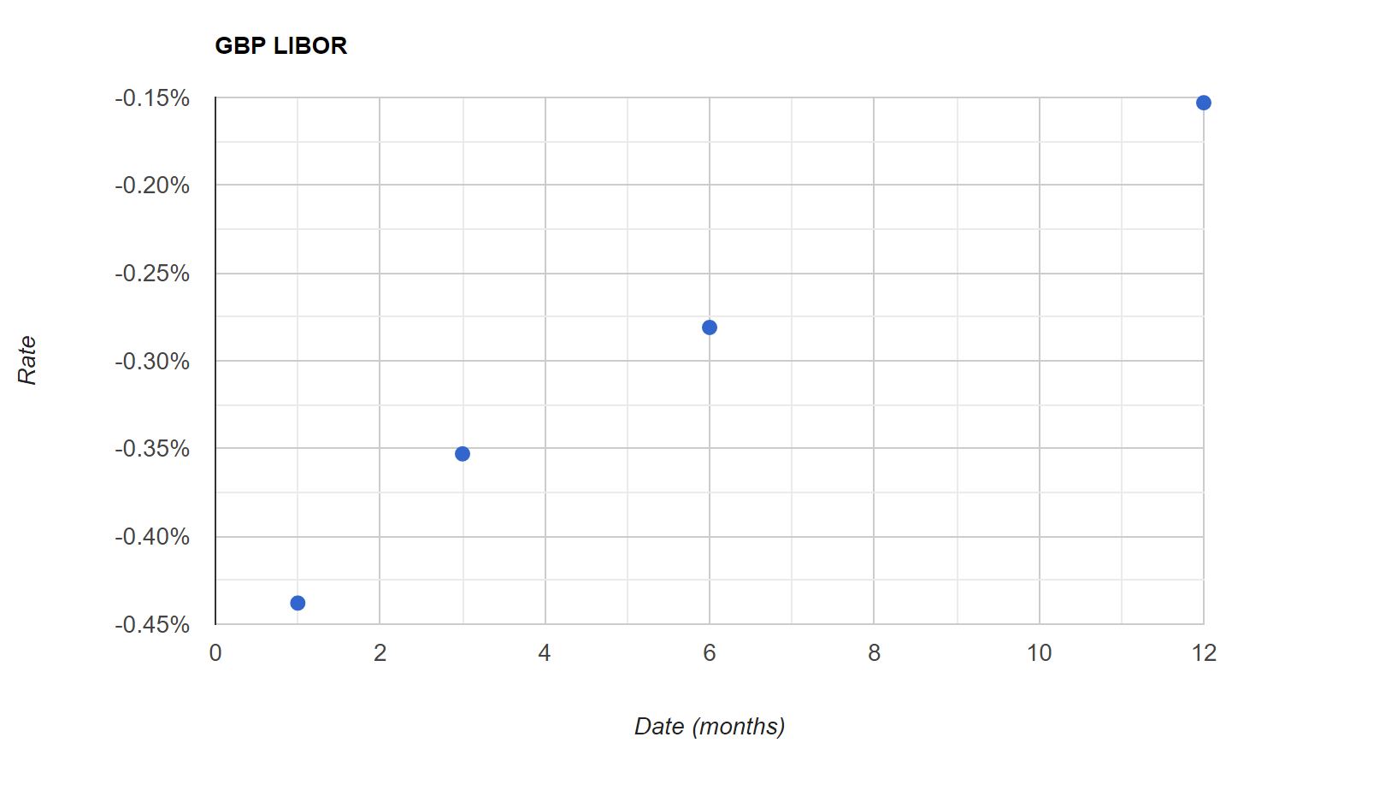

### Interpolation Schemes

#### Linear

##### General Form

The general equation of a straight line is given by



The gradient, slope or rate of change

The y-intercept

##### Equation of straight line through two points

From the general form of the equation we can derive an equation of the straight line through two given points by noting that the gradient m is also the derivative or rate of change.

Second note that the offset is the difference between the y value of one of the points and the product of the derivative and the corresponding x-value.

Substituting these into the original we get



The gradient, slope or rate of change

The difference between the product of x co-ordinate and the derivative and the actual y co-ordinate gives the y-offset

We can also re-write this equation as

And re-arrange to get

And once more

And again

##### Linear Interpolation

Given two bracketing pointsand we can linearly interpolate between then as follows

#### Constant Forward Yield

Given a set of continuous rates we can compute consistent forward rates such that arbitrage is not possible as follows.

Term

Annualized Continuously Compounded zero rates



First, we note that for continuously compounded rates the following must hold. The forward rate from to must be set such that no-one can make money by buying/selling interest rate instruments in the cash market and taking offsetting positions in interest rate forwards. The key to ensuring this is to make sure that

The reason is that with continuously compounded rates

From the laws of powers

Taking the Napier log of both sides

So how do we use this relation to interpolate of a continuously compounded yield curve? First, we calculate the forward rate between the two nearest pillars as mentioned previously

##### Use the forward rate to interpolate the yield

Now that we know the forward rate we calculate the interpolated rate by adding the rate to a proportion of the forward from to . We now get

Finally, we multiply this rate by 1/t to get back to an annualized rate

Questions – Yield Curve Interpolation

Provide the general equation of a straight line

Modify this expression to give the equation of a straight line through two points

From the general form of the equation we can derive an equation of the straight line through two given points by noting that the gradient m is also the derivative or rate of change.

Second note that the offset is the difference between the y value of one of the points and the product of the derivative and the corresponding x-value.

Substituting these into the original we get



The gradient, slope or rate of change

The difference between the product of x co-ordinate and the derivative and the actual y co-ordinate gives the y-offset

We can also re-write this equation as

And re-arrange to get

And once more

And again