The Type System

Defining the structure of Values

## Overview of Type

In Java every item of data created has a type that defines

* How much memory needs to be set aside for that item
* The set of possible values that an instance of that type can take
* The operations that can be carried out on that item

## Categorising Type

## Primitive Types

|  |  |
| --- | --- |
| byte | Signed 8 bit integer |
| short | Signed 16 bit integer |
| int | Signed 32 bit integer |
| long | Signed 64 bit integer |
| int | Signed 32 bit Integer |
| float | 32 bit floating pont |
| char | Unicode character |
| boolean | True or false |
|  |  |
|  |  |
|  |  |
|  |  |

Primitive Types

* All integral types are signed

## Functions

### Local variables

#### Scope

#### Declaring and Initialising variables

#### Copy by value

### Formal parameters and arguments

A method signature declaration specifies a sequence of formal parameters that determine the arguments (actual parameters) that must be passed to the method by calling code. If the formal parameters are not marked with any specific modifiers then the default behaviour is pass by value. The ref and out modifiers can be used to specify pass by reference behaviour. We consider each in turn now.

#### Pass by value for value types

When using pass by value semantics space is allocated on the stack for the formal parameters and the actual parameters are then copied into these locations. If the type of the formal parameter is a struct then the actual value of the object itself is copied from actual to formal parameter. If the type of the formal parameter is a class then a reference to the object is copied from the actual to the formal parameter. The following code highlight pass by value for value types.

### Return values

}

}

### Method Dispatch

#### Non-virtual method

#### Virtual methods

Dispatch is virtual by default

#### Static methods and method resolutions

#### Captured Variables

### Lambdas

## Predefined Typeds

### Char

To understand C# characters in any depth we need to be able to distinguish between a character set and an encode.

A character set maps numeric values to alphanumeric characters. For example in Unicode the finnish character Ö is mapped as follows

d6 -> Ö

In the early years of computing the ASCII character set was prevalent. ASCII supports 128 characters. C# characters use the Unicode character set which has about 1million slots of which about 100,000 are currently allocated.

An encoding defines how the numeric codes for each character are converted to binary. At runtime the .NET runtime encodes characters using UTF-16 which allocates 16 bits to each character. 16 bits support 65536 characters which in theory is not enough to cover every Unicode code point. In practice for most situations it is sufficient as it covers all the code point in a subset of Unicode known as Basic Multilingual plane.

Consider the in-memory layout for a char array of three characters using the UTF-16 encoding.

char[] ab = {'a', 'b', 'c'};

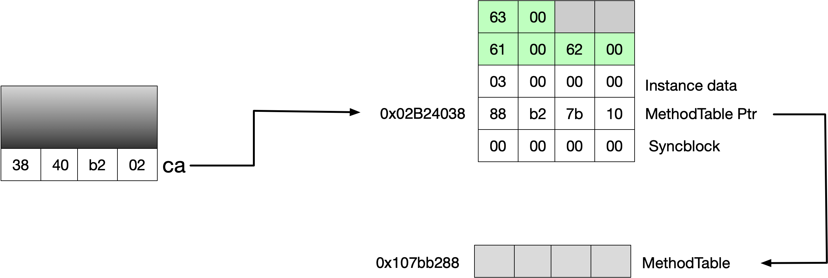

Now if we encode to UTF-8 which is the default for .NET streaming we see the simple characters require only one byte each

byte[] utf8 = Encoding.UTF8.GetBytes(ab);

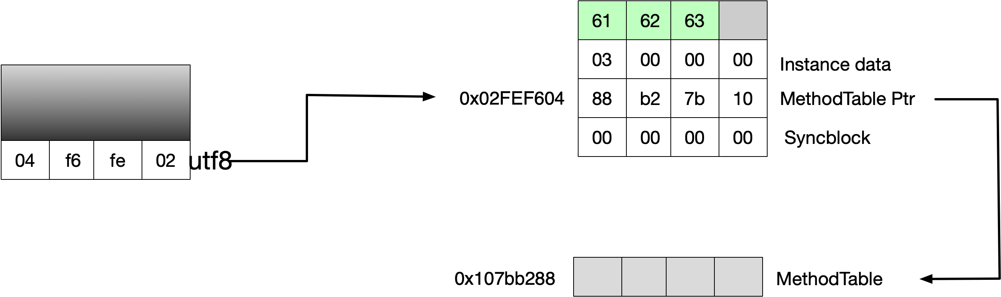

### Strings

A string is an immutable sequence of Unicode characters. Because strings are immutable concatenating long sequences together is inefficient. In such cases use of a StringBuilder is expedient. The < and > operators are not supported for strings. Instead the Compare method can be used

### Nullable types

T? is mapped to the type System.Nullable<T> which is a lightweight valuye type with logic to support being considered null. The compiler has language support for nullable types.

int? nullable = null;

// Equivalent

bool isNull = nullable == null;

bool isNull2 = !nullable.HasValue;

Boxing is clever and boxes the actual value and not the nullable wrapper as boxed types can already be null by virtue of being reference types.

object o = nullable;

Unboxing is also supported.

int? b = o as int?;

WriteLine(b);

The compiler lifts operators from the basic value type to the nullable. The following two methods can be considered equal.

int? x = 5;

int? y = 5;

bool eq1 = x == y;

bool eq2 = (x.HasValue && y.HasValue)

### Anonymous Types

In the following snippet the variable place must be off type var because it is anonymous. Its actually type is generated by the compiler.

var place = new { Street = "Worple Road", Number = 20 };

WriteLine(place.Street);

Equality and hashing are overridden to use value equality

var a = new { Street = "Worple Road", Number = 20 };

var b = new { Street = "Worple Road", Number = 20 };

WriteLine(a.Equals(b)); // true

WriteLine( a == b); // false

var aa = new Dictionary<Object,string>();

aa[a] = "hello";

WriteLine(aa.ContainsKey(b)); // true

The compiler is smart enough to generate only one type in the following code

var c = new { Street = "Worple Road", Number = 20 };

var d = new { Street = "Worple Road", Number = 20 };

WriteLine(c.GetType() == d.GetType()); // true

We can create arrays of anonymous type objects

var ar = new[]

{

new { Street = "Worple Road", Number = 20 },

new { Street = "Worple Road", Number = 25 }

}

We cannot, however, return anonymous types from methods.

### Tuples

Tuples allow one to return multiple values from a method without using out values. The compiler generates types of System.ValueTuple when it sees the following syntax.

var myAddress = (23,"Worple Road");

As with all value types assigning makes a copy.

var a1 = (23,"Worple Road");

var a2 = a1;

a2.Item1 = 46;

WriteLine(a1); // (23, "Worple Road");

In order to return a tuple from a function we use an explicit tuple type.

(int, string) GetAddress() => (23, "Worple Road");

(int, string) address = GetAddress();

WriteLine(address);

We can use tuples with generics

IList<(int,string)> l = new List<(int, string)>()

{

(23,"Worple Road"),

(46,"Worple Road")

};

We can name tuple members

var a3 = (Number:1,Road:"Worple Road");

WriteLine( a3.Number); // 1

(int Number, string Road) a4 = (Number:1,Road:"Worple Road");

(int Number, string Road) a5 = (2,"Worple Road");

We can deconstruct tuples

(int Number, string Road) a6 = (2,"Worple Road");

(int num, string rd) = a5;

WriteLine(rd);

As with anonymous types equality is overridden to do value equality

// Tuples use value equality on both operator and method

(int Number, string Road) a7 = (2,"Worple Road");

(int Number, string Road) a8 = (2,"Worple Road");

WriteLine(Object.ReferenceEquals(a7,a8)); // false

WriteLine(a7 == a8); // true

WriteLine(a7.Equals(a8)); // true

### Numeric types

#### Integers

.NET provides 8, 16, 32 and 64 bit integral types in both signed and unsigned versions. When the compiler sees an integral literal it chooses the first integral type in the list int, uint, long, ulong that accommodates the literal.

On any integral arithmetic overflow is silent and causes wraparound by default. Division on integral types always causes truncation of fractional parts.

#### Floating point

.Net provides float, double and decimal floating point types of size 32, 64 and 128 bits respectively. Literals with no suffix are assumed to be doubles. The following list gives the properties of floating point numbers.

* Float and double internally represent in base 2
* For this reason only numbers expressible in base 2 are precisely represented
* Most literals with a fractional component in base 10 will not be precisely represented
* Decimal works in base 10 and can represent number is base 10 accurately
* Decimal can also represent number expressible in bases which are factors of 10 accurately
* Neither double or Decimal can accurately represent a fractional number whose base 10 representation is repeating
* Double is base 2, moderate precision with large range and high performance
* Decimal is base 10, high precision with moderate range and low performance

The following lists the special results of floating point operations

* When using floating point types .NET doest throw DivideByZero exception
* Not throwing exception is mathematically correct behaviour
* 1.0 / 0.0 = Infinity
* -1.0 / 0.0 = NegativeInfinity
* 1.0 / -0.0 = Negative Infinity
* -1.0 / -0.0 = Infinity
* 1 / 4 = Throw DivideByZeroException
* Dividing, multiplying or subtraction expressions involving NaN result in Nan
* Dividing, multiplying or subtraction expressions involving Infinity result in NaN

#### Numeric Literals

By default the compiler infers a numeric literal to be of either floating point or numeric type according to the following rules

1. If the literal contains a decimal point or the exponentiation symbol E it is assumed to be a double
2. Otherwise it is assumed to be the first integral type in the following list big enough to hold it int, uint, ulong ???

The suffixes F,D,U,L can explicitly define a literal as Float, Double, Unsigned or Long

### Numeric Types

#### Arithmetic Operators

When performing arithmetic operators on integral types the CLR performs overflow which guarantees wraparound. One can use the checked keyword on an expression or statement block to cause the runtime to throw an overflow exception.

Division operators on integers always truncate the result.

### Boolean

The conditional operators && and || short circuit

The conditional operator & and | do not short circuit. These are not biwise operators on bool in Csharp ????

## Type conversion and casting

In .NET the C# cast operator can perform the following operations.

* Numeric conversion
* Reference conversion
* Boxing/Unboxing conversion
* Custom conversion/Operator overloads

An implicit conversion is allowed when no loss of data is possible. An explicit cast is requited where there is a potential to lose data.

### Numeric Conversion and arithmetic operators

For numeric types implicit conversion is allowed where there is no possible loss of data. If there is a possibility that data will be lost an explicit cast will be needed.

By default overflow checking is turned off but the compiler can be instructed to turn it on. Checked an unchecked operators can be used

### Conversion

|  |  |  |  |
| --- | --- | --- | --- |
| Source | Destination | Implicit/Cast Needed | Notes |
| Any integral type | Any floating point type | Implicit | Magnitude is maintained but precision may be lost |
| Any floating point type | Any integral type | Cast needed | Fractional part truncated. Use system.Convert to round |

How overflow works?

How checking works?

### Boxing and unboxing conversion

Often we need to treat a value type as a reference type. In such case the compiler will generate code to copy a value type value onto the heap. In order to highlight how value types work we will make sure of the following simple value type which implements an interface

public interface Iset {void SetValue(double val_);}

public struct SimpleStruct : ISet

{

public double X;

public void SetValue(double val_) => X = val_;

}

Now we perform some simple operations with instances of SimpleStruct. First we create an instance of SimpleStruct on the stack and set the value of its single field. At this point all storage is on the stack.

SimpleStruct ss;

ss.X = 5;

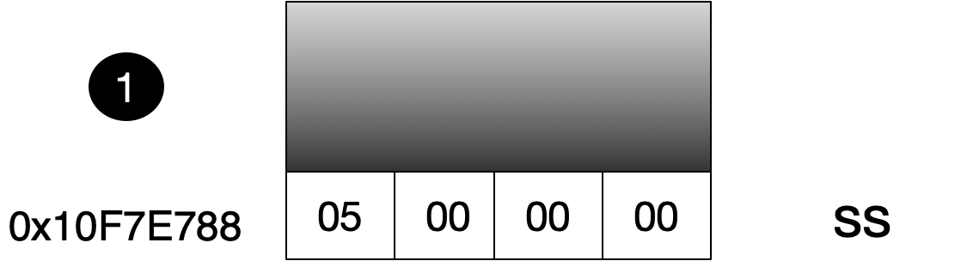

Now we asign our value type of a variable of type Object. This implicit conversion causes a boxing operation to take place. Space is allocated on the heap and the value types bits are copied onto the heap location.

object so = ss;

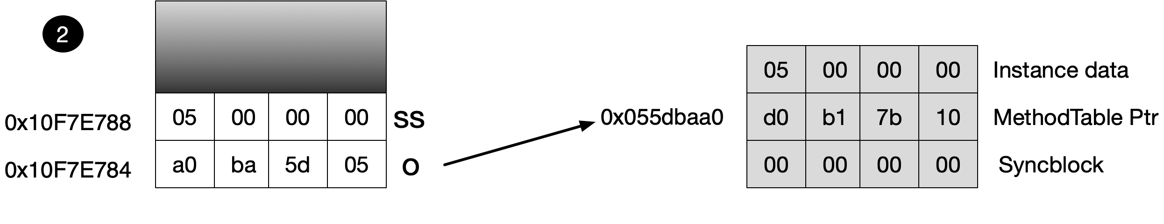

Now we use our setter method to change the value of our value type field. Note that our boxed heap object is not changed by any change to the original stack object as the stack values were simply copied to the heap.

ss.X = 4;

uint val = ss.X;

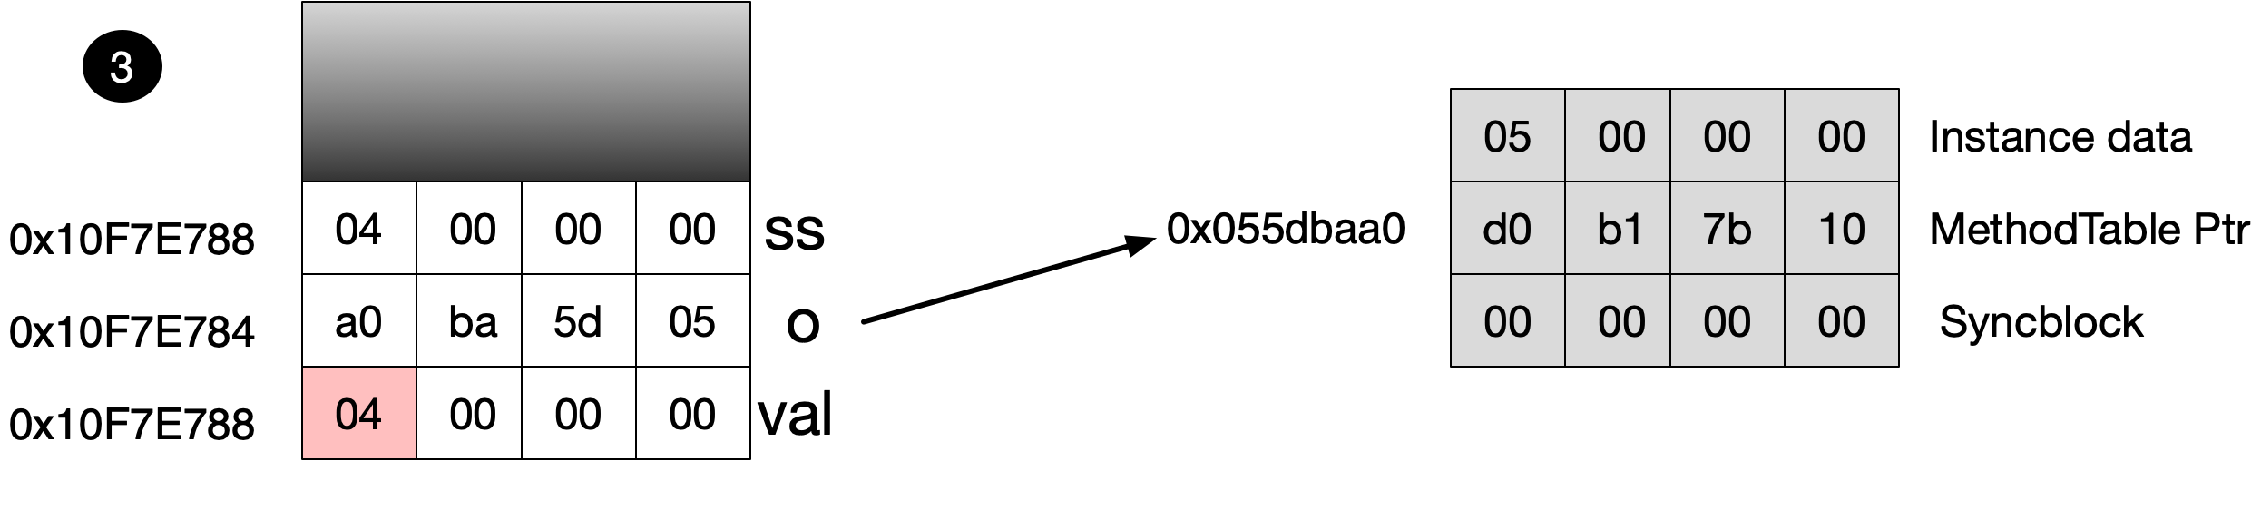

The result of the next piece of code is somewhat surprising. Casting our object to an instance of SimpleStruct causes an unboxing operation which copies the heap values and then changes them. So in fact the heap object is not changed at all.

((SimpleStruct) so).SetValue(3);

val = ((SimpleStruct) so).X;

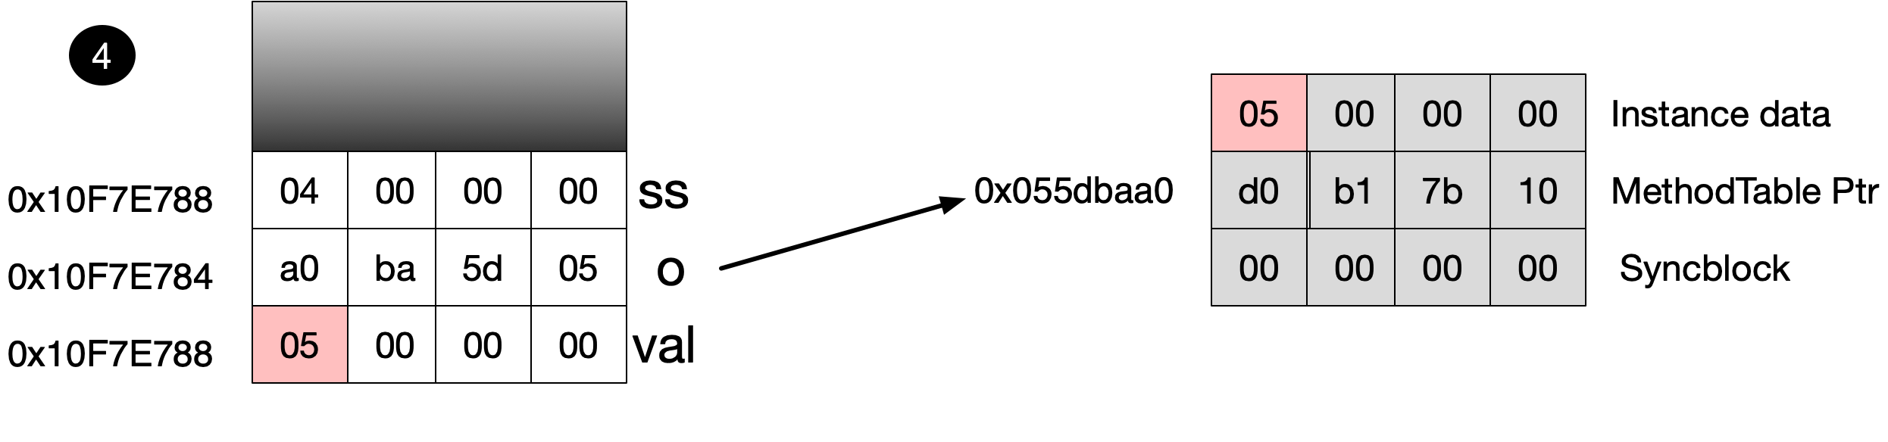

Finally we show how to use an interface to change the value on the heap instance.

((ISet) so).SetValue(3);

val = ((SimpleStruct) so).X;

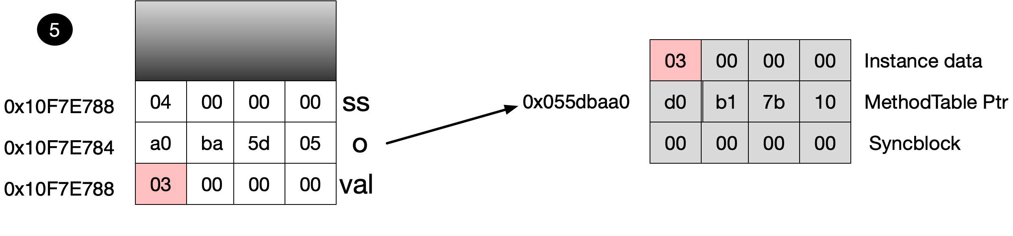

In general, boxing is less necessary since the introduction of generics. Boxing involves allocating enough memory on the heap to encapsulate the value type plus a type pointer and a sync block. Unboxing involves copying the instance data from the refeence object on the heap into a variable stored on the stack. Both operations incur a performane overhead. When unboxing we must use the exact type that was boxed.

## Equality

### Equality Operators (==, !=)

#### Reference Types use Reference equality

public class MyReference { public int Value;}

…

MyReference a = new MyReference {Value = 1};

MyReference b = new MyReference {Value = 1};

WriteLine(a == b); // False

The equality operators == and != are statically resolved like all operators. As such they are fast and efficient. Object implements the operators to perform referential equality

#### Overriding The Equality Operator for Reference Types

public class MyReference

{

public int Value;

public static bool operator==(MyReference a, MyReference b)

=> a.Value == b.Value;

public static bool operator!=(MyReference a, MyReference b)

=> a.Value == b.Value;

}

…

MyReference a = new MyReference {Value = 1};

MyReference b = new MyReference {Value = 1};

WriteLine(a == b); // true

Here we overridden the equality operators to carry out value equality rather than the referential equality performed by Object’s implementation

#### Equality Operators are Statically Resolved

WriteLine(a == (object)b); // false

WriteLine((object)a == b); // false

Because operators are statically resolved asigning a value of a more specific type to a variable of type Object cause Object operator to be used.

#### Value Types Have No Default Equality Operator ImplementaTion

public struct MyStruct

{

public int Value;

public static bool operator ==(MyStruct a, MyStruct b)

=> a.Value == b.Value;

public static bool operator !=(MyStruct a, MyStruct b)

=> a.Value == b.Value;

}

MyStruct c = new MyStruct { Value = 1 };

MyStruct d = new MyStruct { Value = 1 };

WriteLine(c == d); // true

### Object.Equals instance method

The object equals method provides a virtual method for carrying out equality functionality. The default implementation for objects carrying out referential equality

void Main()

{

MyReference a = new MyReference {Value = 1};

MyReference b = new MyReference {Value = 1};

WriteLine(a.Equals(b)); // false

}

public class MyReference { public int Value;}

The default implementation for value types carries out value equality

public struct MyStruct { public int Value;}

…

MyStruct a = new MyStruct {Value = 1};

MyStruct b = new MyStruct {Value = 1};

WriteLine(a.Equals(b)); // true

This default implementation is however ineffient in two ways; It uses reflection for the field by field comparison and it uses boxing which is several times more expensive than the actual comparisonThe first of these problems can be overcome by providing our own value type implementation of the Equals method that does not use reflection

public struct MyStruct

{

public int Value;

public override bool Equals(object obj)

=> Value == (obj as MyStruct?)?.Value;

}

…

MyStruct a = new MyStruct {Value = 1};

MyStruct b = new MyStruct {Value = 1};

WriteLine(a.Equals(b)); // true

If we want to eliminater boxing we can implement the interface IEquatable

public struct MyStruct : IEquatable<MyStruct>

{

public int Value;

public bool Equals(MyStruct other)

=> Value == other.Value;

}

### Object.Equals Static method

Object also provides a static equals method that provides a null checking, unified type equality comparison.

### Pluggable Equality

Consider the following type which does not itself provide any sensible implementation of GetHashCode() and Equals

public class Point

{

public int X;

public int Y;

}

If we try and use objects of this type as hash keys we see the following behaviour.

IDictionary<Point,string> a1 = new Dictionary<UserQuery.Point, string>();

a1[new Point() {X=1,Y=1}] = "hello";

WriteLine(a1.ContainsKey(new Point() {X=1,Y=1})); // False

We can create our our pluggable Equality comparer

public class PointComparer : EqualityComparer<Point>

{

public override bool Equals(Point x, Point y)

=> x.X == y.X && x.Y == y.Y;

public override int GetHashCode(Point obj)

=> obj.X ^ obj.Y;

}

And we can use it as follows which

var pc = new PointComparer()

var a2 = new Dictionary<UserQuery.Point, string>(pc);

a2[new Point() { X = 1, Y = 1 }] = "hello";

WriteLine(a2.ContainsKey(new Point() { X = 1, Y = 1 }));//true

### Structural Equality

int[] x = {3,4,5};

int[] y = {3,4,5};

((IStructuralEquatable)x)

.Equals(y,EqualityComparer<int>.Default);

### Implementing Equality Sensibly

By default most reference types use reference equality and value types use value equality with the equality operators and equal methods being consistent. There are however some exceptions in the framework. Despite being a reference type String overrides Equals and == to use value equality

string a = new string('*',4);

string b = new string('*',4);

string c = a;

WriteLine(Object.ReferenceEquals(a,b)); // false

WriteLine(a==b); // true

WriteLine(a.Equals(b)); // true

StringBuilder uses referential equality for == and value equality for Equals

StringBuilder a = new StringBuilder("Hello");

StringBuilder b = new StringBuilder("Hello");

WriteLine(Object.ReferenceEquals(a,b)); // false

WriteLine(a==b); // false

WriteLine(a.Equals(b)); // true

### Equality in user defined types

Equality operators should respect the following

* Reflexive: x.Equals(x) is true
* Symmetric/Commutative: x.Equals(y) gives same result as y.Equals(y)
* Transitive: x.Equals(y) and y.Equals(z) implies x.Equals(z)
* Consistent
* Any object cannot equal null

Consider the following struct implementation

public struct Point: IEquatable<Point>

{

public int X;

public int Y;

// 1. Implement type safe equals defined in IEquatable

public bool Equals(Point other) => X == other.X && Y == other.Y;

// 2. Override Equals to perform null and type check before

// calling IEquatable method

public override bool Equals(object obj)

{

if (!(obj is Point)) return false;

return Equals((Point)obj);

}

// 3. Implement operators

public static bool operator==(Point a, Point b) => a.Equals(b);

public static bool operator!=(Point a, Point b) => !a.Equals(b);

// 4. override hash code

public override int GetHashCode()

{

return X * 31 + Y;

}

}

The following guidelines can be used when implementing equality

* Return false if the single argument is null
* Return false if the two objects are of different type
* Compare each field and return false if any fields are different
* Call the base class Equality if it isn’t the identity version defined in object
* Implement IEquatable<T> to define a type safe interface
* Overload == and != to internally call the type safe equals method

## Hashing

Why do we do prime messing when creating hashing functions?

## Comparisons

The basic comparison interfaces are IComparable and IComparable<T>. If comparing two objects for equality, via their equality operators or their Equals method, gives true then comparing them for ordinality should return zero. The converse, however, is not true. We could compare two strings using cases insensitive arguments. In this case comparison is zero and equality is false. Consider the following

string a = "hello";

string b = "Hello";

WriteLine(a.Equals(b)); // false

WriteLine(string.Compare(a,b,StringComparison.InvariantCultureIgnoreCase)); // 0

As with equality we can plug in our own algoritms

public class Point

{

public int X;

public int Y;

}

public class PointComparer : Comparer<Point>

{

public override int Compare(Point x, Point y)

{

if (object.Equals(x,y)) return 0;

return x.X.CompareTo(y.X);

}

}

Which we use as follows

Point[] a = new Point[]

{

new Point() {X=3,Y=1},

new Point() {X=1,Y=1},

new Point() {X=5,Y=1}

};

Array.Sort(a,new PointComparer());

WriteLine(a);

## Expressions

The ?? operator returns the left hand operand if it is non-null otherwise it returns the right operand

string b = a ?? "empty";

The ?. operator will

## User Defined Types

User defined types can be any of the following.

* Class types
* Struct types
* Enum types
* Array types
* Delegate types
* Interface types

Any type defined with file scope can be either public or internal. If no visibility modifier is specfied the default visibility is internal. Any assembly can define other assemblies which it considers friends. Any such friend assemblies can see an assemblies internal types

### Members

* Fields
* Properties
* Methods
* Events
* Constructors
* Deconstructors (C#7)

#### Member Visibility

In addition to the following for a member to be visible its owning type must also be visible to the caller.

|  |  |
| --- | --- |
| Modifier | Visibility |
| Private | Accessible by methods in the defining type and in any nested type?? |
| Protected | Accessible by methods in defining type, nested type or derived type |
| Internal | Accessible by methods in the same assembly |
| Internal protected | Accessible by any type in the defining type, nested type, derived type or any method in the defining assembly |
| Public | Accessible to any method in any assembly |

#### Constructors

A constructor performs initialization logic on a class or struct. Overloaded constructors can call other constructors using the this construct. Such a construct cannot use the this pointer, however they can call static mathods. If no constructor is explicitly defined the compiler will implicitly generate a parameterless constructor.

Structs and Parameterless Constructors

A paramterless constructor is an intrinsic part of a struct which initializes each field with default values. For this reason one cannot create ones own parameterless structor constructor

Figure Constructor overloading

// Two overloaded constructors.

// Second constructor calls the first using this keyword

public MethodCallSemantics() { }

public MethodCallSemantics(int a_) : this() { }

// Two overloaded constructors.

// First constructor calls the second using this keyword

// and passes in an expression that calls a static method

public MethodCallSemantics() : this ( ClassMethod() ) { }

public MethodCallSemantics(int a_) { }

// Two overloaded constructors. Invalid defintions

// First constructor calls the second using this keyword

// and passes in an expression that calls a instnace method

// Wont compile due to use of this pointer inside this expression

// Compiler says Error 7 Keyword 'this' is not available in

// the current context

public MethodCallSemantics() : this ( this.InstanceMethod() ) { }

public MethodCallSemantics(int a_) { }

Private constructors are often used in conjuction with static factory methods

// We have a private constructor

// Only was clients can obtain an instance of the

// type is through the static method. This gives us

// control of when and how objects of this type are created

private ObjectFactory() { }

public static ObjectFactory CreateObject()

{

return new ObjectFactory();

}

.NET 3.0 provides object initialization lists for accessible fields or properties

public static void MainMethod()

{

Constructors myObj =

new Constructors() { Height = 10.0, Width = 2.0 };

}

public double Height { set { } }

public double Width { set { } }

public Constructors() { }

##### Order of Execution

* From sub-class to base class field are initialized and then constructor args evaluated
* From base class to sub-class constructor bodies are executed

##### Static Constructors

* Executes once per type before any instances of the type are created
* Cannot have access modifiers
* Static field initialization occurs before static constructor in order of declaration
* Static constructor is invoked by the runtime and cannot be explicitly invoked
* When runtime invokes static constructors is non-deterministic
* A subclasses static constructor can execute before or after its base class

#### Properties

Look to clients like fields but give the type implementer the control of a method. They promote encapsulation, allow derived field etc. Properties can be read-only when they provide only an accessor. Properties can be write-only when they provide only an mutator (uncommon) Csharp 3.0 allows the specification of automatic properties where the compiler generates implemenation

// The compiler will generate a private

// backing field. Set accessor can be

// marked as private if you want a read-only

// behaviour. You cannot just leave out the

// set part

public double AutomaticProperty { get; private set; }

The compiler will generate methods called get_XXX and set_XXX for properties. Non-virtual property accessor are inlined by JIT eliminating performance overhead of property versus field

#### Fields

A field is a member of a class or struct that requires storage. Field initialization occurs before the constructor is invoked in the order of declaration. Any unitialized fields take a default value of zero for numeric values, null for reference types, false for bools. If a field is marked with the readonly modifiers it cannot be modified after an object of that type is constucted. Any fields not explicitly initalized take an implicit value of zero for numeric types, null for reference types and false for bools. Every instance of a struct or class has a special field called this which refeences itself.

#### Methods

A methods signature consists of its name, parameter types but not its return type. Method signatures must be unique within a type. Overloaded methods have the same name but different signatures. Whether a paramater is pass by value or pass by reference forms part of the signature however overloaded methods cannot differ only on ref versus out

// Valid as both methods have differnt signatures

// Whether a param is reference forms part of the

// signature

public static void SingleParamMethod(int a) { }

public static void SingleParamMethod(ref int a) { }

// InValid as both methods have same signatures

// cannot define overloaded methods that differ only on ref and out

public static void SingleParamMethod(out int a) { }

public static void SingleParamMethod(ref int a) { }

#### Indexers

Provide access to elements within a classes internal set. The index can be keyed by one or more arguments of any type. A type can have multiple indexers with different argument types

public int this[string a, Object b]

{

get

{

/* Do some lookup based on the composite key {a,b}*/

}

}

Compiler generate get_Item and set_Item methods

#### Deconstructors

void Main()

{

Point p = new Point(1.0,2.0);

var (a,b) = p;

}

public class Point

{

private double x;

private double y;

public Point(double x, double y)

{

this.x = x;

this.y = y;

}

public void Deconstruct(out double x, out double y)

{

x = this.x;

y = this.y;

}

}

### Constants and read-only fields

A consrtant is a field whose value can never change. It is evaluated statically at compile time and substituted wherever used. Only the built in types can be used as constants and they must be initialized with a value.

Readonly fields however are initialiazed at runtime.

To see the different between the two consider and assembly B which exposes two value; one a const and one a static readonly field. Assembly A is then compiled against assembly B. If before assembly A runs assembly B is recomiled with new value for both fields only the static readonly field change will be picked up. This is because the B’s constant fields value was burned into A at compile time.

### Classes

User defined types defined using the class keyword are reference types. If a class is defined as static it can only contain static methods and cannot be subclassed. A class can contain fields, properties, methods, events, constructors and deconstructors

#### Static classes

* Allow set of related methods to be grouped together in type instantiated type
* E.g. Console, Math, Environment, ThreadPool
* Must directly inherit from object
* Must not implement any interfaces
* Must define only static members
* Class cannot be used as field, method parameter or local variable

### Interfaces

### Enums

[Flags]

public enum Location { None = 0, Left = 1, Right = 2, Top = 4, Bottom = 8 }

void Main()

{

Location vertical = Location.Top | Location.Bottom;

Location horizontal = Location.Left| Location.Right;

// Because we use the Flags attribute this give us "Top, Bottom"

// Without the Flags enum we would get the integer 12

WriteLine(vertical);

// Both output true

WriteLine((Location.Top & vertical) != 0);

WriteLine((Location.Bottom & vertical) != 0);

WriteLine(vertical ^ Location.Top);

WriteLine(horizontal ^ Location.Left);

}

### Nested Types

// Classes and structs can have nested classes, structs,

// interfaces, delegates and enums

public class OuterMost

{

private double x = 4.0;

// Default visibility is private so not accessible outside

enum Location { None, Left };

// Make the innter struct visibile to the outside

public struct InnerStruct {};

}

### Events

Delegates can be used to implement producer consumer behavior. Consider the following producer consumer logic

Figure Producer Consumer with Delegates

void Main()

{

Producer producer = new Producer();

// Register First consumer

producer.ValueChanged += x => WriteLine($"First {x}");

// Register Second consumer

producer.ValueChanged += x => WriteLine($"Second {x}");

// Producer does something

producer.Fire();

}

public delegate void ValueChangedEventHandler(double newValue);

public class Producer

{

public ValueChangedEventHandler ValueChanged;

protected void OnValueChanged(double newValue)

{

ValueChanged?.Invoke(newValue);

}

public void Fire() => OnValueChanged(3.4);

}

There are, however, shortcomings with this approach. Firstly consumers can interfere with each other. Secondly consumers can invoke the delegate which is the responsibility of the producer

Figure Problems with Delegate Approach

// 1. Second consumer blows away first

producer.ValueChanged = x => WriteLine($"Second {x}");

//2. Consumer forcer producer to raise events

producer.ValueChanged.Invoke(6.7);

Events solve these problems with compiler support and a standard pattern. Consider the following code implementation

// 1. Create a subclass of EventArgs with a public

// readonly field for the new value

public class ValueChangedEventArgs : EventArgs

{

public readonly double NewValue;

public ValueChangedEventArgs(double newValue)

{

NewValue = newValue;

}

}

public class Producer

{

// 2. Add an event using the generic EventHandler delegate

// type

public event EventHandler<ValueChangedEventArgs> ValueChanged;

// 3. Add a method called OnValueChanged that raised the event

protected void OnValueChanged(ValueChangedEventArgs args)

{

ValueChanged?.Invoke(this,args);

}

public void Fire(double newValue)

{

OnValueChanged(new ValueChangedEventArgs(newValue));

}

}

By using the event member we get language support for separating the producer and consumer behaviour. Consumers can no longer interfere with each other or cause the underlying delegate to fire. We can write our own logic for registering and deregisting with the delegate as follows. The following is an explicity implementation of the previous code

public class Producer

{

private EventHandler<ValueChangedEventArgs> _delegate;

public event EventHandler<ValueChangedEventArgs> ValueChanged

{

add {_delegate += value;}

remove {_delegate -= value;}

}

// 3. Add a method called OnValueChanged that raised the event

protected void OnValueChanged(ValueChangedEventArgs args)

{

_delegate?.Invoke(this,args);

}

public void Fire(double newValue)

{

OnValueChanged(new ValueChangedEventArgs(newValue));

}

}

While the compiler generates code similar to our explicit add and remove it does so in a thread save manner.

## Generics

### Overview

A generic type declaration has arguments that must be supplied by the user of the type. Generics provide a number of benefits.

Benefits of generics

* Increase type safety
* Reduce the number of casts needed
* Reduce the amount of boxing/unboxing required
* Reduces duplicate code
* Enable us to create collections where the element type is parameterised by the user
* Combines the benefit of reusable collection of object with static type safety

Where we can introduce generic type parameters

// Generic class

public class GenericClass<T> { }

// Generic interface

public interface IGenericInterface<T> { }

// Generic struct

public struct GenericStruct<T> { }

// Generic delegate

public delegate TOut GenericDelegate<TIn,TOut>(TIn param);

public class ClassWithGenericMethod

{

// Generic method

public void Swap<T>(T a, T b) { }

}

Generic type parameters cannot be introduced on constructors, properties, indexers, operators or fields although any of these can use generic type parameters introduced by the enclosing type.

### Open and Closed types

In the below code fragment, I have highlighted the type arguments in bold red. We say the generic type is an **open type**.

Figure Generic Declaration



The user of the generic type specifies the type argument at the point of variable declaration and definition. The generic instance with its type parameter provided is known as a **closed type. The runtime creates the closed type the first time it sees a request for a particular set of type arguments. The CLR effectively creates a new type.**

Figure Generic Use



### Generic Methods

The method signature contains **type parameters**. We can generically write a swap method to swap two elements of any type, both reference and value types, without requiring casting or boxing/unboxing

public static void Swap<T>(ref T a, ref T b)

{

T temp = a;

a = b;

b = temp;

}

public void TestSwap()

{

Object stringA = "Kenny";

Object stringB = "Wilson";

Swap<object>(ref stringA, ref stringB);

int intA = 4;

int intB = 5;

Swap<int>(ref intA, ref intB);

}

In many cases the compiler can infer the type to be used so we don’t even need to provide the type parameter when we use the method. Where there is ambiguity we can provide the compiler with type parameters explicitly.

### Generic Constraints

public interface IInterface {}

public class MyClass {}

// 1. Base class constraint. T must be decendent of MyClass

public class BaseClassConstraint<T> where T : MyClass {}

// 2. Interface constraint. T must implement IInterface

public class InterfaceConstraint<T> where T : IInterface {}

// 3. Reference type constraint

public class ReferenceConstraint<T> where T : class {}

// 4. Value type constraint

public class ValueConstraint<T> where T : struct { }

// 5. Parameterless constructor constraint

public class ConstructorConstraint<T> where T : new() { }

public class Naked<T>

{

// 6. Naked constraint. One generic param must implement

// another

public void NakedMethod<U>(U input) where U : T

{

}

}

## Basic conversions

public class ConversionExample1

{

public String Convert<T>(T arg)

{

// Does not compile are compiler not sure

// whether we are performing a custom

// conversion or not

if ( arg is String)

return (String)arg;

return "Not a string"

}

}

public class ConversionExample2

{

public String Convert<T>(T arg)

{

// Compiles because the compiler considers this

// convertion to object and from object to be either

// boxing or unboxing conversions

if (arg is String)

return (string)(Object)arg;

return "Not a string"

}

}

### Variance

Variance is used to describe how sub-typing in complex type constructions relate to sub typing in the basic polymorphic case. In practice, for C# developers this mean relating subyping in generic interfaces and delegates to subtyping in basic polymorphic situations. This is because in .NET variant type parameters are restricted to generic interfaces and delegate types. Variance is also only applicable to reference types.

#### Covariance

Covariance enables one to asign an object whose generic type parameter is of a more specific type to a variable whose generic type parameter is of a more generic type. This looks much like polymorphism and feels intuitive.

IEnumerable<Cat> cats = new List<Cat>();

IEnumerable<Animal> animals = cats;

In order to allow this the IEnumerable interface specifies it type paramer as out

public interface IEnumerable<out T> : IEnumerable

we can do the same thing with delegates,

Func<Cat> f = () => new Cat();

Func<Animal> g = f;

#### Contravariance

Contravariance enables one to asign an object whose generic type parameter is of a more generic type to a variable whose generic type parameter is of a more specific type. Contravariance looks counterintuitive from the perspecive of basic polymorhism

In order to allow this the IObserver interface is markd as in

public interface IObserver<in T>

We can do the same thing with delegates.

void Main()

{

ContravariantDelegate<object> a = DoSomething;

// Looks a bit strange but it type safe

ContravariantDelegate<string> b = a;

a("A String");

}

public void DoSomething(Object obj) {}

delegate void ContravariantDelegate<in TIn>(TIn inputType);

#### Higher order functions

The previous examples on covariance and contravariance were with first order functions. Higher order functions are functions that either take functions as arguments or return functions as results. Higher order function add complexity, especially where contravariance is involved. Consider the following second order function

void SecondOrderFunction(Action<Derivative> derivative)

{

derivative(new Derivative());

}

As it invokes the passed in delegate with an instance of Derivative it cannot handle functions that require a subclass of Derivative in a type safe manner. However, it can handle base classes. Contravariance has been reversed in the second order function.

Action<Action<Product>> g = SecondOrderFunction;

g(Console.WriteLine);

The basic rule is an even number of contravariance conversions will cause the final result to be covariant and an odd number will cause the resut to be contravariant.

One classic example of a higher order function and contravariance become covariance is with the IObervable<T> interface from Reactive Extensions.

public interface IObservable<out T>

{

IDisposable Subscribe(IObserver<T> observer);

}

Superficially we might expect the type parameter to be marked as in because it is used with a method parameter. Because the parameter is itself a generic type the contravariance is converted to variance. We can use it like this.

IObservable<Derivative> o1 = new Subject<Derivative>();

IObservable<Product> o2 = o1;

Any observers of products will be quite happy to receive derivatives.

Questions

Overview of Type

What is meant by statically typed?

All variables are of a particular type which the compiler is aware of. The compiler will only allow operations relevant to a variables type

Categorising Type

Value versus Reference

What are the performance advantages of value types?

No pointer derefernce needed to access fields

Stack allocations reduce the number of garbage collections

Value type methods can be invoked non-virtually

Can value types be sub-classed?

No they are implicity sealed

When would you chose to use a value type?

Behaves like a primitive and is immutable

Doesn’t need to inherit from another type

Wont need to be extended

Wont be passed as value parameter to functions

What happens if you call a method defined in Object and not overriden in ValueType?

The value type is boxed in order to call the method expecting the value type

What happens if you call a method defined in a ValueType or you subclass?

As value types cannot be subclassed the compiler will use the call rather than callvirt instruction

What happens if you cast your value type ot an interface it implemements?

It will be boxed

Which methods do all types implement?

Equals

GetHashCode

What is the default implementatin of hash code and equality for value types?

Equality if all fields are binary equal

Hashing based on the value in instance fields

What is boxing?

Allocating memory from the heap for the value type fields plus a type pointer and a sync block

Copy the value types fields into the heap

Return a refernce

What is the advantage of boxing?

Allows a unified view of the type system

What is entailed by boxing?

Allocating enough heap memory for a value type plus object overhead

Value type bits are copied onto the heap

The address of the reference type is returned

What is entailed by un-boxing?

A pointer to the value type contained inside the object is returned

The value type that this pointer refers to does not include the usual overhead associated with a true object: a pointer to a virtual method table and a sync block

When should you manually box value types?

If you know that the code you're writing is going to cause the compiler to generate a lot of boxing code, you will get smaller and faster code if you manually box value types

When should you be very careful of boxing?

Boxing and un-boxing in a loop can seriously degrade performance and memory usage

Why is boxing less prevalent since .NET 3.0?

The introduction of generics makes boxing less necessary

What do you need to ensure when unboxing?

You need to ensure the type you un-box to is exactly same type as the original value type

How much memory does a value type occupy?

The sum of the memory occupied by its fields

What is the default implementation of hash-code and equality for value types?

Equality if all instance fields match

Hashing algorithm based on values in instance fields

Why should you override Equality when implementing value types?

Default implementation uses reflection which is inefficient

Where are reference types allocated?

Always on the heap

Which types in C# are reference types?

All class, array, delegate and instance types

What memory is required for an instance of a reference type?

Heap memory for all instance fields plus extra memory for lock, class pointer

Each reference variable on stack need additional memory

How much memory is required for a reference variable on the heap?

Depends on whether the operating system is 32bit or 64 bit

32bit OS requires four bytes, 64 bit OS requires 8 bytes

What are the characteristics of reference types?

Allocated from managed heap using new

Types derived from System.Object type using the class keyword

What are the main disadvantages of reference types?

Memory must be allocated off the managed heap which can force GC

Pointer dereference cause performance overhead

How much memory does a reference type occupy?

Sum of memory occupied by its fields plus

Extra overhead for key to objects type, lock state

Each reference requires an additional four to eight bytes

What are the base classes of value and reference types?

Value types extend ValueType using the struct keyword

Reference type extend Object using the class keyword

Where is memory allocated for reference and value type?

Reference types are always allocated on the heap

Value types are usually allocated on the stack

Compare and contract assignment of reference and value types?

Assignment of value type results in copy of fields

Assignment of reference type simply results in copy of address of object on heap

Can you use a value type as a lock? Explain your answer

No – Value types do not contain the sync block and cannot be used for locking

What are predefined types?

Types supported by the compiler

Categorising Type – Predefined and Primitive Types

What is meant by a predefined type?

A type supported by the compiler

What are predefined types also known as?

Built in types

Are predefined types reference or value types?

Can be either

Give another name for predefined types

Built in types

What are the predefined value types?

The numeric types plus bool and bool

What are the predefined reference types?

String and bool

What are primitive types?

All the predefined value types other than decimal. We expect primitive type to be directly supported by the undelying native instruction set and CPU

User Defined Types

What visibility modifiers are applicable to a file scoped type?

Public or internal

What is the default visibility if no explicit type modifier is provided?

Internal

What is the purpose of a static class?

Allow related methods to be grouped together

What restrictions apply to static classes?

Must directly implement object

Cant implement interfacces

Must define only static members

Cannt be used as field, method parameter or local variable

What visibility modifiers can be applied to a member?

Private – only accessed by methods in the defining type or nested type

Protected – only accessed by methods in defining type, subtype or nested type

Internal – can only be accessed by methods in defiining assembly

Internal protected – can be accessed by defining type, nested type, sub-type or any method in defining assembly

Public – accessible to any method in any assembly

Numeric Types

What size is an int in Csharp?

32 bits

What is the range of int?

-2^31 to 2^(31)-1

What other integral types are there?

Sbyte, byte, short, ushort, uint, long, ulong

What size is a float inCsharp?

32 bits

What size is a double in csharp?

64 bits

How does the compiler infer the type of a numeric literal?

If it containes . or E it is assumed to be a double

Otherwise first int in the list int,uint, long, ulong that can accommodate the literal

What suffixes can be applied to a literal?

L,F,F,U,M

What is the M suffix?

decimal

Numeric type conversion

When is an implicit cast allowed?

No possible loss of data

When is an explicit cast needed?

Possible loss of date

When is default overflow behaviour?

No overflow checking with wrapping

How can overflow checking be turned on?

Use of checked keyword on block or expression

Compiler flag

How can overflow checking be turned off if the compiler turned it on?

Using the unchecked keyword around a block or expression

What happens when you cast from a floating point to integral type?

The fractional part is truncated

How can you obtain rounding behaviour when converting?

The static class Convert provides methods for rounding

What happens when you implicitly convert a large integer to a floating point?

Keep the magnitude but loose the precision

What happened when you use the division operator on integers?

Remainder is always truncated

What happens if arithmetic operations on integral types overflow?

CLR guaranteed wraparound

Why wont the following code compile?

static void Add()

{

short a = 4;

short b = 8;

short c = a + b;

}

Because the 8 and 16 bit integral types lack their own arithmetic operators

C# will implicitly convert them to int causing an error assigning result back to short

Arithmetic operators

Implement a method to compare two numbers for equality without using any equality operators?

public static bool Equals(int a, int b)

{

return (!(a < b) && !(a > b));

}

Nice. Do it now without use of the comparison operators?

public static bool Equals2(int a, int b)

{

int c = a - b;

bool equals = true;

try

{

object[] arr = new object[1];

object res = arr[c];

}

catch (Exception ex)

{

equals = false;

}

return equals;

}

Imagine truth is defined in the same way as C. Implement the comparison method using bitwise operators?

public static bool Equals2(int a, int b)

{

return (!(a ^ b));

}

Implement a comparison operator for two integers?

How are floats and doubles internally represented?

As base 2

What problems can this introduce?

Only numbers expressible in base 2 are represented precisely

Literals with a fractional component will not be represented precisely

Contravariance

Function call

When would a compiler generate a call instruction?

Methods defined on a value type (implicitly sealed so no inheritance)

When would a compiler generate a non-virtual call of a virtual method and why?

When a method call base.method the CLR will call it non-virtually to prevent an infinite recursion

How can one specifiy pass by referenc semantics?

By using the out or ref keywords

How do ref and out keywords differ?

Ref parameters must be initialized by the caller

Out parameters must be initialized by the callee

Are the ref and out parameters specified by the function or caller?

For clarity both

Closures

What is the output of the following code and why?

Action[] actions = new Action[3];

for(int i = 0; i < 3; i++)

{

actions[i] = () => Console.Write(i);

}

foreach (var action in actions)

{

action();

}

333 as it is the variable itself that is captures and not the value of it at the time the action is created.

What is the output from the following code and why?

Action[] actions = new Action[2];

int outer = 0;

for (int j = 0; j<2;j++)

{

int inner = 0;

actions[j] = () => Console.WriteLine($"{outer++},{inner++}");

}

actions[0]();

actions[0]();

actions[0]();

actions[1]();

0,0

1,1

2,2

3,0

4,1

The reason being that both delegates share a reference to the heap stored variable outer whereas each delegate has its own heap stored variable to hold the captured variable inner.

What is the output of the following code and why?

void Main()

{

Action a = GetAction();

a();

a();

}

public static Action GetAction()

{

int i = 5;

return () => Console.WriteLine(++i);

}

6

7

The captured variables are stored on the heap and get extended scope. They stay alive until all delegated holding references to them are collected

What is the point of captured variables?

They prevent the need to write custom classes jus to pass in information from the calling scope into a delegate.

Class Hierarchies and Function Call

What is meant by polymorphism?

A reference to a base class can refer to an instance of a subclass

Define an interface with one field and one method?

interface Interface1

{

string Property { get; }

string Method();

}

Create an abstract implementation that implements one of the fields?

abstract class Abstract : Interface1

{

private string _property ;

public Abstract(string property_)

{

_property = property_;

}

public string Property

{

get { return _property; }

}

public abstract string Method();

}

Now create a concrete subclass of the abstract class

class Concrete : Abstract

{

public Concrete(string aString)

: base(aString)

{

}

public override string Method()

{

return null;

}

}

Finally add a second constructor that take two arguments and calls the existing constructor?

class Concrete : Abstract

{

public Concrete(string aString)

: base(aString)

{

}

public override string Method()

{

return null;

}

}

What is output from the following code?

public class BaseClass

{

public virtual void Foo() { Console.WriteLine("BaseClass.Foo"); }

}

public class Overrider : BaseClass

{

public override void Foo() { Console.WriteLine("Overrider.Foo"); }

}

public class Hider : Overrider

{

public new void Foo() { Console.WriteLine("Hider.Foo"); }

}

public class MainClass

{

public static void MainMethod()

{

Overrider over = new Overrider();

BaseClass b1 = over;

over.Foo();

b1.Foo();

Hider h = new Hider();

BaseClass b2 = h;

h.Foo();

b2.Foo();

}

}

What are the two uses of the base keyword?

Accessing a overridden function member from the subclass

Calling a base class constructor

What happens if a sub-class constructor omits the base keyword?

The base types parameterless constructor will be called

What happens if the base class doesn’t have a parameterless constructor?

The subclass constructor is forced use the base keyword explicitly to choose a base constructor

What are object initializers?

Accessible fields or properties of an object can be initialized in single statement directly after construction

C# 3.0 Feature

ObjectInitializers ob = new ObjectInitializers { SomeField = "Kenn" };

Label each line in the following code with the order in which it is executed?

public class BaseClass

{

public int x = 0;

public BaseClass()

{

int a = x;

}

}

public class SubClass

{

public int y = 1.0;

public SubClass()

{

int z = y;

}

}

The answer is

public class BaseClass

{

public int x = 0; // Executes third

public BaseClass() // Executes fourth

{

int a = x; // Executes Fifth

}

}

public class SubClass

{

public int y = 1.0; // Executes first

public SubClass() // Executes second

{

int z = y; // Executes Sixth

}

}

Delegates

What will happen when the delegate delC is invoked?

* When delegate a is invoked it will first check to see if its previous pointer is set and if it is then it will call that first so that methods are invoked in the order they are added.

What do all delegated in C# contain?

Target object which is null is method is static

Method Pointer

Previous pointer allowing delegates to be chained

What is the effect of the += operator on a delegate?

The same as the static combine method on the delegate

Creates a chain with the second argument as the head

Invoke calls previous invoke first so delegates generally invoked in order added

What is the effect of the -= operator on a delegate?

Remove (-=)

removes a delegate from the chain and returns head

What is MulticastDelegate?

Forms base class for all delegates in C#

Each delegate has three properties

How do the MulticastDelegate type check for equality?

Examines the target object and the method pointer fields

What is a delegate?

An object that encapsulates a method call

Self-describing type-safe function pointer

What are the main uses of a delegate?

Passing in comparison method argument to a sort algorithm

Enabling asynchronous notification

What happens if you try to explicitly inherit from MulticastDelegate?

Compiler will generate an error

What will happen when a compiler compiles the following code?

public delegate void strdel( string str );

A new class that derives from MulticastDelegate will be created

Implementation of the Observer pattern

Which design pattern do C# delegates implement?

Observer pattern

What is the observer pattern also known as?

Also known as publish/subscribe

Notifications of single events broadcast to multiple subscribers

How do events differ from delegates?

Events are members of a type

Events are implemented using delegates

Only the containing type can invoke the delegate and trigger event notification

Assignment not supported outside of containing class

By convention types which provide event information are derived from?

System.EventArgs

What else is needed?

* A method responsible for notifying registered listeners of the event

Define an event?

public delegate void strdel(string str);

public class SomeClass

{

public event strdel MyEvent;

}

Show what the compiler will generate behind the scenes????

public class SomeClass2

{

public strdel MyEvent;

public void add_MyEvent(strdel del) =>

MyEvent = (strdel)Delegate.Combine(MyEvent, del);

public void remove_MyEvent(strdel del) =>

MyEvent = (strdel)Delegate.Remove(MyEvent, del);

}

What else is needed?

A method resposible for notifying registed listeners

Write such code?

{

strdel delA = new strdel(this.SomeInstanceMethod);

Delegate[] dels = delA.GetInvocationList();

foreach (strdel del in dels)

{

try

{

del("Test");

}

catch (Exception ex) { }

}

}

