Combinatorics

Permutations and Combinations

## Summary

Listing Number Type

|  |  |
| --- | --- |
| Cartesian Product |  |
| Permutations of n things taken r at a time |  |

## Permutations and Combinations

The fundamental difference between permutations and combinations is that with permutations order is significant whereas with combinations it is not. So with permutations A,B = B,A whereas with combinatios A,B = B,A.

### Permutations

With permutations order is important. We consider two types of permutation; one which allows repetition and one which does not.

#### Permutations with repetition

If repetition is allowed we have the following situation. We have 3 objects {A, B, C} taken two objects at a time. For each of the three possible values of the first slot we have 3 possible values for the second slot.

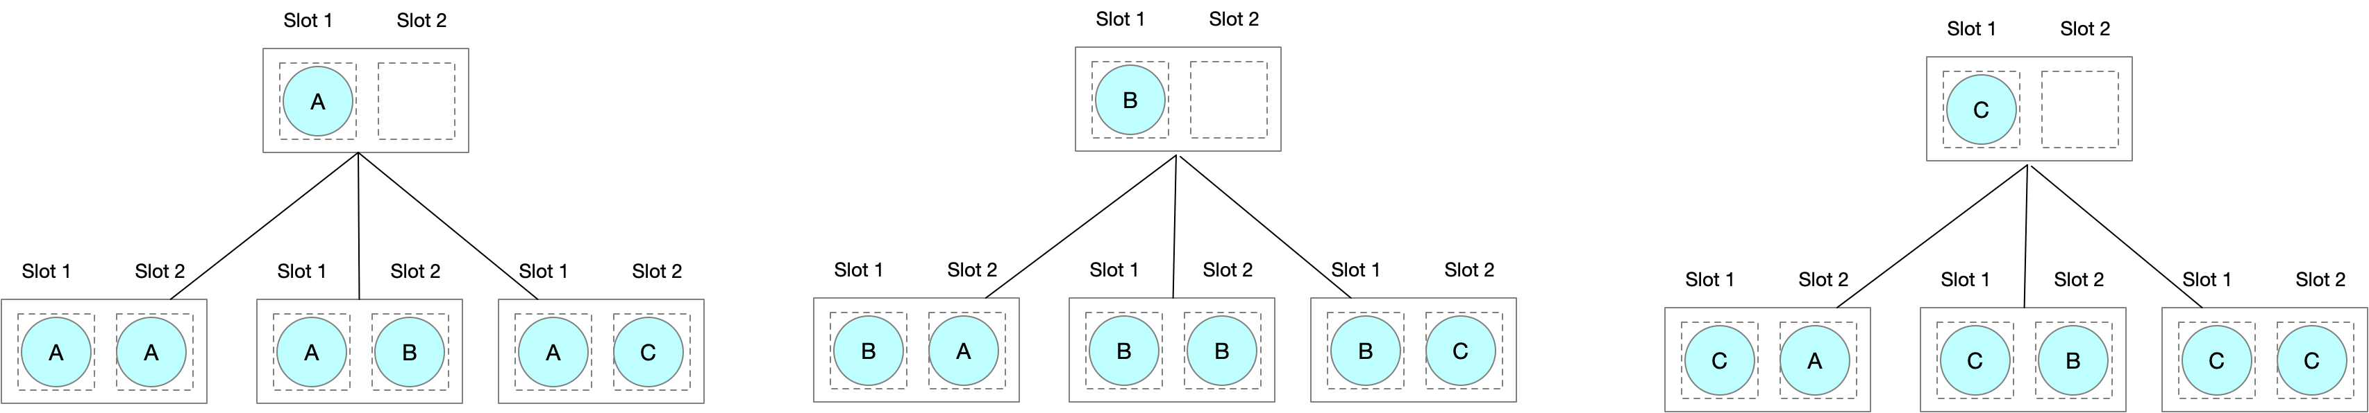

We have permutations. In full generality there are ways of arraning n objects taken two at a time with repetition

#### Permutations without repetition

If repetition is not allowed we have the following situation

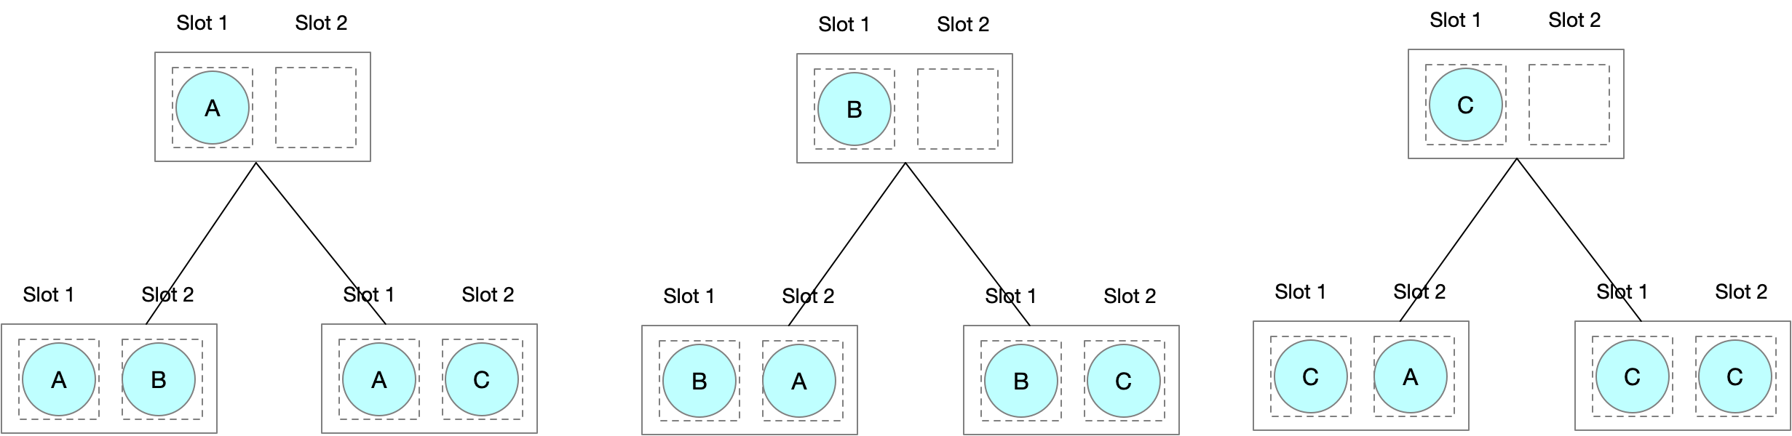

We have three choices for the first slot. But for each of those choices we only have two choices for the second slot as once value from the set have been used up. So we have ways of taking 3 objects 2 at a time without repetition. In full generality we have

Ways of taking n objects r at time withour repetition. R must be less than or equal to n. This can be expressed as . We show why in the following section

##### Proof

Substituting (2) into (1)

And re-arranging

### Combinations

Unlike permutations, where order is important, with combinations we are only concerned that we selected something. One way to visualize this is that the order of slots is unimportant so if we have three slots then

=

Slot 1

Slot 2

Slot 3

Slot 1

Slot 3

Slot 2

=

Slot 2

Slot 1

Slot 3

Slot 2

Slot 3

Slot 1

=

=

Slot 3

Slot 1

Slot 2

Slot 3

Slot 2

Slot 1

=

=

Because we consider all permutations of the same things equal, then the numbers of combinations equals the number of permutations divided by the number of permutations of slots. We can formulate the problem generally as

* The number of ways of selecting r items from a total of n where order in unimportant

### Circular Permutations

With a circular permutation we consider two different permutations where each entry has the same element to its right/left as identical

**=**

B

A

D

B

C

B

D

C

A

B

B

C

B

D

A

B

B

A

C

D

**=**

**=**

From this we can see that the number of circular permutations of n items taken r at a time is given by

## Binomial Theorum

### Overview – A recurrence relation for the co-efficients

Expressions of the form, where n is a positive integer are known as binomial expressions. Multiplying out a binomial expansion gives us a binomial expansion.

Notice the emerging pattern! The co-efficient of in the expansion of is equal to the sum of the co-efficient of and the co-efficient of in the expansion of . In general the co-efficient of in the expansion of is equal to the sum of the co-efficient of and in the expansion of . We can easily see why this is by looking at the following example

### A closd form solution for Binomial Co-efficients

The coefficients of the binomial expansion are given by



It is worth spending a little time looking at why this might be. Consider the expansion of

(1.1). 

(1.2) 

(1.3) 

(1.4) 

(1.5) 

Look at line (1.4) and notice that the number of ways of obtaining a unit power of is the number of ways of selecting one item from the set The ways of obtaining a square power of x is the number of ways of selecting two items from The ways of obtaining a cube power of x is the number of ways of selecting three items from And not forgetting the unit term, the number of ways of obtaining 1 is the number of ways of selecting zero x’s from three things

Since the 1’s have no effect the co-efficient of theterm is the number of combinations of n x’s taken r at a time

## Extending the solution to (a+b)

Now we know how to obtain the coefficients of we can extend the methodology to the expansion of by noting that.

.

Also



So



### Binomial expansion of E

Binomial expansion of E is given by







In the limit  then the above expression tends to



## Properties of Combinatorial Coefficients

**1. ** Because and 

**2. **Because 

**3. ** Because **Insert Proof**