Number Systems

The properties of number

Listing Number Type

|  |  |
| --- | --- |
| Rational Number | A number which can be expresses as a ratio of integers |
| Irrational Number | Any number which can be expressed as a ratio of integers |
| Real Numbers | The set of all numbers, both rational and irrational |

Listing Intervals

|  |  |
| --- | --- |
| Open Interval |  |
| Closed Intrerval |  |

Listing Properties of Operators

|  |  |
| --- | --- |
| Commutative | An operator is commutative if |
| Distributive | An operator  is distributive over another if |

## Arithmetic

#### Fundamental Theorum Of Arithmetic

Any integer is either prime itself prime or can be expressed as a product of prime factors

Where are successive primes and are powers of that prime. For any given p, the corresponding can be zero. We can find the prime factors of any given number by continually dividing through. The following shows how to extract the prime factors of 18

Figure Prime Factorisation of 18

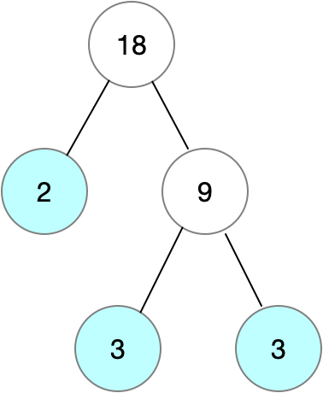

#### Highest Common Factor (HCF)

Given two integers x and y and their corresponding prime factorisations

We can calculate the highest common factor as

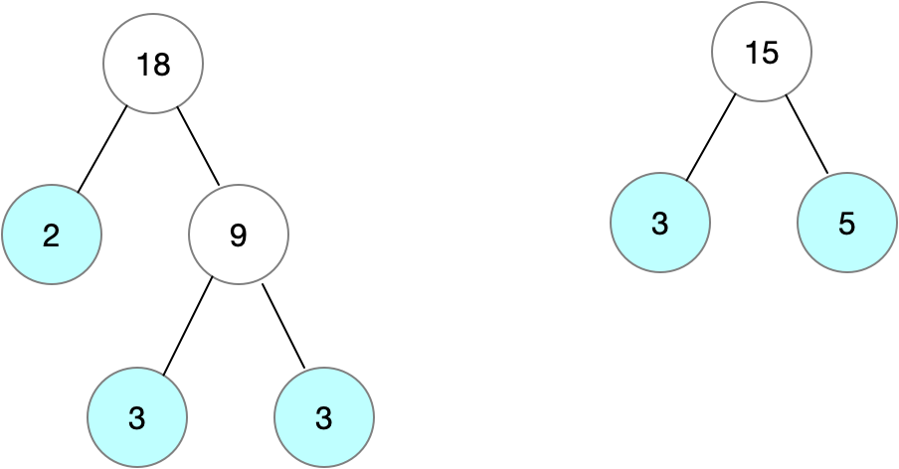

,

#### Lowest Common Multiple (LCM)

Given two integers x and y and their corresponding prime factorisations

We can calculate the lowest common multiple as



#### RelATING LCM and HCF

Given two integers x and y and their corresponding prime factorisations

We can show there is a relationship between lcm and hcf.

So we now know that

This is very powerful as we have efficient algorithms for calculating the hcf, whereas we do not have efficient algorithms for carrying out prime factorisation.

### Proof of Euclids Algorithm for Gcd

#### Show that gcd(a,b) is a divisor of a-b

By the definition of a divisor we know that

#### Show that gcd(a,b) is a common divisor of B and a-b

In the previous step we showed that gcd(a,b) is a divisor of a-b and by definition gcd(a,b) is a divisor of b. We hence know that gcd(a,b) is a common divisor of a and a-b. We know that gcd(a,b) must be less than or equal to gcd(b,a-b) by the definition of gcd(b,a-b) as the **greatest** common divisor

#### Show that gcd(B,A-B) is a divisor of A

By the definition of a divisor we know that

#### Show that gcd(B,A-b) is a common divisor of A and B

By definition gcd(b,a-b) is a divisor of b and we have shown that gcd(b,a-b) is a divisor of a. So we know that gcd(b,a-b) is a common divisor of a and b. Because gcd(a,b) is the **greatest** common divisor of a and bwe know that

Taken (4) and (9) together we have shown that

#### Show that gcd(b,a-b)=gcd(b,A%B)

**We have shown that** . We can apply the formula multiple times

Listing Euclids Algorithm



### Lowest Common Multiple

* Smallest integer that is a multiple of two numbers
* Used to add/subtract vulgar/proper fractions