Numerical Algorithms

## Introduction

This document covers

Introduction

## Root Finding

### Newton Rhapson

Given a function $f$ we want to find $f^{-1}\left(c\right)$ that is to say the value of $x$ such that $f\left(x\right)=c$. In simple situations we calculate this analytically using algebra. In many other situations such as finding $\sqrt{c}$ we need to turn to numerical algorithms. A slightly simpler scenario is when we want to find $x$ such that $f\left(x\right)=0$. This is known as root finding. First, we look at how we might use the Taylor to derive a root finding algorithm

The Taylor series tells us that if we know the value of a function at point $x_{0}$, say $f\left(x_{0}\right)$ then we can use an infinite Taylor series expansion to get the value of $f\left(x_{0}+δx\right)$ as follows

$$f\left(x_{0}+δx\right)=f\left(x_{0}\right)+\frac{f^{1}\left(x_{0}\right)δx}{1!}+\frac{f^{2}\left(x_{0}\right){\left(δx\right)}^{2}}{2!}…$$

A finite Taylor series expansion gives an approximation of the original function. The less terms we use the greater the error in the approximation. A first order approximation is given by

$$f\left(x_{0}+δx\right)≈f\left(x_{0}\right)+f^{1}\left(x_{0}\right)δx$$

In our case we want to find $δx$ so we re-arrange to get

$$δx≈\frac{f\left(x_{0}+δx\right)-f\left(x_{0}\right)}{f^{1}\left(x_{0}\right)}$$

Letting $f\left(x_{0}+δx\right)=0$ such that we are finding the value of $f\left(x_{0}+δx\right)$ that cuts the x-axis.

$$δx≈\frac{-f\left(x_{0}\right)}{f^{1}\left(x_{0}\right)}$$

Letting $δx=\left(x_{1}-x_{0}\right)$

$$\left(x_{1}-x_{0}\right)≈\frac{-f\left(x_{0}\right)}{f^{1}\left(x_{0}\right)}$$

And $$x_{1}≈x_{0}+\frac{-f\left(x_{0}\right)}{f^{1}\left(x_{0}\right)}$$

Now, $x_{1}$ is an approximation of the root of $f$ and the error is given by $f\left(x_{1}\right)-0=f\left(x_{1}\right)$

It can be shown that under certain circumstances if we let

$$x_{n}=x_{n-1}+\frac{-f\left(x_{0}\right)}{f^{1}\left(x_{0}\right)}$$

Then the sequence $x_{1},x_{2},x_{3}…$ converges to the root $x$ The following simple algorithm can be used to find roots using this procedure.

Listing Root Finding Newton

public double Solve(Func<double,double>f, Func<double,double> fd,

double initialGuess)

{

double x = initialGuess;

double y = f(x);

double error = 0.0000001;

while (Math.Abs(y) > error)

{

x = x - (y/fd(x));

y = f(x);

}

return x;

}

While finding roots is of course useful our original desire was to find the value of $x$ such that $f\left(x\right)=c$ for any value of c. Thankfully a small amendment to our algorithm extends it for any c. If we use original function $f$ to form a new function $g=f-c$ then finding a root of $g$ will give us the value of x that makes $f\left(x_{0}\right)=c$. We can use the derivative of $f$ as the derivative of $g$ because c is a constant and hence gets dropped during differentiation.

public double Solve(Func<double,double>f, Func<double,double> fd,

double initialGuess, double c)

{

Func<double,double> g = r => f(r)-c;

double x = initialGuess;

double y = g(x);

double error = 0.0000001;

while (Math.Abs(y) > error)

{

x = x - (y/fd(x));

y = g(x);

}

return x;

}

The converges looks as follows in tabular and graphical form

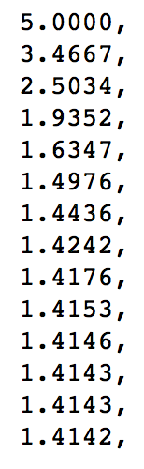

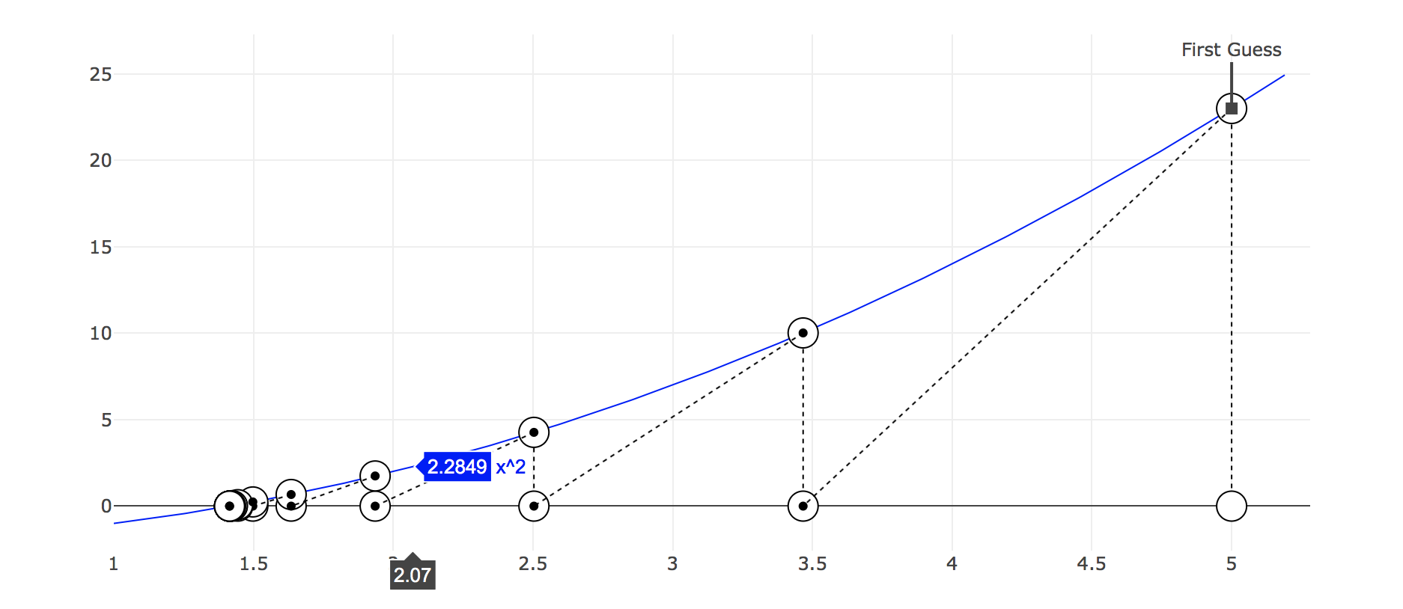

## Linear Regression

## Beta of Portfolio