Stochastic Processes

## Summary

### Table Definitions

|  |  |
| --- | --- |
| Outcome | Each thing that can occur in an experiment is called an outcome. In the example of tossing a coin we have two outcomes ‘heads’ or ‘tails’ which we can denote by the letters H and T respectively. |
| Sample Space | The set of all possible outcomes of an experiment is known as the sample space. By convention we label it ..In our simple coin tossing scenario we would have If we toss two coins our sample space would become |
| Event | A subset of the probability space is ` an event. We define an event using the following notation.  “This means the set of all outcomes such that is a head”. |
| Probability Measure | A probability measure P is a function that assigns to each element in a probability such that  Since an event A is a subset of then the probability of an event is given by |
| Probability Space | A probability space consists of a sample space and a probability measure. The sample space is the set of outcomes and the probability measure is a function that assigns to each element in a value in such that |
| Random Variable | A random variable x is a real valued function defined on . Put another way a random variable maps each outcome from the sample space to a real number. |
| Probability Distribution | We now introduce one more important concept, that of a probability distribution. A random variable is a function defined on  whereas its distribution is a tabulation of the probabilities that the random variable takes its various values. A random variable is **not** a distribution. |

### Table Properties of Expectation

|  |  |
| --- | --- |
| 1. Definition of Expectation |  |
| 1. Expectation of constant multiple | for any constant c |
| 1. Expectation of constant addition | for any constant b |
| 1. Linearity of expectation |  |
| 1. Expectation of a sum of random variables |  |
| 1. Expectation of a function of a random variable |  |

### Table Properties of Variance

|  |  |
| --- | --- |
| 1. Definition of Variance |  |
|  |  |
| 1. Variance of constant |  |
| 1. Variance of addition |  |
| 1. Variance of a constant multiple |  |
| 1. Sum of two independent random variables |  |
| 1. Sum of n IIR variable |  |

## Worked example

### A Single experiment

Imagine a random event that involves the tossing of a single coin. We have two outcomes, heads or tails giving us a sample space of

Furthermore, let us define two random variables. The first takes the value of plus one if we obtain a head and minus one if we obtain a tail.

The second takes a value of plus one if we obtain a head and zero if we get a tail

Notice that our random variables do not say anything about the probability of a head or tail. They just tell us what value we assign to the outcomes of the sample space.

Figure Random variables are real valued functions on the sample space

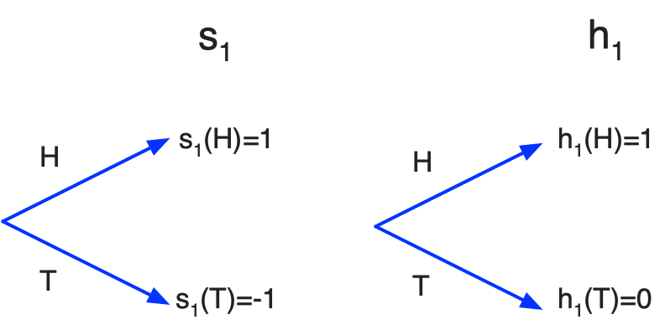

A probability measure is a real valued function that maps each outcome of the sample space to a probability. If our coin is fair, we could have a measure P such that

We might however have a different measure for a loaded coin

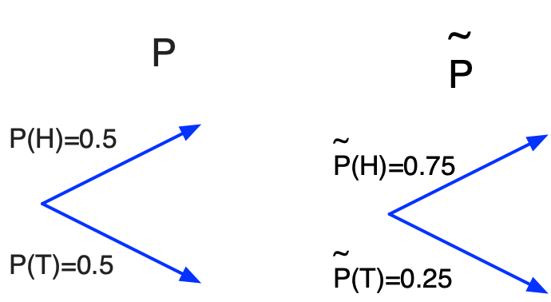

Distribution

Applying a probability measure to a random variable gives us a distribution. The distribution shows the probability of each value of the random variable. Since we have two random variable and two measures we have four probability distributions

Figure Applying measures to random variables give us distributions

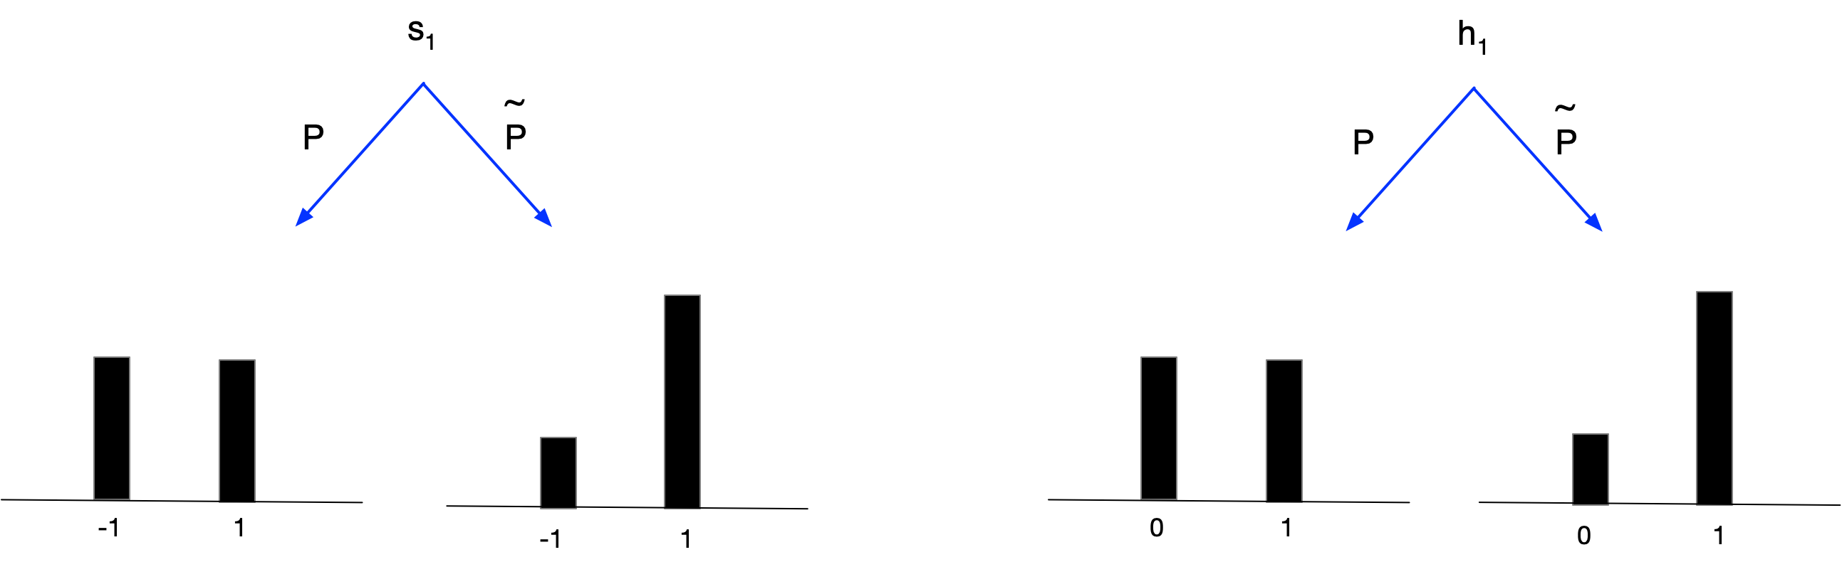

Mean and variance

We can define the expectation or expected value of any random variable X under a probability measure P as

For any actual value of a random variable X we can calculate the difference between that value and the expectation .We might ask the question “on average how much does a given value differ from the expected value?” We could calculate the average difference as however where the distribution is symmetric around the mean this value will be zero. A more instructive measure is given by calculating the average of the difference squared

We now add the mean and variance values to the four distributions obtained by applying the two measures to our two random variables

Figure Mean and variance

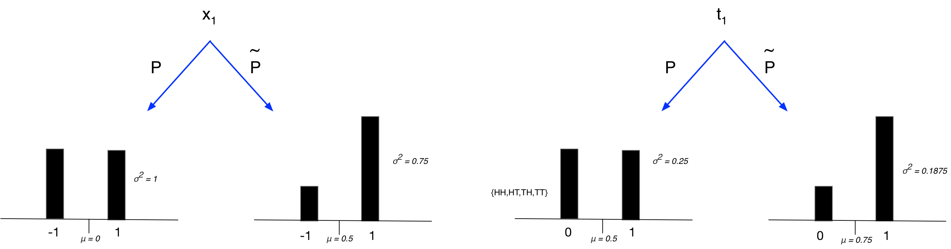

Table Summary

|  |  |  |
| --- | --- | --- |
| Outcome | H | Each outcome is a thing that can occur in an experiment |
| Sample Space |  | The set of all possible outcomes that can occur in an experiment is called the sample space |
| Event |  | A subset of the sample space is called an event |
| Probability Measure |  | A probability measure P is a function that assigns to each element in a probability such that |
| Probability Space |  | A probability space consists of a sample space and a probability measure |
| Random Variable |  | A random variable is a real valued function defined on the sample space. |
| Probability Distribution |  | Tabulation of the probabilities that the random variable takes its various values. |
| Expectation |  | We define the expected value of our random variable under the probability measure P |
| Variation |  |  |

## Performing twice

We can create a new game by playing the original games multiple times. If we play the original game twice then our new game effectively involves tossing the coin two times and our sample space becomes . We can define two new random variables by summing the original variables

.

.

Under our two measures our distributions of the two variables are as follows

Figure Mean and variance

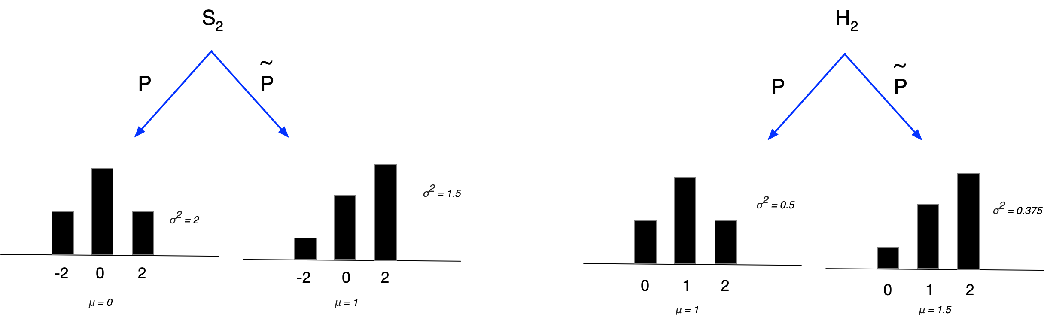

## Performing three times

Let us go one-step further and look at the event obtained by summing three of the original events. Under the probability measure P we get the following distribution, whose mean is zero and whose variance is three.

Figure Distribution of under P

-3

-1

3

1

Figure Distribution of under P

0

1

3

2

**ToDo – move to Onmi and c hange x to s**





Figure Tree for

## Generalizing

If we then perform n identical tosses of the coin and define n identical random variables we can define a new random variable as the sum of the individual random variables

.

And similarly for we can define a new random variable

The sample space of and is then

In the general case to calculate the probability of obtaining k heads in n tosses we need to take into account the probability of a head on a single toss which we call p and the number of paths through the decision tree that come to that number of heads. The paths are given by the binomial co-efficients and the probability becomes

**ToDo – move to Omni and change x to s**

following figure shows the paths though the tree for



. . .



. . .

**.**

**.**

**.**

Figure Paths through the tree for under measure P

Our distribution depends on both the random variable and the probability measure. Under our measure P representing a fairly weighted coin the expectations of our two random variables are given by and

We can intepret S as the distance from the origin if we move one unit in a positive direction whenever we obtain a head and one unit in a negative direction whenever we obtain a tail. This is the ‘random walk’ interpretation.

In general the sum of n independent, identically distributed random variables with mean and variance is a random variable with mean and variance For a proof of why this is the case see the proofs section below.

## Details

Probability Distribution

We now introduce one more important concept, that of a probability distribution. A random variable is a function defined on  whereas its distribution is a tabulation of the probabilities that the random variable takes its various values. A random variable is **not** a distribution.

x1

(Random Variable)

Distribution of

x1

Probability measure

Under the probability measure P defined on  either a head or tail are equally likely so our distribution becomes

-1

1

****Expectation****

We can define the expectation or expected value of any random variable X under a probability measure P as.

* Weighted average of the values the random variable X can take
* Weighting by the probability of each value
* Measure of centrality

Expectation of Variable Squared

We are often interested in expectation of the square of the variable which we call the mean squared.

Variation from expected value

For any actual value of a random variable X we can calculate the difference between that value and the expectation .We might ask the question “on average how much does a given value differ from the expected value?” We could calculate the average difference as however where the distribution is symmetric around the mean this value will be zero. A more instructive measure is given by calculating the average of the difference squared

Under our two probability measures we get

Expectation of a function of random variable

* The expectation of a function of a random variable is **not equal** to the function of the expectation 

## Manipulations

### Central Limit Theorem

From our previous sections we can see that if we sum n identical independent random variables with mean zero and unit variance we obtain a new random variable

with mean zero and variance . But what happens as we increase the number of steps? In the limit as is normally distributed with mean and variance. The following example show this

#### Examples

Consider a skewed random variable which takes the value one with probability 0.75 and minus one with probability 0.25.



##### One play

##### Two plays

##### Three plays

##### Tens plays

##### 100plays

### Scaling and Shifting

If we have a random variable X which under a given measure has mean zero and variance one we can use it to generate a distribution with mean and variance by multiplying by and adding .

Proof

Leting and let

From the properties of expectation we know that

therefore

Since then

From the properties of variance we know that

therefore

Since then

By the same reasoning if we know that a random variable is distributed with mean and variance under some measure then we also know that the random variable is distributed with mean zero and variance one

### Splitting and Combining

We define a random variable S to be the sum of n independent identical random variables as follows

If each has expected value and variance then

The reverse is also true. Given a random variable with expectation and variance and we can split it into n independent identical random variable each with expectation variance and

Furthermore we can use a random variable X distributed with mean zero and variance one to generate both and

Using the standard normal distribution

The standard normal distribution with mean zero and standard deviation one has been studied extensively and its properties are well known. So if we have a random variable which we know is normally distributed with mean and variance then we can represent it via a scale and shift of the standard normal distribution as follows

## Stochastic Time Series

We know the sum of n identical, independently distributed random variables with mean and finite non-zero variances is a random variable with mean and variance .

Mean and standard deviation

Mean and standard deviation

Mean and standard deviation

Mean and standard deviation

Mean and standard deviation

What if we were to replace the subscript n with the subscript t as follows?

Mean and standard deviation 

Mean and standard deviation 

Mean and standard deviation 

Mean and standard deviation

Mean and standard deviation

We can view as a random variable which describes the displacement of a particle that starts at the origin and is displaced the distance at time t.



Two sample paths through the above distribution

Once again we note that it is the variance that scales linearly. The total variance in this example is three so each individual part has variance one.

## Stock Price Process

Consider a stock price that starts at some level . On each tick one of two equally probable outcomes can occur; either the stock moves up by one dollar or it moves down by one dollar. Over three ticks we could model our stock using the process in the previous section with one small modification; we adjust the mean to be the current stock level.



We have created a simple stochastic process to model the change in value of our stock over time. We know from the introductory sections that if over one unit of time our stochastic process has variance and mean zero then over a period of time T it will have variance

We also know that if we break down a stochastic process with variance into n equal steps represented by the random variables then at each step we will need the variance of to equal . The change in our asset price can then be modelled as

In the limit as n tends to infinity the steps in our stochastic process become finer and finer but the total variance remains at and our process converges to a Gaussian variable with mean zero and variance and hence is normally distributed with mean zero and variance one. We can hence represent the change in our stock price over the time T as the stochastic process

We can then represent the terminal value of our stock price over the time T as the stochastic process

Normal distribution notation

Normal distribution with mean zero and variance of one

Normal distribution with mean zero and variance of two

If a process has a variance of per unit of time then we get

## A more realistic stock price process

The Markov property

The value of given is that determined by and so the behaviour of is totally unaffected by the values of for r less than s. This is known as the Markov property.

Brownian Motion

We say that a stochastic process  is a Brownian motion if it has the following properties.

* 
* For every s less than t, is normally distributed with variance .

From these properties it follows that

.

In the limit as  tends to zero we get

.

We can then represent a process with non unit variance as



Stochastic differential equation

We extend this notion to define a family X of random variables that satisfy the stochastic differential equation.



Dropping the parameters of the drift and volatility we get a general stochastic differential equation for a variable with a constant growth or drift rate plus some noise.



## Proofs

If X is a random variable with sample space and Y is an independent random variable with sample space then the sample space of X+Y is

.

.

.

The expectation of the sum of the two variables in then given by

Multiplying out we get

Noting that and

Therefore we can note that

The following figure shows the a specific example approach



+



=



We have random variable with sample space and a second identically distributed random variable with sample space. The sample space of the joint distribution is given by the set of pairs

The expectation of the sum of the variables is then given by

Multiplying out

Noting that and

Therefore we can note that

We can calculate the expectation of the sum of n identically distributed random variables denoted by as which is equal to

From definition 1

By multiplying out the brackets

From the properties of summation

From definition 1

From axioms of probability

Let

From definition

= Multiplying out

=

From definition 3

Properties of summations

Axioms of probability

From definition 2

Letting 

From definition

From definition 4

The following diagram shows the general approach.



+



=



We have random variable with sample space and another identically distributed random variable with sample space. The sample space of the joint distribution is given by the set of pairs

Therefore

Questions

If a coin is weighted such that a head has probability 0.75, what is the mean and distribution of the number of head obtained when tossing the coin 500 time?

If X and Y are normally distributed what is the probability P(X>5Y)?