Series

This document covers

Definitions

Introduction

Sequences

Series

Recurrence Relations

Recursion

Proof by Induction

Integrating Series

Proofs

## Definitions

Sequence

A list of numbers in a definitive order order .

Series

Obtained by adding the terms of a sequence

geometric Series

The ratio of each term to its predecessor is constant.

Taylor Series

We can approximate a functionfor small values around some anchor point a, as a power series

## Properties of sums

|  |  |  |
| --- | --- | --- |
| Law | Name | Notes |
| Constant multiple |  |  |
| Adding |  |  |
| Linearity |  |  |
| First n integers |  |  |
| First n integers squared |  |  |
| First n integers cubed |  |  |
| Value of geometric series |  |  |
| Value of ininite geometric series where absolute value of x is less than 1 |  |  |

## Introduction

Even elementary functions can be difficult to work with. Even simple functions like can be difficult to evaluate because every integer input results in an irrational. A small subset, however, known as the polynomials are much easier to work with because they are

* Easy to integrate
* Easy to evaluate for any value of x
* Infinitely differentiable

The tactic of expressing complicated functions as infinite series motivates much of the study of infinite series

## Sequences

### Definition

* List of numbers in a definitive order 
* If has a limit L we can make as close to L as we like by increasing n
* is bounded above if there is some M such that 
* is bounded below if there is some M such that 
* Every bounded monotonic sequence is convergent



### Notation

The following notations are equivalent

Some sequences can be defined by a formula for the nth term.

## Series

### Definition

* Obtained by adding the terms of an infinite sequence
* Given a series we can generate a sequence of its partial sums
* If the resulting sequence is convergent we say the series is convergent
* With any series we associate two sequences
* the terms
* the partial sums
* If is convergent
* If does not exist is divergent
* thenis divergent

### Geometric Series

A geometric series is a series where the ratio of each term to its predecessor is constant.

The value of a geometric series is given by

#### Infinite Geometric Series

If the first N elements in a geometric series are given by then the first N-1 elements will be given by and in the case where x is greater than -1 and less than one then in the limit as the number of elements tends to infinity we get

Since in the case where the absolute value of x is less than zerowill tend to zero as N tends to infinity the second term also tends to zero and we have an expression for an infinite geometric series.

### Power Series

* For each x the series is a series of constants which we can test for convergence
* The sum of the series is a function
* The domain of this function is the set of x for which the series converges

### Taylor Series

We can approximate a functionfor small values around some anchor point a, as a power series.

For a giventhe Taylor series will only be valid for a given subset of the domain, known as the radius of convergence.

### Fibonacci

Questions Series

Fibonacci

#### Fibonacci Iterative

Write Fibonacci iterative

public static int FibonacciIterative(int n)

{

// f0 f1 f2 f3 f4

// 0 1 1 2 3

// fn = Fibonacci(n)

// fn1 = Fibonacci(n+1)

// fn2 = Fibonacci(n+2)

int fn = 0, fn1 = 1;

for (int i = 0; i < n; i++)

{

int fn2 = fn + fn1;

fn = fn1;

fn1 = fn2;

}

return fn;

}

Analyse the runtime?

O(N)

#### Fibonacci Recursive

Write Fibonacci recursive

public static int FibonacciRecursive(int n)

{

if (n == 0)

return 0;

if (n == 1)

return 1;

return FibonacciRecursive(n - 1) + FibonacciRecursive(n - 2);

}

Analyse the runtime?

Consider the following call graph of f(4)

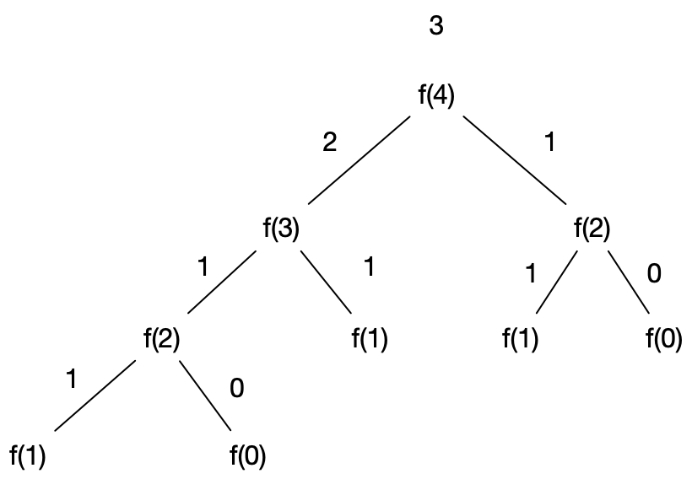

The runtime is upper bounded by . There is a slighter tighter bound

Improve the performance of the recursive algorithm

This is O(2n) =O(n)

public static int FibonacciRecursiveMemo(int i)

{

var cache = new int[i + 1];

int F(int x)

{

if (x == 0 || x == 1) return x;

if (cache[x] == 0) cache[x] = F(x - 1) + F(x - 2);

return cache[x];

}

return F(i);

}

## Proofs

Prove that

and

therefore

Prove that

We show a now a proof of the value of a geometric series

Subtracting the second expression from the first we get

Factoring both sides

Dividing both sides by

Prove that

We prove this useful result by looking at the limit



And noting that the numerator will tend to a as n tends to infinity