Sets

## Overview

### Operators

|  |  |  |  |
| --- | --- | --- | --- |
| Symbol | Meaning | Example | Description/Example |
|  | Is in the set |  | 1 is in the set |
|  | Is not in the set |  | 3 is not in |
|  | Cardinality |  | The cardinality of the empty set is zero. |
|  | Subset | **,**  **,** |  |
|  | Proper subset |  |  |
|  | Intersection |  |  |
|  | Union |  |  |
|  | Difference/Relative Complement |  |  |
|  | Absolute complement |  |  |
|  | Symmetric difference |  |  |
|  | Open Interval |  |  |
|  | Closed Iterval |  |  |
|  | Cross Product / Cartesian Product |  |  |

### Rules

|  |  |  |
| --- | --- | --- |
| Law | Name | Description/Example |
|  | Idempotency |  |
|  | Idempotency |  |
|  | Commutative |  |
|  | Commutative |  |
|  | Associative |  |
|  | Associative |  |
|  | Absorption |  |
|  | Absorption |  |
|  | Distributive |  |
|  | Distributive |  |
|  | De Morgan |  |
|  | De Morgan |  |
|  | De Morgan |  |
|  | De Morgan |  |

### Common Sets

|  |  |  |  |
| --- | --- | --- | --- |
| Set | Meaning | Example | Description/Example |
|  | The natural numbers |  | Can sometimes be assumed to include 0, especially by computer scientists |
|  | The integers |  |  |
|  | The positive integers |  |  |
|  | The rational numbers |  |  |
|  | The real numbers |  |  |
|  | Complex numbers |  |  |

Note that:

### Defining Sets

A set is a collection of things. We call the things elements of the set. If a set consists of the difference faces of a die we can write.

#### - Subset

A

 B

A



**- Proper Subset**

**Equality**

**- Intersection**

 B

A



**- Union**

 B

A

Note the following about the union of A and B

 B

A



 B

A

**B -Difference (Relative Complement)**

 B

A

**– Absolute Complement**

The set of elements in the universe U which are not in the set A

 U

A

**Symmetric Difference**

The elements in A or B but not in both

 B

A



#### Cross Product / Cartesian Product

If A and B are sets we can form the product C as

And we write

#### Distributive Law 1

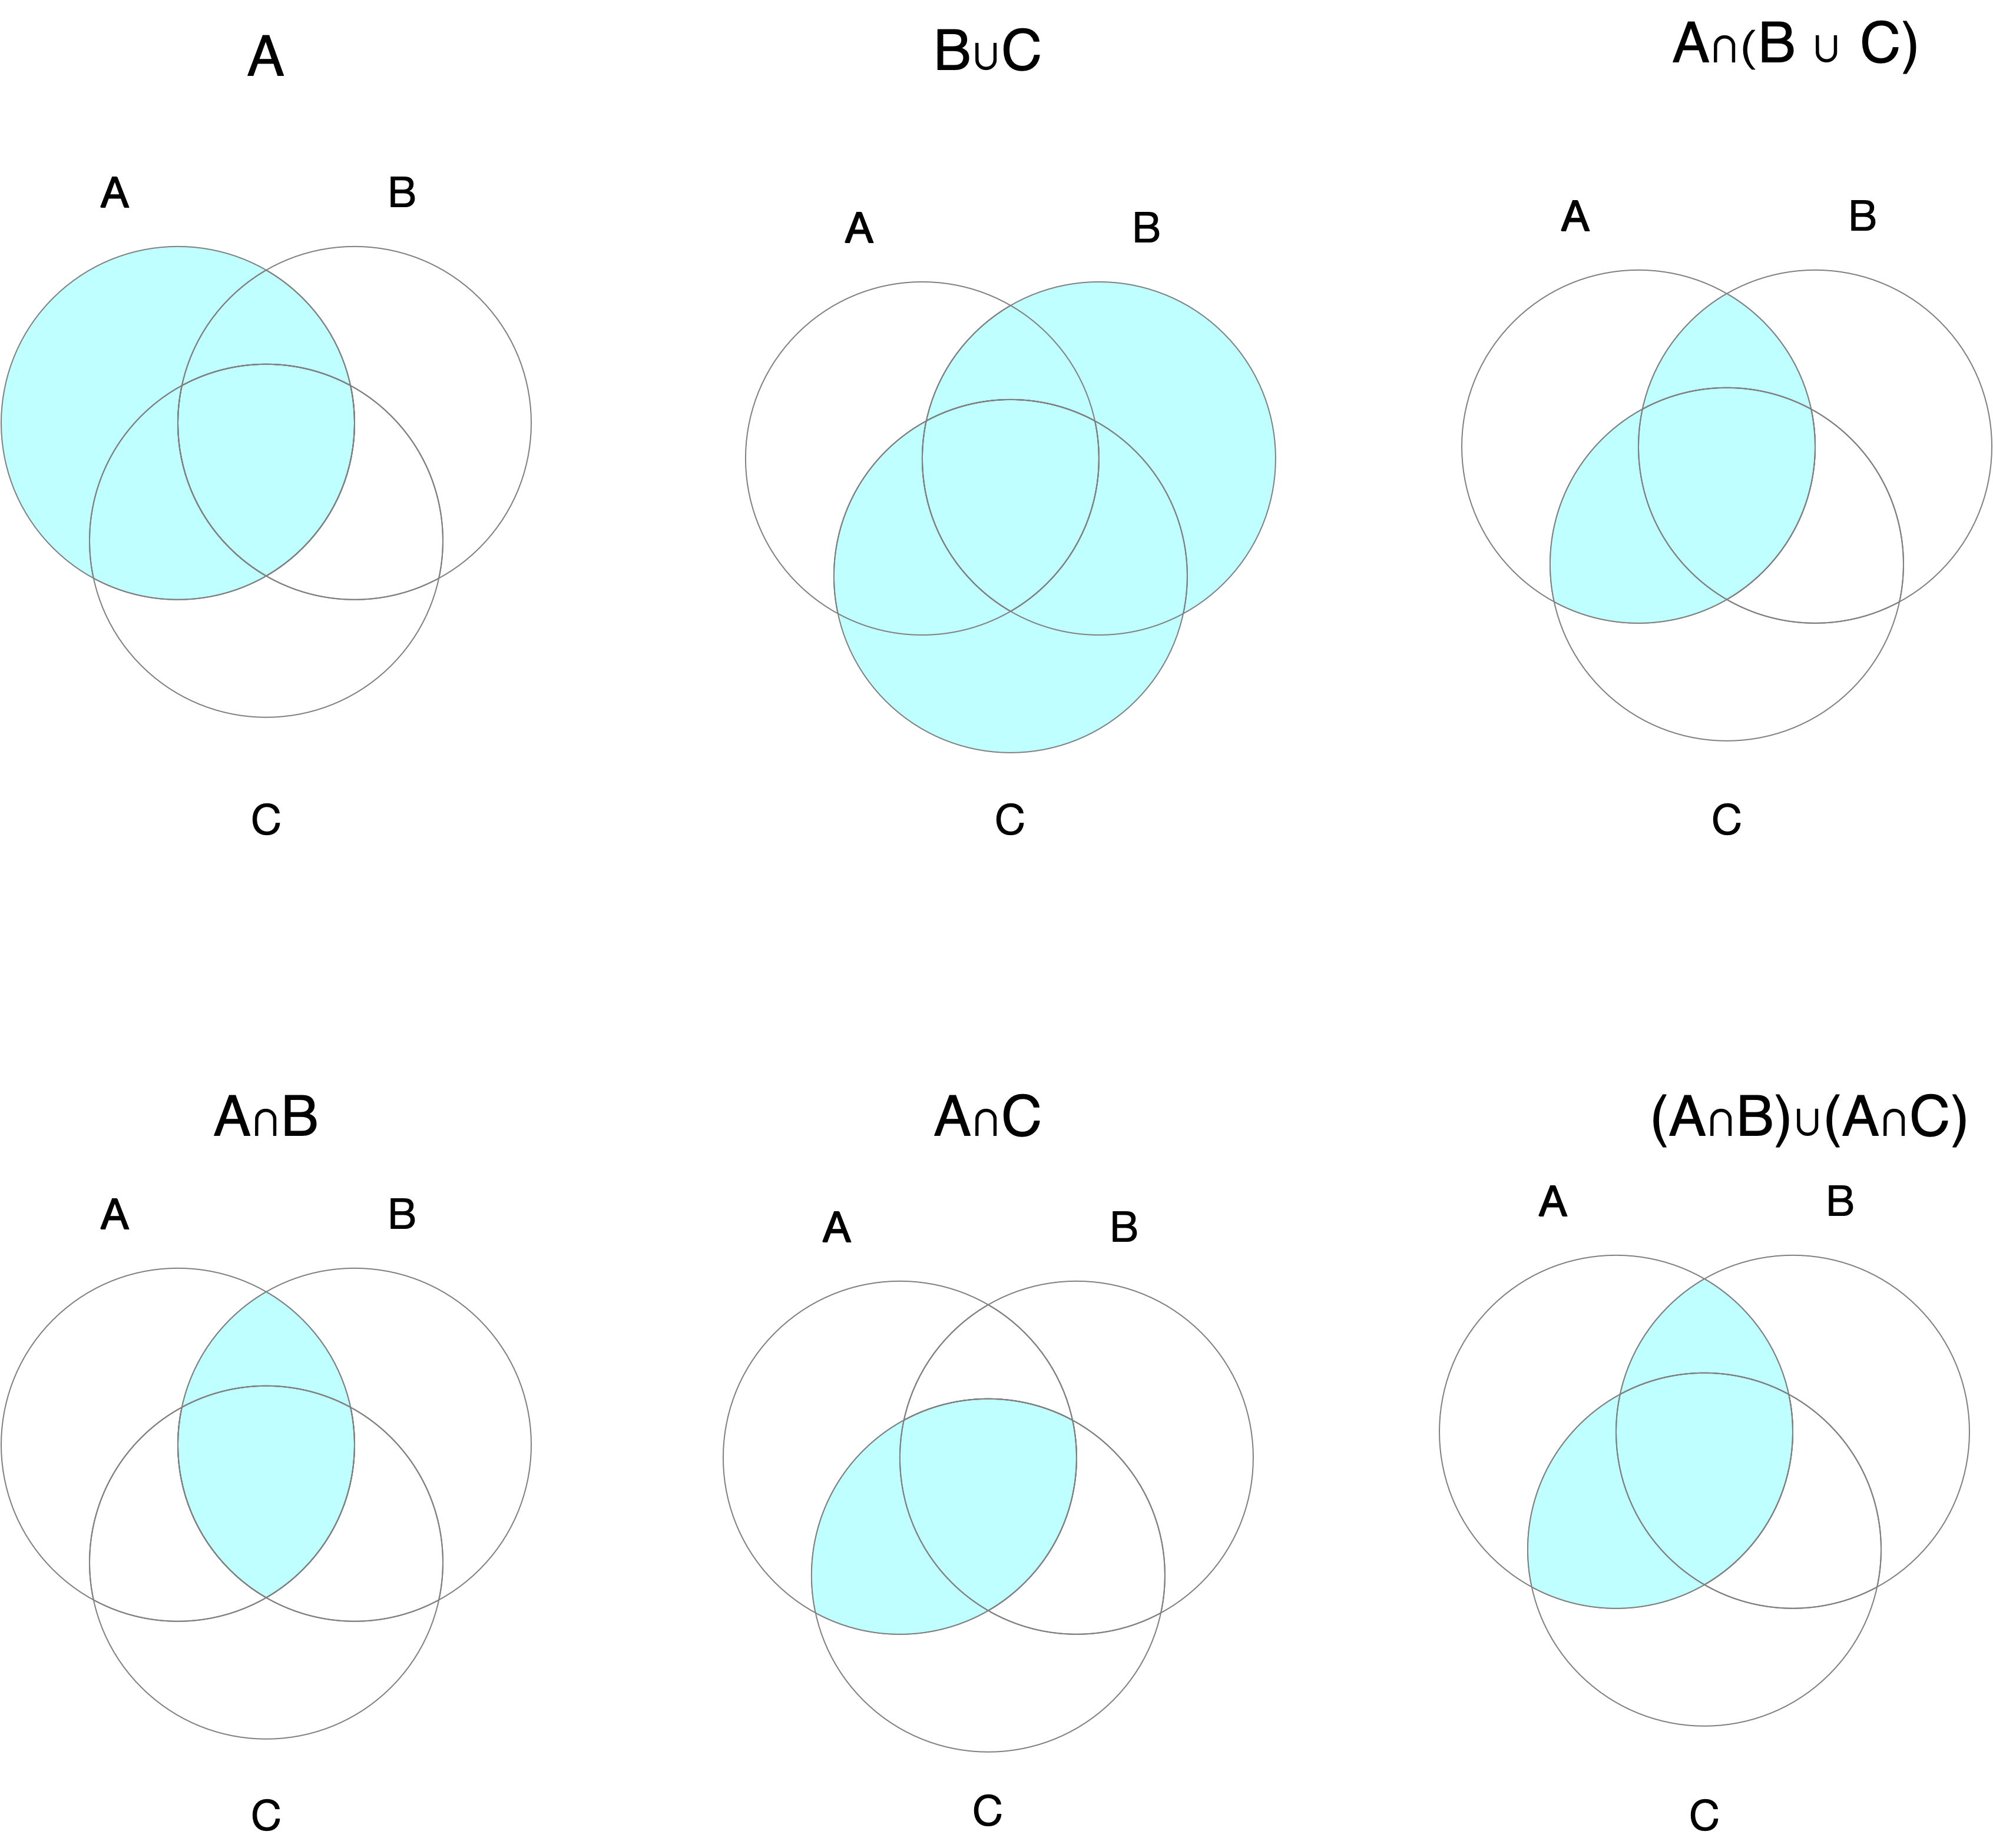

#### Distributive Law 2

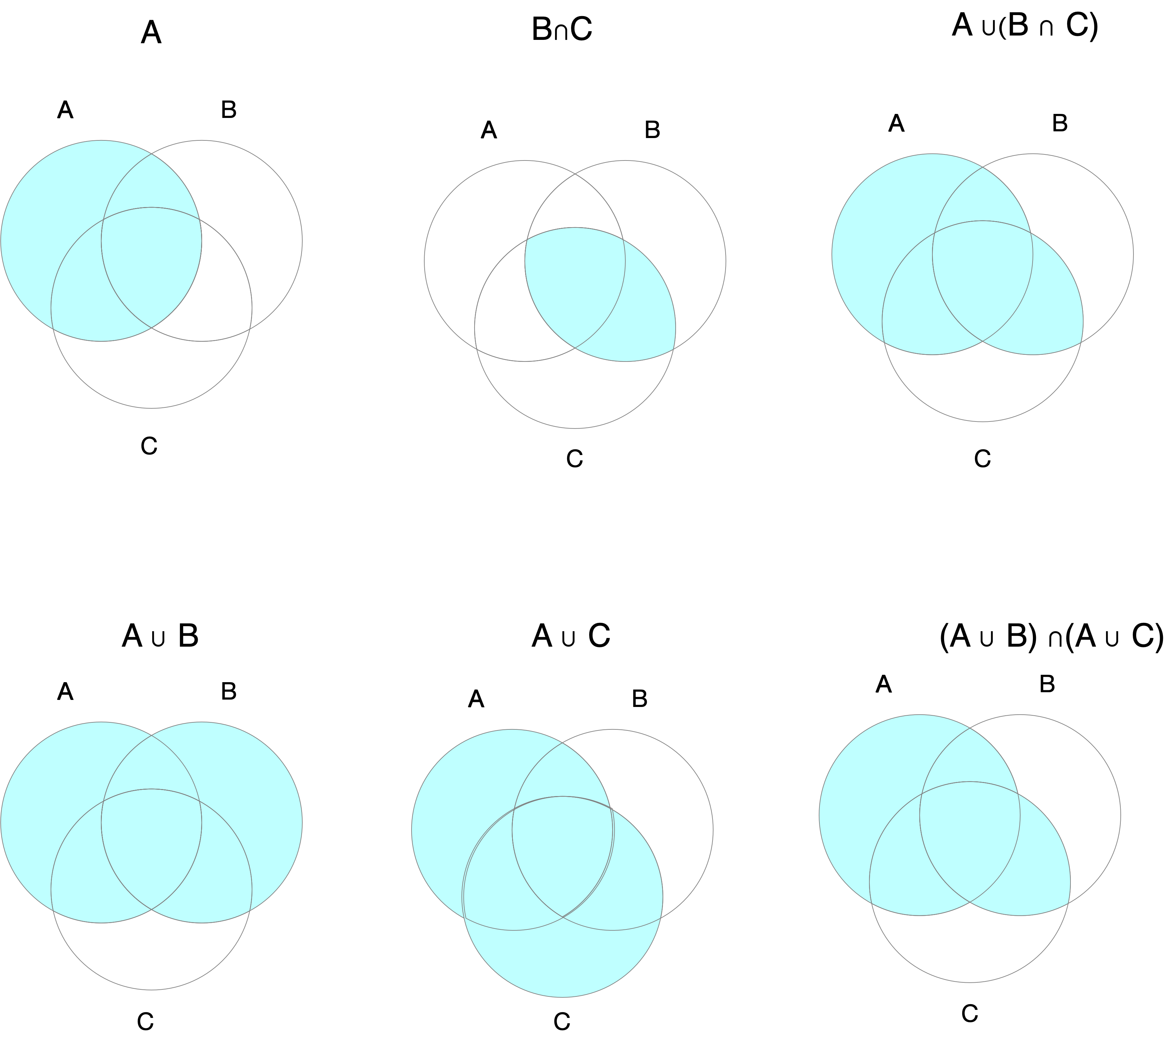

#### DeMorgan Law