Docker

## Introduction

This document covers

Introduction

## Docker commands

### General

|  |  |
| --- | --- |
|  | Column Header |
| Version | docker --version |
| Pull image from Dockerhub | docker pull <image-name> |
| Start container from image | docker run <image-name> |
| List all running containers | docker ps |
| Stop container | docker stop <contId> |
| List all containers including stopped | docker ps -a |
| Delete container | docker rm <container-id> |
| Image List | docker images |
| Delete image | docker rmi <image-name> |
| Map container port to host port | docker run -p <host-port>:<container-port> myapp |
| Map container directory to host directory | docker run -v <host-dir> <cont-dir> |
| Inspect running container | docker inspect <image-name> |
| Execute command on container |  |

### Run

|  |  |
| --- | --- |
|  | Column Header |
| Start a container | docker run hello-world |
| Start container in background | docker run -d hello-world |
| Start container with std in/out | docker run -i -t <image> |

### Port mapping

The following runs a container and maps port 80 on the container to port **4000** on the container host.

docker run -d -p **4000**:80 --name myapp2 aspnetapp

### Docker logs

We can list the logs for the container using

docker logs <container-id>

The following shows a simple example

> docker logs 6ff

> Hosting environment: Production

> Content root path: /app/

> Now listening on: http://[::]:80

> Application started. Press Ctrl+C to shut down.

### Docker Inspect

We can list the entire information for a container using. This also gives the container IP Address.

docker inspect <container-id>

### Viewing the directory structure of running container

If the container is Linux based we can execute a shell to log on and see what is happening on a running container

docker exec -i -t 7d bash

We now have a shell onto the container.

## Building Images

### CMD and ENTRYPOINT

To illustrate the difference between CMD and ENTRYPOINT we will use the following simple web application

Source Code

namespace ASPHelloWorld

{

public class Program

{

public static void Main(string[] args)

{

string message = args.Length > 0 ? args[0] : "Hello";

var webHost = new WebHostBuilder()

.UseKestrel()

.Configure(app =>

{

app.Run(async ctx =>

{

await ctx.Response.WriteAsync(message);

});

})

.Build();

webHost.Run();

}

}

}

Dockerfile

FROM mcr.microsoft.com/dotnet/core/sdk:3.1 AS build

# WORKDIR sets the working directory for any RUN, CMD, ENTRYPOINT, COPY and ADD

# instructions that follow it. If the workdir does not exist it is created

WORKDIR /app

# copy .sln to /app/.sln

COPY *.sln .

# copy aspnetapp/*.csproj to /app/aspnetapp/*.csproj

COPY ASPHelloWorld/*.csproj ./ASPHelloWorld/

# Use NuGet to restore dependencies.

RUN dotnet restore

# copy everything else to /app/aspnetapp

COPY ASPHelloWorld/. ./ASPHelloWorld/

# Set the wordir

WORKDIR /app/ASPHelloWorld

# Compiles the application and publishes the results to a directory

RUN dotnet publish -c Release -o out

FROM mcr.microsoft.com/dotnet/core/aspnet:3.1 AS runtime

WORKDIR /app

# --from=build sets the source location to the previous step named build

COPY --from=build /app/ASPHelloWorld/out ./

ENTRYPOINT ["dotnet", "ASPHelloWorld.dll"]

CMD ["Docker CMD"]

We can build and run an instance of our web application as follows

build -t aspnetapp .

docker run -d -p 8080:80 --name myapp aspnetapp

When we connect to our application from a browser we see the value of the CMD is returned

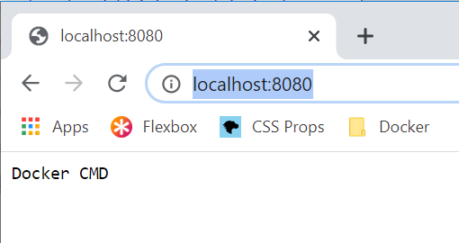

If we want to override the value of CMD we can do this from the command line. We create a second instance on a different port and with a different message

docker run -d -p 8081:80 --name myapp2 aspnetapp "Hello Kenny"

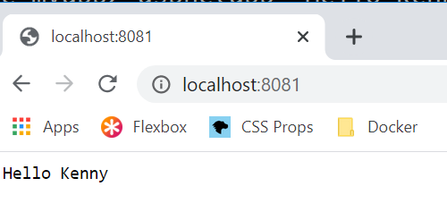

For ports see

<https://stackoverflow.com/questions/48669548/why-does-aspnet-core-start-on-port-80-from-within-docker>

## Dockerize ASP.Net core

### Basic Example

Consider a single file ASP.NET Core application. It is the simplest hello world application

public class Program

{

public static void Main(string[] args)

{

var webHost = new WebHostBuilder()

.UseKestrel()

.Configure(app =>

{

app.Run(async ctx =>

{

await ctx.Response.WriteAsync("Hello World");

} );

})

.Build();

webHost.Run();

}

}

And a simple launchSettings.json as follows

{

"profiles": {

"ASPHelloWorld": {

"commandName": "Project",

"launchBrowser": true,

"applicationUrl": "http://localhost:5000",

"environmentVariables": {

"ASPNETCORE_ENVIRONMENT": "Development"

}

}

}

}

Running this application inside of Visual Studio and connecting to <http://localhost:5000> gives the following.

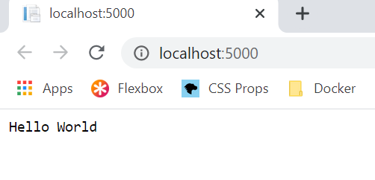

#### Dockerize

##### Create the Docker File

FROM mcr.microsoft.com/dotnet/core/sdk:3.0 AS build

WORKDIR /app

# copy csproj and restore as distinct layers

COPY *.sln .

COPY aspnetapp/*.csproj ./aspnetapp/

RUN dotnet restore

# copy everything else and build app

COPY aspnetapp/. ./aspnetapp/

WORKDIR /app/aspnetapp

RUN dotnet publish -c Release -o out

FROM mcr.microsoft.com/dotnet/core/aspnet:3.0 AS runtime

WORKDIR /app

COPY --from=build /app/aspnetapp/out ./

ENTRYPOINT ["dotnet", "aspnetapp.dll"]

##### Build an image

Run the following command

docker build -t aspnetapp .

##### Run a container from the image

docker run -d -p 8080:80 --name myapp aspnetapp

Note that the docker image runs in the container on port 80. The launchSettings.json is ignored. For this reason, we map port 80 on the container to port 8080 on the container host so we can access it from localhost

### Mapping directory from docker container to host

Now consider the situation where our application logs to the container via Serilog. The configuration is as follows.

Serilog (appsettings.config)

"WriteTo": [

{

"Name": "File",

"Args": {

**"path": "/var/tmp/logs/log.txt",**

"rollingInterval": "Day"

}

},

{

"Name": "Console"

}

]

We create the directory /var/tmp in the Dockerfile.

Dockerfile

WORKDIR /app

COPY *.sln .

COPY ASPHelloWorld/*.csproj ./ASPHelloWorld/

RUN dotnet restore

COPY ASPHelloWorld/. ./ASPHelloWorld/

WORKDIR /app/ASPHelloWorld

RUN dotnet publish -c Release -o out

FROM mcr.microsoft.com/dotnet/core/aspnet:3.1 AS runtime

WORKDIR /app

RUN mkdir -p /var/tmp/logs

COPY --from=build /app/ASPHelloWorld/out ./

ENTRYPOINT ["dotnet", "ASPHelloWorld.dll"]

CMD ["Docker CMD"]

We now build the container

docker build -t aspdotnetapp .

Finally, we run the container and map the container log file /var/tmp/logs to the folder C:\Users\rps\docker\logs on the container host

docker run -d -p 8080:80 -v C:\Users\rps\docker\logs:/var/tmp/logs aspdotnetapp

When we attach a browser to the port localhost:8080 we will see the log file shows up in the docker host filesystem in directory C:\Users\rps\docker\logs

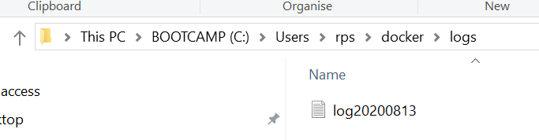

We can also view the mount that maps the directory by running the docker inspect command on the running container

Docker inspect 7d

And inside the output we see

"Mounts": [

{

"Type": "bind",

"Source": "/host_mnt/c/Users/rps/docker/logs",

"Destination": "/var/tmp/logs",

"Mode": "",

"RW": true,

"Propagation": "rprivate"

}

],

A docker image captures the private filesystem that the that your containerized component will run in. The image contains just what the component needs. The image isolates all the dependencies your component needs.

A Dockerfile describes how to assemble a private filesystem for a container. This file provides step by step instructions on how to build up the image.

## Docker Compose

### Linking Containers

Consider a simple example where one container runs an instance of MongoDB and other container runs a script that uploads data. The upload container needs to have access to the MongoDB container IP address. The way we do this is with links. Consider the following. The bold pieces link together the containers for mongohost

docker-compose.yaml

version: '3'

services:

**mongohost**:

image: mongo

ports:

- 27010:27017

mongo-load:

build:

context: MongoPopulate

dockerfile: Dockerfile

links:

- **mongohost**

MongoPopulate/Dockerfile

FROM mongo

COPY myarchive /myarchive

COPY populate.sh /populate.sh

CMD "./populate.sh"

MongoPopulate/populate.sh

echo "Doing the load"

sleep 10

mongorestore --uri="mongodb://**mongohost**:27017" --drop --archive=myarchive --gzip

echo "Finished"

## Overviews

### Compare Docker and Virtual Machines

Consider the following diagram that shows how virtualization works.

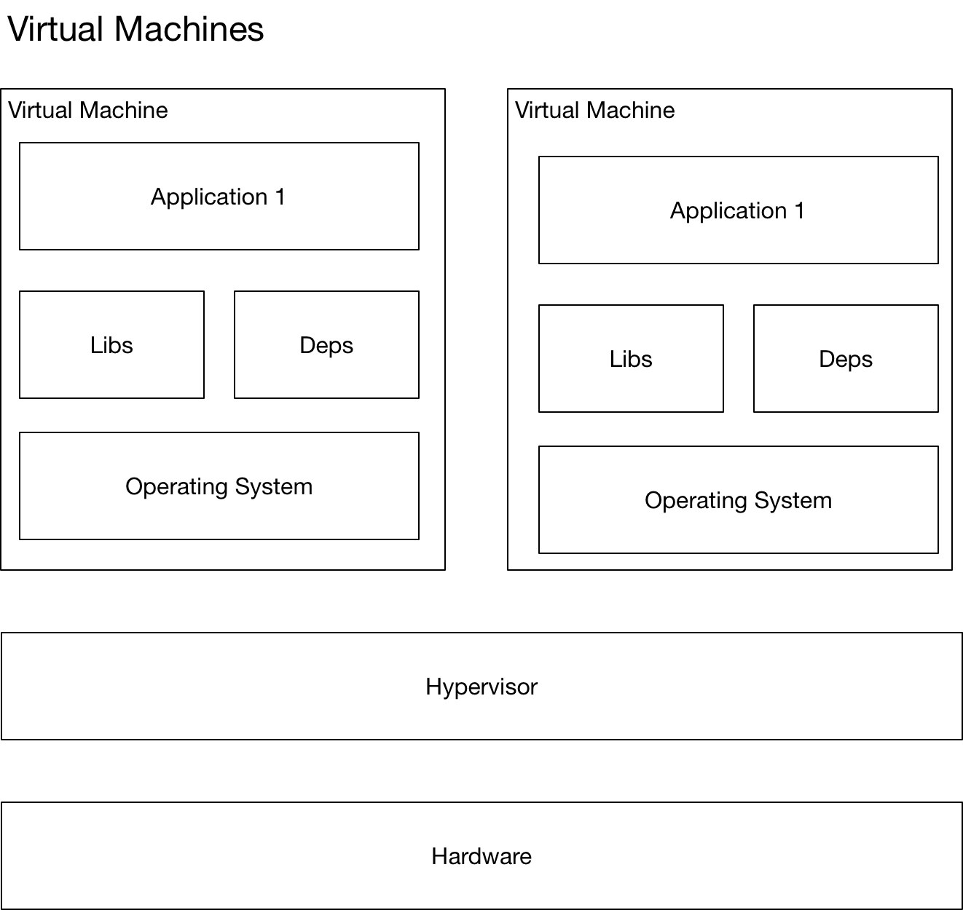

* Multiple virtual machines running on the same hardware
* Heavyweight solution
* Each virtual machine has its own operating system
* Each VM typically requires GB of desk space as it runs whole OS
* Complete Isolation
* High overhead
* Start-up time can be minutes as OS needs to start.

Now let us look at Docker.

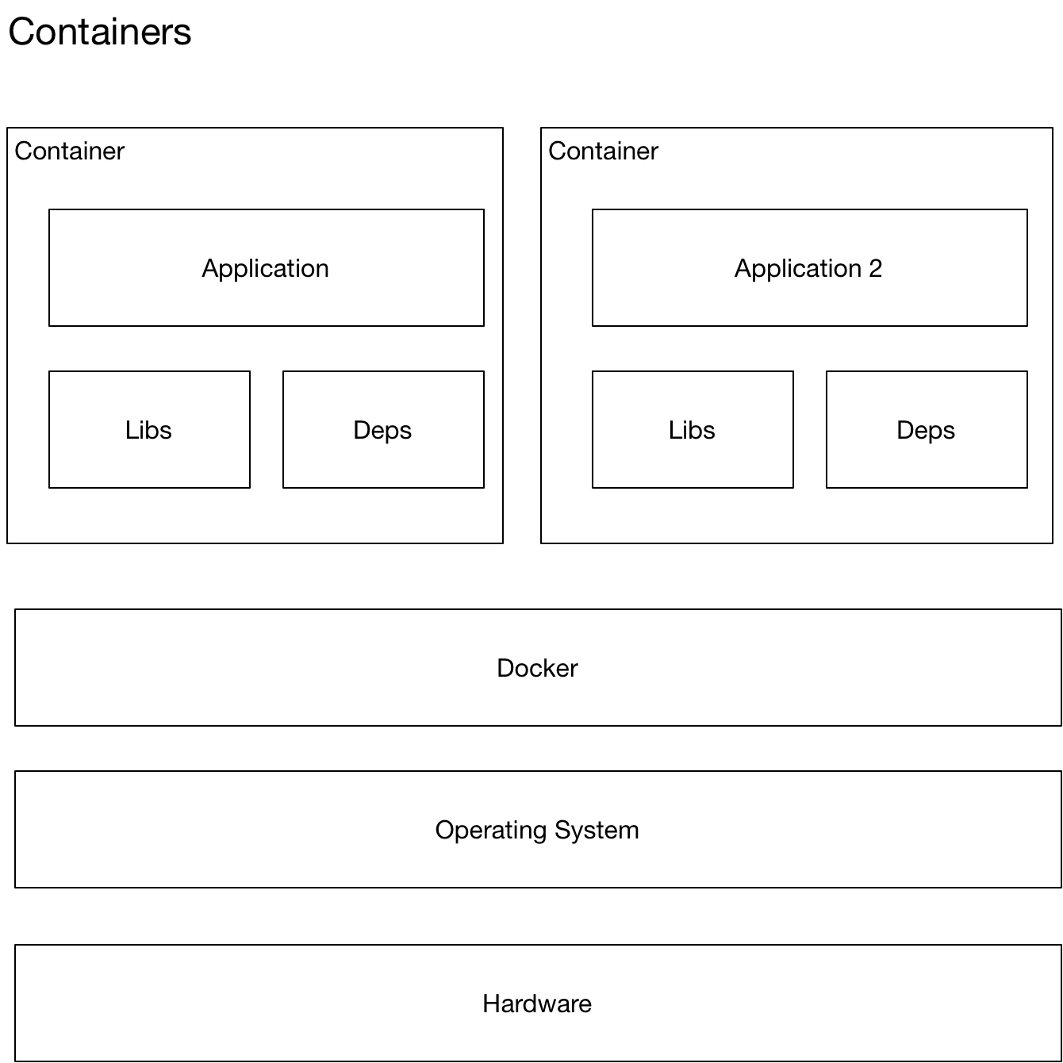

* Lightweight solution
* Each container typically MB in size
* Starts up in second.
* Docker has less isolation as more resources are shared across containers (kernel)

### Overview of Docker

Docker runs on the OS and manages multiple containers. Each container has its own set of libraries and other dependencies. These dependencies are used by the application that runs inside the container.

A docker image is a template that is used to create docker containers. Each container is hence an instance of the image. A container is created using the docker run command. Dockerhub is a public repository of images for applications such as MongoDB and Node.js. We can also create our own images

A container is a running process with some added features to keep it isolated from the host and from other containers. Each container has its own private filesystem. The filesystem is provided by the docker image.

### Docker Run

#### Tags

If you look up an image on Dockerhub.com is listed all supported tags for that image. We can specify versions using the tags

docker run redis:4.0

#### StdIn/StdOut

By default docker containers run in non-interactive form. It does not listen to stdin. Its does not have a terminal to read input from. To provide input we must map stdin from our host to the docker container

docker run -i <image>

If we want a prompt and terminal, we need to add a terminal too.

docker run -i -t <image>

#### Port Mapping

Consider we run a simple webapp.

docker run kodekloud/webapp

If we want to know the IP of a docker container we run the command.

docker inspect --format='{{range .NetworkSettings.Networks}}{{.IPAddress}}{{end}}' $INSTANCE_ID

If we want to map a port from our docker container to the docker host we run the command as follows

docker run -p80:5000 kodekloud/webapp

|  |  |  |
| --- | --- | --- |
| docker run image:tag | Docker run redis: | Show the version of docker installed |

## Docker Training

Why docker?

Multiple services require difference versions of the OS or different versions of dependencies. With docker each container can have its own dependencies, libraries, processes, networks and mounts.

The purpose of docker is to package and containerise applications so we can ship them and run them as many times as we need.

Many products are containerised on Dockerhub repository. Such products include OS versions, database versions etc.

All containers share the same OS kernel.

What is an image?

A template used to create containers

What are containers?

Running instances of containers that are isolated and have their own processes

How long does a container live?

As long as the process inside it

### Commands

Containers are meant to run a specific task or process e.g. to host an instance of a web server or database. Once the task is complete the container exits. The container only lives as long as the process inside it is alive. Once a web server stops the container exits. We can instruct docker to run a command on our container

docker run ubuntu sleep 120

Now we can execute a command on this ubuntu container while it is running

C:\Users\rps>docker exec ce55 cat /etc/hosts

127.0.0.1 localhost

::1 localhost ip6-localhost ip6-loopback

fe00::0 ip6-localnet

ff00::0 ip6-mcastprefix

ff02::1 ip6-allnodes

ff02::2 ip6-allrouters

172.17.0.2 ce5539c1b552

##### Available Images

To see what kind of images are available go to

<https://hub.docker.com/>

## Docker For Windows

I am installed Docker Community Edition for Windows.

<https://hub.docker.com/editions/community/docker-ce-desktop-windows>

There are two ways to use Docker on windows. Docker Toolbox is a legacy application so we only consider Docker desktop for windows.

### Docker desktop for windows

Docker for windows uses the windows virtualization technology Hyper V. Because of this dependency Docker for Windows requires Windows Professional or Enterprise. The default option is to run Linux underneath. In this configuration all container are Linux containers.

There is now also an option for Windows Container where each container runs on windows.