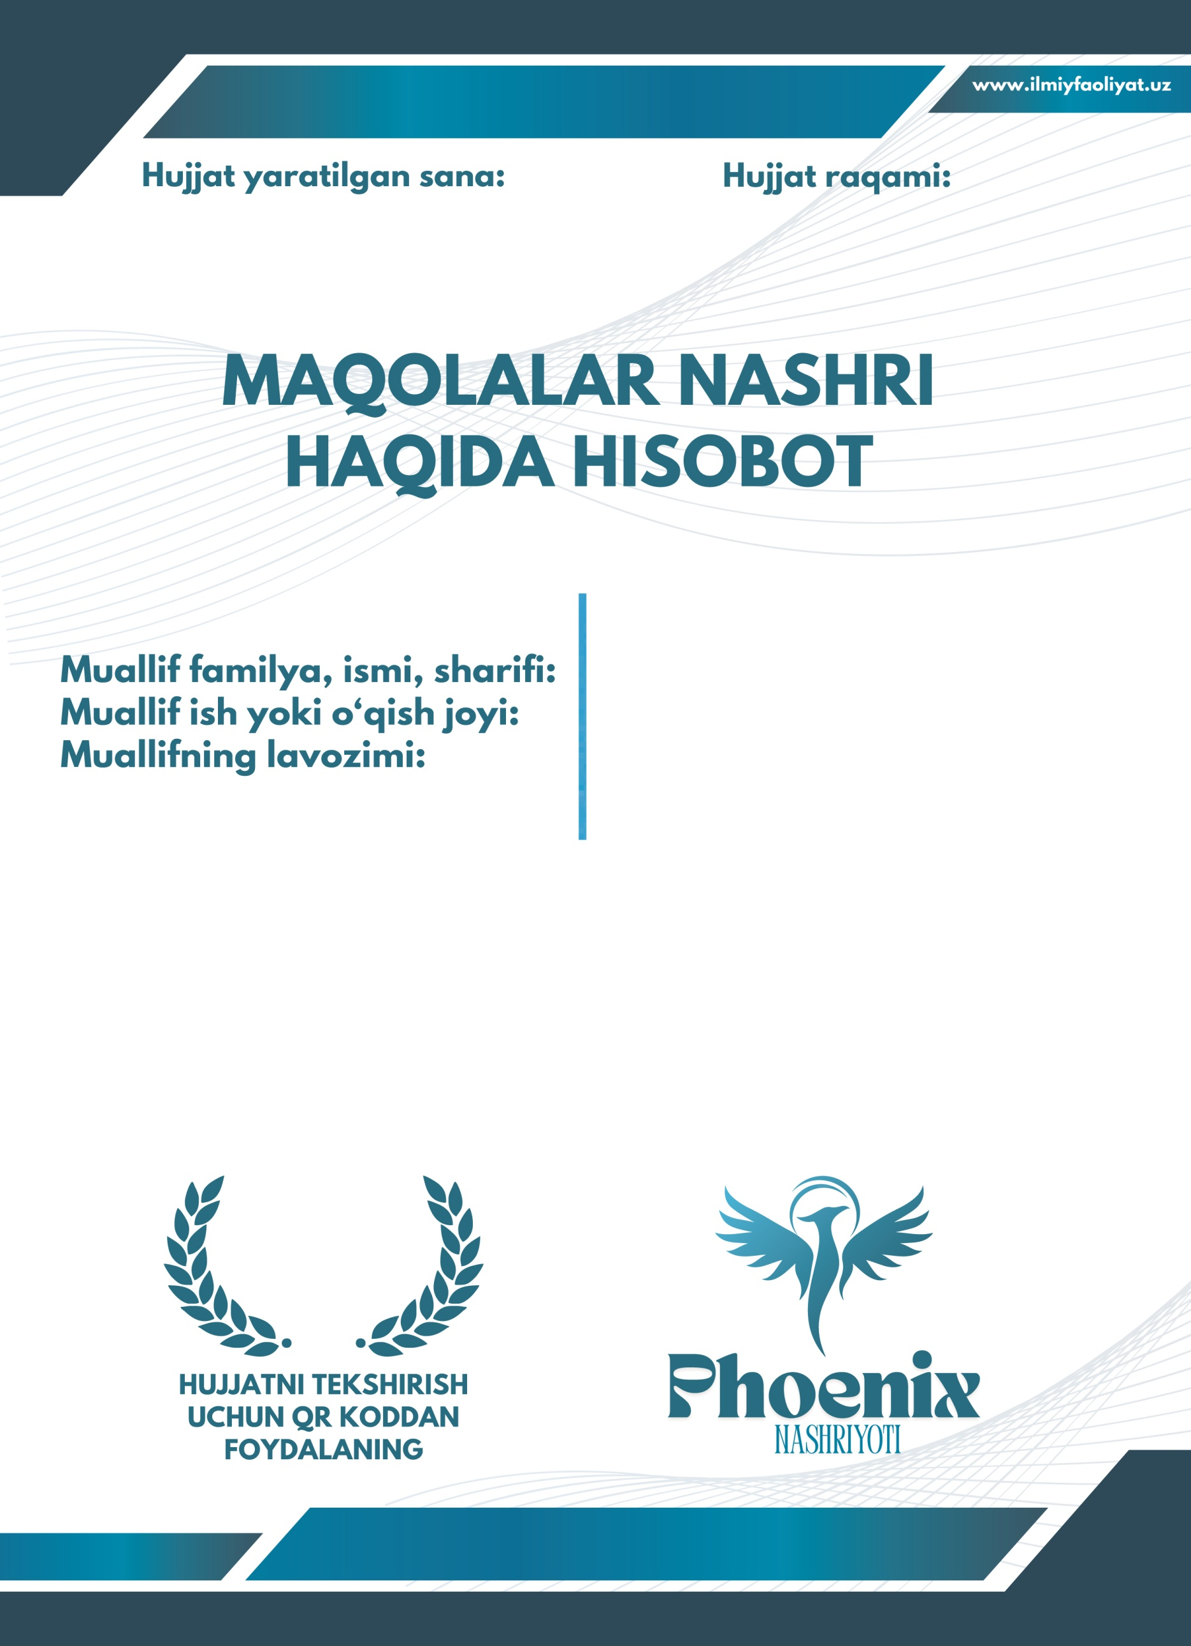
MAQOLALAR NASHRI HAQIDA HISOBOT

№ | Ilmiy ish nomi | Nashr nomi va shakli | Internet havolasi | Hammualliflar
1. | Ta’limda innovatsion g‘oyalar va ularning inqilobi | Jurnal: “Yangi O‘zbekiston- Yangi tadqiqotlar jurnali”  III son  14.11.2025 | https://phoenixpublication.net/index.php/TTVAL/article/view/7095 | -
2. | Pedagogical science and their best issues in 2025 | Xalqaro konferensiya:  “MODERN EDUCATIONAL SYSTEM AND INNOVATIVE TEACHING SOLUTIONS” | https://esiconf.org/index.php/MESAS/article/view/5545 | 1. Alimov Bekmurod  2. Nabiyev Hojakbar

