BluEmaTrend Trade
A Trend-Continuation Trading Method
By Iyaloo “Risky” — @riskybankss

Risk Warning
Leveraged trading in foreign currency and other off-exchange products on margin carries significant risk and may not be suitable for all investors. Losses can occur when using this method. Practice the method on a virtual/demo account before applying it to a live account. This material is educational and is not personal financial advice. The author is not responsible for losses resulting from use of this method.

What Is BluEmaTrend Trade?
BluEmaTrend Trade is a trend-trading method designed to identify trend direction over a period of time and look for entries during trend continuation after price corrections. The method combines price action, market structure, continuation patterns, and two Exponential Moving Averages (EMAs).
Indicator | Setting
Red EMA | 20
Blue EMA | 50
Before applying the method, understand price action and how moving averages work. Use the EMAs together with support/resistance, market structure (uptrend, downtrend, or range), key levels (HH, HL, LH, LL), and continuation patterns such as bullish/bearish flags and triangles.

Visual Example 1
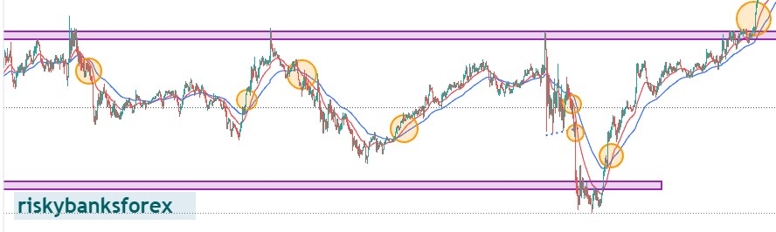

Visual Example 2

Visual Example 3
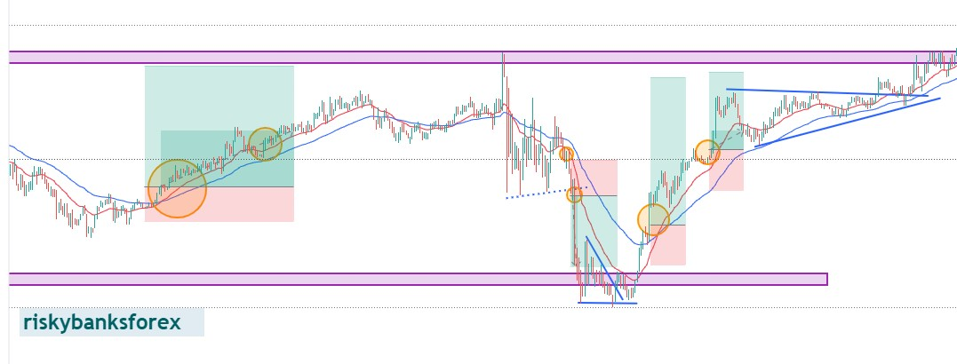

Visual Example 4

Visual Example 5
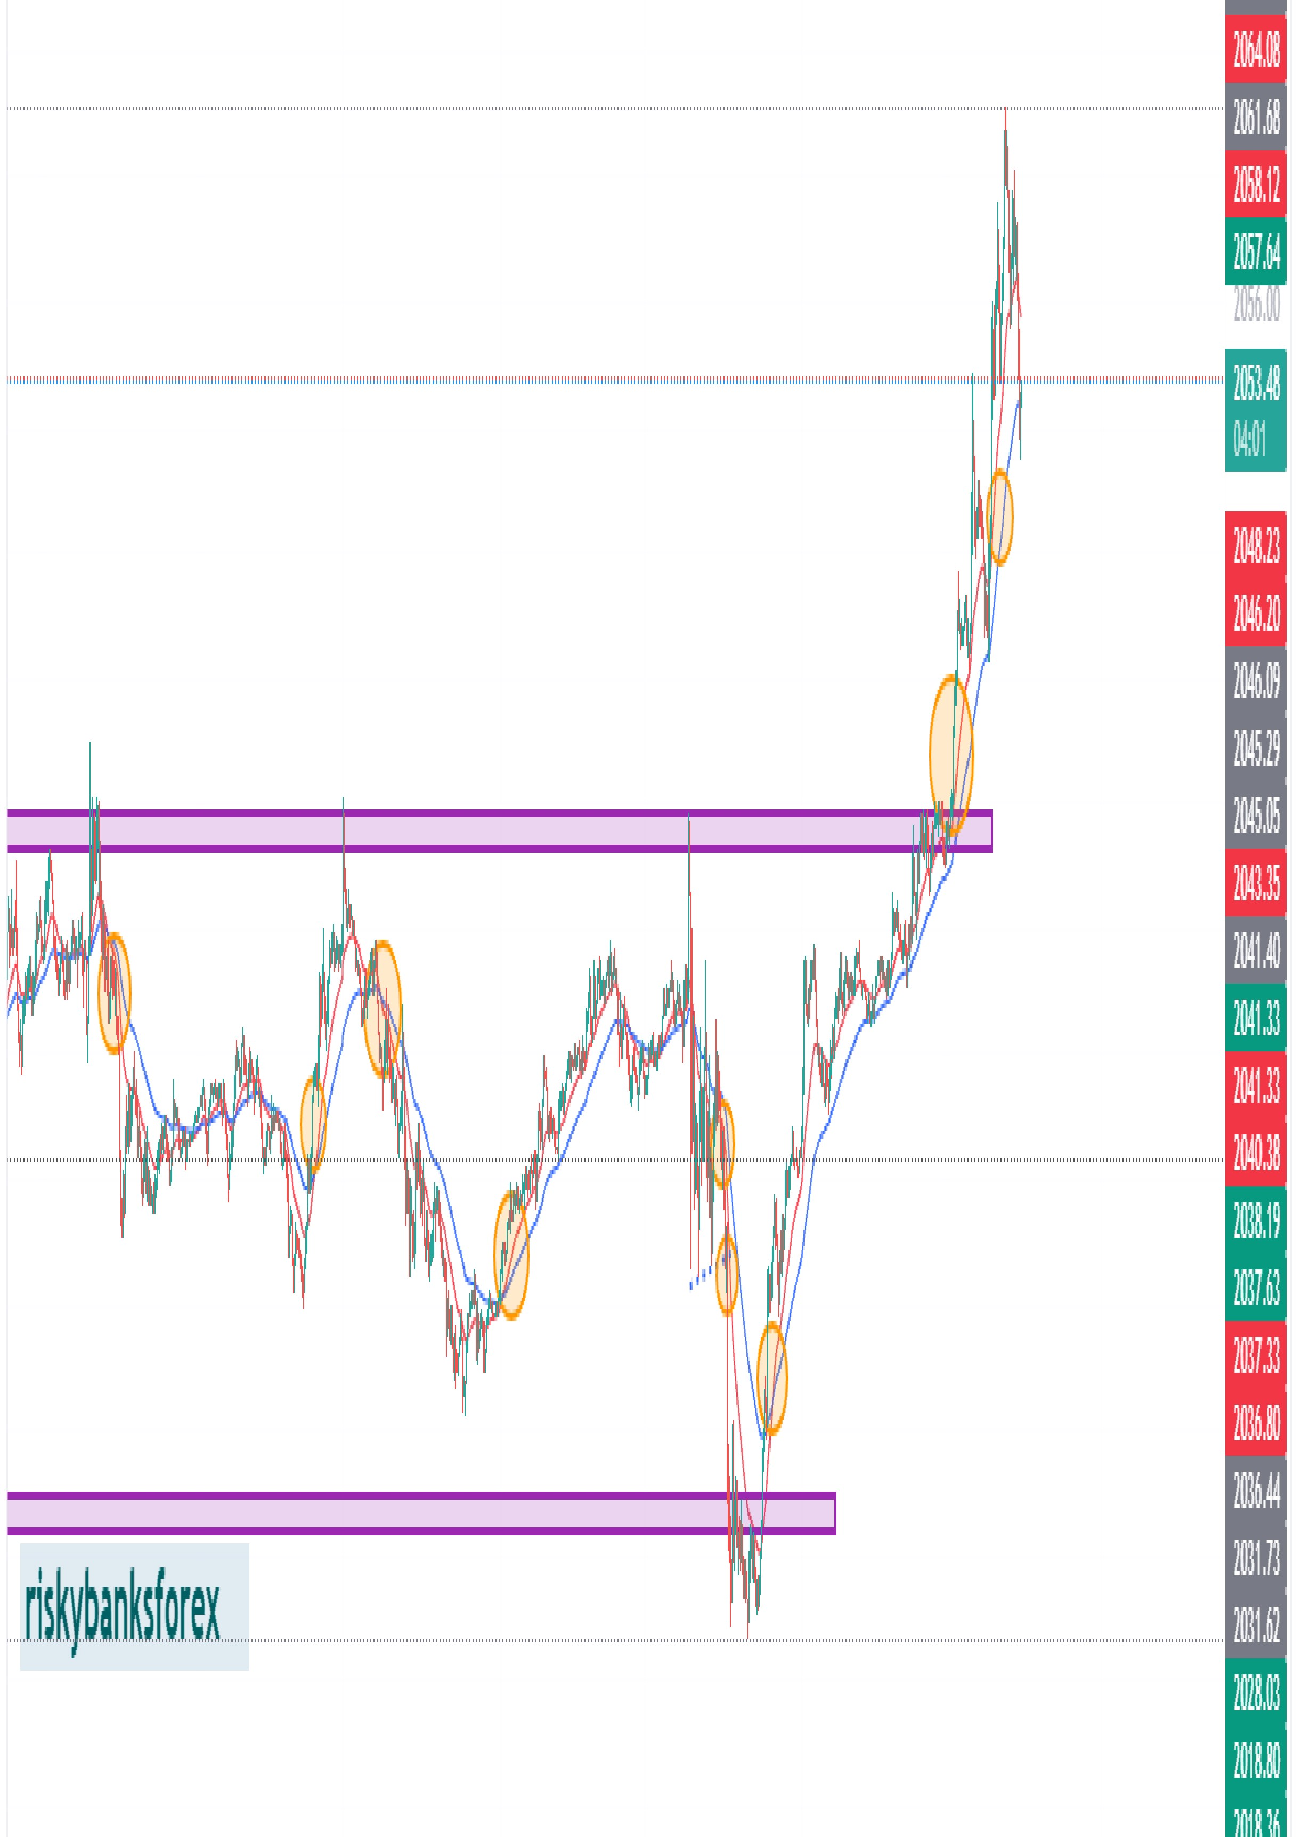

Visual Example 6

Five Factors Before Opening a Trade

1. Correction and EMA Interaction
Price should be around the EMAs or rejecting the EMAs, followed by a breakout from the correction zone in the direction of the trend.

2. Clear Trend — Avoid Sideways Conditions
Price should be in an uptrend or downtrend rather than moving sideways. Look for price leaving the EMA area with a continuation pattern or rejection candlestick, such as a pin bar or evening star, that supports continuation.

3. Risk-to-Reward and Trade Management
The risk-to-reward ratio should be greater than 1:1. For stop-loss or trailing-stop placement, use the recent swing high/low with an ATR buffer. Take profit at the nearest relevant key level or support/resistance zone.

4. Trend Change Confirmation
If the trend appears to be changing, especially near support or resistance, wait for price to cross the blue 50 EMA and retest it with a continuation pattern before considering the new trend. Until that confirmation occurs, avoid assuming a reversal against the existing trend.

5. Breakout and Retest
When price is ranging or approaching/breaking a support or resistance zone, wait for a breakout and retest with a continuation pattern, then confirm the setup with the two EMAs.
DON’T TRADE BY ASSUMPTIONS. TRADE WHAT YOU SEE.

Chart Preparation & Multi-Timeframe Framework
- Set the red EMA to 20 and the blue EMA to 50.
- Identify the current market direction on the 4H and 1H timeframes.
- Find trading setups and entries on the 5M and 1M timeframes, or use timeframes that suit your trading style.
- For 5M/1M buys, the source document specifies that 1H price should be above its 50 EMA and forming Higher Highs/Higher Lows.
- For 5M/1M sells, the source document specifies that price should be below its 50 EMA and forming Lower Lows/Lower Highs.

Markets Mentioned as Tested
- Gold (XAUUSD)
- GBPUSD
- JP225
- Nasdaq (US100)

Refined Rule Checklist
Trade Phase | Action Step
Trend Identification | 1H & 15M should show clear structure (HH/HL or LH/LL) above/below the 50 EMA.
Setup | Price retraces to the 20 or 50 EMA zone inside a continuation pattern such as a flag or triangle.
Entry Trigger | Engulfing or rejection candle closing back in the trend direction.
Stop Loss | Recent swing high/low plus an ATR buffer.
Take Profit | Next key support/resistance level, with the source checklist targeting ≥ 1:1.5 R:R.

Testing, Discipline & Personal Adaptation
The method is not presented as a perfect or automatic system. The source emphasizes backtesting and forward testing so the trader can understand and adapt the method to their own trading style. The original document also describes a personal experience of finding approximately 2–3 strong setups per day on a single instrument; this is a personal experience, not a performance guarantee.

About the Author
Iyaloo “Risky” — Trader • Market Analyst • Mentor
@riskybankss

Important Note
This document describes the author’s trading methodology for educational purposes. It does not guarantee profitability or future results. Market conditions can change, and every trader should independently evaluate risk, execution, position sizing, and suitability before using any strategy with real funds.
More info: https://t.me/castlecc_company
https://wa.me/264836765533

