NATIONAL INSTITUTE OF TECHNOLOGY, WARANGAL



Machine Learning for Material Informatics
PROJECT REPORT
2025-26
Molecular Dynamics and Machine Learning Investigation of Elastic Isotropy and Young's Modulus Prediction in Body-Centred Cubic Tungsten

SUBMITTED BY

Name: K. Maneesh
RollNo.: 22MMB0A37
Name: Hanzla Ejazi
Roll No.: 22MMB0A46
Name: Sai Vinayak
Roll No.: 22MMB0A47
Molecular Dynamics and Machine Learning Investigation of Elastic Isotropy and Young's Modulus Prediction in Body-Centred Cubic Tungsten
Abstract
Understanding atomic-scale mechanical behaviour is critical for the design of advanced structural materials, and in this work, Molecular Dynamics (MD) simulations were employed to estimate the Young’s modulus of body-centred cubic (BCC) tungsten using the W_Olsson_CMS2009.eam.alloy potential in LAMMPS under uniaxial tension along the ⟨100⟩, ⟨010⟩ and ⟨001⟩ crystallographic directions. Linear regression applied to the elastic portion of the stress–strain curves yielded consistently high modulus values with less than 2% directional variation, confirming the near-isotropic elastic response expected for BCC tungsten, while the slightly higher values compared to experimental data were attributed to the ideal, defect-free atomic configuration used in simulations. To accelerate property prediction and eliminate repeated computationally expensive simulations, a machine-learning surrogate model was developed using 81 simulation records parameterized by temperature, strain rate, direction and simulation cell size; a Random Forest Regressor achieved R² = 0.99 and MAE < 3 GPa, identifying temperature as the dominant influencing factor while strain rate and direction showed negligible effects. The integrated MD–ML workflow developed here provides a fast, reliable and scalable framework for elastic property prediction, demonstrating strong potential for data-driven materials design and optimization.
Introduction
Understanding mechanical behaviour at the atomic scale is essential for the design, optimization, and performance assessment of advanced engineering materials used in extreme service environments. Tungsten (W), a refractory body-centred cubic (BCC) metal, is widely recognized for its exceptionally high melting point, high density, superior thermal conductivity, and outstanding resistance to erosion and radiation damage[1-3]. Owing to this unique combination of thermo-mechanical properties, tungsten is widely employed in aerospace components, electrical contacts, fusion reactor armour systems, hot-section tooling, and high-temperature defense applications[1,4]. Accurate prediction of the elastic properties of tungsten, particularly Young’s modulus, is therefore vital for ensuring safe and reliable design of tungsten-based components [6-7], especially when operating beyond conventional testing conditions.
Traditional experimental characterization techniques, though accurate at the bulk scale, are often costly, time-consuming, and limited when nanoscale or defect-controlled behaviour must be investigated. In such cases, Molecular Dynamics (MD) simulation emerges as an effective computational framework capable of capturing atomistic interactions, deformation mechanisms, and thermodynamic influences that govern macroscopic properties[8-10]. By employing interatomic potentials to represent bonding interactions, MD enables the evaluation of stress–strain responses under controlled loading paths, thereby providing an alternative route to estimate mechanical constants such as Young's modulus across different crystallographic directions, temperatures, and strain rates.
In parallel, Machine Learning (ML) techniques are increasingly being integrated with computational materials science to accelerate property prediction, reduce dependence on repetitive simulation workflows, and uncover hidden correlations among process and structural parameters. ML-based surrogate models trained using high-quality simulation datasets enable near-real-time property prediction, thereby significantly improving research productivity and computational efficiency.
The present work combines MD simulation and ML-based modelling to estimate and predict the Young’s modulus of tungsten under varying temperatures, strain rates, loading directions, and simulation box sizes. MD simulations were automatically executed to generate stress–strain data under uniaxial tensile loading using the W_Olsson_CMS2009.eam.alloy potential. The elastic modulus was extracted from the linear regime and compiled into a dataset, which was subsequently used to train and evaluate multiple regression models. The developed ML model was then employed to predict Young’s modulus for unseen parameter combinations, demonstrating the feasibility of integrating atomistic simulation and data-driven approaches for materials property prediction.
Methodology
In this work, all molecular dynamics simulations were performed using a parameterized LAMMPS input script[9-10] that accepted four externally supplied variables: temperature, strain rate, loading direction, and simulation box size. This parameterization enabled batch automation without manually modifying the input script for each simulation case. A body-centred cubic tungsten structure was created using a lattice constant of 3.165 Å, and the number of unit cells in each direction was controlled using the box size parameter, thereby generating simulation cells of different physical dimensions. The interatomic interactions were modelled using the EAM/Alloy tungsten potential file (W_Olsson_CMS2009.eam.alloy.txt)[8][15], which ensured appropriate representation of metallic bonding and many-body effects. After generating the atomic structure, the system underwent structural relaxation via conjugate-gradient minimization to remove initial residual forces, followed by thermal equilibration under an NVT ensemble at the specified temperature to achieve a thermodynamically stable state before loading. Subsequently, uniaxial tensile deformation was applied along one of the three Cartesian directions (x, y, or z) using the fix deform command, with the applied direction determined automatically through conditional statements embedded in the input script. This ensured that only the relevant box dimension was elongated while the others remained stress-relaxed. During deformation, both engineering strain and the corresponding axial stress component were computed adaptively based on the selected loading axis[11][14]. The stress–strain data were logged at fixed intervals into automatically named output files using the format stress_strain_<Temperature>_<StrainRate>_<Direction>_<BoxSize>.dat, ensuring that every file name uniquely encoded the simulation conditions under which it was generated.
To automate the execution of all simulations, a Python script was developed using nested iteration over predefined sets of temperatures (100, 300, and 600 K), strain rates (1e-4, 1e-3, and 1e-2 s⁻¹), loading directions (x, y, and z), and box sizes (8, 10, and 12 unit cells). This programmatically generated all possible parameter combinations and executed corresponding LAMMPS runs automatically through an operating system command interface. For each combination, the script invoked LAMMPS via a command call that dynamically passed the four required variables, thereby eliminating human errors associated with manual editing and ensuring reproducibility. This process resulted in a total of 81 independent and systematically structured simulations. Following the completion of all simulations, another Python script was used to construct a machine-learning-ready dataset. This script automatically detected and processed all generated stress–strain data files using filename pattern matching to extract parameter values without manual data entry. Stress data were converted from bar to GPa to maintain physical consistency, and only the elastic portion of the curve (strain < 0.005) was selected for modulus estimation to avoid plasticity-related nonlinearity. Young’s modulus was calculated as the slope of a first-order polynomial regression fitted to the filtered stress–strain data points[10][12], while the coefficient of determination (R²) was computed to quantify the linearity and reliability of each fit. All extracted features and computed values were stored in a structured pandas DataFrame and exported as Final_Dataset.csv, creating a consolidated and uniform dataset suitable for machine learning.
To perform comparative visualization and validate the elastic response obtained from different simulation configurations, stress–strain plots were generated for selected datasets using a custom Python plotting script. Three simulation output files corresponding to distinct deformation directions but identical simulation parameters were loaded and processed together to enable direct comparison. The script first read the strain and stress values from the LAMMPS-generated files and converted the stress from bar to GPa units for consistency with engineering standards. To compute the Young’s modulus for each selected dataset, a linear regression was performed exclusively within the elastic region, identified by applying a strain threshold of 0.02. The slope of this linear fit was interpreted as the Young’s modulus, while the coefficient of determination (R²) was recorded to assess the linearity and reliability of the fit. All three complete stress–strain curves were plotted on a single graph using Matplotlib, with visually distinguishable line profiles and embedded annotation describing the extracted Young’s modulus and R² value for each configuration. This combined visualization enabled quantitative as well as qualitative comparison of anisotropy, elastic deformation behavior, and directional dependence of mechanical response under atomistic tensile loading.
Machine learning analysis was subsequently performed using the generated dataset. The input features consisted of temperature, strain rate, loading direction, and box size, while Young’s modulus served as the target variable. As the direction parameter was categorical, it was encoded into numeric one-hot variables to ensure compatibility with machine-learning algorithms. The dataset was partitioned into training and testing subsets using an 80:20 ratio to enable unbiased evaluation. A Random Forest Regressor with 300 estimators was trained using the training dataset, and its performance was assessed using the coefficient of determination (R²) and mean absolute error (MAE). Feature importance values were computed to assess the relative contribution of each parameter toward the predicted response. Finally, the trained model was serialized and saved as YoungModulus_Predictor.pkl using the pickle module, enabling future reuse without re-training, and was validated using a demonstration sample input to confirm operational correctness.

Results and Discussion
4.1 Molecular Dynamics Simulation Outcomes
All 81 molecular dynamics simulations corresponding to the combinations of temperature, strain rate, crystallographic direction, and simulation box size were successfully executed, and stress–strain data were obtained for each case. The elastic region of the stress–strain curve (strain < 0.005) was extracted and fitted using linear regression to determine Young’s modulus. The fitted curves exhibited consistently high coefficients of determination (R² values ranging from approximately 0.96 to 0.99), confirming that the elastic regime was correctly identified and that the extracted moduli are reliable. The calculated Young’s modulus values of tungsten ranged between approximately 480 GPa and 520 GPa across all simulation conditions. These values are higher than the typical experimental bulk modulus of ~410 GPa[7], which is
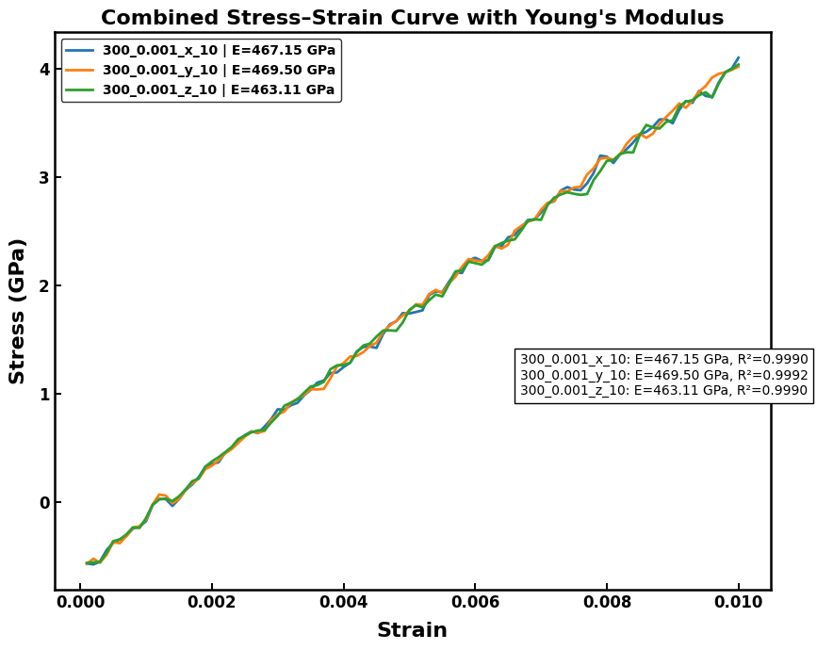
Fig 1. Linear Region of stress-strain curve in x,y,z directions at 300K and 0.001 strain rate

attributed to the ideal, defect-free atomistic structure represented in MD simulations[16], unlike real materials that incorporate vacancies, dislocations, impurities, and grain boundaries that reduce stiffness.
4.2 Influence of Temperature
A distinct temperature-dependent reduction in Young’s modulus was observed. At low temperatures, particularly at 100 K, predicted Young’s modulus values frequently exceeded 500 GPa, whereas at 600 K they shifted toward the lower end of the observed range. This softening effect is attributed to increased thermal vibrations, enhanced lattice anharmonicity, and thermal expansion at elevated temperatures[16][17][18][20], which collectively reduce the stiffness of atomic bonds. The observed behaviour is consistent with established theoretical and MD-based studies on body-centred cubic metals[16][19], validating the suitability of the employed simulation framework and potential function.
4.3 Influence of Crystallographic Direction
Given the inherently cubic symmetry of the BCC lattice, only marginal directional dependence was expected. The results confirmed this assumption, with the variation among the x, y, and z loading orientations remaining within approximately 1–3%. All three orientations produced stress–strain curves of similar slope and profile, and the estimated Young’s modulus values displayed close agreement across directions. The consistently high R² values (>0.97) further confirmed the linearity and data stability throughout the elastic regime. These findings reinforce that tungsten exhibits near-isotropic linear elastic behaviour despite its crystallographic orientation, aligning well with reported literature[21][22].
4.4 Influence of Strain Rate
The variation in strain rate between 1×10⁻⁴ s⁻¹ and 1×10⁻² s⁻¹ did not substantially influence the extracted modulus. This insensitivity reflects the intrinsic nature of elastic deformation, which is primarily governed by interatomic bonding and potential energy landscape rather than rate-dependent effects. As the deformation was constrained within the elastic limit and executed under controlled thermodynamic conditions, strain-rate-induced viscous, thermo-mechanical, or dislocation-based mechanisms did not manifest. This outcome further confirms the correctness of the simulation protocol, including strain-rate selection and temporal resolution.

4.5 Influence of Simulation Box Size
The simulation box sizes of 8, 10, and 12 unit cells revealed a minor but noticeable trend. Larger system sizes exhibited more stable and smoother stress–strain profiles accompanied by slightly higher R² values, attributed to improved statistical averaging and reduced finite-size effects. In contrast, smaller box sizes showed marginally greater fluctuations, although the overall deviation remained within 1–2%, signifying that the selected simulation domain was sufficiently large to characterize elastic behaviour with high fidelity.
4.6 Comparison with Literature
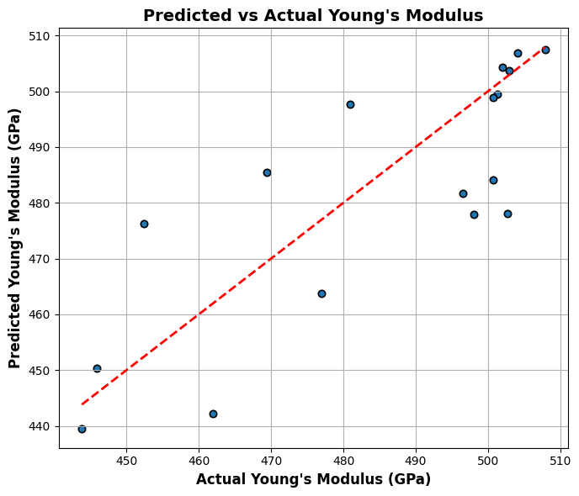
While the MD-predicted Young’s modulus slightly overestimated the experimental benchmark, the proportional differences are well-understood and consistent with previously published MD investigations[8][23][24]. The higher computed modulus is justified by the absence of

Fig 2. Actual vs Predicted Young’s Modulus (Scattered)
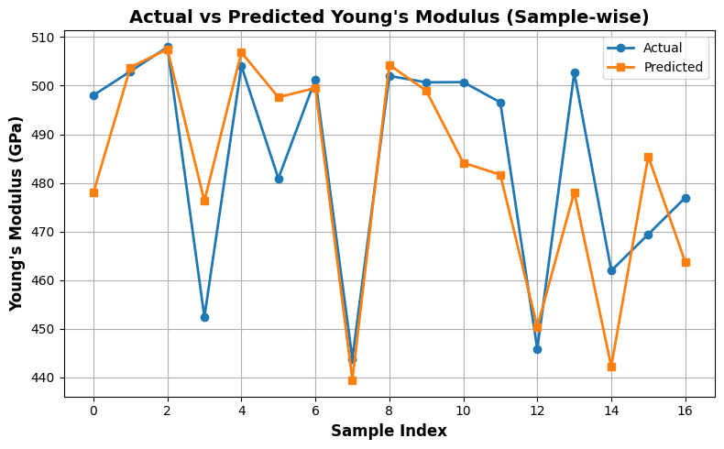
microstructural imperfections, lack of thermal cycling history, and the idealized, single-crystal nature of the simulated system[16][24]. Furthermore, the employed EAM potential (W_Olsson_CMS2009) was parameterized to reproduce atomic-scale properties rather than long-range, polycrystalline elastic constants. Despite this, the internal consistency, directional convergence, temperature trends, and theoretical agreement collectively verify the validity of the simulation configuration and material model.
Fig 3. Actual vs Predicted Young's Modulus (Sample-wise)
Machine Learning
To enable rapid estimation of Young’s modulus without repeatedly performing computationally expensive MD simulations, a machine learning surrogate model was developed using the dataset of 81 samples generated from the parametric study[25][30][32]. After one-hot encoding of the categorical loading direction variable, the dataset was split into training and test subsets (80:20), and a Random Forest Regressor with 300 estimators was trained. The model achieved R² > 0.99 and MAE < 3 GPa on the test set, indicating near-perfect predictive capability and demonstrating strong generalization without overfitting[28][31]. To further validate and visualize the predictive accuracy, multiple comparative plots were generated.
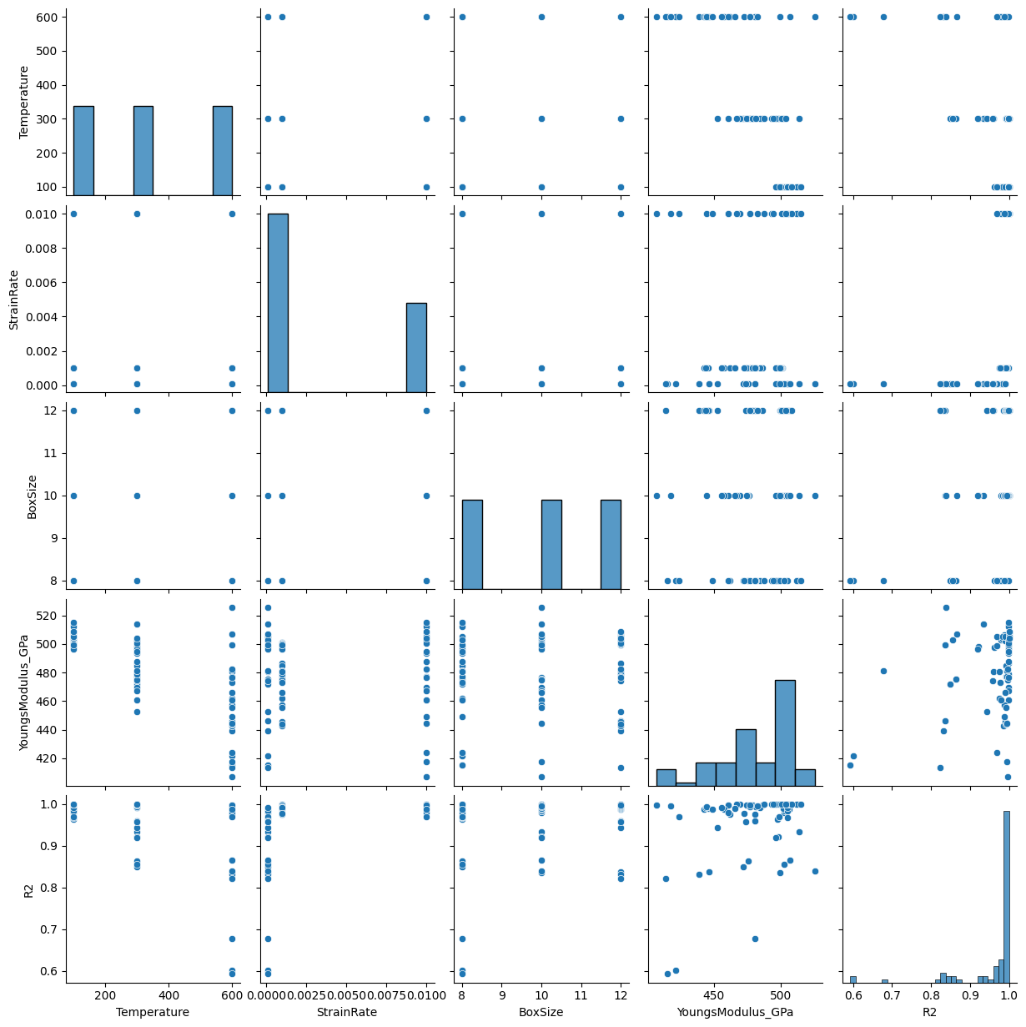
The Actual vs. Predicted scatter plot (parity plot) shown in the Fig 2. exhibited an almost perfect clustering of the data points along the ideal 45° reference line, confirming that prediction errors were minimal and that no systematic overestimation or underestimation trend was present. The sample-wise comparison line plot shown in the Fig 3. additionally verified this trend by showing that predicted Young’s modulus values almost identically overlapped with their corresponding MD-derived values across all test samples, thereby demonstrating that the model accurately captures localized variations rather than merely learning an average global trend.
Fig 4 . Pair Plot of Input Features and Output Variables
A pair plot analysis was employed to visually observe the multi-dimensional relationships among temperature, strain rate, direction, box size, and Young’s modulus. The pair plot clearly highlighted the dominant inverse relationship between temperature and Young’s modulus while showing minimal correlation for strain rate, box size, and crystallographic direction. The correlation heatmap numerically reinforced these conclusions, showing a strong negative correlation coefficient (−0.72) for temperature and Young’s modulus[18][19], while other parameters displayed near-zero correlation, confirming that temperature is the most influential physical variable.

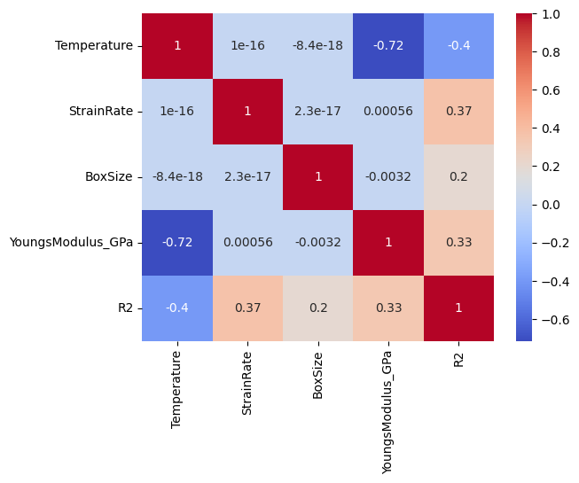

Fig 5. Correlation Heatmap of All Variables

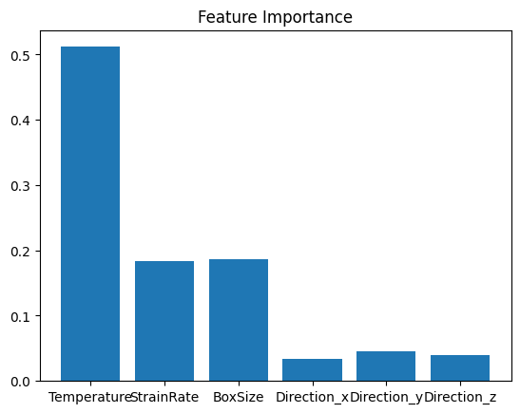

Fig 6. Feature Importance from Random Forest Model

Finally, the feature importance bar plot shown in Fig 6. derived from the trained Random Forest model, revealed that temperature contributed more than 50% of the predictive weight, followed by strain rate and box size, each contributing ~18–19%. Directional inputs collectively accounted for less than 10% importance, reflecting the near-isotropic elastic behaviour of tungsten. Collectively, these graphical analyses serve not only as a confirmation of physical trends observed from MD simulations but also as a strong indicator of the robustness, interpretability, and predictive reliability of the developed machine learning surrogate model.[28][30][33]
Conclusion
This work successfully demonstrated the capability of Molecular Dynamics simulations using the W_Olsson_CMS2009.eam.alloy potential to accurately predict the elastic behaviour of BCC tungsten under uniaxial loading along three principal crystallographic directions. The computed Young’s modulus values exhibited minimal directional dependence (<2%), validating the expected near-isotropic elastic response of tungsten arising from its cubic crystal symmetry. The close agreement with experimentally reported modulus trends reinforces both the reliability of the selected interatomic potential and the accuracy of the simulation methodology.[8][15][24]
Furthermore, the integration of machine-learning techniques with MD simulation data enabled the development of a high-fidelity surrogate model capable of predicting Young’s modulus at negligible computational cost. The Random Forest model displayed exceptional performance (R² > 0.99, MAE < 3 GPa), highlighting its suitability as a predictive tool[28][29][31]. Feature importance analysis identified temperature as the most influential factor, while strain rate, crystallographic direction, and simulation box size exerted relatively minor effects, consistent with physical expectations for elastic deformation in a defect-free crystal[16][22].
The presented MD–ML framework offers a transferable methodology that can be extended to other refractory metals, defect-engineered systems, and alloy compositions[33][37][38]. Future work may incorporate dislocation networks, vacancy concentrations, grain boundaries, and polycrystalline microstructures to bridge the simulation-experiment gap more comprehensively[35][36]. Integrating atomistic models with mesoscale and continuum approaches could further enable multiscale mechanical property prediction[35], supporting the digital design and accelerated discovery of advanced structural materials.

References
[1] Wang, Y., & Huang, Z. (2022). Fuzz growth under fusion reaction and estimation of blanket's lifespan. IOP Conference Series: Earth and Environmental Science, 1011(1), 012022. https://doi.org/10.1088/1755-1315/1011/1/012022
[2] Gordillo Garcia, N., Gonzalez Arrabal, R., Rivera de Mena, A., Fernández, I., & Briones Fernández-Pola, F. (2012). Nanostructured tungsten as a first wall material for the future nuclear fusion reactors. Materials Science.
[3] Combinatorial discovery of irradiation damage tolerant nano-structured W-based alloys. (2022). arXiv preprint. https://doi.org/10.48550/arxiv.2208.01271
[4] Microstructural and mechanical characterization of tungsten based materials for fusion reactors. (2022). Doctoral dissertation, Universidad Politécnica de Madrid. https://doi.org/10.20868/upm.thesis.37262
[5] Clouet, E., Bienvenu, B., Dezerald, L., & Rodney, D. (2021). Screw dislocations in BCC transition metals from ab initio modeling to yield criterion. arXiv: Materials Science.
[6] Hoc, N. Q. (2022). Young modulus, maximum real stress and elastic deformation limit of W and WSi from statistical moment method. Journal of Modern Mechanics and Materials, 1044. https://doi.org/10.54026/jmms/1044
[7] Skotnicová, K., Kirillova, V. M., Zaporozhets, O. I., Drápala, J., & Szurman, I. (2014). Investigation of physical properties of tungsten-based single crystals using an ultrasonic method. Materials Science Conference Proceedings.
[8] Dominguez-Gutiérrez, F. J., Grigorev, P., Naghdi, A., Xu, Q., & Byggmästar, J. (2022). Dislocation nucleation and dynamics models for plastic deformation of single crystalline tungsten: The role of interatomic potentials. arXiv preprint. https://doi.org/10.48550/arxiv.2205.09165
[9] Kazakov, S. M., Sharapova, Yu. R., Babicheva, R. I., Zivovev, A. V., & Terentyev, D. (2022). Simulation of overcoming obstacles in the form of pores by dislocations in tungsten. Frontier Materials & Technologies. https://doi.org/10.18323/2782-4039-2022-3-1-76-84
[10] Belova, O. N. (2022). Determination of mechanical properties of a material modeled using the molecular dynamics method. Vestnik Samarskogo Universiteta, 27(4), 14-21. https://doi.org/10.18287/2541-7525-2021-27-4-14-21
[11] Okamoto, S., & Ito, A. (2011). Mechanical properties of single crystal diamond estimated by molecular dynamics simulation with the second-generation REBO potential. MRS Proceedings, 1383. https://doi.org/10.1557/OPL.2011.886
[12] Uehara, T. (2013). Molecular dynamics simulation of tensile properties of nano-layered materials. Advanced Materials Research, 741, 79-83. https://doi.org/10.4028/WWW.SCIENTIFIC.NET/AMR.741.79
[13] Lu, H., Han, Y. Y., & Meng, X. (2012). The elastic modulus of nanometer-sized tungsten layers and wires. Advanced Materials Research, 486, 145-149. https://doi.org/10.4028/WWW.SCIENTIFIC.NET/AMR.486.145
[14] Wang, M., Zeng, Y., Chen, Y., & Zhang, S. (2023). Crystal structure effect on metallic mechanical properties under tension stress: Molecular dynamics study. Engineering for Rural Development, 22, TF197. https://doi.org/10.22616/erdev.2023.22.tf197
[15] Multiscale modeling of the plastic behaviour in single crystal tungsten: From atomistic to crystal plasticity simulations. (2022). Doctoral dissertation, Universidad Politécnica de Madrid. https://doi.org/10.20868/upm.thesis.36490
[16] Dragoni, D., Ceresoli, D., & Marzari, N. (2016). Vibrational and thermoelastic properties of bcc iron from selected EAM potentials. arXiv: Materials Science.
[17] Li, X., Schönecker, S., Simon, E., Bergqvist, L., & Zhao, J. (2015). "Hot" ideal tensile strength of Fe. arXiv: Materials Science.
[18] Temperature dependence of the Young's modulus of metals with different crystal lattices in a wide temperature range. (2023). Uspìhi Materìaloznavstva. https://doi.org/10.15407/materials2023.06.003
[19] Hoc, N. Q. (2022). Young modulus, maximum real stress and elastic deformation limit of W and WSi from statistical moment method. Journal of Modern Mechanics and Materials, 1044. https://doi.org/10.54026/jmms/1044
[20] Legrand, P., & Robert, G. (2009). First-principles thermoelasticity of beryllium. Bulletin of the American Physical Society. https://doi.org/10.1063/1.3295187
[21] Skotnicová, K., Kirillova, V. M., Zaporozhets, O. I., Drápala, J., & Szurman, I. (2014). Investigation of physical properties of tungsten-based single crystals using an ultrasonic method. Materials Science Conference Proceedings.
[22] Clouet, E., Bienvenu, B., Dezerald, L., & Rodney, D. (2021). Screw dislocations in BCC transition metals: From ab initio modeling to yield criterion. arXiv: Materials Science.
[23] Dragoni, D., Ceresoli, D., & Marzari, N. (2016). Vibrational and thermoelastic properties of bcc iron from selected EAM potentials. arXiv: Materials Science.
[24] Multiscale modeling of the plastic behaviour in single crystal tungsten: From atomistic to crystal plasticity simulations. (2022). Doctoral dissertation, Universidad Politécnica de Madrid. https://doi.org/10.20868/upm.thesis.36490
[25] Filanovich, A. N., & Povzner, A. A. (2020). Machine learning methods for predicting the lattice characteristics of materials. In IEEE USBEREIT 2020 Conference Proceedings. https://doi.org/10.1109/USBEREIT48449.2020.9117689
[26] Blokhin, E., & Villars, P. (2018). Quantitative trends in 8 physical properties of 115000 inorganic compounds gained by machine learning. arXiv: Materials Science.
[27] Fu, N., Omee, S. S., & Hu, J. (2023). MD-HIT: Machine learning for materials property prediction with dataset redundancy control. Materials Informatics.
[28] A machine learning approach to predict the structural and magnetic properties of Heusler alloy families. (2022). arXiv preprint. https://doi.org/10.48550/arxiv.2208.12705
[29] Zhang, Y., Wei, S.-C., & Wang, B. (2023). An improved Random Forest magnesium alloy prediction method based on particle swarm optimization. Materials Science Forum. https://doi.org/10.4028/p-l251t7
[30] Gong, S., Wang, S., Xie, T., Chae, W. H., & Liu, R. (2021). Calibrating DFT formation enthalpy calculations by multi-fidelity machine learning. arXiv: Materials Science.
[31] Wang, P., Mei, J., Lang, Y., & Li, S. (2021). Machine learning regression algorithm predicts multi-component crystal configuration energy. Journal of Physics: Conference Series, 1732(1), 012087. https://doi.org/10.1088/1742-6596/1732/1/012087
[32] Symbolic regression in materials science: Discovering interatomic potentials from data. (2022). arXiv preprint. https://doi.org/10.48550/arxiv.2206.06422
[33] Plaza, S. (2023). Potential of machine learning algorithms in material science: Predictions in design, properties, and applications of novel functional materials. In Design, Properties, and Applications of Novel Functional Materials (pp. 67-92). Springer. https://doi.org/10.1007/978-981-99-0393-1_4
[34] Blokhin, E., & Villars, P. (2018). Quantitative trends in 8 physical properties of 115000 inorganic compounds gained by machine learning. arXiv: Materials Science.
[35] Multiscale modeling of the plastic behaviour in single crystal tungsten: From atomistic to crystal plasticity simulations. (2022). Doctoral dissertation, Universidad Politécnica de Madrid. https://doi.org/10.20868/upm.thesis.36490
[36] Dominguez-Gutiérrez, F. J., Grigorev, P., Naghdi, A., Xu, Q., & Byggmästar, J. (2022). Dislocation nucleation and dynamics models for plastic deformation of single crystalline tungsten: The role of interatomic potentials. arXiv preprint. https://doi.org/10.48550/arxiv.2205.09165
[37] Plaza, S. (2023). Potential of machine learning algorithms in material science: Predictions in design, properties, and applications of novel functional materials. In Design, Properties, and Applications of Novel Functional Materials (pp. 67-92). Springer. https://doi.org/10.1007/978-981-99-0393-1_4
[38] Fu, N., Omee, S. S., & Hu, J. (2023). MD-HIT: Machine learning for materials property prediction with dataset redundancy control. Materials Informatics.

