HANDYCONNECT
A Web-Based Gig Marketplace for Home Services
Final Year Project Documentation
Student Name: ______________________________
Registration Number: _______________________
Supervisor: _______________________________
Institution / Department: ___________________
Academic Year: 2025 / 2026

Abstract
HandyConnect is a web-based gig marketplace that connects clients who need home services with vetted handymen in Zimbabwe. The platform digitises the full service lifecycle: a client posts a job, professionals quote and accept it, work and progress are tracked, and the client settles the bill through an in-app wallet using QR-code or short-code payments. Around this core loop the system provides real-time chat and voice messaging, a community feed with portfolios, a review and rating system, and an administrative console for user management, professional verification, dispute resolution and payout processing.
The application is implemented as a single-page application (SPA) built with React 19 and Vite, styled with Tailwind CSS 4, and backed by Firebase - using Firestore as the real-time NoSQL database, Firebase Authentication for identity management and Cloud Storage for media. Payments are executed atomically as Firestore transactions to guarantee that a completed payment, the recipient's wallet credit, and the payer's debit transaction are always consistent. A client-side security layer (PIN, payment password and WebAuthn biometrics with a lockout policy) protects sensitive wallet actions.
This document presents the background and problem statement, a review of existing platforms, requirements analysis, system design (architecture, data model, security and payment design), implementation details, testing, deployment and an evaluation of the completed system together with directions for future work.

Table of Contents
Table of contents - right-click here and choose 'Update Field' to generate.

1. Introduction

1.1 Background
Home maintenance and repair services - plumbing, electrical work, painting, roofing, carpentry and cleaning - are overwhelmingly delivered through informal networks in Zimbabwe. Clients typically find a professional by word of mouth, negotiate on the phone, and pay in cash or through mobile money such as EcoCash and OneMoney. This arrangement has well-known weaknesses: there is no way to compare prices or verify qualifications, no record of the work or the payment, no reliable feedback mechanism, and disputes are resolved informally, if at all.
Meanwhile, the global gig economy has produced digital marketplaces such as TaskRabbit, Airtasker and Thumbtack that match service providers with consumers, manage the transaction and provide rating systems. HandyConnect applies this proven model to the local Zimbabwean context, adapting it to local payment habits (mobile money and short payment codes) and the informal services sector.

1.2 Problem Statement
Clients in Zimbabwe lack a reliable, structured channel for finding and paying home-service professionals, while handymen lack a channel for discovering work and building a reputation. The specific problems addressed are:
- No central discovery: professionals are found informally, with no searchable profile, portfolio or verified skill set.
- No price transparency: quotes are ad hoc and unrecorded, making comparison difficult.
- Payment risk: cash and person-to-person mobile money transfers leave no job-linked payment record and provide no buyer protection.
- Weak accountability: poor-quality work is hard to contest because there is no formal dispute channel.
- Fragmented communication: conversations and media are scattered across phone calls and messaging apps.
- No reputation system: clients cannot share feedback, and skilled professionals cannot build a visible track record.

1.3 Aim and Objectives
The aim of the project is to design and implement a web-based gig marketplace that connects clients with handymen and supports the entire job-to-payment workflow in one system. The specific objectives are:
- O1 - Develop an authentication and role-management subsystem supporting client, handyman and administrator accounts (email/password and Google sign-in).
- O2 - Implement the job lifecycle: posting, quoting, assignment, milestone and progress tracking, completion and dispute handling.
- O3 - Design and implement an in-app digital wallet with QR-code and short-code payments, funds top-up, transfers and withdrawals.
- O4 - Provide real-time communication through job-scoped and direct chat with text, image and voice messages and call signaling.
- O5 - Build discovery and trust features: handyman portfolios, a community feed, and a review and rating system.
- O6 - Provide an administrative console for user management, professional verification, content moderation, dispute resolution and payout processing.

1.4 Scope
The system is a responsive web application intended for desktop and mobile browsers. It targets the Harare metropolitan area as its primary market but is geographically agnostic. The payment subsystem simulates real-money movement with a wallet ledger: funds are credited atomically within the database and external gateways (card processors, mobile-money APIs) are out of scope. The security gate (PIN, password, biometrics) is implemented client-side as a demonstration and is not a substitute for server-enforced rules in production.

1.5 Significance
HandyConnect contributes a complete, working reference implementation of a localised gig marketplace. It demonstrates how modern web technologies (React, Tailwind CSS, Firebase) can digitise an informal service economy, and how database transactions can guarantee payment integrity in a system without a central payment gateway.

1.6 Report Organisation
Chapter 2 reviews existing platforms. Chapter 3 analyses the requirements. Chapter 4 presents the system design. Chapter 5 describes the implementation. Chapter 6 covers testing, Chapter 7 deployment and configuration, Chapter 8 evaluates the system and Chapter 9 concludes with future work.

2. Literature Review

2.1 Existing Gig Platforms
Platform | Region | Core model | Payments | Rating / trust | Relevance to HandyConnect
TaskRabbit | USA / UK / EU | Taskers post profiles; clients book by category | Cards, in-app fees | Reviews after each task | Job-posting model; heavy focus on trust
Airtasker | Australia / NZ | Reverse auction - clients post tasks, offers come in | In-app escrow with cards | Ratings and verified badges | Offer/quote flow resembles HandyConnect quoting
Thumbtack | USA | Lead-based matching of pros to projects | Online payment via Stripe | Background-checked pros | Verification/background checks
Local WhatsApp / word of mouth | Zimbabwe | Informal referrals, phone negotiation | Cash, EcoCash, OneMoney | No structured feedback | Status quo HandyConnect replaces

2.2 Gaps Addressed
- Local payment culture: the dominant platforms rely on international card processors. HandyConnect adds QR-code and 6-character payment codes that mirror short-code mobile-money practices.
- Informal workforce: no requirement for formal employment - verification is lightweight and managed by an administrator.
- Data-light context: the platform works over a normal browser connection and does not assume a permanent data link for core functions.

3. Requirements Analysis

3.1 Actors
Actor | Description | Primary goals
Client | A person who needs a home service and posts jobs | Find a professional, compare quotes, pay securely, track work
Handyman | A professional who offers services | Find work, win jobs, get paid, build a reputation
Administrator | Platform operator | Verify professionals, moderate content, resolve disputes, process payouts

3.2 Use-Case Diagram
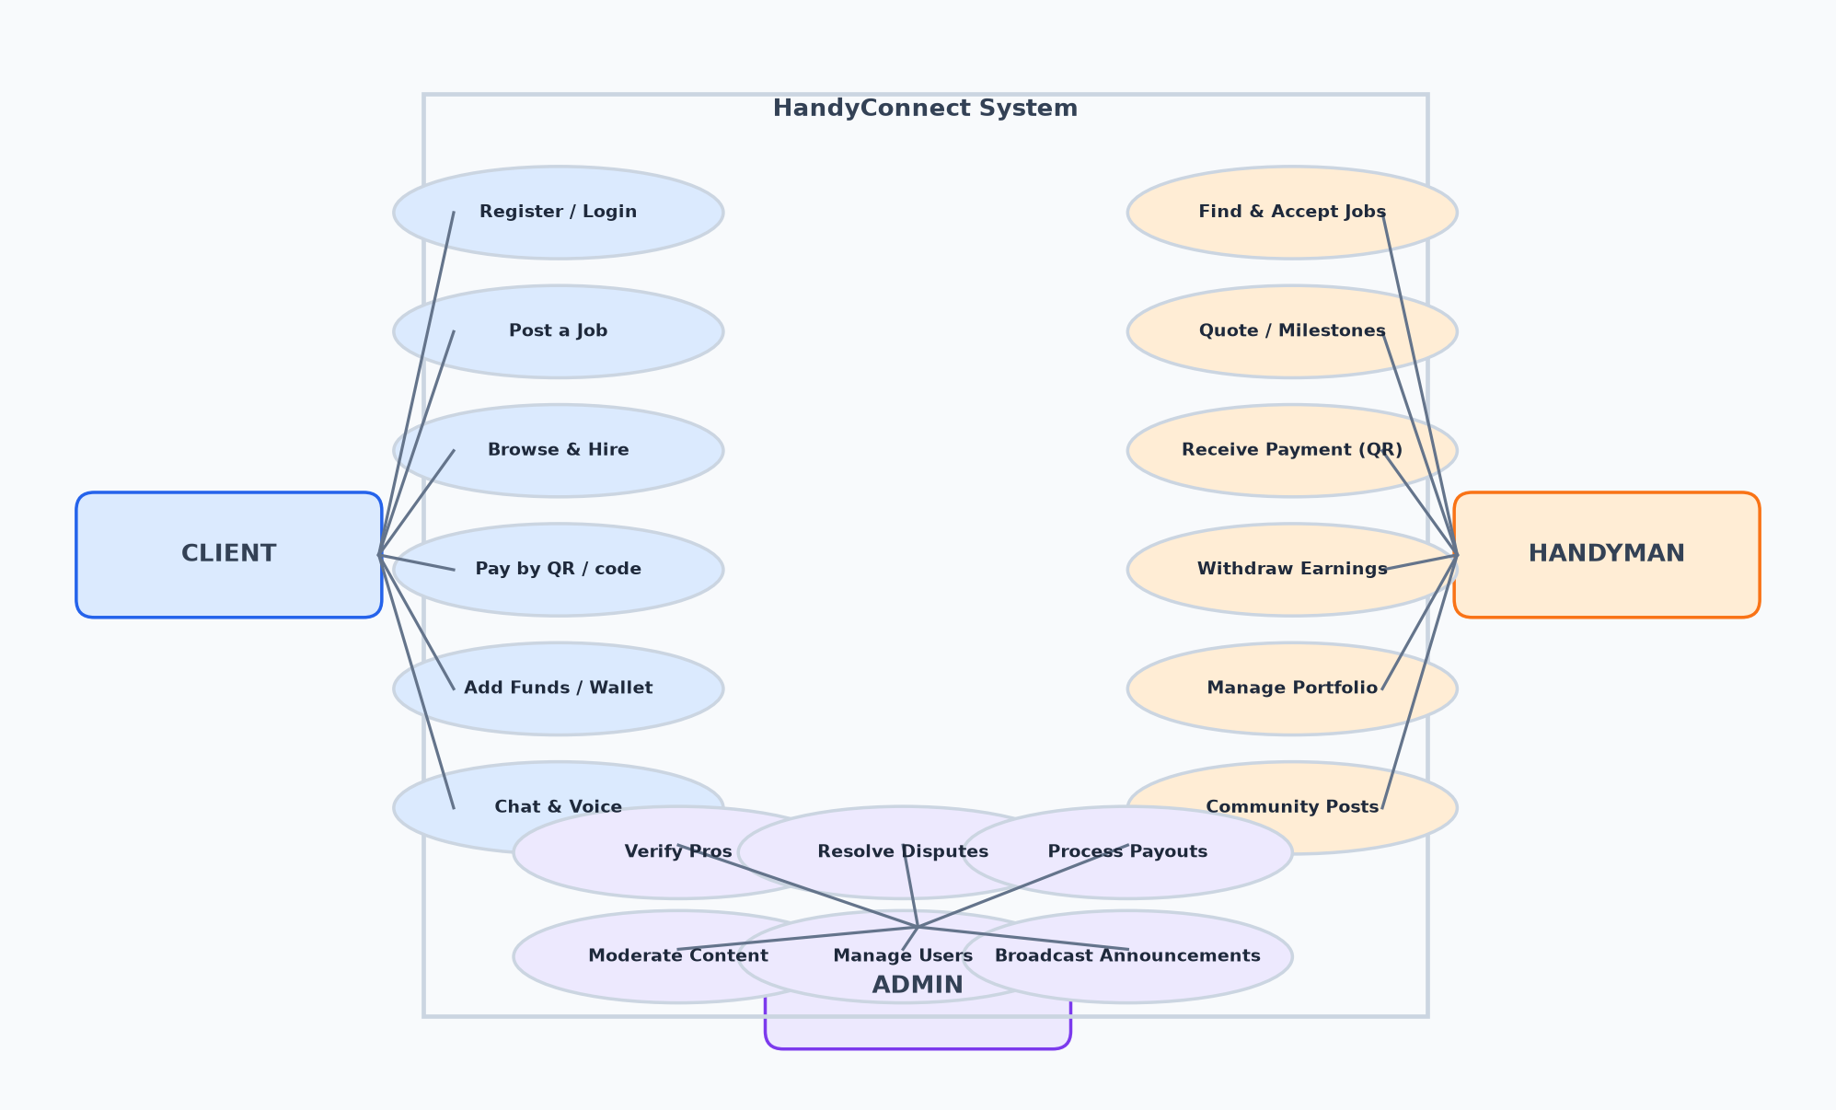
Figure 3.1 - Use-case diagram of the HandyConnect system.

3.3 Functional Requirements
ID | Module | Requirement
FR-01 | Auth | A user can register with email/password (with verification) or sign in with Google.
FR-02 | Auth | A user selects a role (client, handyman, admin) that controls access to areas of the app.
FR-03 | Jobs | A client can post a job with title, category, budget, location and optional attachments.
FR-04 | Jobs | A handyman can browse open jobs, submit quotes and accept jobs.
FR-05 | Jobs | Progress, milestones and disputes can be recorded on an assigned job.
FR-06 | Jobs | Completing a job credits the handyman's wallet.
FR-07 | Payments | A handyman can generate a QR code and 6-character code for a payment request.
FR-08 | Payments | A client can pay by scanning the QR, entering the code, or from the wallet.
FR-09 | Payments | Payment settlement is atomic: wallet credit, ledger entries and job status update together.
FR-10 | Wallet | A user can view balance, pending amounts, transactions and receipt details.
FR-11 | Wallet | A handyman can withdraw funds (minimum $20) and view payout history.
FR-12 | Wallet | A client can add funds via card or mobile money methods and transfer between users.
FR-13 | Security | Wallet actions can be gated by PIN, payment password or biometric verification with a lockout policy.
FR-14 | Chat | Clients and handymen can exchange text, image and voice messages in job or direct conversations.
FR-15 | Community | Users can post text, images, before/after project updates and react and comment.
FR-16 | Portfolio | A handyman can manage a portfolio of projects with photos, prices and featured items.
FR-17 | Reviews | A client can rate and review a professional after a payment.
FR-18 | Admin | An administrator can manage users, verify professionals, resolve disputes, delete content and process payouts.

3.4 Non-Functional Requirements
Category | Requirement
Usability | Responsive interface usable on mobile browsers and desktop; consistent design system with light and dark themes.
Performance | Pages render quickly; real-time data via Firestore listeners updates the UI without refresh.
Availability | Backend is hosted on Firebase infrastructure with minimal downtime; graceful fallbacks when external APIs (e.g. maps) are unavailable.
Security | Authentication enforced by route guards; wallet actions optionally gated by PIN/password/biometrics; payment mutations run as transactions.
Integrity | A payment cannot be partially applied - wallet and ledger updates occur in one Firestore transaction.
Maintainability | Clear module separation (features, services, hooks) and consistent coding conventions.

4. System Design

4.1 System Architecture
HandyConnect uses a three-tier architecture delivered as a single-page application backed by Firebase services. The presentation layer is a React SPA; the feature modules form the application layer; the service layer encapsulates all data access; and Firebase provides the backend (authentication, Firestore, storage) with Google Maps as an external API. Firestore real-time listeners push changes to the UI, which is what gives the platform its live, chat-like behaviour.
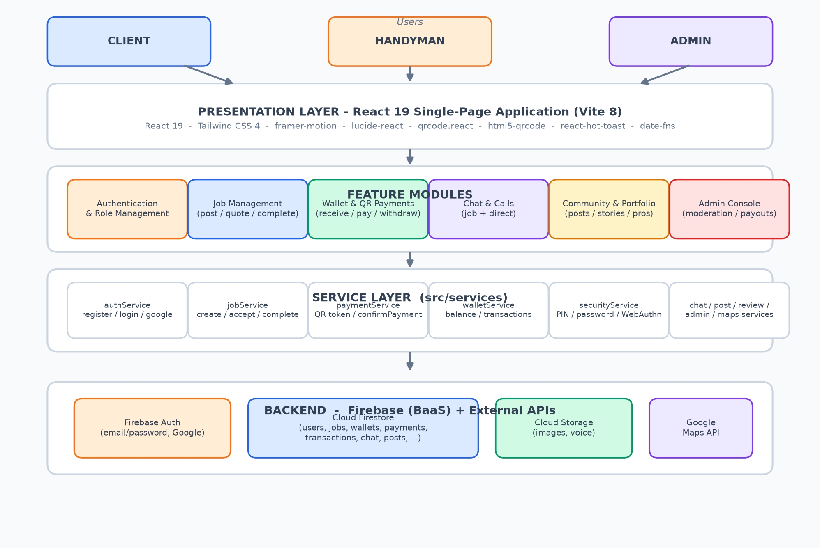
Figure 4.1 - Layered architecture of HandyConnect.

4.2 Technology Stack
Layer | Technology | Purpose
Frontend | React 19 | UI components and application state
Build | Vite 8 | Dev server, bundling, code-splitting
Styling | Tailwind CSS 4 | Utility-first styling with a design-token system
Routing | react-router-dom 7 | Client-side routing with role-based guards
Animations | framer-motion | Page transitions and modal animations
Icons | lucide-react | Icon set
Forms | react-hook-form + zod | Form state and validation
Dates | date-fns | Date formatting and grouping
QR | qrcode.react / html5-qrcode | QR generation and camera scanning
Feedback | react-hot-toast / canvas-confetti | Notifications and success effects
Backend | Firebase (Auth, Firestore, Storage) | Identity, NoSQL database, media
Maps | @react-google-maps/api | Location picker, geocoding, directions

4.3 Database Design (Firestore)
Firestore is a document database organised into collections and subcollections. The diagram below shows the principal collections, their key fields and the relationships between them. Payments, transactions and wallets are the heart of the settlement system; conversations and posts use subcollections for messages and comments to keep list reads cheap.
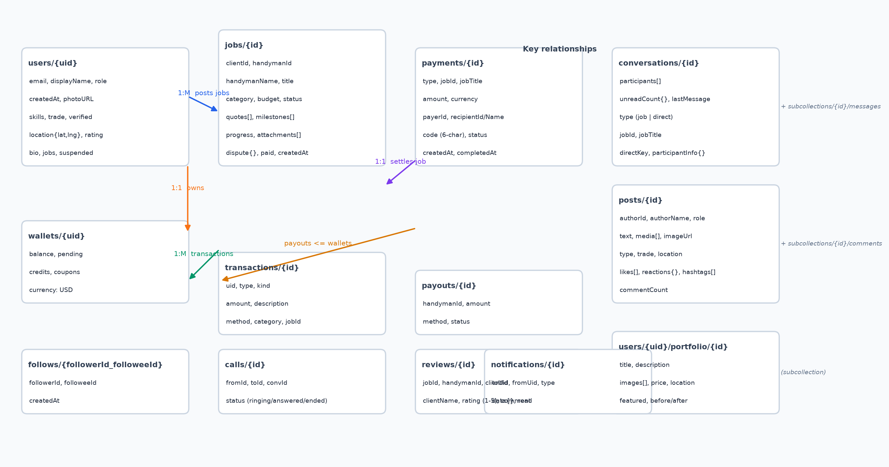
Figure 4.2 - Firestore data model for HandyConnect.

4.3.1 Composite Indexes
Firestore requires composite indexes for queries that filter and order on different fields. The project ships the following in firestore.indexes.json:
Collection | Fields
conversations | participants (array-contains) + lastActivity (desc)
calls | toId + status
messages | senderId + read
notifications | toUid + createdAt (desc)
notifications | toUid + read

4.4 Security Design
Access control operates at two levels. At the application level, React route guards (ProtectedRoute and RoleLayout) redirect unauthenticated users to the login page, send role-less users to role selection, and route each role to its own dashboard. At the data level, Firestore security rules (configured in the Firebase console) restrict reads and writes; the repository documents the required collections and an example ruleset in the deployment chapter.
For sensitive wallet operations (adding funds, withdrawing, paying, scanning) the app includes an optional SecurityGate. A user can configure a PIN, a payment password, or biometric sign-in (WebAuthn). PINs and passwords are stored only as salted SHA-256 hashes (Web Crypto), and five consecutive failed attempts trigger a 30-second lockout. This layer demonstrates the UX of payment verification; production hardening would enforce equivalent checks server-side.

4.5 Payment System Design
Payments are designed to work in low-data, mobile-first conditions:
- A payment request records job, amounts, payer and recipient, a six-character code, and a status (pending, completed, cancelled).
- A canonical QR payload encodes the request: HC-PAY|v1|<paymentId>. Scanning resolves the payment by id; a manual fallback enters the six-character code.
- Settlement is a single Firestore runTransaction: mark the payment completed, increment the recipient's wallet balance, write a credit transaction for the recipient and a debit transaction for the payer, and set the job to paid. Notifications are sent best-effort after the transaction commits.
- Completion generates a job reference (HCJ-YYYY-####) and a transaction reference shown on a confetti success screen with a downloadable receipt.
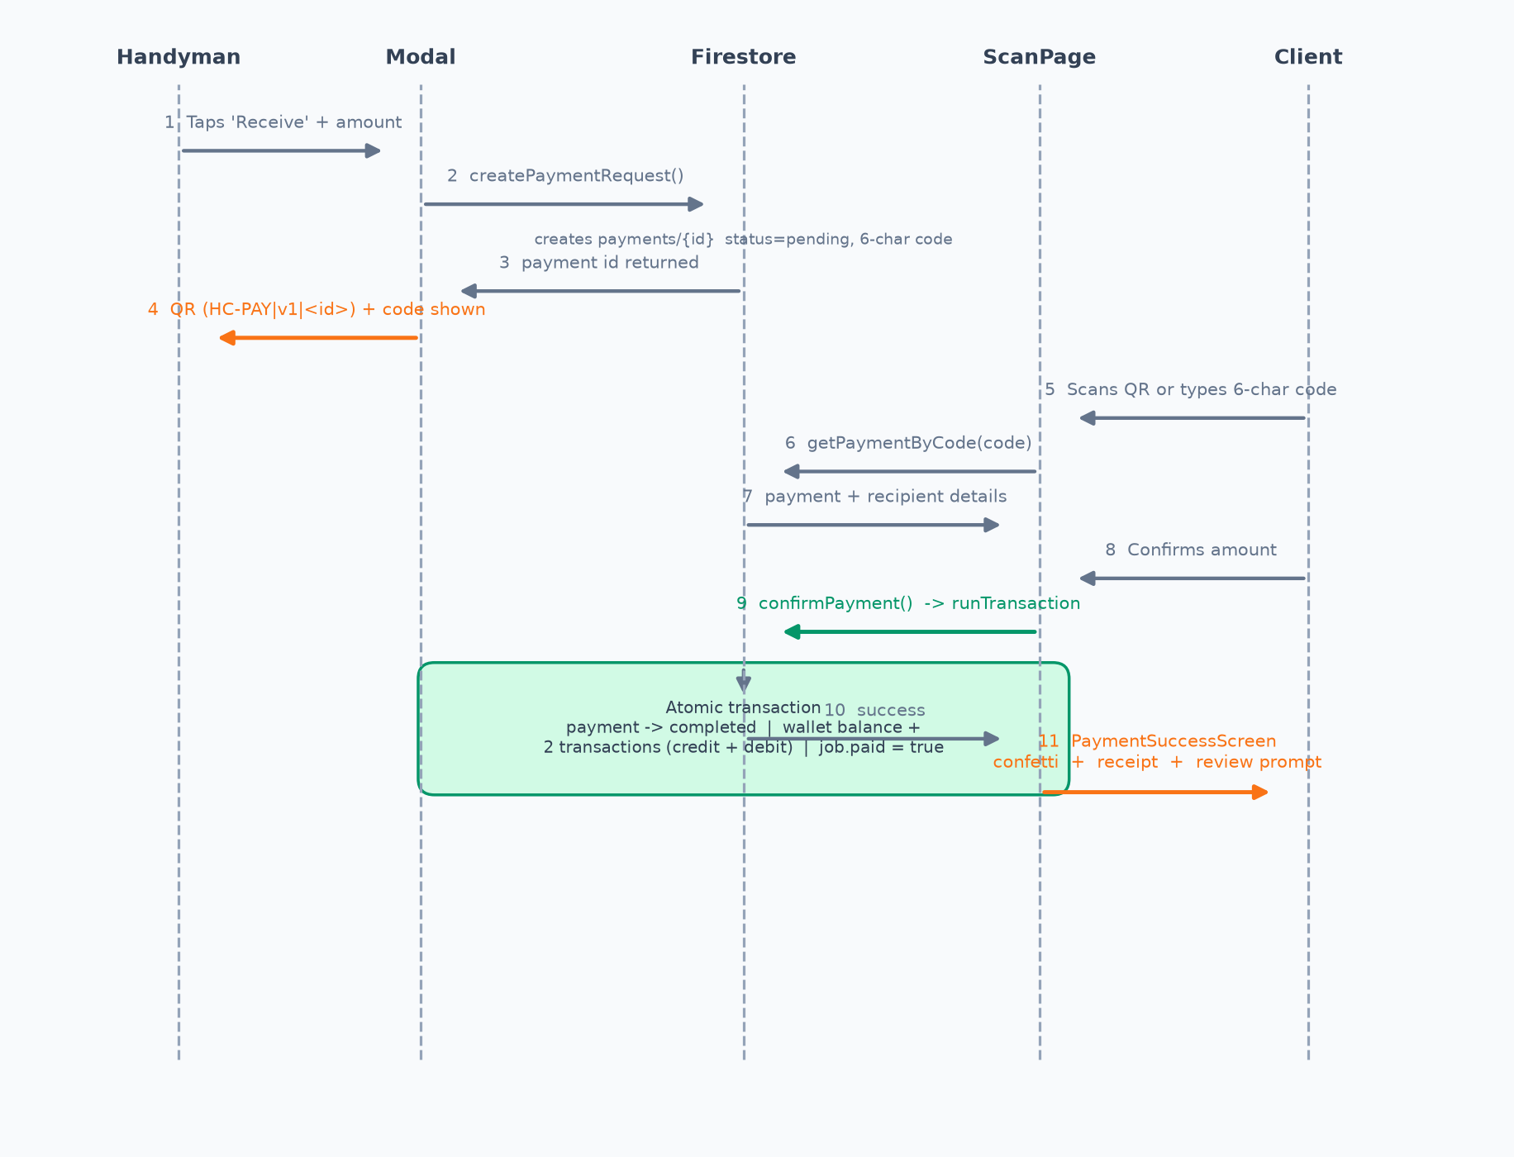
Figure 4.3 - Sequence diagram of the QR payment flow.

4.6 Realtime Design
Live behaviour is achieved with Firestore onSnapshot subscriptions exposed through custom hooks (useWallet, useConversations, useNotifications, useUnreadCount, useClientJobs). When documents change - a new message, an updated wallet balance, a new notification - the listener fires and React re-renders. Unread counts are derived from per-participant unreadCount maps on conversations and notifications.

4.7 UI/UX Design
The interface uses a single design system: an orange primary colour (#F97316) with a slate/gray palette, Inter and Plus Jakarta Sans typography, rounded 12-24px surfaces, soft shadows, and light/dark/system themes persisted to localStorage. Each role has a dedicated layout (sidebar on desktop, bottom navigation on mobile). Reusable primitives (Button, Card, Modal, Tabs, Badge, Avatar, Skeleton) keep screens consistent, and framer-motion provides subtle page transitions.

5. Implementation

5.1 Authentication and Role Management
Email/password registration creates the user, sends a verification email and stores a user document with role: null. Google sign-in creates the document if it does not exist. The user then chooses a role on the role-selection page, which writes the role to the user document. Route guards read this role and gate every protected route.
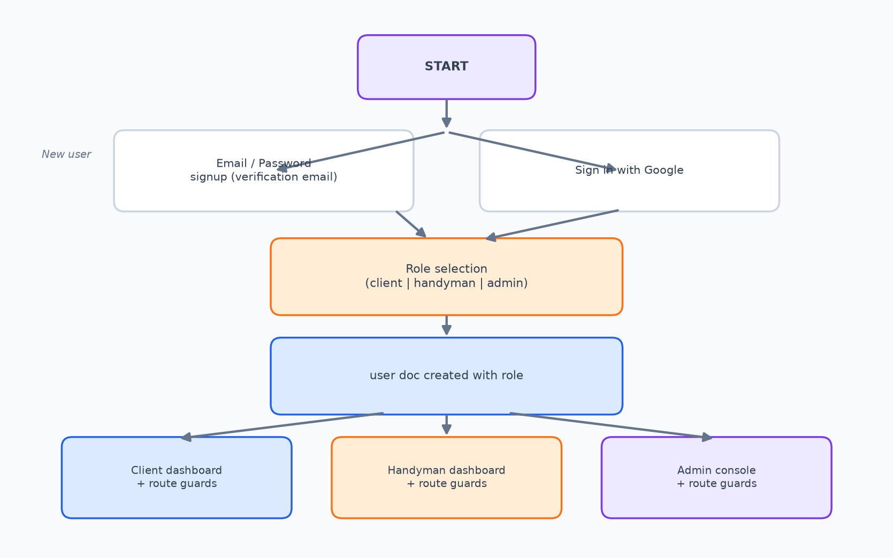
Figure 5.1 - Authentication and role-selection flow.

5.2 Job Lifecycle
A job moves through discrete states. Clients create open jobs; handymen submit quotes or accept directly; milestones and progress updates are recorded on assigned jobs; completing a job credits the handyman's wallet; the client's payment marks the job paid. Either party can open a dispute, which an administrator resolves. The state diagram below summarises the transitions implemented in jobService.
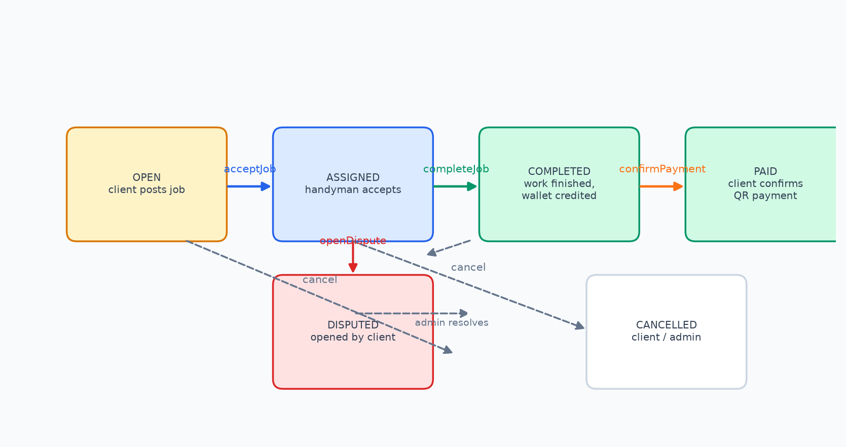
Figure 5.2 - Job lifecycle state diagram.

5.3 Wallet and Payments
The wallet is a single document per user holding balance, pending, credits and coupons. Every money movement writes a transaction document (type and kind) so that history is fully auditable. The core of the payment system is confirmPayment:
// paymentService.js - settlement is one atomic transaction
export async function confirmPayment(paymentId, payerId) {
return await runTransaction(db, async (tx) => {
const payRef = doc(db, "payments", paymentId);
const paySnap = await tx.get(payRef);
if (paySnap.data().status !== "pending") throw new Error("Payment already settled");

const walletRef = doc(db, "wallets", paySnap.data().recipientId);
await tx.update(payRef, { status: "completed", completedAt: serverTimestamp() });
await tx.update(walletRef, { balance: increment(paySnap.data().amount) });
await tx.set(doc(collection(db, "transactions")), {
uid: paySnap.data().recipientId, type: "payment", kind: "credit",
amount: paySnap.data().amount, jobId: paySnap.data().jobId, /* ... */
});
await tx.set(doc(collection(db, "transactions")), {
uid: payerId, type: "payment", kind: "debit",
amount: paySnap.data().amount, jobId: paySnap.data().jobId, /* ... */
});
await tx.update(doc(db, "jobs", paySnap.data().jobId), { paid: true });
});
}

5.4 Security Gate
The securityService stores a per-user configuration (PIN, payment password, or WebAuthn credential) with a per-user salt. Values are hashed with SHA-256 via the Web Crypto API, so plaintext secrets are never persisted. Failure counters and lockout timestamps implement the lockout policy.
// securityService.js - salted hash + lockout (abridged)
async function hashSecret(secret, salt) {
const data = new TextEncoder().encode(`${salt}::${secret}`);
const digest = await crypto.subtle.digest("SHA-256", data);
return Array.from(new Uint8Array(digest)).map(b => b.toString(16).padStart(2, "0")).join("");
}

export async function verifyPin(uid, pin) {
const cfg = loadSecurityConfig(uid); // hc_security_<uid>
if (isLockedOut(cfg)) return { ok: false, error: "Too many attempts. Try again in 30 seconds." };
const ok = (await hashSecret(pin, cfg.salt)) === cfg.pinHash;
if (!ok) return recordFailure(cfg); // 5 fails -> 30s lockout
return { ok: true };
}

5.5 Chat, Community and Portfolio
Conversations are either job-scoped (created from a job) or direct (deduplicated by a sorted participant key). Messages live in a subcollection and drive the chat UI through a listener; unread counts are updated per participant. The community feed stores posts with likes, emoji reactions, bookmarks, hashtags and comments; the portfolio is a subcollection of the handyman user document with photo galleries and before/after pairs. To make first-run demos lively, the app seeds realistic posts and portfolios once per browser (guarded by localStorage flags).

5.6 Administrative Console
Admin pages subscribe to users, jobs and wallets for real-time tables, and expose actions for role changes, suspension, verification of professionals, job cancellation, dispute resolution, community post deletion and payout processing. Payout processing uses a Firestore transaction to debit the handyman wallet and record the payout.

6. Testing

6.1 Strategy
Testing combined manual functional testing across roles, responsive/browser checks, and automated verification of code quality (ESLint) and the production build (Vite). Camera scanning was validated on real devices because html5-qrcode requires actual camera hardware. A representative sample of test cases is shown below.

6.2 Test Cases
ID | Module | Test scenario | Expected result | Status
TC-01 | Auth | Register with email, verify, choose role 'handyman' | Redirected to handyman dashboard; user doc has role | Pass
TC-02 | Auth | Logged-in client visits /handyman/dashboard | Blocked by role guard and redirected | Pass
TC-03 | Jobs | Client posts a job with budget and location | Job appears as open in Find Work | Pass
TC-04 | Jobs | Handyman accepts job, completes it | Handyman wallet credited, job completed | Pass
TC-05 | Payments | Handyman generates QR request; client scans it | Payment screen shows recipient and amount | Pass
TC-06 | Payments | Client confirms payment | Payment completed; recipient balance +amount; two ledger entries; job paid | Pass
TC-07 | Payments | Confirm the same payment twice | Second attempt rejected (status no longer pending) | Pass
TC-08 | Payments | Enter a 6-char code for a non-existent payment | Friendly error, no state change | Pass
TC-09 | Wallet | Withdraw below the $20 minimum | Action disabled with explanation | Pass
TC-10 | Security | Enter wrong PIN 5 times | 30-second lockout enforced | Pass
TC-11 | Chat | Send a message in a job conversation | Appears instantly on the other role's thread | Pass
TC-12 | Admin | Admin processes a payout | Wallet debited, payout recorded | Pass
TC-13 | Responsive | Use wallet on a 360px-wide phone | No horizontal overflow; bottom nav visible | Pass

6.3 Build and Lint
The production build completes successfully (Vite transforms ~2,686 modules and emits the bundle with a separate cacheable CSS file). The wallet and payment modules are clean under the project's ESLint configuration; a small set of pre-existing lint warnings in unrelated legacy files remains to be addressed.
Check | Command | Result
Production build | npm run build | Pass - 2,686 modules, ~2.08 MB JS bundle
Lint (wallet/payments) | npx eslint src/features/wallet src/features/payments | Pass - no issues
Lint (full repo) | npx eslint src/features src/app | 43 pre-existing issues in legacy files (unused imports, hook rules)

7. Deployment and Configuration

7.1 Environment Configuration
Configuration is injected through environment variables in a .env file. The build embeds these values into the client bundle; they must never be considered server-side secrets.
Variable | Purpose
VITE_FIREBASE_API_KEY | Firebase project API key
VITE_FIREBASE_AUTH_DOMAIN | Authentication domain
VITE_FIREBASE_PROJECT_ID | Firestore project identifier
VITE_FIREBASE_STORAGE_BUCKET | Cloud Storage bucket
VITE_FIREBASE_MESSAGING_SENDER_ID | Messaging sender (reserved)
VITE_FIREBASE_APP_ID | Firebase application id
VITE_GOOGLE_MAPS_API_KEY | Google Maps / Places / Geocoding key

7.2 Firebase Setup
- Create a Firebase project and enable Authentication (email/password and Google providers), Firestore, and Storage.
- Create the users, jobs, wallets, transactions, payments, payouts, notifications, reviews, conversations, posts, follows and calls collections (Firestore creates documents implicitly).
- Deploy the composite indexes from firestore.indexes.json (the project's firebase.json points at it).
- Configure Firestore security rules to restrict reads/writes to authenticated owners and roles. A minimal starting ruleset is shown below; tighten it for production.
rules_version = '2';
service cloud.firestore {
match /databases/{database}/documents {
// every authenticated user may read and update their own profile
match /users/{uid} {
allow read: if request.auth != null;
allow write: if request.auth != null && request.auth.uid == uid;
}
match /wallets/{uid} {
allow read: if request.auth != null;
allow write: if request.auth != null && request.auth.uid == uid;
}
match /jobs/{id} {
allow read: if request.auth != null;
allow write: if request.auth != null;
}
// payments are only mutated by the settlement transaction in code
match /payments/{id} {
allow read, write: if request.auth != null;
}
// ... additional rules for chat, posts, reviews, payouts
}
}

7.3 Hosting
The application is a static SPA. After npm run build, the dist/ folder can be deployed to Firebase Hosting, Netlify or Vercel with a redirect rule that serves index.html for unknown paths (so client-side routes resolve on refresh).

8. Evaluation

8.1 Achievement of Objectives
Objective | Status | Evidence
O1 - Authentication and roles | Met | AuthContext, RoleLayout/ProtectedRoute guards, role-selection page
O2 - Job lifecycle | Met | jobService state transitions, quotes, milestones, disputes
O3 - Wallet and payments | Met | QR + code payments, atomic confirmPayment, receipts
O4 - Realtime communication | Met | Chat threads, voice messages, call signaling over Firestore
O5 - Discovery and trust | Met | Portfolios, community feed, reviews with star ratings
O6 - Admin console | Met | User/job/payout management, verification, dispute resolution

8.2 Limitations
- Payment security (PIN, password, biometrics) is verified client-side; without strict Firestore rules a malicious client could bypass the gate. Server-enforced rules and, ideally, server-side verification are required for production.
- No real money movement: funds are ledger credits, not actual EcoCash/card transfers. A gateway integration is future work.
- Push notifications are not wired (Firebase Messaging module is reserved but unused); notifications currently surface only inside the running app.
- Portfolio and community seed data are generated for demonstration; real deployments should not seed.
- No automated unit/integration test suite yet; testing is manual plus lint/build.
- Google Maps features require an API key and degrade gracefully when it is absent.

9. Conclusion and Future Work

9.1 Conclusion
HandyConnect successfully demonstrates a complete gig-marketplace web application tailored to the Zimbabwean services economy. All six objectives were met: users authenticate and are separated by role; the full job lifecycle is supported; wallet payments work through QR codes and short codes and settle atomically; communication is real-time; trust is built through portfolios, community and reviews; and administrators can operate the platform. The project shows that a production-quality marketplace can be delivered with modern open-source frontend tooling and a serverless Firebase backend, with payment integrity guaranteed by database transactions.

9.2 Future Work
- Integrate real payment gateways (EcoCash, Visa/Mastercard, ZIPIT) and escrow/holding accounts.
- Move payment verification server-side (Firebase Callable Functions or Cloud Functions) with strict security rules.
- Add Firebase Cloud Messaging for true push notifications on mobile.
- Introduce automated tests (Vitest + React Testing Library) and CI pipelines.
- Develop a native mobile app (React Native / Expo) reusing the service layer.
- Add analytics and recommendation features for professionals and pricing.
- Extend verification with background checks, licences and in-app identification.

References
React Documentation - https://react.dev
Vite - Next Generation Frontend Tooling - https://vite.dev
Tailwind CSS Documentation - https://tailwindcss.com/docs
Firebase Documentation (Authentication, Firestore, Storage) - https://firebase.google.com/docs
Web Authentication API (WebAuthn) - https://developer.mozilla.org/en-US/docs/Web/API/Web_Authentication_API
TaskRabbit - https://www.taskrabbit.com
Airtasker - https://www.airtasker.com
html5-qrcode library - https://github.com/mebjas/html5-qrcode

