**Brief**

My client is “Risky” website to ensure they have something that is different and separates their web from the rest.

He currently doesn’t have a website, he is a music producer singer & song writer.

He DJs, composes and produces music, he needs a website to advertise his portfolio and content to gather more followers and keep people up to date with what he is doing.

He also stated that the site needs to be simple and not too complicated so people can navigate through it.

**Research**

In order to meet the clients needs out lining in the brief I have acquired the following research

* What examples of similar web sites exist?

<https://chetfaker.com/>

<https://www.stateofmindnz.com>

<http://www.netskymusic.com/>

* What are the key items to include in such a site?
* A clear description of who they are
* A simple web address – Riskymusic.co
* Easily navigated site map
* Easy to find contact information
* Customer testimonials
* An obvious call to action – Sign up to their mailing list
* Knowing the basics of SEO – Plenty of links, naming your page titles and URLs correctly, employing the magic of images and videos
* Fresh, quality content
* A secure hosting platform
* A design and style that’s friendly to online readers
* What special requirements does your client have?

Easy way to upload content and keep updating site as they go.

* What current web design trends apply to this kind of site?
* Broken grid layouts
* Illustrations take centre stage
* Over laying shapes to make more 3d transparency

**Specifications**

* Nav Bar
* Logo
* Intro video
* About
* Image
* Art gallery
* Join mailing list widget
* Footer
* Social links
* Banner
* Sound cloud embed
* Spotify embed
* Join mailing list widget

**Detail**

He has decided that his Colour scheme will be plain and simple with a black and white due to it emphasizing any art that is portrayed on the website for new music that is released.

Widgets included would be all social media platforms he has and also to link all to a mass share posting of new content that is applied within the website.

Navigation should standard static bar along the top with a 3d visual and a different cover for its hover over it which in a sense It should be simple, straightforward and easy for customers to find things they want to look at. The links should be driven to pages that pull them to act.

The website should reflect his brand, with an easy-to-identify logo and colours that make your customers feel warm or look more like art. It should put off a good vibe and reflect the personality of their company.

Player can be linked via SoundCloud or off another pre-built widget that is created that music can be stored in.

Storage should be a linked folder where people can drop files into which will be linked to his google drive so he can check for Label releases etc.

**Wireframes**

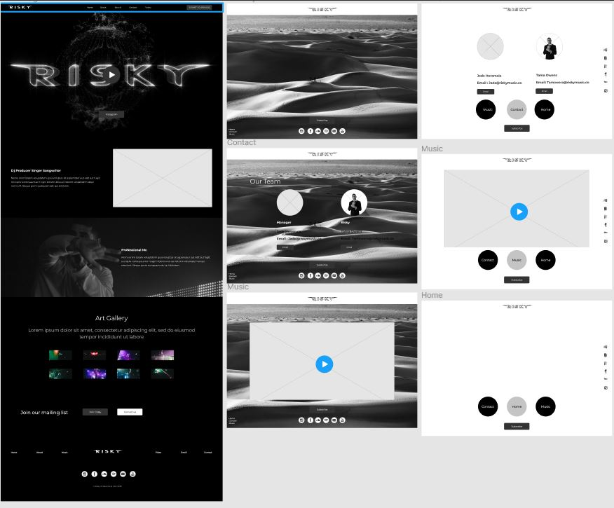

**SiteMap**

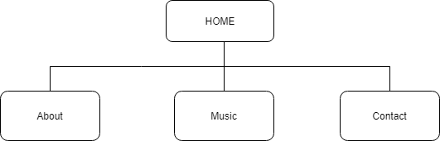

**Testing**

|  |  |  |  |
| --- | --- | --- | --- |
| Test Number | Test Type | Input Data | Expected output |
| 1 | Responsiveness – Checking to see whether it works on all devices | Iphone, Tablet, PC | Invalid |
| 2 | Nav bar links work to open other pages | Home, Music, contact  Music, Home, Contact  Contact, Music, Home | Valid – working efficiently |
| 3 | Intro video | Autoplay | Valid – works when you open up site |
| 4 | Social links | Hyper links active | Valid – all links are working for site |
| 5 | Follow Button | Follow – to link and follow social media | Invalid – Button has not been coded yet |
| 6 | Contact - email | Click email to auto bring up emailing program | Invalid – Cant seem to get the email isolated – it makes all other text hyperlinked |
| 7 | Soundcloud widget | Plays music on site | Valid – responding accordingly |
| 8 | Banner – hyperlink to home page | Hyperlink click | Invalid – banner isn’t responding properly |
| 9 | Intro video – Duration scrolling bar | Hover mouse over | Invalid – can see duration scrolling bar |
| 10 | Lined stroke nav | Once page opened – links on nav and lined stroked | Valid – responding accordingly |

**Product Backlog**

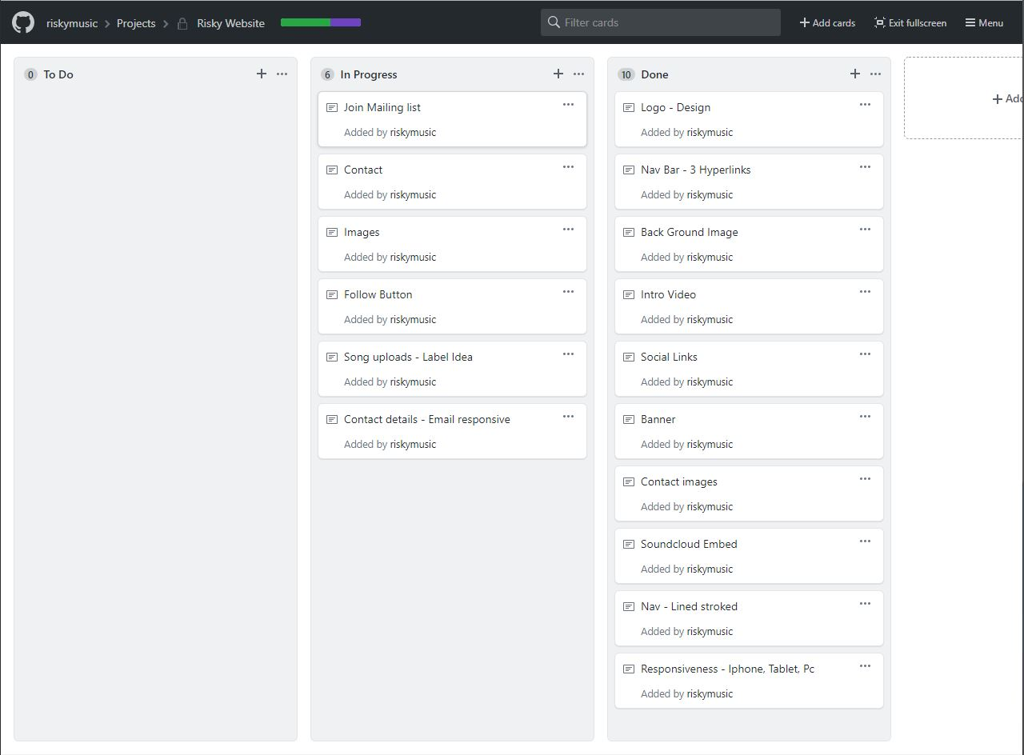

**Progress log**

|  |  |  |
| --- | --- | --- |
| Logo design | I had to get a friend to help me design logo – which becomes costly. | Done |
| Contact page | Had major troubles with aligning information – I still have not yet hyperlinked the emails on the page. | In progress |
| Images | Put them into a container grid | Done |
| Follow button | I have got the button on the page but it is currently inactive | In progress |
| Nav Bar with hyper links | All links are working | Done |
| Back ground image | I had issues with it wrapping around the whole site but now its working properly | Done |
| Intro video | I still need the duration bar to not be seen as when you hover mouse over it can be seen – its currently working | In progress |
| Social links | Simple | Done |
| Banner | Header image – fits perfectly | Done |
| Contact images | Alignment is not quite there in regards to responsiveness – will need to fix | In progress |
| Soundcloud embed | Works perfectly and sized correctly | Done |
| Nav lined strokes | Works fine | Done |
| Responsiveness | Site doesn’t work on other devices - needs fixing | In progress |

**Extended.**

**OVERVIEW**

This section should give a basic overview of the project and the organisation behind it. An overview could include:

* **About your organisation** – Music Business
* **What problem are you trying to solve?** – To set up a landing page towards more foot traffic for risky’s music.
* **High-level project scope** – It will be a brand new Website
* **Target market** – All demographics

**PROJECT TEAM**

* Risky (Tamawera Owens) – Director – Tamawera@riskymusic.co
* Jade Heremaia – Manager – Jade@riskymusic.co

**GOALS**

* Monthly traffic to rise up by 10% within 1 month
* Submissions to new content
* Mass posting without having to post to a single page each time
* Upload content without having to re-format anything.
* Monthly Marketing schedules implemented

Goals should be [SMART](https://en.wikipedia.org/wiki/SMART_criteria), that is:

* Specific
* Measurable
* Assignable
* Realistic
* Time-related

**PHASES**

* Phase 1 – Basic marketing website – Current project
* Phase 2 – Add e-commerce – Record Label
* Phase 3 – Publishing Company

### **Content types**

* People
* Products

#### **Content type data - People**

* First name
* Last name
* Position
* Bio
* Email address
* Phone number

#### **Content type data – Products**

* Song name
* ISRC codes
* Aggregator links
* APRA