1. *Once the participant has finished the task, open their behavioral data (example* ***10905.edat2****).* This will allow you to export their data to be read as a csv.

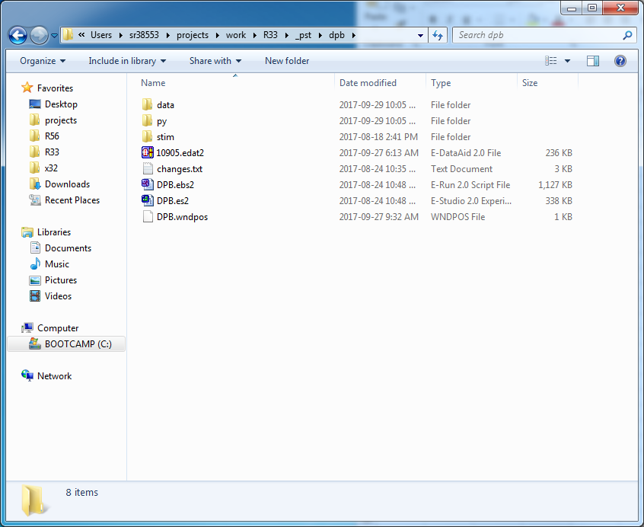

1. *To export the data, go to* ***File>Export*** *and under* ***Export to*** *select* ***Excel****.* Save the file using the participant name (**10905.txt**) and save it into the **py/data** subfolder. Click OK and close the **edat2** file.

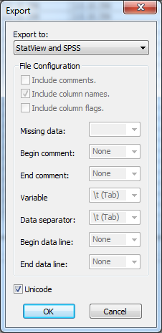

1. *To prepare the csv data so it can be read by python, open* ***Microsoft Excel****.* Go to the **Data** tab and under the **Get External Data** subheading select **From Text**.

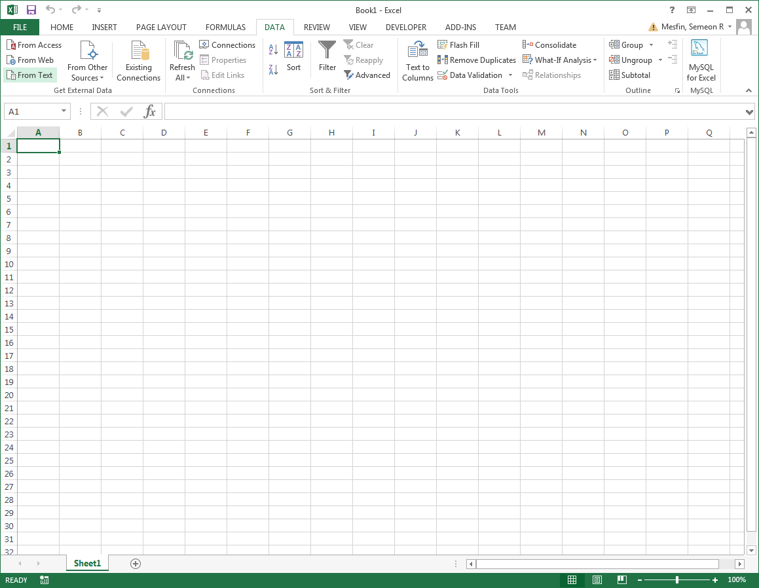

1. In the **Import Text File** window select the new txt file. Then in the **Text Import Wizard** window. Be sure delimited is selected, then select **Finish**.

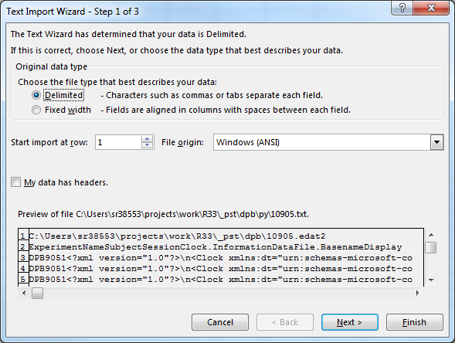

1. *Save the CSV file in the same folder as the text file and name it using the participant number* (**10905.csv**). Be sure to select Save As type: CSV (Comma delimited) (*.csv). Close Microsoft Excel.

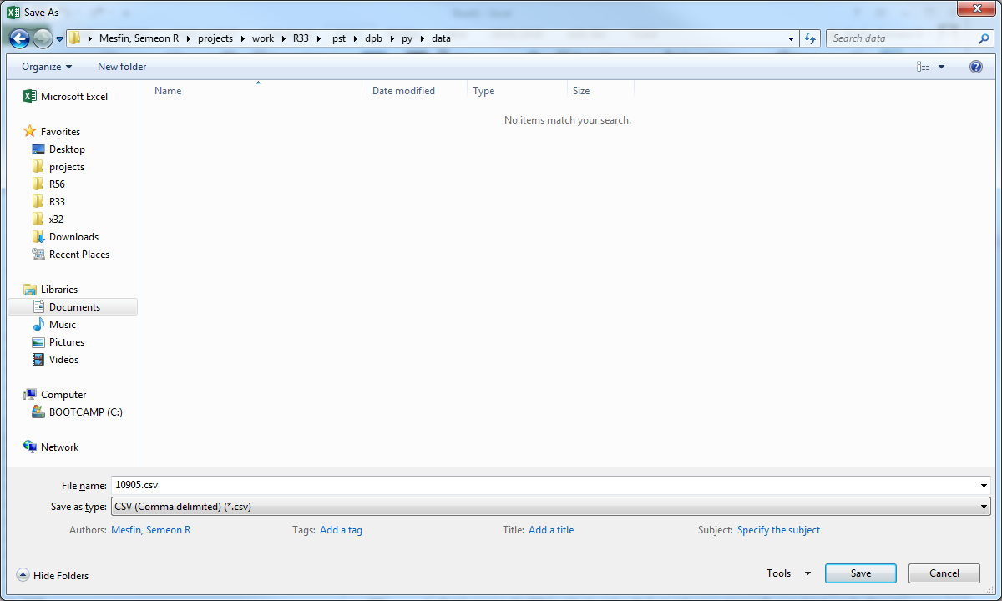

1. *In the* ***py*** *subfolder, double-click on* ***mean-st.py****.* This should automatically create an **index.csv** file, listing the participants mean and standard deviation. Once complete, open the **index.csv** file.

**Note**: If you have multiple participant csv files in the data folder, each csv file will have a listing in the index.csv file. If you still have the participants edat2 file (from step 1), then you can delete the particpants csv file after this step.

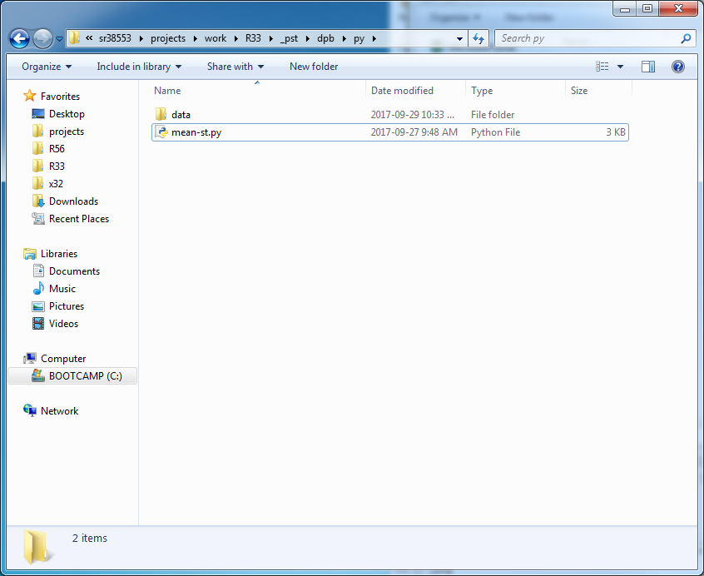

1. *Last step: Open the* ***index.csv file****.* This lists each participant file with their mean and standard deviation.

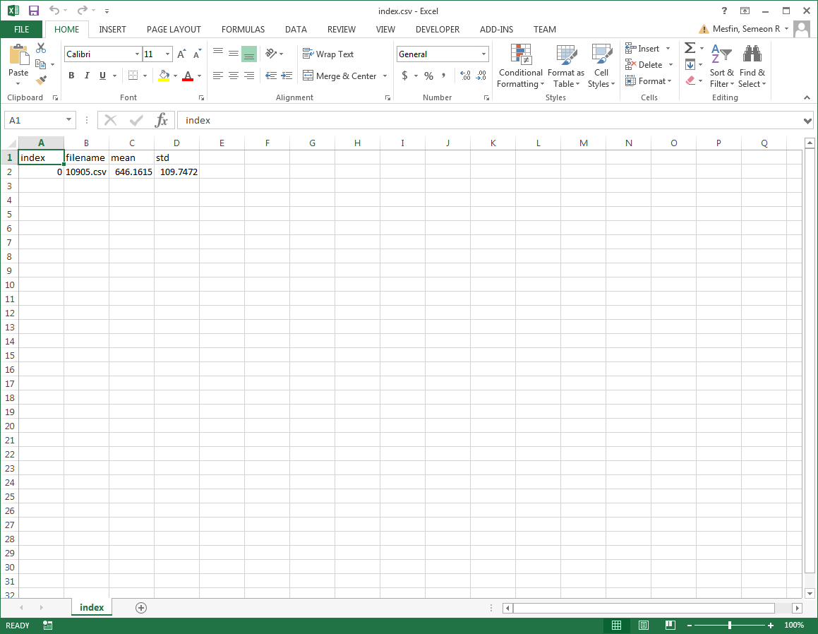

Finished