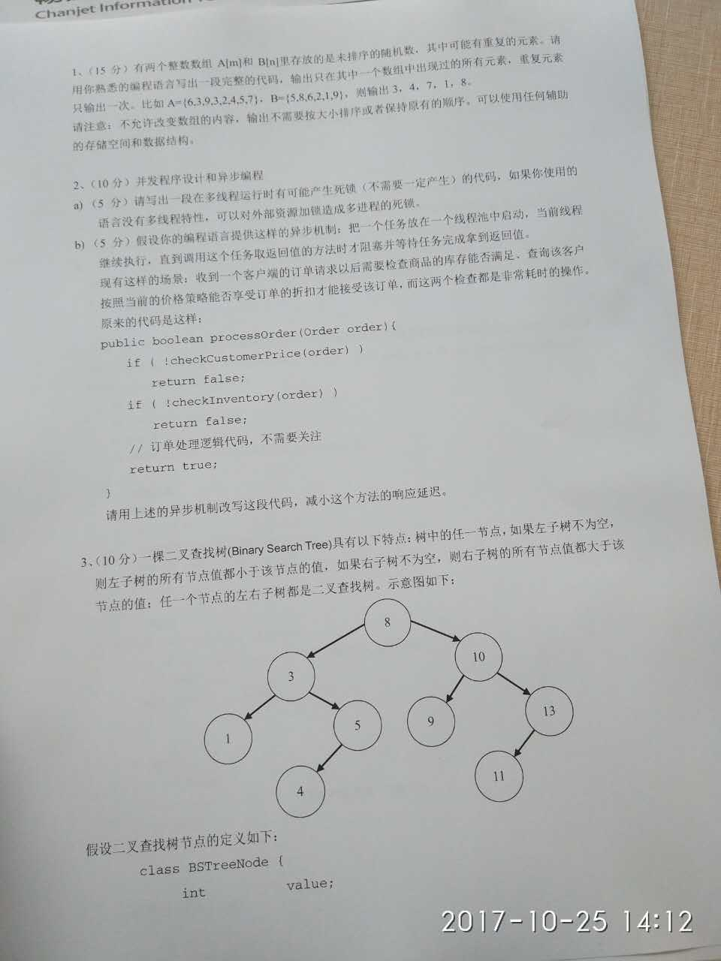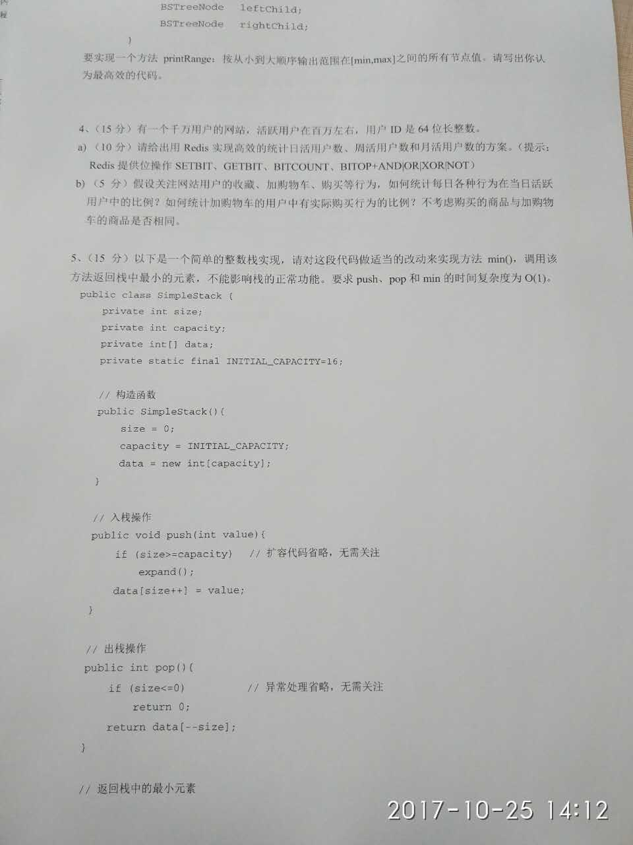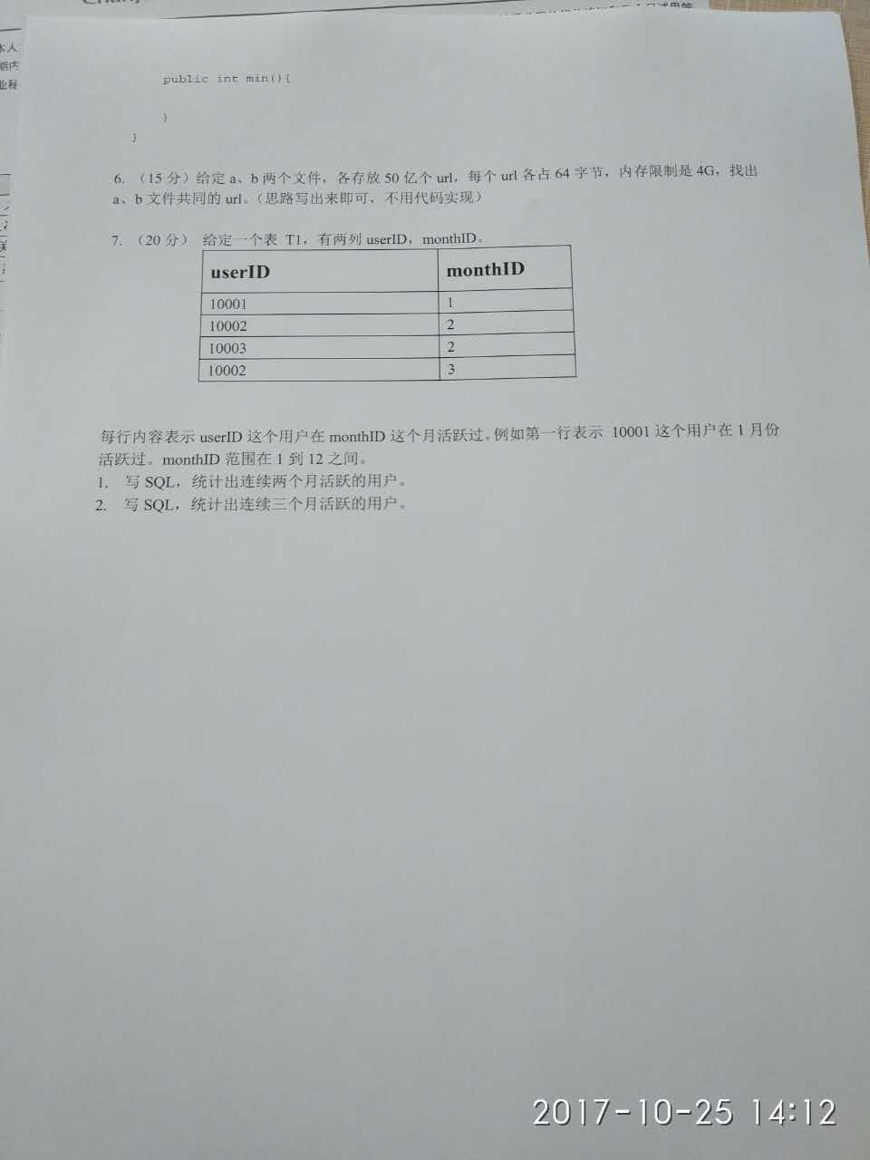

# 1.

# 2.

|  |
| --- |
| 第2 a)题  public class DeadLock {  public static String obj1 = "obj1";  public static String obj2 = "obj2";  public static void main(String[] args){  Thread a = new Thread(new Lock1());  Thread b = new Thread(new Lock2());  a.start();  b.start();  }  }  class Lock1 implements Runnable{  @Override  public void run(){  try{  System.out.println("Lock1 running");  while(true){  synchronized(DeadLock.obj1){  System.out.println("Lock1 lock obj1");  Thread.sleep(3000);//获取obj1后先等一会儿，让Lock2有足够的时间锁住obj2  synchronized(DeadLock.obj2){  System.out.println("Lock1 lock obj2");  }  }  }  }catch(Exception e){  e.printStackTrace();  }  }  }  class Lock2 implements Runnable{  @Override  public void run(){  try{  System.out.println("Lock2 running");  while(true){  synchronized(DeadLock.obj2){  System.out.println("Lock2 lock obj2");  Thread.sleep(3000);  synchronized(DeadLock.obj1){  System.out.println("Lock2 lock obj1");  }  }  }  }catch(Exception e){  e.printStackTrace();  }  }  } |

# 3.

# 4.

# 5.

# 6.

# 7.