Artificial Neural Network (ANN) - Regression
Rafiq Islam
2025-03-25
Table of contents

Simple Linear Regression Using ANN
The simple linear regression equation is given as
$$y_{i}=β_{0}+β_{1}x_{i}+ξ_{i}=σ(w_{0}+x^{T}w)=σ(x^{T}w)$$
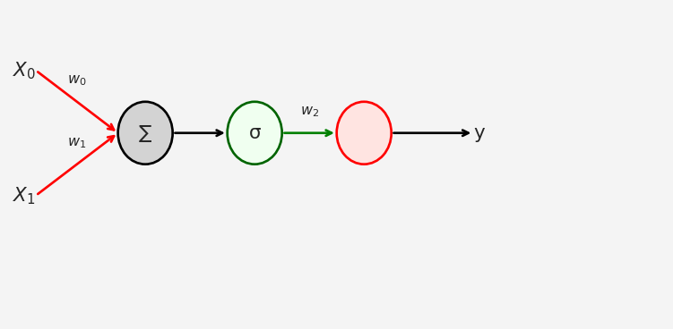
The loss function in this case MSE: Mean Squared Error
import torch
n = 50
# Creating n=50 random X values from the standard normal distribution
X = torch.randn(n,1)
# y = mX + c + noise. Here m=1, c = 0, noise = N(0,1)/2
y = X + torch.randn(n,1)/2
plt.plot(X,y, 'ro')
plt.xlabel('X')
plt.ylabel('y')
plt.show()
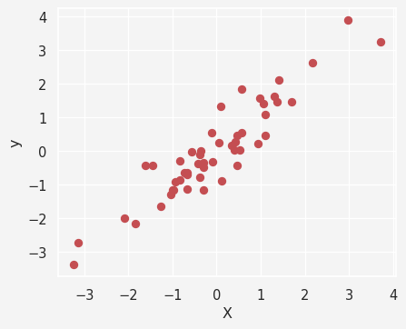
Now the model
import numpy as np
import torch.nn as nn
ANN_regressor = nn.Sequential(
nn.Linear(1,1), # Input Layer
nn.ReLU(), # Rectified Linear Unit (ReLU) activation function
nn.Linear(1,1) # Output Layer
)
ANN_regressor
Sequential(
(0): Linear(in_features=1, out_features=1, bias=True)
(1): ReLU()
(2): Linear(in_features=1, out_features=1, bias=True)
)
Next we want to train our model using Stochastic Gradient Descent optimizer
lr = 0.05 # Learning rate/stepsize
loss_function = nn.MSELoss() # MSE loss function
optimizer = torch.optim.SGD( # SGD Optimizer
ANN_regressor.parameters(),
lr=lr
)
training_epochs = 500 # Epochs
losses = torch.zeros(training_epochs) # Creating 1D zero vector of size 500
# Train the model
for epoch in range(training_epochs):
# forward pass
pred = ANN_regressor(X)
# compute the loss
loss = loss_function(pred, y)
losses[epoch] = loss
# back propagation
optimizer.zero_grad()
loss.backward()
optimizer.step()
predictions = ANN_regressor(X)
test_loss = (predictions - y).pow(2).mean()
plt.plot(losses.detach())
plt.plot(training_epochs, test_loss.detach(), 'ro')
plt.title('Final Loss = %g' %test_loss.item())
plt.xlabel('Epoch')
plt.ylabel('Loss')
plt.show()
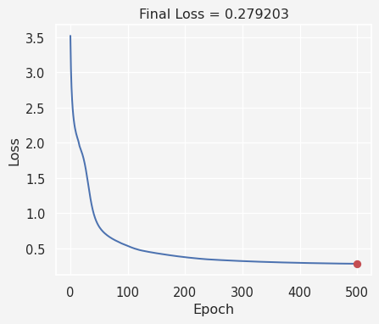
Now let’s calculate the predictions
plt.plot(X,y, 'ro', label = 'Data')
plt.plot(X,predictions.detach(), 'bs', label='Predictions')
plt.legend()
plt.show()
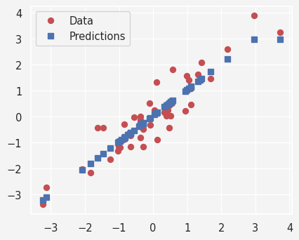
Putting all together
def ann_reg(X,y):
model = nn.Sequential(
nn.Linear(1,1),
nn.ReLU(),
nn.Linear(1,1)
)
loss_function = nn.MSELoss()
optimizer = torch.optim.SGD(model.parameters(), lr=0.05)
training_epochs = 500
losses = torch.zeros(training_epochs)
for epoch in range(training_epochs):
pred = model(X)
loss = loss_function(pred, y)
losses[epoch] = loss
optimizer.zero_grad()
loss.backward()
optimizer.step()
return model(X), losses
def data(m):
X = torch.randn(50,1)
y = m*X + torch.randn(50,1)/2
return X, y
slopes = np.linspace(-2,2,21)
train = 30
results = np.zeros((len(slopes), train,2))
for m in range(len(slopes)):
for t in range(train):
X,y = data(slopes[m])
prediction,loss = ann_reg(X,y)
results[m, t, 0] = loss[-1]
results[m, t, 1] = np.corrcoef(y.T,prediction.detach().T)[0,1]
results[np.isnan(results)]=0
fig, ax = plt.subplots(1,2, figsize=(8,4))
ax[0].plot(slopes, np.mean(results[:,:,0], axis=1),'ko-')
ax[0].set_xlabel('Slope')
ax[0].set_title('Loss')
ax[1].plot(slopes, np.mean(results[:,:,1],axis=1),'ms-')
ax[1].set_xlabel('Slope')
ax[1].set_ylabel('Real vs Predicted correlation')
ax[1].set_title('Model Performance')
plt.show()
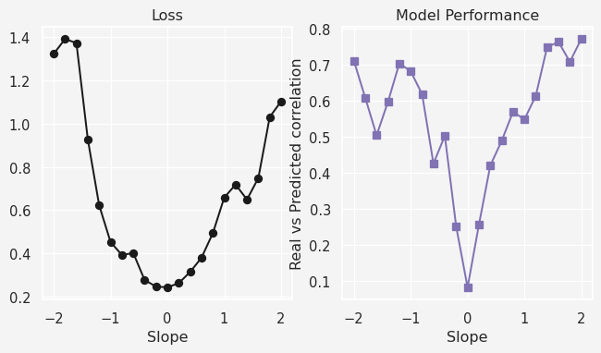

Share on

You may also like

