Exploratory Data Analysis (EDA) and Data Visualization
Rafiq Islam
2024-11-08
Table of contents

In this Exploratory Data Analysis and Visualization notebook, we want to explore the 911 call data from Kaggle.com

The Dataset
import pandas as pd
import numpy as np
import seaborn as sns
import matplotlib.pyplot as plt
df = pd.read_csv('911.csv')

Discriptive Statistics
We first check the data information to see the number of observations, datatype, memory usages etc.
df.info()
<class 'pandas.core.frame.DataFrame'>
RangeIndex: 105957 entries, 0 to 105956
Data columns (total 9 columns):
# Column Non-Null Count Dtype
--- ------ -------------- -----
0 lat 105957 non-null float64
1 lng 105957 non-null float64
2 desc 105957 non-null object
3 zip 92735 non-null float64
4 title 105957 non-null object
5 timeStamp 105957 non-null object
6 twp 105924 non-null object
7 addr 105957 non-null object
8 e 105957 non-null int64
dtypes: float64(3), int64(1), object(5)
memory usage: 7.3+ MB
A first look of the data
df.head()
 | lat | lng | desc | zip | title | timeStamp | twp | addr | e
0 | 40.297876 | -75.581294 | REINDEER CT & DEAD END; NEW HANOVER; Station ... | 19525.0 | EMS: BACK PAINS/INJURY | 12/10/15 17:10 | NEW HANOVER | REINDEER CT & DEAD END | 1
1 | 40.258061 | -75.264680 | BRIAR PATH & WHITEMARSH LN; HATFIELD TOWNSHIP... | 19446.0 | EMS: DIABETIC EMERGENCY | 12/10/15 17:29 | HATFIELD TOWNSHIP | BRIAR PATH & WHITEMARSH LN | 1
2 | 40.121182 | -75.351975 | HAWS AVE; NORRISTOWN; 2015-12-10 @ 14:39:21-St... | 19401.0 | Fire: GAS-ODOR/LEAK | 12/10/15 14:39 | NORRISTOWN | HAWS AVE | 1
3 | 40.116153 | -75.343513 | AIRY ST & SWEDE ST; NORRISTOWN; Station 308A;... | 19401.0 | EMS: CARDIAC EMERGENCY | 12/10/15 16:47 | NORRISTOWN | AIRY ST & SWEDE ST | 1
4 | 40.251492 | -75.603350 | CHERRYWOOD CT & DEAD END; LOWER POTTSGROVE; S... | NaN | EMS: DIZZINESS | 12/10/15 16:56 | LOWER POTTSGROVE | CHERRYWOOD CT & DEAD END | 1
Some data related questions. For example,
- What are the top 10 zipcodes for 911 calls?
- df.zip.value_counts().head(10)
- zip
19401.0 7445
19464.0 7122
19403.0 5189
19446.0 5060
19406.0 3404
19002.0 3238
19468.0 3202
19454.0 2984
19090.0 2832
19046.0 2779
Name: count, dtype: int64
- What are the top 10 twonships for the 911 calls?
- df.twp.value_counts().head(10)
- twp
LOWER MERION 9069
ABINGTON 6403
NORRISTOWN 6265
UPPER MERION 5551
CHELTENHAM 4882
POTTSTOWN 4448
UPPER MORELAND 3658
LOWER PROVIDENCE 3435
PLYMOUTH 3371
HORSHAM 3142
Name: count, dtype: int64

Feature Engineering
Sometimes creating new features from the existing features helps understand the data better. For example, for this dataset, we can create a new column called Reason for emergency 911 call.
df['reason'] = df.title.apply(lambda title: title.split(':')[0])
df.head(3)
 | lat | lng | desc | zip | title | timeStamp | twp | addr | e | reason
0 | 40.297876 | -75.581294 | REINDEER CT & DEAD END; NEW HANOVER; Station ... | 19525.0 | EMS: BACK PAINS/INJURY | 12/10/15 17:10 | NEW HANOVER | REINDEER CT & DEAD END | 1 | EMS
1 | 40.258061 | -75.264680 | BRIAR PATH & WHITEMARSH LN; HATFIELD TOWNSHIP... | 19446.0 | EMS: DIABETIC EMERGENCY | 12/10/15 17:29 | HATFIELD TOWNSHIP | BRIAR PATH & WHITEMARSH LN | 1 | EMS
2 | 40.121182 | -75.351975 | HAWS AVE; NORRISTOWN; 2015-12-10 @ 14:39:21-St... | 19401.0 | Fire: GAS-ODOR/LEAK | 12/10/15 14:39 | NORRISTOWN | HAWS AVE | 1 | Fire
what are top reasons for the emergency calls?
df.reason.value_counts()
reason
EMS 52515
Traffic 37505
Fire 15937
Name: count, dtype: int64
visualization of the reason column
sns.countplot(x=df.reason, hue=df.reason, palette='viridis')
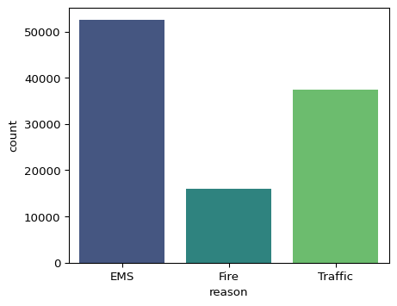
The timeStamp column contains time information year-month-day hour:minute:second format but in string value/object. So we can convert this column to obtain new features.
df['timeStamp'] = pd.to_datetime(df.timeStamp)
time = df.timeStamp.iloc[0]
/tmp/ipykernel_3393/1994586768.py:1: UserWarning: Could not infer format, so each element will be parsed individually, falling back to `dateutil`. To ensure parsing is consistent and as-expected, please specify a format.
df['timeStamp'] = pd.to_datetime(df.timeStamp)
Let’s create new features called hour, month, and day of the calls.
df['hour'] = df.timeStamp.apply(lambda time: time.hour)
df['month'] = df.timeStamp.apply(lambda time: time.month)
df['day'] = df.timeStamp.apply(lambda time: time.dayofweek)
days = {
0:'Monday', 1:'Tuesday', 2:'Wednesday',
3:'Thursday', 4:'Friday', 5:'Saturday',
6:'Sunday'
}
df.day = df.day.map(days)
df = df[
['lat','lng','zip','twp','e','reason',
'month','day','hour','title','timeStamp',
'desc','addr']
]
df.head(3)
 | lat | lng | zip | twp | e | reason | month | day | hour | title | timeStamp | desc | addr
0 | 40.297876 | -75.581294 | 19525.0 | NEW HANOVER | 1 | EMS | 12 | Thursday | 17 | EMS: BACK PAINS/INJURY | 2015-12-10 17:10:00 | REINDEER CT & DEAD END; NEW HANOVER; Station ... | REINDEER CT & DEAD END
1 | 40.258061 | -75.264680 | 19446.0 | HATFIELD TOWNSHIP | 1 | EMS | 12 | Thursday | 17 | EMS: DIABETIC EMERGENCY | 2015-12-10 17:29:00 | BRIAR PATH & WHITEMARSH LN; HATFIELD TOWNSHIP... | BRIAR PATH & WHITEMARSH LN
2 | 40.121182 | -75.351975 | 19401.0 | NORRISTOWN | 1 | Fire | 12 | Thursday | 14 | Fire: GAS-ODOR/LEAK | 2015-12-10 14:39:00 | HAWS AVE; NORRISTOWN; 2015-12-10 @ 14:39:21-St... | HAWS AVE
Now that we have almost a clean dataset, we can analyze the reason column based on the days of the week or months of a year.
sns.countplot(x='day', data= df, hue='reason', palette='viridis')
plt.legend(bbox_to_anchor=(1.05,1), loc=2, borderaxespad=0.0)
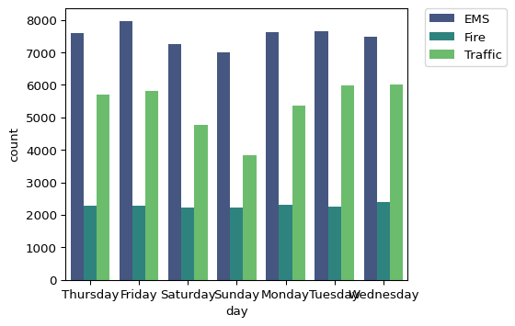
For the month column
sns.countplot(x='month', data= df, hue='reason', palette='viridis')
plt.legend(bbox_to_anchor=(1.05,1), loc=2, borderaxespad=0.0)
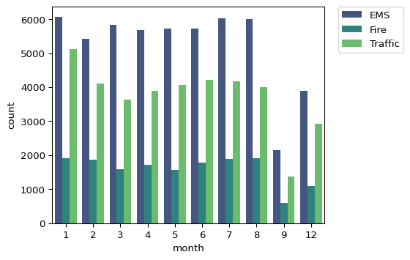
To create a time series data
df['date'] = df['timeStamp'].apply(lambda time: time.date())
df.groupby('date').count()['twp'].plot()
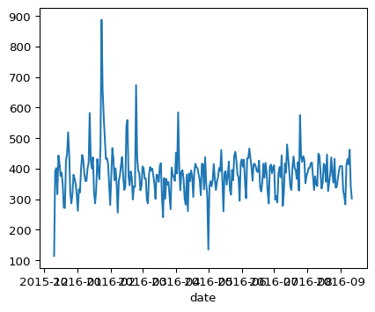
Now to see for each reason
start_date = pd.to_datetime('2019-01-01')
df['date'] = pd.to_datetime(df['date'])
fig = plt.figure(figsize=(7.9,6))
ax1 = fig.add_subplot(311)
df[(df['reason'] == 'Traffic') & (df['date'] >= start_date)].groupby('date').count()['twp'].plot(ax=ax1)
ax2 = fig.add_subplot(312)
df[(df['reason'] == 'Fire') & (df['date'] >= start_date)].groupby('date').count()['twp'].plot(ax=ax2)
ax3 = fig.add_subplot(313)
df[(df['reason'] == 'EMS') & (df['date'] >= start_date)].groupby('date').count()['twp'].plot(ax=ax3)
plt.tight_layout()
plt.show()
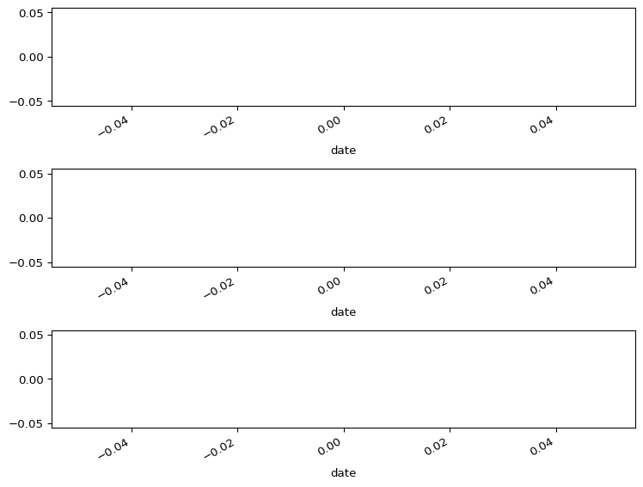

Share on

You may also like

