Simple Linear Regression
Rafiq Islam
2024-08-29
Table of contents

Simple Linear Regression
A simple linear regression in multiple predictors/input variables/features/independent variables/ explanatory variables/regressors/ covariates (many names) often takes the form
$$y=f(x)+ϵ=βx+ϵ$$
where $β∈R^{d}$ are regression parameters or constant values that we aim to estimate and $ϵ∼N(0,1)$ is a normally distributed error term independent of $x$ or also called the white noise.
In this case, the model:
$$y=f(x)+ϵ=β_{0}+β_{1}x+ϵ$$
Therefore, in our model we need to estimate the parameters $β_{0},β_{1}$. The true relationship between the explanatory variables and the dependent variable is $y=f(x)$. But our model is $y=f(x)+ϵ$. Here, this $f(x)$ is the working model with the data. In other words, $\hat{y}=f(x)={\hat{β}}_{0}+{\hat{β}}_{1}x$. Therefore, there should be some error in the model prediction which we are calling $ϵ=∥y−\hat{y}∥$ where $y$ is the true value and $\hat{y}$ is the predicted value. This error term is normally distributed with mean 0 and variance 1. To get the best estimate of the parameters $β_{0},β_{1}$ we can minimize the error term as much as possible. So, we define the residual sum of squares (RSS) as:

Using multivariate calculus we see

Setting the partial derivatives to zero we solve for $\hat{β_{0}},\hat{β_{1}}$ as follows

and,

Therefore, we have the following

Simple Linear Regression slr is applicable for a single feature data set with contineous response variable.
import numpy as np
import matplotlib.pyplot as plt
from sklearn.linear_model import LinearRegression

Assumptions of Linear Regressions
- Linearity: The relationship between the feature set and the target variable has to be linear.
- Homoscedasticity: The variance of the residuals has to be constant.
- Independence: All the observations are independent of each other.
- Normality: The distribution of the dependent variable $y$ has to be normal.

Synthetic Data
To implement the algorithm, we need some synthetic data. To generate the synthetic data we use the linear equation $y(x)=2x+\frac{1}{2}+ξ$ where $ξ∼N(0,1)$
X=np.random.random(100)
y=2*X+0.5+np.random.randn(100)
Note that we used two random number generators, np.random.random(n) and np.random.randn(n). The first one generates $n$ random numbers of values from the range (0,1) and the second one generates values from the standard normal distribution with mean 0 and variance or standard deviation 1.
plt.figure(figsize=(9,6))
plt.scatter(X,y)
plt.xlabel('$X$')
plt.ylabel('y')
plt.gca().set_facecolor('#f4f4f4')
plt.gcf().patch.set_facecolor('#f4f4f4')
plt.show()
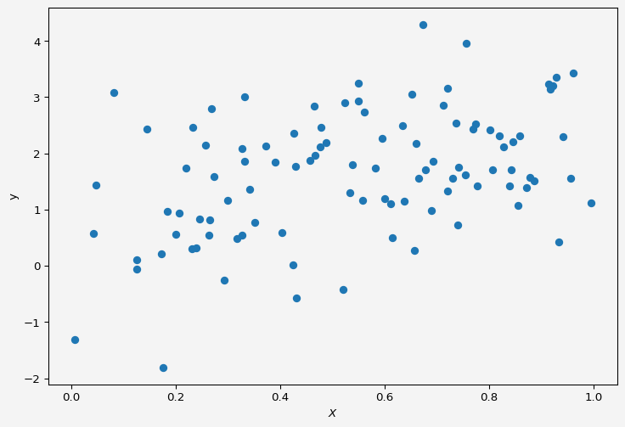

Model
We want to fit a simple linear regression to the above data.
slr=LinearRegression()
Now to fit our data $X$ and $y$ we need to reshape the input variable. Because if we look at $X$,
X
array([0.4766488 , 0.99594214, 0.6659838 , 0.33238052, 0.69268864,
0.23349923, 0.7741959 , 0.77809404, 0.43176155, 0.40280449,
0.33232473, 0.12544828, 0.91478823, 0.58282485, 0.20597755,
0.46708794, 0.23913211, 0.17325416, 0.8391829 , 0.56183767,
0.65247622, 0.3271252 , 0.84528406, 0.1758189 , 0.29281794,
0.6776681 , 0.95588499, 0.80185143, 0.23074119, 0.85607799,
0.74247372, 0.66033065, 0.87782086, 0.04170197, 0.59477239,
0.31709896, 0.80649671, 0.82762994, 0.2460917 , 0.39023331,
0.2628611 , 0.46565639, 0.42928399, 0.73081009, 0.54996328,
0.96049338, 0.85930973, 0.92275811, 0.8205815 , 0.54956078,
0.27355314, 0.55757873, 0.93426983, 0.45783536, 0.08153554,
0.5236525 , 0.84264604, 0.53847444, 0.42416563, 0.94116653,
0.14523123, 0.48878545, 0.32733062, 0.12600241, 0.69019665,
0.25634448, 0.71190513, 0.72060326, 0.61478582, 0.21896517,
0.26831471, 0.73693688, 0.91767234, 0.2650815 , 0.53413004,
0.35120176, 0.8862037 , 0.42680516, 0.76936132, 0.75564541,
0.87111972, 0.47756509, 0.18462289, 0.72058937, 0.52007204,
0.63485799, 0.37294769, 0.63843383, 0.34108062, 0.20052594,
0.75482525, 0.2996518 , 0.00593879, 0.92840679, 0.65650502,
0.61088676, 0.60048694, 0.0466812 , 0.67409371, 0.7403338 ])
It is a one-dimensional array/vector but the slr object accepts input variable as matrix or two-dimensional format.
X=X.reshape(-1,1)
X[:10]
array([[0.4766488 ],
[0.99594214],
[0.6659838 ],
[0.33238052],
[0.69268864],
[0.23349923],
[0.7741959 ],
[0.77809404],
[0.43176155],
[0.40280449]])
Now we fit the data to our model
slr.fit(X,y)
slr.predict([[2],[3]])
array([4.2026145 , 5.95524405])
We have our $X=2,3$ and the corresponding $y$ values are from the above cell output, which are pretty close to the model $y=2x+\frac{1}{2}$.
intercept = round(slr.intercept_,4)
slope = slr.coef_
Now our model parameters are: intercept $β_{0}=$ np.float64(0.6974) and slope $β_{1}=$ array([1.75262956]).
plt.figure(figsize=(9,6))
plt.scatter(X,y, alpha=0.7,label="Sample Data")
plt.plot(np.linspace(0,1,100),
slr.predict(np.linspace(0,1,100).reshape(-1,1)),
'k',
label='Model $\hat{f}$'
)
plt.plot(np.linspace(0,1,100),
2*np.linspace(0,1,100)+0.5,
'r--',
label='$f$'
)
plt.xlabel('$X$')
plt.ylabel('y')
plt.legend(fontsize=10)
plt.gca().set_facecolor('#f4f4f4')
plt.gcf().patch.set_facecolor('#f4f4f4')
plt.show()
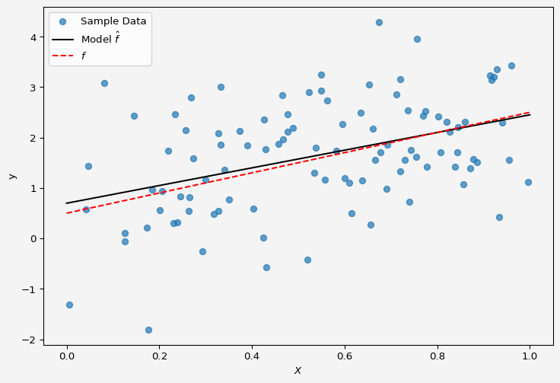
So the model fits the data almost perfectly.
Up next multiple linear regression.
Share on

You may also like

