Artificial Neural Network (ANN) - Classification 1

Rafiq Islam

2025-03-25

Table of contents

**Incomplete**

## Binary Classification

Say we have a dataset like this

import torch  
import numpy as np  
import matplotlib.pyplot as plt  
from mywebstyle import plot_style  
plot_style('#f4f4f4')  
  
np.random.seed(0)  
n=100  
center1 = [2, 2]  
center2 = [0, -2]  
stdv = 1.5  
cluster1 = [  
 center1[0] + np.random.randn(n)*stdv, center1[1] + np.random.randn(n)*stdv  
]  
cluster2 = [  
 center2[0] + np.random.randn(n)*stdv, center2[1] + np.random.randn(n)*stdv  
]  
  
data_matrix = np.hstack((cluster1, cluster2)).T  
data = torch.tensor(data_matrix).float()  
labels = torch.tensor(  
 np.vstack((np.zeros((n,1)),(np.ones((n,1)))))  
).float()  
  
plt.scatter(  
 data[np.where(labels==0)[0],0],  
 data[np.where(labels==0)[0],1],  
 color='red',  
 label = 'class 1'  
)  
plt.scatter(  
 data[np.where(labels==1)[0],0],  
 data[np.where(labels==1)[0],1],  
 color='blue',  
 label = 'class 2'  
)  
plt.legend()  
plt.xlabel('Feature 1')  
plt.ylabel('Feature 2')  
plt.show()

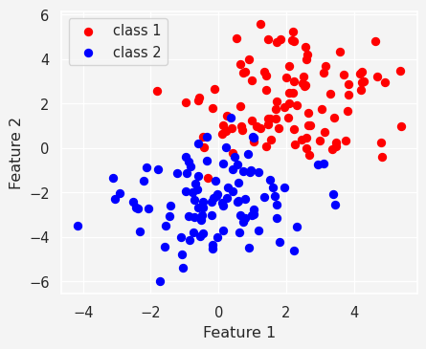

and we want to make an ANN classifier model with this data. So, we consider a two layer neural network

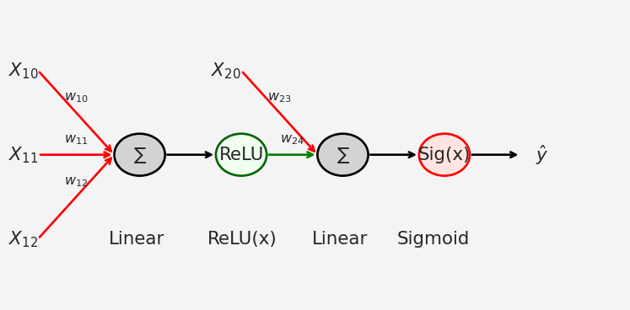

So our model

import torch.nn as nn  
  
ANN_classifier = nn.Sequential(  
 nn.Linear(2,1), # Input layer mapping R^2--> R  
 nn.ReLU(), # Activation function in layer 1  
 nn.Linear(1,1), # Output layer  
 nn.Sigmoid() # Activation function in layer 2  
)

Now let’s train the model

lr = 0.01 # Learning Rate  
loss_function = nn.BCELoss() # Binary Cross Entropy Loss  
optimizer = torch.optim.SGD( # Stochastic Gradient Descent Optimizer  
 ANN_classifier.parameters(),  
 lr=lr  
)  
num_epochs = 1000 # Number of Epochs  
  
# Define losses to store the loss from each epoch  
losses = torch.zeros(num_epochs)  
for epoch in range(num_epochs):  
 # Forward Pass  
 pred = ANN_classifier(data)  
  
 # Compute loss  
 loss = loss_function(pred, labels)  
 losses[epoch] = loss   
  
 # Backpropagation  
 optimizer.zero_grad()  
 loss.backward()  
 optimizer.step()  
  
plt.plot(losses.detach())  
plt.xlabel('Epoch')  
plt.ylabel('Loss')  
plt.show()

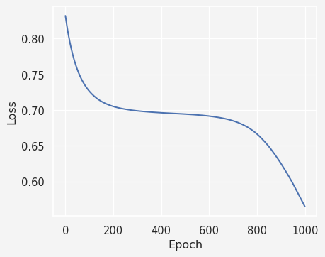

Next we compute the predictions made the model

preds = ANN_classifier(data)  
predicted_labels = preds>0.5  
mis_classification = np.where(predicted_labels != labels)[0]  
acc = 100 - 100*len(mis_classification)/(2*100)  
plt.plot(  
 data[mis_classification,0], data[mis_classification,1],  
 'rx', markersize=12, markeredgewidth=3  
)  
plt.plot(  
 data[np.where(~predicted_labels)[0],0],  
 data[np.where(~predicted_labels)[0],1],'bs'  
)  
plt.plot(  
 data[np.where(predicted_labels)[0],0],  
 data[np.where(predicted_labels)[0],1],'ko'  
)  
plt.title(f'{acc}% correct')  
plt.show()

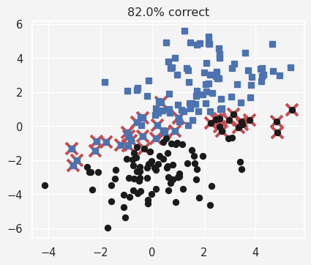

## Multiclass Classification

We use the IRIS data for this project

import seaborn as sns  
iris = sns.load_dataset('iris')  
sns.pairplot(iris, hue='species')  
plt.show()

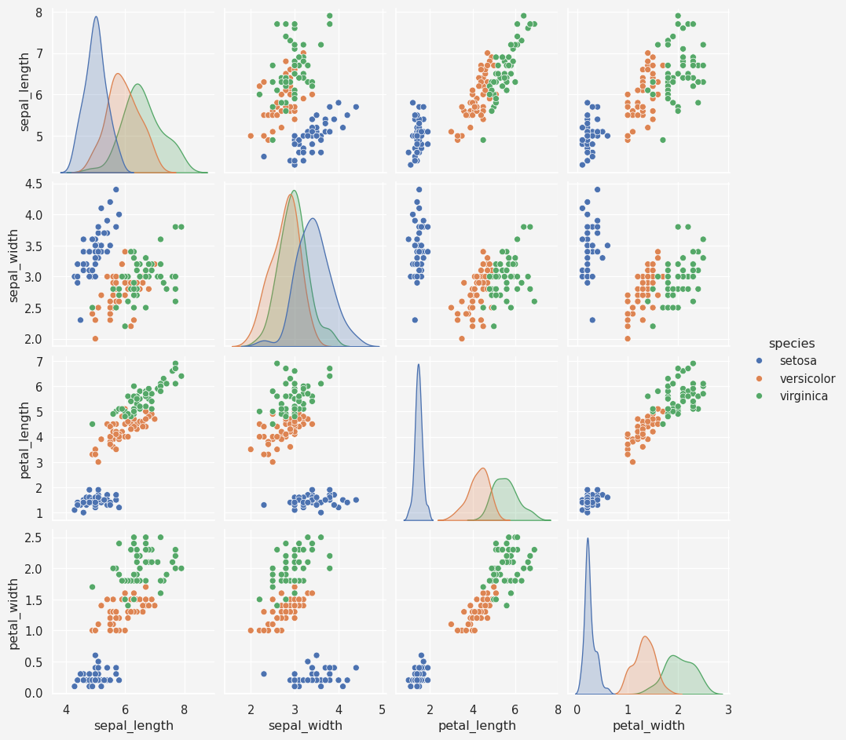

### Data Pre-process

data = torch.tensor(iris[iris.columns[0:4]].values).float()  
labels = torch.zeros(len(data), dtype=torch.long)  
labels[iris.species=='versicolor']=1  
labels[iris.species=='virginica']=2

Model

iris_classifier = nn.Sequential(  
 nn.Linear(4,64),  
 nn.ReLU(),  
 nn.Linear(64,64),  
 nn.ReLU(),  
 nn.Linear(64,3)  
)  
loss_fun = nn.CrossEntropyLoss()  
optimizer = torch.optim.SGD(iris_classifier.parameters(), lr=0.01)

Training

num_epochs = 1000  
losses = torch.zeros(num_epochs)  
running_acc = []  
  
for epoch in range(num_epochs):  
 # forward pass  
 yhat = iris_classifier(data)  
 # compute loss  
 loss = loss_fun(yhat, labels)  
 losses[epoch] = loss  
  
 # back-prop  
 optimizer.zero_grad()  
 loss.backward()  
 optimizer.step()  
  
 # accuracy   
 matches = torch.argmax(yhat, axis=1)==labels  
 matchesNum = matches.float()  
 acc = 100*torch.mean(matchesNum)  
 running_acc.append(acc)  
  
# Model prediction  
preds = iris_classifier(data)  
predicted_labels = torch.argmax(preds, axis=1)  
totalacc = 100*torch.mean((predicted_labels==labels).float())  
  
fig, ax = plt.subplots(1,2, figsize=(9,4))  
ax[0].plot(losses.detach())  
ax[0].set_ylabel('loss')  
ax[0].set_xlabel('epoch')  
ax[0].set_title('Losses')  
  
ax[1].plot(running_acc)  
ax[1].set_ylabel('accuracy')  
ax[1].set_xlabel('epoch')  
ax[1].set_title('Accuracy')  
plt.show()

