Artificial Neural Network (ANN) - Regression

Rafiq Islam

2025-03-25

Table of contents

## Simple Linear Regression Using ANN

The simple linear regression equation is given as

$$y_{i}=β_{0}+β_{1}x_{i}+ξ_{i}=σ\left(w_{0}+x^{T}w\right)=σ\left(x^{T}w\right)$$

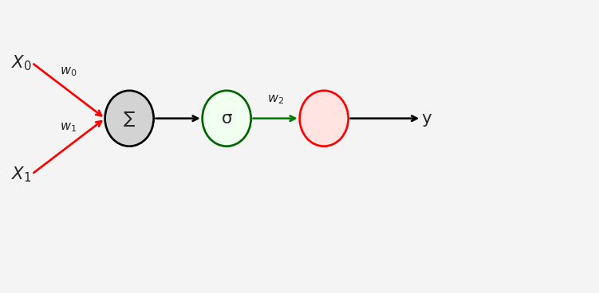

The loss function in this case MSE: Mean Squared Error

import torch   
n = 50   
# Creating n=50 random X values from the standard normal distribution  
X = torch.randn(n,1)   
# y = mX + c + noise. Here m=1, c = 0, noise = N(0,1)/2  
y = X + torch.randn(n,1)/2   
  
plt.plot(X,y, 'ro')  
plt.xlabel('X')  
plt.ylabel('y')  
plt.show()

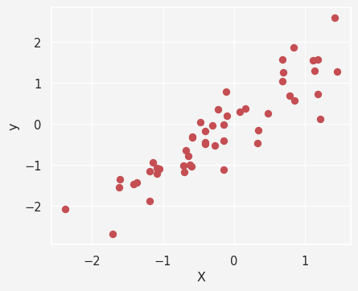

Now the model

import numpy as np  
import torch.nn as nn   
  
ANN_regressor = nn.Sequential(  
 nn.Linear(1,1), # Input Layer   
 nn.ReLU(), # Rectified Linear Unit (ReLU) activation function  
 nn.Linear(1,1) # Output Layer  
)   
ANN_regressor

Sequential(  
 (0): Linear(in_features=1, out_features=1, bias=True)  
 (1): ReLU()  
 (2): Linear(in_features=1, out_features=1, bias=True)  
)

Next we want to train our model using *Stochastic Gradient Descent* optimizer

lr = 0.05 # Learning rate/stepsize  
loss_function = nn.MSELoss() # MSE loss function   
optimizer = torch.optim.SGD( # SGD Optimizer  
 ANN_regressor.parameters(),   
 lr=lr  
)  
  
training_epochs = 500 # Epochs  
losses = torch.zeros(training_epochs) # Creating 1D zero vector of size 500  
  
# Train the model   
  
for epoch in range(training_epochs):  
  
 # forward pass   
 pred = ANN_regressor(X)  
  
 # compute the loss  
 loss = loss_function(pred, y)  
 losses[epoch] = loss  
  
 # back propagation   
 optimizer.zero_grad()  
 loss.backward()  
 optimizer.step()  
  
predictions = ANN_regressor(X)  
test_loss = (predictions - y).pow(2).mean()  
  
plt.plot(losses.detach())  
plt.plot(training_epochs, test_loss.detach(), 'ro')  
plt.title('Final Loss = %g' %test_loss.item())  
plt.xlabel('Epoch')  
plt.ylabel('Loss')  
plt.show()

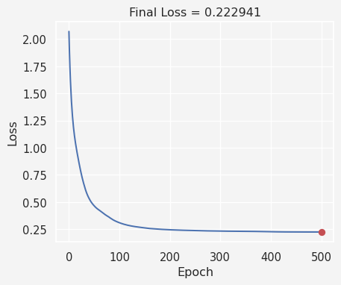

Now let’s calculate the predictions

plt.plot(X,y, 'ro', label = 'Data')  
plt.plot(X,predictions.detach(), 'bs', label='Predictions')  
plt.legend()  
plt.show()

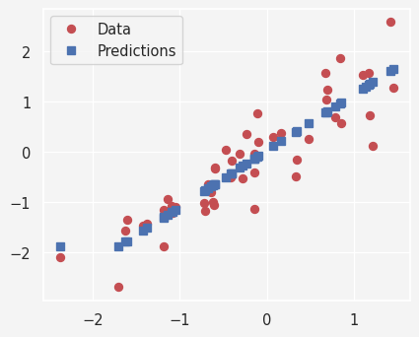

Putting all together

def ann_reg(X,y):  
 model = nn.Sequential(  
 nn.Linear(1,1),  
 nn.ReLU(),  
 nn.Linear(1,1)  
 )  
 loss_function = nn.MSELoss()  
 optimizer = torch.optim.SGD(model.parameters(), lr=0.05)  
 training_epochs = 500  
  
 losses = torch.zeros(training_epochs)  
  
 for epoch in range(training_epochs):  
 pred = model(X)  
  
 loss = loss_function(pred, y)  
 losses[epoch] = loss   
  
 optimizer.zero_grad()  
 loss.backward()  
 optimizer.step()  
   
 return model(X), losses  
  
def data(m):  
 X = torch.randn(50,1)  
 y = m*X + torch.randn(50,1)/2  
  
 return X, y   
  
slopes = np.linspace(-2,2,21)  
  
train = 30  
  
results = np.zeros((len(slopes), train,2))  
  
for m in range(len(slopes)):  
 for t in range(train):  
 X,y = data(slopes[m])  
 prediction,loss = ann_reg(X,y)  
 results[m, t, 0] = loss[-1]  
 results[m, t, 1] = np.corrcoef(y.T,prediction.detach().T)[0,1]  
  
results[np.isnan(results)]=0  
  
fig, ax = plt.subplots(1,2, figsize=(8,4))  
  
ax[0].plot(slopes, np.mean(results[:,:,0], axis=1),'ko-')  
ax[0].set_xlabel('Slope')  
ax[0].set_title('Loss')  
  
ax[1].plot(slopes, np.mean(results[:,:,1],axis=1),'ms-')  
ax[1].set_xlabel('Slope')  
ax[1].set_ylabel('Real vs Predicted correlation')  
ax[1].set_title('Model Performance')  
plt.show()

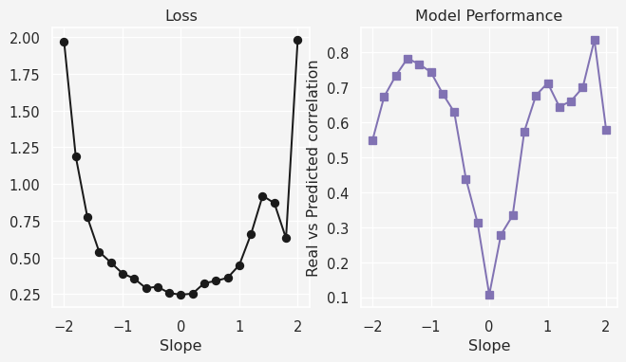

**Share on**

**You may also like**