Support Vector Machine (SVM) Algorithm

Rafiq Islam

2024-11-05

Table of contents

## Introduction

Support Vector Machines (SVM) is a powerful non-parametric supervised machine learning algorithm used for classification and, less commonly, regression tasks. Support Vector Machines are designed to find an optimal hyperplane that best separates data points into classes. The key idea behind SVMs is to maximize the margin between data points of different classes while minimizing classification errors. This leads to a robust decision boundary that generalizes well to unseen data.

## The Mathematical Foundation of SVM

Consider a classification problem. Given a dataset $\left(x_{i},y_{i}\right)$ where $i=1,2,…,N$, $x_{i}∈R^{d}$ represents the feature vector of the $i$-th sample, and $y_{i}∈\{−1,1\}$ represents the class label. The goal of SVM is to find a hyperplane that maximally separates the classes.

### Hyperplane and Dicision Boundary

Definition (Hyperplane)

A hyperplane in an $n$-dimensional space is defined by:

$$w^{T}x+b=0$$

where:

* $w$ is the weight vector,
* $b$ is the bias term,
* $x$ is any point on the hyperplane.

For a two-dimensional space, this hyperplane is simply a line.

$$
w^T\mathbf{x}+b=0;\hspace{4mm}\implies w_0x+w_1y+b=0;\hspace{4mm}\implies y=\frac{-w_0x-b}{w_1}
$$

and for a three-dimensional space, this hyperplane is simply a 2D plane

$$
w^T\mathbf{x}+b=0;\hspace{4mm}\implies w_0x+w_1y+w_2z+b=0;\hspace{4mm}\implies z=\frac{-w_0x-w_1y-b}{w_2}
$$

import numpy as np  
import matplotlib.pyplot as plt  
from mpl_toolkits.mplot3d import Axes3D  
  
w_2d = np.array([1,1])  
b_2d = -0.5  
  
w_3d = np.array([1,1,1])  
b_3d = -1  
  
def decision_boundary_2d(x):  
 return (-w_2d[0]*x-b_2d) / w_2d[1]  
  
def decision_boundary_3d(x, y):  
 return (-w_3d[0]*x-w_3d[1]*y-b_3d) / w_3d[2]  
  
np.random.seed(0)  
class1x_2d = np.random.normal(loc=[1,1],scale=0.5, size=(30,2))  
class2x_2d = np.random.normal(loc=[-1,-1],scale=0.5, size=(30,2))  
  
class1x_3d = np.random.normal(loc=[1,1,1],scale=0.5, size=(90,3))  
class2x_3d = np.random.normal(loc=[-1,-1,-1],scale=0.5, size=(90,3))  
  
fig = plt.figure( figsize=(7.9,4))  
ax1 = fig.add_subplot(121)  
x_vals_2d = np.linspace(-2,3,100)  
plt.plot(  
 x_vals_2d, decision_boundary_2d(x_vals_2d),  
 'k-', label = "Decision Boundary (Hyperplane)"  
 )  
ax1.scatter(  
 class1x_2d[:,0], class1x_2d[:,1], color='blue',  
 marker='o', label = 'Class +1'  
 )  
ax1.scatter(  
 class2x_2d[:,0], class2x_2d[:,1], color='red',  
 marker='o', label = 'Class -1'  
 )  
ax1.set_xlabel('x')  
ax1.set_ylabel('y')  
ax1.set_title('Hyperplane (a line) in 2D Space')  
ax1.axhline(0, color='grey', lw = 0.5)  
ax1.axvline(0, color='grey', lw = 0.5)  
  
  
ax2 = fig.add_subplot(122, projection = '3d')  
x_vals_3d = np.linspace(-2,2,30)  
y_vals_3d = np.linspace(-2,2,30)  
X, Y = np.meshgrid(x_vals_3d, y_vals_3d)  
Z = decision_boundary_3d(X, Y)  
  
ax2.plot_surface(X, Y, Z, color='k', alpha = 0.3, rstride=100, cstride=100, edgecolor='none')  
ax2.scatter(class1x_3d[:,0], class1x_3d[:,1],class1x_3d[:,2], color = 'blue', marker='o', label='Class +1')  
ax2.scatter(class2x_3d[:,0], class2x_3d[:,1],class2x_3d[:,2], color = 'red', marker='o', label='Class -1')  
ax2.set_xlabel('X')  
ax2.set_ylabel('Y')  
ax2.set_zlabel('Z')  
ax2.set_title('Hyperplane (a 2D plate) in 3D Space')  
  
plt.tight_layout()  
axes = [ax1,ax2]  
for ax in axes:  
 ax.set_facecolor('#f4f4f4')  
plt.gcf().patch.set_facecolor('#f4f4f4')  
plt.show()

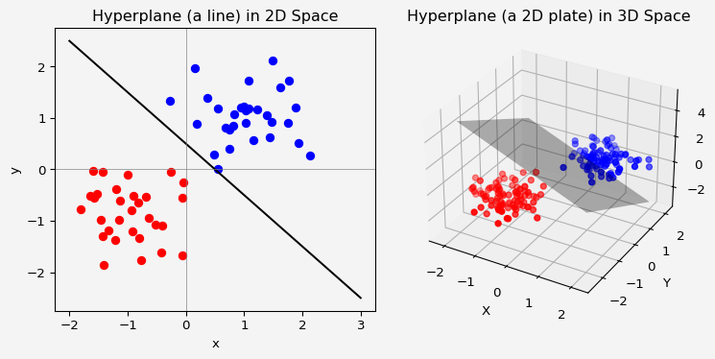

### Margin and the Optimal Hyperplane

Definition (Margin)

The margin is the distance between the hyperplane and the nearest data points from either class. SVM aims to maximize this margin to achieve better separation, which makes the classifier more robust.

To define the margin mathematically, we impose that for all points:

$$y_{i}\left(w^{T}x_{i}+b\right)≥1 ∀i$$

For a data vector $x_{i}$ with label $y_{i}$:

* If $y_{i}=+1$: we want $w^{T}x_{i}+b≥1$ (to be on the correct side of the hyperplane)
* If $y_{i}=−1$: we want $w^{T}x_{i}+b≤1$ (to be on the correct side of the hyperplane)

These two conditions combaine the equation mention above. That is all points must be at least a unit distance from the hyperplane on the correct side. The data points that satisfy $y_{i}\left(w^{T}x_{i}+b\right)=1$ or $y_{i}\left(w^{T}x_{i}+b\right)=−1$ lie on the “support vectors,” or the points closest to the hyperplane.

We know from the elementary geometry that the distance between two parallel lines $ax+by+c_{1}=0$ and $ax+by+c_{2}=0$ is given by

$$\frac{\left|c_{1}−c_{2}\right|}{\sqrt{a^{2}+b^{2}}}$$

and the distance between two 2D parallel planes $ax+by+cz+d_{1}=0$ and $ax+by+cz+d_{2}=0$ in 3D space is given as

$$\frac{\left|d_{1}−d_{2}\right|}{\sqrt{a^{2}+b^{2}+c^{2}}}$$

import plotly.graph_objects as go  
import plotly.io as pio  
pio.renderers  
  
z1 = np.array([  
 [8.83,8.89,8.81,8.87,8.9,8.87],  
 [8.89,8.94,8.85,8.94,8.96,8.92],  
 [8.84,8.9,8.82,8.92,8.93,8.91],  
 [8.79,8.85,8.79,8.9,8.94,8.92],  
 [8.79,8.88,8.81,8.9,8.95,8.92],  
 [8.8,8.82,8.78,8.91,8.94,8.92],  
 [8.75,8.78,8.77,8.91,8.95,8.92],  
 [8.8,8.8,8.77,8.91,8.95,8.94],  
 [8.74,8.81,8.76,8.93,8.98,8.99],  
 [8.89,8.99,8.92,9.1,9.13,9.11],  
 [8.97,8.97,8.91,9.09,9.11,9.11],  
 [9.04,9.08,9.05,9.25,9.28,9.27],  
 [9,9.01,9,9.2,9.23,9.2],  
 [8.99,8.99,8.98,9.18,9.2,9.19],  
 [8.93,8.97,8.97,9.18,9.2,9.18]  
])  
  
z2 = z1 + 1  
z3 = z1 - 1  
  
fig = go.Figure(data=[  
 go.Surface(z=z1),  
 go.Surface(z=z2, showscale=False, opacity=0.9),  
 go.Surface(z=z3, showscale=False, opacity=0.9)  
  
])  
fig.update_layout(  
 scene=dict(  
 xaxis=dict(backgroundcolor='#f4f4f4'),  
 yaxis=dict(backgroundcolor='#f4f4f4'),  
 zaxis=dict(backgroundcolor='#f4f4f4')  
 ),  
 paper_bgcolor = '#f4f4f4',  
 title = "Hyperplanes in higher dimension"  
)  
fig.show()

Unable to display output for mime type(s): text/html

Unable to display output for mime type(s): text/html

For the hyperplanes in higher dimensions, the distance between two parallel hyperplanes $w^{T}x+b=1$ and $w^{T}x+b=−1$ is given as

$$\text{Distance: }M=\frac{\left|1−\left(−1\right)\right|}{∥w∥}=\frac{2}{∥w∥}$$

This distance, $M$ is the margin and our objective is to maximize $M$, or equivalently, minimize $∥w∥$ subject to the constraints $y_{i}\left(w^{T}x_{i}+b\right)≥1$.

### Optimization of the SVM

The optimization problem can be formulated as follows:

**Primal Form:**

$$\min_{w,b}\frac{1}{2}∥w∥^{2}$$

subject to:

$$y_{i}\left(w^{T}x_{i}+b\right)≥1, ∀i$$

This is a convex optimization problem because the objective function $\frac{1}{2}∥w∥^{2}$ is convex, and the constraints are linear.

### The Dual Form of SVM

To solve the optimization problem, it is often more efficient to use the dual form. By introducing Lagrange multipliers $α_{i}≥0$, we can construct the Lagrangian:

$$L\left(w,b,α\right)=\frac{1}{2}∥w∥^{2}−\sum_{i=1}^{n}{α_{i}}\left(y_{i}\left(w^{T}x_{i}+b\right)−1\right)$$

Taking the partial derivatives of $L$ with respect to $w$ and $b$ and setting them to zero yields:

This tells us that $w$ can be expressed as a linear combination of the training points $x_{i}$ with weights given by $α_{i}y_{i}$ and the sum of the weighted labels is zero.

Now we substitute $w=\sum_{i=1}^{n}{α_{i}}y_{i}x_{i}$ back into the Lagrangian $L\left(w,b,α\right)$. The primal objective function $\frac{1}{2}∥w∥^{2}$ becomes:

Substituting back into the Lagrangian,

$$L\left(w,b,α\right)=\frac{1}{2}∥w∥^{2}−\sum_{i=1}^{n}{α_{i}}y_{i}\left(w^{T}x_{i}+b\right)+\sum_{i=1}^{n}{α_{i}}$$

we get the dual form as:

$$\max_{α}\sum_{i=1}^{n}{α_{i}}−\frac{1}{2}\sum_{i=1}^{n}{\sum_{j=1}^{n}{α_{i}}}α_{j}y_{i}y_{j}x_{i}^{T}x_{j}$$

subject to:

$$α_{i}≥0 ∀i, \text{and} \sum_{i=1}^{n}{α_{i}}y_{i}=0$$

The solution to the dual form gives the values of $α_{i}$, which are used to construct the optimal hyperplane. The final decision boundary is then:

$$f\left(x\right)=\text{sign}\left(\sum_{i=1}^{N}{α_{i}}y_{i}x_{i}^{T}x+b\right)$$

## Nonlinear Support Vector Machines

Imagine we have a dataset that looks like this.

from sklearn.datasets import make_moons  
X,y = make_moons(n_samples=300, noise=0.2, random_state=42)  
plt.figure(figsize=(8,6))  
plt.scatter(X[y==0][:,0], X[y==0][:,1], color='red', label='Class 0')  
plt.scatter(X[y==1][:,0], X[y==1][:,1], color='blue', label='Class 1')  
plt.xlabel('Feature 1')  
plt.ylabel('Feature 2')  
plt.legend()  
plt.gca().set_facecolor('#f4f4f4')  
plt.gcf().patch.set_facecolor('#f4f4f4')  
plt.show()

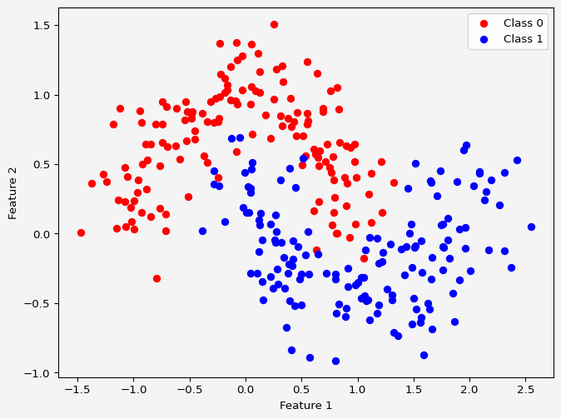

There is now way that a linear hyperplane seperates the data. Therefore, when the data is not linearly separable, SVMs use the **kernel trick** to map the data into a higher-dimensional space where a linear separation is possible. The idea is to map the original data points $x$ from the input space to a higher-dimensional feature space using a *feature transformation function $ϕ\left(x\right)$.

For example,

$$
\phi: \mathbb{R}^n\mapsto \mathbb{R}^m, \hspace{4mm} \text{where } m>n
$$

In the higher-dimensional space, it’s often easier to find a hyperplane that separates the two classes linearly. However, explicitly calculating and working with this higher-dimensional transformation $ϕ\left(x\right)$ can be computationally expensive, especially when the dimensionality $m$ is very high or infinite. This is where the **kernel trick** comes in.

### The Kernel Trick

The **kernel trick** is a method that allows us to compute the inner product between two transformed data points $ϕ\left(x_{i}\right)$ and $ϕ\left(x_{j}\right)$ in the higher-dimensional space **without** explicitly computing the transformation $ϕ\left(x\right)$. Instead of computing $ϕ\left(x_{i}\right)$ and $ϕ\left(x_{j}\right)$ separately and then taking their inner product, we define a **kernel function $K\left(x_{i},x_{j}\right)$** that directly computes this inner product in the higher-dimensional space:

$$K\left(x_{i},x_{j}\right)=ϕ{\left(x_{i}\right)}^{T}ϕ\left(x_{j}\right)$$

By substituting this kernel function into the SVM optimization problem, we can work in the higher-dimensional space implicitly, without ever explicitly mapping the data points to that space. This allows us to handle complex, nonlinear decision boundaries with a more computationally efficient approach.

#### Polynomial Kernel

The polynomial kernel allows us to model nonlinear decision boundaries using polynomial functions. It is defined as:

$$K\left(x_{i},x_{j}\right)={\left(x_{i}^{T}x_{j}+c\right)}^{d}$$

where:

* $c$ is a constant that controls the influence of higher-order terms.
* $d$ is the degree of the polynomial.

The polynomial kernel creates a feature space that corresponds to all monomials up to degree $d$. It can model interactions between features, allowing the SVM to classify data with polynomial decision boundaries.

For example, when we have 1-D data and it is linearly inseperable, we can use polynomial kernel with degree 2 or higher. Say $c=1/2$ and $d=2$,

x1 = list(range(1,11))  
x2 = list(range(14,24))  
x3 = list(range(27,37))  
x = [j for sub in [x1,x2,x3] for j in sub]  
y = [0]*30  
colors = ['blue']*10+['red']*10+ ['blue']*10  
y_squared = [i**2 for i in x]  
slope = (197-529.5)/(14-23)  
line_x = np.linspace(0,40,100)  
line_y = slope* (line_x - 14) + 197  
  
fig = plt.figure(figsize=(7.9,4))  
ax1 = fig.add_subplot(121)  
ax1.scatter(x,y, c=colors, label='Actual Data in 1D')  
ax1.set_xlabel(r'$feature$')  
ax1.set_xlim(0,40)  
ax1.set_ylim(-50,50)  
  
ax2 = fig.add_subplot(122)  
ax2.scatter(x,y, c=colors, label='Actual Data in 1D')  
ax2.scatter(x,y_squared, c= colors, marker='o', label='Transformed Data in 2D')  
ax2.plot(line_x,line_y, color='green',label='1D Hyperplane')  
ax2.set_xlim(0,40)  
ax2.set_ylim(-100,1400)  
ax2.set_xlabel(r'$feature$')  
ax2.set_ylabel(r'$feature^2$')  
ax2.legend()  
  
plt.tight_layout()  
axes = [ax1,ax2]  
for ax in axes:  
 ax.set_facecolor('#f4f4f4')  
plt.gcf().patch.set_facecolor('#f4f4f4')  
plt.show()

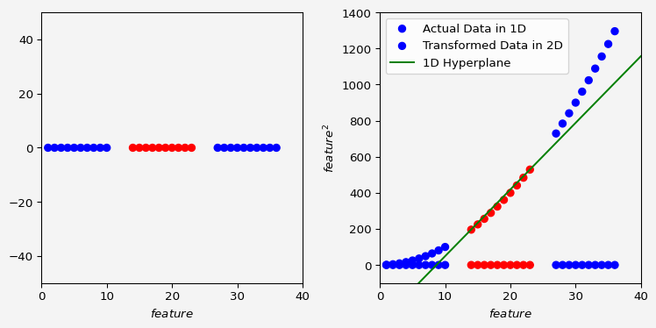

or for a 2D data to 3D transformation along with 2D hyperplane

from sklearn.datasets import make_circles  
from mpl_toolkits.mplot3d import Axes3D  
  
# Generate a dataset that is not linearly separable  
X, y = make_circles(n_samples=300, factor=0.3, noise=0.1, random_state=42)  
  
# Plot the original dataset  
fig = plt.figure(figsize=(7.9, 4))  
ax1 = fig.add_subplot(121)  
ax1.scatter(X[y == 0][:, 0], X[y == 0][:, 1], color='red', label='Class 0')  
ax1.scatter(X[y == 1][:, 0], X[y == 1][:, 1], color='blue', label='Class 1')  
ax1.set_title('Original Data')  
ax1.set_xlabel('feature 1')  
ax1.set_ylabel('feature 2')  
ax1.legend()  
  
# Apply polynomial kernel transformation  
X_transformed = np.hstack((X, (X[:, 0]**2 + X[:, 1]**2).reshape(-1, 1)))  
  
# Plot the transformed dataset in 3D  
ax2 = fig.add_subplot(122, projection='3d')  
ax2.scatter(X_transformed[y == 0][:, 0], X_transformed[y == 0][:, 1], X_transformed[y == 0][:, 2], color='red', label='Class 0')  
ax2.scatter(X_transformed[y == 1][:, 0], X_transformed[y == 1][:, 1], X_transformed[y == 1][:, 2], color='blue', label='Class 1')  
ax2.set_title('2D to 3D transformed')  
ax2.set_xlabel('Feature 1')  
ax2.set_ylabel('Feature 2')  
ax2.set_zlabel('Poly Feature')  
ax2.legend()  
  
axes = [ax1, ax2]  
for ax in axes:  
 ax.set_facecolor('#f4f4f4')  
plt.gcf().patch.set_facecolor('#f4f4f4')  
plt.show()

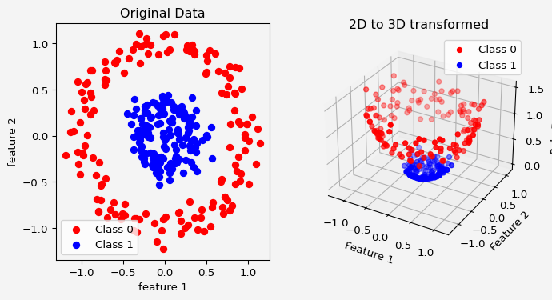

#### Radial Basis Function (RBF) Kernel (Gaussian Kernel)

The RBF kernel, also known as the Gaussian kernel, is one of the most popular kernels because it can map the data to an infinite-dimensional space, allowing the model to capture highly complex relationships. It’s defined as:

$$K\left(x_{i},x_{j}\right)=exp\left(−\frac{∥x_{i}−x_{j}∥^{2}}{2σ^{2}}\right)$$

or equivalently:

$$K\left(x_{i},x_{j}\right)=exp\left(−γ∥x_{i}−x_{j}∥^{2}\right)$$

where:

* $∥x_{i}−x_{j}∥^{2}$ is the squared Euclidean distance between the points $x_{i}$ and $x_{j}$.
* $σ$ (or $γ=\frac{1}{2σ^{2}}$) controls the width of the Gaussian function and, thus, the influence of each training example.

The RBF kernel is particularly effective when the relationship between classes is highly nonlinear. It maps each data point to an infinite-dimensional space, allowing the SVM to capture fine-grained patterns.

#### Sigmoid Kernel

The sigmoid kernel is related to neural networks and is defined as:

$$K\left(x_{i},x_{j}\right)=tanh\left(κx_{i}^{T}x_{j}+θ\right)$$

where:

* $κ$ and $θ$ are parameters that control the shape of the kernel.

This kernel can be interpreted as simulating a neural network with a single hidden layer, where $tanh$ serves as the activation function.

### Dual Formulation with the Kernel Trick

In the dual form of the SVM optimization problem, we only require the inner products $x_{i}^{T}x_{j}$ between data points. By replacing these inner products with $K\left(x_{i},x_{j}\right)=ϕ{\left(x_{i}\right)}^{T}ϕ\left(x_{j}\right)$, we obtain the dual form of the optimization problem for a kernelized SVM:

$$\max_{α}\sum_{i=1}^{n}{α_{i}}−\frac{1}{2}\sum_{i=1}^{n}{\sum_{j=1}^{n}{α_{i}}}α_{j}y_{i}y_{j}K\left(x_{i},x_{j}\right)$$

subject to:

$$α_{i}≥0 ∀i, \text{and} \sum_{i=1}^{n}{α_{i}}y_{i}=0$$

Using the kernel function $K\left(x_{i},x_{j}\right)$, we can compute the decision boundary in the original space without explicitly mapping to the higher-dimensional space.

### Decision Function with the Kernel Trick

Once we solve for $α$ and determine the support vectors, the decision function for a new point $x$ becomes:

$$f\left(x\right)=\sum_{i=1}^{n}{α_{i}}y_{i}K\left(x_{i},x\right)+b$$

where:

* $α_{i}$ are the Lagrange multipliers found from the optimization.
* $y_{i}$ are the labels of the support vectors.
* $K\left(x_{i},x\right)$ is the kernel function that calculates the inner product between the support vector $x_{i}$ and the new data point $x$.

This decision function allows us to classify new data points by evaluating their relationship with the support vectors in the original input space, using the kernel to measure similarity.

### Soft Margin SVM

The concept of **soft margin SVM** extends the hard margin SVM approach to handle cases where data is not perfectly separable. In real-world datasets, it’s often impossible to perfectly separate classes without allowing some misclassification or overlap. Soft margin SVM addresses this by introducing a **margin of tolerance**—it allows some data points to lie within the margin or even on the wrong side of the decision boundary.

In hard margin SVM, we strictly enforced that:

$$y_{i}\left(w^{T}x_{i}+b\right)≥1, ∀i$$

which means that each point is correctly classified and outside the margin.

In soft margin SVM, we introduce **slack variables $ξ_{i}$** , which allow some points to violate this constraint. The constraints become:

$$y_{i}\left(w^{T}x_{i}+b\right)≥1−ξ_{i}, ξ_{i}≥0$$

where:

* $ξ_{i}$ measures the degree of misclassification for each data point $x_{i}$.
* If $ξ_{i}=0$, then $x_{i}$ lies on or outside the margin (correct classification).
* If $0<ξ_{i}≤1$, then $x_{i}$ lies within the margin but is still correctly classified.
* If $ξ_{i}>1$, then $x_{i}$ is misclassified.

To find the optimal hyperplane with a soft margin, we modify the objective function to include a **penalty** for misclassifications. The goal is to balance maximizing the margin and minimizing the misclassification error. The objective function becomes:

$$\min_{w,b,ξ} \frac{1}{2}∥w∥^{2}+C\sum_{i=1}^{n}{ξ_{i}}$$

where:

* The term $\frac{1}{2}∥w∥^{2}$ encourages a large margin, just as in hard margin SVM.
* The term $C\sum_{i=1}^{n}{ξ_{i}}$ penalizes misclassified points, where $C$ is a **regularization parameter** that controls the trade-off between maximizing the margin and minimizing the classification error.

The **parameter $C$** :

* If $C$ is large, the optimization emphasizes minimizing misclassifications (more sensitive to individual data points), which leads to a narrower margin with fewer violations.
* If $C$ is small, the optimization focuses more on maximizing the margin, allowing more misclassifications.

The optimization problem for soft margin SVM can be written as:

$$\min_{w,b,ξ} \frac{1}{2}∥w∥^{2}+C\sum_{i=1}^{n}{ξ_{i}}$$

subject to:

$$y_{i}\left(w^{T}x_{i}+b\right)≥1−ξ_{i}, ξ_{i}≥0 ∀i$$

This problem is still convex and can be solved using Lagrange multipliers, though it becomes slightly more complex due to the introduction of slack variables $ξ_{i}$.

The dual form of the soft margin SVM, similar to the hard margin case, can be derived using Lagrange multipliers. The dual problem becomes:

$$\max_{α}\sum_{i=1}^{n}{α_{i}}−\frac{1}{2}\sum_{i=1}^{n}{\sum_{j=1}^{n}{α_{i}}}α_{j}y_{i}y_{j}K\left(x_{i},x_{j}\right)$$

subject to:

$$0≤α_{i}≤C, \sum_{i=1}^{n}{α_{i}}y_{i}=0$$

The main difference here is that each $α_{i}$ is now bounded by $C$ instead of being unrestricted, which introduces a balance between the margin maximization and error tolerance.

In soft margin SVM, the margin is not strict. Some points are allowed to lie within the margin or even be misclassified. Points that lie on the wrong side of the margin are called **support vectors** with non-zero slack values $ξ_{i}$.

* **High $C$** : A larger $C$ results in a narrower margin with fewer violations, meaning fewer points within the margin or misclassified. This leads to a more complex model that might overfit if $C$ is too high.
* **Low $C$** : A smaller $C$ results in a wider margin with more allowed violations, meaning more tolerance to misclassifications. This generally leads to a simpler, more robust model that might underfit if $C$ is too low.

The regularization parameter $C$ controls the trade-off between margin width and classification accuracy. **Cross-validation** is commonly used to select the optimal value of $C$ by evaluating the model’s performance across different values of $C$ and choosing the one that generalizes best to unseen data.

import numpy as np  
import matplotlib.pyplot as plt  
from sklearn import svm  
from sklearn.datasets import make_blobs  
  
# Generate synthetic dataset  
X, y = make_blobs(n_samples=40, centers=2, random_state=6)  
y = np.where(y == 0, -1, 1) # Transform labels to -1 and +1 for SVM  
  
# Different values of C for comparison  
C_values = [0.1, 1, 100]  
  
# Plotting  
plt.figure(figsize=(6, 15)) # Adjust figure size for vertical layout  
plt.gcf().patch.set_facecolor('#f4f4f4') # Set background color for the figure  
  
for i, C in enumerate(C_values):  
 # Fit SVM model with the given C value  
 model = svm.SVC(kernel='linear', C=C)  
 model.fit(X, y)  
   
 # Create a mesh to plot decision boundaries  
 x_min, x_max = X[:, 0].min() - 1, X[:, 0].max() + 1  
 y_min, y_max = X[:, 1].min() - 1, X[:, 1].max() + 1  
 xx, yy = np.meshgrid(np.linspace(x_min, x_max, 200), np.linspace(y_min, y_max, 200))  
   
 # Plot decision boundary and margin  
 Z = model.decision_function(np.c_[xx.ravel(), yy.ravel()])  
 Z = Z.reshape(xx.shape)  
   
 ax = plt.subplot(len(C_values), 1, i + 1) # Adjust to create vertical subplots  
 ax.set_facecolor('#f4f4f4') # Set background color for the plot area  
 plt.contourf(xx, yy, Z, levels=[-1, 0, 1], colors=['#FFAAAA', '#AAAAFF', '#AAAAFF'], alpha=0.3)  
 plt.contour(xx, yy, Z, levels=[-1, 0, 1], linestyles=['--', '-', '--'], colors='k')  
   
 # Plot training points  
 plt.scatter(X[:, 0], X[:, 1], c=y, cmap=plt.cm.bwr, s=30, edgecolors='k')  
 plt.title(f"SVM with Soft Margin (C={C})")  
 plt.xlabel("Feature 1")  
 plt.ylabel("Feature 2")  
   
 # Mark support vectors  
 plt.scatter(model.support_vectors_[:, 0], model.support_vectors_[:, 1], s=100, facecolors='none', edgecolors='k')  
  
plt.suptitle("Effect of Regularization Parameter C on Soft Margin SVM", y=0.96)  
plt.tight_layout(rect=[0, 0, 1, 0.95])  
plt.show()

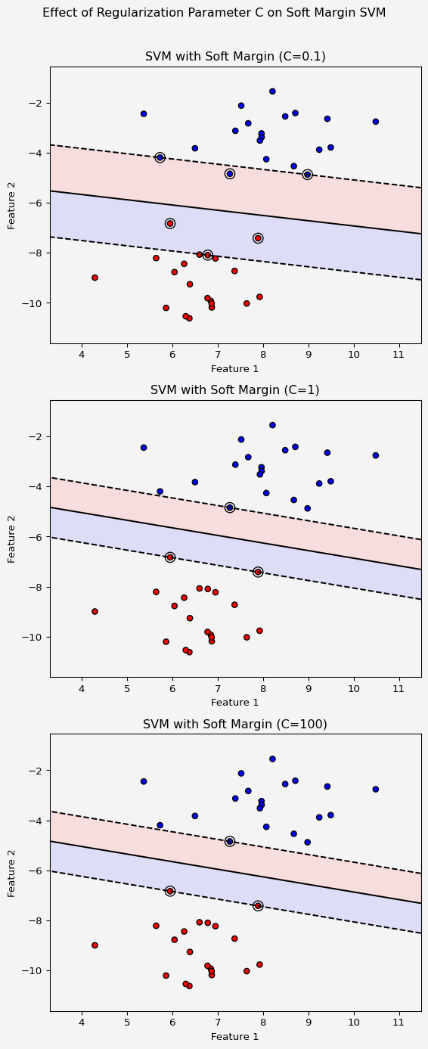

## Python Implementation of SVM

### LinearSVC

Let’s first create the data

np.random.seed(123)  
n_rows = 200  
diff = 0.1  
X1 = np.random.random((n_rows,2))  
X_1 = X1[(X1[:,1]-X1[:,0])<= -diff,:]  
X_2 = X1[(X1[:,1]-X1[:,0])>= diff,:]  
  
X = np.append(X_1, X_2, axis=0)  
y = np.empty(np.shape(X)[0])  
y[(X[:,1]-X[:,0])<= -diff] = -1  
y[(X[:,1]-X[:,0])>= diff] = 1  
plt.scatter(X[y==-1,0], X[y==-1,1], c='blue', label=-1)  
plt.scatter(X[y==1,0], X[y==1,1], c='red', label=1)  
plt.xlabel('$x_1$')  
plt.ylabel('$x_2$')  
plt.grid(True)  
plt.legend()  
plt.gca().set_facecolor('#f4f4f4')  
plt.gcf().patch.set_facecolor('#f4f4f4')  
plt.show()

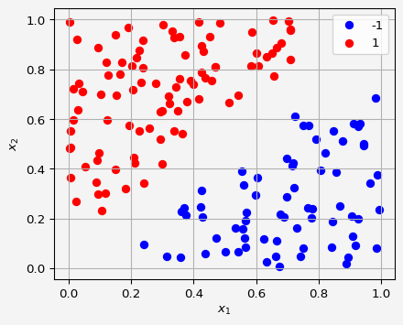

Now we apply linear SVM classifier

from sklearn.svm import LinearSVC  
  
maximum_margin_SVC = LinearSVC(C= 1000, max_iter=10000, dual="auto")  
maximum_margin_SVC.fit(X,y)  
x1 = np.linspace(0,1,100)  
x2 = np.linspace(0,1,100)  
  
x1,x2 = np.meshgrid(x1,x2)  
x1x2 = np.vstack([x1.ravel(),x2.ravel()]).T  
z = maximum_margin_SVC.decision_function(x1x2).reshape(x1.shape)  
  
plt.scatter(X[y==-1,0],X[y==-1,1], c='blue', label='Training -1')  
plt.scatter(X[y==1,0],X[y==1,1], c='red', label='Training 1')  
plt.contour(x1,x2,z, colors='k',levels=[-1,0,1], alpha=0.7, linestyles=['--','-','--'])  
plt.legend()  
plt.xlim(0,1)  
plt.ylim(0,1)  
plt.xlabel('$x_1$')  
plt.ylabel('$x_2$')  
plt.grid(True)  
plt.legend()  
plt.gca().set_facecolor('#f4f4f4')  
plt.gcf().patch.set_facecolor('#f4f4f4')  
plt.show()

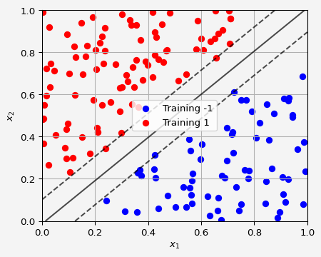

The data that we used to explain the polynomial kernels

from sklearn.svm import SVC  
X = 2*np.random.random(50)-1  
y = np.ones(len(X))  
y[(X>0.35) | (X<-0.35)] = -1  
  
svc = SVC(kernel='poly', degree=2, C=1000)  
svc.fit(X.reshape(-1,1),y)  
plt.scatter(X[y==-1],np.ones(sum(y==-1)), c='blue',label='class -1')  
plt.scatter(X[y==1],np.ones(sum(y==1)), c='red',label='class 1')  
dcsns = svc.decision_function(np.linspace(-1,1,10000).reshape(-1,1)).round(1)  
plt.scatter(  
 np.linspace(-1,1,10000)[dcsns==0],  
 np.ones(10000)[dcsns==0],  
 marker='|',  
 s= 400,  
 c='green',  
 label='Decision Boundary'  
 )  
plt.legend()  
plt.gca().set_facecolor('#f4f4f4')  
plt.gcf().patch.set_facecolor('#f4f4f4')  
plt.show()

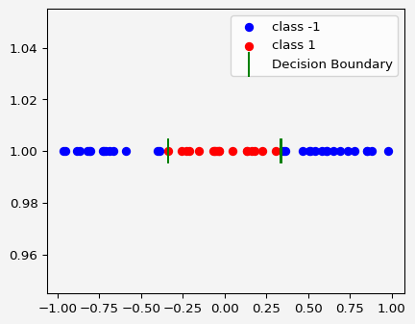

For the higher dimensions

X, y = make_circles(n_samples=300, factor=0.3, noise=0.1, random_state=42)  
  
# Create SVM models with polynomial and RBF kernels  
model_poly = svm.SVC(kernel='poly', degree=2, C=1000)  
model_rbf = svm.SVC(kernel='rbf', gamma=1, C=1000)  
  
# Fit the models  
model_poly.fit(X, y)  
model_rbf.fit(X, y)  
  
# Create a mesh to plot decision boundaries  
x_min, x_max = X[:, 0].min() - 1, X[:, 0].max() + 1  
y_min, y_max = X[:, 1].min() - 1, X[:, 1].max() + 1  
xx, yy = np.meshgrid(np.linspace(x_min, x_max, 300), np.linspace(y_min, y_max, 300))  
  
# Plotting  
plt.figure(figsize=(7.9, 4))  
  
# Polynomial Kernel  
plt.subplot(1, 2, 1)  
Z_poly = model_poly.decision_function(np.c_[xx.ravel(), yy.ravel()])  
Z_poly = Z_poly.reshape(xx.shape)  
plt.contourf(xx, yy, Z_poly, levels=[-1, 0, 1], colors=['#FFAAAA', '#AAAAFF', '#AAAAFF'], alpha=0.3)  
plt.contour(xx, yy, Z_poly, levels=[-1, 0, 1], linestyles=['--', '-', '--'], colors='k')  
plt.scatter(X[:, 0], X[:, 1], c=y, cmap=plt.cm.bwr, s=20, edgecolors='k')  
plt.title("SVM with Polynomial Kernel")  
plt.xlabel("Feature 1")  
plt.ylabel("Feature 2")  
plt.gca().set_facecolor('#f4f4f4')  
  
# RBF Kernel  
plt.subplot(1, 2, 2)  
Z_rbf = model_rbf.decision_function(np.c_[xx.ravel(), yy.ravel()])  
Z_rbf = Z_rbf.reshape(xx.shape)  
plt.contourf(xx, yy, Z_rbf, levels=[-1, 0, 1], colors=['#FFAAAA', '#AAAAFF', '#AAAAFF'], alpha=0.3)  
plt.contour(xx, yy, Z_rbf, levels=[-1, 0, 1], linestyles=['--', '-', '--'], colors='k')  
plt.scatter(X[:, 0], X[:, 1], c=y, cmap=plt.cm.bwr, s=20, edgecolors='k')  
plt.title("SVM with RBF Kernel")  
plt.xlabel("Feature 1")  
plt.ylabel("Feature 2")  
plt.gca().set_facecolor('#f4f4f4')  
  
plt.suptitle("Polynomial and RBF Kernels on Nonlinear Data")  
plt.tight_layout(rect=[0, 0, 1, 0.96])  
plt.gca().set_facecolor('#f4f4f4')  
plt.gcf().patch.set_facecolor('#f4f4f4')  
plt.show()

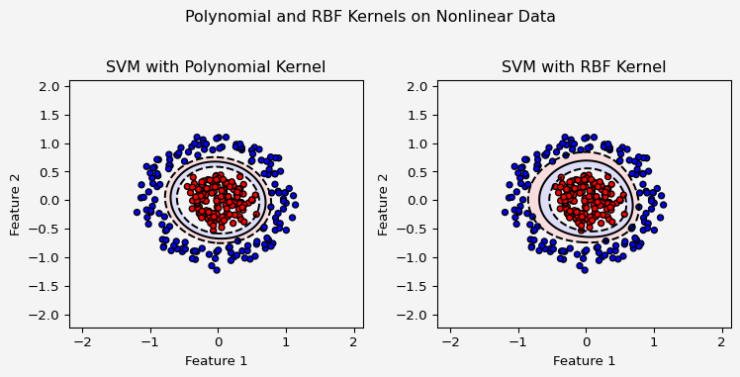

## References

### Books

* Bishop, C. M. (2006). *Pattern Recognition and Machine Learning*. Springer
* Hastie, T., Tibshirani, R., & Friedman, J. (2009). *The Elements of Statistical Learning: Data Mining, Inference, and Prediction*. 2nd Edition. Springer.
* Boyd, S., & Vandenberghe, L. (2004). *Convex Optimization*. Cambridge University Press.
* Schölkopf, B., & Smola, A. J. (2002). *Learning with Kernels: Support Vector Machines, Regularization, Optimization, and Beyond*. MIT Press.
* Murphy, K. P. (2012). *Machine Learning: A Probabilistic Perspective*. MIT Press.
* Vapnik, V. (1998). *Statistical Learning Theory*. Wiley-Interscience.

### Lecture Notes

* Andrew Ng’s *Machine Learning* course on Coursera, particularly the lectures on Support Vector Machines, covering linear SVMs, geometric interpretation, and constraints.
* StatQuest with Josh Starmer
* Data Science Bootcamp by *The Erdos Institute*

### Journals and Articles

* Cortes, C., & Vapnik, V. (1995). “Support-vector networks.” *Machine Learning*, 20(3), 273-297.
* Aizerman, M. A., Braverman, E. M., & Rozonoer, L. I. (1964). “Theoretical foundations of the potential function method in pattern recognition learning.” *Automation and Remote Control*, 25, 821-837.

**Share on**

**You may also like**