|  |  |  |
| --- | --- | --- |
| **F. EXAMPLE PROJECTS WHICH BEST ILLUSTRATE PROPOSED TEAM'S QUALIFICATIONS FOR THIS CONTRACT**  *(Present as many projects as requested by the agency, or 10 projects, if not specified.*  *Complete one Section F for each project.)* | | 20. EXAMPLE PROJECT KEY NUMBER |
| 21. TITLE AND LOCATION *(City and State)*  **[{{!thstd__Project__c.name}}]**  **[{{!thstd__Project__c.thstd__project_address_new__city__s}}], [{{!thstd__Project__c.thstd__project_address_new__statecode__s}}]** | 22. YEAR COMPLETED | |
| PROFESSIONAL SERVICES  **[{{!thstd__Project__c.year_awarded__c}}]** | CONSTRUCTION *(If applicable)*  **[{{!thstd__Project__c.year_completed__c}}]** |

1. PROJECT OWNER'S INFORMATION

|  |  |  |
| --- | --- | --- |
| a. PROJECT OWNER  **[{{!thstd__Project__c.Ultimate_Client__r.name}}]** | b. POINT OF CONTACT NAME (Owner)  **[{{!thstd__Project__c.Owner.name}}]** | c. POINT OF CONTACT TELEPHONE NUMBER  **[{{!thstd__Project__c.project_owner_phone__c}}]** |

1. BRIEF DESCRIPTION OF PROJECT AND RELEVANCE TO THIS CONTRACT *(Include scope, size, and cost)*

**CM Point of Contact:**

[{{!thstd__Project__c.thstd__Project_Contact__r.thstd__formal_name__c}}]

[{{!thstd__Project__c.thstd__Project_Contact__r.email}}]

[{{!thstd__Project__c.thstd__Project_Contact__r.phone ###-###-####}}]

[{{!thstd__Project__c.x330f_description__c}}]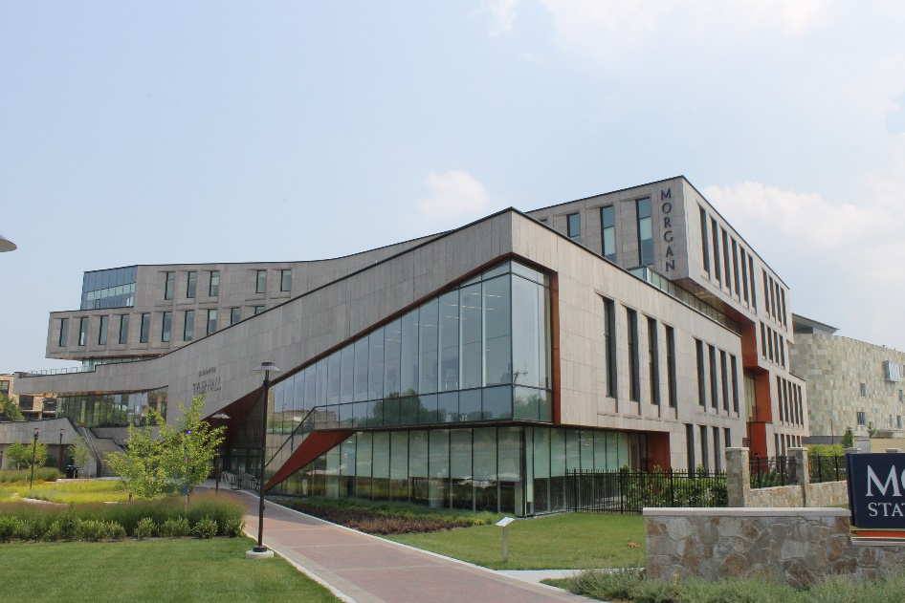

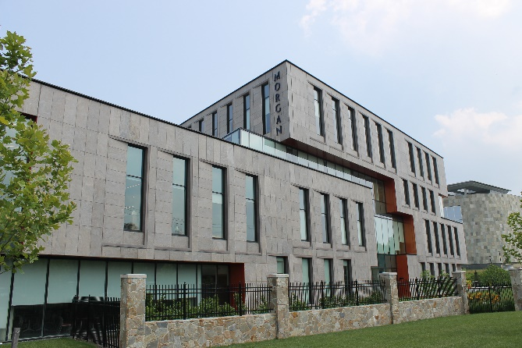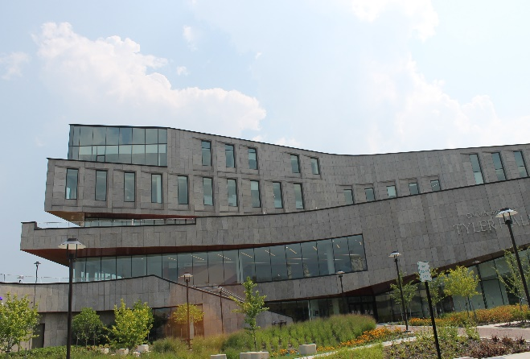

[{{!thstd__Project__c.thstd__services__c}}]

[{{!thstd__Project__c.thstd__size_total_square_feet__c #,###}}] GSF

[{{!thstd__Project__c.leed_level__c}}]

[{{!thstd__Project__c.thstd__delivery_method__c}}]

[{{!thstd__Project__c.thstd__original_contract_amount__c #,###}}]

[{{!thstd__Project__c.thstd__final_contract_amount__c #,###}}]

**Services**

**Project size**

**LEED LEVEL**

**PROJECT DELIVERY**

**fORELLA eSTIMATE**

**actual bid value**

­­

*­_______________________________________________________________________________________*

1. FIRMS FROM SECTION C INVOLVED WITH THIS PROJECT

|  |  |  |  |
| --- | --- | --- | --- |
| **a.** | (1) FIRM NAME  **Forella Group, LLC** | (2) FIRM LOCATION *(City and State)*  **Chantilly, VA** | (3) ROLE  **Cost Management** |

**STANDARD FORM 330** (REV. 8/2016) **PAGE 3**