|  |  |  |
| --- | --- | --- |
| **F. EXAMPLE PROJECTS WHICH BEST ILLUSTRATE PROPOSED TEAM'S QUALIFICATIONS FOR THIS CONTRACT**  *(Present as many projects as requested by the agency, or 10 projects, if not specified.*  *Complete one Section F for each project.)* | | 20. EXAMPLE PROJECT KEY NUMBER |
| 21. TITLE AND LOCATION *(City and State)*  **Vivien T. Thomas Medical Arts Academy, Baltimore City Public Schools**  **,** | 22. YEAR COMPLETED | |
| PROFESSIONAL SERVICES | CONSTRUCTION *(If applicable)* |

1. PROJECT OWNER'S INFORMATION

|  |  |  |
| --- | --- | --- |
| a. PROJECT OWNER | b. POINT OF CONTACT NAME (Owner)  **TrebleHook Admin** | c. POINT OF CONTACT TELEPHONE NUMBER |

1. BRIEF DESCRIPTION OF PROJECT AND RELEVANCE TO THIS CONTRACT *(Include scope, size, and cost)*

**CM Point of Contact:**

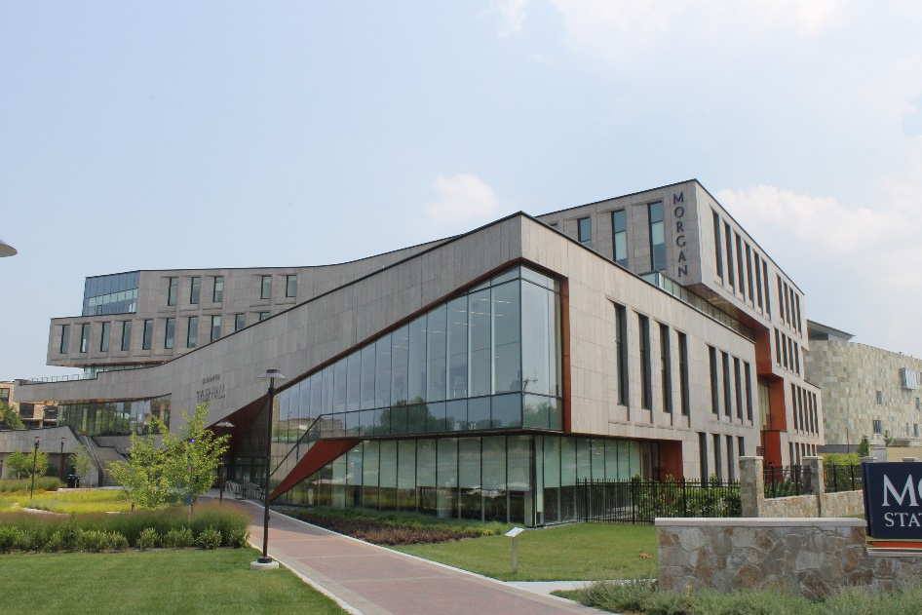

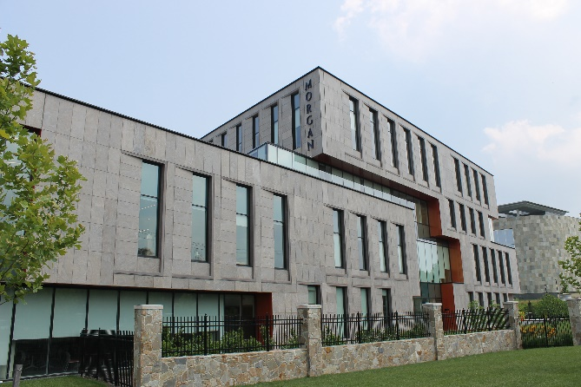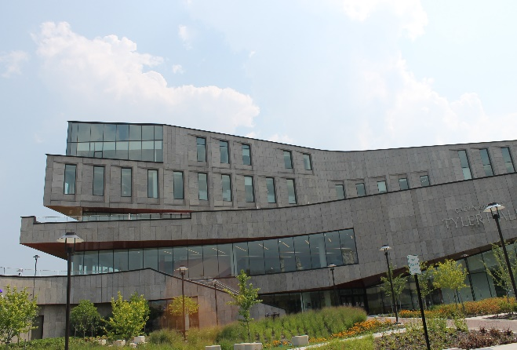

GSF

**Services**

**Project size**

**LEED LEVEL**

**PROJECT DELIVERY**

**fORELLA eSTIMATE**

**actual bid value**

­­

*­_______________________________________________________________________________________*

1. FIRMS FROM SECTION C INVOLVED WITH THIS PROJECT

|  |  |  |  |
| --- | --- | --- | --- |
| **a.** | (1) FIRM NAME  **Forella Group, LLC** | (2) FIRM LOCATION *(City and State)*  **Chantilly, VA** | (3) ROLE  **Cost Management** |

**STANDARD FORM 330** (REV. 8/2016) **PAGE 3**