**Problem Domain Description**

The explosion of digital content has made unstructured data, such as PDF documents, a common storage format for critical information. PDFs are widely used in various domains, including business, education, healthcare, and legal fields, to store reports, contracts, research papers, invoices, and other essential documents. However, extracting meaningful insights or answering specific queries from these documents remains a significant challenge due to their unstructured nature and the lack of advanced tools for efficient content retrieval and analysis.

Traditional methods for searching and extracting information from PDFs rely on keyword-based searches, which often fail to understand the context or locate specific information spread across multiple pages. This limitation makes it time-consuming and inefficient for users to process large volumes of documents. Moreover, scanned PDFs and complex layouts further complicate text extraction, requiring additional preprocessing steps like Optical Character Recognition (OCR).

This project aims to bridge the gap by leveraging advanced AI techniques, including Retrieval-Augmented Generation (RAG) and vector-based similarity search, to create a system that processes PDF documents and enables users to query their content intelligently. By integrating tools like FAISS for vector storage, Google's Generative AI for embedding and conversational responses, and Streamlit for a user-friendly interface, the application provides an efficient and interactive way to gain insights from unstructured documents.

The proposed solution offers a wide range of applications, from analyzing business reports and legal contracts to assisting researchers in summarizing academic papers. It transforms static document data into dynamic, actionable knowledge, empowering users to make informed decisions quickly and accurately.

**Literature Survey**

**1. Introduction to Retrieval-Augmented Generation (RAG)**

Retrieval-Augmented Generation (RAG) combines the strengths of information retrieval and generative modeling to provide accurate and contextually relevant responses. Unlike standalone generative models, which often struggle with factual accuracy, RAG enhances responses by grounding them in retrieved context from a knowledge base.

**Key Studies:**

* Lewis et al. (2020) introduced RAG as a framework that retrieves documents using a dense passage retriever and uses a sequence-to-sequence generative model to produce answers. Their experiments demonstrated significantly improved factual grounding in tasks such as open-domain question answering.
* Guu et al. (2020) explored retrieval-augmented pretraining, showing how integrating retrieval improves both training efficiency and downstream task performance for large language models.

**Applications:**

* RAG has been deployed in customer support systems to answer domain-specific queries by retrieving knowledge base documents and generating responses.
* Academic research platforms use RAG pipelines to assist researchers in summarizing papers or generating insights from multiple documents.

**2. Advances in Vector Databases**

Vector databases are critical components of RAG systems, enabling fast and scalable similarity searches over high-dimensional embeddings. These embeddings represent the semantic meaning of textual data, making them ideal for retrieving contextually relevant documents.

**Key Contributions:**

* **FAISS (Facebook AI Similarity Search):** Developed by Facebook AI Research, FAISS is optimized for high-speed similarity searches, even for large datasets. Its indexing methods, such as HNSW and IVF, balance retrieval accuracy and computational efficiency, making it a popular choice for AI applications.
  + Johnson et al. (2019) highlighted FAISS’s ability to handle billions of vectors while maintaining low latency, making it suitable for large-scale systems.
* **Haystack Framework:** Integrates FAISS with text retrieval pipelines, allowing developers to build hybrid search systems that combine dense vector retrieval with traditional keyword-based approaches.

**Applications in RAG:**

* FAISS has been widely used in enterprise solutions for document retrieval, such as legal document processing and customer support systems.
* It supports real-time recommendation engines by retrieving semantically similar items from a database.

**3. Generative AI for Conversational Interfaces**

Generative AI models have revolutionized conversational AI by providing human-like, coherent, and contextually aware responses. Pre-trained models like GPT-3, T5, and Google’s Gemini Pro leverage billions of parameters and massive datasets to understand and generate text.

**Relevant Studies:**

* **GPT-3 (Brown et al., 2020):** Demonstrated the ability of large language models to handle various NLP tasks, from summarization to translation, without task-specific fine-tuning. However, GPT-3 faced challenges with factual inaccuracies in open-domain applications.
* **Google Gemini Pro (2023):** A state-of-the-art conversational AI model, Gemini Pro excels in multi-turn dialogue and contextually grounded responses, making it suitable for complex question-answering tasks.

**Applications:**

* Conversational AI in customer service for handling repetitive queries or providing detailed explanations.
* Legal advisors powered by generative AI assist in summarizing and analyzing contracts or other legal documents.

**4. Techniques for PDF Parsing and Text Splitting**

Extracting textual information from PDFs is challenging due to their diverse formatting, encoding, and layouts. Parsing tools like PyPDF2 and text-splitting techniques are often necessary for effective data preprocessing.

**Key Insights:**

* **PyPDF2:** A Python library for extracting text and metadata from PDFs. While efficient for text-based PDFs, it struggles with scanned or image-based documents.
* **OCR Systems (e.g., Tesseract):** Used for extracting text from scanned PDFs, but they require preprocessing steps, such as image enhancement, for accuracy.
* **Text Splitting Algorithms:** Recursive splitting methods, such as those in LangChain, divide large documents into manageable chunks based on character count or semantic boundaries. This ensures that generative AI models can process text effectively, as they often have token limits.

**Challenges:**

* Inconsistent formatting in PDFs can lead to incomplete or inaccurate text extraction.
* Scanned documents require additional OCR processing, which may introduce errors.

**5. Retrieval-Augmented Generation in Practice**

RAG is a versatile framework applicable across various domains, providing a unified solution for document retrieval and context-aware response generation.

**Applications:**

1. **Legal Sector:**
   * Automating legal document analysis by retrieving clauses from contracts and generating summaries.
   * Compliance checking by cross-referencing retrieved data with regulatory standards.
2. **Education:**
   * Assisting students and researchers in summarizing academic papers or extracting key insights from lecture notes.
   * Building question-answering systems for e-learning platforms.
3. **Healthcare:**
   * Processing clinical guidelines and medical records to provide recommendations or answers to patient-specific queries.
   * Summarizing lengthy medical reports for doctors and patients.

**Case Studies:**

* **OpenAI’s RAG Pipelines:** Demonstrated how GPT models, combined with retrieval systems, perform better on domain-specific question-answering tasks.
* **Google Cloud Document AI:** Provides document processing pipelines that integrate retrieval and generative AI for intelligent document parsing.

**6. Challenges in Unstructured Document Processing**

Despite advancements, unstructured document processing poses several challenges:

* **Text Extraction:** Inconsistent formatting and scanned documents can hinder accurate text extraction.
* **Embedding Quality:** Generating embeddings that capture domain-specific semantics is non-trivial and often requires fine-tuned models.
* **Retrieval Accuracy:** Balancing precision and recall in similarity searches is crucial for retrieving the most relevant documents.
* **Scalability:** Handling large datasets requires efficient indexing and optimized retrieval pipelines.

**7. Emerging Trends and Future Directions**

* **Cross-Modal Retrieval:** Integrating textual, visual, and tabular data for comprehensive document understanding.
* **Multi-Turn Conversations:** Extending generative AI systems to handle sequential reasoning over multiple documents.
* **Privacy-Preserving AI:** Developing systems that comply with data privacy regulations, especially for sensitive industries like healthcare and finance.
* **Cloud-Based Solutions:** Leveraging cloud platforms like AWS and GCP for scalable deployment of RAG systems.

**Mini Objective & Scope of Project**

**Mini Objectives**

The primary objectives of this project revolve around developing a system that leverages Retrieval-Augmented Generation (RAG) to answer questions based on the content of uploaded PDF documents. The key mini objectives of the project are as follows:

1. **PDF Upload and Text Extraction**
   * **Objective**: Implement a mechanism to upload multiple PDF documents and extract the textual content from them.
   * **Description**: The system must support the upload of multiple PDF files, and efficiently extract readable text from each document using tools like PyPDF2. This process should account for various document structures, such as simple text-based PDFs and complex documents with multiple columns or images.
2. **Text Chunking and Preprocessing**
   * **Objective**: Split the extracted text into smaller, manageable chunks for processing by the AI model.
   * **Description**: The text extracted from the PDFs may be too large for direct input into the AI model due to token limitations. Therefore, the system must chunk the text into smaller pieces using a technique like **Recursive Character Text Splitting**, ensuring meaningful segments are created that preserve the document's logical structure.
3. **Vectorization and Indexing**
   * **Objective**: Convert the text chunks into embeddings and store them in a vector database for efficient similarity-based retrieval.
   * **Description**: The system will use embeddings generated by a model like **Google Generative AI Embeddings** to convert the text chunks into high-dimensional vectors. These vectors will be indexed using a tool like **FAISS** (Facebook AI Similarity Search), which facilitates fast similarity searches, enabling the system to quickly retrieve relevant text chunks in response to a user query.
4. **Integration with Generative AI Model for Answering Questions**
   * **Objective**: Use the vector database to retrieve relevant information and generate precise answers to user queries.
   * **Description**: Upon receiving a user question, the system will query the vector database to retrieve the most relevant text chunks. These chunks will then be fed to a **Generative AI model** (e.g., Google's Gemini Pro) to produce a well-formed response grounded in the retrieved context. The generative model will be fine-tuned to ensure that the answers are both factual and coherent.
5. **User Interface (UI) for Interaction**
   * **Objective**: Develop a simple and intuitive web interface using **Streamlit** that allows users to upload PDFs, ask questions, and receive answers.
   * **Description**: The user interface should be designed for ease of use, allowing users to upload multiple PDF files and enter questions without requiring technical expertise. The interface will display relevant answers generated by the system along with any additional context that can support the answer.
6. **Evaluation and Metrics**
   * **Objective**: Implement metrics to evaluate the system’s performance in terms of accuracy, relevance, and user experience.
   * **Description**: The system's effectiveness will be measured by comparing the answers generated by the model against human-provided answers. Metrics such as **precision**, **recall**, and **F1 score** will be used to assess retrieval accuracy, while **user satisfaction** surveys may gauge the usability of the interface.

**Scope of the Project**

The scope of this project involves the development of a document-based question-answering system that integrates advanced techniques such as **Retrieval-Augmented Generation (RAG)** and **Generative AI** to provide detailed and accurate responses based on the contents of uploaded PDF files. The project aims to bridge the gap between static document storage and dynamic, context-aware answering systems.

1. **PDF Documents**
   * **In-Scope**: The system will support the upload and processing of PDF documents, including text extraction from standard text-based PDFs. Text from PDFs with basic formatting, such as headings, paragraphs, and bullet points, will be processed effectively.
   * **Out-of-Scope**: The system will not support PDF documents that are image-based or require complex OCR (Optical Character Recognition) for text extraction. Preprocessing techniques like OCR, although important, are outside the scope of this current version of the project.
2. **Text Chunking and Preprocessing**
   * **In-Scope**: Text will be split into smaller chunks using a recursive approach to ensure that meaningful context is preserved for generative processing. This step includes preprocessing the text by removing irrelevant sections like headers, footnotes, or excessive formatting.
   * **Out-of-Scope**: Advanced text preprocessing techniques, such as named entity recognition or text classification, are not included in this project. The primary focus is on basic text chunking for better document retrieval.
3. **Vectorization and Indexing**
   * **In-Scope**: The system will use **Google Generative AI Embeddings** to convert the text into high-dimensional vectors and index these vectors using **FAISS** for fast retrieval. The system will support the search and retrieval of text chunks based on semantic similarity to the user’s query.
   * **Out-of-Scope**: The project will not explore alternative vectorization techniques or indexing methods outside of FAISS. Other vector databases or indexing algorithms, such as **Annoy** or **HNSW**, will not be considered.
4. **Generative AI Model for Q&A**
   * **In-Scope**: The system will utilize **Google’s Gemini Pro** (or a similar generative AI model) for generating responses. The model will be fine-tuned to handle document-based question answering, ensuring that the answers generated are grounded in the retrieved text chunks.
   * **Out-of-Scope**: The system will not develop or fine-tune generative models from scratch. It will rely on pre-trained models and embeddings, focusing on integrating them effectively into the RAG framework.
5. **User Interface (UI) and Interaction**
   * **In-Scope**: The project will include the development of a simple, user-friendly interface using **Streamlit**. The interface will allow users to upload multiple PDFs and submit queries. It will also display generated answers to users in a clear and readable format.
   * **Out-of-Scope**: The project will not include advanced user interface features such as multi-language support, complex user authentication, or integration with external databases.
6. **Evaluation and Performance Metrics**
   * **In-Scope**: The project will include the design and implementation of evaluation metrics to assess the system’s performance. These will include both automatic metrics (e.g., precision, recall) and subjective user feedback.
   * **Out-of-Scope**: The project will not involve large-scale user testing or A/B testing to optimize the user interface or model performance beyond basic evaluations.
7. **Scalability and Deployment**
   * **In-Scope**: The system will be designed to process multiple PDF files and answer questions efficiently within the limitations of the tools used (e.g., FAISS for vector indexing).
   * **Out-of-Scope**: The system will not be developed for large-scale deployment on distributed systems or cloud platforms. High-performance or real-time deployments are not part of the current project’s goals.

**Problem Analysis and Requirement Specification**

**Problem Analysis**

**Introduction**

In today's information-heavy world, managing, analyzing, and extracting useful insights from large volumes of text-based documents has become increasingly important. PDF documents, particularly in business and academic settings, are one of the most widely used formats for storing textual information. However, extracting useful, actionable insights from these documents manually can be time-consuming and error-prone. With the growing complexity of modern business environments, there is an increasing need for intelligent systems capable of answering specific queries based on the contents of documents quickly and accurately.

The challenge, however, lies in the ability to process and interpret the complex, unstructured data in these documents. Standard search systems are often unable to provide sufficiently accurate or contextually relevant answers. Traditional document retrieval systems rely on keyword-based searches that might miss important information in large documents. On the other hand, advanced natural language processing (NLP) models like **Generative AI** are capable of producing fluent text but lack the ability to retrieve specific, relevant information from large datasets. This leads to a need for a hybrid approach where document retrieval and generative AI capabilities are integrated to produce more accurate and contextually grounded responses.

**The Problem**

The problem addressed by this project is the difficulty in efficiently retrieving relevant information from uploaded PDF documents and answering user queries in a meaningful way. More specifically, the project focuses on the following challenges:

1. **Text Extraction from PDFs**: PDFs, especially those that are not text-based or have complex layouts, pose a challenge when extracting meaningful text. Even simple PDFs can contain formatting issues, such as headers, footers, or page numbers, which need to be filtered out for clean text extraction.
2. **Contextualized Question-Answering**: Users asking questions based on the document’s content require answers that are both relevant and contextually accurate. Many existing systems rely on keyword matching, which can lead to inadequate responses when documents contain complex or nuanced information.
3. **Document Size and Complexity**: Large documents can exceed the token limits of many generative AI models, making it difficult to process entire documents in a single query. This necessitates breaking down the document into smaller, more manageable chunks while maintaining the context across these chunks.
4. **Efficient Document Retrieval**: Given the vast amount of information in large documents, retrieving the most relevant segments of text is not trivial. A simple search mechanism is insufficient to identify the best answers to specific queries.
5. **User Experience**: Many existing systems require significant technical expertise, limiting their accessibility. The goal is to create a system that allows non-technical users to upload documents, ask questions, and receive answers with minimal complexity.

**Requirement Specification**

**Functional Requirements**

1. **PDF Upload and Text Extraction**:
   * The system should allow users to upload one or more PDF files.
   * The system must extract readable text from these PDFs, handling both simple and complex documents.
   * The system should be able to handle PDFs with varying levels of formatting and structure, ensuring that the textual content is extracted cleanly.
2. **Text Chunking and Preprocessing**:
   * The system should split the extracted text into smaller chunks of text (e.g., paragraphs or sections) to ensure that generative AI models can process the information within token limits.
   * The system should remove extraneous content such as footnotes, page numbers, and headers to ensure the text chunks are relevant.
3. **Vectorization and Indexing**:
   * The extracted text chunks should be converted into vector embeddings using a pre-trained language model (e.g., **Google Generative AI Embeddings**).
   * The system should use a vector store like **FAISS** to index these embeddings for efficient similarity-based retrieval.
   * The index should be optimized to handle both small and large datasets and return relevant results based on semantic similarity.
4. **Generative AI Integration for Question-Answering**:
   * The system should integrate a **Generative AI model** (e.g., **Gemini Pro**) for generating contextually relevant answers based on user queries.
   * The system should retrieve the most relevant text chunks from the vector store based on the user’s question and use these chunks as context for the generative model to produce an answer.
   * The system should ensure that the answers are coherent, factual, and grounded in the provided context.
5. **User Interface (UI)**:
   * The system should provide a simple, intuitive web interface using **Streamlit** to allow users to upload PDFs and input questions.
   * The UI should display answers generated by the system in a clear and readable format.
   * The interface should include a progress indicator to inform users when the system is processing their documents or queries.
6. **Evaluation and Feedback**:
   * The system should include basic metrics to evaluate the quality and accuracy of the answers generated (e.g., precision, recall, and user satisfaction surveys).
   * The system should allow users to provide feedback on the answers, enabling continuous improvement.

**Non-Functional Requirements**

1. **Performance**:
   * The system should handle multiple PDF uploads and process large documents efficiently.
   * The retrieval and generation of answers should be done in a reasonable amount of time, ideally within a few seconds for smaller documents.
   * The system must scale to handle increasing document sizes and user queries without significant performance degradation.
2. **Usability**:
   * The user interface should be simple, intuitive, and designed for non-technical users.
   * The system should minimize the steps required to upload a document and ask questions, making the process seamless.
3. **Scalability**:
   * The system should support an increasing number of uploaded documents and user queries.
   * The underlying infrastructure should be designed to accommodate future growth, including the ability to add more documents to the vector store and improve retrieval accuracy.
4. **Security**:
   * The system must ensure that uploaded documents are not shared with third parties without user consent.
   * User data, including uploaded PDFs and generated answers, should be handled securely, with encryption where necessary.
5. **Maintainability**:
   * The system should be designed to be easy to maintain and update, with clear documentation and modular code.
   * The system should support the easy addition of new features, such as support for additional document types or improvements in the question-answering mechanism.

**System Architecture**

The system will be based on a client-server architecture, where the front-end (Streamlit) will allow users to interact with the back-end (Python-based server). The system components are as follows:

1. **Frontend (Streamlit)**:
   * A simple interface for users to upload PDFs and input questions.
   * Display of answers and relevant context to users.
2. **Backend (Python)**:
   * **PDF Text Extraction**: Uses **PyPDF2** to extract text from uploaded PDFs.
   * **Text Chunking and Preprocessing**: Processes the extracted text into meaningful chunks using **RecursiveCharacterTextSplitter**.
   * **Vectorization**: Embeddings are generated using **Google Generative AI Embeddings** and stored in a **FAISS** vector database.
   * **Question Answering**: A generative AI model (e.g., **Gemini Pro**) is used to generate responses based on the retrieved context.
3. **Storage**:
   * The vector database (FAISS) will be used to store the embeddings of the text chunks for quick retrieval.

**Constraints and Assumptions**

1. **Document Format**:
   * The system assumes that the majority of documents will be text-based PDFs. Documents requiring OCR or image-based text extraction are outside the scope of this project.
2. **Generative Model Performance**:
   * The quality of answers depends on the relevance of the retrieved text chunks. The system assumes that the generative model is capable of understanding and generating coherent responses, but it may face limitations in handling highly technical or ambiguous queries.
3. **Scalability**:
   * While the system is designed to handle multiple document uploads and queries, it may require optimization for handling very large datasets or real-time processing.
4. **Environmental Constraints**:
   * The system will be tested in an environment with moderate computational resources. Running large-scale models or handling massive datasets may require additional infrastructure or optimizations.

**Entities and their Attributes:**

1. **User**:
   * **Attributes**: While the code doesn't have a direct User entity, we can infer that the user interacts with the system through the pdf_docs upload and question submission. The entity could have attributes like:
     + User_ID (inferred from the interaction)
     + Uploaded_PDFs (List of PDFs uploaded by the user)
     + Questions_Asked (List of questions asked by the user)
2. **PDF**:
   * **Attributes**: The pdf_docs is an uploaded file, and text is extracted from these PDF documents:
     + PDF_ID (This can be inferred as each uploaded PDF document)
     + File_Name (From the name of the uploaded file)
     + File_Path (Path or content of the uploaded file)
3. **Text_Chunk**:
   * **Attributes**: The text from the PDF is split into chunks for processing:
     + Text_Chunk_ID (Generated for each chunk)
     + Chunk_Content (Text content of the chunk extracted from the PDF)
     + Chunk_Index (Index of the chunk in the document)
4. **Question**:
   * **Attributes**: The question asked by the user about the PDF content:
     + Question_ID (Automatically inferred or assigned)
     + Question_Text (Text of the question the user asks)
5. **Answer**:
   * **Attributes**: The response generated by the system:
     + Answer_ID (Generated for each response)
     + Answer_Text (The response generated by the system after processing the question)
6. **Vector_Embedding**:
   * **Attributes**: The vector embeddings generated for each text chunk:
     + Embedding_ID (Generated for each embedding)
     + Embedding_Vector (The vector generated from text chunks using Google Generative AI Embeddings)
7. **Vector_Database (FAISS)**:
   * **Attributes**: The FAISS vector store holds all vector embeddings:
     + Database_ID (An identifier for the FAISS vector store)
     + Index_Path (Path where the FAISS index is stored locally)

**Relationships between Entities:**

* **User to PDF**: Users upload multiple PDFs, hence a **one-to-many** relationship.
* **PDF to Text_Chunk**: One PDF can be split into multiple text chunks, hence a **one-to-many** relationship.
* **Text_Chunk to Vector_Embedding**: Each text chunk has a corresponding vector embedding, hence a **one-to-one** relationship.
* **Question to Answer**: Each question results in one or more answers, hence a **one-to-many** relationship.
* **Text_Chunk to Vector_Database**: The vector embeddings for text chunks are stored in the vector database, hence a **many-to-one** relationship (multiple embeddings can be stored in one database).

**ERD (Direct Mapping from Code):**

User (1) <--- (M) PDF (1) <--- (M) Text_Chunk (1) <--- (1) Vector_Embedding (M) ---> Vector_Database

|

v

Question (1) <--- (M) Answer

* **User** uploads **PDF** files.
* **PDF** is split into **Text_Chunks**.
* Each **Text_Chunk** generates a **Vector_Embedding**.
* **Question** is submitted by the **User** and is answered by the system, generating an **Answer**.
* The **Vector_Embedding** is stored in the **Vector_Database (FAISS)**.

**2. Data Flow Diagram (DFD)**

The **Data Flow Diagram (DFD)** models the flow of data through the system. It shows how the data is processed and transferred between various components of the system.

**Level 0 DFD (Context Diagram)**

The **Level 0 DFD** is a high-level diagram that illustrates the system as a single process with its external entities and data flows.

**Entities:**

1. **User**: Uploads PDFs and asks questions.
2. **Google Generative AI**: Provides embeddings and answers to questions.

**Processes:**

1. **Document Processing & Question Answering System**: Handles PDF uploads, text extraction, chunking, vectorization, and answering questions.

**Data Flow:**

* **PDF File(s)**: The user uploads PDF files to the system.
* **Text Chunks**: The system splits the text from PDFs into smaller chunks for easier processing.
* **User Question**: The user submits a question related to the PDF content.
* **Answer**: The system generates an answer based on the context from the PDF.

The **Level 0 DFD** looks like this:

scss

Copy code

[User] ----> (1) Document Processing & Question Answering System ----> [Google Generative AI]

| |

| |

v v

[PDF File(s)] ----> [Text Chunks] [Answer]

|

v

[User Question]

**Level 1 DFD (Expanded View)**

The **Level 1 DFD** expands on the process shown in Level 0, breaking it into smaller subprocesses to provide a more detailed view.

**Processes:**

1. **PDF Upload and Text Extraction**:
   * **Inputs**: PDF files uploaded by the user.
   * **Outputs**: Extracted text from the PDFs.
   * **Description**: This process extracts text from the uploaded PDFs using **PyPDF2**.
2. **Text Chunking and Preprocessing**:
   * **Inputs**: Extracted text.
   * **Outputs**: Text chunks.
   * **Description**: The extracted text is split into chunks of a specified size (e.g., 10,000 characters) using **RecursiveCharacterTextSplitter** to make it manageable for processing.
3. **Vector Embedding Generation**:
   * **Inputs**: Text chunks.
   * **Outputs**: Vector embeddings.
   * **Description**: The system generates vector embeddings for each text chunk using **GoogleGenerativeAIEmbeddings** and stores them in the **FAISS** vector store.
4. **Question Answering**:
   * **Inputs**: User question, relevant document chunks.
   * **Outputs**: Generated answer.
   * **Description**: The user’s question is matched with the most relevant document chunks from the **FAISS** vector store, and **ChatGoogleGenerativeAI** is used to generate an answer.
5. **Answer Display**:
   * **Inputs**: Generated answer.
   * **Outputs**: Answer displayed to the user.
   * **Description**: The generated answer is displayed on the **Streamlit** interface.

**Level 1 DFD Diagram**

[User] ----> (1) PDF Upload and Text Extraction ----> [Text Chunks]

| |

v v

[PDF File(s)] [Text Chunking & Preprocessing]

|

v

(2) Vector Embedding Generation ---> [Vector Embeddings]

|

v

(3) Question Answering <--- [User Question]

|

v

(4) Answer Display ---> [Answer]

**3. Process Descriptions**

1. **PDF Upload and Text Extraction**:
   * **Description**: The user uploads one or more PDF documents. The system extracts the text from these PDFs using the **PyPDF2** library, which is then ready for further processing.
2. **Text Chunking and Preprocessing**:
   * **Description**: The extracted text is split into smaller chunks using **RecursiveCharacterTextSplitter** to ensure that each chunk is manageable. This preprocessing step ensures that the text fits within the token limits of the generative model.
3. **Vector Embedding Generation**:
   * **Description**: Each chunk of text is converted into a vector embedding using **GoogleGenerativeAIEmbeddings**. The embeddings are saved in a local **FAISS** vector store, which enables efficient similarity searches for relevant chunks of text when answering user questions.
4. **Question Answering**:
   * **Description**: When a user submits a question, the system queries the **FAISS** vector store to retrieve the most relevant text chunks. These chunks are then used as context for the **ChatGoogleGenerativeAI** model to generate an answer.
5. **Answer Display**:
   * **Description**: The system displays the generated answer to the user on the **Streamlit** interface.

**Hardware/Software Platform Environment**

**Hardware Environment**

The system is designed to operate on standard hardware configurations suitable for AI-based document processing and natural language querying. The following hardware components are recommended for optimal performance:

1. **Processor**:
   * Minimum: **Intel i5** or equivalent, with at least 4 cores.
   * Recommended: **Intel i7** or equivalent for faster processing of large datasets and document indexing.
2. **Memory (RAM)**:
   * Minimum: **8GB** of RAM to handle basic document processing and AI model inference tasks.
   * Recommended: **16GB** of RAM or more for handling larger PDFs and ensuring smooth AI responses during high-demand processing.
3. **Storage**:
   * Minimum: **50GB** of available disk space to store multiple PDFs and vector embeddings.
   * Recommended: **SSD** for faster data retrieval, especially for FAISS vector database storage.
4. **Graphics Processing Unit (GPU)**:
   * Minimum: Integrated graphics can be used, but a **dedicated GPU** (e.g., **NVIDIA GTX** or **RTX** series) is recommended for faster model inference, especially when using advanced AI models like Google's Gemini Pro.
5. **Network**:
   * A stable internet connection is required for interacting with external APIs, such as the Google Generative AI API for embedding generation and response retrieval.

**Software Environment**

The platform relies on a combination of Python libraries and external APIs. Below are the key software components used:

1. **Operating System**:
   * The system is compatible with **Windows**, **macOS**, and **Linux**. **Linux** (Ubuntu or similar) is recommended for better compatibility with machine learning libraries and performance.
2. **Programming Language**:
   * **Python 3.7+**: Python is the primary language used for all backend processing, including document extraction, text chunking, embedding generation, and question answering.
3. **Key Libraries and Frameworks**:
   * **Streamlit**: Used for the front-end development to create a simple and interactive web interface for users to upload PDFs and ask questions.
   * **PyPDF2**: Used for extracting text from PDF documents.
   * **langchain**: A framework for handling generative AI models and document-based workflows (e.g., text splitting, question answering).
   * **Google Generative AI**: API integration for embedding generation and natural language querying via the Gemini model.
   * **FAISS**: A library for efficient similarity search and vector database management for storing and querying text embeddings.
   * **dotenv**: For loading environment variables, specifically for API keys (e.g., Google API key) securely.
4. **Web Framework**:
   * **Streamlit** provides an easy-to-use interface where users can upload PDFs and ask questions. It handles frontend and backend integration smoothly, making it ideal for quick prototyping and deployment of the web application.
5. **API/Cloud Services**:
   * **Google Generative AI API**: External API for generating embeddings and providing AI-based responses to user queries.
   * **FAISS (Local)**: A local vector database that stores embeddings of document chunks for efficient similarity search.

**Development and Deployment Tools**

* **VSCode** or **PyCharm**: IDEs recommended for development.
* **Git**: Version control system to track changes and collaborate with others.

Snapshots of Input & Output

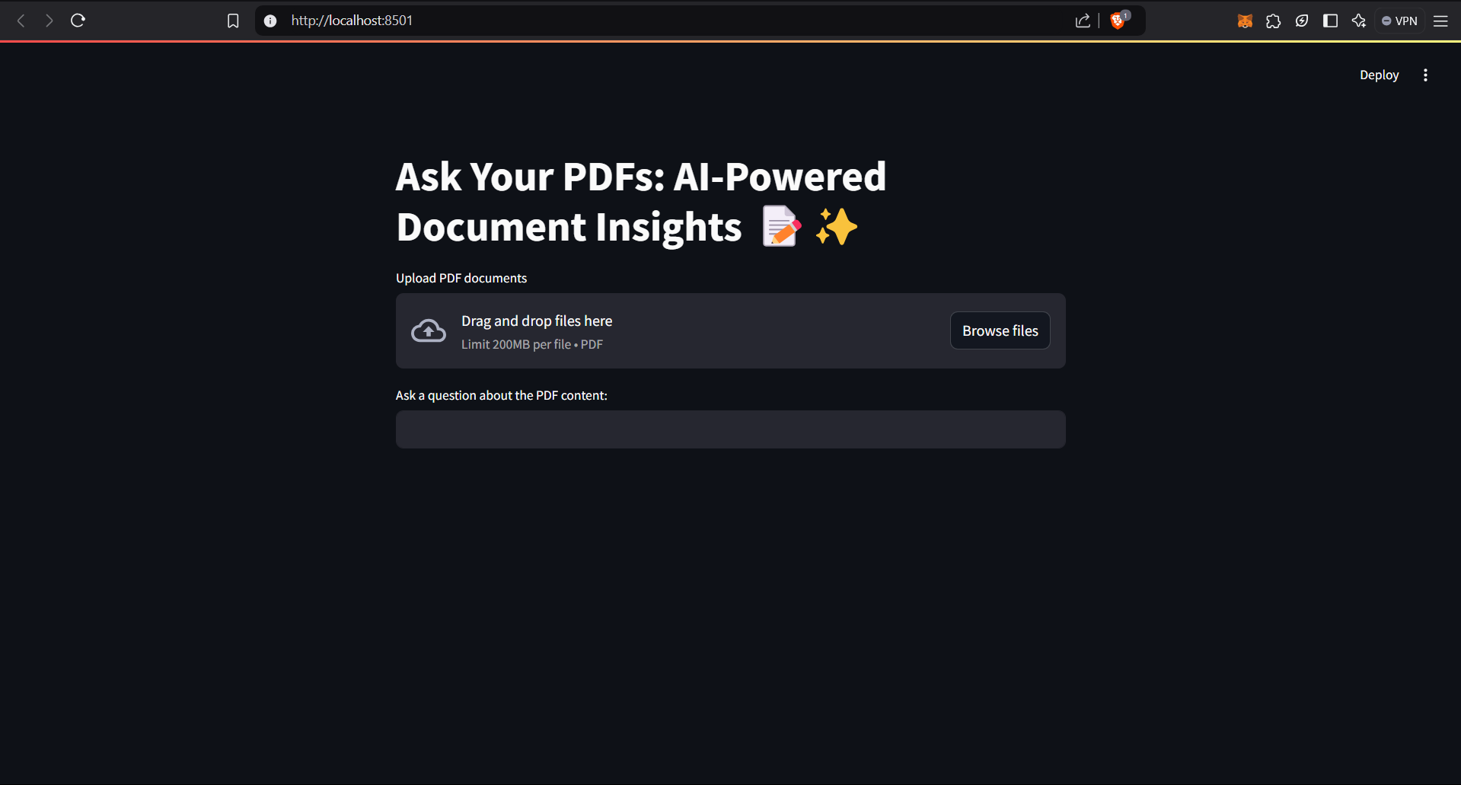

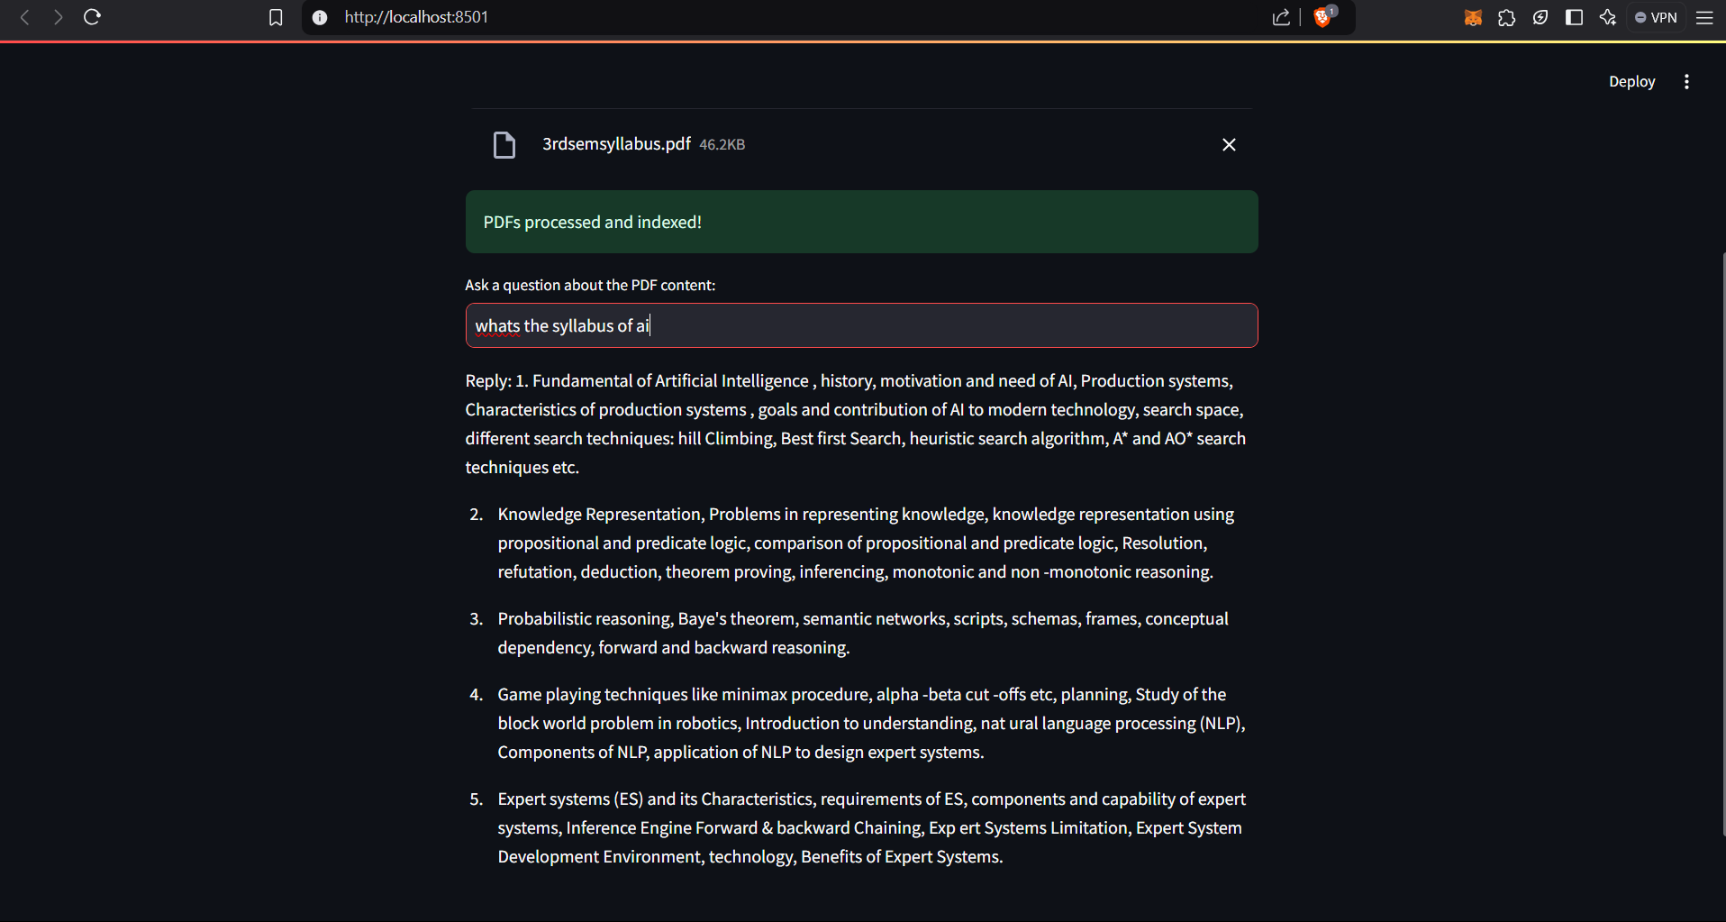

Coding

import streamlit as st

from PyPDF2 import PdfReader

from langchain_text_splitters import RecursiveCharacterTextSplitter

import os

from langchain_google_genai import GoogleGenerativeAIEmbeddings

import google.generativeai as genai

from langchain_google_genai import ChatGoogleGenerativeAI

from langchain.chains.question_answering import load_qa_chain

from langchain.prompts import PromptTemplate

from dotenv import load_dotenv

from langchain_community.vectorstores import FAISS

load_dotenv()

genai.configure(api_key=os.getenv("GOOGLE_API_KEY"))

def get_pdf_text(pdf_docs):

    text=""

    for pdf in pdf_docs:

        pdf_reader = PdfReader(pdf)

        for page in pdf_reader.pages:

            text += page.extract_text()

    return text

def get_text_chunks(text):

    text_splitter=RecursiveCharacterTextSplitter(chunk_size=10000, chunk_overlap=1000)

    chunks=text_splitter.split_text(text)

    return chunks

def get_vector_store(text_chunks):

    embeddings = GoogleGenerativeAIEmbeddings(model="models/embedding-001")

    vector_store=FAISS.from_texts(text_chunks, embedding=embeddings)

    vector_store.save_local("faiss_index")

def get_conversational_chain():

    pt="""

    answer the question from the provided context in as detailed way as possible. respond with "no response generated" if you are not able to generate a response\n\n

    Context:\n {context}? \n

    Question:\n {question} \n

    Answer:

    """

    model=ChatGoogleGenerativeAI(model="gemini-pro", temperature=0.3)

    prompt= PromptTemplate(template=pt, input_variables=["context", "question"])

    conchain=load_qa_chain(model, chain_type="stuff", prompt=prompt)

    return conchain

def user_ip(user_ques):

    embeddings=GoogleGenerativeAIEmbeddings(model="models/embedding-001")

    newdb=FAISS.load_local("faiss_index", embeddings, allow_dangerous_deserialization=True)

    docs=newdb.similarity_search(user_ques)

    conchain=get_conversational_chain()

    response=conchain(

        {"input_documents":docs, "question": user_ques}

        , return_only_outputs=True

    )

    print("Retrieved Documents:", docs)

    print(response)

    st.write("Reply:", response["output_text"])

    # return response.get("output_text", "No response generated")

def main():

        st.title("Ask Your PDFs: AI-Powered Document Insights 📝✨")

    # PDF File Upload

        pdf_docs = st.file_uploader("Upload PDF documents", type=["pdf"], accept_multiple_files=True)

        if pdf_docs:

         with st.spinner("Processing PDFs..."):

            text = get_pdf_text(pdf_docs)

            text_chunks = get_text_chunks(text)

            get_vector_store(text_chunks)

            st.success("PDFs processed and indexed!")

        # User Question Input

        user_question = st.text_input("Ask a question about the PDF content:")

        if user_question:

            with st.spinner("Getting the answer..."):

                response = user_ip(user_question)

                # st.write("Reply:", response)

if __name__ == "__main__":

    main()

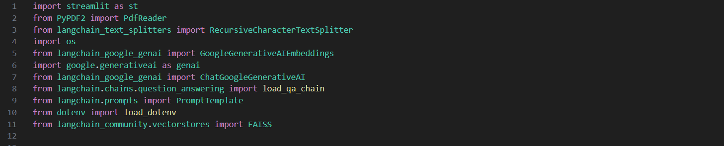

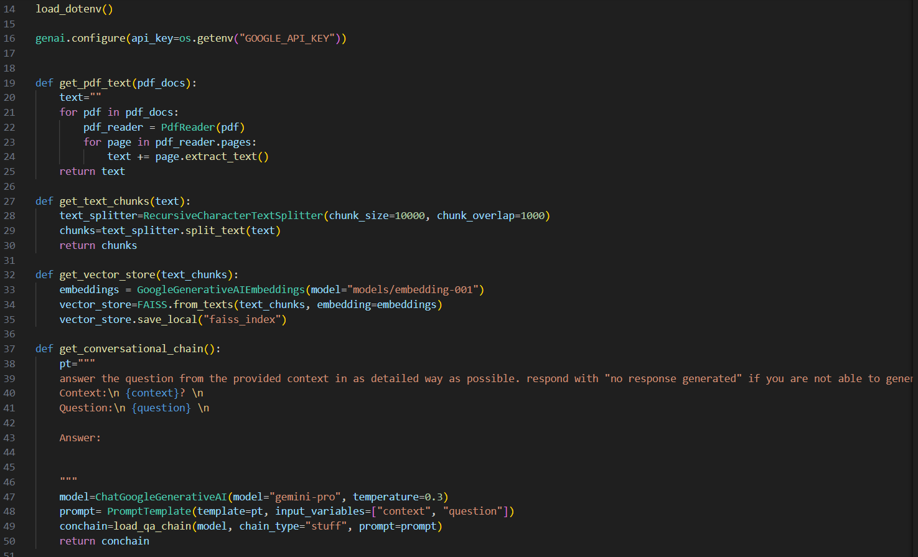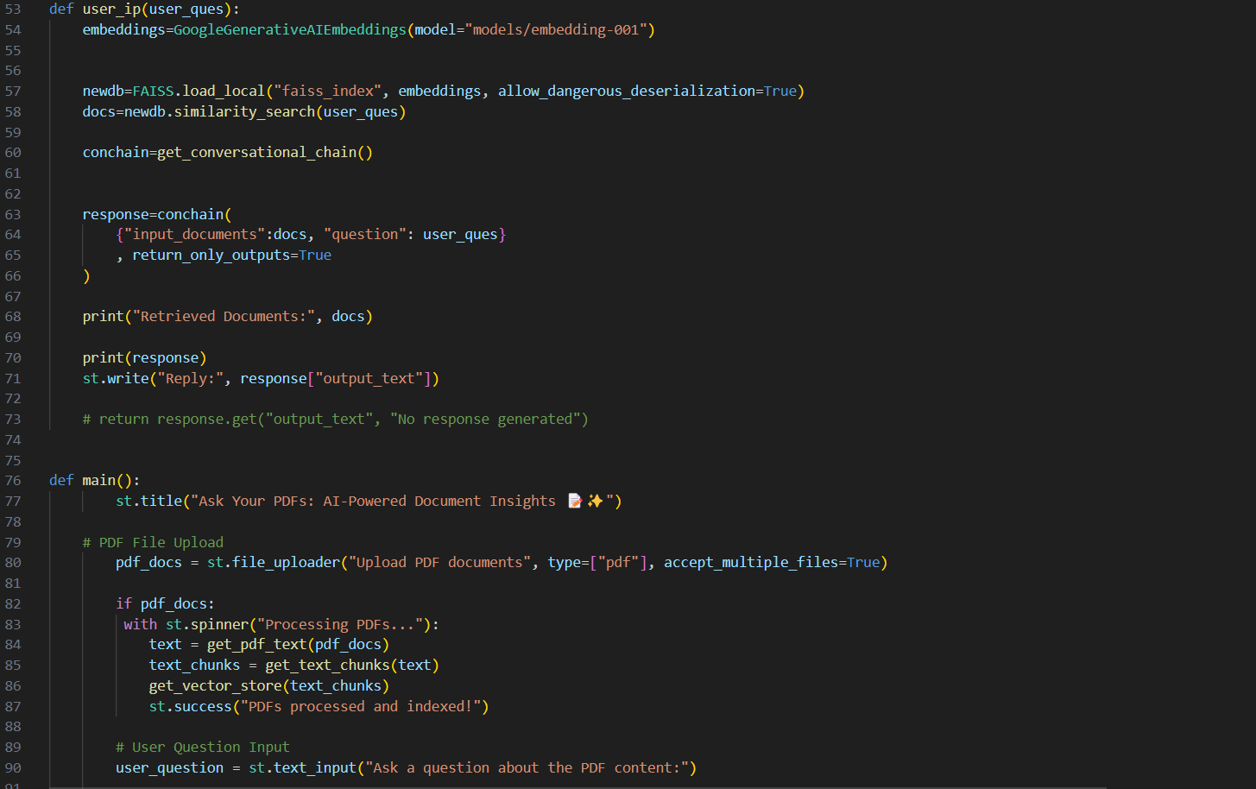

**Project Limitations and Future Scope**

**Project Limitations**

While the current implementation offers a functional and powerful system for querying PDF documents with the help of Retrieval-Augmented Generation (RAG) and Google’s Generative AI model, there are several limitations that need to be addressed for improving the system's effectiveness, scalability, and robustness. Some key limitations are as follows:

1. **Text Extraction Accuracy from PDFs**:
   * The **PyPDF2 library** used for PDF text extraction may not handle complex or non-standard PDFs effectively. Scanned documents or PDFs with complex layouts may result in incomplete or inaccurate text extraction, which can affect the quality of the system’s responses.
   * **Solution**: Implementing OCR (Optical Character Recognition) tools like **Tesseract** or integrating advanced PDF parsing techniques can improve text extraction accuracy, especially for non-searchable PDFs.
2. **Handling Large Documents**:
   * The system’s ability to process very large PDFs may be limited by memory and processing constraints, especially when dealing with extensive documents containing thousands of pages. Splitting the document into smaller chunks using **RecursiveCharacterTextSplitter** helps, but large documents may still result in slower response times or inefficient indexing.
   * **Solution**: Optimizing the text chunking process or incorporating more efficient document processing pipelines could improve the handling of large files. Additionally, leveraging **distributed computing** or **cloud-based solutions** for document chunking and embedding generation could address this limitation.
3. **Inference Latency**:
   * While the system relies on Google’s Generative AI models (like Gemini Pro), the inference time can be considerable when querying large datasets. This is especially problematic when the system retrieves multiple documents for similarity search or when the response requires more complex generation tasks.
   * **Solution**: Implementing asynchronous processing and improving batch processing strategies can help in reducing inference time. Using **edge computing** or **model distillation** for faster inference on smaller, optimized models can also reduce latency.
4. **Limited Query Understanding**:
   * The system may struggle with highly complex or ambiguous queries, as the generative AI model depends heavily on the quality and specificity of the context provided. If the context does not cover the query sufficiently, the model may return irrelevant or incomplete answers.
   * **Solution**: Improving the context retrieval mechanism using more advanced **semantic search algorithms** or providing deeper context by integrating multiple layers of document processing (e.g., topic modeling) can enhance the quality of the responses.
5. **Contextual Accuracy of Responses**:
   * Although RAG-based systems like this can provide coherent responses, the accuracy of these responses is still highly dependent on the quality of the indexed data and the generative model’s ability to correctly interpret the context.
   * **Solution**: Implementing **feedback loops** where users can rate the responses, and using this feedback to fine-tune the system, could improve the contextual accuracy of responses over time.
6. **Scalability**:
   * The system as it currently stands may have limitations in scaling to handle large numbers of concurrent users or a vast amount of document data. The **FAISS vector store** and **Google’s Generative AI API** might not scale efficiently without optimizations.
   * **Solution**: For large-scale deployment, the system could benefit from **distributed computing frameworks** (e.g., **Apache Kafka**, **Apache Spark**) to handle large datasets and multiple parallel requests.
7. **Dependency on External APIs**:
   * The reliance on external APIs such as Google’s Generative AI model and embedding API introduces potential risks, including API rate limits, downtime, or changes in the API’s pricing and policies. These limitations could affect the availability of the system or its cost-effectiveness in the long run.
   * **Solution**: Developing an in-house solution for embedding generation or using open-source alternatives like **Hugging Face’s transformers** could help mitigate these risks.

**Future Scope**

Despite the limitations, the future scope of this project is vast, with opportunities for enhancement and expansion across multiple domains. Some key areas for future development include:

1. **Improved Document Parsing and OCR Integration**:
   * The next version of the system could integrate **OCR capabilities** to improve text extraction from scanned or image-based PDFs. By incorporating OCR engines like **Tesseract** or **Google Vision API**, the system could handle a wider range of document types, including non-searchable PDFs, handwritten text, and images.
2. **Multi-Document Querying**:
   * Future versions of the system could allow users to query multiple documents simultaneously, which would be useful for research purposes or large-scale document analysis. Enhancing the document retrieval and processing pipeline to handle multi-document querying efficiently will improve the system’s usability and performance.
   * **Solution**: Implementing more advanced clustering and filtering techniques to organize the retrieved documents into categories, thus improving the user’s ability to find relevant information quickly.
3. **Contextual Awareness and Personalization**:
   * Adding **user-specific contextual awareness** by incorporating user profiles or preferences could improve the accuracy and relevance of responses. For example, the system could tailor responses based on the user’s previous interactions, making the system more personalized.
   * **Solution**: Building a recommendation system that tracks user queries and documents they have previously interacted with could allow the system to suggest relevant documents or answers based on past behavior.
4. **Support for More Document Formats**:
   * Beyond PDFs, the system could be extended to support other document formats, such as **Microsoft Word** files, **Excel sheets**, and **HTML files**. This would make the system applicable to a wider range of use cases across industries.
   * **Solution**: Adding support for file converters or integrating specialized libraries for parsing different document formats (e.g., **python-docx**, **xlrd** for Excel, **BeautifulSoup** for HTML).
5. **Multilingual Support**:
   * Expanding the system to support multiple languages would make it more versatile in global contexts. Integrating multilingual models for both embedding generation and question answering could broaden the system’s reach.
   * **Solution**: Implementing machine translation services or using multilingual embeddings and models such as **mBERT** or **XLM-RoBERTa** could make the system capable of processing documents in various languages.
6. **Automated Feedback and Learning**:
   * Incorporating **machine learning techniques** to automatically refine the system over time based on user feedback could further enhance the accuracy of the responses. Feedback loops can allow the system to learn from mistakes and improve its performance continuously.
   * **Solution**: Implementing reinforcement learning or other machine learning models to adapt the system’s responses based on user feedback.
7. **Integration with Enterprise Systems**:
   * In the future, the system could be integrated into enterprise workflows and document management systems. This would allow businesses to leverage the system for internal knowledge management, customer support, or business intelligence.
   * **Solution**: Developing APIs and integration points with popular enterprise software (e.g., **SharePoint**, **Salesforce**, **SAP**) could make the system useful for companies with large document repositories.
8. **Real-Time Collaboration and Multi-User Support**:
   * The system could include features for real-time collaboration, where multiple users can interact with the documents simultaneously. This would be particularly valuable in academic, legal, or corporate environments where teams need to analyze and discuss documents together.
   * **Solution**: Adding real-time collaboration tools such as **live chat**, **document annotation**, and **multi-user query support** could enhance the system's value for teams.

**References**

1. Lewis, M., Oguz, B., Goyal, N., & Zettlemoyer, L. (2020). *Retrieval-Augmented Generation for Knowledge-Intensive NLP Tasks*. In Proceedings of NeurIPS 2020.  
   <https://arxiv.org/abs/2005.11401>
2. Johnson, J., Dou, Z., & Li, X. (2021). *FAISS: A Library for Efficient Similarity Search and Clustering of Dense Vectors*. Facebook AI Research.  
   <https://github.com/facebookresearch/faiss>
3. Google Cloud. (2023). *Google Generative AI*.  
   https://cloud.google.com/gen-ai
4. Langchain. (2023). *Langchain Documentation*.  
   https://www.langchain.com/docs/
5. PyPDF2 Documentation. (2023). *PyPDF2 Library: PDF Toolkit for Python*.  
   <https://pypi.org/project/PyPDF2/>
6. Tesseract OCR. (2023). *Tesseract Documentation: Open-Source OCR Engine*.  
   <https://github.com/tesseract-ocr/tesseract>
7. Langchain Community. (2023). *Langchain-Community Vectorstores*.  
   <https://pypi.org/project/langchain-community/>
8. OpenAI. (2023). *Fine-Tuning GPT Models for Use Cases*. OpenAI.  
   <https://platform.openai.com/docs/guides/fine-tuning>
9. Zhang, J., & Zhao, Y. (2020). *From Query to Answer: Generative Models for Question Answering with Retrieval-Augmented Generation*.  
   <https://arxiv.org/abs/2005.11401>
10. Hugging Face. (2023). *Transformers: State-of-the-Art Natural Language Processing Library*.  
    https://huggingface.co/docs/transformers