|  |  |
| --- | --- |
| **Specifications of my computer** | **Apple Macbook Pro** |
| The brand of CPU (Intel or AMD) | Apple Silicon |
| The model of CPU (e.g. Intel i7-9700K Coffee Lake) | Apple M1 Pro |
| The number of cores on CPU | 8 (6 performance and 2 efficiency) |
| The clock rate of CPU in GHz | 3.2 GHz to 3.8 GHz |
| The amount of memory in GB | 16GB RAM |
| The speed of memory (for example: DDR4 3200) | 3845 MHz |
| The type of hard drive: magnetic or SSD | SSD |
| The capacity of hard drive | 512 GB |
| The RPM number | doesn’t contain any Serial ATA devices |
| Cache size | 6317 MB |
| Average latency | 21 ms |
| Max sequential read speed | 3230.3 MB/s |
| Max sequential write speed | 2893.2 MB/s |
| Max random read speed | 5048.8 MB/s |
| Max random write speed | 3042.9 MB/s |

|  |  |
| --- | --- |
| **Benchmarks** | **Execution Time (seconds)** |
| a)32-bit Integer operation benchmark | 1686.6233 |
| b)64-bit Floating point operation benchmark | 86.1979 |
| c)Memory benchmark | 18.6653 |
| d)Hard drive benchmark 1 | 2.3488 |
| e)Hard drive benchmark 2 | 1.78918 |

Now calculation execution time ration ,

Ratio = reference time/execution time

a = 100/1686.6233 = 0.08

b = 100/86.1979 = 1.16012

c = 100/18.6653 = 5.3575

d= 250/2.3488 = 106.4373

e= 10/1.78918 = 5.58915

N =5

Geometric mean = (a*b*c*d*e)^1/N

= (0.059290 * 1.16012 * 5.3575 * 106.4373 * 5.58915) ^ ⅕

= 2.9388

**Screenshots:**

**32-bit Integer operation benchmark**

**64-bit Floating point operation benchmark**

**Memory benchmark**

**Hard drive benchmark**

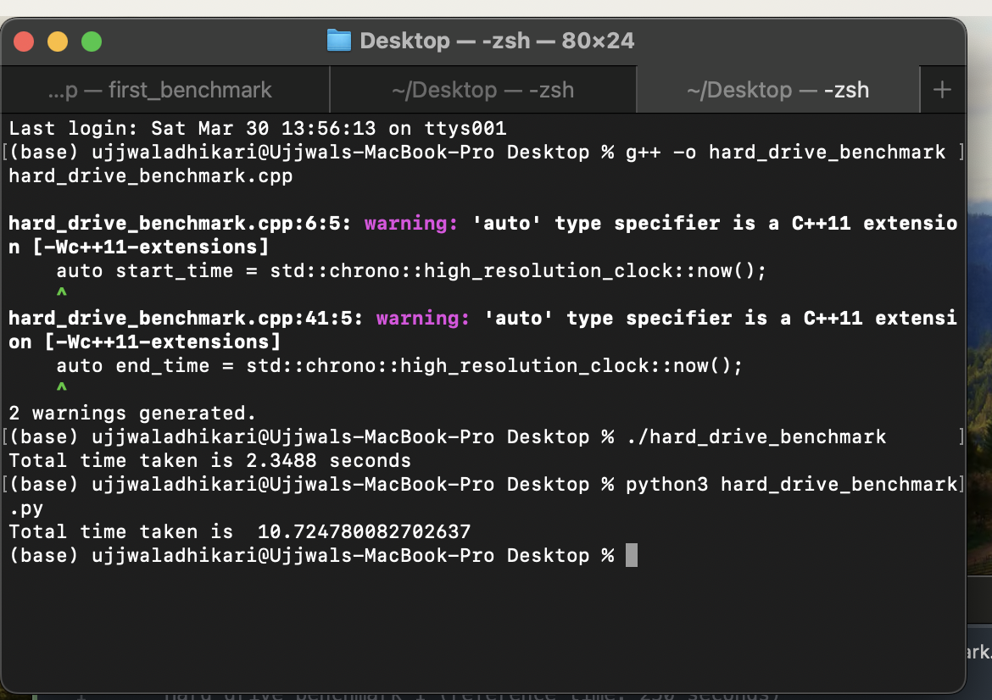

**Hard Drive benchmark 2**

