**MLIB**

**Fitur Ekstraktor**

**TF-IDF**

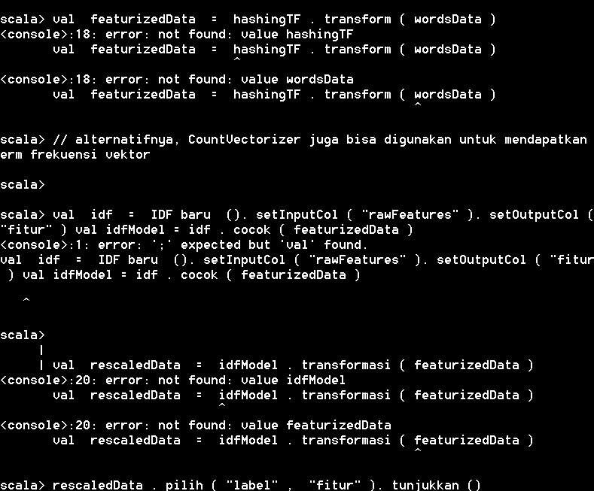

## Word2Vec

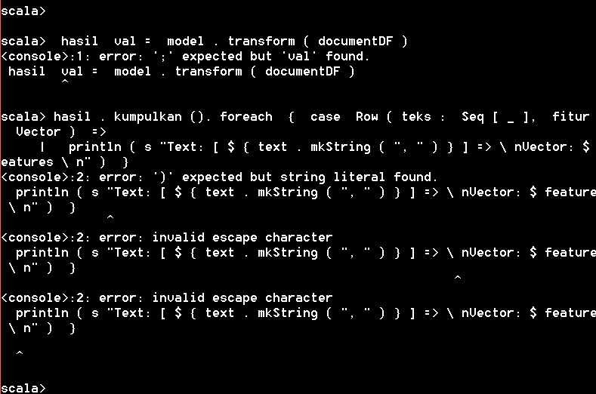

## CountVectorizer

