Installing Spark on Windows 10.

Shantanu Sharma

Department of Computer Science, Ben-Gurion University, Israel.

sharmas@cs.bgu.ac.il

- Install Scala: Download Scala from the link: http://downloads.lightbend.com/scala/2.11.8/scala-2.11.8.msi

  - Set environmental variables:

    - User variable:

Variable: SCALA_HOME;

Value: C:\Program Files (x86)\scala

    - System variable:

Variable: PATH

Value: C:\Program Files (x86)\scala\bin

  - Check it on cmd, see below.
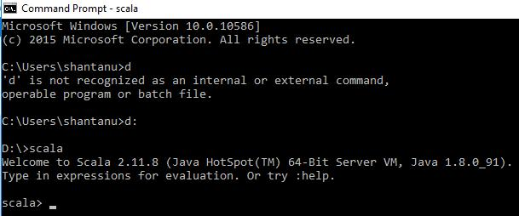

- Install Java 8: Download Java 8 from the link: http://www.oracle.com/technetwork/java/javase/downloads/jdk8-downloads-2133151.html

  - Set environmental variables:

    - User variable:

Variable: JAVA_HOME

Value: C:\Program Files\Java\jdk1.8.0_91

    - System variable:

Variable: PATH

Value: C:\Program Files\Java\jdk1.8.0_91\bin

  - Check on cmd, see below:
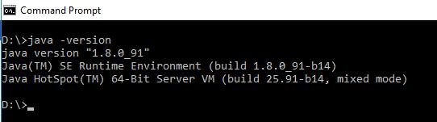

- Install Eclipse Mars. Download it from the link: https://eclipse.org/downloads/ and extract it into C drive.

a. Set environmental variables:

    - User variable:

Variable: ECLIPSE_HOME

Value: C:\eclipse

    - System variable:

Variable: PATH

Value: C:\eclipse \bin

- Install Spark 1.6.1. Download it from the following link: http://spark.apache.org/downloads.html and extract it into D drive, such as D:\Spark.
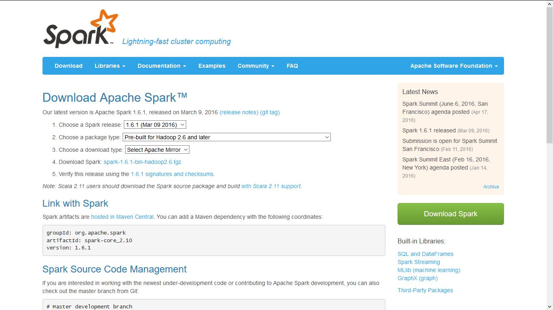

- Set environmental variables:

  - User variable:

Variable: SPARK_HOME

Value: D:\spark\spark-1.6.1-bin-hadoop2.6

  - System variable:

Variable: PATH
Value: D:\spark\spark-1.6.1-bin-hadoop2.6\bin

- Download Windows Utilities: Download it from the link:

https://github.com/steveloughran/winutils/tree/master/hadoop-2.6.0/bin And paste it in D:\spark\spark-1.6.1-bin-hadoop2.6\bin

- Execute Spark on cmd, see below:
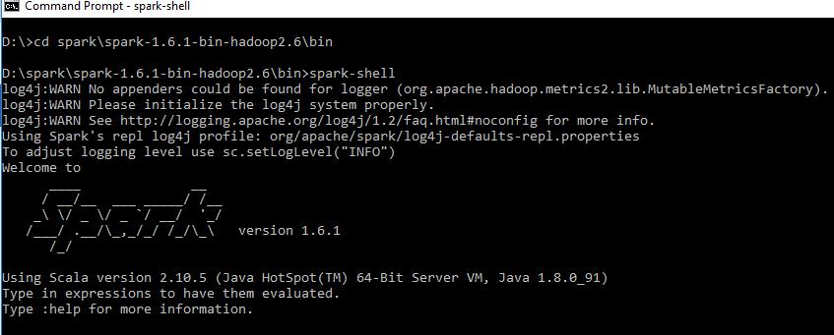

- Install Maven 3.3. Download Apache-Maven-3.3.9 from the link: http://apache.mivzakim.net/maven/maven-3/3.3.9/binaries/apache-maven-3.3.9-bin.zip And extract it into D drive, such as D:\apache-maven-3.3.9

  - Set Environmental variables:

    - User variable

Variable: MAVEN_HOME

Value: D:\apache-maven-3.3.9

    - System variable

Variable: Path

Value: D:\apache-maven-3.3.9\bin

  - Check on cmd, see below
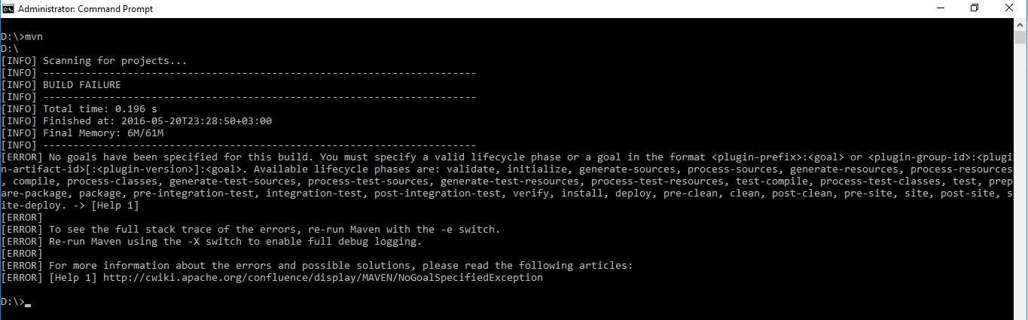

- Create first WordCount project.
  - Open Eclipse and do File→ New → project → Select Maven Project; see below.

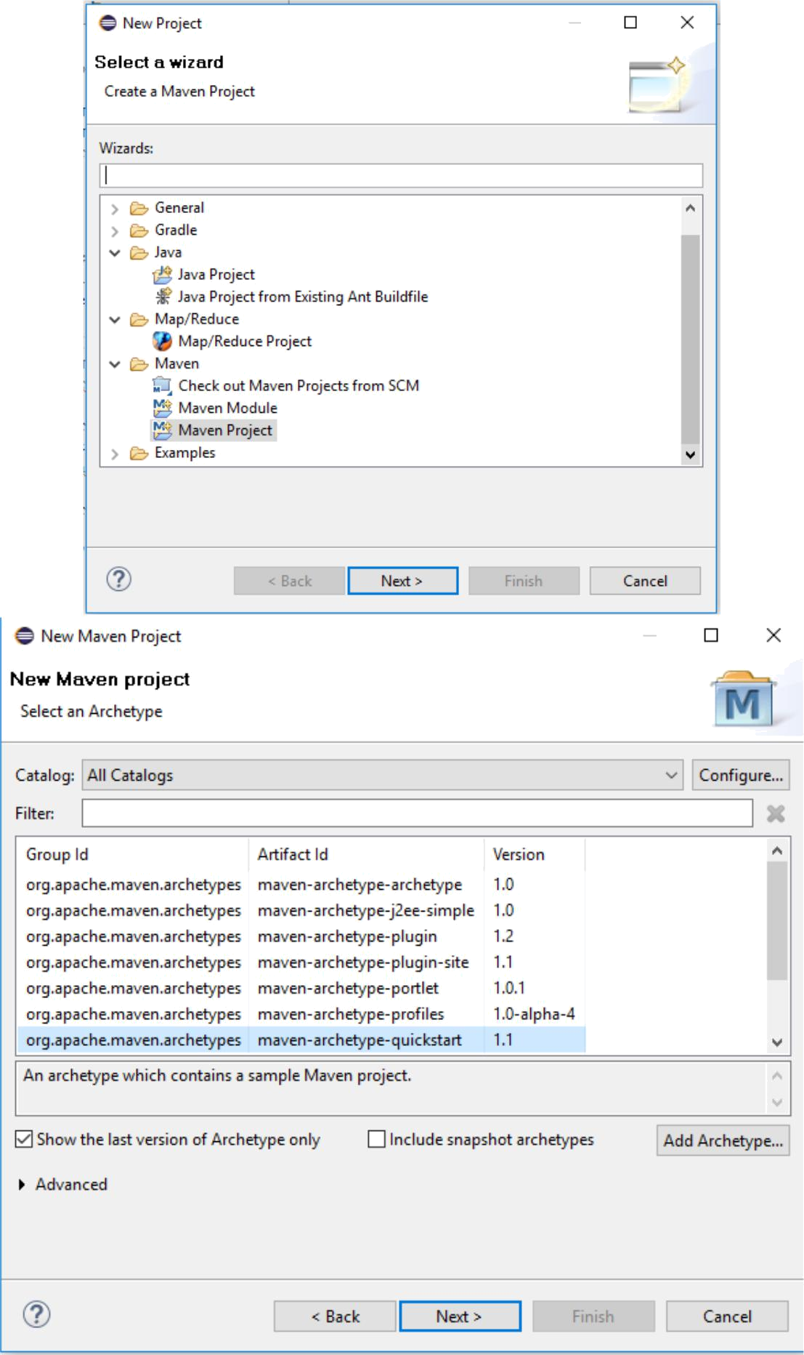

b. Enter Group id, Artifact id, and click finish.
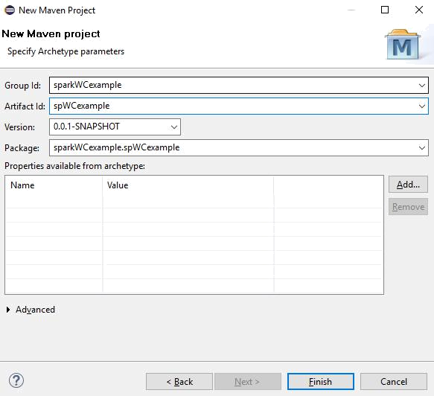

c. Edit pom.xml. Paste the following code.

<project xmlns="http://maven.apache.org/POM/4.0.0" xmlns:xsi="http://www.w3.org/2001/XMLSchema-instance"

xsi:schemaLocation="http://maven.apache.org/POM/4.0.0 http://maven.apache.org/xsd/maven-4.0.0.xsd"> <modelVersion>4.0.0</modelVersion>

<groupId>sparkWCexample</groupId>
<artifactId>spWCexample</artifactId>
<version>1.0-SNAPSHOT</version>

<dependencies>
<dependency>
<groupId>org.apache.spark</groupId>
<artifactId>spark-core_2.10</artifactId>
<version>1.2.0</version>
</dependency>
</dependencies>

<build>
<plugins>
<plugin>
<groupId>org.apache.maven.plugins</groupId>
<artifactId>maven-compiler-plugin</artifactId>
<version>3.3</version>
</plugin>
</plugins>
</build>
</project>

- Write your code or just copy given WordCount code from D:\spark\spark-1.6.1-bin-hadoop2.6\examples\src\main\java\org\apache\spark\examples
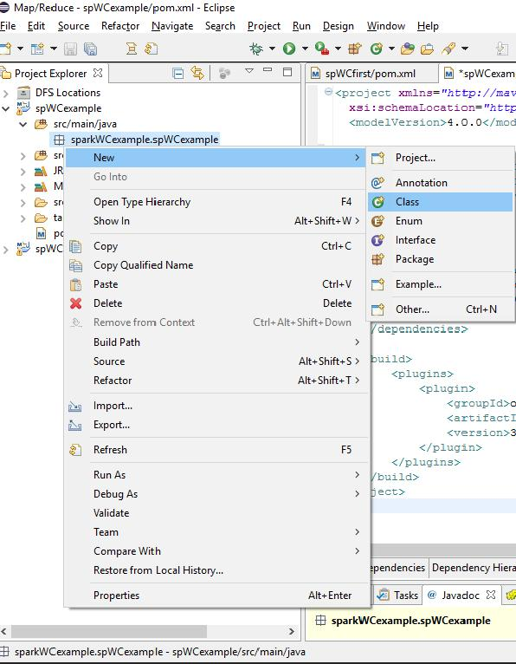

- Now, add external jar from the location D:\spark\spark-1.6.1-bin-hadoop2.6\lib and set Java 8 for compilation; see below.
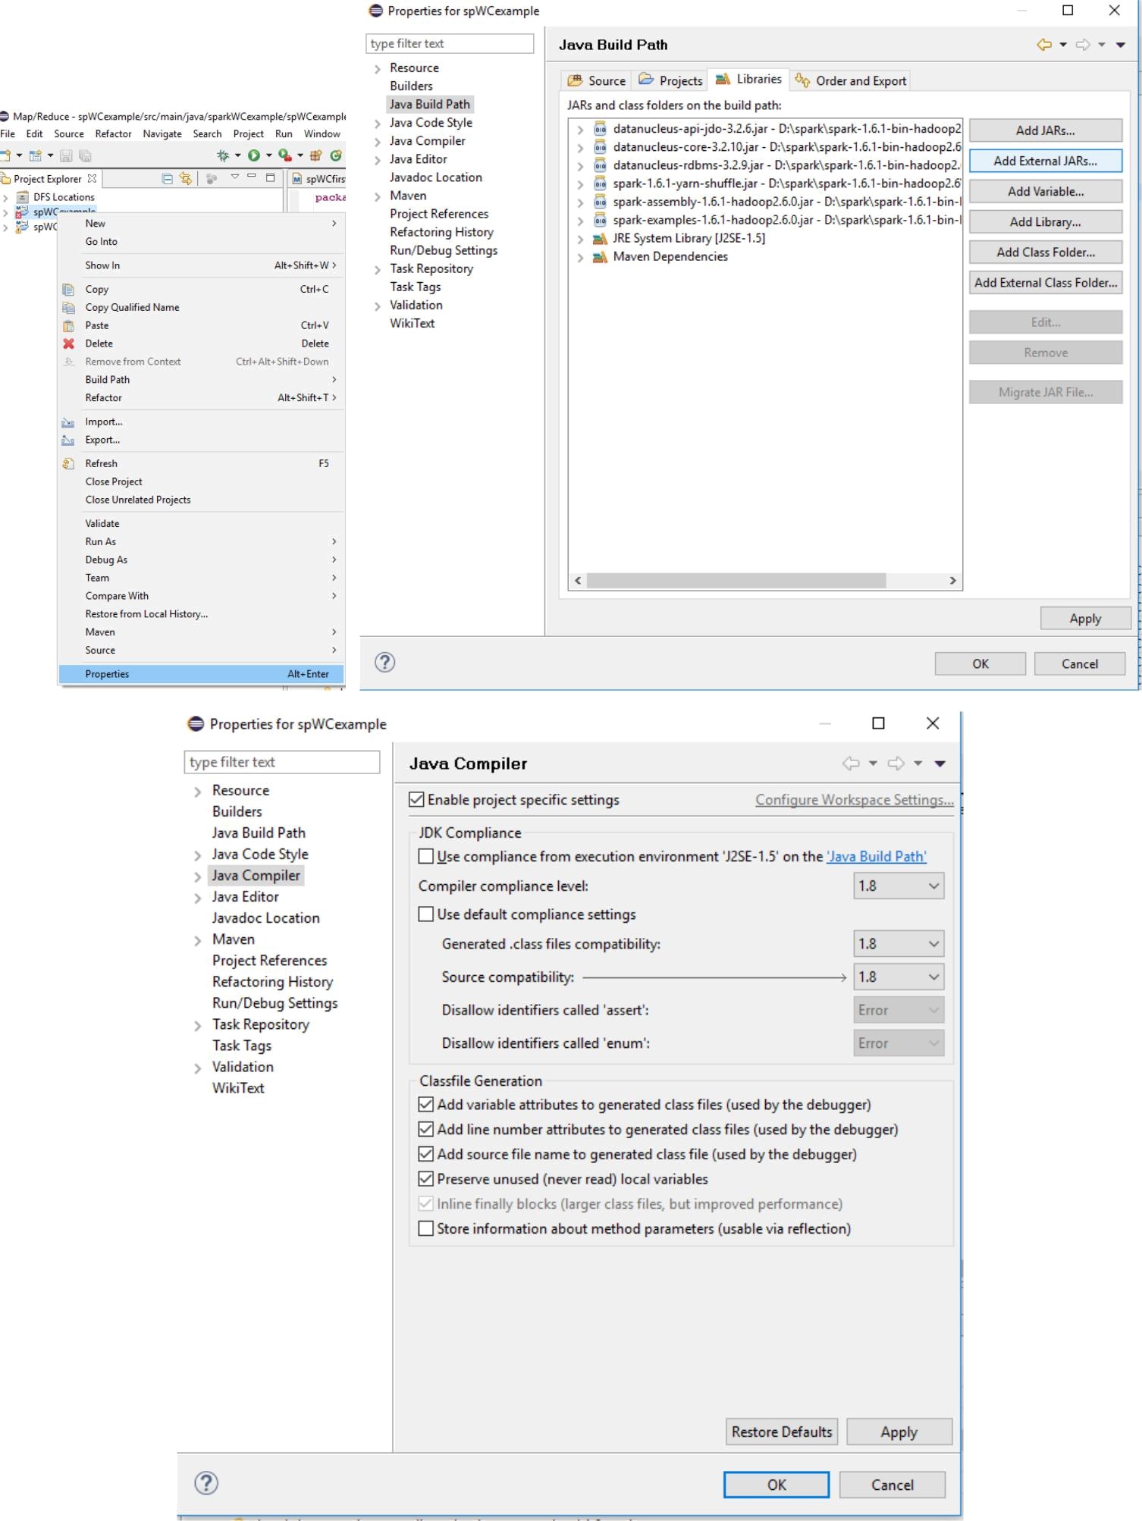

- Build the project: Go to the following location (where we stored the project) on cmd: D:\hadoop\examples\spWCexample

Write mvn package on cmd
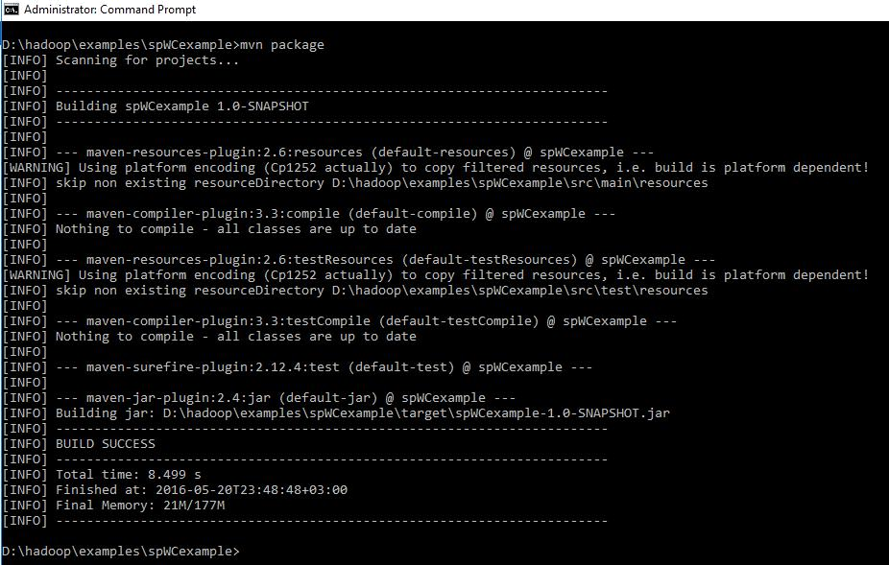

- Execute the project: Go to the following location on cmd: D:\spark\spark-1.6.1-bin-hadoop2.6\bin

Write the following command

spark-submit --class groupid.artifactid.classname --master local[2] /path to the jar file created using maven /path to a demo test file /path to output directory

spark-submit --class sparkWCexample.spWCexample.WC --master local[2] /hadoop/examples/spWCexample/target/spWCexample-1.0-SNAPSHOT.jar /hadoop/examples/spWCexample/how.txt /hadoop/examples/spWCexample/anwer.txt
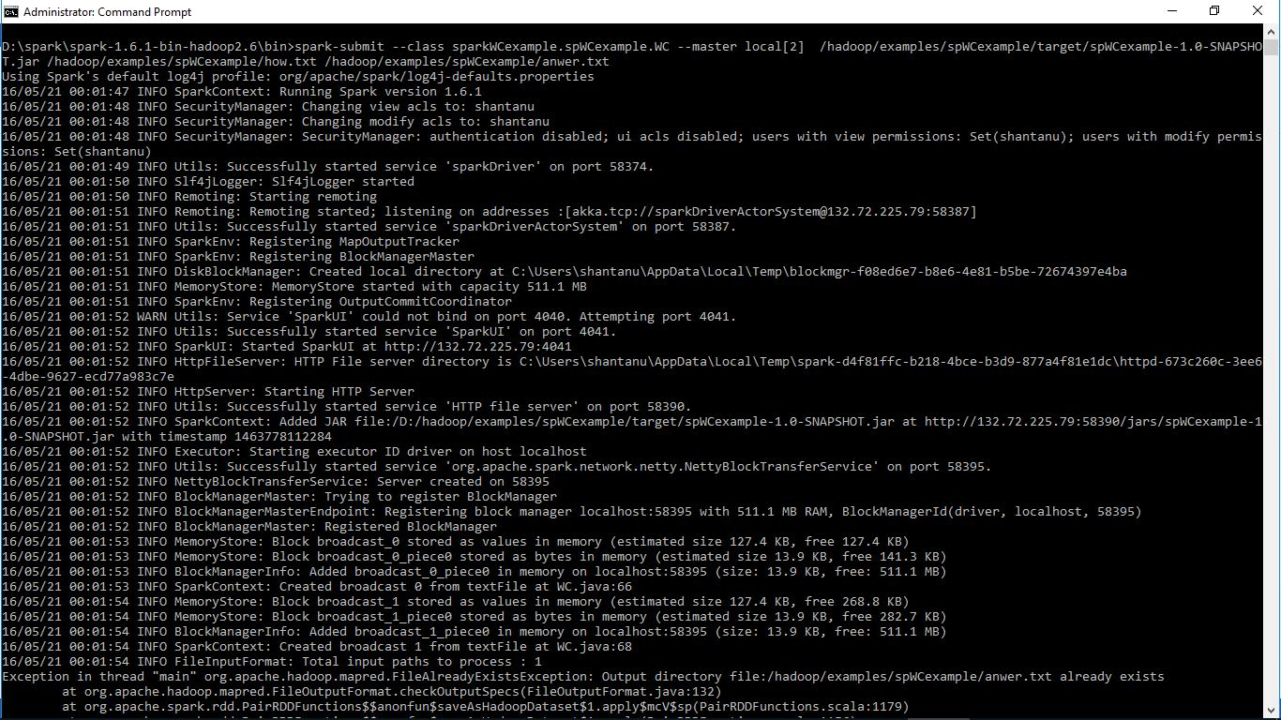

- You can also check the progress of the project at: http://localhost:4040/jobs/

- Finally get the answers; see below.
