DCU Active — Database Design
Item | Value
Phase | Phase 1 — Solution Architecture and UX Design
Version | 1.0 (Draft for review)
Date | 2026-10-14
Database | PostgreSQL (Supabase), region Southeast Asia (Singapore)
Related | SOLUTION-ARCHITECTURE.md (schema layout §3.1, security model §3.2), API-RPC-SPECIFICATION.md, TRD §5–8, §10

The SQL in this document is design-level DDL for review. It becomes versioned migrations in Phase 2, where exact syntax is validated by supabase db reset and pgTAP. Nothing here has been executed.

1. Conventions
Topic | Convention
Schemas | app (tables, not exposed), api (RPC functions, exposed), private (helpers, not exposed)
Keys | uuid (gen_random_uuid()) for transactional rows; smallint identity for small reference tables
Time | Instants are timestamptz (stored UTC). Business dates are date in WIB. Business timezone Asia/Jakarta (UTC+7, no DST).
Naming | snake_case; plural table names; constraints <table>_<col>_<type> (e.g. bookings_no_overlap_excl)
Soft state | Nothing is hard-deleted except expired notifications (retention)
Audit columns | created_at, updated_at (trigger private.touch_updated_at)

2. Entity relationship diagram
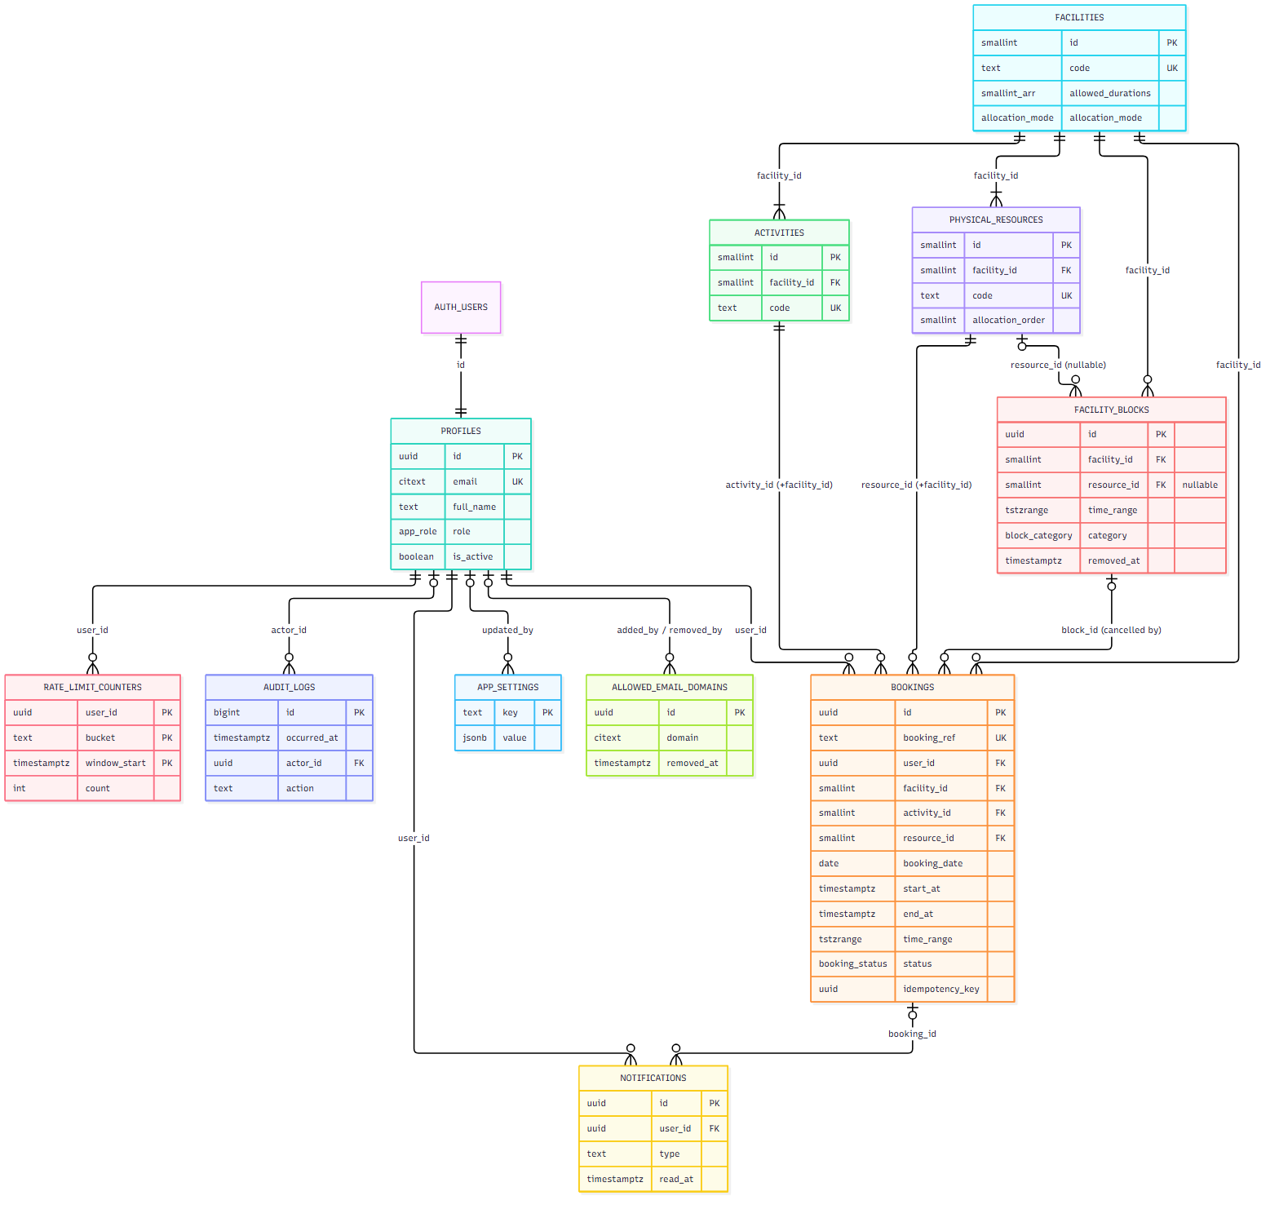
INTEGRITY_CHECK_RUNS (operational, no foreign keys) is omitted from the diagram.

2.1 How the model meets the key rules
Rule | Mechanism
Facility ≠ activity ≠ physical resource | Three tables. Bookings reference all three. Composite FKs guarantee the activity and resource belong to the booked facility.
Basketball/Futsal share one court | Facility COURT has 2 activities and 1 resource. Overlap is checked per resource. The daily limit is keyed by facility.
Pooled Air Hockey / Foosball | allocation_mode = 'AUTO_POOL', 2 resources each, allocated by allocation_order
No overlap | bookings_no_overlap_excl GiST exclusion constraint on (resource_id, time_range) for occupying statuses
Blocks | facility_blocks with nullable resource_id (NULL = whole facility). Checked under the same resource locks as bookings.
History | Status changes only. cancelled_*, checked_in_at, no_show_at, completed_at columns. audit_logs append-only.
Configurable policy | app_settings (validated ranges) read live by every RPC
Domain allow-list | allowed_email_domains (soft-removable, ≥ 1 active)

3. DDL (design)

3.1 Extensions, schemas, types
create extension if not exists btree_gist; -- '=' on scalars inside GiST exclusion
create extension if not exists citext;
create extension if not exists pg_trgm; -- admin search
create extension if not exists pg_cron; -- scheduled jobs (Supabase: enable via dashboard/migration)

create schema if not exists app;
create schema if not exists api;
create schema if not exists private;

create type app.app_role as enum ('USER', 'ADMIN');
create type app.booking_status as enum ('CONFIRMED', 'CHECKED_IN', 'COMPLETED', 'CANCELLED', 'ADMIN_CANCELLED', 'NO_SHOW');
create type app.cancel_source as enum ('USER', 'ADMIN', 'BLOCK', 'DEACTIVATION');
create type app.block_category as enum ('MAINTENANCE', 'EVENT', 'OPERATIONAL', 'OTHER');
create type app.allocation_mode as enum ('SINGLE', 'AUTO_POOL');

3.2 app.profiles
create table app.profiles (
id uuid primary key references auth.users(id) on delete restrict,
email citext not null unique,
full_name text not null check (char_length(btrim(full_name)) between 2 and 100),
role app.app_role not null default 'USER',
is_active boolean not null default true,
deactivated_at timestamptz,
deactivated_by uuid references app.profiles(id),
deactivation_reason text,
created_at timestamptz not null default now(),
updated_at timestamptz not null default now(),
constraint profiles_deactivation_consistent check (
(is_active and deactivated_at is null and deactivation_reason is null)
or (not is_active and deactivated_at is not null and char_length(deactivation_reason) >= 5)
)
);
create index profiles_name_trgm on app.profiles using gin (full_name gin_trgm_ops);
create index profiles_email_trgm on app.profiles using gin ((email::text) gin_trgm_ops);
create index profiles_admins on app.profiles (id) where role = 'ADMIN' and is_active;

3.3 Reference tables
create table app.facilities (
id smallint generated always as identity primary key,
code text not null unique check (code ~ '^[A-Z_]{3,30}$'),
name text not null,
description text,
allowed_durations smallint[] not null
check (cardinality(allowed_durations) >= 1
and allowed_durations <@ array[30,60,90]::smallint[]),
allocation_mode app.allocation_mode not null,
display_order smallint not null unique,
is_active boolean not null default true
);

create table app.activities (
id smallint generated always as identity primary key,
facility_id smallint not null references app.facilities(id),
code text not null unique check (code ~ '^[A-Z_]{3,30}$'),
name text not null,
is_active boolean not null default true,
unique (id, facility_id) -- target of composite FK
);

create table app.physical_resources (
id smallint generated always as identity primary key,
facility_id smallint not null references app.facilities(id),
code text not null unique check (code ~ '^[A-Z0-9_]{3,40}$'),
name text not null,
allocation_order smallint not null,
is_active boolean not null default true,
unique (facility_id, allocation_order),
unique (id, facility_id) -- target of composite FK
);

3.4 app.facility_blocks
create table app.facility_blocks (
id uuid primary key default gen_random_uuid(),
facility_id smallint not null references app.facilities(id),
resource_id smallint,
start_at timestamptz not null,
end_at timestamptz not null,
time_range tstzrange generated always as (tstzrange(start_at, end_at, '[)')) stored,
category app.block_category not null,
reason text not null check (char_length(btrim(reason)) between 5 and 500),
created_by uuid not null references app.profiles(id),
created_at timestamptz not null default now(),
removed_at timestamptz,
removed_by uuid references app.profiles(id),
removal_reason text,
foreign key (resource_id, facility_id) references app.physical_resources(id, facility_id),
check (end_at > start_at),
check (extract(epoch from start_at)::bigint % 1800 = 0
and extract(epoch from end_at)::bigint % 1800 = 0), -- 30-min aligned (UTC+7 is whole hours)
check ((removed_at is null and removed_by is null)
or (removed_at is not null and removed_by is not null and char_length(removal_reason) >= 5))
);
create index facility_blocks_active_range on app.facility_blocks
using gist (facility_id, time_range) where removed_at is null;
Operating-hours containment for each day of a multi-day block is validated in api.admin_create_block (it needs WIB calendar logic).

3.5 app.bookings
create table app.bookings (
id uuid primary key default gen_random_uuid(),
booking_ref text not null unique check (booking_ref ~ '^DCU-[0-9]{6}-[A-HJ-NP-Z2-9]{4}$'),
user_id uuid not null references app.profiles(id),
facility_id smallint not null references app.facilities(id),
activity_id smallint not null,
resource_id smallint not null,
booking_date date not null, -- WIB date of start (validated by trigger)
start_at timestamptz not null,
end_at timestamptz not null,
duration_minutes smallint not null check (duration_minutes in (30, 60, 90)),
time_range tstzrange generated always as (tstzrange(start_at, end_at, '[)')) stored,
status app.booking_status not null default 'CONFIRMED',
idempotency_key uuid not null,
checked_in_at timestamptz,
completed_at timestamptz,
no_show_at timestamptz,
cancelled_at timestamptz,
cancelled_by uuid references app.profiles(id),
cancel_source app.cancel_source,
cancellation_reason text,
block_id uuid references app.facility_blocks(id),
created_at timestamptz not null default now(),
updated_at timestamptz not null default now(),

foreign key (activity_id, facility_id) references app.activities(id, facility_id),
foreign key (resource_id, facility_id) references app.physical_resources(id, facility_id),
unique (user_id, idempotency_key),
check (end_at = start_at + make_interval(mins => duration_minutes)),
check (extract(epoch from start_at)::bigint % 1800 = 0),
-- status ↔ column consistency
check (status <> 'CHECKED_IN' or checked_in_at is not null),
check (status <> 'COMPLETED' or (checked_in_at is not null and completed_at is not null)),
check (status <> 'NO_SHOW' or (no_show_at is not null and checked_in_at is null)),
check (status not in ('CANCELLED','ADMIN_CANCELLED')
or (cancelled_at is not null and cancel_source is not null)),
check (status <> 'ADMIN_CANCELLED' or char_length(cancellation_reason) >= 5),
check (status <> 'CANCELLED' or cancel_source = 'USER'),

-- BR-11: no overlapping occupying bookings on the same physical resource
constraint bookings_no_overlap_excl exclude using gist (
resource_id with =,
time_range with &&
) where (status in ('CONFIRMED', 'CHECKED_IN', 'COMPLETED'))
);
create index bookings_facility_date on app.bookings (facility_id, booking_date);
create index bookings_user_daily on app.bookings (user_id, facility_id, booking_date);
create index bookings_user_active on app.bookings (user_id, end_at) where status in ('CONFIRMED','CHECKED_IN');
create index bookings_status_due on app.bookings (status, start_at) where status in ('CONFIRMED','CHECKED_IN');
create index bookings_created_desc on app.bookings (created_at desc);
Booking reference: DCU-<YYMMDD of booking_date>-<4 chars from 23456789ABCDEFGHJKLMNPQRSTUVWXYZ>. Generated in create_booking; retried on the (very unlikely) unique collision.

3.6 app.allowed_email_domains
create table app.allowed_email_domains (
id uuid primary key default gen_random_uuid(),
domain citext not null
check (domain::text = lower(domain::text)
and domain::text ~ '^([a-z0-9]([a-z0-9-]{0,61}[a-z0-9])?\.)+[a-z]{2,63}$'),
added_by uuid references app.profiles(id), -- null for seed rows
added_at timestamptz not null default now(),
removed_by uuid references app.profiles(id),
removed_at timestamptz,
removal_reason text
);
create unique index allowed_email_domains_active_uq on app.allowed_email_domains (domain) where removed_at is null;

3.7 app.app_settings
create table app.app_settings (
key text primary key,
value jsonb not null,
is_editable boolean not null,
min_value integer, -- for editable integer settings
max_value integer,
description text not null,
updated_at timestamptz not null default now(),
updated_by uuid references app.profiles(id)
);
-- trigger private.validate_setting(): editable integer keys must be integers within [min_value, max_value]

3.8 app.notifications, app.audit_logs, operational tables
create table app.notifications (
id uuid primary key default gen_random_uuid(),
user_id uuid not null references app.profiles(id),
type text not null check (type in ('BOOKING_CONFIRMED','BOOKING_CANCELLED','CHECKED_IN',
'ADMIN_CANCELLED','NO_SHOW','ACCOUNT_DEACTIVATED')),
title text not null,
body text not null,
booking_id uuid references app.bookings(id),
created_at timestamptz not null default now(),
read_at timestamptz
);
create index notifications_user_recent on app.notifications (user_id, created_at desc);

create table app.audit_logs (
id bigint generated always as identity primary key,
occurred_at timestamptz not null default now(),
actor_id uuid references app.profiles(id), -- null = SYSTEM
actor_role text not null check (actor_role in ('USER','ADMIN','SYSTEM')),
action text not null,
entity_type text not null,
entity_id text not null,
before jsonb,
after jsonb,
reason text,
request_id uuid
);
create index audit_logs_time on app.audit_logs (occurred_at desc);
create index audit_logs_entity on app.audit_logs (entity_type, entity_id);
create index audit_logs_actor on app.audit_logs (actor_id, occurred_at desc);

create table app.rate_limit_counters ( -- TR-SEC-13
user_id uuid not null references app.profiles(id),
bucket text not null, -- e.g. 'create_booking'
window_start timestamptz not null, -- truncated to the minute
count integer not null default 0,
primary key (user_id, bucket, window_start)
);

create table app.integrity_check_runs ( -- TR-OPS-05
id bigint generated always as identity primary key,
ran_at timestamptz not null default now(),
check_name text not null,
violations integer not null,
sample jsonb
);
Audit actions:
- Admin: BOOKING_ADMIN_CANCEL, BLOCK_CREATE, BLOCK_REMOVE, USER_DEACTIVATE, USER_ACTIVATE, ROLE_GRANT, ROLE_REVOKE, SETTING_UPDATE, DOMAIN_ADD, DOMAIN_RENAME, DOMAIN_REMOVE.
- User/system: BOOKING_CREATE, BOOKING_CANCEL, BOOKING_CHECKIN, BOOKING_NO_SHOW, BOOKING_COMPLETE (system, PROPOSED: aggregated, not per row), PROFILE_UPDATE.

4. Status transitions (enforced by private.enforce_booking_transition)
From \ To | CHECKED_IN | COMPLETED | CANCELLED | ADMIN_CANCELLED | NO_SHOW
CONFIRMED | ✔ user (window) | — | ✔ user (≥ cutoff before start) | ✔ admin / block / deactivation | ✔ system (after deadline)
CHECKED_IN | — | ✔ system (end passed) | — | ✔ admin (before end) | —
COMPLETED, CANCELLED, ADMIN_CANCELLED, NO_SHOW | terminal — no transitions

Any other transition raises INVALID_STATUS_TRANSITION (an internal error, never expected from correct code; covered by TEST-45).

5. Row Level Security and grants
-- Grants: schema usage for invoker functions; read-only table privileges; no write privileges.
grant usage on schema app to authenticated;
grant select on app.profiles, app.facilities, app.activities, app.physical_resources,
app.bookings, app.notifications, app.facility_blocks, app.audit_logs,
app.allowed_email_domains, app.app_settings to authenticated;
revoke insert, update, delete, truncate on all tables in schema app from anon, authenticated;
revoke all on schema app, private from anon;

alter table app.profiles enable row level security; -- … and every other app table

create policy profiles_select on app.profiles for select to authenticated
using (id = (select auth.uid()) or (select private.is_admin()));

create policy bookings_select on app.bookings for select to authenticated
using ((user_id = (select auth.uid()) and (select private.current_user_active()))
or (select private.is_admin()));

create policy notifications_select on app.notifications for select to authenticated
using (user_id = (select auth.uid()) and (select private.current_user_active()));

create policy reference_select on app.facilities for select to authenticated
using ((select private.current_user_active()) and (is_active or (select private.is_admin())));
-- same pattern for app.activities, app.physical_resources

create policy admin_only_select on app.facility_blocks for select to authenticated using ((select private.is_admin()));
create policy admin_only_select on app.audit_logs for select to authenticated using ((select private.is_admin()));
create policy admin_only_select on app.allowed_email_domains for select to authenticated using ((select private.is_admin()));
create policy admin_only_select on app.app_settings for select to authenticated using ((select private.is_admin()));
-- rate_limit_counters, integrity_check_runs: RLS on, no policies (definer functions only)
private.is_admin() = active ADMIN profile for auth.uid(). private.current_user_active() = profile exists and is_active. Both are SECURITY DEFINER STABLE, search_path = ''.

5.1 Realtime authorization (realtime.messages)
create policy realtime_availability_read on realtime.messages for select to authenticated
using ( (select realtime.topic()) like 'availability:%' and (select private.current_user_active()) );

create policy realtime_user_read on realtime.messages for select to authenticated
using ( (select realtime.topic()) = 'user:' || (select auth.uid())::text );
-- No INSERT policy: clients cannot broadcast.

6. Functions (inventory)

6.1 private helpers
Function | Returns | Purpose
now() | timestamptz | Server clock with test override (Architecture §6.6)
today_wib() | date | (private.now() at time zone 'Asia/Jakarta')::date
wib_to_instant(p_date date, p_time time) | timestamptz | (p_date + p_time) at time zone 'Asia/Jakarta'
setting_int(p_key text) | integer | Typed settings read
raise_business_error(p_code text, p_detail jsonb) | void | Standard error
is_admin(), current_user_active(), assert_active_user(), assert_admin() | boolean / void | Authorization
is_email_domain_allowed(p_email text) | boolean | Exact, case-insensitive domain match
hook_before_user_created(event jsonb) | jsonb | Auth hook (domain check)
effective_status(b app.bookings) | text | Display status (TRD 11.5)
sweep_user(p_user uuid), sweep_resources(p_resource_ids smallint[]) | void | In-transaction status sweep
process_booking_statuses() | integer | Cron job
purge_notifications(), run_integrity_checks() | integer | Cron jobs
write_audit(...), notify_user(...) | void | Shared write helpers
check_rate_limit(p_bucket text, p_max int) | void | Raises RATE_LIMITED
new_booking_ref(p_date date) | text | Reference generator
trigger functions | trigger | §6.4 of the architecture document

6.2 api functions
The full contracts are in API-RPC-SPECIFICATION.md. Inventory (33 functions: 2 public, 12 user, 19 admin):
Group | Functions
Public | get_registration_domains, health
User | get_my_profile, update_my_profile, get_app_config, list_facilities, get_availability, create_booking, list_my_bookings, get_my_booking, cancel_my_booking, check_in, list_my_notifications, mark_notifications_read
Admin | admin_dashboard_metrics, admin_list_bookings, admin_get_booking, admin_cancel_booking, admin_preview_block, admin_create_block, admin_remove_block, admin_list_blocks, admin_list_users, admin_get_user, admin_set_user_active, admin_set_user_role, admin_get_settings, admin_update_setting, admin_list_email_domains, admin_add_email_domain, admin_rename_email_domain, admin_remove_email_domain, admin_list_audit_logs

7. Seed / reference data (migration, idempotent)

7.1 Facilities, activities, resources
Facility code | Name | Durations | Mode | Order | Activities (code — name) | Resources (code — name, order)
TENNIS | Tennis Court | {30,60,90} | SINGLE | 1 | TENNIS — Tennis | TENNIS_COURT_1 — Tennis Court 1 (1)
COURT | Basketball / Futsal Court | {30,60,90} | SINGLE | 2 | BASKETBALL — Basketball; FUTSAL — Futsal | MULTI_COURT_1 — Multipurpose Court 1 (1)
TABLE_TENNIS | Table Tennis | {30} | SINGLE | 3 | TABLE_TENNIS — Table Tennis | TABLE_TENNIS_1 — Table Tennis 1 (1)
FOOTBALL | Football Field | {30,60,90} (OD-19) | SINGLE | 4 | FOOTBALL — Football | FOOTBALL_FIELD_1 — Football Field 1 (1)
AIR_HOCKEY | Air Hockey | {30} | AUTO_POOL | 5 | AIR_HOCKEY — Air Hockey | AIR_HOCKEY_1 — Air Hockey Table 1 (1); AIR_HOCKEY_2 — Air Hockey Table 2 (2)
FOOSBALL | Foosball | {30} | AUTO_POOL | 6 | FOOSBALL — Foosball | FOOSBALL_1 — Foosball Table 1 (1); FOOSBALL_2 — Foosball Table 2 (2)

7.2 Settings
Key | Value | Editable | Range
timezone | "Asia/Jakarta" | no | —
slot_minutes | 30 | no | —
operating_open | "06:00" | no | —
operating_close | "21:00" | no | —
booking_horizon_days | 7 | yes | 0–30
max_active_bookings | 2 | yes | 1–10
max_bookings_per_facility_per_day | 1 | yes | 1–5
checkin_open_before_minutes | 15 | yes | 0–60
checkin_close_after_minutes | 15 | yes | 5–60
user_cancel_cutoff_minutes | 30 | yes | 0–240
notification_retention_days | 90 | no | —
rate_limit_create_booking_per_min | 20 | no | —

7.3 Allowed email domains
danamon.co.id, adira.co.id, homecredit.co.id (added_by = NULL, seeded).

7.4 Not seeded by migration
- Users and admins. Admins register like everyone else (with an @danamon.co.id address) and are promoted by scripts/provision-admin.sql (TR-AUTH-10).
- Test users exist only in supabase/seed.sql (local) and the staging seed script.

8. Migration plan (Phase 2)
# | Migration | Contents
0001 | extensions_and_schemas | Extensions, schemas, enum types, exposed-schema notes
0002 | reference_tables | facilities, activities, physical_resources + seed
0003 | profiles_and_auth_triggers | profiles, auth.users triggers
0004 | settings_and_domains | app_settings (+ validation trigger, seed), allowed_email_domains (+ seed)
0005 | bookings_and_blocks | facility_blocks, bookings, exclusion constraint, transition trigger
0006 | notifications_audit_ops | notifications, audit_logs (+ immutability trigger), rate_limit_counters, integrity_check_runs
0007 | private_helpers | private functions (auth, time, errors, sweep, audit, notify)
0008 | rls_and_grants | RLS enable + policies, grants/revokes
0009 | api_user_functions | user-facing RPCs
0010 | api_admin_functions | admin RPCs
0011 | realtime | broadcast triggers + realtime.messages policies
0012 | auth_hook | before-user-created hook function + grants to supabase_auth_admin
0013 | cron_jobs | pg_cron schedules

Each migration has matching pgTAP tests under supabase/tests/.

9. Data integrity checks (daily, TR-OPS-05)
Check | Violation query (concept) | Expected
overlap | Self-join of occupying bookings on the same resource with time_range && | 0 (impossible by constraint; defence in depth)
outside_hours | Bookings whose WIB start < 06:00 or WIB end > 21:00 | 0
over_active_limit | Users with more active/future bookings than the setting at creation time | 0 (note: lowering the setting later can legitimately create excess; reported as informational)
overdue_confirmed | CONFIRMED bookings past their check-in deadline by > 5 min | 0 (job health)
orphan_profiles | auth.users without profile or vice versa | 0
no_active_admin | Count of active admins = 0 | must be ≥ 1
no_active_domain | Count of active domains = 0 | must be ≥ 1

10. Retention
Data | Retention | Mechanism
Notifications | 90 days | purge-notifications job (only data that is hard-deleted)
Bookings, blocks, audit logs, profiles | ≥ 2 years (OD-17 pending legal confirmation) | Kept. An archival/anonymisation procedure is defined in the Operations Guide (Phase 6).
Rate-limit counters | 1 day | Purged by the same daily job
Integrity check runs | 90 days | Purged by the same daily job

