DCU Active — Security Design
Item | Value
Phase | Phase 1 — Solution Architecture and UX Design
Version | 1.0 (Draft for review)
Date | 2026-10-14
Related | TRD §9, §10, §14; SOLUTION-ARCHITECTURE.md; DATABASE-DESIGN.md §5

1. Security objectives
- Only verified, active employees of the allowed companies can use the system.
- Users see only their own bookings and personal data. Availability never reveals who booked.
- Only active administrators can perform administrative actions, and every such action is audited.
- Business rules (no double booking, fair-use limits) cannot be bypassed through the API.
- No privileged secret ever reaches the browser.
- Deactivation, role, domain, and settings changes take effect immediately.

2. Assets and data classification
Asset | Classification | Location
User identity: name, corporate email | Personal data (UU PDP) | auth.users, app.profiles
Password hashes, sessions, refresh tokens | Secret | Supabase Auth (managed)
Booking records (who / when / where) | Personal data (behavioural) | app.bookings
Audit logs (admin actions, reasons) | Internal, personal data | app.audit_logs
Availability (aggregate) | Internal, non-personal | computed
Settings, domains | Internal | app.app_settings, app.allowed_email_domains
Supabase secret key, DB password, SMTP credentials, CI tokens | Secret | Supabase dashboard, CI secret store only
Supabase publishable key, project URL | Public by design | SPA bundle

3. Trust boundaries
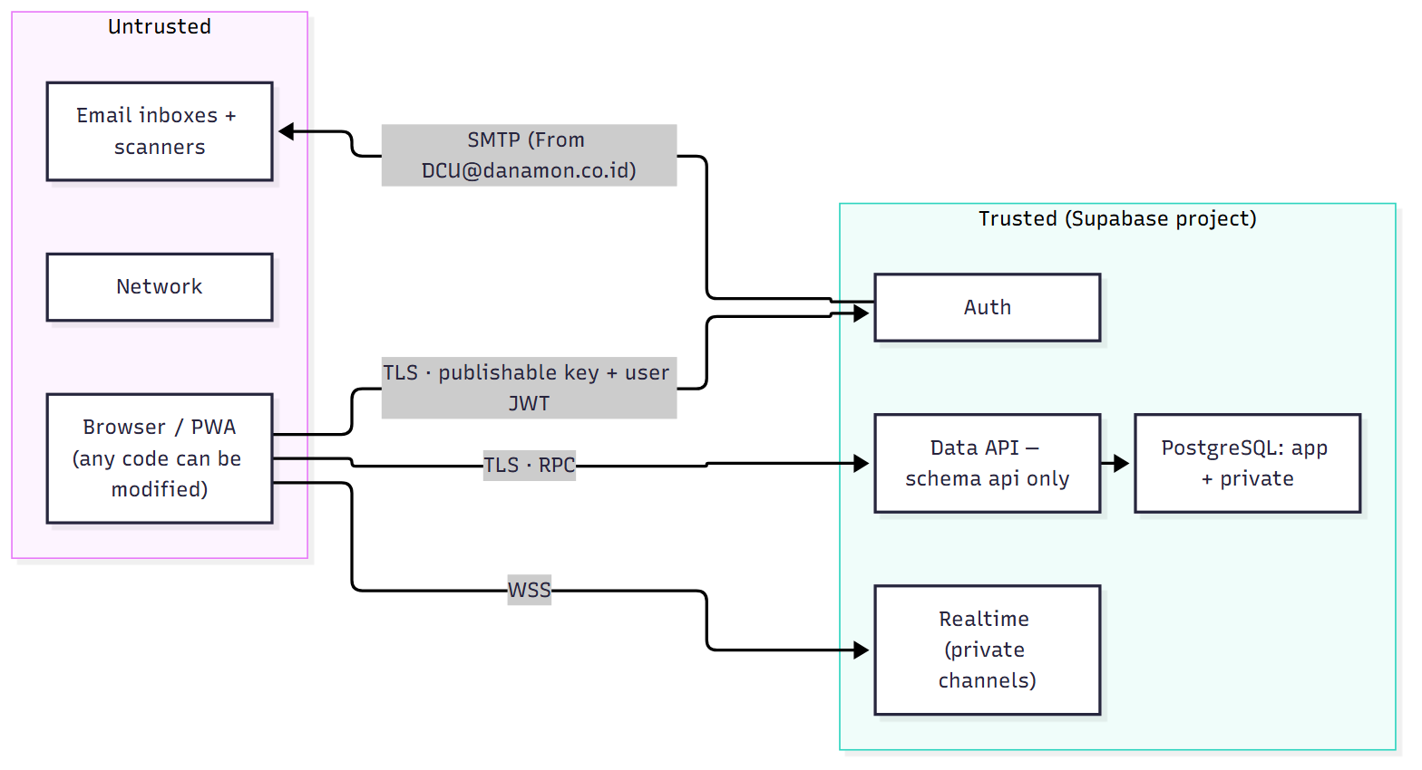
Everything coming from the browser is untrusted: arguments, timing, number of requests, and even the absence of the UI. The database validates every input as if it came from an attacker.

4. Threat model (STRIDE)
# | Threat | Category | Mitigation | Verified by
T-01 | Attacker registers with a non-company email | Spoofing | Before-User-Created hook domain check (server); exact match; email verification required | TEST-52
T-02 | Credential stuffing / brute force | Spoofing | Auth rate limits; strong password policy; optional CAPTCHA (TR-AUTH-05); generic error messages | TEST-51, config review
T-03 | Email security scanner consumes the verification/reset link | Spoofing / DoS | Link opens a page that requires an explicit click before verifyOtp; a 6-digit code alternative | TEST-49
T-04 | Session theft via XSS | Spoofing / Info disclosure | Strict CSP (no inline script, no third-party script origins); React escaping; react/no-danger lint; no HTML rendering of user text | TEST-47 (XSS case), CSP check
T-05 | User reads another user's bookings via direct API | Info disclosure | Tables not exposed; INVOKER read RPCs under RLS; BOOKING_NOT_FOUND for foreign ids | TEST-23
T-06 | Availability or Realtime leaks booker identity | Info disclosure | Aggregate-only outputs; Realtime payload {facility_code, date_wib}; private channels | TEST-42
T-07 | User calls admin RPCs | Elevation of privilege | private.assert_admin() on live DB state + RLS admin policies | TEST-24
T-08 | User sets own role or active flag | Elevation of privilege | No table write grants; no RPC accepts role/status for self; admin RPC forbids self-modification | TEST-40
T-09 | Deactivated user keeps acting with a valid JWT | Elevation of privilege | Every RPC and RLS policy checks is_active live; optional Auth session revocation | TEST-25
T-10 | Race conditions bypass limits or double-book | Tampering | Profile/resource row locks; exclusion constraint; idempotency keys | TEST-07…14, 26, 34
T-11 | Tampered request (past time, wrong duration, foreign facility/resource) | Tampering | Server derives times from date + time in WIB; validates everything; composite FKs | TEST-15, 16, 34
T-12 | Admin abuses power without trace | Repudiation | Mandatory reason + append-only audit logs (immutable trigger) | TEST-33
T-13 | SQL injection via RPC arguments | Tampering | Parameterised PL/pgSQL; no dynamic SQL built from input (any EXECUTE uses format('%I/%L')) | Code review checklist, pgTAP
T-14 | search_path hijacking of SECURITY DEFINER functions | Elevation of privilege | SET search_path = ''; fully qualified names; Security Advisor | pgTAP lint test
T-15 | Secret key leaked in the frontend bundle or repo | Info disclosure | Only VITE_* public vars; .gitignore; CI bundle scan; secret scanning on GitHub | TEST-35
T-16 | Open redirect after login/reset | Spoofing | safeNext() allow-list; Supabase redirect URL allow-list | TEST-50
T-17 | Clickjacking | Tampering | frame-ancestors 'none', X-Frame-Options: DENY | Header check
T-18 | Booking spam / resource exhaustion | DoS | Per-user rate limit on create_booking; fair-use limits; Auth rate limits | Test + config
T-19 | Malicious admin settings (e.g. horizon 0) | Tampering / DoS | Server-side ranges; reason + audit; read-only critical keys | TEST-54
T-20 | Domain list emptied → nobody can register | DoS | ≥ 1 active domain safeguard | TEST-53
T-21 | Spoofed emails "from DCU" (phishing users) | Spoofing | SPF/DKIM/DMARC for danamon.co.id sender (OD-03); emails contain no links except to the official domain | Mail config review
T-22 | Test clock abused in production | Tampering | private.now() honours overrides only if app.allow_time_override = on, which is never set in production; deployment check | Deployment checklist

5. Authentication configuration (per environment)
Setting | Value
Providers | Email only (others disabled)
Allow new sign-ups | On
Confirm email | On
Before-User-Created hook | private.hook_before_user_created (domain allow-list)
Minimum password length | 8
Password requirements | Lowercase, uppercase, digits, and symbols
Leaked password protection | On if the plan supports it
OTP / link expiry | 3600 s (≤ 60 min)
JWT expiry | 3600 s
Refresh-token rotation + reuse detection | On
Session time-box / inactivity timeout (if plan supports) | 30 days / 7 days
Site URL / Redirect URLs | Exact origins per environment: /auth/confirm, /reset-password
SMTP | Custom; sender DCU@danamon.co.id, name "DCU Active" (OD-03 method)
Email templates | Confirm signup and Reset password: code + scanner-safe link. Magic link and email change are disabled or not used.
Secure email change | Not used in V1 (email change disabled in the UI)

6. Authorization model
Decision point | Check | Source of truth
Is the caller authenticated? | auth.uid() not null | JWT signature (Supabase)
Is the caller active? | app.profiles.is_active | Database (live)
Is the email verified? | auth.users.email_confirmed_at not null | Database (live)
Is the caller an admin? | app.profiles.role = 'ADMIN' and is_active | Database (live)
Does the caller own the booking? | bookings.user_id = auth.uid() | RLS + function check
Is the email domain allowed? | app.allowed_email_domains | Database (live), at sign-up and admin grant

JWT custom claims are not used for authorization (ADR-006).

7. Database function security checklist (enforced in code review and pgTAP)
- SECURITY DEFINER functions declare SET search_path = '' and use schema-qualified names.
- EXECUTE is revoked from public and anon, then granted explicitly (authenticated; anon only for get_registration_domains, health).
- The first statement authenticates and authorizes (private.assert_active_user() / private.assert_admin()).
- Inputs are validated for type, range, and format before use. Text lengths are bounded.
- No dynamic SQL from input. If unavoidable, use format() with %I/%L.
- Errors go through private.raise_business_error. No database internals appear in messages.
- Mutations write their audit row in the same transaction.
- Outputs of DEFINER read functions are reviewed for personal data (privacy test).
- Lock order follows Architecture §6.2.
- A pgTAP "lint" test fails if any api function lacks a fixed search_path or grants EXECUTE to public.

8. Frontend security

8.1 Security headers (host config; staging starts with CSP in Report-Only)
Content-Security-Policy: default-src 'self'; script-src 'self'; style-src 'self';
img-src 'self' data: blob:; font-src 'self';
connect-src 'self' https://<ref>.supabase.co wss://<ref>.supabase.co https://<sentry-ingest-host>;
manifest-src 'self'; worker-src 'self'; frame-ancestors 'none'; base-uri 'self';
form-action 'self'; object-src 'none'; upgrade-insecure-requests
Strict-Transport-Security: max-age=31536000; includeSubDomains
X-Content-Type-Options: nosniff
X-Frame-Options: DENY
Referrer-Policy: strict-origin-when-cross-origin
Permissions-Policy: camera=(), microphone=(), geolocation=(), payment=(), usb=()
Cross-Origin-Opener-Policy: same-origin
- Tailwind 4 emits static CSS files, and the system font stack needs no font host, so style-src 'self' is achievable.
- If a library requires inline styles, use CSP hashes rather than 'unsafe-inline'.
- The Sentry host is added only if OD-08 selects Sentry.

8.2 Other frontend controls
- Session storage is handled by supabase-js (localStorage, PKCE flow). XSS is the main risk to it, hence the strict CSP.
- No secrets in VITE_* variables. The CI script scripts/bundle-secret-scan.mjs fails the build if dist/ contains sb_secret_, service_role, or a JWT whose role is not anon.
- safeNext() accepts only relative paths matching known routes, and rejects //, \, schemes, and encoded variants.
- Monitoring beforeSend scrubs emails, names, and tokens from events and URLs.

9. Email security (sender DCU@danamon.co.id)
Control | Requirement
SPF | danamon.co.id SPF authorises the sending infrastructure (Danamon relay or provider)
DKIM | Mail signed with a DKIM key published under danamon.co.id (aligned)
DMARC | Danamon's existing DMARC policy must pass via aligned SPF or DKIM
Content | Plain, branded "DCU Active" emails; code shown in the body; link only to the official app domain; no tracking pixels
Recipient side | Allow-list request to the IT of Danamon, Adira, Home Credit (TR-R13)
Abuse | Auth email rate limits; resend cooldown in the UI (60 s)

10. Privacy (UU PDP — Law No. 27 of 2022)
Topic | Design
Data minimisation | Only name, corporate email, bookings, and notifications are stored. No phone, photo, location, or device fingerprint.
Purpose | Facility booking and fair-use administration only
Transparency | Short privacy notice linked on the registration and profile screens (text to be approved by Legal, OD-17)
Access control | Own data for users; admins see what they need for operations; all admin views are audited where they change data
Cross-border transfer | Data stored in Singapore. The PO confirmed overseas storage is allowed (OD-22). Legal to confirm the notice wording.
Retention | Bookings/audit ≥ 2 years (pending OD-17); notifications 90 days
Data subject requests | V1: handled by an admin through a documented procedure (export or anonymise profile), Operations Guide (Phase 6)
Third parties | Supabase (processor), host/CDN, email provider, monitoring (no PII). The processor list goes into the privacy notice.

11. Audit design
- Immutable: a BEFORE UPDATE OR DELETE trigger raises an error, and no role has write grants.
- Content: actor, role, time (UTC; displayed in WIB), action, entity, before/after (minimal), reason, request id.
- Coverage: all admin mutations (mandatory) and user booking lifecycle events.
- Access: admins read via admin_list_audit_logs.

12. Security testing plan (summary; details in TEST-PLAN.md)
Activity | When
pgTAP privilege tests per role (anon, user A/B, deactivated, admin) | Phase 2, every CI run
Function lint test (search_path, grants) | Phase 2, every CI run
Concurrency abuse tests | Phase 2 / 4
Bundle secret scan, dependency audit | Every CI run
Supabase Security Advisor review | End of Phase 2 and before production
OWASP ZAP baseline scan against staging | Phase 4
Manual review of auth flows, RLS, RPCs, headers | Phase 4
Go-live gate: no open Critical/High findings | Phase 5

13. Incident response (outline for the Operations Guide)
- Detect. Monitoring alerts, integrity check failures, or a user report.
- Contain. Deactivate the affected accounts. Remove the affected domain. Rotate keys (Supabase secret key, SMTP credentials). Block a facility if needed.
- Investigate. Audit logs, Supabase logs.
- Recover. Restore from backup if data was corrupted (OD-09).
- Notify. Follow the UU PDP notification obligations through DCU's DPO/Legal.
- Review. Post-incident review and backlog actions.

