DCU Active — Solution Architecture
Item | Value
Phase | Phase 1 — Solution Architecture and UX Design
Version | 1.0 (Draft for review)
Date | 2026-10-14
Inputs | docs/requirements/BRD.md v0.2, TRD.md v0.2, OPEN-DECISIONS.md v0.3
Related | DATABASE-DESIGN.md, API-RPC-SPECIFICATION.md, SECURITY-DESIGN.md, ../design/UX-UI-SPECIFICATION.md, ../testing/TEST-PLAN.md

This document turns the TRD into a buildable design. Where it refines the TRD, the refinement is flagged [Refines TRD] so reviewers can see what changed and why.

1. Scope and goals
DCU Active is a responsive single-page web application (with PWA support) for booking DCU sports facilities.
The architecture must guarantee:
- no double booking (BR-11, BR-20);
- server-side enforcement of every business rule (BR-15);
- privacy of booking owners (SEC-05);
- immediate effect of deactivation, role, domain, and settings changes (SEC-19, FR-ADM-12/13);
- a simple, fast mobile experience for occasional users (FR-UX-02).

2. System context
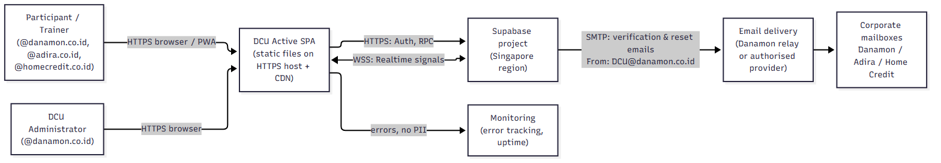
External system | Purpose | Decision
Supabase (Auth, PostgreSQL, Realtime, cron) | Identity, data, business logic, live signals | APPROVED stack; region Singapore (OD-22)
Static HTTPS host + CDN | Serves the SPA and security headers | Host-agnostic design; provider = OD-01 (default Cloudflare Pages)
Email delivery for DCU@danamon.co.id | Verification and password-reset emails | Sender decided; method pending Danamon IT (OD-03, §11)
Monitoring | Frontend errors and uptime | OD-08 (default Sentry + uptime monitor)

3. Container view
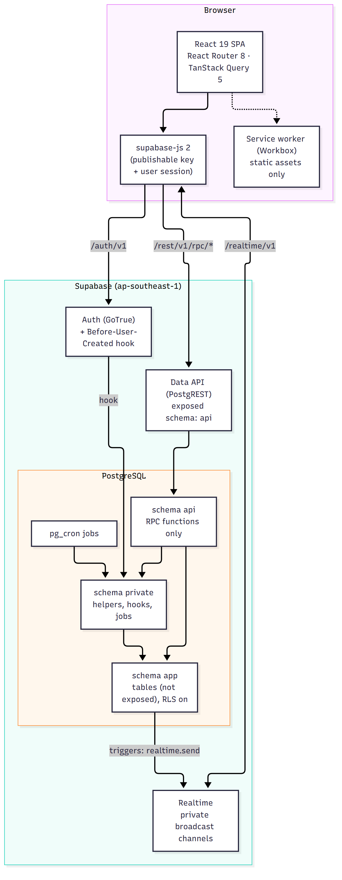

3.1 Schema layout [Refines TRD]
Schema | Exposed to the Data API? | Contents | Why
api | Yes (the only exposed schema) | RPC functions only. No tables or views. | The public surface is exactly the reviewed function list, so new tables can never leak by accident.
app | No | All business tables (profiles, bookings, …) with RLS enabled | Tables are reachable only through functions. Direct REST access is impossible.
private | No | Helper functions (is_admin, now_wib, error helpers), the Auth hook, scheduled jobs, trigger functions | Never callable by clients.
public | Not exposed (removed from "Exposed schemas") | Empty except extensions if required | Prevents accidental exposure.

The TRD assumed tables in an exposed schema protected by RLS. Moving tables to a non-exposed schema keeps RLS (defence in depth) but removes the direct table API entirely. All TRD requirements still hold.

3.2 Function security model [Refines TRD]
Function type | Security mode | Rationale
Own-data reads (list_my_bookings, get_my_booking, get_my_profile, list_my_notifications) | SECURITY INVOKER. Runs as authenticated, so RLS filters the rows. | RLS is the real authority for "own rows only" (SEC-03). A bug in the function's WHERE clause cannot leak data.
Admin reads (admin_list_*, admin_get_*, admin_dashboard_metrics) | SECURITY INVOKER + RLS admin policies + explicit private.assert_admin() | Two independent checks.
Aggregated public reads (get_availability, list_facilities, get_app_config, get_registration_domains) | SECURITY DEFINER, returning aggregates only | Must count other users' bookings without exposing them (SEC-05). Output contract reviewed in tests (TEST-42).
All writes (create_booking, cancel_my_booking, check_in, all admin_* mutations) | SECURITY DEFINER, SET search_path = '', explicit authorization at the top | Writes need cross-row validation and locking that RLS cannot express. The authenticated role has no INSERT/UPDATE/DELETE grants on app tables.

4. Environments and configuration
Environment | Frontend | Supabase | Email | Data
Local (developer PC) | vite dev on http://localhost:5173 | Supabase CLI local stack (Docker) | Inbucket/Mailpit (local mail catcher, built into the CLI) | supabase/seed.sql test data
Staging | Host preview URL (HTTPS) | Separate Supabase project, Singapore | Real delivery from DCU@danamon.co.id (once OD-03 is resolved) | Synthetic test users; UAT accounts
Production | Custom domain (OD-02), HTTPS | Separate Supabase project, Singapore, paid plan (OD-09) | Real delivery | Real users only

Frontend environment variables (public by design, embedded at build time):
Variable | Example
VITE_SUPABASE_URL | https://<ref>.supabase.co
VITE_SUPABASE_PUBLISHABLE_KEY | sb_publishable_…
VITE_APP_ENV | local | staging | production
VITE_SENTRY_DSN | optional

Server-side secrets — SMTP credentials, the Supabase secret key, and the CI access token — live only in the Supabase dashboard and CI secret store. They never appear in VITE_* variables (SEC-06).
Database-level settings per environment:
Setting | Local / staging | Production
app.allow_time_override | on (enables the test clock, §6.6) | Must not be set

5. Frontend architecture

5.1 Selected libraries (pinned in Phase 2; versions checked on npm 2026-10-14)
Concern | Library | Version | Notes
UI runtime | react, react-dom | 19.3.0
Language | typescript | 6.0.3 | typescript-eslint 8.71.2 supports TS < 6.1 (ADR-008)
Build | vite 8.3.4, @vitejs/plugin-react 6.1.2
Routing | react-router | 8.4.0 | Data router (createBrowserRouter); data loading is done by React Query, not route loaders
Server state | @tanstack/react-query | 5.104.2
Backend client | @supabase/supabase-js | 2.117.3 | db.schema = 'api', auth.flowType = 'pkce'
Styling | tailwindcss + @tailwindcss/vite | 4.3.3 | Peer: vite ^5–^8 ✔
Accessible primitives | radix-ui | 1.8.1 | Dialog, Sheet, Tabs, Toast, Select, Tooltip
Icons | lucide-react | 1.56.0
Forms & validation | react-hook-form 7.90.0, @hookform/resolvers 5.9.1, zod 4.6.7 |  | UX-only validation
PWA | vite-plugin-pwa 2.0.0, workbox-window 7.4.1
Error monitoring (OD-08) | @sentry/react | 11.7.0 | Peer supports react-router 8 ✔
Tests | vitest 5.0.4, @testing-library/react 16.3.3, jsdom 30.1.2, msw 3.0.3, @playwright/test 1.64.0, @axe-core/playwright 4.13.0

5.2 Source structure (planned for Phase 3)
src/
app/ router.tsx, providers.tsx (QueryClient, Auth, Realtime), layouts/
features/
auth/ Login, Register, Verify, AuthConfirm, ForgotPassword, ResetPassword, AccountDisabled
home/ Home (upcoming booking, check-in banner, facility tiles)
facilities/ FacilityList, FacilityBooking (date strip + slot grid + duration), ReviewSheet
bookings/ MyBookings (Upcoming | History), BookingDetail, BookingConfirmed
notifications/ NotificationList, unread badge
profile/ Profile, ChangePassword
admin/ dashboard/, bookings/, blocks/, users/, settings/ (Booking settings | Email domains), audit/
components/ui/ design-system components (Button, Sheet, SlotCell, DateStrip, StatusBadge, …)
lib/
supabase.ts single client instance
api/ typed RPC wrappers (one file per feature), generated DB types
errors.ts business error code → message map
time.ts WIB formatting helpers (Intl, timeZone 'Asia/Jakarta')
realtime.ts channel manager (subscribe/unsubscribe, status → polling fallback)
safe-redirect.ts safeNext() allow-list
pwa/ registration, update prompt, offline detector
styles/ tokens.css (CSS variables from UX spec), tailwind entry
tests/ unit/ (Vitest), e2e/ (Playwright), a11y/
supabase/ migrations/, tests/ (pgTAP), seed.sql, config.toml
scripts/ provision-admin.sql, bundle-secret-scan.mjs, concurrency/ harness

5.3 Routing and guards
Guard | Applies to | Behaviour
PublicOnly | /login, /register, /verify, /forgot-password | Signed-in user → redirect to /
RequireSession | everything except public routes and /auth/confirm, /reset-password | No session → /login?next=<safe path>
RequireActive | user and admin routes | Calls get_my_profile. If is_active = false → /account-disabled
RequireAdmin | /admin/** | Role ≠ ADMIN → Not-found page (does not reveal that admin routes exist). Backend checks regardless.

The admin route tree is lazy-loaded into a separate chunk, so normal users never download admin code (TR-PERF-02).

5.4 Server-state strategy (TanStack Query)
Query key | Source RPC | staleTime | Refetch
['config'] | get_app_config | 5 min | on focus
['facilities'] | list_facilities | 1 h | —
['availability', facilityCode, date] | get_availability | 15 s | Realtime signal; focus; reconnect; 30 s polling when Realtime is down; always before opening the review sheet
['my-bookings', 'upcoming' | 'history'] | list_my_bookings | 30 s | after any booking mutation; at status boundaries (check-in opens/closes, cancel cutoff)
['booking', id] | get_my_booking | 30 s | as above
['notifications'] | list_my_notifications | 60 s | user Realtime topic
['admin', …] | admin RPCs | 30 s | after admin mutations

Mutation rules:
- networkMode: 'online' for all mutations, so nothing is queued offline (TR-PWA-04).
- No query persistence to storage.
- create_booking uses an idempotency key generated when the review sheet opens (crypto.randomUUID()) and reused for retries of that same review (FR-BKG-05).

5.5 Time handling
- The server returns instants as ISO-8601 UTC and pre-formatted WIB strings (date_wib, start_wib, end_wib). The UI displays the WIB strings or formats with Intl.DateTimeFormat('en-GB', { timeZone: 'Asia/Jakarta' }). All displayed times carry the "WIB" suffix.
- The "today" used for the date strip comes from get_app_config().today_wib, not the device clock (TEST-27).
- Client timers only refresh labels and trigger refetches. Actions are always re-validated by the server.

5.6 Error handling
- RPC errors arrive as PostgREST errors with message = <BUSINESS_CODE> and details = <JSON> (see API-RPC-SPECIFICATION.md §2).
- lib/errors.ts maps codes to plain-English copy (UX spec §9).
- An unknown error shows "Something went wrong. Reference: {id}" and is reported to monitoring without personal data.
- A React error boundary per route shows the Error state with a "Try again" action.

5.7 Realtime client
- After sign-in, the client subscribes to the private channel availability:<facility_code> only while that facility's booking screen is open, and to user:<uid> for the session.
- Channel status SUBSCRIBED disables polling. Any other status enables 30-second polling for the open screen (TR-RT-05).

5.8 PWA and offline
- vite-plugin-pwa with registerType: 'prompt' and generateSW.
- Precache build assets only. NetworkOnly for the Supabase origin.
- navigateFallback: '/index.html' with a deny-list for /auth/confirm so email links always reach the network.
- The offline banner and disabled action buttons are driven by an useOnlineStatus hook (navigator.onLine + events + failed-fetch detection).
- The update prompt is deferred while the booking review sheet is open.

6. Backend architecture

6.1 Function conventions
Convention | Rule
Naming | api.<verb>_<noun> for client RPCs; private.<name> for internals; admin RPCs prefixed admin_
Arguments | Prefixed p_; business-level types (e.g. p_date date, p_start_time text 'HH:MM')
Return | jsonb (single object) or SETOF/jsonb arrays for lists, with stable field names (API spec)
Errors | perform private.raise_business_error('<CODE>', jsonb_build_object(...)) → RAISE EXCEPTION USING ERRCODE = 'P0001', MESSAGE = code, DETAIL = json
Security | Definer functions: SECURITY DEFINER SET search_path = '', fully-qualified names, owner = postgres
Grants | REVOKE ALL ON FUNCTION … FROM public, anon; GRANT EXECUTE … TO authenticated (exception: get_registration_domains → anon too)
Timeouts | Mutations: SET LOCAL lock_timeout = '3s', statement_timeout = '10s' → mapped to SYSTEM_BUSY
Clock | All "now" comes from private.now() (§6.6)

6.2 Lock ordering (deadlock avoidance, TR-CON-06)
1. app.profiles (requesting user) -- FOR UPDATE (booking, check-in, cancel)
2. app.physical_resources of the facility -- FOR UPDATE, ORDER BY allocation_order
3. app.bookings rows -- FOR UPDATE (cancel, check-in, conflicts)
Admin role/activation changes: lock all ADMIN profiles ORDER BY id (last-admin check), then the target.
Status processor: bookings FOR UPDATE SKIP LOCKED (never waits).

6.3 Scheduled jobs (pg_cron)
Job | Schedule (UTC cron) | Function | Purpose
booking-status | * * * * * (every minute) | private.process_booking_statuses() | CONFIRMED → NO_SHOW after the deadline; CHECKED_IN → COMPLETED after end
purge-notifications | 0 20 * * * (03:00 WIB) | private.purge_notifications() | Retention (90 days)
integrity-check | 15 20 * * * (03:15 WIB) | private.run_integrity_checks() | Writes results to app.integrity_check_runs; monitoring alerts on failures (TR-OPS-05)

6.4 Triggers
Table | Trigger | Purpose
auth.users AFTER INSERT | private.on_auth_user_created | Create app.profiles (role USER, full name from sign-up metadata)
auth.users AFTER UPDATE OF email | private.on_auth_user_email_changed | Keep profiles.email in sync (email change is disabled in V1, defensive only)
app.bookings BEFORE UPDATE | private.enforce_booking_transition | Allowed status transitions only (TR-BKG-09)
app.bookings AFTER INSERT/UPDATE OF status | private.broadcast_availability_change | realtime.send to availability:<code>
app.facility_blocks AFTER INSERT/UPDATE | same | Same signal
app.notifications AFTER INSERT | private.broadcast_user_notification | realtime.send to user:<uid> with {type} only
app.audit_logs BEFORE UPDATE/DELETE | private.deny_audit_mutation | Audit trail immutability
all tables with updated_at | private.touch_updated_at | Timestamps

6.5 Auth hook: email domain check
- Primary: Supabase Auth Before User Created hook → private.hook_before_user_created(event jsonb). It extracts the email domain, compares it case-insensitively with active rows in app.allowed_email_domains (exact match), and returns an error object (HTTP 403, message EMAIL_DOMAIN_NOT_ALLOWED) when not allowed.
- Fallback (if the Phase 2 spike shows the hook is unsuitable): BEFORE INSERT trigger on auth.users raising the same error.
- Both share private.is_email_domain_allowed(email text) returns boolean.

6.6 Test clock
private.now() returns now() normally. When the database setting app.allow_time_override = 'on' and the transaction sets app.test_now, it returns that value instead. This lets pgTAP and integration tests simulate check-in windows, cancel cutoffs, and no-shows deterministically (TR-TEST-11). Production never has app.allow_time_override set, and a pgTAP test asserts it is absent in production configuration (deployment checklist).

6.7 Optional Edge Function
admin-revoke-sessions (TR-AUTH-08, SHOULD) bans or signs out a deactivated user in Auth using the secret key held in Edge Function secrets. It is called by the admin UI after a successful admin_set_user_active(false). The database check remains the guaranteed control. Scheduled for Phase 2 only if time allows; not required for acceptance.

7. Key flows

7.1 Registration with domain check and verification
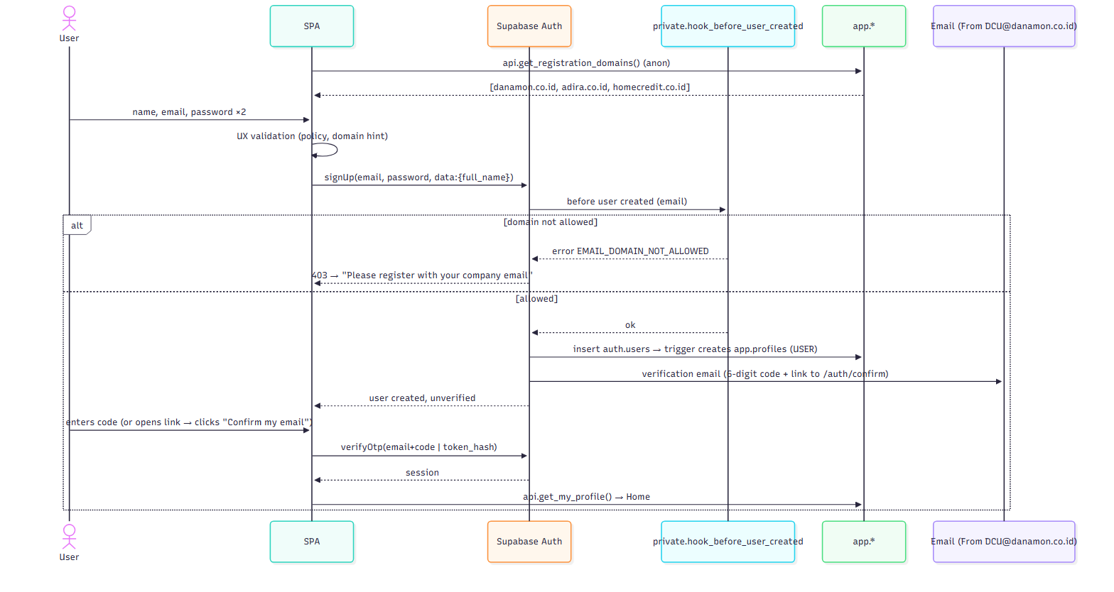

7.2 Create booking (atomic)
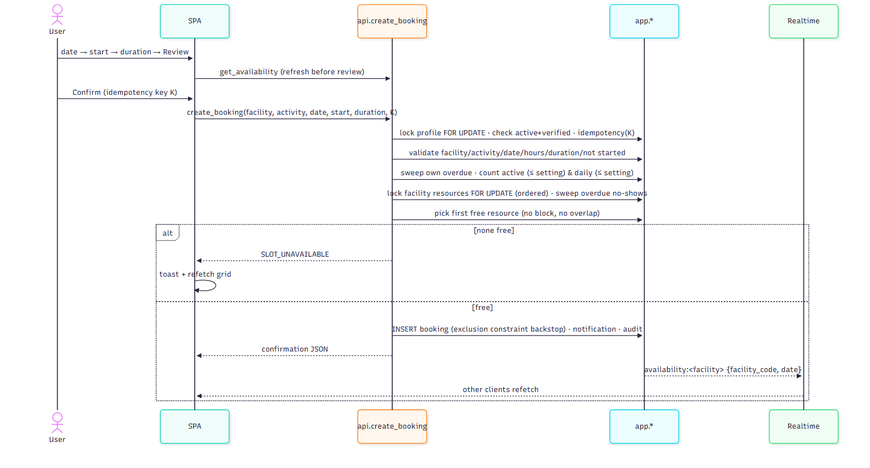

7.3 Check-in, cancel cutoff, no-show
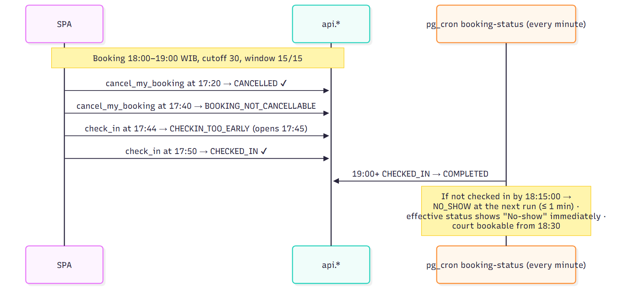

7.4 Admin block with conflicts
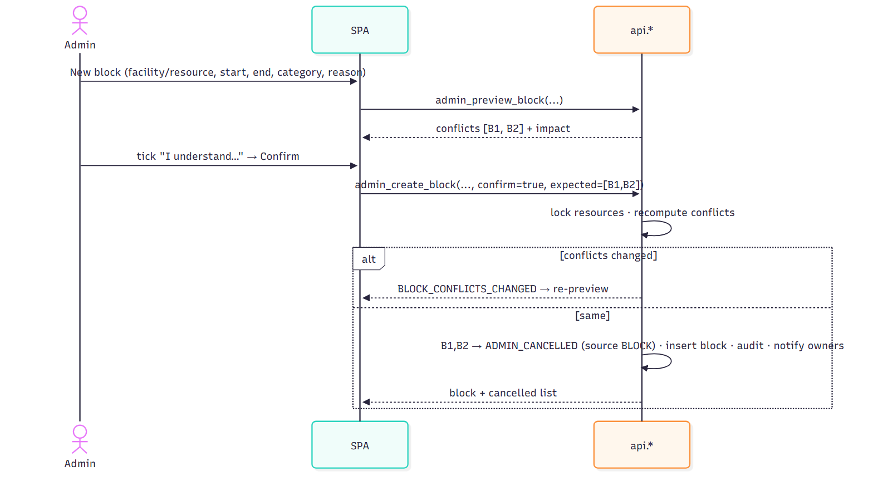

7.5 Settings and domain changes
Admin → /admin/settings. Each change calls admin_update_setting or admin_*_email_domain with a reason. The change is validated against the allowed range, written, and audited (old/new). It takes effect for the very next RPC call, because every RPC reads app.app_settings and app.allowed_email_domains live, with no caching in the database layer.

8. Cross-cutting concerns
Concern | Design
Audit | app.audit_logs written inside the same transaction as the change (atomic). Admin actions are mandatory. User booking lifecycle events are recorded too (create, cancel, check-in, no-show) for dispute handling.
Logging | Supabase API/DB logs. Frontend errors go to monitoring with emails/names scrubbed (beforeSend). No business data is logged client-side.
Monitoring (OD-08) | Error tracking; uptime check on the app URL and on api.get_app_config (requires auth → use a dedicated health RPC api.health() granted to anon returning {ok, db_time, last_status_job_at}); alert if last_status_job_at is older than 5 min. [Refines TRD: adds api.health]
Performance | Indexed lookups only. get_availability computes 30 slots × ≤ 2 resources per call (tiny). Admin lists paginated (cursor). Static assets cached by the CDN with hashed filenames.
Accessibility | Radix primitives + design tokens with verified contrast (UX spec §3).
Internationalisation | English only in V1. All copy centralised in lib/copy.ts so Bahasa Indonesia can be added later (FE-12).

9. Deployment architecture
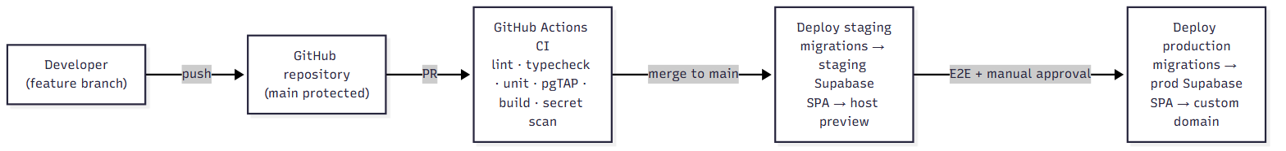
- Migrations: supabase db push with the project-specific access token from CI secrets. Production requires a manual approval step.
- SPA deploy: static dist/ upload plus host config files: _headers for CSP/HSTS, _redirects for the SPA fallback, or the provider equivalent (OD-01).
- Rollback: redeploy the previous SPA build. Database changes are forward-only migrations with a written down-script reviewed per release; no destructive migration without a backup.

10. Architecture decision records (ADR summary)
ADR | Decision | Status
ADR-001 | All business rules in PostgreSQL functions; SPA is a thin client | Accepted (TRD AP-01)
ADR-002 | Only schema api (functions) is exposed; tables live in non-exposed app | Accepted — refines TRD
ADR-003 | Own-data reads are SECURITY INVOKER so RLS is authoritative; writes are SECURITY DEFINER | Accepted — refines TRD
ADR-004 | Overlap prevention via GiST exclusion constraint + ordered row locks | Accepted
ADR-005 | No-show via pg_cron every minute + in-transaction sweep + effective status on read | Accepted (OD-06 default)
ADR-006 | Authorization from live database state (profiles.role/is_active), not JWT claims | Accepted
ADR-007 | Email domain allow-list enforced by the Auth Before-User-Created hook (trigger fallback) | Accepted (verify in Phase 2 spike)
ADR-008 | TypeScript 6.0.3 instead of 7.0.2 (lint toolchain compatibility) | Accepted
ADR-009 | Tailwind CSS 4 + Radix primitives; system font stack (no web-font download, simpler CSP) | Accepted
ADR-010 | Realtime = private broadcast "something changed" signals; data always re-fetched via RPC | Accepted
ADR-011 | Host-agnostic static SPA; security headers delivered by host config | Accepted (provider OD-01)
ADR-012 | Configurable limits enforced transactionally under the user's profile lock (no partial unique index) | Accepted (TRD v0.2)

11. Email delivery design for DCU@danamon.co.id (OD-03)
Sending authentication email as DCU@danamon.co.id means the receiving mail systems (Danamon, Adira, Home Credit) check that the sender is authorised by danamon.co.id. Without that authorisation, verification emails will be rejected or quarantined (risk TR-R13).
Option | How it works | What Danamon IT must do | Pros | Cons
A. Danamon mail relay | Supabase custom SMTP points at Danamon's mail relay, authenticating as the DCU@danamon.co.id mailbox (or an app relay account) | Provide SMTP host/port/credentials or a relay allowed for Supabase's sending IPs; confirm sending limits | Mail originates from Danamon's own infrastructure; best trust with Danamon recipients | Corporate relays often restrict app/basic-auth SMTP; IP-based relays are hard with cloud senders
B. Transactional provider authorised for danamon.co.id (recommended) | Supabase custom SMTP → provider (e.g. Amazon SES, Postmark, Resend). The provider signs mail with DKIM for danamon.co.id. | Add the provider's SPF include and DKIM CNAME/TXT records to danamon.co.id DNS (or to a delegated subdomain); confirm DMARC alignment | Reliable delivery, bounce/complaint reporting, no mailbox password stored | Requires a DNS change on Danamon's domain and a provider account

Both options need:
- the mailbox DCU@danamon.co.id to exist so replies reach someone;
- an allow-list request to the IT teams of Adira and Home Credit;
- a delivery test to all three domains before go-live (BRD SC-M4).
Until OD-03 is resolved, local and staging development use the local mail catcher. Staging auth tests that need real delivery wait for the chosen option.

12. Open items carried into Phase 2
Item | Owner | Blocking?
OD-03 email sending method with Danamon IT | PO + Danamon IT | Blocks only real-email staging tests
OD-04 names of the first 2 admins (@danamon.co.id) | PO | Needed for the staging seed
GitHub remote repository creation (GitHub CLI not installed) | PO / developer | No — local Git is in place
Spike: Before-User-Created hook behaviour on the chosen plan | Dev | No — fallback defined
OD-01, 02, 08, 09, 17, 10 | PO | Before production / go-live

