Airport Scene (plane arrival)

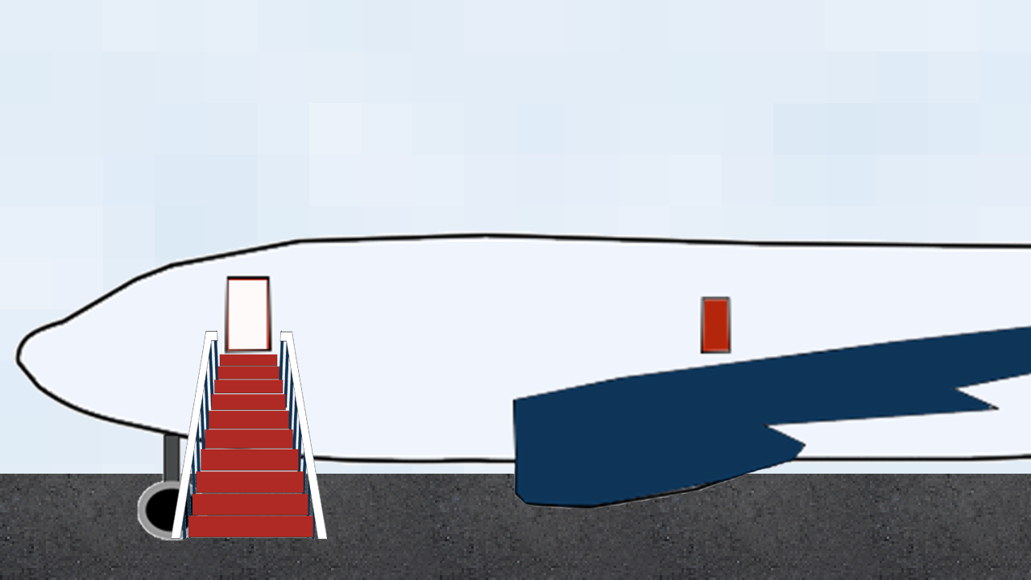

Inside airport scene (Try to get directions to hotel, search bus schedules, head to Jenny’s house instead)

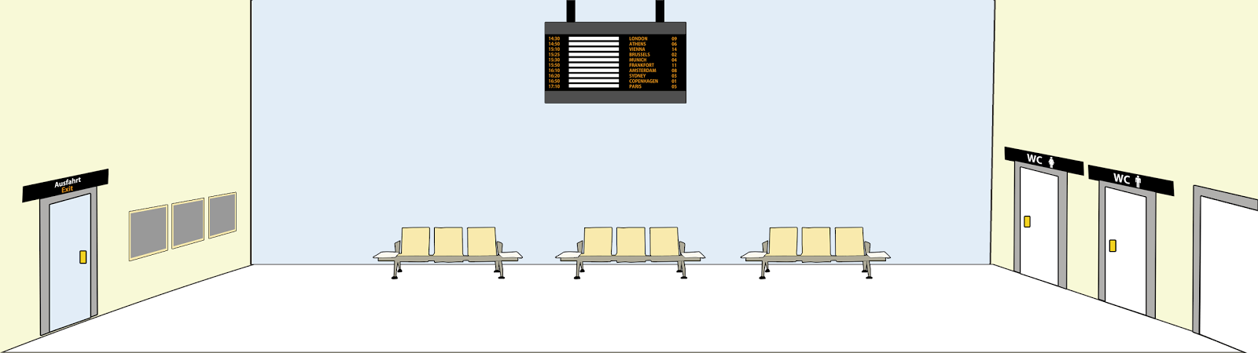

Outside Jenny’s house (arrive there, ring door bell, head to tool shed to open window blinds)

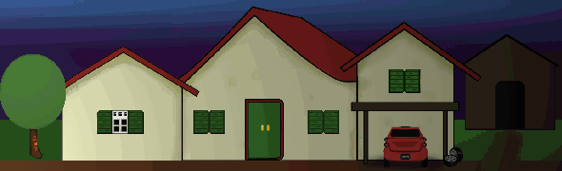

Toolsshed (search for something to open window blinds, grab crowbar)

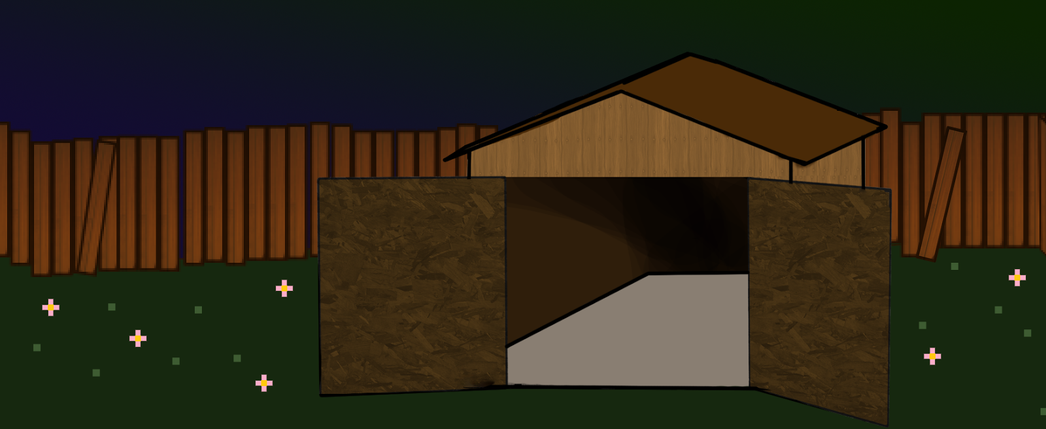

Bathroom (crawl in through bathroom window blind)

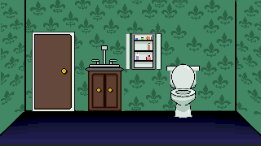

Rest of house (search for Jenny all over the house - optional movement to: living room and hallway; end up in kitchen)

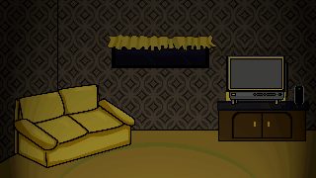

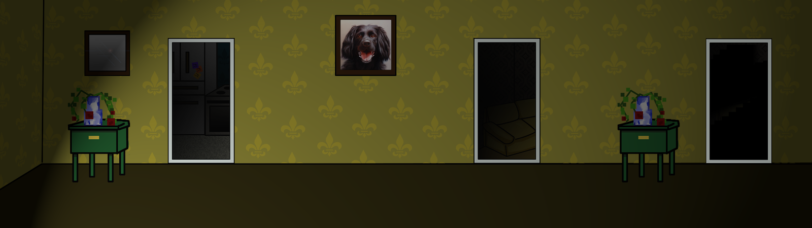

Kitchen (end first search attempt)

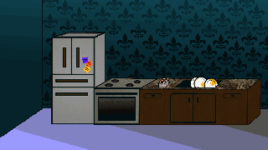

Look around house again ((search for Jenny again - optional movement to: living room, hallway, kitchen, and bathroom; end up in Jenny’s bedroom)

Jenny’s Bedroom (try to login to Jenny’s PC by looking around her room for password clues; find where you need to go - Bielefeld)

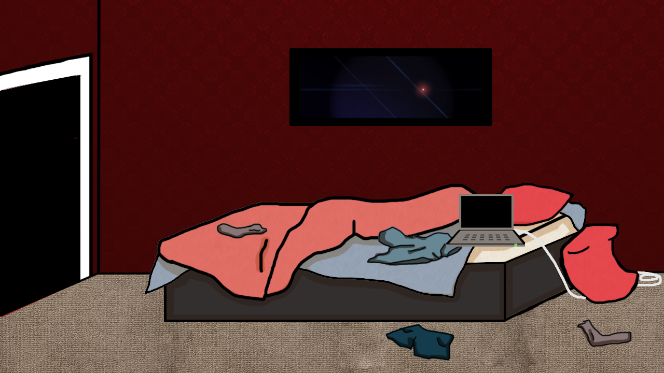

Outside of Hotel (transition screen)

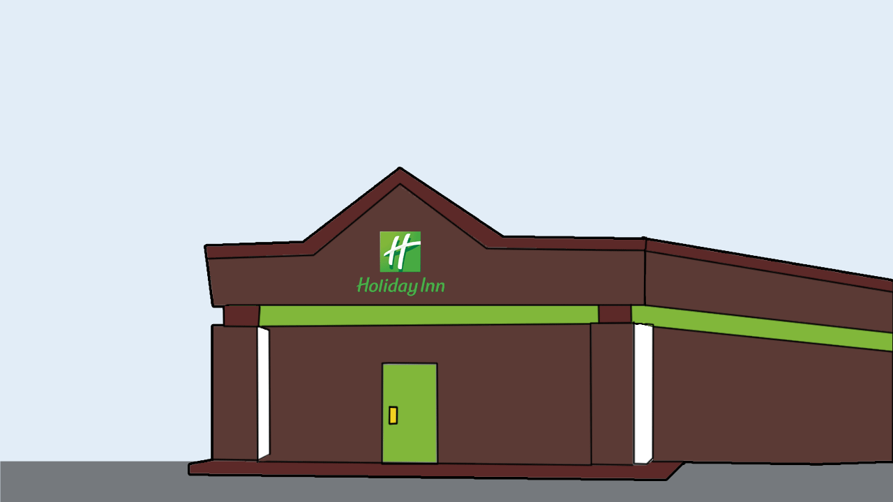

Hotel Lobby (ask for directions to bus station in Bielefeld from the hotel receptionist)

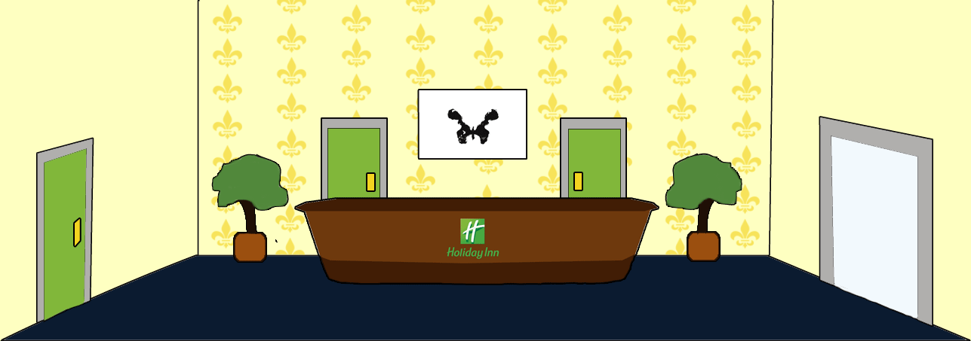

Bus station (take bus to Bielefeld)

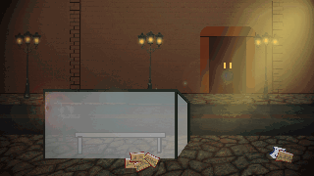

Bielefeld (shopping center where you find and “kill” Jenny)

