
MongoDB is an open-source document database .
this is leading NoSQL database.
MongoDB is written in C++.
MongoDB is a cross-platform, document oriented database .
MongoDB works on concept of collection and document.
Database (set of collections)
Database is a physical container for collections.
Collection(set of documents)
Collection is a group of MongoDB documents.
It is the equivalent of an RDBMS table.
A collection exists within a single database.
Documents within a collection can have different fields.
Typically, all documents in a collection are of similar or related purpose.
Document
A document is a set of key-value pairs.
Documents have dynamic schema.

Differences bet’n RDBMS n MongoDB
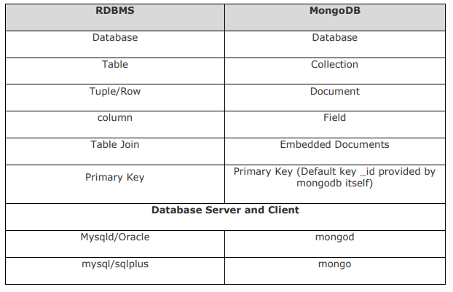

Note:MongoDB requires a “data” folder to store its files.
The default location for the MongoDB data directory is “c:\data\db”.
So you need to create this folder using the Command Prompt.
Execute the following command sequence.
C:\>md data
C:\md data\db

MongoDB Help
db.help()
To get a list of commands, type db.help() in MongoDB client.

MongoDB Statistics
db.stats()
To get stats about MongoDB server, type the command db.stats() in MongoDB client. This will show the database name, number of collection and documents in the database.

Create ddatabase
>use ajit;
databases list
>show dbs
Note:
Your created database (mydb) is not present in list.
To display database, you need to insert at least one document into it.
>db.ajit.insert({"name":"one man army"})
>show dbs

dropDatabase

>db.dropDatabases()
createCollection
>db.createCollection("mycollection")
check the created collection by using the command show collections.
>show collections
To insert data into MongoDB collection
use MongoDB's insert() or save()method.
Syntax
>db.COLLECTION_NAME.insert(document)
>db.mycol.insert({
title: 'MongoDB Overview',
description: 'MongoDB is no sql database',
by: 'tutorials point',
url: 'http://www.ajit.com',
tags: ['mongodb', 'database', 'NoSQL'],
likes: 100
})

>db.post.insert([
{
title: 'MongoDB Overview',
description: 'MongoDB is no sql database',
by: 'tutorials point',
url: 'http://www.Ajit.com',
tags: ['mongodb', 'database', 'NoSQL'],
likes: 100
},
{
title: 'NoSQL Database',
description: 'NoSQL database doesnt have tables',
by: 'tutorials point',
url: 'http://www.Ajit.com',
tags: ['mongodb', 'database', 'NoSQL'],
likes: 20,
comments: [
{
user:'user1',
message: 'My first comment',
dateCreated: new Date(2013,11,10,2,35),
like: 0
}
]
}
]);
how to query document from MongoDB collection.
find()method will display all the documents in a non-structured way, pretty()
>db.mycol.find().pretty()
Apart from find() method, there is findOne() method, that returns only one document in formated.
RDBMS Where Clause Equivalents in MongoDB
Equality
>db.mycol.find({"ename":"ajit"}).pretty()
Less Than
>db.mycol.find({"salary":{$lt:500000}}).prett y()
Less Than Equals
>db.mycol.find({"likes":{$lte:50}}).pret ty()
Greater Than
db.mycol.find({"likes":{$gt:50}}).pret ty()
Greater Thanb Equals
db.mycol.find({"likes":{$gte:50}}).pretty()

Not Equals
db.mycol.find({"likes":{$ne:50}}).pret ty()

AND in MongoDB
In the find() method, if you pass multiple keys by separating them by ',' then MongoDB
treats it as AND condition.
>db.mycol.find({$and:[{"by":"tutorials point","title": "MongoDB Overview"}]}).pretty()

OR in MongoDB
>db.mycol.find({$or:[{"by":"ajit"},{"title": "MongoDB Overview"}]}).pretty()

Using AND and OR Together
db.mycol.find({"likes": {$gt:10}, $or: [{"by": "ajit"}, {"title": "MongoDB Overview"}]}).pretty()
MongoDB Update() Method

MongoDB's update() and save() methods are used to update document into a collection. The update() method updates the values in the existing document while the save() method replaces the existing document with the document passed in save() method.
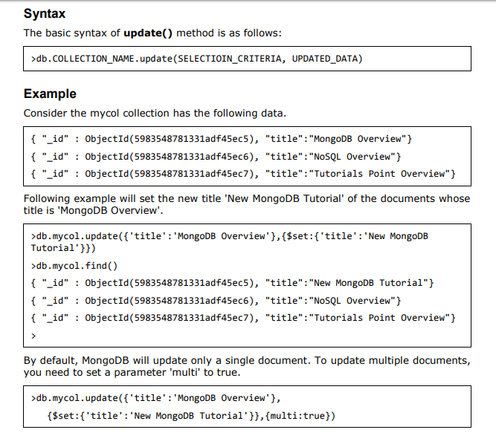

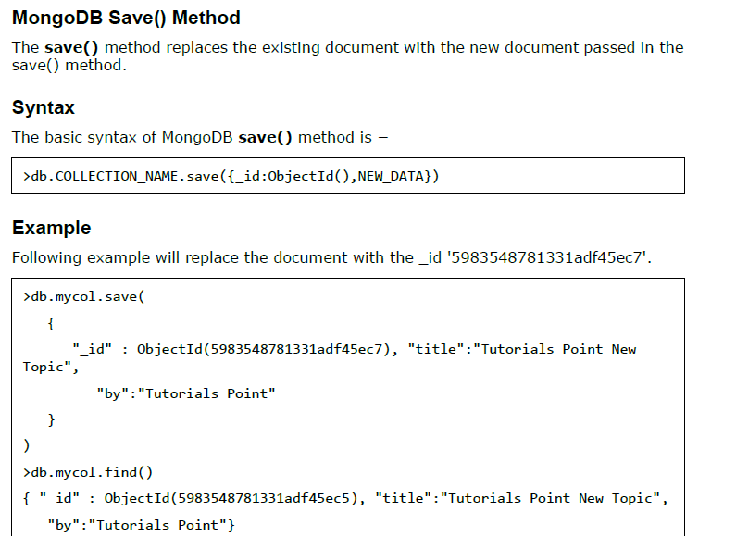

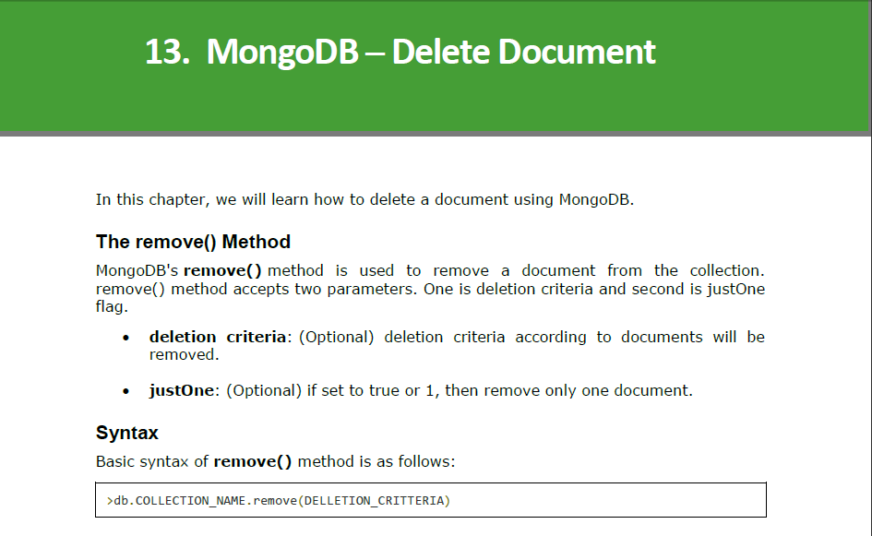
>db.mycol.remove({'title':'MongoDB Overview'})
>db.mycol.find()
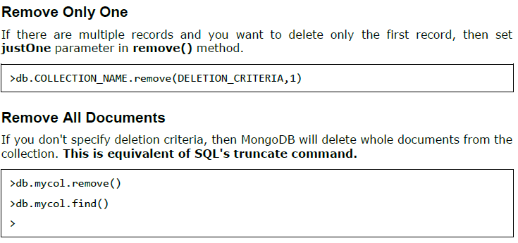
>db.emp.remove({})
>db.mycol.find({},{"title":1,_id:0})
Please note _id field is always displayed while executing find() method, if you don't want
this field, then you need to set it as 0.

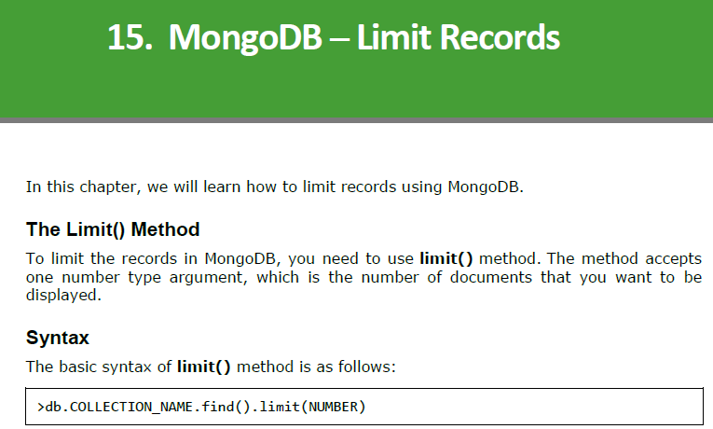

>db.mycol.find({},{"title":1,_id:0}).limit(2)
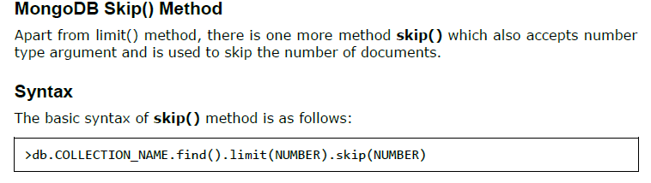
Following example will display only the second document.
>db.mycol.find({},{"title":1,_id:0}).limit(1).skip(1)
Please note, the default value in skip() method is 0.

db.emp.find().pretty().sort({empno:-1}) db.emp.find().pretty().sort({empno:-1})
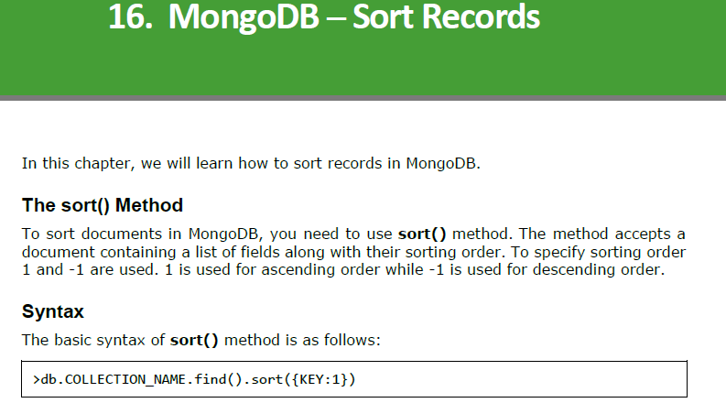
>db.emp.find().pretty().sort({empno:-1})

Following example will display the documents sorted by title in the descending order.
>db.mycol.find({},{"title":1,_id:0}).sort({"title":-1})

Please note, if you don't specify the sorting preference, then sort() method will display
the documents in ascending order.
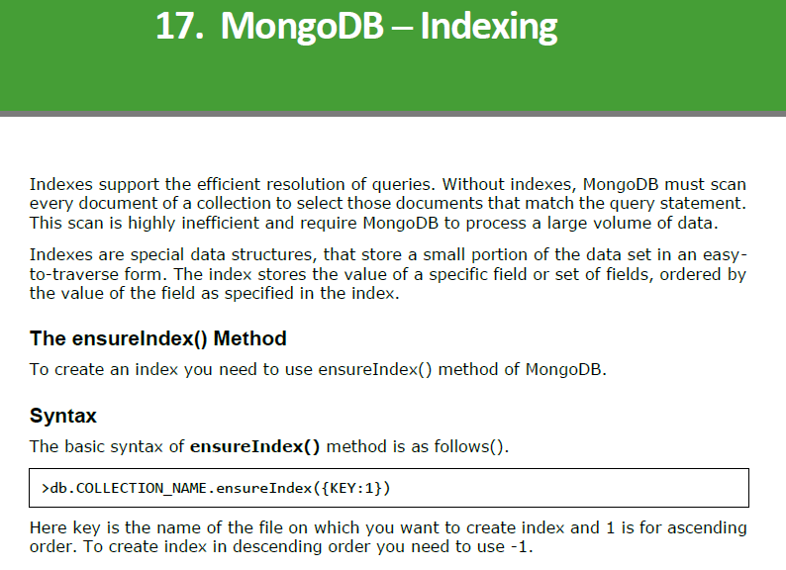
Example
>db.mycol.ensureIndex({"title":1})
>
In ensureIndex() method you can pass multiple fields, to create index on multiple fields.
>db.mycol.ensureIndex({"title":1,"description":-1})
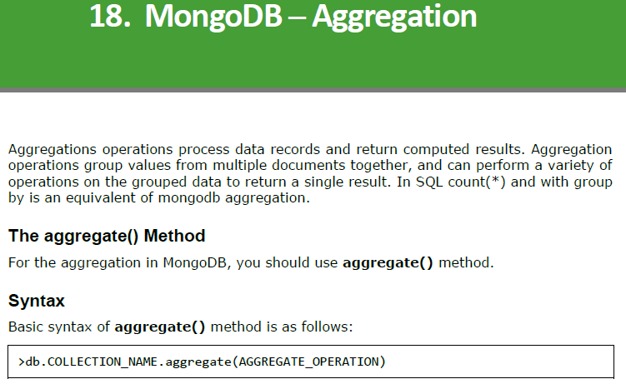
>
>db.emp.aggregate([{$count:"total record"}])
>db.emp.count()
> db.emp.aggregate([{$group:{_id:"$ename",empno:{$sum:1}}}])

if you want to display a list stating how many tutorials are
written by each user, then you will use the following aggregate() method:

> db.mycol.aggregate([{$group : {_id : "$by_user", num_tutorial : {$sum :
1}}}])

Sql equivalent query for the above use case will be select by_user, count(*) from
mycol group by by_user.
In the above example, we have grouped documents by field by_user and on each
occurrence of by_user previous value of sum is incremented.

