- Node.js is an open-source, cross-platform runtime environment
- Node.js applications are written in JavaScript
- Single Threaded(Asynchronous) and Event Driven(Loop)

Node.js also provides a rich library of various JavaScript modules which simplifies the development of web applications using Node.js to a great extent.
Node.js = Runtime Environment + JavaScript Library
- Extremely fast: Node.js is built on Google Chrome's V8 JavaScript Engine, so its library is very fast in code execution.
- I/O is Asynchronous and Event Driven: All APIs of Node.js library are asynchronous i.e. non-blocking. So a Node.js based server never waits for an API to return data. The server moves to the next API after calling it and a notification mechanism of Events of Node.js helps the server to get a response from the previous API call. It is also a reason that it is very fast.
- Single threaded: Node.js follows a single threaded model with event looping.
- Highly Scalable: Node.js is highly scalable because event mechanism helps the server to respond in a non-blocking way.
- No buffering: Node.js cuts down the overall processing time while uploading audio and video files. Node.js applications never buffer any data. These applications simply output the data in chunks.

Event Loop

Let's say we have a code like this:
console.clear();
console.log("a");
setTimeout(function(){console.log("b");},1000);
console.log("c");
setTimeout(function(){console.log("d");},0);
A request comes in, and JS engine starts executing the code above step by step. The first two calls are sync calls. But when it comes to setTimeout method, it becomes an async execution. But JS immediately returns from it and continue executing, which is called Non-Blocking or Async. And it continues working on other etc.
The results of this execution is the following:
a c d b
So basically the second setTimeout got finished first and its callback function gets executed earlier than the first one and that makes sense.
We are talking about single-threaded application here. JS Engine keeps executing this and unless it finishes the first request, it won't go to second one. But the good thing is that it won't wait for blocking operations like setTimeout to resolve so it will be faster because it accepts the new incoming requests.
But my questions arises around the following items:
#1: If we are talking about a single-threaded application, then what mechanism processes setTimeouts while the JS engine accepts more requests and executes them? How does the single thread continue working on other requests? What works on setTimeout while other requests keep coming in and get executed.
#2: If these setTimeout functions get executed behind the scenes while more requests are coming in and being executed, what carries out the async executions behind the scenes? What is this thing that we talk about called the EventLoop?
#3: But shouldn't the whole method be put in the EventLoop so that the whole thing gets executed and the callback method gets called? This is what I understand when talking about callback functions:
function downloadFile(filePath, callback)
{
blah.downloadFile(filePath);
callback();
}

Where to Use Node.js?
Following are the areas where Node.js is proving itself as a perfect technology partner.
- I/O bound Applications
- Data Streaming Applications
- Data Intensive Real-time Applications (DIRT)
- JSON APIs based Applications
- Single Page Applications

Where Not to Use Node.js?
Node.js can be used for a lot of applications with various purpose, the only scenario where it should not be used is if there are long processing times which is required by the application.
Node is structured to be single threaded. If any application is required to carry out some long running calculations in the background. So if the server is doing some calculation, it won't be able to process any other requests. As discussed above, Node.js is best when processing needs less dedicated CPU time.

Node.js console-based Example
File: console_example1.js
console.log('Hello JavaTpoint');
Open Node.js command prompt and run the following code:
node console_example1.js
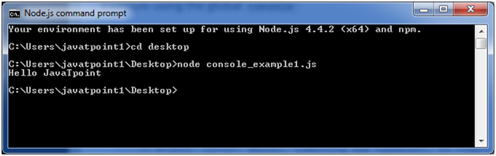
Here, console.log() function displays message on console.

Node.js web-based Example
A node.js web application contains the following three parts:
- Import required modules: The "require" directive is used to load a Node.js module.
- Create server: You have to establish a server which will listen to client's request similar to Apache HTTP Server.
- Read request and return response: Server created in the second step will read HTTP request made by client which can be a browser or console and return the response.
How to create node.js web applications
Follow these steps:
- Import required module: The first step is to use ?require? directive to load http module and store returned HTTP instance into http variable. For example:
  - var http = require("http");
- Create server: In the second step, you have to use created http instance and call http.createServer() method to create server instance and then bind it at port 8081 using listen method associated with server instance. Pass it a function with request and response parameters and write the sample implementation to return "Hello World". For example:
http.createServer(function (request, response) {
// Send the HTTP header
// HTTP Status: 200 : OK
// Content Type: text/plain
response.writeHead(200, {'Content-Type': 'text/plain'});
// Send the response body as "Hello World"
response.end('Hello World\n');
}).listen(8081);
// Console will print the message
console.log('Server running at http://127.0.0.1:8081/');
- Combine step1 and step2 together in a file named "main.js".
File: main.js
var http = require("http");
http.createServer(function (request, response) {
// Send the HTTP header
// HTTP Status: 200 : OK
// Content Type: text/plain
response.writeHead(200, {'Content-Type': 'text/plain'});
// Send the response body as "Hello World"
response.end('Hello World\n');
}).listen(8081);
// Console will print the message
console.log('Server running at http://127.0.0.1:8081/');
How to start your server:
Go to start menu and click on the Node.js command prompt.

Now command prompt is open:
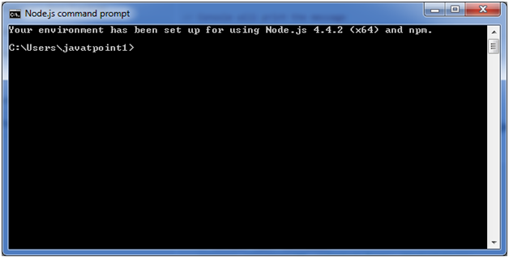
Set path: Here we have save "main.js" file on the desktop.
So type cd desktop on the command prompt. After that execute the main.js to start the server as follows:
- node main.js
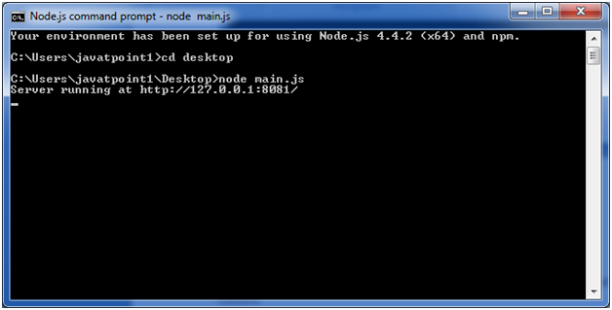
Now server is started.
Make a request to Node.js server:
Open http://127.0.0.1:8081/ in any browser. You will see the following result.
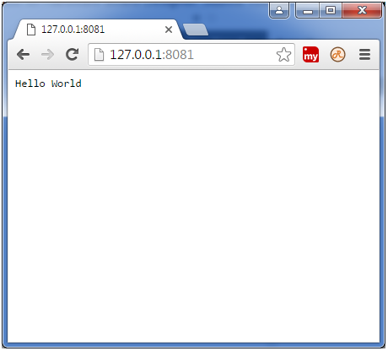
Now, if you make any changes in the "main.js" file, you need to again run the "node main.js" command.

Running your first Hello world application in Node.js
Create file Node.js with file name firstprogram.js
var http = require('http');

http.createServer(function (req, res) {
res.writeHead(200, {'Content-Type': 'text/html'});
res.end('Hello World!');
}).listen(8080);
Code Explanation:
- The basic functionality of the "require" function is that it reads a JavaScript file, executes the file, and then proceeds to return an object. Using this object, one can then use the various functionalities available in the module called by the require function. So in our case, since we want to use the functionality of http and we are using the require(http) command.
- In this 2nd line of code, we are creating a server application which is based on a simple function. This function is called, whenever a request is made to our server application.
- When a request is received, we are asking our function to return a "Hello World" response to the client. The writeHead function is used to send header data to the client and while the end function will close the connection to the client.
- We are then using the server.listen function to make our server application listen to client requests on port no 7000. You can specify any available port over here.
Executing the code
- Save the file on your computer: C:\Users\Your Name\ firstprogram.js
- In the command prompt, navigate to the folder where the file is stored. Enter the command Node firstprogram.js
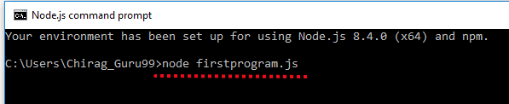
- Now, your computer works as a server! If anyone tries to access your computer on port 8080, they will get a "Hello World!" message in return!
- Start your internet browser, and type in the address: http://localhost:8080
OutPut


modules in Node.js
- Express framework – Express is a minimal and flexible Node js web application framework that provides a robust set of features for the web and Mobile applications.
- Socket.io - Socket.IO enables real-time bidirectional event-based communication. This module is good for creation of chatting based applications.
- Jade - Jade is a high-performance template engine and implemented with JavaScript for node and browsers.
- MongoDB - The MongoDB Node.js driver is the officially supported node.js driver for MongoDB.
- Restify - restify is a lightweight framework, similar to express for building REST APIs
- Bluebird - Bluebird is a fully featured promise library with focus on innovative features and performance

Node.js Console
The Node.js console module provides a simple debugging console similar to JavaScript console mechanism provided by web browsers.
There are three console methods that are used to write any node.js stream:
- console.log()
- console.error()
- console.warn()

Node.js console.log()
The console.log() function is used to display simple message on console.
File: console_example1.js
- console.log('Hello JavaTpoint');
Open Node.js command prompt and run the following code:
- node console_example1.js
We can also use format specifier in console.log() function.
File: console_example2.js
- console.log('Hello %s', 'JavaTpoint');
Open Node.js command prompt and run the following code:
- node console_example2.js
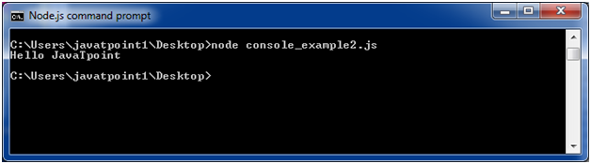

Node.js console.error()
The console.error() function is used to render error message on console.
File: console_example3.js
- console.error(new Error('Hell! This is a wrong method.'));
Open Node.js command prompt and run the following code:
- node console_example3.js
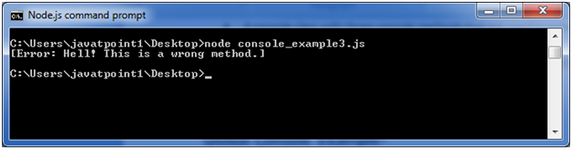

Node.js console.warn()
The console.warn() function is used to display warning message on console.
File: console_example4.js
- const name = 'John';
- console.warn(`Don't mess with me ${name}! Don't mess with me!`);
Open Node.js command prompt and run the following code:
- node console_example4.js

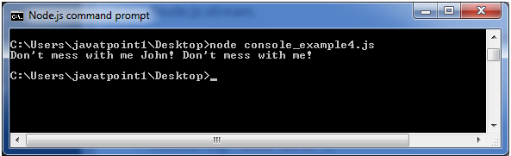

Node.js Package Manager
Node Package Manager provides two main functionalities:
- It provides online repositories for node.js packages/modules which are searchable on search.nodejs.org
- It also provides command line utility to install Node.js packages, do version management and dependency management of Node.js packages.
The npm comes bundled with Node.js installables in versions after that v0.6.3. You can check the version by opening Node.js command prompt and typing the following command:
- npm version
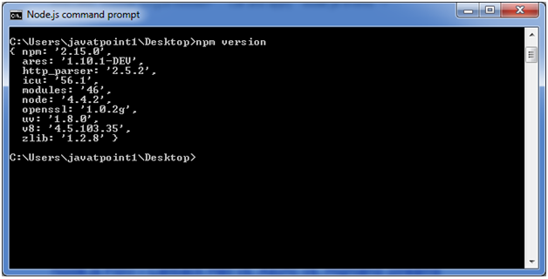

Installing Modules using npm
Following is the syntax to install any Node.js module:
- npm install <Module Name>
Let's install a famous Node.js web framework called express:
Open the Node.js command prompt and execute the following command:
- npm install express
You can see the result after installing the "express" framework.
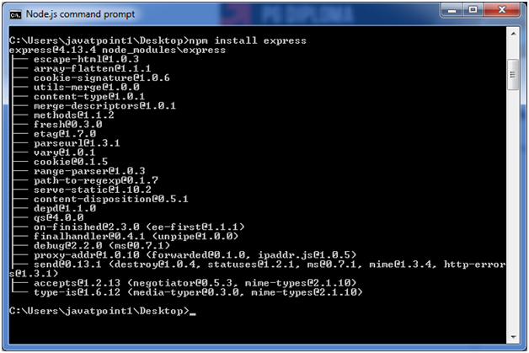

Global vs Local Installation
By default, npm installs dependency in local mode. Here local mode specifies the folder where Node application is present. For example if you installed express module, it created node_modules directory in the current directory where it installed express module.
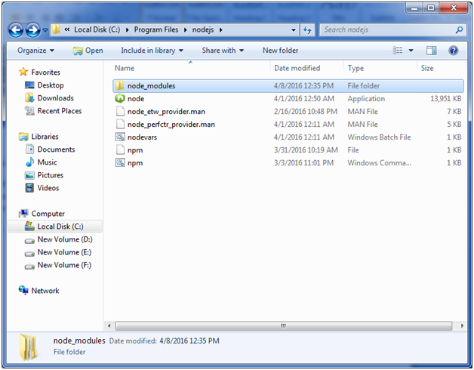
You can use npm ls command to list down all the locally installed modules.
Open the Node.js command prompt and execute "npm ls":
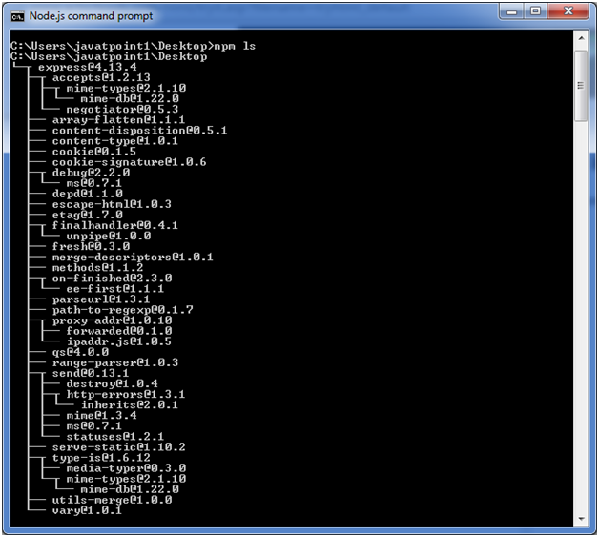
Globally installed packages/dependencies are stored in system directory. Let's install express module using global installation. Although it will also produce the same result but modules will be installed globally.
Open Node.js command prompt and execute the following code:
- npm install express -g
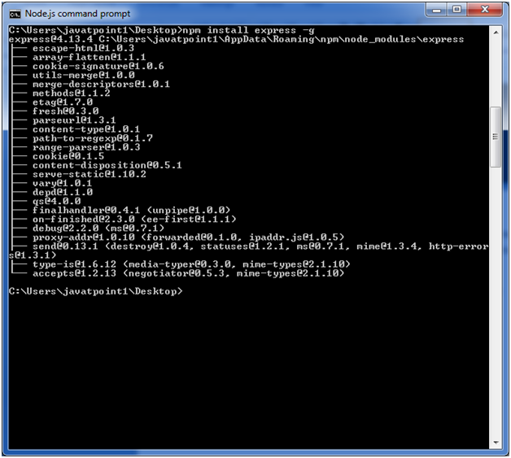
Here first line tells about the module version and its location where it is getting installed.

Uninstalling a Module
To uninstall a Node.js module, use the following command:
- npm uninstall express
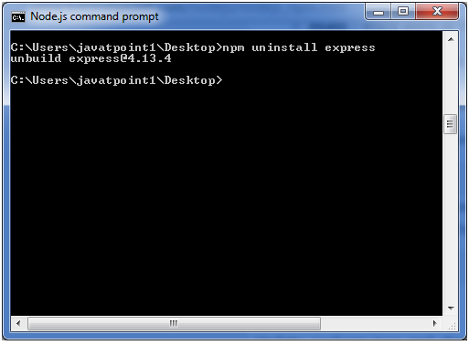
The Node.js module is uninstalled. You can verify by using the following command:
- npm ls
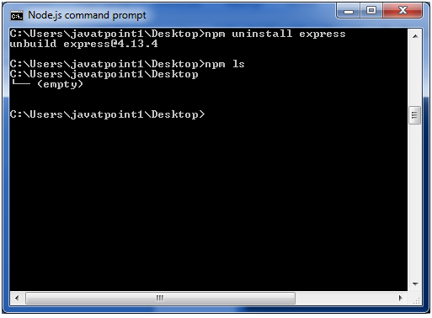
You can see that the module is empty now.

Searching a Module
"npm search express" command is used to search express or module.
- npm search express

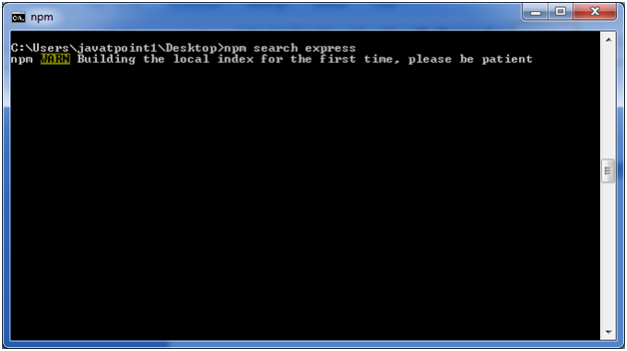

What is a Module in Node.js?
Consider modules to be the same as JavaScript libraries.
A set of functions you want to include in your application.

Built-in Modules
Node.js has a set of built-in modules which you can use without any further installation.

Include Modules
To include a module, use the require() function with the name of the module:

Create Your Own Modules
You can create your own modules, and easily include them in your applications.
The following example creates a module that returns a date and time object:

Example
Create a module that returns the current date and time:
exports.myDateTime = function () {
return Date();
};
Use the exports keyword to make properties and methods available outside the module file.
Save the code above in a file called "myfirstmodule.js"

Include Your Own Module
Now you can include and use the module in any of your Node.js files.

Example
Use the module "myfirstmodule" in a Node.js file:
var http = require('http');
var dt = require('./myfirstmodule');
http.createServer(function (req, res) {
res.writeHead(200, {'Content-Type': 'text/html'});
res.write("The date and time are currently: " + dt.myDateTime());
res.end();
}).listen(8080);
Notice that we use ./ to locate the module, that means that the module is located in the same folder as the Node.js file.
Save the code above in a file called "demo_module.js", and initiate the file:
Initiate demo_module.js:
C:\Users\Your Name>node demo_module.js
If you have followed the same steps on your computer, you will see the same result as the example: http://localhost:8080

Node.js Global Objects
Node.js global objects are global in nature and available in all modules. You don't need to include these objects in your application; rather they can be used directly. These objects are modules, functions, strings and object etc. Some of these objects aren't actually in the global scope but in the module scope.
A list of Node.js global objects are given below:
- __dirname
- __filename
- Console
- Process
- Buffer
- setImmediate(callback[, arg][, ...])
- setInterval(callback, delay[, arg][, ...])
- setTimeout(callback, delay[, arg][, ...])
- clearImmediate(immediateObject)
- clearInterval(intervalObject)
- clearTimeout(timeoutObject)

Node.js __dirname
It is a string. It specifies the name of the directory that currently contains the code.
File: global-example1.js
- console.log(__dirname);
Open Node.js command prompt and run the following code:
- node global-example1.js
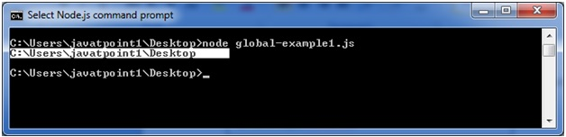

Node.js __filename
It specifies the filename of the code being executed. This is the resolved absolute path of this code file. The value inside a module is the path to that module file.
File: global-example2.js
- console.log(__filename);
Open Node.js command prompt and run the following code:
- node global-example2.js
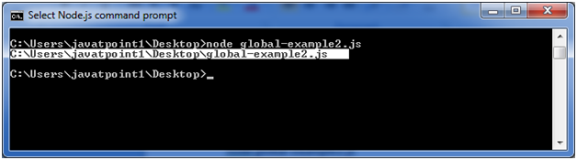

Node.js Timer
Node.js Timer functions are global functions. You don't need to use require() function in order to use timer functions. Let's see the list of timer functions.
Set timer functions:
- setImmediate(): It is used to execute setImmediate.
- setInterval(): It is used to define a time interval.
- setTimeout(): ()- It is used to execute a one-time callback after delay milliseconds.
Clear timer functions:
- clearImmediate(immediateObject): It is used to stop an immediateObject, as created by setImmediate
- clearInterval(intervalObject): It is used to stop an intervalObject, as created by setInterval
- clearTimeout(timeoutObject): It prevents a timeoutObject, as created by setTimeout

Node.js Timer setInterval() Example
This example will set a time interval of 1000 millisecond and the specified comment will be displayed after every 1000 millisecond until you terminate.
File: timer1.js
- setInterval(function() {
- console.log("setInterval: Hey! 1 millisecond completed!..");
- }, 1000);
Open Node.js command prompt and run the following code:
- node timer1.js
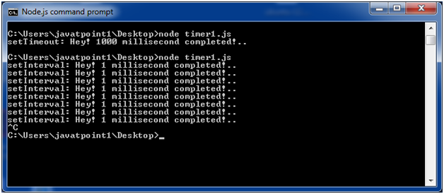
File: timer5.js
- var i =0;
- console.log(i);
- setInterval(function(){
- i++;
- console.log(i);
- }, 1000);
Open Node.js command prompt and run the following code:
- node timer5.js
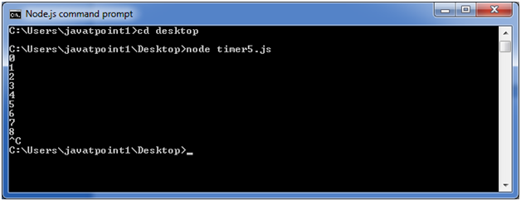

Node.js Timer setTimeout() Example
File: timer1.js
- setTimeout(function() {
- console.log("setTimeout: Hey! 1000 millisecond completed!..");
- }, 1000);
Open Node.js command prompt and run the following code:
- node timer1.js
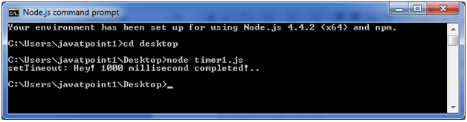
This example shows time out after every 1000 millisecond without setting a time interval. This example uses the recursion property of a function.
File: timer2.js
- var recursive = function () {
- console.log("Hey! 1000 millisecond completed!..");
- setTimeout(recursive,1000);
- }
- recursive();
Open Node.js command prompt and run the following code:
- node timer2.js
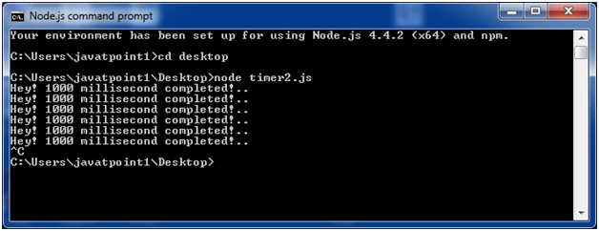

Node.js setInterval(), setTimeout() and clearTimeout()
Let's see an example to use clearTimeout() function.
File: timer3.js
- function welcome () {
- console.log("Welcome to JavaTpoint!");
- }
- var id1 = setTimeout(welcome,1000);
- var id2 = setInterval(welcome,1000);
- clearTimeout(id1);
- //clearInterval(id2);
Open Node.js command prompt and run the following code:
- node timer3.js
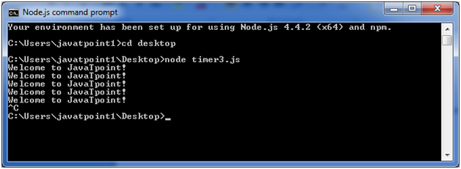
You can see that the above example is recursive in nature. It will terminate after one step if you use ClearInterval.

Node.js setInterval(), setTimeout() and clearInterval()
Let's see an example to use clearInterval() function.
File: timer3.js
- function welcome () {
- console.log("Welcome to JavaTpoint!");
- }
- var id1 = setTimeout(welcome,1000);
- var id2 = setInterval(welcome,1000);
- //clearTimeout(id1);
- clearInterval(id2);
Open Node.js command prompt and run the following code:
- node timer3.js
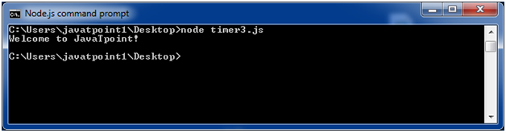

Node.js Errors Example 1
Let's take an example to deploy standard JavaScript error - ReferenceError.
File: error_example1.js
- // Throws with a ReferenceError because b is undefined
- try {
- const a = 1;
- const c = a + b;
- } catch (err) {
- console.log(err);
- }
Open Node.js command prompt and run the following code:
- node error_example1.js

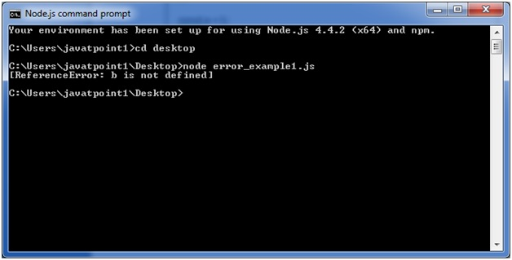

Node.js Crypto
The Node.js Crypto module supports cryptography. It provides cryptographic functionality that includes a set of wrappers for open SSL's hash HMAC, cipher, decipher, sign and verify functions.

What is Hash
A hash is a fixed-length string of bits i.e. procedurally and deterministically generated from some arbitrary block of source data.

What is HMAC
HMAC stands for Hash-based Message Authentication Code. It is a process for applying a hash algorithm to both data and a secret key that results in a single final hash.

Encryption Example using Hash and HMAC
File: crypto_example1.js
- const crypto = require('crypto');
- const secret = 'abcdefg';
- const hash = crypto.createHmac('sha256', secret)
- .update('Welcome to JavaTpoint')
- .digest('hex');
- console.log(hash);
Open Node.js command prompt and run the following code:
- node crypto_example1.js
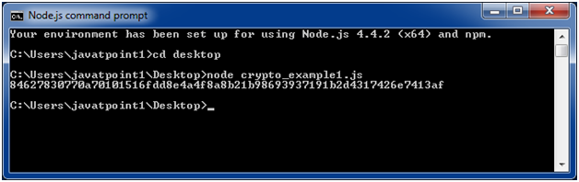

Encryption example using Cipher
File: crypto_example2.js
- const crypto = require('crypto');
- const cipher = crypto.createCipher('aes192', 'a password');
- var encrypted = cipher.update('Hello JavaTpoint', 'utf8', 'hex');
- encrypted += cipher.final('hex');
- console.log(encrypted);
Open Node.js command prompt and run the following code:
- node crypto_example2.js
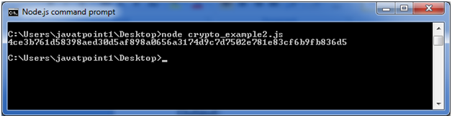

Decryption example using Decipher
File: crypto_example3.js
- const crypto = require('crypto');
- const decipher = crypto.createDecipher('aes192', 'a password');
- var encrypted = '4ce3b761d58398aed30d5af898a0656a3174d9c7d7502e781e83cf6b9fb836d5';
- var decrypted = decipher.update(encrypted, 'hex', 'utf8');
- decrypted += decipher.final('utf8');
- console.log(decrypted);
Open Node.js command prompt and run the following code:
- node crypto_example3.js

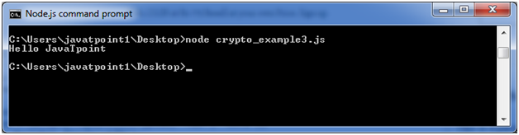

Node.js Query String
The Node.js Query String provides methods to deal with query string. It can be used to convert query string into JSON object and vice-versa.
To use query string module, you need to use require('querystring').

Node.js Query String Methods
The Node.js Query String utility has four methods. The two important methods are given below.
Method | Description
querystring.parse(str[, sep][, eq][, options]) | converts query string into JSON object.
querystring.stringify(obj[, sep][, eq][, options]) | converts JSON object into query string.

Node.js Query String Example 1: parse()
Let's see a simple example of Node.js Query String parse() method.
File: query-string-example1.js
- querystring = require('querystring');
- const obj1=querystring.parse('name=sonoo&company=javatpoint');
- console.log(obj1);
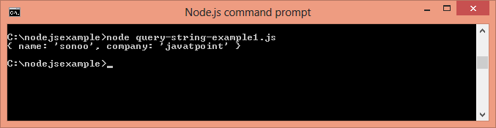

Node.js Query String Example 2: stringify()
Let's see a simple example of Node.js Query String stringify() method.
File: query-string-example2.js
- querystring = require('querystring');
- const qs1=querystring.stringify({name:'sonoo',company:'javatpoint'});
- console.log(qs1);
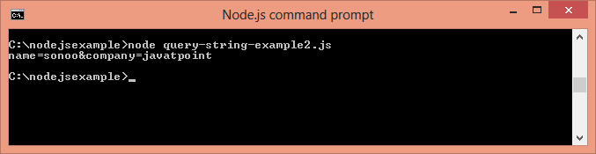

Node.js Events
In Node.js applications, Events and Callbacks concepts are used to provide concurrency. As Node.js applications are single threaded and every API of Node js are asynchronous. So it uses async function to maintain the concurrency. Node uses observer pattern. Node thread keeps an event loop and after the completion of any task, it fires the corresponding event which signals the event listener function to get executed.

Event Driven Programming
Node.js uses event driven programming. It means as soon as Node starts its server, it simply initiates its variables, declares functions and then simply waits for event to occur. It is the one of the reason why Node.js is pretty fast compared to other similar technologies.
There is a main loop in the event driven application that listens for events, and then triggers a callback function when one of those events is detected.
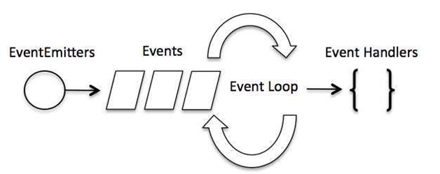

Difference between Events and Callbacks:
Although, Events and Callbacks look similar but the differences lies in the fact that callback functions are called when an asynchronous function returns its result where as event handling works on the observer pattern. Whenever an event gets fired, its listener function starts executing. Node.js has multiple in-built events available through events module and EventEmitter class which is used to bind events and event listeners.
EventEmitter class to bind event and event listener:
- // Import events module
- var events = require('events');
- // Create an eventEmitter object
- var eventEmitter = new events.EventEmitter();
To bind event handler with an event:
- // Bind event and even handler as follows
- eventEmitter.on('eventName', eventHandler);
To fire an event:
- // Fire an event
- eventEmitter.emit('eventName');

Node.js Event Example
File: main.js
- // Import events module
- var events = require('events');
- // Create an eventEmitter object
- var eventEmitter = new events.EventEmitter();

- // Create an event handler as follows
- var connectHandler = function connected() {
- console.log('connection succesful.');

- // Fire the data_received event
- eventEmitter.emit('data_received');
- }

- // Bind the connection event with the handler
- eventEmitter.on('connection', connectHandler);
- // Bind the data_received event with the anonymous function
- eventEmitter.on('data_received', function(){
- console.log('data received succesfully.');
- });
- // Fire the connection event
- eventEmitter.emit('connection');
- console.log("Program Ended.");
Now, open the Node.js command prompt and run the following code:0
- node main.js
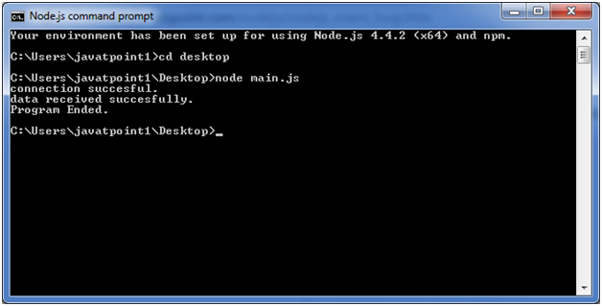

Node.js Web Module

What is Web Server
Web Server is a software program that handles HTTTP requests sent by HTTP clients like web browsers, and returns web pages in response to the clients. Web servers usually respond with html documents along with images, style sheets and scripts.
Most of the web server support server side scripts using scripting language or redirect to application server which perform the specific task of getting data from database, perform complex logic etc. and then sends a result to the HTTP client through the Web server.
Apache web server is one of the most commonly used web server. It is an open source project.

Web Application Architecture
A web application can be divided in 4 layers:
- Client Layer: The Client layer contains web browsers, mobile browsers or applications which can make HTTP request to the web server.
- Server Layer: The Server layer contains Web server which can intercepts the request made by clients and pass them the response.
- Business Layer: The business layer contains application server which is utilized by web server to do required processing. This layer interacts with data layer via data base or some external programs.
- Data Layer: The Data layer contains databases or any source of data.
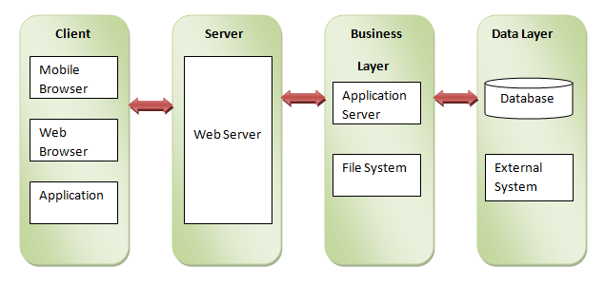

Creating Web Server using Node.js
Node.js provides http module which can be used to create either HTTP client of server. Create a js file named server.js having the following code:
- var http = require('http');
- var fs = require('fs');
- var url = require('url');

- // Create a server
- http.createServer( function (request, response) {
- // Parse the request containing file name
- var pathname = url.parse(request.url).pathname;

- // Print the name of the file for which request is made.
- console.log("Request for " + pathname + " received.");

- // Read the requested file content from file system
- fs.readFile(pathname.substr(1), function (err, data) {
- if (err) {
- console.log(err);
- // HTTP Status: 404 : NOT FOUND
- // Content Type: text/plain
- response.writeHead(404, {'Content-Type': 'text/html'});
- }else{
- //Page found
- // HTTP Status: 200 : OK
- // Content Type: text/plain
- response.writeHead(200, {'Content-Type': 'text/html'});

- // Write the content of the file to response body
- response.write(data.toString());
- }
- // Send the response body
- response.end();
- });
- }).listen(8081);
- // Console will print the message
- console.log('Server running at http://127.0.0.1:8081/');
Next, create an html file named index.html having the following code in the same directory where you created server.js
- <html>
- <head>
- <title>Sample Page</title>
- </head>
- <body>
- Hello World!
- </body>
- </html>
Now open the Node.js command prompt and run the following code:
node server.js
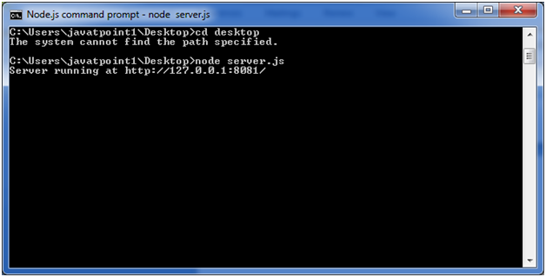
Open http://127.0.0.1:8081/index.htm in any browser and see the below result.
