- Node.js is an open-source, cross-platform runtime environment
- Node.js applications are written in JavaScript
- Single Threaded(Asynchronous) and Event Driven(Loop)

Node.js also provides a rich library of various JavaScript modules which simplifies the development of web applications using Node.js to a great extent.
Node.js = Runtime Environment + JavaScript Library
- Extremely fast: Node.js is built on Google Chrome's V8 JavaScript Engine, so its library is very fast in code execution.
- I/O is Asynchronous and Event Driven: All APIs of Node.js library are asynchronous i.e. non-blocking. So a Node.js based server never waits for an API to return data. The server moves to the next API after calling it and a notification mechanism of Events of Node.js helps the server to get a response from the previous API call. It is also a reason that it is very fast.
- Single threaded: Node.js follows a single threaded model with event looping.
- Highly Scalable: Node.js is highly scalable because event mechanism helps the server to respond in a non-blocking way.
- No buffering: Node.js cuts down the overall processing time while uploading audio and video files. Node.js applications never buffer any data. These applications simply output the data in chunks.

Event Loop

Let's say we have a code like this:
console.clear();
console.log("a");
setTimeout(function(){console.log("b");},1000);
console.log("c");
setTimeout(function(){console.log("d");},0);
A request comes in, and JS engine starts executing the code above step by step. The first two calls are sync calls. But when it comes to setTimeout method, it becomes an async execution. But JS immediately returns from it and continue executing, which is called Non-Blocking or Async. And it continues working on other etc.
The results of this execution is the following:
a c d b
So basically the second setTimeout got finished first and its callback function gets executed earlier than the first one and that makes sense.
We are talking about single-threaded application here. JS Engine keeps executing this and unless it finishes the first request, it won't go to second one. But the good thing is that it won't wait for blocking operations like setTimeout to resolve so it will be faster because it accepts the new incoming requests.
But my questions arises around the following items:
#1: If we are talking about a single-threaded application, then what mechanism processes setTimeouts while the JS engine accepts more requests and executes them? How does the single thread continue working on other requests? What works on setTimeout while other requests keep coming in and get executed.
#2: If these setTimeout functions get executed behind the scenes while more requests are coming in and being executed, what carries out the async executions behind the scenes? What is this thing that we talk about called the EventLoop?
#3: But shouldn't the whole method be put in the EventLoop so that the whole thing gets executed and the callback method gets called? This is what I understand when talking about callback functions:
function downloadFile(filePath, callback)
{
blah.downloadFile(filePath);
callback();
}

Where to Use Node.js?
Following are the areas where Node.js is proving itself as a perfect technology partner.
- I/O bound Applications
- Data Streaming Applications
- Data Intensive Real-time Applications (DIRT)
- JSON APIs based Applications
- Single Page Applications

Where Not to Use Node.js?
Node.js can be used for a lot of applications with various purpose, the only scenario where it should not be used is if there are long processing times which is required by the application.
Node is structured to be single threaded. If any application is required to carry out some long running calculations in the background. So if the server is doing some calculation, it won't be able to process any other requests. As discussed above, Node.js is best when processing needs less dedicated CPU time.

Node.js console-based Example
File: console_example1.js
console.log('Hello JavaTpoint');
Open Node.js command prompt and run the following code:
node console_example1.js
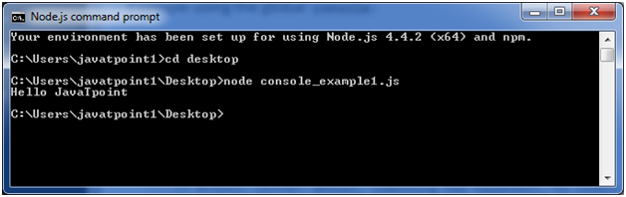
Here, console.log() function displays message on console.

Node.js web-based Example
A node.js web application contains the following three parts:
- Import required modules: The "require" directive is used to load a Node.js module.
- Create server: You have to establish a server which will listen to client's request similar to Apache HTTP Server.
- Read request and return response: Server created in the second step will read HTTP request made by client which can be a browser or console and return the response.
How to create node.js web applications
Follow these steps:
- Import required module: The first step is to use ?require? directive to load http module and store returned HTTP instance into http variable. For example:
  - var http = require("http");
- Create server: In the second step, you have to use created http instance and call http.createServer() method to create server instance and then bind it at port 8081 using listen method associated with server instance. Pass it a function with request and response parameters and write the sample implementation to return "Hello World". For example:
http.createServer(function (request, response) {
// Send the HTTP header
// HTTP Status: 200 : OK
// Content Type: text/plain
response.writeHead(200, {'Content-Type': 'text/plain'});
// Send the response body as "Hello World"
response.end('Hello World\n');
}).listen(8081);
// Console will print the message
console.log('Server running at http://127.0.0.1:8081/');
- Combine step1 and step2 together in a file named "main.js".
File: main.js
var http = require("http");
http.createServer(function (request, response) {
// Send the HTTP header
// HTTP Status: 200 : OK
// Content Type: text/plain
response.writeHead(200, {'Content-Type': 'text/plain'});
// Send the response body as "Hello World"
response.end('Hello World\n');
}).listen(8081);
// Console will print the message
console.log('Server running at http://127.0.0.1:8081/');
How to start your server:
Go to start menu and click on the Node.js command prompt.

Now command prompt is open:
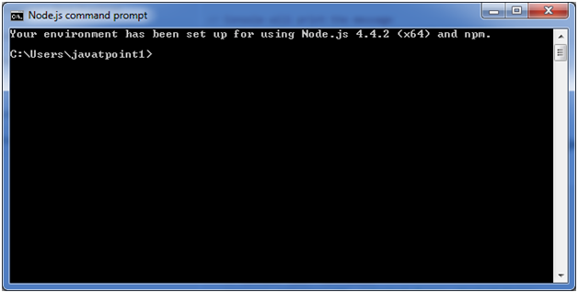
Set path: Here we have save "main.js" file on the desktop.
So type cd desktop on the command prompt. After that execute the main.js to start the server as follows:
- node main.js
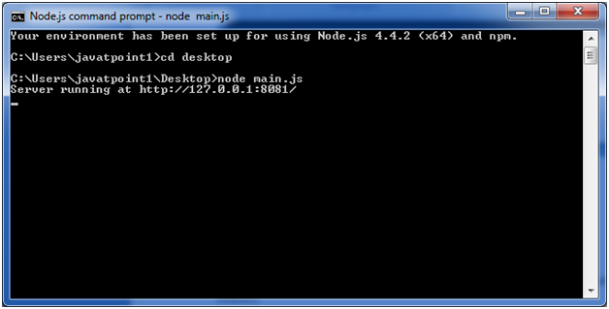
Now server is started.
Make a request to Node.js server:
Open http://127.0.0.1:8081/ in any browser. You will see the following result.
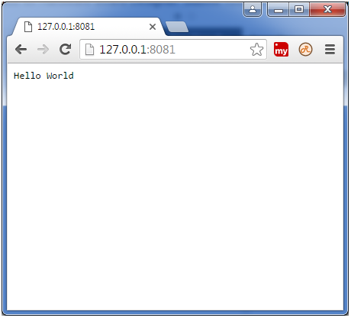
Now, if you make any changes in the "main.js" file, you need to again run the "node main.js" command.

Running your first Hello world application in Node.js
Create file Node.js with file name firstprogram.js
var http = require('http');

http.createServer(function (req, res) {
res.writeHead(200, {'Content-Type': 'text/html'});
res.end('Hello World!');
}).listen(8080);
Code Explanation:
- The basic functionality of the "require" function is that it reads a JavaScript file, executes the file, and then proceeds to return an object. Using this object, one can then use the various functionalities available in the module called by the require function. So in our case, since we want to use the functionality of http and we are using the require(http) command.
- In this 2nd line of code, we are creating a server application which is based on a simple function. This function is called, whenever a request is made to our server application.
- When a request is received, we are asking our function to return a "Hello World" response to the client. The writeHead function is used to send header data to the client and while the end function will close the connection to the client.
- We are then using the server.listen function to make our server application listen to client requests on port no 7000. You can specify any available port over here.
Executing the code
- Save the file on your computer: C:\Users\Your Name\ firstprogram.js
- In the command prompt, navigate to the folder where the file is stored. Enter the command Node firstprogram.js
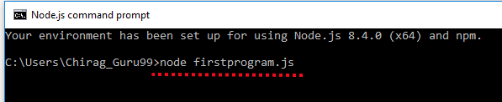
- Now, your computer works as a server! If anyone tries to access your computer on port 8080, they will get a "Hello World!" message in return!
- Start your internet browser, and type in the address: http://localhost:8080
OutPut


modules in Node.js
- Express framework – Express is a minimal and flexible Node js web application framework that provides a robust set of features for the web and Mobile applications.
- Socket.io - Socket.IO enables real-time bidirectional event-based communication. This module is good for creation of chatting based applications.
- Jade - Jade is a high-performance template engine and implemented with JavaScript for node and browsers.
- MongoDB - The MongoDB Node.js driver is the officially supported node.js driver for MongoDB.
- Restify - restify is a lightweight framework, similar to express for building REST APIs
- Bluebird - Bluebird is a fully featured promise library with focus on innovative features and performance

Node.js Console
The Node.js console module provides a simple debugging console similar to JavaScript console mechanism provided by web browsers.
There are three console methods that are used to write any node.js stream:
- console.log()
- console.error()
- console.warn()

Node.js console.log()
The console.log() function is used to display simple message on console.
File: console_example1.js
- console.log('Hello JavaTpoint');
Open Node.js command prompt and run the following code:
- node console_example1.js
We can also use format specifier in console.log() function.
File: console_example2.js
- console.log('Hello %s', 'JavaTpoint');
Open Node.js command prompt and run the following code:
- node console_example2.js
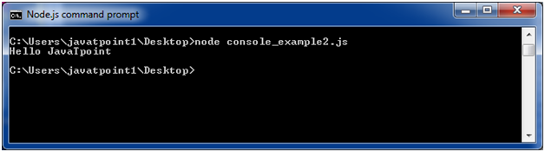

Node.js console.error()
The console.error() function is used to render error message on console.
File: console_example3.js
- console.error(new Error('Hell! This is a wrong method.'));
Open Node.js command prompt and run the following code:
- node console_example3.js
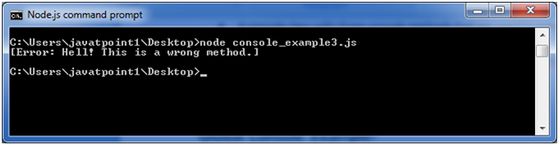

Node.js console.warn()
The console.warn() function is used to display warning message on console.
File: console_example4.js
- const name = 'John';
- console.warn(`Don't mess with me ${name}! Don't mess with me!`);
Open Node.js command prompt and run the following code:
- node console_example4.js

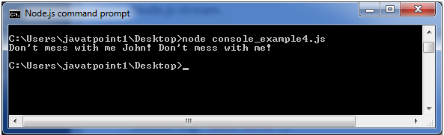

Node.js Package Manager
Node Package Manager provides two main functionalities:
- It provides online repositories for node.js packages/modules which are searchable on search.nodejs.org
- It also provides command line utility to install Node.js packages, do version management and dependency management of Node.js packages.
The npm comes bundled with Node.js installables in versions after that v0.6.3. You can check the version by opening Node.js command prompt and typing the following command:
- npm version
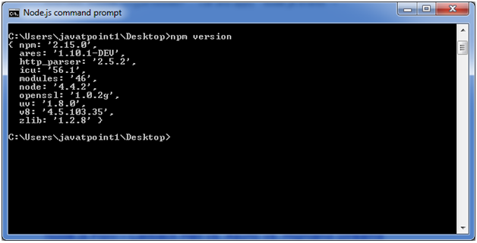

Installing Modules using npm
Following is the syntax to install any Node.js module:
- npm install <Module Name>
Let's install a famous Node.js web framework called express:
Open the Node.js command prompt and execute the following command:
- npm install express
You can see the result after installing the "express" framework.
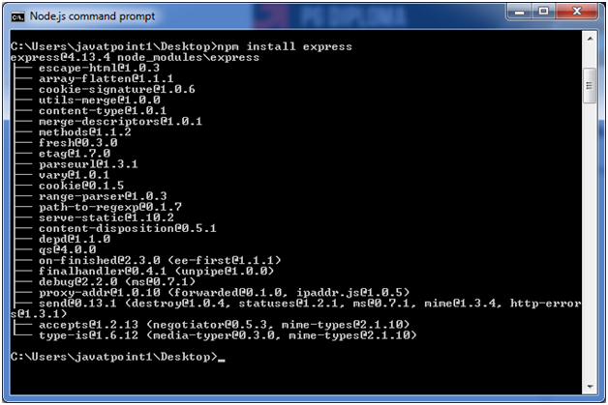

Global vs Local Installation
https://flaviocopes.com/npm-packages-local-global/
By default, npm installs dependency in local mode. Here local mode specifies the folder where Node application is present. For example if you installed express module, it created node_modules directory in the current directory where it installed express module.
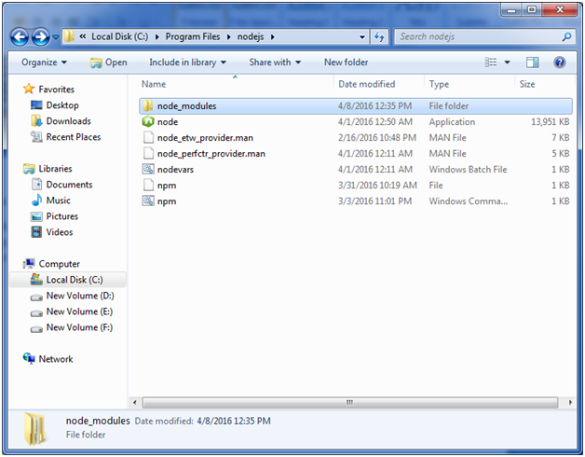
You can use npm ls command to list down all the locally installed modules.
Open the Node.js command prompt and execute "npm ls":
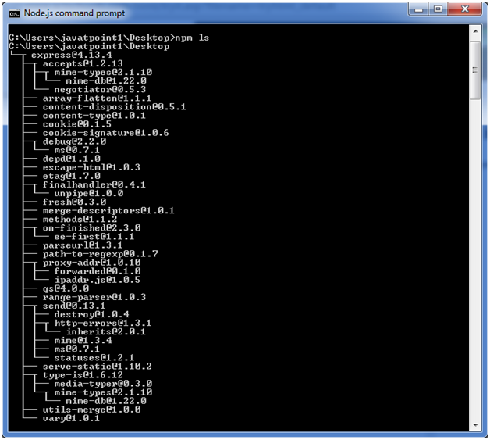
Globally installed packages/dependencies are stored in system directory. Let's install express module using global installation. Although it will also produce the same result but modules will be installed globally.
Open Node.js command prompt and execute the following code:
- npm install express -g
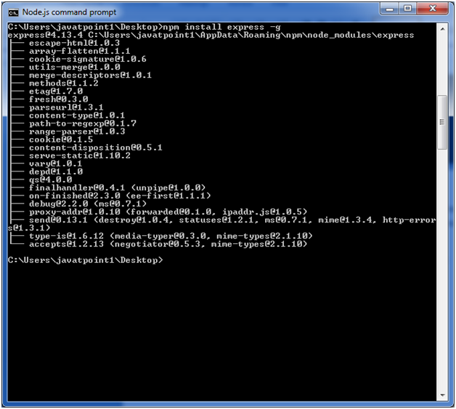
Here first line tells about the module version and its location where it is getting installed.

Uninstalling a Module
To uninstall a Node.js module, use the following command:
- npm uninstall express
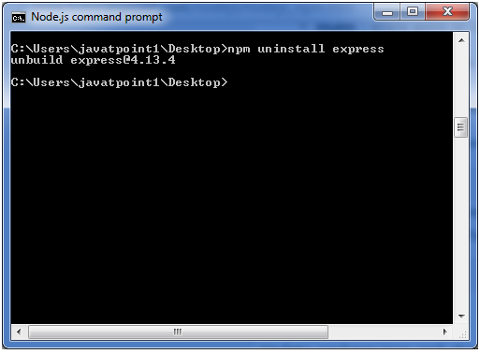
The Node.js module is uninstalled. You can verify by using the following command:
- npm ls
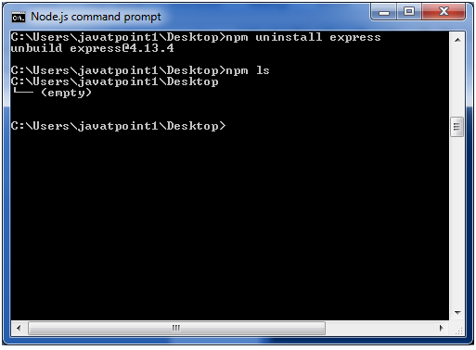
You can see that the module is empty now.

Searching a Module
"npm search express" command is used to search express or module.
- npm search express

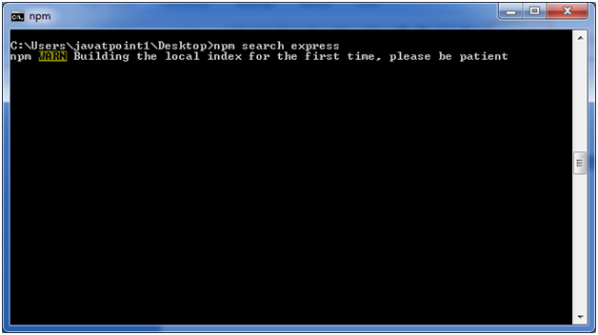

What is a Module in Node.js?
Consider modules to be the same as JavaScript libraries.
A set of functions you want to include in your application.

Built-in Modules
Node.js has a set of built-in modules which you can use without any further installation.

Include Modules
To include a module, use the require() function with the name of the module:

Create Your Own Modules
You can create your own modules, and easily include them in your applications.
The following example creates a module that returns a date and time object:

Example
Create a module that returns the current date and time:
exports.myDateTime = function () {
return Date();
};
Use the exports keyword to make properties and methods available outside the module file.
Save the code above in a file called "myfirstmodule.js"

Include Your Own Module
Now you can include and use the module in any of your Node.js files.

Example
Use the module "myfirstmodule" in a Node.js file:
var http = require('http');
var dt = require('./myfirstmodule');
http.createServer(function (req, res) {
res.writeHead(200, {'Content-Type': 'text/html'});
res.write("The date and time are currently: " + dt.myDateTime());
res.end();
}).listen(8080);
Notice that we use ./ to locate the module, that means that the module is located in the same folder as the Node.js file.
Save the code above in a file called "demo_module.js", and initiate the file:
Initiate demo_module.js:
C:\Users\Your Name>node demo_module.js
If you have followed the same steps on your computer, you will see the same result as the example: http://localhost:8080

Node.js Global Objects
Node.js global objects are global in nature and available in all modules. You don't need to include these objects in your application; rather they can be used directly. These objects are modules, functions, strings and object etc. Some of these objects aren't actually in the global scope but in the module scope.
A list of Node.js global objects are given below:
- __dirname
- __filename
- Console
- Process
- Buffer
- setImmediate(callback[, arg][, ...])
- setInterval(callback, delay[, arg][, ...])
- setTimeout(callback, delay[, arg][, ...])
- clearImmediate(immediateObject)
- clearInterval(intervalObject)
- clearTimeout(timeoutObject)

Node.js __dirname
It is a string. It specifies the name of the directory that currently contains the code.
File: global-example1.js
- console.log(__dirname);
Open Node.js command prompt and run the following code:
- node global-example1.js
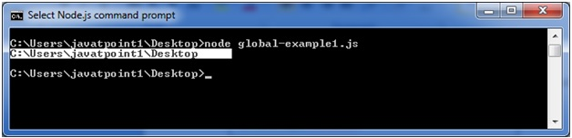

Node.js __filename
It specifies the filename of the code being executed. This is the resolved absolute path of this code file. The value inside a module is the path to that module file.
File: global-example2.js
- console.log(__filename);
Open Node.js command prompt and run the following code:
- node global-example2.js
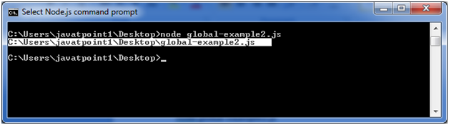

Node.js Timer
Node.js Timer functions are global functions. You don't need to use require() function in order to use timer functions. Let's see the list of timer functions.
Set timer functions:
- setImmediate(): It is used to execute setImmediate.
- setInterval(): It is used to define a time interval.
- setTimeout(): ()- It is used to execute a one-time callback after delay milliseconds.
Clear timer functions:
- clearImmediate(immediateObject): It is used to stop an immediateObject, as created by setImmediate
- clearInterval(intervalObject): It is used to stop an intervalObject, as created by setInterval
- clearTimeout(timeoutObject): It prevents a timeoutObject, as created by setTimeout

Node.js Timer setInterval() Example
This example will set a time interval of 1000 millisecond and the specified comment will be displayed after every 1000 millisecond until you terminate.
File: timer1.js
- setInterval(function() {
- console.log("setInterval: Hey! 1 millisecond completed!..");
- }, 1000);
Open Node.js command prompt and run the following code:
- node timer1.js
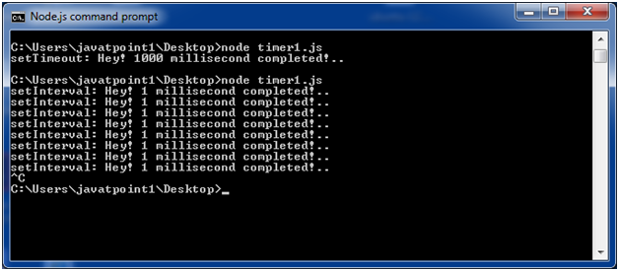
File: timer5.js
- var i =0;
- console.log(i);
- setInterval(function(){
- i++;
- console.log(i);
- }, 1000);
Open Node.js command prompt and run the following code:
- node timer5.js
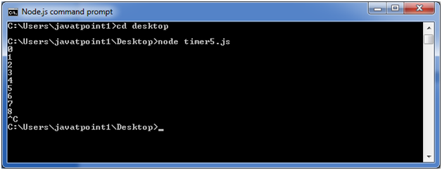

Node.js Timer setTimeout() Example
File: timer1.js
- setTimeout(function() {
- console.log("setTimeout: Hey! 1000 millisecond completed!..");
- }, 1000);
Open Node.js command prompt and run the following code:
- node timer1.js
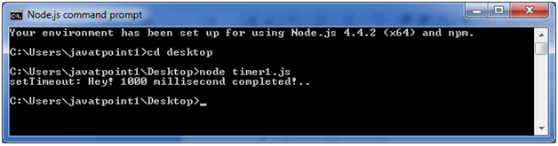
This example shows time out after every 1000 millisecond without setting a time interval. This example uses the recursion property of a function.
File: timer2.js
- var recursive = function () {
- console.log("Hey! 1000 millisecond completed!..");
- setTimeout(recursive,1000);
- }
- recursive();
Open Node.js command prompt and run the following code:
- node timer2.js
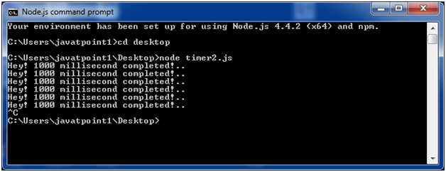

Node.js setInterval(), setTimeout() and clearTimeout()
Let's see an example to use clearTimeout() function.
File: timer3.js
- function welcome () {
- console.log("Welcome to JavaTpoint!");
- }
- var id1 = setTimeout(welcome,1000);
- var id2 = setInterval(welcome,1000);
- clearTimeout(id1);
- //clearInterval(id2);
Open Node.js command prompt and run the following code:
- node timer3.js
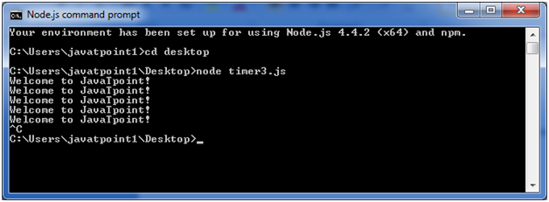
You can see that the above example is recursive in nature. It will terminate after one step if you use ClearInterval.

Node.js setInterval(), setTimeout() and clearInterval()
Let's see an example to use clearInterval() function.
File: timer3.js
- function welcome () {
- console.log("Welcome to JavaTpoint!");
- }
- var id1 = setTimeout(welcome,1000);
- var id2 = setInterval(welcome,1000);
- //clearTimeout(id1);
- clearInterval(id2);
Open Node.js command prompt and run the following code:
- node timer3.js
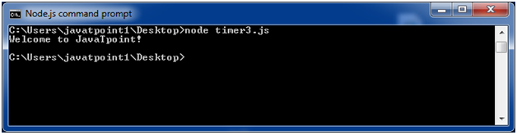

Node.js Errors Example 1
Let's take an example to deploy standard JavaScript error - ReferenceError.
File: error_example1.js
- // Throws with a ReferenceError because b is undefined
- try {
- const a = 1;
- const c = a + b;
- } catch (err) {
- console.log(err);
- }
Open Node.js command prompt and run the following code:
- node error_example1.js

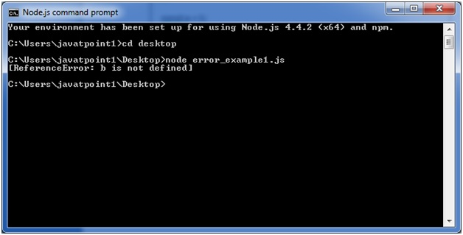

Node.js Crypto
The Node.js Crypto module supports cryptography. It provides cryptographic functionality that includes a set of wrappers for open SSL's hash HMAC, cipher, decipher, sign and verify functions.

What is Hash
A hash is a fixed-length string of bits i.e. procedurally and deterministically generated from some arbitrary block of source data.

What is HMAC
HMAC stands for Hash-based Message Authentication Code. It is a process for applying a hash algorithm to both data and a secret key that results in a single final hash.

Encryption Example using Hash and HMAC
File: crypto_example1.js
- const crypto = require('crypto');
- const secret = 'abcdefg';
- const hash = crypto.createHmac('sha256', secret)
- .update('Welcome to JavaTpoint')
- .digest('hex');
- console.log(hash);
Open Node.js command prompt and run the following code:
- node crypto_example1.js
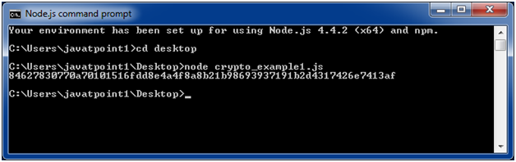

Encryption example using Cipher
File: crypto_example2.js
- const crypto = require('crypto');
- const cipher = crypto.createCipher('aes192', 'a password');
- var encrypted = cipher.update('Hello JavaTpoint', 'utf8', 'hex');
- encrypted += cipher.final('hex');
- console.log(encrypted);
Open Node.js command prompt and run the following code:
- node crypto_example2.js
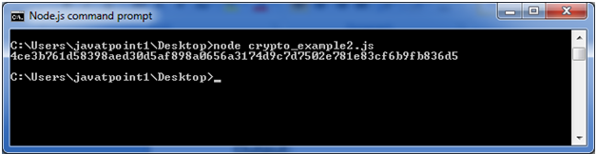

Decryption example using Decipher
File: crypto_example3.js
- const crypto = require('crypto');
- const decipher = crypto.createDecipher('aes192', 'a password');
- var encrypted = '4ce3b761d58398aed30d5af898a0656a3174d9c7d7502e781e83cf6b9fb836d5';
- var decrypted = decipher.update(encrypted, 'hex', 'utf8');
- decrypted += decipher.final('utf8');
- console.log(decrypted);
Open Node.js command prompt and run the following code:
- node crypto_example3.js

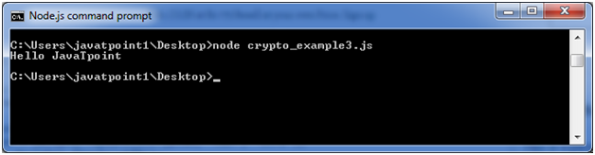

Node.js Query String
The Node.js Query String provides methods to deal with query string. It can be used to convert query string into JSON object and vice-versa.
To use query string module, you need to use require('querystring').

Node.js Query String Methods
The Node.js Query String utility has four methods. The two important methods are given below.
Method | Description
querystring.parse(str[, sep][, eq][, options]) | converts query string into JSON object.
querystring.stringify(obj[, sep][, eq][, options]) | converts JSON object into query string.

Node.js Query String Example 1: parse()
Let's see a simple example of Node.js Query String parse() method.
File: query-string-example1.js
- querystring = require('querystring');
- const obj1=querystring.parse('name=sonoo&company=javatpoint');
- console.log(obj1);
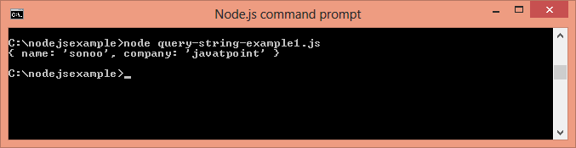

Node.js Query String Example 2: stringify()
Let's see a simple example of Node.js Query String stringify() method.
File: query-string-example2.js
- querystring = require('querystring');
- const qs1=querystring.stringify({name:'sonoo',company:'javatpoint'});
- console.log(qs1);
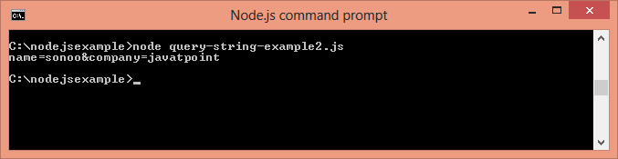

Node.js Events
In Node.js applications, Events and Callbacks concepts are used to provide concurrency. As Node.js applications are single threaded and every API of Node js are asynchronous. So it uses async function to maintain the concurrency. Node uses observer pattern. Node thread keeps an event loop and after the completion of any task, it fires the corresponding event which signals the event listener function to get executed.

Event Driven Programming
Node.js uses event driven programming. It means as soon as Node starts its server, it simply initiates its variables, declares functions and then simply waits for event to occur. It is the one of the reason why Node.js is pretty fast compared to other similar technologies.
There is a main loop in the event driven application that listens for events, and then triggers a callback function when one of those events is detected.
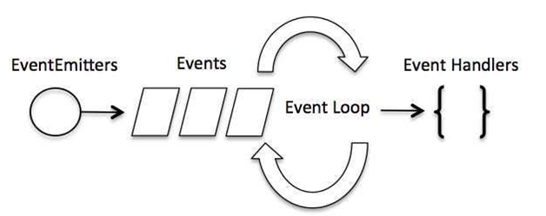

Difference between Events and Callbacks:
Although, Events and Callbacks look similar but the differences lies in the fact that callback functions are called when an asynchronous function returns its result where as event handling works on the observer pattern. Whenever an event gets fired, its listener function starts executing. Node.js has multiple in-built events available through events module and EventEmitter class which is used to bind events and event listeners.
EventEmitter class to bind event and event listener:
- // Import events module
- var events = require('events');
- // Create an eventEmitter object
- var eventEmitter = new events.EventEmitter();
To bind event handler with an event:
- // Bind event and even handler as follows
- eventEmitter.on('eventName', eventHandler);
To fire an event:
- // Fire an event
- eventEmitter.emit('eventName');

Node.js Event Example
File: main.js
- // Import events module
- var events = require('events');
- // Create an eventEmitter object
- var eventEmitter = new events.EventEmitter();

- // Create an event handler as follows
- var connectHandler = function connected() {
- console.log('connection succesful.');

- // Fire the data_received event
- eventEmitter.emit('data_received');
- }

- // Bind the connection event with the handler
- eventEmitter.on('connection', connectHandler);
- // Bind the data_received event with the anonymous function
- eventEmitter.on('data_received', function(){
- console.log('data received succesfully.');
- });
- // Fire the connection event
- eventEmitter.emit('connection');
- console.log("Program Ended.");
Now, open the Node.js command prompt and run the following code:
- node main.js
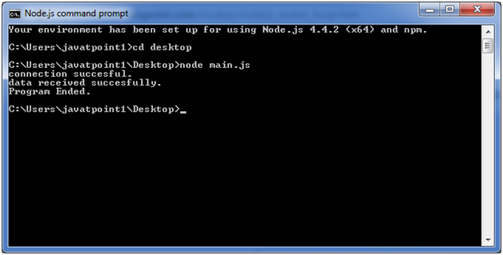

Node.js - Web Module

What is a Web Server?
A Web Server is a software application which handles HTTP requests sent by the HTTP client, like web browsers, and returns web pages in response to the clients. Web servers usually deliver html documents along with images, style sheets, and scripts.
Most of the web servers support server-side scripts, using scripting languages or redirecting the task to an application server which retrieves data from a database and performs complex logic and then sends a result to the HTTP client through the Web server.
Apache web server is one of the most commonly used web servers. It is an open source project.

Web Application Architecture
A Web application is usually divided into four layers −
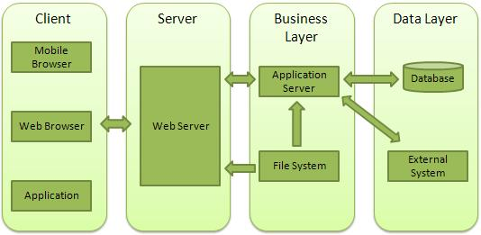
- Client − This layer consists of web browsers, mobile browsers or applications which can make HTTP requests to the web server.
- Server − This layer has the Web server which can intercept the requests made by the clients and pass them the response.
- Business − This layer contains the application server which is utilized by the web server to do the required processing. This layer interacts with the data layer via the database or some external programs.
- Data − This layer contains the databases or any other source of data.

Creating a Web Server using Node
Node.js provides an http module which can be used to create an HTTP client of a server. Following is the bare minimum structure of the HTTP server which listens at 8081 port.
Create a js file named server.js −
File: server.js
var http = require('http');
var fs = require('fs');
var url = require('url');

// Create a server
http.createServer( function (request, response) {
// Parse the request containing file name
var pathname = url.parse(request.url).pathname;

// Print the name of the file for which request is made.
console.log("Request for " + pathname + " received.");

// Read the requested file content from file system
fs.readFile(pathname.substr(1), function (err, data) {
if (err) {
console.log(err);

// HTTP Status: 404 : NOT FOUND
// Content Type: text/plain
response.writeHead(404, {'Content-Type': 'text/html'});
} else {
//Page found
// HTTP Status: 200 : OK
// Content Type: text/plain
response.writeHead(200, {'Content-Type': 'text/html'});

// Write the content of the file to response body
response.write(data.toString());
}

// Send the response body
response.end();
});
}).listen(8081);

// Console will print the message
console.log('Server running at http://127.0.0.1:8081/');
Next let's create the following html file named index.htm in the same directory where you created server.js.
File: index.htm
<html>
<head>
<title>Sample Page</title>
</head>

<body>
Hello World!
</body>
</html>
Now let us run the server.js to see the result −
$ node server.js
Verify the Output.
Server running at http://127.0.0.1:8081/

Make a request to Node.js server
Open http://127.0.0.1:8081/index.htm in any browser to see the following result.
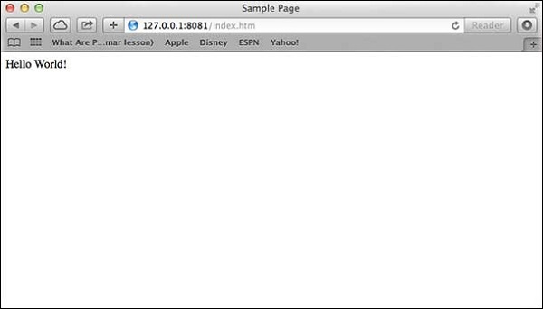
Verify the Output at server end.
Server running at http://127.0.0.1:8081/
Request for /index.htm received.

Creating Web client using Node
A web client can be created using http module. Let's check the following example.
Create a js file named client.js −
File: client.js
var http = require('http');

// Options to be used by request
var options = {
host: 'localhost',
port: '8081',
path: '/index.htm'
};

// Callback function is used to deal with response
var callback = function(response) {
// Continuously update stream with data
var body = '';
response.on('data', function(data) {
body += data;
});

response.on('end', function() {
// Data received completely.
console.log(body);
});
}
// Make a request to the server
var req = http.request(options, callback);
req.end();
Now run the client.js from a different command terminal other than server.js to see the result −
$ node client.js
Verify the Output.
<html>
<head>
<title>Sample Page</title>
</head>

<body>
Hello World!
</body>
</html>
Verify the Output at server end.
Server running at http://127.0.0.1:8081/
Request for /index.htm received.

Node.js - Express Framework

Express Overview
Express is a minimal and flexible Node.js web application framework that provides a robust set of features to develop web and mobile applications. It facilitates the rapid development of Node based Web applications. Following are some of the core features of Express framework −
- Allows to set up middlewares to respond to HTTP Requests.
- Defines a routing table which is used to perform different actions based on HTTP Method and URL.
- Allows to dynamically render HTML Pages based on passing arguments to templates.

Installing Express
Firstly, install the Express framework globally using NPM so that it can be used to create a web application using node terminal.
$ npm install express --save
The above command saves the installation locally in the node_modules directory and creates a directory express inside node_modules. You should install the following important modules along with express −
- body-parser − This is a node.js middleware for handling JSON, Raw, Text and URL encoded form data.
- cookie-parser − Parse Cookie header and populate req.cookies with an object keyed by the cookie names.
- multer − This is a node.js middleware for handling multipart/form-data.
$ npm install body-parser --save
$ npm install cookie-parser --save
$ npm install multer --save

Hello world Example
Following is a very basic Express app which starts a server and listens on port 8081 for connection. This app responds with Hello World! for requests to the homepage. For every other path, it will respond with a 404 Not Found.
var express = require('express');
var app = express();

app.get('/', function (req, res) {
res.send('Hello World');
})

var server = app.listen(8081, function () {
var host = server.address().address
var port = server.address().port

console.log("Example app listening at http://%s:%s", host, port)
})
Save the above code in a file named server.js and run it with the following command.
$ node server.js
You will see the following output −
Example app listening at http://0.0.0.0:8081
Open http://127.0.0.1:8081/ in any browser to see the following result.
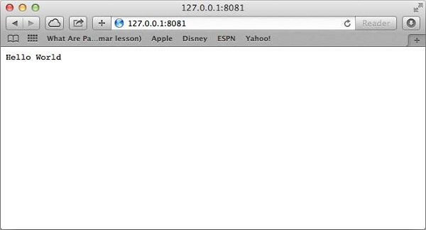

Request & Response
Express application uses a callback function whose parameters are request and response objects.
app.get('/', function (req, res) {
// --
})
- Request Object − The request object represents the HTTP request and has properties for the request query string, parameters, body, HTTP headers, and so on.
- Response Object − The response object represents the HTTP response that an Express app sends when it gets an HTTP request.
You can print req and res objects which provide a lot of information related to HTTP request and response including cookies, sessions, URL, etc.

Basic Routing
We have seen a basic application which serves HTTP request for the homepage. Routing refers to determining how an application responds to a client request to a particular endpoint, which is a URI (or path) and a specific HTTP request method (GET, POST, and so on).
We will extend our Hello World program to handle more types of HTTP requests.
var express = require('express');
var app = express();

// This responds with "Hello World" on the homepage
app.get('/', function (req, res) {
console.log("Got a GET request for the homepage");
res.send('Hello GET');
})

// This responds a POST request for the homepage
app.post('/', function (req, res) {
console.log("Got a POST request for the homepage");
res.send('Hello POST');
})

// This responds a DELETE request for the /del_user page.
app.delete('/del_user', function (req, res) {
console.log("Got a DELETE request for /del_user");
res.send('Hello DELETE');
})

// This responds a GET request for the /list_user page.
app.get('/list_user', function (req, res) {
console.log("Got a GET request for /list_user");
res.send('Page Listing');
})

// This responds a GET request for abcd, abxcd, ab123cd, and so on
app.get('/ab*cd', function(req, res) {
console.log("Got a GET request for /ab*cd");
res.send('Page Pattern Match');
})

var server = app.listen(8081, function () {
var host = server.address().address
var port = server.address().port

console.log("Example app listening at http://%s:%s", host, port)
})
Save the above code in a file named server.js and run it with the following command.
$ node server.js
You will see the following output −
Example app listening at http://0.0.0.0:8081
Now you can try different requests at http://127.0.0.1:8081 to see the output generated by server.js. Following are a few screens shots showing different responses for different URLs.
Screen showing again http://127.0.0.1:8081/list_user
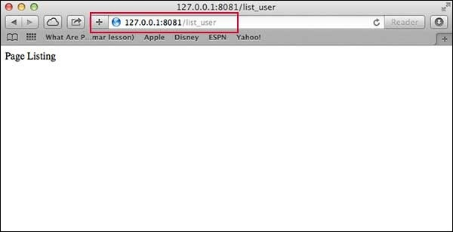
Screen showing again http://127.0.0.1:8081/abcd
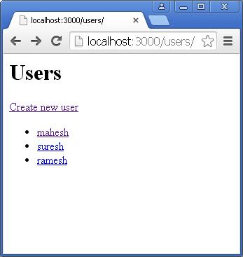
Screen showing again http://127.0.0.1:8081/abcdefg
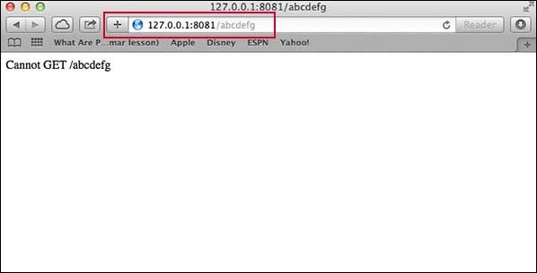

Serving Static Files
Express provides a built-in middleware express.static to serve static files, such as images, CSS, JavaScript, etc.
You simply need to pass the name of the directory where you keep your static assets, to the express.static middleware to start serving the files directly. For example, if you keep your images, CSS, and JavaScript files in a directory named public, you can do this −
app.use(express.static('public'));
We will keep a few images in public/images sub-directory as follows −
node_modules
server.js
public/
public/images
public/images/logo.png
Let's modify "Hello Word" app to add the functionality to handle static files.
var express = require('express');
var app = express();

app.use(express.static('public'));

app.get('/', function (req, res) {
res.send('Hello World');
})

var server = app.listen(8081, function () {
var host = server.address().address
var port = server.address().port

console.log("Example app listening at http://%s:%s", host, port)
})
Save the above code in a file named server.js and run it with the following command.
$ node server.js
Now open http://127.0.0.1:8081/images/logo.png in any browser and see observe following result.
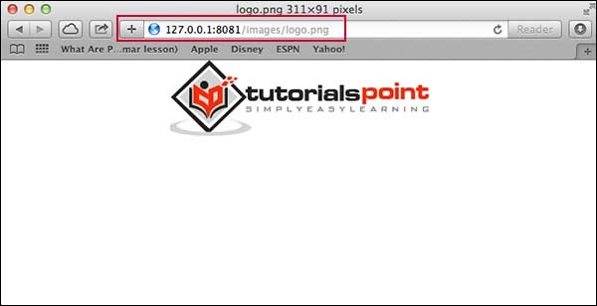

GET Method
Here is a simple example which passes two values using HTML FORM GET method. We are going to use process_get router inside server.js to handle this input.
<html>
<body>

<form action = "http://127.0.0.1:8081/process_get" method = "GET">
First Name: <input type = "text" name = "first_name"> <br>
Last Name: <input type = "text" name = "last_name">
<input type = "submit" value = "Submit">
</form>

</body>
</html>
Let's save above code in index.htm and modify server.js to handle home page requests as well as the input sent by the HTML form.
var express = require('express');
var app = express();

app.use(express.static('public'));
app.get('/index.htm', function (req, res) {
res.sendFile( __dirname + "/" + "index.htm" );
})

app.get('/process_get', function (req, res) {
// Prepare output in JSON format
response = {
first_name:req.query.first_name,
last_name:req.query.last_name
};
console.log(response);
res.end(JSON.stringify(response));
})

var server = app.listen(8081, function () {
var host = server.address().address
var port = server.address().port

console.log("Example app listening at http://%s:%s", host, port)
})
Accessing the HTML document using http://127.0.0.1:8081/index.htm will generate the following form −
Top of Form

First Name: | 
Last Name:

Bottom of Form

Now you can enter the First and Last Name and then click submit button to see the result and it should return the following result −
{"first_name":"John","last_name":"Paul"}

POST Method
Here is a simple example which passes two values using HTML FORM POST method. We are going to use process_get router inside server.js to handle this input.
<html>
<body>

<form action = "http://127.0.0.1:8081/process_post" method = "POST">
First Name: <input type = "text" name = "first_name"> <br>
Last Name: <input type = "text" name = "last_name">
<input type = "submit" value = "Submit">
</form>

</body>
</html>
Let's save the above code in index.htm and modify server.js to handle home page requests as well as the input sent by the HTML form.
var express = require('express');
var app = express();
var bodyParser = require('body-parser');

// Create application/x-www-form-urlencoded parser
var urlencodedParser = bodyParser.urlencoded({ extended: false })

app.use(express.static('public'));
app.get('/index.htm', function (req, res) {
res.sendFile( __dirname + "/" + "index.htm" );
})

app.post('/process_post', urlencodedParser, function (req, res) {
// Prepare output in JSON format
response = {
first_name:req.body.first_name,
last_name:req.body.last_name
};
console.log(response);
res.end(JSON.stringify(response));
})

var server = app.listen(8081, function () {
var host = server.address().address
var port = server.address().port

console.log("Example app listening at http://%s:%s", host, port)
})
Accessing the HTML document using http://127.0.0.1:8081/index.htm will generate the following form −
Top of Form

First Name:
Last Name:

Bottom of Form

Now you can enter the First and Last Name and then click the submit button to see the following result −
{"first_name":"John","last_name":"Paul"}

File Upload
The following HTML code creates a file uploader form. This form has method attribute set to POST and enctype attribute is set to multipart/form-data
<html>
<head>
<title>File Uploading Form</title>
</head>

<body>
<h3>File Upload:</h3>
Select a file to upload: <br />

<form action = "http://127.0.0.1:8081/file_upload" method = "POST"
enctype = "multipart/form-data">
<input type="file" name="file" size="50" />
<br />
<input type = "submit" value = "Upload File" />
</form>

</body>
</html>
Let's save above code in index.htm and modify server.js to handle home page requests as well as file upload.
var express = require('express');
var app = express();
var fs = require("fs");

var bodyParser = require('body-parser');
var multer = require('multer');

app.use(express.static('public'));
app.use(bodyParser.urlencoded({ extended: false }));
app.use(multer({ dest: '/tmp/'}));

app.get('/index.htm', function (req, res) {
res.sendFile( __dirname + "/" + "index.htm" );
})

app.post('/file_upload', function (req, res) {
console.log(req.files.file.name);
console.log(req.files.file.path);
console.log(req.files.file.type);
var file = __dirname + "/" + req.files.file.name;

fs.readFile( req.files.file.path, function (err, data) {
fs.writeFile(file, data, function (err) {
if( err ) {
console.log( err );
} else {
response = {
message:'File uploaded successfully',
filename:req.files.file.name
};
}

console.log( response );
res.end( JSON.stringify( response ) );
});
});
})

var server = app.listen(8081, function () {
var host = server.address().address
var port = server.address().port

console.log("Example app listening at http://%s:%s", host, port)
})
Accessing the HTML document using http://127.0.0.1:8081/index.htm will generate the following form −
File Upload:
Select a file to upload:

NOTE: This is just dummy form and would not work, but it must work at your server.

Cookies Management
You can send cookies to a Node.js server which can handle the same using the following middleware option. Following is a simple example to print all the cookies sent by the client.
var express = require('express')
var cookieParser = require('cookie-parser')

var app = express()
app.use(cookieParser())

app.get('/', function(req, res) {
console.log("Cookies: ", req.cookies)
})
app.listen(8081)

Node.js - RESTful API

What is REST architecture?
REST stands for REpresentational State Transfer. REST is web standards based architecture and uses HTTP Protocol. It revolves around resource where every component is a resource and a resource is accessed by a common interface using HTTP standard methods. REST was first introduced by Roy Fielding in 2000.
A REST Server simply provides access to resources and REST client accesses and modifies the resources using HTTP protocol. Here each resource is identified by URIs/ global IDs. REST uses various representation to represent a resource like text, JSON, XML but JSON is the most popular one.

HTTP methods
Following four HTTP methods are commonly used in REST based architecture.
- GET − This is used to provide a read only access to a resource.
- PUT − This is used to create a new resource.
- DELETE − This is used to remove a resource.
- POST − This is used to update a existing resource or create a new resource.

RESTful Web Services
A web service is a collection of open protocols and standards used for exchanging data between applications or systems. Software applications written in various programming languages and running on various platforms can use web services to exchange data over computer networks like the Internet in a manner similar to inter-process communication on a single computer. This interoperability (e.g., communication between Java and Python, or Windows and Linux applications) is due to the use of open standards.
Web services based on REST Architecture are known as RESTful web services. These webservices uses HTTP methods to implement the concept of REST architecture. A RESTful web service usually defines a URI, Uniform Resource Identifier a service, which provides resource representation such as JSON and set of HTTP Methods.

Creating RESTful for A Library
Consider we have a JSON based database of users having the following users in a file users.json:
{
"user1" : {
"name" : "mahesh",
"password" : "password1",
"profession" : "teacher",
"id": 1
},

"user2" : {
"name" : "suresh",
"password" : "password2",
"profession" : "librarian",
"id": 2
},

"user3" : {
"name" : "ramesh",
"password" : "password3",
"profession" : "clerk",
"id": 3
}
}
Based on this information we are going to provide following RESTful APIs.
Sr.No. | URI | HTTP Method | POST body | Result
1 | listUsers | GET | empty | Show list of all the users.
2 | addUser | POST | JSON String | Add details of new user.
3 | deleteUser | DELETE | JSON String | Delete an existing user.
4 | :id | GET | empty | Show details of a user.
I'm keeping most of the part of all the examples in the form of hard coding assuming you already know how to pass values from front end using Ajax or simple form data and how to process them using express Request object.

List Users
Let's implement our first RESTful API listUsers using the following code in a server.js file −
server.js
var express = require('express');
var app = express();
var fs = require("fs");

app.get('/listUsers', function (req, res) {
fs.readFile( __dirname + "/" + "users.json", 'utf8', function (err, data) {
console.log( data );
res.end( data );
});
})

var server = app.listen(8081, function () {
var host = server.address().address
var port = server.address().port
console.log("Example app listening at http://%s:%s", host, port)
})
Now try to access defined API using URL: http://127.0.0.1:8081/listUsers and HTTP Method : GET on local machine using any REST client. This should produce following result −
You can change given IP address when you will put the solution in production environment.
{
"user1" : {
"name" : "mahesh",
"password" : "password1",
"profession" : "teacher",
"id": 1
},

"user2" : {
"name" : "suresh",
"password" : "password2",
"profession" : "librarian",
"id": 2
},

"user3" : {
"name" : "ramesh",
"password" : "password3",
"profession" : "clerk",
"id": 3
}
}

Add User
Following API will show you how to add new user in the list. Following is the detail of the new user −
user = {
"user4" : {
"name" : "mohit",
"password" : "password4",
"profession" : "teacher",
"id": 4
}
}
You can accept the same input in the form of JSON using Ajax call but for teaching point of view, we are making it hard coded here. Following is the addUser API to a new user in the database −
server.js
var express = require('express');
var app = express();
var fs = require("fs");

var user = {
"user4" : {
"name" : "mohit",
"password" : "password4",
"profession" : "teacher",
"id": 4
}
}

app.post('/addUser', function (req, res) {
// First read existing users.
fs.readFile( __dirname + "/" + "users.json", 'utf8', function (err, data) {
data = JSON.parse( data );
data["user4"] = user["user4"];
console.log( data );
res.end( JSON.stringify(data));
});
})

var server = app.listen(8081, function () {
var host = server.address().address
var port = server.address().port
console.log("Example app listening at http://%s:%s", host, port)
})
Now try to access defined API using URL: http://127.0.0.1:8081/addUser and HTTP Method : POST on local machine using any REST client. This should produce following result −
{
"user1":{"name":"mahesh","password":"password1","profession":"teacher","id":1},
"user2":{"name":"suresh","password":"password2","profession":"librarian","id":2},
"user3":{"name":"ramesh","password":"password3","profession":"clerk","id":3},
"user4":{"name":"mohit","password":"password4","profession":"teacher","id":4}
}

Show Detail
Now we will implement an API which will be called using user ID and it will display the detail of the corresponding user.
server.js
var express = require('express');
var app = express();
var fs = require("fs");

app.get('/:id', function (req, res) {
// First read existing users.
fs.readFile( __dirname + "/" + "users.json", 'utf8', function (err, data) {
var users = JSON.parse( data );
var user = users["user" + req.params.id]
console.log( user );
res.end( JSON.stringify(user));
});
})

var server = app.listen(8081, function () {
var host = server.address().address
var port = server.address().port
console.log("Example app listening at http://%s:%s", host, port)
})
Now try to access defined API using URL: http://127.0.0.1:8081/2 and HTTP Method : GET on local machine using any REST client. This should produce following result −
{"name":"suresh","password":"password2","profession":"librarian","id":2}

Delete User
This API is very similar to addUser API where we receive input data through req.body and then based on user ID we delete that user from the database. To keep our program simple we assume we are going to delete user with ID 2.
server.js
var express = require('express');
var app = express();
var fs = require("fs");

var id = 2;

app.delete('/deleteUser', function (req, res) {
// First read existing users.
fs.readFile( __dirname + "/" + "users.json", 'utf8', function (err, data) {
data = JSON.parse( data );
delete data["user" + 2];

console.log( data );
res.end( JSON.stringify(data));
});
})

var server = app.listen(8081, function () {
var host = server.address().address
var port = server.address().port
console.log("Example app listening at http://%s:%s", host, port)
})
Now try to access defined API using URL: http://127.0.0.1:8081/deleteUser and HTTP Method : DELETE on local machine using any REST client. This should produce following result −
{"user1":{"name":"mahesh","password":"password1","profession":"teacher","id":1},
"user3":{"name":"ramesh","password":"password3","profession":"clerk","id":3}}

