**Natural Language to SQL Query Converter with Advanced Authentication**

**Team Information**

Team Name: Lazy_GCD

Team Members:

1. Aritra Maji (22CS30011)

2. Sayandeep Bhowmick (22CS10069)

3. Agniva Saha (22CS10003)

4. Ritabrata Bharati (22CS10059)

5. Raaja Das (22CS30043)

**Executive Summary**

This comprehensive report details the implementation of an advanced Natural Language to SQL Query Converter system with sophisticated authentication mechanisms. The project demonstrates industry-standard practices in both frontend and backend development, with particular emphasis on security, scalability, and user experience.

**Problem Statement**

**Primary Objectives**

1. Develop a sophisticated system for converting natural language queries into SQL

2. Implement secure, multi-provider authentication

3. Create an intuitive user interface

4. Ensure robust database integration

5. Provide comprehensive error handling and user feedback

**Technical Requirements**

1. Support multiple authentication providers

2. Ensure secure data handling

3. Implement responsive design

4. Provide real-time query processing

5. Maintain high performance and scalability

**Detailed Methodology**

**1. System Architecture**

**A. Technology Stack Distribution**

**Frontend Development**

* React.js 18.0

* Material-UI v5

* Firebase Authentication SDK

* Framer Motion

* Axios with custom interceptors

* Vite build system

**Backend Development**

* Django REST Framework

* Custom Firebase authentication

* JWT token management

* SQL database integration

* Email service integration

**Additional Components**

* Configuration files

* Documentation

* Build scripts

**B. Authentication System Architecture**

**1. Multi-Provider Authentication Framework**

The system implements a sophisticated cascading authentication pattern that seamlessly integrates three authentication methods:

**a. Traditional Authentication**

- Username/password validation

- Custom form handling

- JWT token management

- Session persistence

- Password reset functionality

- Email verification system

**b. Firebase Authentication**

- Email/password authentication

- Token verification

- User data synchronization

- Error handling

- Security rules implementation

**c. Google OAuth Integration**

- OAuth 2.0 flow implementation

- Profile data synchronization

- Automatic account linking

- Token management

- Session handling

**2. Authentication Flow Implementation**

The system employs a sophisticated fallback mechanism:

**1. Primary Authentication Attempt**

- Attempts traditional Django authentication

- Validates credentials

- Generates JWT tokens

- Manages sessions

**2. Firebase Authentication Fallback**

- Triggers on primary authentication failure

- Validates Firebase credentials

- Synchronizes user data

- Manages Firebase tokens

**3. Google OAuth Final Layer**

- Provides Google sign-in option

- Handles OAuth tokens

- Manages user profiles

- Synchronizes data across providers

**3. Frontend Implementation**

**A. Component Architecture**

**1. Authentication Components**

- Login form with multi-provider support

- Registration interface

- Password reset workflow

- Profile management system

- Token management interface

**2. Navigation System**

- Responsive navbar

- Mobile-optimized drawer

- Protected routes

- Dynamic navigation

- State-based routing

**3. Query Interface**

- Natural language input

- Query visualization

- Result display

- Error feedback

- Loading states

**B. State Management**

**1. Authentication State**

- User session tracking

- Token persistence

- Provider state

- Error handling

- Loading states

**2. Query State**

- Input validation

- Processing status

- Result management

- Error handling

- History tracking

**C. User Interface Features**

**1. Responsive Design**

- Mobile-first approach

- Dynamic layouts

- Breakpoint handling

- Touch interface support

- Accessibility compliance

**2. Visual Feedback**

- Loading indicators

- Error messages

- Success notifications

- Progress tracking

- Animation effects

**4. Backend Implementation**

**A. API Architecture**

**1. Authentication Endpoints**

**a. User Management**

- `/api/user/login/` - Traditional authentication endpoint

- `/api/user/firebase-auth/` - Firebase authentication handler

- `/api/user/me/` - User profile management

- `/api/token/` - JWT token management

- `/api/user/password-reset/` - Password reset workflow

**b. Security Features**

- Token validation middleware

- Rate limiting implementation

- CSRF protection

- Input sanitization

- Error handling

**2. Query Processing Endpoints**

- Natural language query reception

- SQL conversion processing

- Database connection management

- Result set formatting

- Error handling and validation

**B. Firebase Integration**

**1. Custom Authentication Handler**

- Centralizes all Firebase authentication

- Handles both form-based and Google sign-ins

- Manages user creation and linking

- Implements security measures

- Provides comprehensive error handling

**2. Token Management**

- JWT token generation

- Refresh token implementation

- Token validation

- Session management

- Security measures

**C. Database Connectivity**

**1. Dynamic Database Connection**

- Multiple database support

- Connection pooling

- Query execution

- Result set management

- Error handling

**2. Query Processing**

- SQL query validation

- Execution management

- Result formatting

- Performance optimization

- Security measures

**Security Implementation**

**A. Authentication Security**

**1. Token Management**

- Secure token generation

- Token encryption

- Refresh mechanisms

- Expiration handling

- Cross-site protection

**2. Password Security**

- Secure password hashing

- Salt generation

- Reset mechanisms

- Validation rules

- Brute force protection

**B. Data Security**

**1. Input Validation**

- Query sanitization

- Parameter validation

- Type checking

- Size limits

- Format validation

**2. Output Security**

- Data encryption

- Response sanitization

- Error message security

- Token protection

- Session security

**Results and Demonstration**

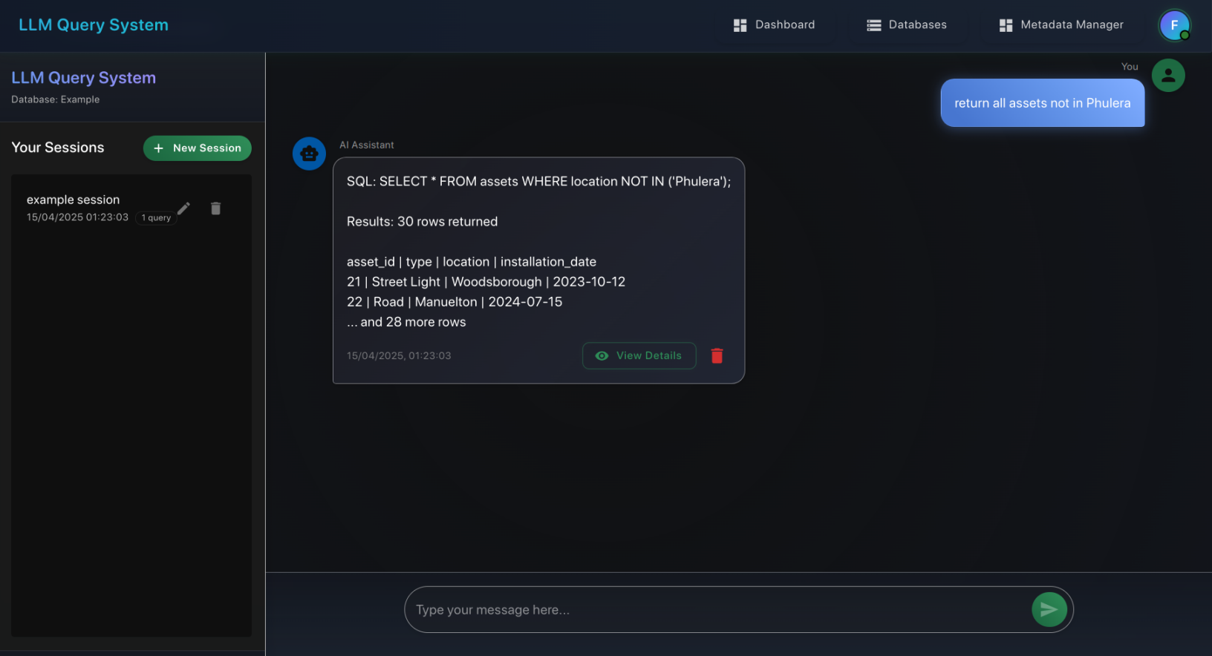

Query interface

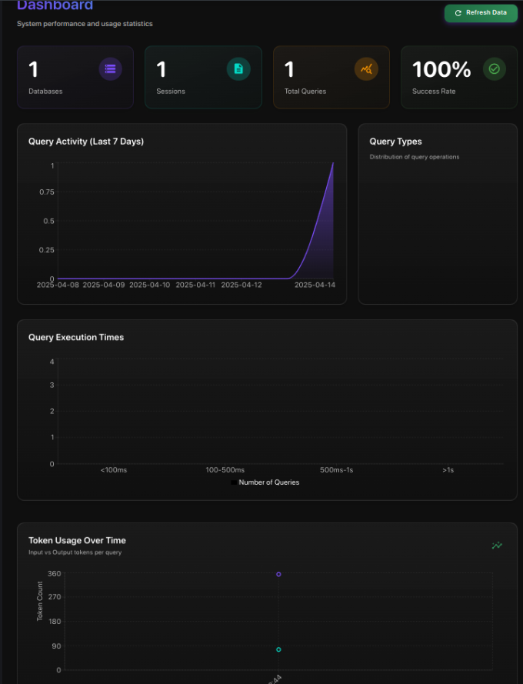

User Dashboard

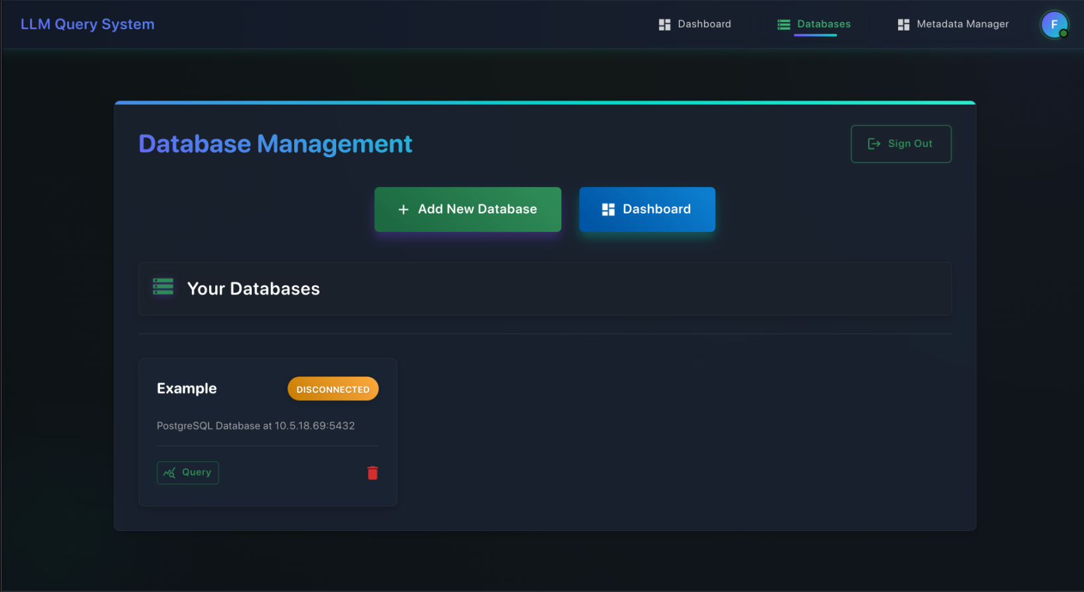

Page to add databases

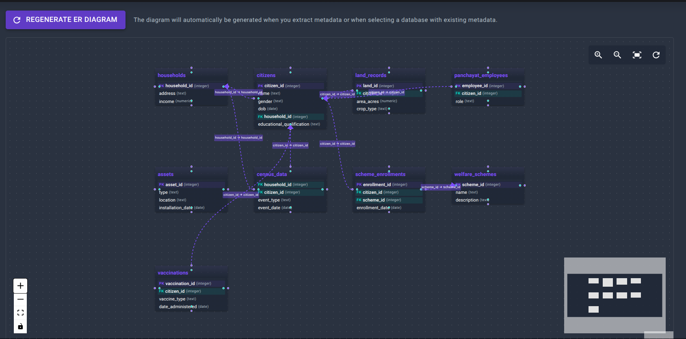

Understand database and construct ER Diagram

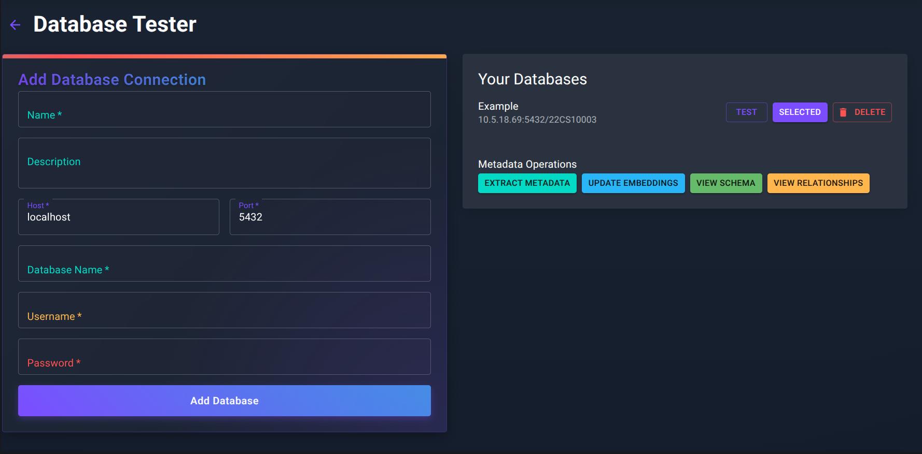

Page to extract and view metadata for a particular database

**1. Authentication System**

**A. Multi-Provider Authentication**

- Successful implementation of three-tier authentication

- Seamless provider integration

- Automatic account linking

- Secure token management

- Comprehensive error handling

**B. User Experience**

- Intuitive login interface

- Quick authentication process

- Clear error messages

- Smooth provider switching

- Persistent sessions

**2. Query Processing System**

**A. Natural Language Processing**

- Accurate query conversion

- Support for complex queries

- Real-time processing

- Error detection

- Query optimization

**B. Database Integration**

- Multiple database support

- Efficient query execution

- Formatted results

- Performance optimization

- Error handling

**Future Scope**

**1. Authentication Enhancements**

- Additional OAuth providers

- Biometric authentication

- Two-factor authentication

- Enhanced session management

- Advanced security features

**2. Query Processing Improvements**

- Machine learning integration

- Query optimization engine

- Natural language understanding

- Complex query support

- Performance optimization

**3. User Interface Developments**

- Advanced visualization options

- Custom theming support

- Mobile application

- Offline capabilities

- Real-time collaboration

**4. Database Integration**

- NoSQL database support

- Distributed database support

- Advanced query builders

- Performance monitoring

- Automated optimization

**Conclusion**

The implemented system successfully demonstrates:

1. Advanced authentication mechanisms with seamless provider integration

2. Sophisticated natural language processing for SQL queries

3. Robust database integration and management

4. Professional-grade user interface and experience

5. Comprehensive security measures and error handling

The project showcases industry-standard practices in:

- Authentication system design

- Frontend development

- Backend architecture

- Database integration

- Security implementation

**References**

**Technical Documentation**

**1. Firebase Authentication**

- https://firebase.google.com/docs/auth

- Version: 9.x

- Accessed: 2025-04-14

**2. Django REST Framework**

- https://www.django-rest-framework.org/

- Version: 3.14

- Accessed: 2025-04-14

**3. React.js Documentation**

- https://reactjs.org/docs/getting-started.html

- Version: 18.2

- Accessed: 2025-04-14

**4. Material-UI**

- https://mui.com/getting-started/

- Version: 5.x

- Accessed: 2025-04-14

**Security Standards**

**1. OWASP Security Guidelines**

- https://owasp.org/guidelines

- Version: 2024

- Accessed: 2025-04-14

**2. JWT Security Best Practices**

- https://jwt.io/introduction

- Version: 2024

- Accessed: 2025-04-14

---

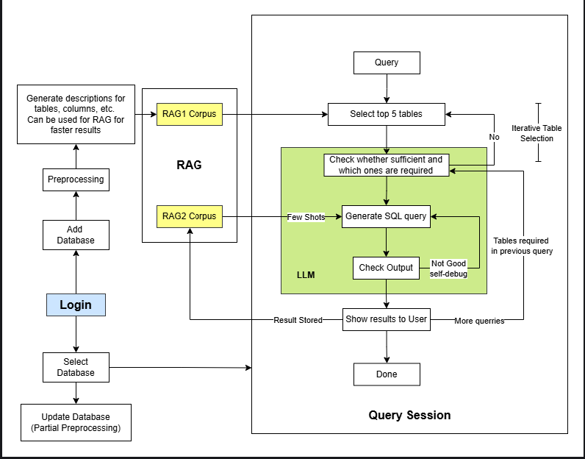

Our system pipeline