https://gomakethings.com/articles/
The Program Schedule
Here’s exactly what you’ll learn in Modern JavaScript for Beginners.

Module 0. Getting Started
- How JavaScript differs from HTML and CSS
- How to load JavaScript files in the browser
- Variables, functions, and comments
- Developer tools, the console, and debugging
- Tools of the trade: recommended browsers and text editors
- Tips for working on projects

Module 1. DOM Essentials
- Getting elements in the DOM
- Listening for events and user interactions
- Looping over elements
- Getting and setting text and HTML
- Working with custom HTML attributes

Module 2. APIs & Asynchronous JS
- Working with fetch()
- Parsing and manipulating API data
- Promises and chaining API calls
- Making multiple API calls and structuring code
- Cross-site scripting attacks and sanitizing third-party data
- async and await

Module 3. Arrays, Objects, Strings, & Numbers
- Looping over and manipulating arrays and objects
- Advanced array and object methods
- Shuffling arrays
- Adding and removing items from arrays and objects
- Converting strings to numbers and numbers to strings
- Doing math with JavaScript

Module 4. Browser Storage
- Storing data locally in the browser
- How to convert objects to strings and back again
- How to build local apps using browser storage
- Serializing form data
- Debouncing
- Dynamic status messages
Across all of the sections, you’ll also learn about web performance, debugging, and web accessibility.
Work on fun projects!
Grow your portfolio and build a wide range of fun projects, including…

Toggle Password Visibility
Show and hide passwords by toggling a checkbox field.

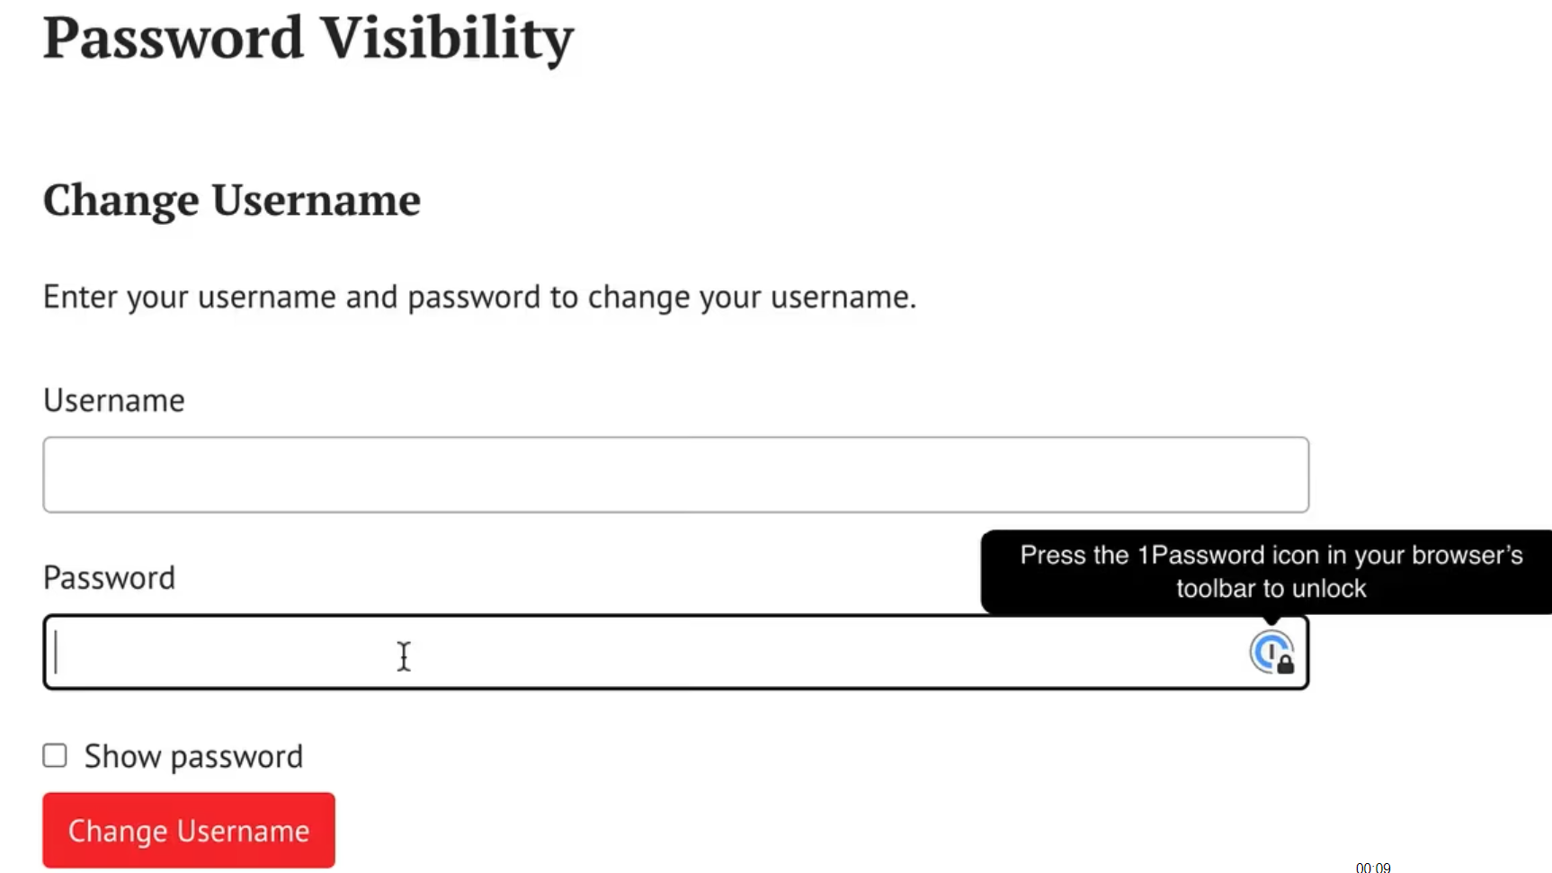

Word Count
Count the number of words and characters in a block of text as the user types.
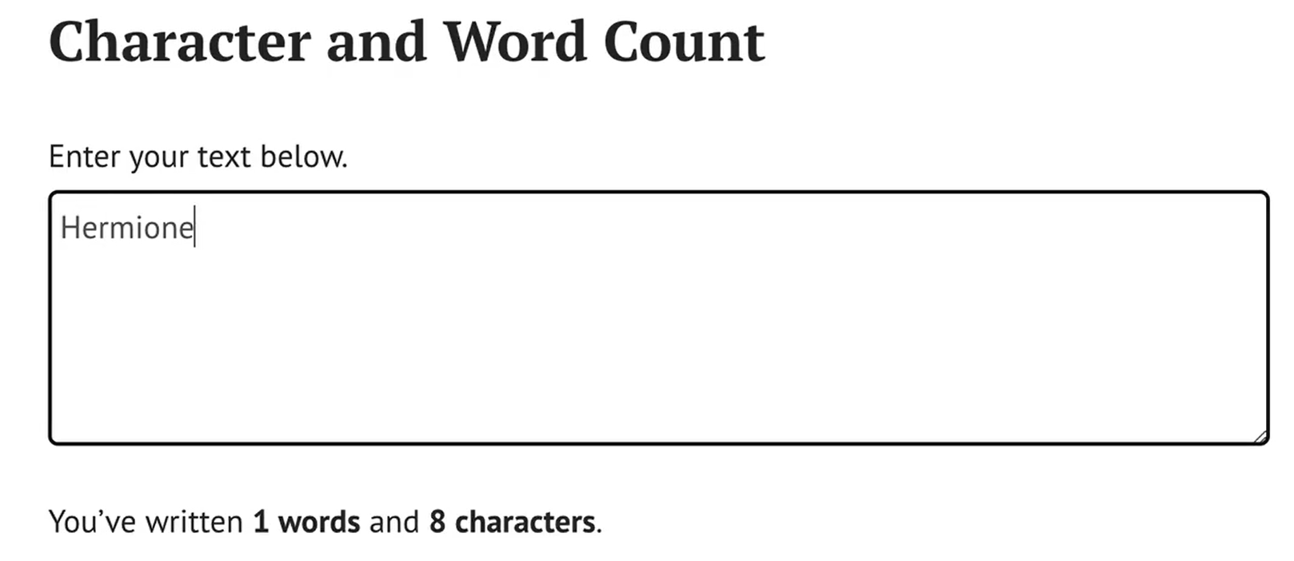

Random Ron
Show random Ron Swanson quotes on a website using an API.


Dragon Trainer Magazine
Create a magazine website by combining several APIs from Dragon Trainer Magazine.


Find the Monsters
Create a fun game where you find your monster friends and avoid the sock.
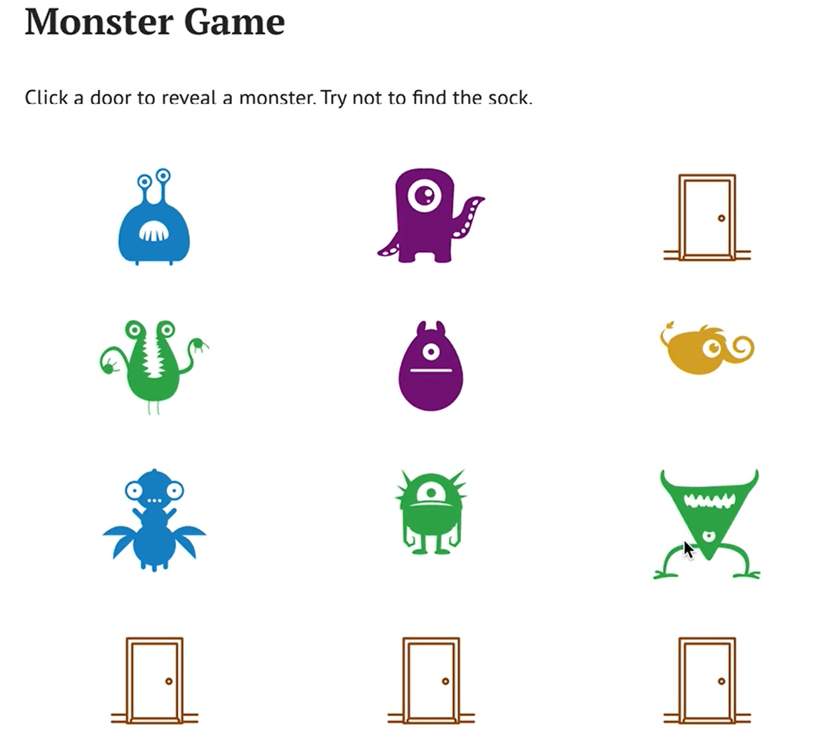

Form Saver
Automatically save form data as a user types and reload it on future visits.
