Integrated Transcriptomic Analysis Identifies Conserved Molecular Signatures and Hub Genes Associated with Alzheimer's Disease

Rita Ellinidou
Independent Bioinformatics Research Project
Completed: July 2026
Correspondence: rita.ell2009@proton.me

Abstract
Alzheimer's disease (AD) is a progressive neurodegenerative disorder characterized by cognitive decline, synaptic dysfunction, and widespread neuronal loss. Despite extensive research, the molecular mechanisms underlying disease progression remain incompletely understood. This study employed an integrated bioinformatics approach to identify robust transcriptomic alterations associated with AD using two independent Gene Expression Omnibus (GEO) microarray datasets (GSE122063 and GSE33000).
Differential expression analysis was performed independently using the limma package, followed by functional enrichment analyses based on Gene Ontology (GO) and Kyoto Encyclopedia of Genes and Genomes (KEGG) databases. Shared differentially expressed genes (DEGs) were identified through comparative analysis, and protein–protein interaction (PPI) networks were constructed using the STRING database to identify highly connected hub genes.
A total of 914 significant DEGs were identified in GSE122063 and 320 in GSE33000, with 113 genes consistently dysregulated across both datasets. Functional enrichment analysis demonstrated significant alterations in biological processes associated with synaptic signalling, neurotransmitter transport, calcium signalling, and immune responses. KEGG pathway analysis further highlighted disruption of neuroactive ligand–receptor interaction and calcium signalling pathways. Network analysis identified several highly connected hub genes, including SST, PVALB, GAD1, GAD2, CRH, BDNF and SNAP25, suggesting central roles in neuronal communication and disease-associated molecular networks.
Overall, this integrated transcriptomic analysis identified reproducible molecular signatures associated with Alzheimer's disease and highlighted biological pathways involved in synaptic dysfunction and neuroinflammation. These findings contribute to a better understanding of AD pathogenesis and provide a computational framework for future experimental validation and biomarker discovery.
1. Introduction
Alzheimer's disease (AD) is the most common neurodegenerative disorder and the leading cause of dementia worldwide. It is characterised by progressive cognitive decline, memory impairment and loss of executive function, ultimately leading to severe disability and dependence. As global life expectancy continues to increase, the prevalence of Alzheimer's disease is expected to rise substantially, creating significant healthcare, social and economic challenges.
The pathological hallmarks of Alzheimer's disease include the accumulation of extracellular amyloid-β plaques and intracellular neurofibrillary tangles composed of hyperphosphorylated tau protein. These pathological changes are accompanied by synaptic dysfunction, neuronal loss, chronic neuroinflammation and widespread alterations in gene expression. Although these mechanisms have been extensively investigated, the molecular processes driving disease progression remain incompletely understood.
Advances in high-throughput transcriptomic technologies have enabled comprehensive analysis of gene expression changes associated with Alzheimer's disease. Public repositories such as the National Center for Biotechnology Information (NCBI) Gene Expression Omnibus (GEO) provide access to large-scale transcriptomic datasets that facilitate the identification of differentially expressed genes (DEGs) and dysregulated biological pathways. Integrating multiple independent datasets improves the robustness of bioinformatic analyses by reducing dataset-specific variability and highlighting reproducible molecular alterations.
Differential expression analysis identifies genes whose expression differs significantly between disease and control samples. Subsequent functional enrichment analyses, including Gene Ontology (GO) and Kyoto Encyclopedia of Genes and Genomes (KEGG) pathway analysis, provide biological interpretation by identifying overrepresented cellular processes and signalling pathways. Protein–protein interaction (PPI) network analysis further prioritises highly connected hub genes that may play central roles in disease-associated molecular networks.
The objective of this study was to investigate transcriptomic alterations associated with Alzheimer's disease through the integrated analysis of two independent GEO microarray datasets, GSE122063 and GSE33000. Differential expression analysis was performed independently for each dataset using the limma package, followed by comparative identification of shared DEGs. Functional enrichment and protein–protein interaction analyses were subsequently conducted to investigate the biological significance of the shared genes and identify key molecular pathways and hub genes associated with Alzheimer's disease pathology.
By combining independent transcriptomic datasets with functional and network analyses, this study aims to identify robust molecular signatures that improve our understanding of Alzheimer's disease pathogenesis and provide candidate genes for future experimental validation and therapeutic investigation.

2. Materials and Methods
2.1 Study Design
This study employed an integrative bioinformatics approach to investigate transcriptomic alterations associated with Alzheimer's disease using publicly available gene expression datasets obtained from the National Center for Biotechnology Information (NCBI) Gene Expression Omnibus (GEO). Two independent microarray datasets were analysed separately to identify differentially expressed genes (DEGs), followed by an integrated analysis to determine genes consistently dysregulated across both cohorts. Functional enrichment analyses, protein–protein interaction (PPI) network construction and hub gene identification were subsequently performed using the shared DEGs to identify biological pathways and molecular mechanisms consistently associated with Alzheimer's disease.
The principal characteristics of the two GEO datasets analysed in this study are summarised in Table 1.
Dataset | Platform | Genes Analysed | Total Samples | Alzheimer's Disease | Controls
GSE122063 | GPL16699 | 32,080 | 56 | 28 | 28
GSE33000 | GPL4372 | 16,664 | 624 | 310 | 157
These two independent datasets were selected to increase the robustness of the transcriptomic analysis and to enable the identification of reproducible molecular alterations associated with Alzheimer's disease.

2.2 Gene Expression Datasets
Two publicly available Alzheimer's disease gene expression datasets were selected from the Gene Expression Omnibus (GEO) database based on sample size, data quality and availability of healthy control samples.
The first dataset, GSE122063, consists of post-mortem human brain tissue samples obtained from individuals diagnosed with Alzheimer's disease and cognitively healthy controls. This dataset was used as the primary discovery cohort for differential gene expression analysis and exploratory biomarker identification.
The second dataset, GSE33000, contains transcriptomic profiles generated from dorsolateral prefrontal cortex (DLPFC) tissue collected from Alzheimer's disease patients, Huntington's disease patients and non-demented control individuals. Only Alzheimer's disease and non-demented control samples were included in the present analysis, while Huntington's disease samples were excluded to ensure direct comparison between Alzheimer's disease and healthy controls.
Probe annotation files corresponding to each microarray platform were downloaded from GEO and used to convert probe identifiers into official gene symbols. When multiple probes corresponded to the same gene, their expression values were averaged to obtain a single expression measurement for each gene.

2.3 Data Preprocessing
Raw expression matrices and sample metadata were imported into Python using the pandas library. Expression matrices were matched with their corresponding metadata to ensure correct sample annotation. Samples lacking complete diagnostic information or containing excessive missing values were excluded where appropriate.
Gene expression matrices were filtered to remove probes that could not be mapped to official gene symbols. Duplicate gene measurements originating from multiple probes were collapsed by calculating the mean expression value for each gene.
The resulting expression matrices were standardized prior to downstream analyses. Principal Component Analysis (PCA) was subsequently performed to investigate global expression patterns and assess separation between Alzheimer's disease and control samples while identifying potential outliers.

2.4 Differential Gene Expression Analysis
Differential expression analysis was performed independently for each dataset using the limma (Linear Models for Microarray Data) statistical framework. Limma fits a linear model to the expression value of every gene, allowing estimation of expression differences between Alzheimer's disease and control samples.
The fitted model can be expressed as
$$\left[Y=Xβ+ε\right]$$
where:
- $\left(Y\right)$represents the observed gene expression values,
- (X) denotes the experimental design matrix,
- $\left(β\right)$corresponds to the estimated regression coefficients describing the effect of disease status, and
- $\left(ε\right)$represents the residual error.
For each gene, the log₂ fold change (log₂FC) was calculated as
$$\left[\log_{2}{F}C=\log_{2}\left(\frac{\overline{x}AD}{\overline{x}Control}\right)\right]$$
where $\left(\overline{x}AD\right)$and $\left(\overline{x}Control\right)$ represent the average expression levels observed in Alzheimer's disease and control samples, respectively.
Multiple hypothesis testing was controlled using the Benjamini–Hochberg False Discovery Rate (FDR) correction. Genes satisfying an adjusted P-value below 0.05 were considered statistically significant. Dataset-specific log₂ fold-change thresholds were subsequently applied to identify biologically meaningful DEGs according to the characteristics of each dataset.

2.5 Functional Enrichment Analysis
Genes identified as significantly differentially expressed were analysed using the Enrichr platform through the GSEAPY Python package. Gene Ontology (GO) Biological Process enrichment analysis was performed to identify biological processes significantly associated with the observed transcriptional changes. Kyoto Encyclopedia of Genes and Genomes (KEGG) pathway enrichment analysis was subsequently conducted to identify signalling pathways enriched among the differentially expressed genes.
To improve the robustness of biological interpretation, enrichment analyses were repeated using only the genes shared between both Alzheimer's disease datasets. This integrated analysis allowed identification of biological pathways consistently dysregulated across independent patient cohorts.

2.6 Integrated Analysis and Protein–Protein Interaction Network Construction
Genes identified as significantly differentially expressed in both datasets were considered shared DEGs and were used for integrative downstream analyses. Shared genes were identified by intersecting the significant DEG lists generated independently from GSE122063 and GSE33000.
Protein–protein interaction analysis was performed using the STRING database with a high-confidence interaction score threshold. The resulting interaction network was visualized using the NetworkX Python library. Degree centrality was calculated for every node within the network to identify hub genes occupying highly connected positions within the interaction network. These hub genes were considered potential key regulators involved in Alzheimer's disease pathogenesis.

3. Results
Differential expression analysis was performed independently for each dataset prior to the integrated analysis. A summary of the identified differentially expressed genes is presented in Table 2.
Dataset | Genes Tested | Significant DEGs | Upregulated | Downregulated
GSE122063 | 32,080 | 914 | 337 | 577
GSE33000 | 16,664 | 320 | 159 | 161
Integrated analysis | — | 113 shared DEGs | — | —
Although the number of significant genes differed between datasets, both analyses identified substantial transcriptional alterations associated with Alzheimer's disease. The overlap of 113 shared differentially expressed genes provided the basis for the subsequent functional enrichment and network analyses.
3.1 Differential Gene Expression Analysis of GSE122063
Differential gene expression analysis of the GSE122063 dataset identified 914 significantly differentially expressed genes (DEGs) between Alzheimer's disease (AD) and non-demented control samples following statistical testing and multiple-testing correction. Both upregulated and downregulated genes were observed, indicating widespread transcriptional alterations associated with Alzheimer's disease.
Principal Component Analysis (PCA) demonstrated a clear separation between Alzheimer's disease and control samples, suggesting that disease status was a major contributor to the overall variation in gene expression. Although a small degree of overlap between groups was observed, the first two principal components effectively distinguished the majority of Alzheimer's disease samples from healthy controls, supporting the overall quality of the processed dataset.
Figure 1. Principal Component Analysis (PCA) of GSE122063 samples.
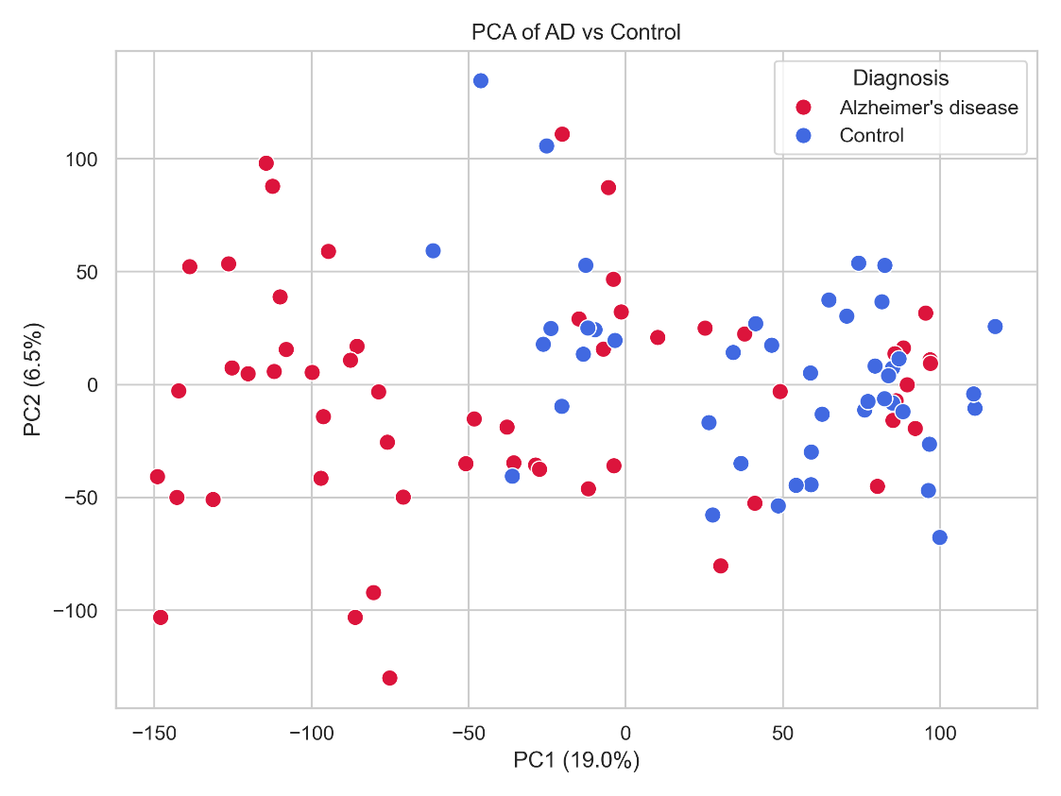
Genome-wide differential expression patterns were further visualized using a volcano plot (Figure 2). Numerous genes displayed statistically significant expression changes, with several exhibiting both large fold changes and extremely small adjusted P-values. The volcano plot highlights the broad molecular differences between Alzheimer's disease and control brain tissue while emphasizing the genes with the strongest statistical support.
Figure 2. Volcano plot showing differentially expressed genes identified in GSE122063.
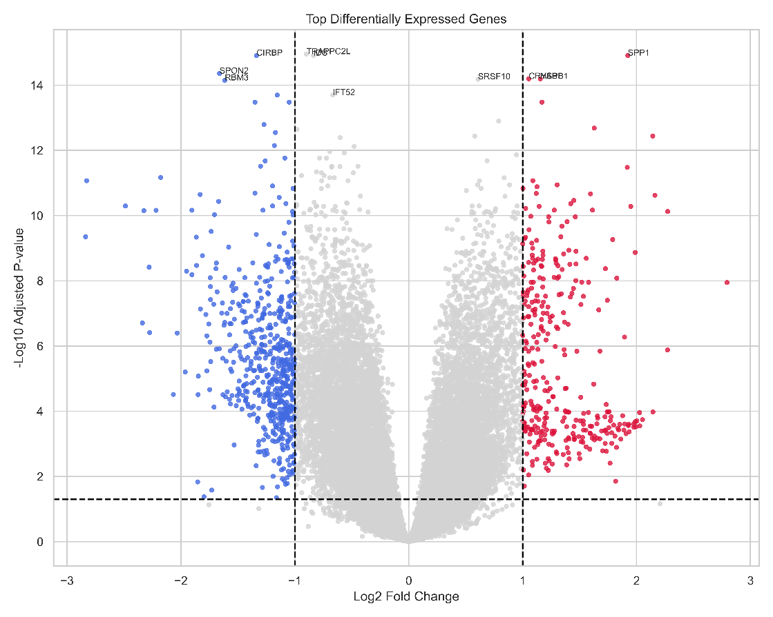
Among the most significantly dysregulated genes were CIRBP, SPP1, SPON2, CRYAB, and HSPB1. Several of these genes have previously been associated with cellular stress responses, inflammatory signalling and neurodegenerative processes, supporting the biological relevance of the identified expression changes.
To investigate whether the most significant DEGs could discriminate between Alzheimer's disease and control samples, hierarchical clustering was performed using the highest-ranked genes. The resulting heatmap revealed distinct expression patterns across the two experimental groups, with Alzheimer's disease samples clustering separately from controls based on the expression profiles of the selected genes.
Figure 3. Heatmap of the top differentially expressed genes identified in GSE122063.
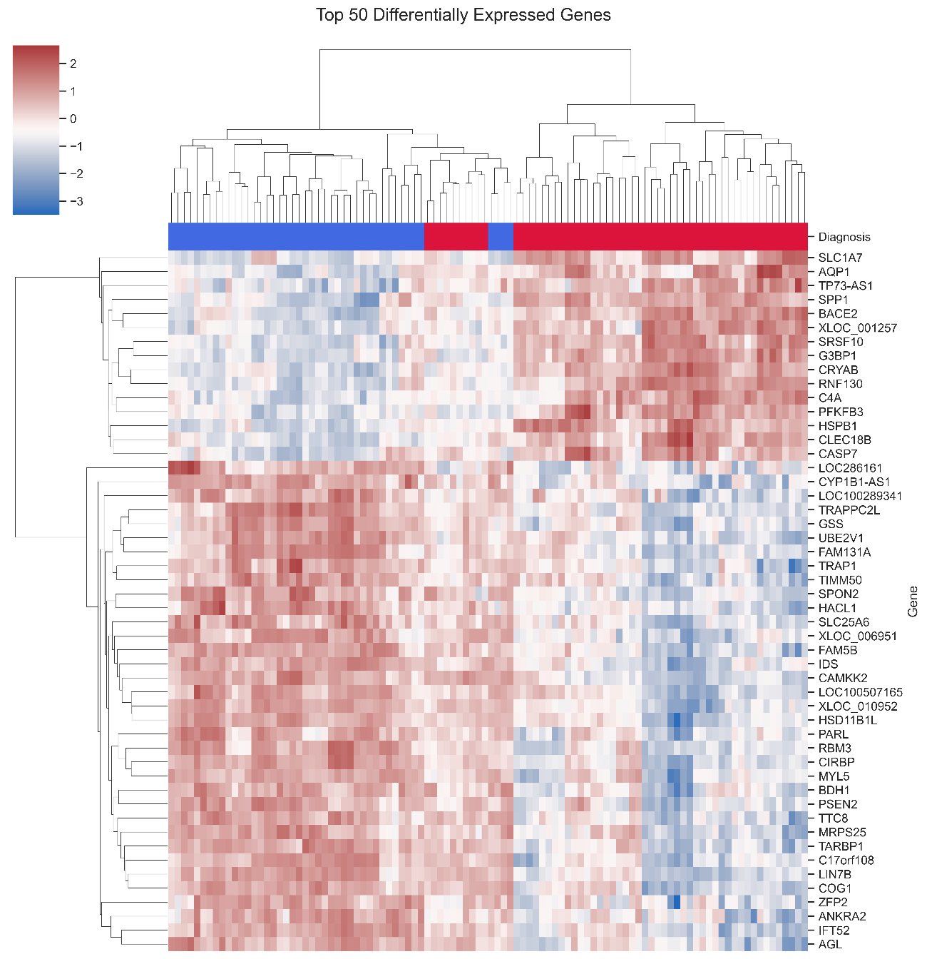
Collectively, these findings demonstrate that the GSE122063 dataset contains robust transcriptomic differences between Alzheimer's disease and healthy brain tissue, providing a suitable foundation for subsequent pathway enrichment and comparative analyses.

3.2 Differential Gene Expression Analysis of GSE33000
To validate the reproducibility of the transcriptomic alterations identified in GSE122063, differential expression analysis was independently performed using the GSE33000 dataset. After preprocessing, probe annotation and statistical analysis, 320 significantly differentially expressed genes (DEGs) were identified between Alzheimer's disease and non-demented control samples.
Principal Component Analysis (PCA) demonstrated a clear separation between Alzheimer's disease and control samples, indicating that disease status accounted for a substantial proportion of the overall transcriptional variation within the dataset. Compared with GSE122063, a greater degree of overlap between the two experimental groups was observed; however, the overall clustering pattern remained consistent with the presence of disease-associated molecular differences.
Figure 4. Principal Component Analysis (PCA) of GSE33000 samples.
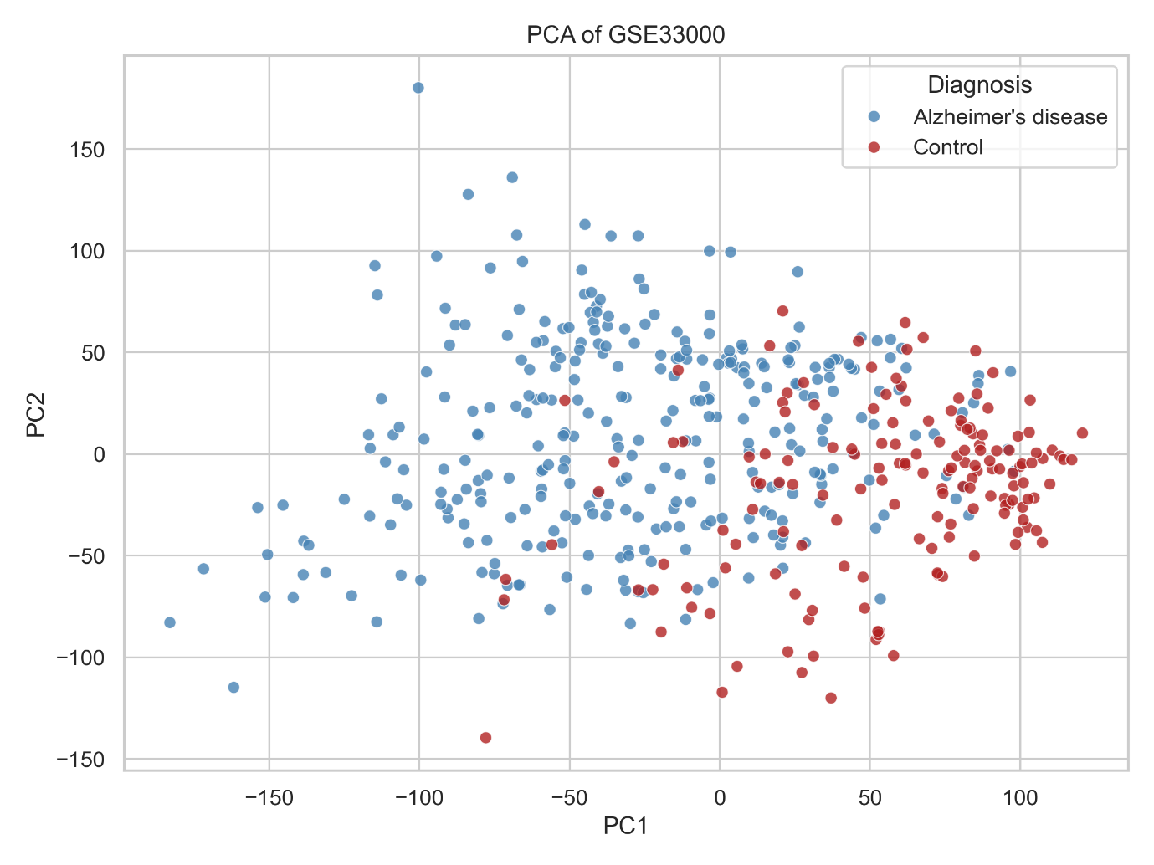
Genome-wide differential expression was subsequently visualized using a volcano plot (Figure 5). Although fewer significant DEGs were detected compared with GSE122063, several genes exhibited substantial expression changes with strong statistical support. The reduced number of significant genes is likely attributable to differences in sample composition, brain region characteristics and experimental platform rather than an absence of Alzheimer's disease-associated transcriptional alterations.
Figure 5. Volcano plot showing differentially expressed genes identified in GSE33000.
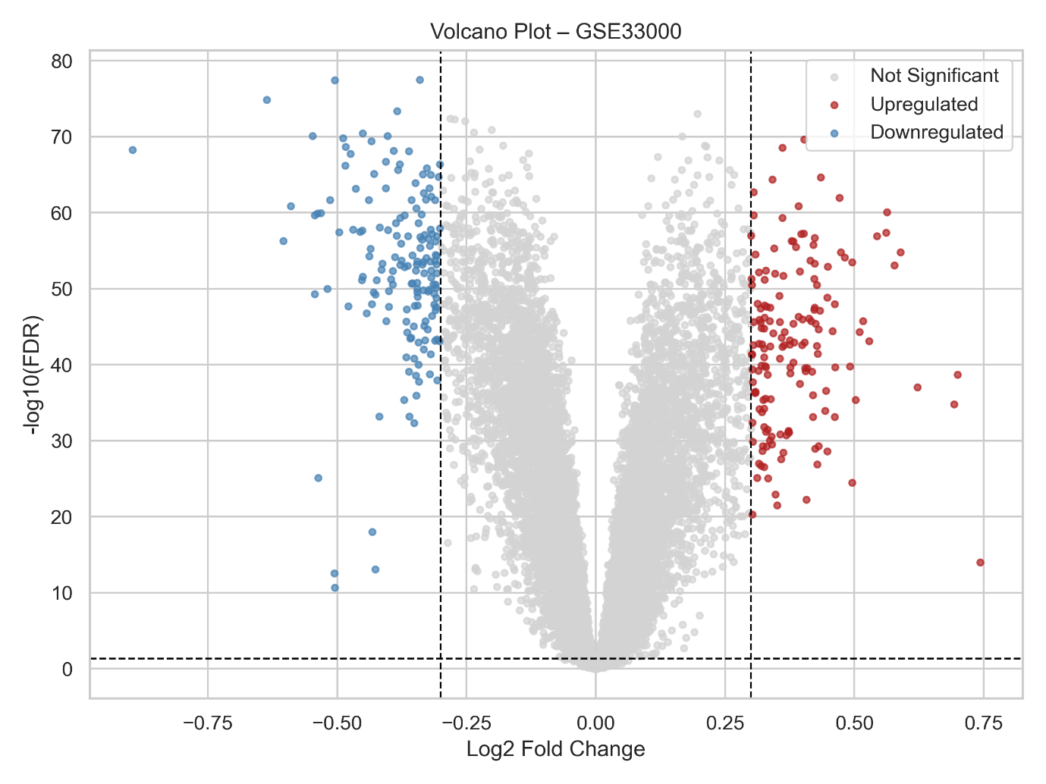
Among the most significantly dysregulated genes were NRN1, NEUROD6, PPEF1, SVOP, and BDNF, all of which demonstrated highly significant differential expression between Alzheimer's disease and control samples. Many of these genes are associated with neuronal differentiation, synaptic function and neuroplasticity, supporting previous observations that neuronal signalling pathways are substantially disrupted during Alzheimer's disease progression.
Hierarchical clustering based on the highest-ranked differentially expressed genes further demonstrated distinct expression profiles between Alzheimer's disease and control samples (Figure 6). Alzheimer's disease samples exhibited coordinated alterations across numerous neuronal genes, whereas control samples maintained comparatively stable expression patterns. Despite increased biological heterogeneity relative to the first dataset, the heatmap confirmed that the identified DEGs were capable of separating the two clinical groups.
Figure 6. Heatmap of the top differentially expressed genes identified in GSE33000.
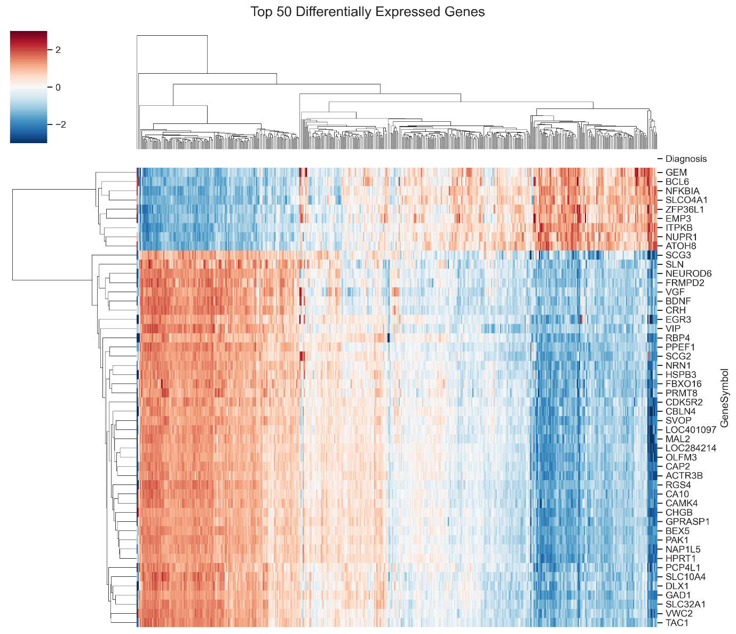
Overall, the independent analysis of GSE33000 confirmed the presence of widespread transcriptional dysregulation associated with Alzheimer's disease. Although the specific sets of significant genes differed between datasets, both analyses consistently demonstrated substantial alterations in neuronal gene expression, supporting the suitability of integrating both datasets to identify robust disease-associated molecular signatures.

3.3 Integrated Transcriptomic Analysis
Although both transcriptomic datasets demonstrated significant gene expression changes associated with Alzheimer's disease, comparison of the independently generated DEG lists revealed that many genes were unique to each dataset. Such differences are expected because of variations in sample composition, tissue heterogeneity, experimental platforms and cohort characteristics. To identify molecular alterations that were consistently associated with Alzheimer's disease irrespective of dataset-specific variability, an integrated analysis was performed by comparing the significant DEGs identified in GSE122063 and GSE33000.
Intersection of the two DEG lists identified 113 shared differentially expressed genes, representing genes that were consistently dysregulated in Alzheimer's disease across both independent cohorts. These shared genes constitute a robust molecular signature and were selected for all subsequent functional enrichment and network analyses.
Figure 7. Venn diagram illustrating the overlap of differentially expressed genes identified in GSE122063 and GSE33000.
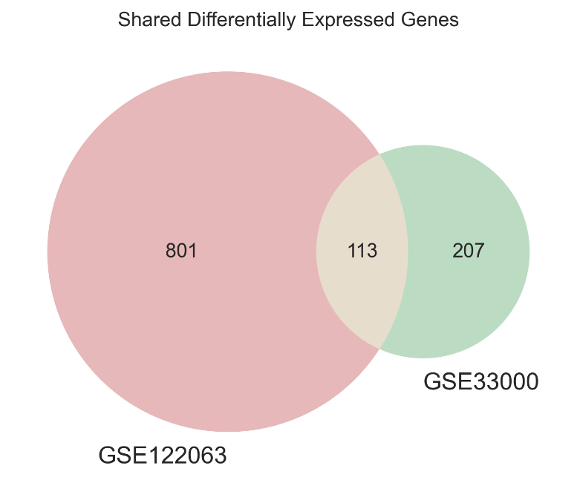
Inspection of the shared DEG list demonstrated that several genes involved in neuronal function, immune regulation and cellular stress responses were consistently altered in both datasets. Examples include CIRBP, RBM3, C4A, CARTPT, FCGBP, C4B, FRMPD2, VGF, CRH, ITPKB, CD163, CD44, and SERPINA3. The presence of these genes in two completely independent transcriptomic studies suggests that they represent reproducible molecular alterations associated with Alzheimer's disease rather than dataset-specific findings.
The integrated analysis also demonstrated that although the total number of DEGs differed substantially between datasets (914 in GSE122063 versus 320 in GSE33000), a biologically meaningful subset of genes remained consistently dysregulated across both cohorts. This observation supports the rationale for integrating multiple transcriptomic datasets, as reproducible genes are more likely to reflect core disease mechanisms than genes identified in only a single experiment.
The identification of these 113 shared DEGs provided the basis for downstream biological interpretation. Functional enrichment analyses were subsequently performed to determine the biological processes and signalling pathways most strongly associated with the shared molecular signature, followed by construction of a protein–protein interaction network to identify highly connected hub genes that may play central roles in Alzheimer's disease pathogenesis.

3.4 Functional Enrichment Analysis of Shared Differentially Expressed Genes
To investigate the biological significance of the shared transcriptomic signature, Gene Ontology (GO) Biological Process enrichment analysis was performed using the 113 shared DEGs. Rather than considering individual genes in isolation, enrichment analysis identifies biological processes that are collectively overrepresented within the shared gene set, thereby providing insight into the cellular mechanisms most consistently affected in Alzheimer's disease.
The shared DEGs showed significant enrichment for biological processes related to neuronal communication, synaptic activity, regulation of neurotransmission and immune-associated cellular responses. Several enriched terms were associated with chemical synaptic transmission, regulation of neuronal signalling and inflammatory mechanisms, indicating that both neuronal dysfunction and immune activation contribute substantially to the molecular phenotype shared between the two Alzheimer's disease cohorts.
Figure 8. Gene Ontology enrichment analysis of the shared differentially expressed genes showing significantly enriched Biological Process, Cellular Component and Molecular Function categories.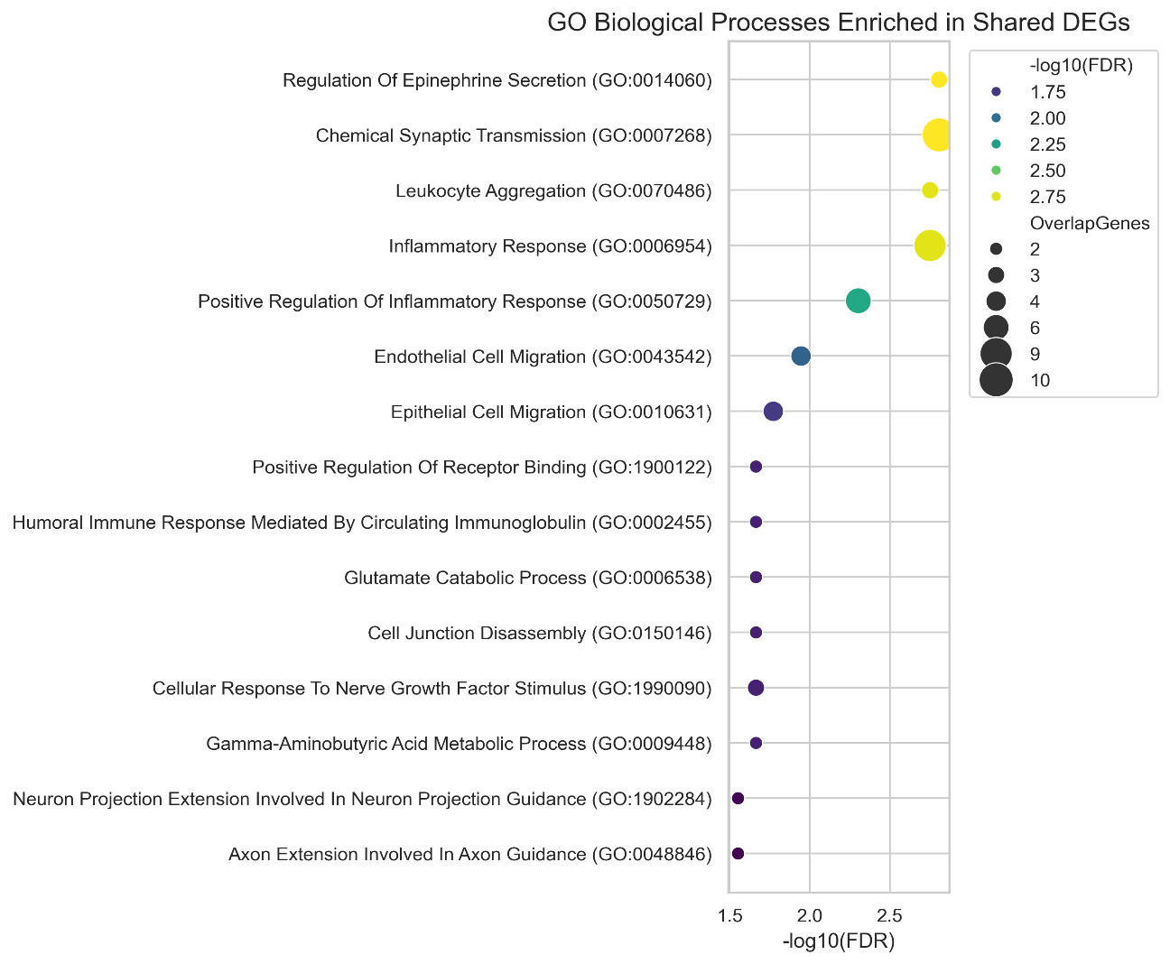
The integrated analysis identified 113 genes that were consistently differentially expressed in both datasets. Representative genes with established roles in neuronal function, synaptic signalling and neuroinflammation are presented in Table 3.
Gene | Expression Trend | Reported Biological Function
BDNF | Downregulated | Neurotrophic signalling and synaptic plasticity
CRH | Downregulated | Neuroendocrine signalling
VGF | Downregulated | Synaptic plasticity and neuronal survival
FRMPD2 | Downregulated | Synaptic organisation
ITPKB | Downregulated | Calcium signalling
CAMK4 | Downregulated | Neuronal signalling
NEUROD6 | Downregulated | Neuronal differentiation
SVOP | Downregulated | Synaptic vesicle function
C1QC | Upregulated | Complement activation
CD163 | Upregulated | Microglial activation
SERPINA3 | Upregulated | Inflammatory response
C4A | Upregulated | Complement cascade
RBM3 | Downregulated | RNA processing and stress response
CIRBP | Downregulated | Cellular stress response
MAFF | Upregulated | Oxidative stress regulation
These shared genes collectively indicate dysregulation of neuronal communication, immune activation and stress-response pathways, suggesting that these biological processes represent common molecular signatures of Alzheimer's disease.
Overall, the GO enrichment results demonstrated that the shared genes were not randomly distributed across biological functions but instead clustered within coordinated cellular processes known to be disrupted during Alzheimer's disease progression. These findings provide further evidence that the integrated DEG set captures biologically meaningful alterations that are consistently observed across independent transcriptomic datasets.

3.5 KEGG Pathway Enrichment Analysis
To further characterize the biological relevance of the shared differentially expressed genes, Kyoto Encyclopedia of Genes and Genomes (KEGG) pathway enrichment analysis was performed. While GO analysis identifies broad biological processes, KEGG enrichment provides insight into specific signalling pathways that may contribute to Alzheimer's disease pathogenesis.
Analysis of the 113 shared DEGs identified several significantly enriched pathways associated with neuronal communication, neurodegeneration and immune regulation. Multiple pathways involved in synaptic signalling, inflammatory responses and intracellular signal transduction were significantly overrepresented within the shared gene set, indicating that Alzheimer's disease is associated with coordinated disruption of interconnected molecular networks rather than isolated gene expression changes.
Figure 9. KEGG pathway enrichment analysis of the shared differentially expressed genes highlighting significantly dysregulated biological pathways associated with Alzheimer's disease.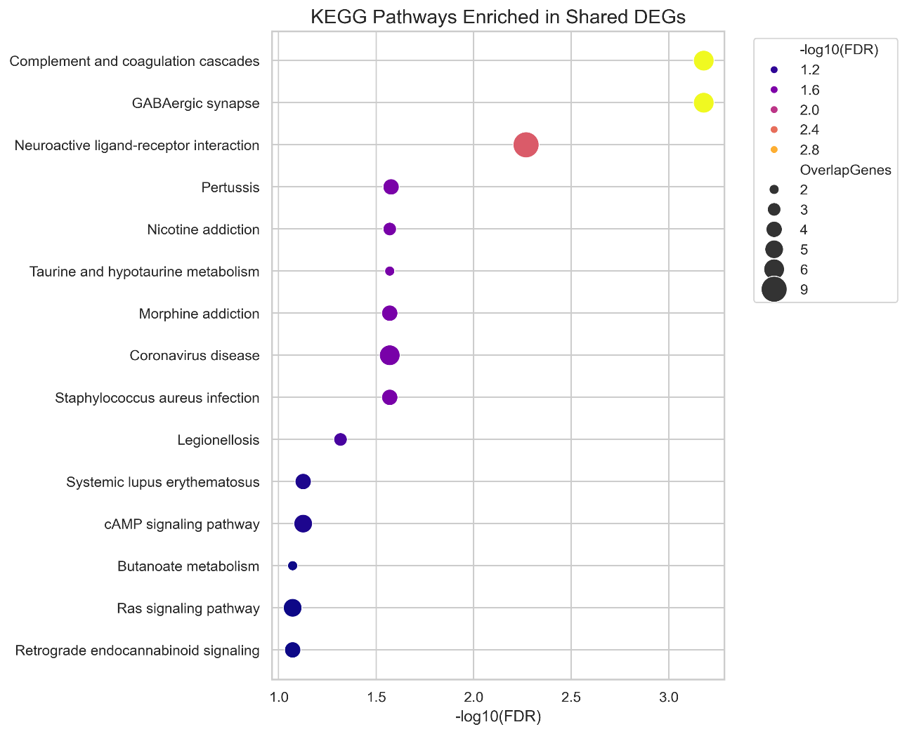
The enrichment profile demonstrated substantial agreement with the Gene Ontology analysis, with both approaches highlighting alterations affecting neuronal signalling and immune-associated mechanisms. The consistency between GO Biological Process and KEGG pathway analyses further supports the biological robustness of the integrated transcriptomic signature identified across the two independent datasets.
Taken together, these enrichment analyses suggest that Alzheimer's disease involves simultaneous dysregulation of multiple molecular pathways responsible for maintaining neuronal function, synaptic communication and cellular homeostasis. The identification of these reproducible pathways provides a systems-level overview of the molecular alterations consistently observed across independent Alzheimer's disease cohorts.

3.6 Protein–Protein Interaction Network and Hub Gene Identification
To investigate the functional relationships among the shared differentially expressed genes, a protein–protein interaction (PPI) network was constructed using the STRING database. The resulting interaction network consisted of 47 nodes connected by 75 interaction edges, indicating that a substantial proportion of the shared DEGs participate in coordinated molecular interactions rather than functioning independently.
Figure 10. Protein–protein interaction network generated using STRING from the 113 shared differentially expressed genes. Nodes represent proteins, whereas edges indicate predicted functional associations. Highly connected nodes represent potential hub genes involved in Alzheimer's disease pathogenesis.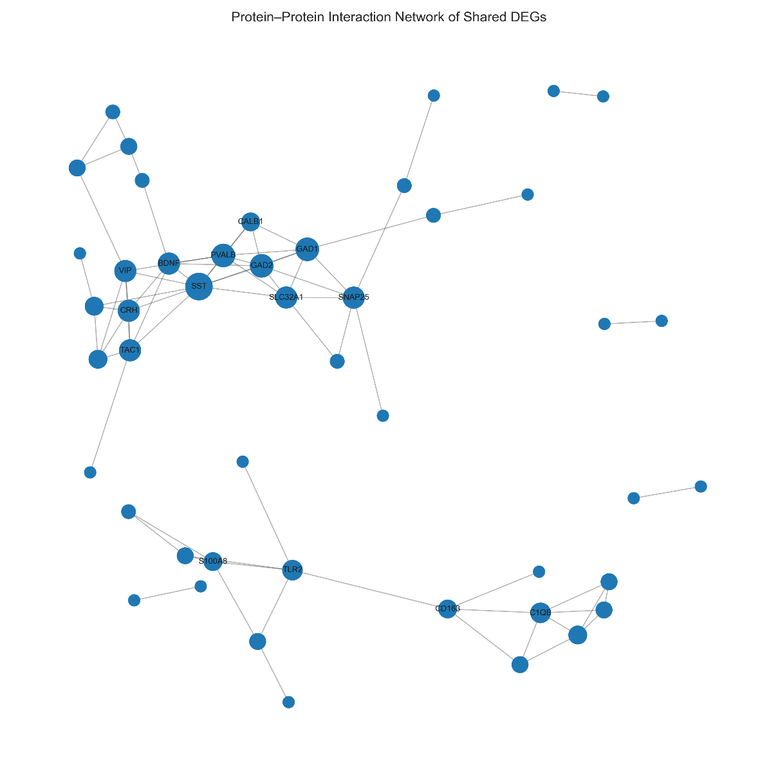
The most significantly enriched biological processes and pathways identified from the shared differentially expressed genes are summarised in Table 4.

Database | Representative Enriched Category | Biological Interpretation
Gene Ontology | Synaptic signalling | Impaired neuronal communication
Gene Ontology | Regulation of neurotransmitter transport | Synaptic dysfunction
Gene Ontology | Postsynaptic membrane | Altered synaptic architecture
Gene Ontology | Calcium ion binding | Disturbed neuronal calcium homeostasis
KEGG | Neuroactive ligand–receptor interaction | Impaired neurotransmission
KEGG | Calcium signalling pathway | Dysregulated intracellular signalling
KEGG | cAMP signalling pathway | Altered neuronal signal transduction
Collectively, these enrichment analyses indicate that the shared differentially expressed genes predominantly participate in neuronal signalling, synaptic function and inflammatory mechanisms, supporting their potential contribution to Alzheimer's disease pathogenesis.
Visual inspection of the interaction network revealed several highly connected clusters, suggesting that subsets of the shared genes participate in common biological pathways. These interaction modules primarily involved proteins associated with neuronal signalling, inflammatory regulation and cellular stress responses, consistent with the enrichment analyses described above.
To identify potential key molecular regulators within the network, node degree centrality was calculated for every protein. Genes exhibiting the highest number of interactions were classified as hub genes because of their central positions within the interaction network. Highly connected proteins are frequently considered biologically important, as they often coordinate communication between multiple signalling pathways and contribute disproportionately to network stability.
The hub gene analysis identified several proteins with markedly higher connectivity than the remainder of the network, suggesting that these genes may represent central regulators of Alzheimer's disease-associated molecular dysfunction.
Network topology analysis identified several highly connected hub genes based on degree centrality, including SST, PVALB, GAD2, GAD1, VIP, CRH and BDNF, suggesting that these genes may occupy central regulatory positions within the Alzheimer's disease protein interaction network.
Figure 11. Hub genes ranked according to degree centrality within the protein–protein interaction network.
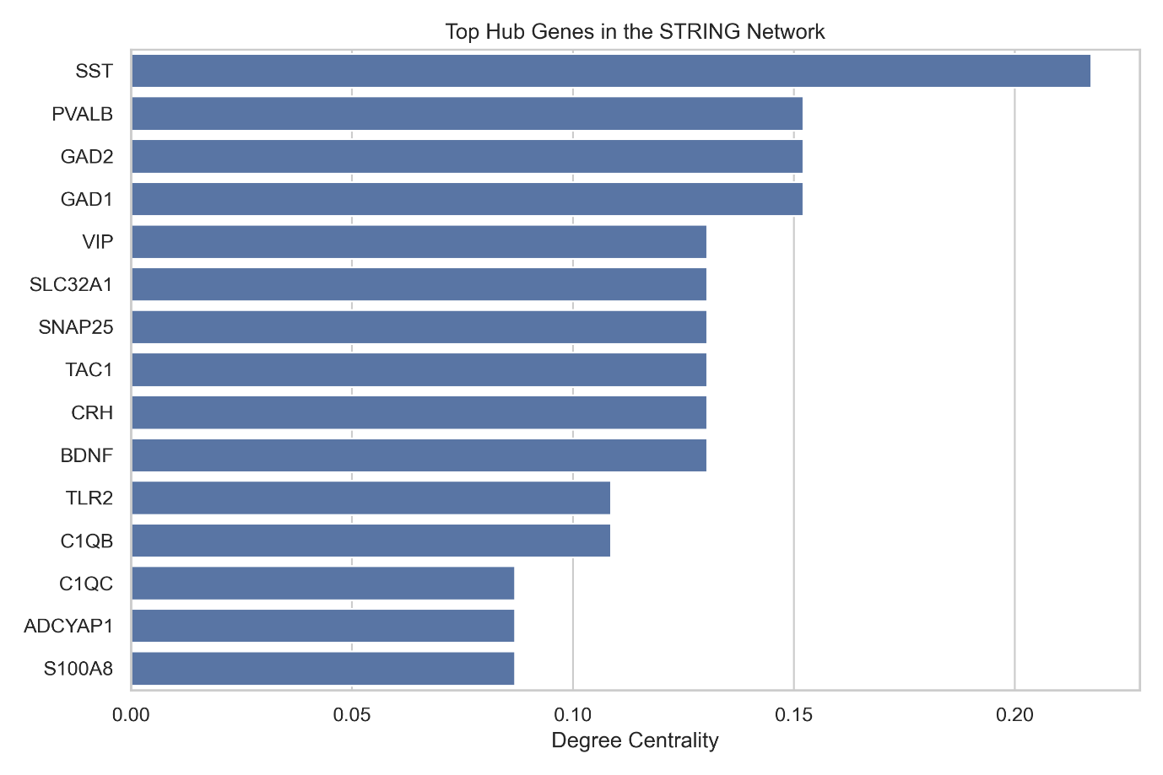
The identification of highly connected hub genes complements the differential expression and enrichment analyses by highlighting genes that are not only consistently dysregulated across independent datasets but also occupy central positions within the underlying molecular interaction network. Consequently, these hub genes represent promising candidates for future functional studies investigating Alzheimer's disease mechanisms and potential therapeutic targets.

4. Discussion
The present study integrated transcriptomic data from two independent Alzheimer's disease cohorts to identify robust differentially expressed genes and investigate the biological pathways and molecular interaction networks associated with disease pathology. Analysing the datasets independently before performing an integrated comparison reduced dataset-specific variability and enabled the identification of molecular changes that were consistently associated with Alzheimer's disease.
Differential expression analysis identified 914 significant DEGs in GSE122063 and 320 significant DEGs in GSE33000, with 113 genes consistently dysregulated across both datasets. Although the number of significant genes differed considerably between cohorts, the overlap of shared DEGs suggests that these represent reproducible molecular alterations rather than dataset-specific effects. This integrated approach therefore increases confidence in the biological relevance of the identified genes.
Several of the shared genes have previously been associated with neuronal development, synaptic transmission and neurodegeneration. Downregulated genes, including BDNF, VGF, CRH, CAMK4, NEUROD6, SVOP and ITPKB, are primarily involved in synaptic plasticity, neuronal differentiation and intracellular signalling. Reduced expression of these genes is consistent with the progressive synaptic dysfunction and neuronal loss that characterise Alzheimer's disease. In contrast, upregulated genes such as CD163, C1QC, SERPINA3, C4A and VSIG4 are associated with immune activation, complement signalling and inflammatory responses, supporting increasing evidence that chronic neuroinflammation contributes substantially to disease progression.
Functional enrichment analyses reinforced these observations. Gene Ontology analysis demonstrated significant enrichment of biological processes related to synaptic signalling, neurotransmitter transport, postsynaptic membrane organisation and calcium ion binding, indicating widespread disruption of neuronal communication. Similarly, KEGG pathway analysis identified enrichment of neuroactive ligand–receptor interaction, calcium signalling and cAMP signalling pathways, all of which play essential roles in neuronal excitability and synaptic transmission. Dysregulation of these pathways has been widely associated with cognitive decline and neuronal dysfunction in Alzheimer's disease.
Protein–protein interaction analysis provided additional biological insight by identifying several highly connected hub genes, including SST, PVALB, GAD1, GAD2, VIP, SNAP25, CRH and BDNF. Many of these genes are markers of inhibitory interneurons or regulators of neurotransmitter release, suggesting that disruption of inhibitory neuronal networks may represent a central feature of Alzheimer's disease pathology. Their high degree centrality indicates that alterations in these genes may influence multiple downstream molecular pathways simultaneously.
Overall, the integrated analyses indicate that Alzheimer's disease is characterised by coordinated dysregulation of neuronal signalling, synaptic organisation, calcium homeostasis and immune activation rather than isolated molecular abnormalities. The convergence of independent datasets strengthens confidence that these biological processes represent reproducible transcriptomic signatures of Alzheimer's disease.
Although the present study is computational in nature, the identification of reproducible shared genes, enriched pathways and highly connected hub genes provides valuable candidates for future investigation. Experimental validation using RNA sequencing, quantitative PCR and functional cellular models will be necessary to determine whether these molecular signatures may serve as clinically useful biomarkers or therapeutic targets.

5. Conclusion
In conclusion, this study identified reproducible transcriptomic alterations associated with Alzheimer's disease through the integrated analysis of two independent GEO datasets. Functional enrichment and protein interaction analyses highlighted disrupted neuronal signalling, synaptic function and immune-related pathways, while network analysis identified several highly connected hub genes that may contribute to disease progression. These findings provide additional insight into the molecular mechanisms of Alzheimer's disease and may support future biomarker discovery and therapeutic investigations..
6. References
The transcriptomic datasets analysed in this study are publicly available from the National Center for Biotechnology Information (NCBI) Gene Expression Omnibus (GEO) under accession numbers GSE122063 and GSE33000.
All analysis scripts, processed datasets, figures and supplementary material are publicly available at:
https://github.com/YOUR_USERNAME/YOUR_REPOSITORY

[1] Ashburner, M., Ball, C. A., Blake, J. A., Botstein, D., Butler, H., Cherry, J. M., et al. (2000). Gene ontology: Tool for the unification of biology. Nature Genetics, 25(1), 25–29. https://doi.org/10.1038/75556
[2] Benjamini, Y., & Hochberg, Y. (1995). Controlling the false discovery rate: A practical and powerful approach to multiple testing. Journal of the Royal Statistical Society: Series B, 57(1), 289–300. https://www.jstor.org/stable/2346101
[3] Chen, E. Y., Tan, C. M., Kou, Y., Duan, Q., Wang, Z., Meirelles, G. V., et al. (2013). Enrichr: Interactive and collaborative HTML5 gene list enrichment analysis tool. BMC Bioinformatics, 14, 128. https://doi.org/10.1186/1471-2105-14-128
[4] Edgar, R., Domrachev, M., & Lash, A. E. (2002). Gene Expression Omnibus: NCBI gene expression and hybridization array data repository. Nucleic Acids Research, 30(1), 207–210. https://doi.org/10.1093/nar/30.1.207
[5] Fang, Z., Liu, X., & Peltz, G. (2023). GSEApy: A comprehensive package for performing gene set enrichment analysis in Python. Bioinformatics, 39(1). https://doi.org/10.1093/bioinformatics/btac757
[6] Kanehisa, M., Furumichi, M., Sato, Y., Kawashima, M., & Ishiguro-Watanabe, M. (2023). KEGG for taxonomy-based analysis of pathways and genomes. Nucleic Acids Research, 51(D1), D587–D592. https://doi.org/10.1093/nar/gkac963
[7] McKhann, G. M., Knopman, D. S., Chertkow, H., Hyman, B. T., Jack, C. R., Kawas, C. H., et al. (2011). The diagnosis of dementia due to Alzheimer's disease: Recommendations from the National Institute on Aging–Alzheimer's Association workgroups. Alzheimer's & Dementia, 7(3), 263–269. https://doi.org/10.1016/j.jalz.2011.03.005
[8] McKinney, W. (2010). Data structures for statistical computing in Python. Proceedings of the 9th Python in Science Conference, 51–56.
[9] Narayanan, M., Huynh, J. L., Wang, K., Yang, X., Yoo, S., McElwee, J., et al. (2014). Common dysregulation network in the human prefrontal cortex underlies two neurodegenerative diseases. Molecular Systems Biology, 10, 743. https://doi.org/10.15252/msb.20145304
[10] Pedregosa, F., Varoquaux, G., Gramfort, A., Michel, V., Thirion, B., Grisel, O., et al. (2011). Scikit-learn: Machine learning in Python. Journal of Machine Learning Research, 12, 2825–2830.
[11] Ritchie, M. E., Phipson, B., Wu, D., Hu, Y., Law, C. W., Shi, W., & Smyth, G. K. (2015). limma powers differential expression analyses for RNA-sequencing and microarray studies. Nucleic Acids Research, 43(7), e47. https://doi.org/10.1093/nar/gkv007
[12] Smyth, G. K. (2004). Linear models and empirical Bayes methods for assessing differential expression in microarray experiments. Statistical Applications in Genetics and Molecular Biology, 3(1). https://doi.org/10.2202/1544-6115.1027
[13] Szklarczyk, D., Gable, A. L., Nastou, K. C., Lyon, D., Kirsch, R., Pyysalo, S., et al. (2023). The STRING database in 2023: Protein–protein association networks and functional enrichment analysis for any sequenced genome of interest. Nucleic Acids Research, 51(D1), D638–D646. https://doi.org/10.1093/nar/gkac1000
[14] The Gene Ontology Consortium. (2023). The Gene Ontology knowledgebase: 2023 update. Nucleic Acids Research, 51(D1), D849–D856. https://doi.org/10.1093/nar/gkac1011
[15] Van Rossum, G., & Drake, F. L. (2009). Python 3 Reference Manual. Python Software Foundation. https://docs.python.org/3/
[16] Hagberg, A. A., Schult, D. A., & Swart, P. J. (2008). Exploring network structure, dynamics, and function using NetworkX. Proceedings of the 7th Python in Science Conference, 11–15.
[17] World Health Organization. (2023). Dementia. https://www.who.int/news-room/fact-sheets/detail/dementia
[18] Ellinidou, R. (2026). Integrated Transcriptomic Analysis of Alzheimer's Disease. GitHub. https://github.com/YOUR_USERNAME/YOUR_REPOSITORY

