**How to change your Default R Library Folder**

**R 3.6.1 Updated on 2019_08_30**

1. Go to quant_workgroup > r in the TeamPSD folder
2. Copy the 3.6 folder to your Desktop

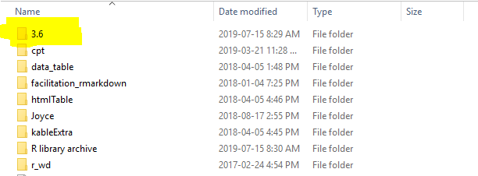

1. Go to the Windows Start > Select Windows System > Select Control Panel

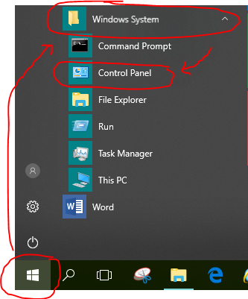

1. Select User Accounts

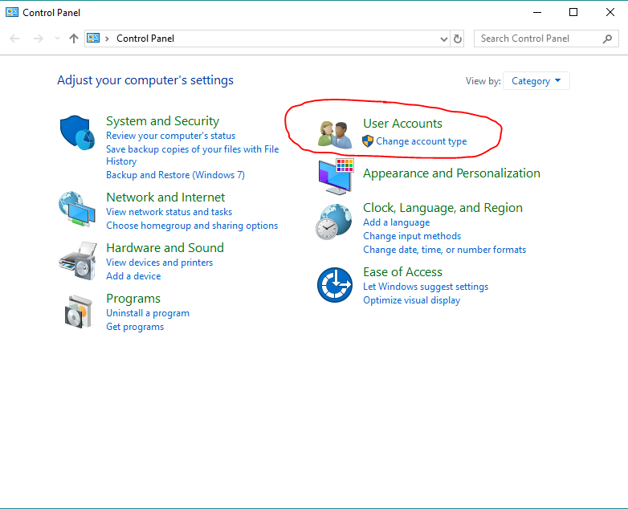

1. Select User Accounts again

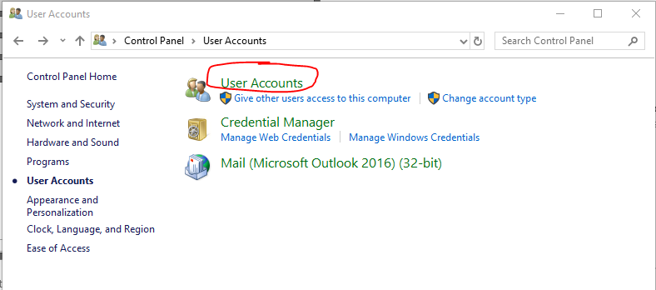

1. Select Change my environment variables on the left

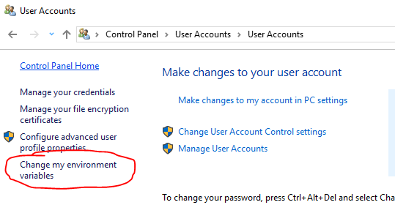

1. Select New under User Variables > Enter “R_LIBS” as Variable name > Enter folder path to the 3.6 Folder on your desktop as Variable value. After, it should be under the list of User Variables with “R_LIBS” as the Variable and Value starting with C:\Users.

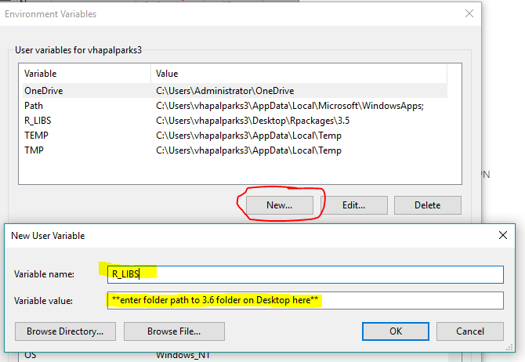

1. Launch RStudio > Type in “.libPaths()” in the R console. The first output should be the path to the desktop library you just created.

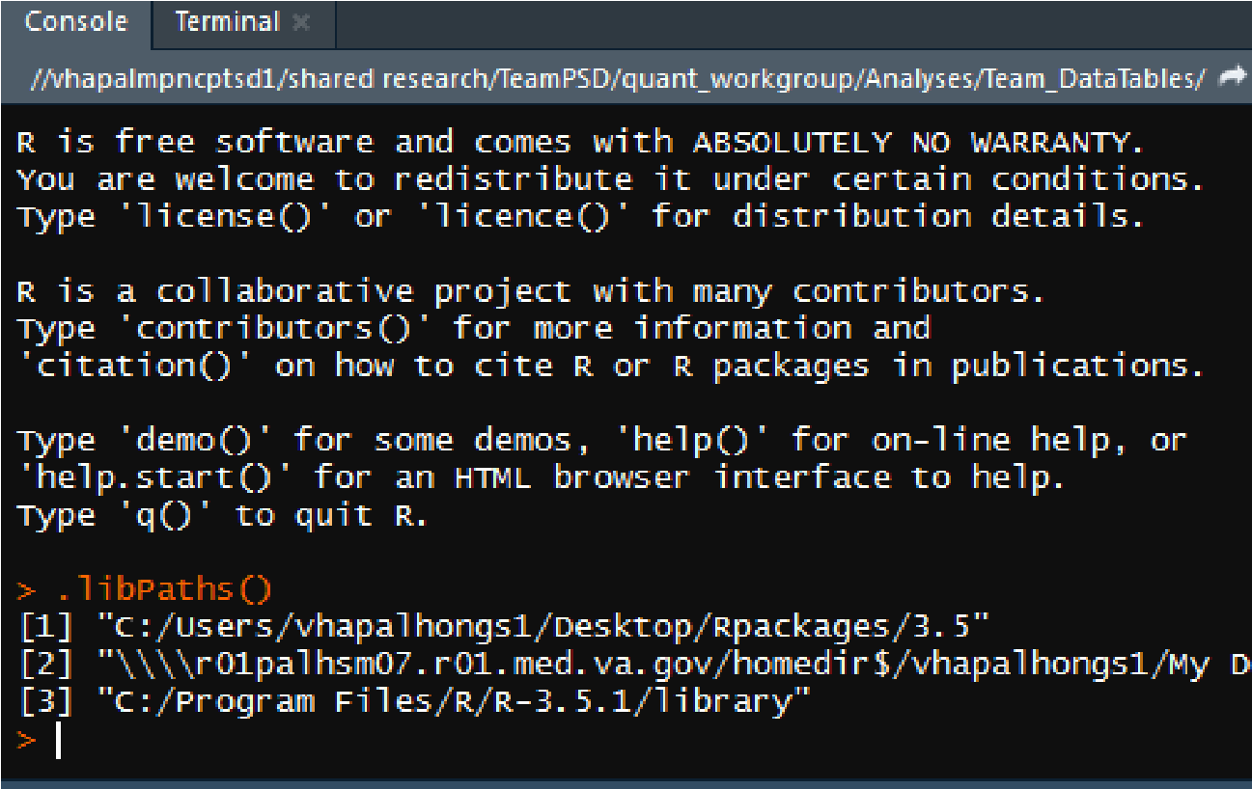

1. Test installing a package by typing in “install.packages(“tidyverse”) in the R console. The first line should indicate that it is installing the package to the desktop library you just created.

