ECE/CS6770 Project: Finite State Machine as an Arbiter Circuit

High-Level Description:
The goal of this project is to implement a digital arbiter based on standard digital design flow. A basic Verilog description for the digital arbiter will be provided. You can modify, improve, or change the Verilog file.

Deliverables:
- Design files (Verilog, verification, makefile, etc), all zipped in a single file.
- A short technical report that highlights the project outcomes in a systematic way, using tables, and adding snapshot of layout or simulation results whenever needed.

Project Description:
The purpose of the machine (digital arbiter) is to control access by various devices to a shared resource in each system. Only one device can use the resource at a time. Assume that all signals in the system can change values only following the positive edge of the clock signal. Each device provides one input to the FSM, called a request, and the FSM produces a separate output for each device, called a grant. A device indicates its need to use the resource by asserting its request signal. Whenever the shared resource is not already in use, the FSM considers all requests that are active. Based on a priority scheme, it selects one of the requesting devices and asserts its grant signal. When the device is finished its task and no more using the resource, it desserts its request signal.

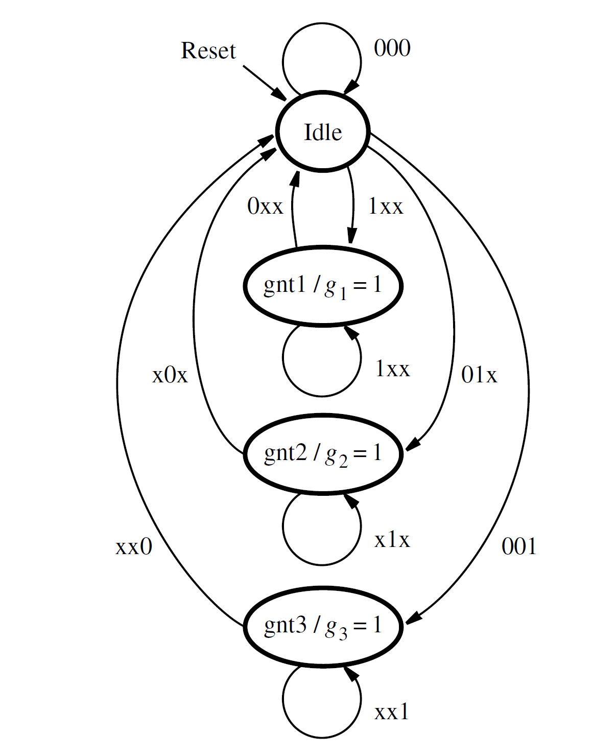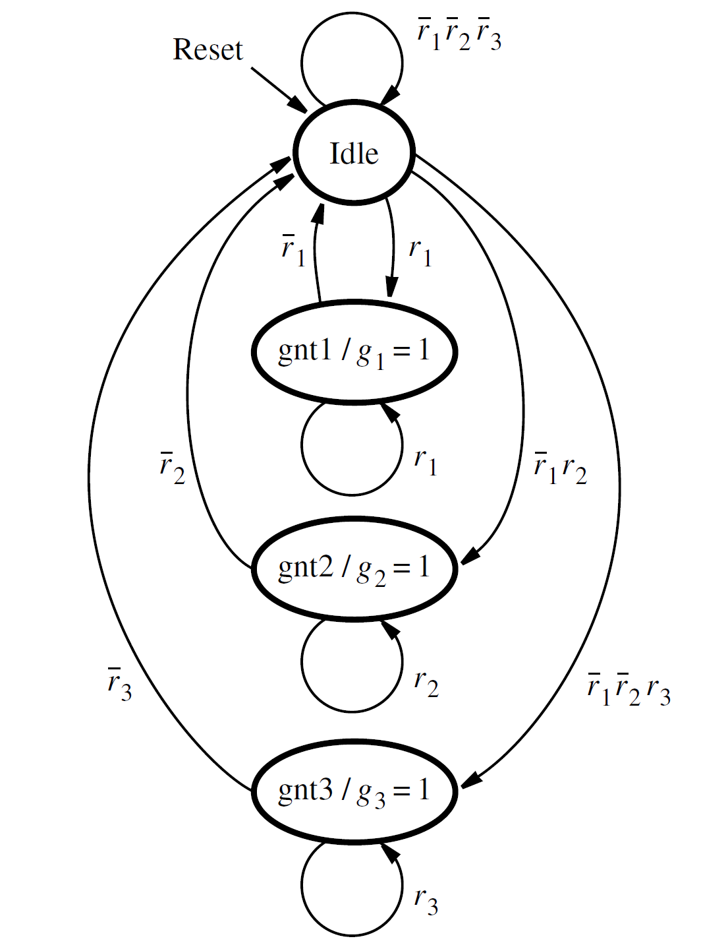
Figure 1: State Diagram for the arbiter
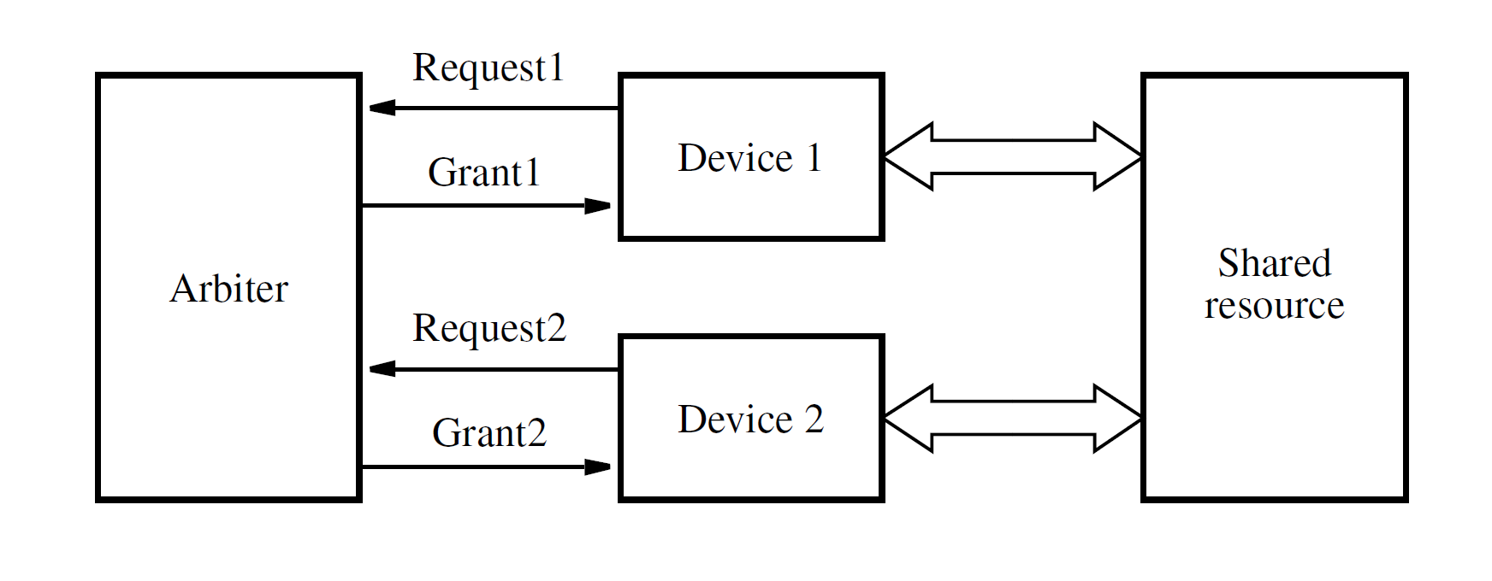
Figure 2: Arbitration Structure

We will assume that there are three devices in the system, called device 1, device 2, and device 3. It is easy to see how the FSM can be extended to handle more devices. The request signals are named r1, r2, and r3, and the grant signals are called g1, g2, and g3. The devices are assigned a priority level such that device 1 has the highest priority, device 2 has the next highest, and device 3 has the lowest priority. Thus if more than one request signal is asserted when the FSM assigns a grant, the grant is given to the requesting device that has the highest priority.

Initially, on reset the machine is in the state called Idle. No grant signals are asserted, and the shared resource is not in use. There are three other states, called gnt1, gnt2, and gnt3. Each of these states asserts the grant signal for one of the devices.

The FSM remains in the Idle state as long as all of the request signals are 0. In the state diagram the condition r1r2r3 = 000 is indicated by the arc labeled 000. When one or more request signals become 1, the machine moves to one of the grant states, according to the priority scheme. If r1 is asserted, then device 1 will receive the grant because it has the highest priority. This is indicated by the arc labeled 1xx that leads to state gnt1, which sets g1 = 1. The meaning of 1xx is that the request signal r1 is 1, and the values of signals r2 and r3 are irrelevant because of the priority scheme. As before, we use the symbol x to indicate that the value of the corresponding variable can be either 0 or 1. The machine stays in state gnt1 as long as r1 is 1. When r1 = 0, the arc labeled 0xx causes a change on the next positive clock edge back to state Idle, and g1 is de-asserted. If other requests are active at this time, then the FSM will change to a new grant state after the next clock edge.

The arc that causes a change to state gnt2 is labeled 01x. This label adheres to the priority scheme because it represents the condition that r2 = 1, but r1 = 0. Similarly, the condition for entering state gnt3 is given as 001, which indicates that the only request signal asserted is r3.

Write a Verilog Code for the Arbiter, complete the synthesis process, P&R. The operation of the circuit should be verified by proper simulation test bench.

Reference:
Stephen D. Brown and Zvonko G Vranesic, Fundamentals of Digital Logic with Verilog Design.

