BotPatrimonial: Aplicação de bot do Telegram para gerenciamento de patrimônios

Igor1, Hilton2, José L.1, Rita de C. L. Lopes3

1Instituto Metrópole Digital de Informática – Universidade Federal do Rio Grande do Norte (UFRN)  
CEP 59078 970, Avenida Senador Salgado Filho, 3000 - Candelária, Natal – RN

emaildeIgor@algo.com, [emaildeHilton@algo.com](mailto:emaildeHilton@algo.com), emaildeLucio@algo.com, rita_lino@outlook.com

**Abstract.** Escreva aqui.

**Resumo.** Escreva aqui.

# 1. General Information

All full papers and posters (short papers) submitted to some SBC conference, including any supporting documents, should be written in English or in Portuguese. The format paper should be A4 with single column, 3.5 cm for upper margin, 2.5 cm for bottom margin and 3.0 cm for lateral margins, without headers or footers. The main font must be Times, 12 point nominal size, with 6 points of space before each paragraph. Page numbers must be suppressed.

Full papers must respect the page limits defined by the conference. Conferences that publish just abstracts ask for **one**-page texts.

# 2. First Page

The first page must display the paper title, the name and address of the authors, the abstract in English and “resumo” in Portuguese (“resumos” are required only for papers written in Portuguese). The title must be centered over the whole page, in 16 point boldface font and with 12 points of space before itself. Author names must be centered in 12 point font, bold, all of them disposed in the same line, separated by commas and with 12 points of space after the title. Addresses must be centered in 12 point font, also with 12 points of space after the authors’ names. E-mail addresses should be written using font Courier New, 10 point nominal size, with 6 points of space before and 6 points of space after.

The abstract and “resumo” (if is the case) must be in 12 point Times font, indented 0.8cm on both sides. The word **Abstract** and **Resumo**, should be written in boldface and must precede the text.

# 3. CD-ROMs and Printed Proceedings

In some conferences, the papers are published on CD-ROM while only the abstract is published in the printed Proceedings. In this case, authors are invited to prepare two final versions of the paper. One, complete, to be published on the CD and the other, containing only the first page, with abstract and “resumo” (for papers in Portuguese).

# 4. Sections and Paragraphs

Section titles must be in boldface, 13pt, flush left. There should be an extra 12 pt of space before each title. Section numbering is optional. The first paragraph of each section should not be indented, while the first lines of subsequent paragraphs should be indented by 1.27 cm.

## 4.1. Subsections

The subsection titles must be in boldface, 12pt, flush left.

# 5. Figures and Captions

Figure and table captions should be centered if less than one line (Figure 1), otherwise justified and indented by 0.8cm on both margins, as shown in Figure 2. The caption font must be Helvetica, 10 point, boldface, with 6 points of space before and after each caption.

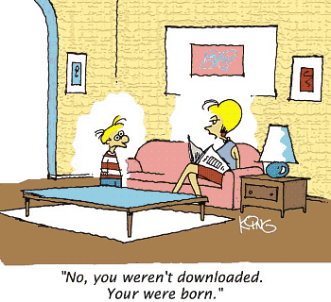

Figure 1. A typical figure

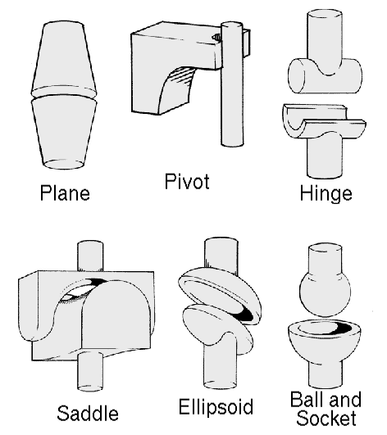

Figure 2. This figure is an example of a figure caption taking more than one line and justified considering margins mentioned in Section 5.

In tables, try to avoid the use of colored or shaded backgrounds, and avoid thick, doubled, or unnecessary framing lines. When reporting empirical data, do not use more decimal digits than warranted by their precision and reproducibility. Table caption must be placed before the table (see Table 1) and the font used must also be Helvetica, 10 point, boldface, with 6 points of space before and after each caption.

Table 1. Variables to be considered on the evaluation of interaction techniques

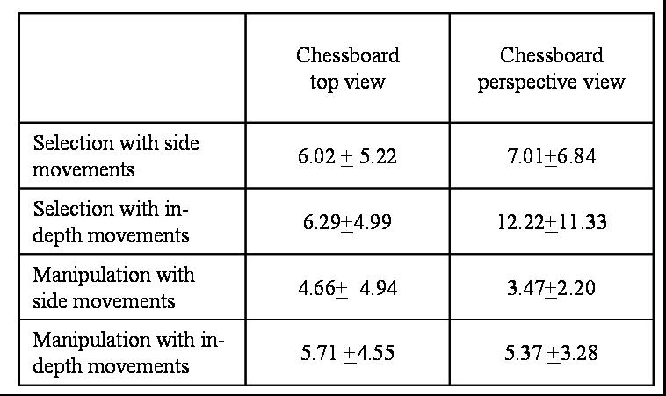

# 6. Images

All images and illustrations should be in black-and-white, or gray tones, excepting for the papers that will be electronically available (on CD-ROMs, internet, etc.). The image resolution on paper should be about 600 dpi for black-and-white images, and 150-300 dpi for grayscale images. Do not include images with excessive resolution, as they may take hours to print, without any visible difference in the result.

# 7. References

Bibliographic references must be unambiguous and uniform. We recommend giving the author names references in brackets, e.g. [Knuth 1984], [Boulic and Renault 1991]; or dates in parentheses, e.g. Knuth (1984), Smith and Jones (1999).

The references must be listed using 12 point font size, with 6 points of space before each reference. The first line of each reference should not be indented, while the subsequent should be indented by 0.5 cm.

# References

Boulic, R. and Renault, O. (1991) “3D Hierarchies for Animation”, In: New Trends in Animation and Visualization, Edited by Nadia Magnenat-Thalmann and Daniel Thalmann, John Wiley & Sons ltd., England.

Dyer, S., Martin, J. and Zulauf, J. (1995) “Motion Capture White Paper”, <http://reality.sgi.com/employees/jam_sb/mocap/MoCapWP_v2.0.html>, December.

Holton, M. and Alexander, S. (1995) “Soft Cellular Modeling: A Technique for the Simulation of Non-rigid Materials”, Computer Graphics: Developments in Virtual Environments, R. A. Earnshaw and J. A. Vince, England, Academic Press Ltd., p. 449-460.

Knuth, D. E. (1984), The TeXbook, Addison Wesley, 15th edition.

Smith, A. and Jones, B. (1999). On the complexity of computing. In *Advances in Computer Science*, pages 555–566. Publishing Press.