**Course 3 – T1**

* The predictions concerning how far a certain car can travel based on speed is As it is indicated below.

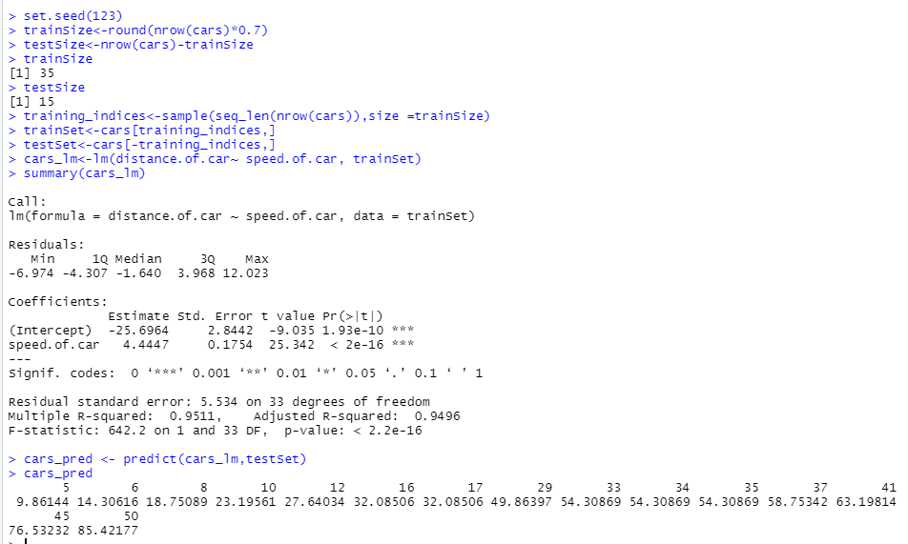

* The below data shows the predictions concerning the petal length through using the petal’s width.
* Table

  Description automatically generated
* The errors/warning messages that you encountered and how you overcame them. Table

  Description automatically generated
* Was it straightforward to install R and RStudio?
  + I had errors while installing the packages.
* Was the tutorial useful? Would you recommend it to others?
  + It will be better if it includes the guidelines clearly about how to install packages.
* What are the main lessons you've learned from this experience?
  + How to import dataset to R Studio
  + How to change data types of the columns
  + How to make predictions by using Linear Model
  + How to plot Graphs