

**Detailed Project Report**

On

**Development of Low-Cost Anemometer and**

**Wind vane sensor**

**By:**

Ritam Majumder [Dept. of Electronics and Communication Engineering, Techno International Newtown]

Hrishav Karmakar [Dept. of Electronics and Communication Engineering, Techno International Newtown]

**Mentors:**

Dr. Manabendra Maiti [Head of the Department, Dept. of Electronics and Communication Engineering, Techno International Newtown]

Dr. Subhankar Bhattacharjee [Associate Professor, Dept. of Electronics and Communication Engineering, Techno International Newtown]

**Assisted by:**

Abhirup Bhattacharyya [Associate Electronics Engineer, Department of Research and Development, Elecbits Technologies Private Limited]

**CONTENTS**

1. **Chapter 1:** Introduction
2. **Chapter 2:** Project Background
   1. Project Objectives
   2. Significance of the Project
3. **Chapter 3:** Technical Overview
4. **Chapter 4:** Expenses Overview

**Chapter 1 : INTRODUCTION**

Wind speed and direction are vital parameters for numerous applications. Anemometers measure wind speed while wind vanes determine wind direction. Traditional methods involve mechanical sensors prone to wear and inaccuracies. The proposed project seeks to develop advanced sensors using modern electronic and material science technologies to overcome these limitations.

The need for accurate and reliable environmental monitoring has become increasingly crucial in various fields, ranging from meteorology and renewable energy to building automation and industrial applications. Wind speed and direction are fundamental parameters in understanding and predicting weather patterns, optimizing renewable energy systems, and ensuring the safety and efficiency of various processes.

This project focuses on the development and implementation of advanced anemometer and wind vane sensors, designed to provide precise and real-time data on wind conditions. The integration of these sensors into a comprehensive environmental monitoring system aims to enhance our ability to gather, analyze, and utilize critical information related to atmospheric dynamics.

**Chapter 2 : PROJECT BACKGROUND**

The project aims to design, develop, and deploy anemometer and wind vane sensors for accurate measurement of wind speed and direction. These sensors are crucial for various applications including weather monitoring, renewable energy systems, agriculture, aviation, and environmental research. The project will focus on creating reliable, durable, and cost-effective sensors that can be deployed in diverse environmental conditions.

**2.1 Project Objectives**

The primary objective of this project is to design, develop, and implement a state-of-the-art anemometer and wind vane sensor system capable of delivering accurate and reliable measurements of wind speed and direction. The project seeks to address the following specific goals:

1. **Accuracy and Precision:** Develop sensors with a high degree of accuracy and precision to ensure reliable data for meteorological and industrial applications.
2. **Integration:** Integrate the anemometer and wind vane sensors seamlessly into existing environmental monitoring networks, enabling efficient data collection and analysis.
3. **Compatibility:** Ensure compatibility with modern communication protocols and connectivity options, allowing for easy integration with IoT platforms and other data management systems.
4. **Environmental Resilience:** Design sensors that can withstand a range of environmental conditions, including extreme temperatures, humidity, and exposure to various elements.
5. **User-Friendly:** Create a user-friendly interface for configuring, monitoring, and extracting data from the sensors, facilitating ease of use for both professionals and researchers.
   1. **Significance of the Project**

The successful implementation of this project holds several significant implications:

1. **Improved Weather Forecasting:** Accurate wind data contributes to better weather forecasting models, aiding meteorologists in predicting and managing severe weather events.
2. **Enhanced Renewable Energy Optimization:** The data provided by the sensors can be utilized to optimize the performance of wind turbines and other renewable energy systems, increasing overall efficiency.
3. **Safety and Environmental Monitoring:** The sensors can be employed in industrial settings to enhance safety measures and monitor environmental conditions, ensuring compliance with regulatory standards.
4. **Research and Development:** Researchers can utilize the collected data for a wide range of studies, contributing to a deeper understanding of atmospheric conditions and their impact on various ecosystems.

**Chapter 3: TECHNICAL OVERVIEW**

The technical aspects of this project include: Design specifications, Architecture, Hardware Implementation.

**3.1 Design Specifications**

* The anemometer consists of a freely rotating three-cup based structure with another cylindrical PVC structure for the base.
* The wind vane sensor consists of a freely rotating arrow-based structure made using an aluminium sheet pipe and PVC along with another cylindrical PVC structure as the base.
* The anemometer uses a magnetic Hall sensor that uses the principle of electromagnetic induction to detect the magnetic field from a permanent neodymium magnet equipped at the circumference of the cup structure. It can measure wind speeds accurately as the sensor output is interfaced at 12-bits with a very low response time.
* The wind vane sensor also uses magnetic Hall sensors in eight major directions to determine the wind direction. Also, a variable resistor is also used to accurately determine the exact angle of wind. The Hall sensors are interfaced at 12-bits whereas the variable resistor is interfaced at 16-bits using an external ADC (Analog to Digital Converter).
* Moderate size, easy to setup and can be easily integrated with other sensors and microcontrollers.

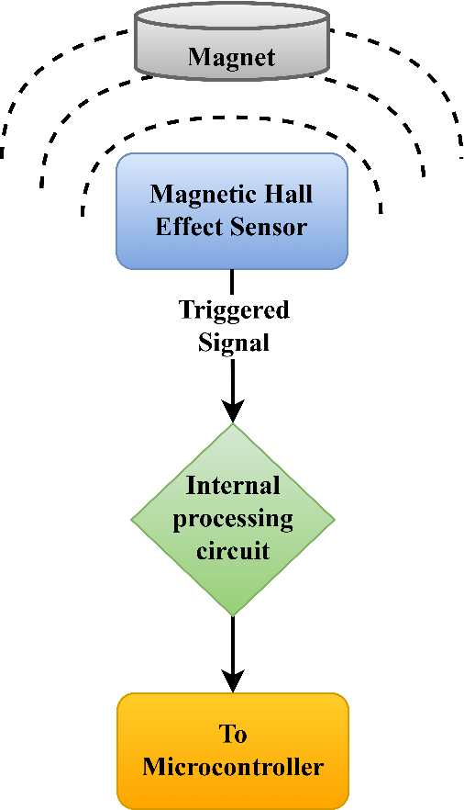**3.2 Architecture**

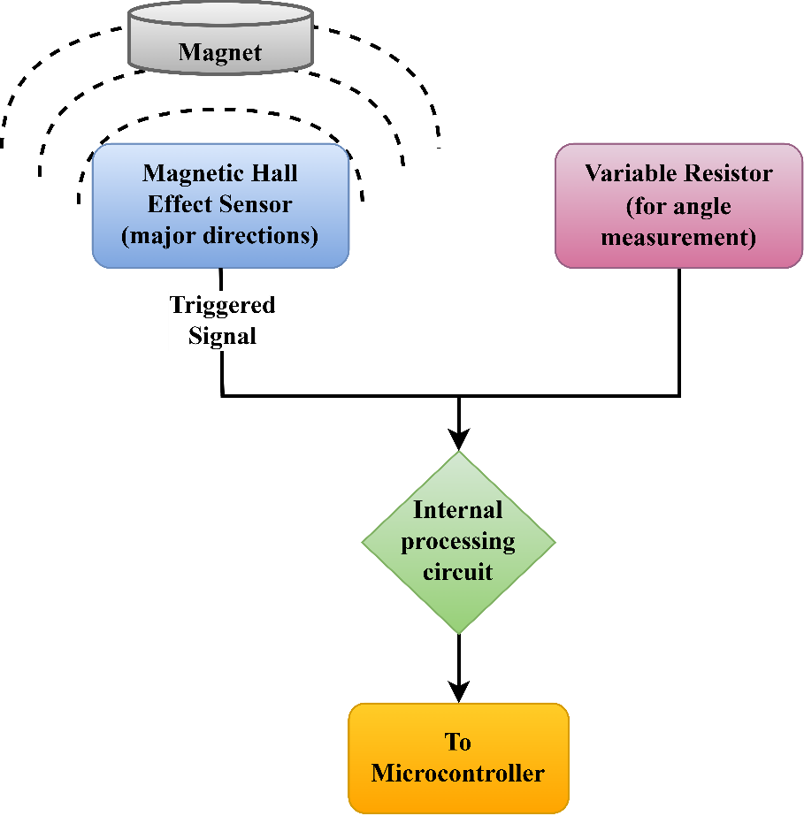

**Fig.** Basic working architecture of Wind Vane

**Fig.** Basic working architecture of Anemometer

**3.3 Hardware Implementation**

The structure of the anemometer is made using good quality PVC with the top cup-based structure 3D printed using PTEG filament to make it durable and weatherproof. Few 3mm neodymium magnets are fitted in one compartment under the cup-based structure. For free rotation of the structure, two 10mm metal ball bearings are fitted with a nut that work as the shaft of the structure.

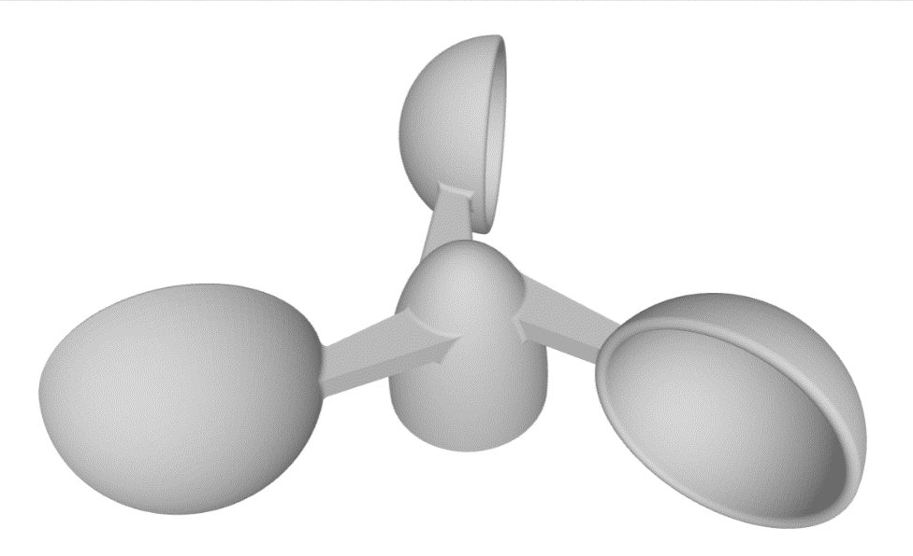The base of the sensor consists of a cylindrical PVC part that has the magnetic Hall sensor along with its interfacing circuit that generates a low signal when triggered. The total structure is completely sealed to make it waterproof and prevent short circuit in the internal circuitry. Only three wires are kept out from the structure to interface it with microcontrollers.

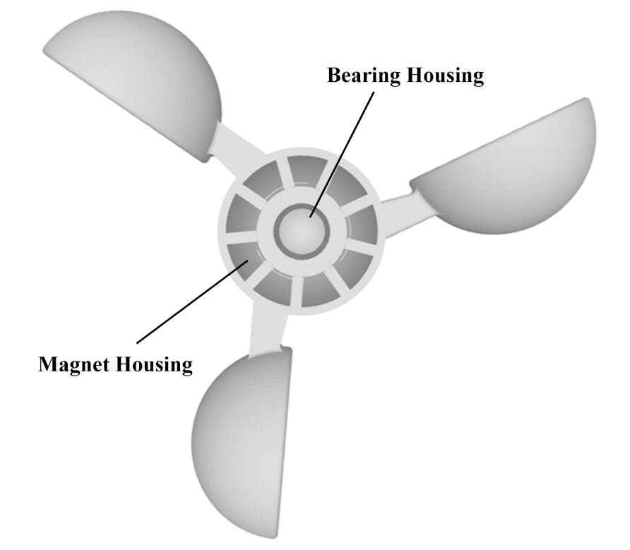

**Fig.** Anemometer rotating part design

The structure of the wind vane is made using PVC and a lightweight aluminium sheet pipe. The top arrow structure is made using the lightweight aluminium pipe as the body and a cone-shaped structure made using epoxy glue as the tip of the arrow. The tail is made using a PVC sheet to make it lightweight so that the arrow can move along the direction of the wind.

A 23mm diameter PVC pipe is used for the shaft of the sensor above which the arrow structure is fitted. A 5mm neodymium magnet is fitted at the bottom part of the shaft along the direction of the arrow tip. The shaft is connected to a 52mm metal ball bearing for free rotation of the arrow structure.

The base of the sensor consists of a cylindrical PVC part that has the magnetic Hall sensors along the eight major directions, with an interfacing circuit that generates a low signal depending on which sensor is triggered. The variable resistor is equipped underneath the circuit. The total structure is completely sealed to make it waterproof and prevent short circuit in the internal circuitry. A few wires are kept out from the structure to interface it with microcontrollers.

For the internal circuitry of the sensors, an interfacing circuit is used that processes the signals generated when hall effect sensors are triggered to remove any noise in the circuit and to ensure that it can be interfaced easily with a microcontroller with low complexity.

The interfacing circuit for both the sensors are currently under development, implementing different solutions to meet the desired requirements with less interfacing complexity and at a budget-friendly method.

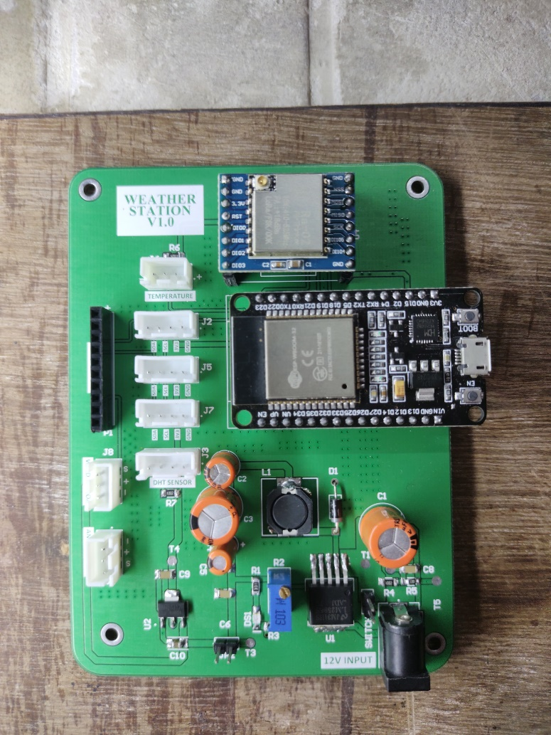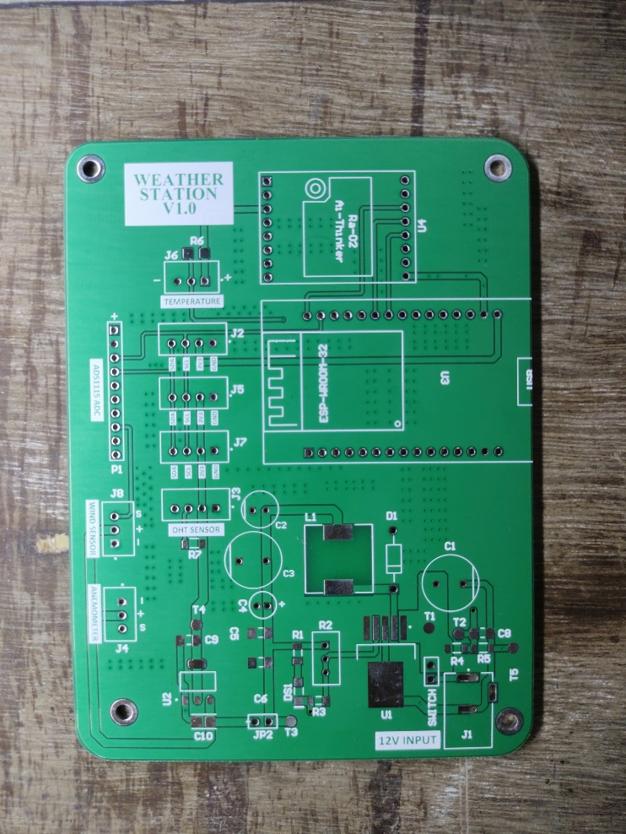**Chapter 4: EXPENSES OVERVIEW**

**Fig.** Sensor interfacing PCB





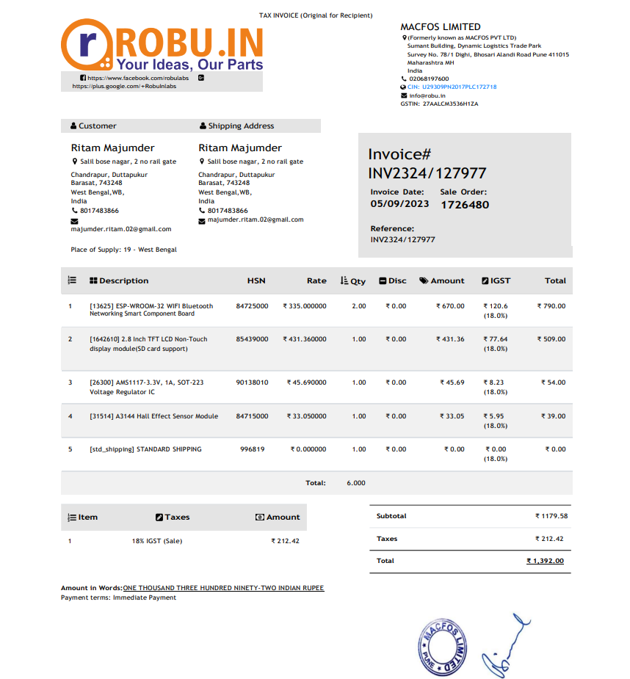



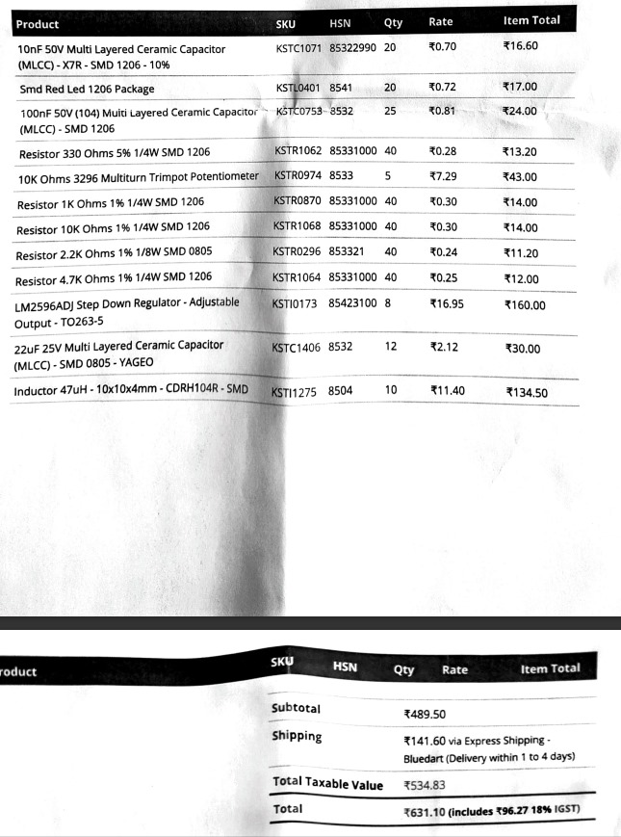

**TOTAL : 7965/-**