PoshanSarthi
पोषण सारथि — Your AI Nutrition Charioteer
An AI Diet-Planning, Tracking & Food-Awareness Agent for the Indian Subcontinent
Product & High-Level Design Document
Version 1.0
August 2026
Prepared by: Product Management — Health & Nutrition AI

Document Control
Field | Detail
Document Title | PoshanSarthi — AI Nutrition Agent: Product & HLD Document
Version | 1.0
Status | Draft for Review
Owner | Product Management, Health & Nutrition AI
Scope | India / Indian subcontinent cuisines, languages and dietary patterns
Audience | Engineering, Design, Data Science, Clinical Advisory, Leadership

Table of Contents
1. Executive Summary
2. Problem Statement & Market Context
3. Product Vision & Design Principles
4. Target Users & Personas
5. Use Case Overview
6. Feature Deep Dive
7. High-Level System Architecture (HLD)
8. Data Flow
9. Sequence Diagrams
10. High-Level Data Model
11. Agent Design Detail
12. Non-Functional Requirements
13. Technology Stack Recommendation
14. Success Metrics
15. Risks & Mitigations
16. MVP Scope & Roadmap
17. Appendix — Mermaid Source for the HLD Architecture Diagram

1. Executive Summary
PoshanSarthi is an AI nutrition agent purpose-built for how people on the Indian subcontinent actually eat: thalis instead of plates of “150g protein, 200g carbs”; roti and katori counts instead of grams; festival fasts, tiffin services, hostel messes, and a home kitchen that cooks for the whole family rather than one dieter. It combines three tightly integrated capabilities — (1) goal-based, cuisine-aware diet planning, (2) low-friction multi-modal tracking with adaptive replanning, and (3) practical, conversational food awareness — into a single agentic system that reasons about the user's goal, their real-world eating behaviour, and India-specific food knowledge.
Unlike Western-first calorie counters retrofitted with an Indian food list, PoshanSarthi is designed India-in, India-out: the food database, portion vocabulary, festival calendar, and nudges are native to the subcontinent from day one, while remaining architecturally generic enough to extend to other cuisines later.
This document lays out the product vision, target users, detailed feature design for all three pillars, and the high-level system architecture — including use case, architecture, data flow, entity, and sequence diagrams — needed to take this from concept to a buildable engineering plan.

2. Problem Statement & Market Context
India carries a well-documented double burden of malnutrition: rising overweight/obesity and diet-related lifestyle disease in urban populations, alongside continuing under-nutrition and micronutrient gaps elsewhere — often within the same household. At the same time, food culture is hyper-local: what counts as a “healthy plate” in Punjab, Kerala, Bengal, and Gujarat looks nothing alike, and everyday questions (“Is curd at night bad?”, “Can I eat rice for weight loss?”, “Is this paneer real?”) rarely have a single Google-able answer people trust.
The existing nutrition-app landscape in India (HealthifyMe, MyFitnessPal, Fittr, and a wave of newer AI-photo-logging entrants) has converged on a similar pattern: a large Indian food database, an AI chat layer for questions, and photo-based meal logging — usually gated behind a premium tier, with human coaching as the top paid layer. Common gaps reported by users across this category include: shallow personalization beyond calorie math, generic meal plans that ignore regional/cuisine preference, weak handling of deviations (either silence or blunt warnings with no re-planning), and food-database coverage that thins out for home-style regional and street food compared to packaged/branded items.

2.1 Where PoshanSarthi differentiates
- Deadline-aware adaptive planning — most trackers log a deviation; few ask “do you want to stay on the original deadline (aggressive correction) or extend it (sustainable correction)?” and then actually rewrite the plan.
- India-native portions and language — katori/roti/spoon-based portions, 11+ Indian languages, and a WhatsApp-first logging surface for users who won't install another app.
- Household-aware, not just individual-aware — one kitchen often cooks for a diabetic parent, a weight-gain teenager, and a weight-loss adult together — the plan should acknowledge that.
- Awareness as a first-class pillar, not a blog — the same reasoning pipeline that plans and tracks also answers “is this okay?” questions and proactively flags red-flag items (colas, analog paneer, ultra-processed snacks) in the moment.

3. Product Vision & Design Principles
“A nutrition companion that understands the Indian plate as well as it understands your goal — and changes course with you, not at you.”

3.1 Design principles
- Culturally native by default — regional cuisine, festival calendars, and vernacular language are core inputs, not a localization layer bolted on later.
- Sustainable over aggressive, by default — the agent always shows the sustainable path first and makes the aggressive path an explicit, informed opt-in.
- Multi-modal, low-friction logging — photo, voice, text, barcode and WhatsApp — logging a meal should take under 10 seconds.
- Transparent reasoning — every plan and every warning comes with a short “why” the user can expand, never a black-box number.
- Human safety net — the agent recognizes the edge of its competence (medical conditions, disordered eating signals, rapid unintended weight change) and escalates to a certified dietitian rather than guessing.
- Privacy-first — health data is sensitive by definition; consent, minimization, and encryption are non-negotiable, aligned to India's DPDP Act, 2023.

4. Target Users & Personas
PoshanSarthi is designed around five recurring patterns of Indian users rather than a single “fitness enthusiast” archetype:
Persona | Profile | Primary need
Rohit, 29 — “The Canteen Professional” | IT professional, Bengaluru. Eats office canteen + Swiggy/Zomato most days. Wants to lose 8 kg. | Fast logging on the go, restaurant/canteen-aware suggestions, deviation coaching without guilt.
Meera, 45 — “The Household Planner” | Homemaker, Lucknow. Cooks for a diabetic husband, a growing teenager, and herself. | One meal plan that serves three different targets from a shared kitchen.
Arjun, 22 — “The Hostel Builder” | College student, Chennai. Eats mess food, wants to gain muscle on a tight budget. | Realistic plans using mess-menu items, high-protein Indian veg options, cheap swaps.
Kavita, 34 — “The New Mother” | Pune. Postpartum, breastfeeding, wants gradual, safe weight normalization. | Conservative, medically-aware pacing; easy escalation to a dietitian.
Suresh, 58 — “The Voice-First Elder” | Retired, Kochi. Hypertension and type-2 diabetes, low smartphone literacy. | Voice logging in Malayalam, large-text UI, family member can co-manage the plan.

5. Use Case Overview
The diagram below captures the primary actors — the end user, an optional family/household member, a certified dietitian, the internal nutrition content/ops team, and connected wearables — and how they interact with the system's core capabilities.
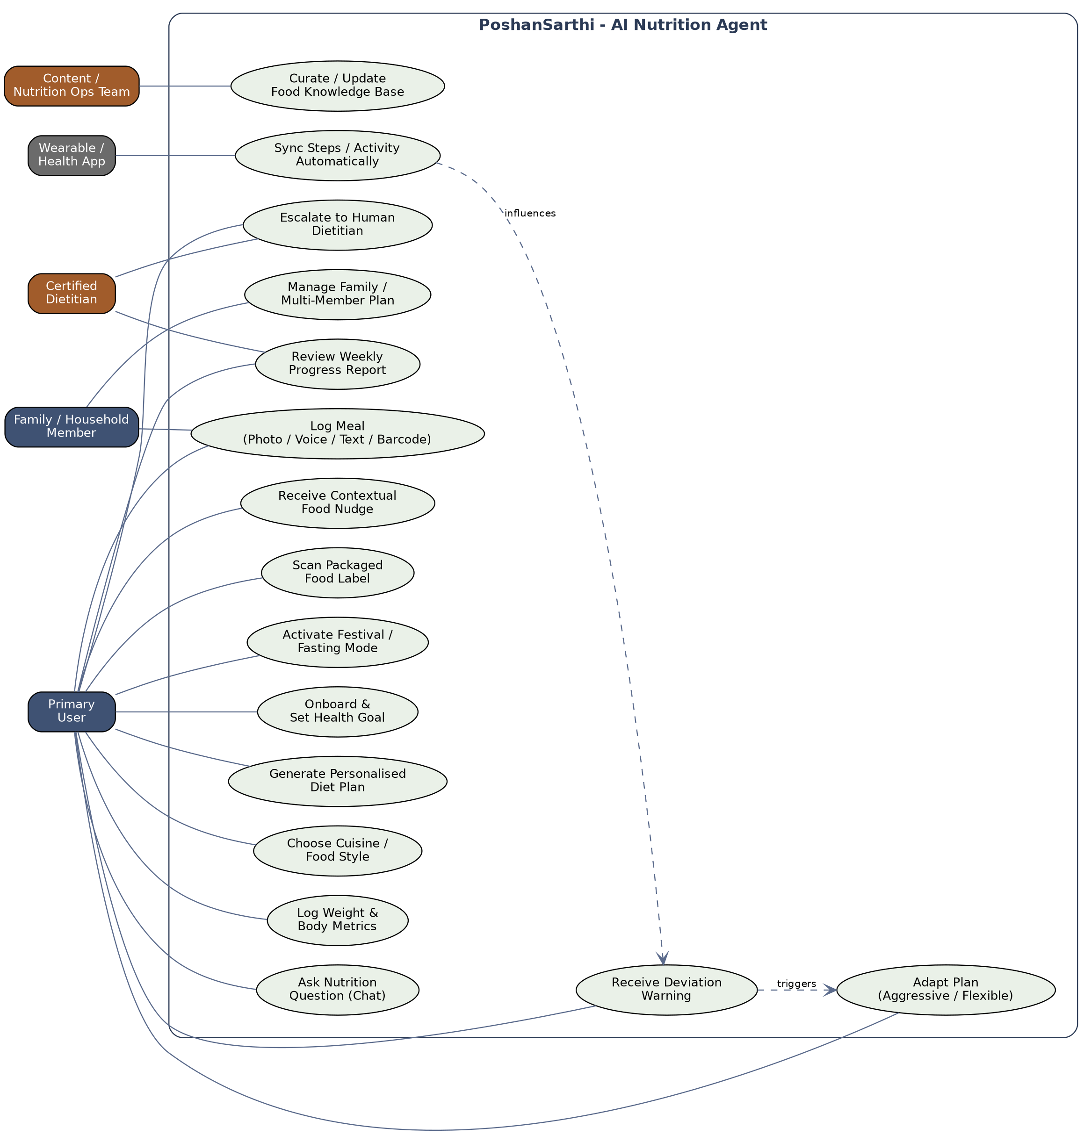
Figure 1. Use case diagram — PoshanSarthi actors and capabilities

5.1 Key use cases
Use case | Actor(s) | Description
Onboard & set health goal | User | Capture age, gender, height/weight (BMI), activity level, target (lose/gain/maintain), medical flags, and deadline preference.
Generate personalised diet plan | User | Agent produces a day-wise, milestone-based plan matched to the user's cuisine style and calculated targets.
Log meal (photo/voice/text/barcode) | User, Family member | Capture what was eaten with minimum friction, including outside-plan meals.
Receive deviation warning & adapt plan | User | System compares actual vs. planned intake and, on meaningful deviation, offers a corrective path.
Ask nutrition question / receive nudge | User | Conversational Q&A and proactive, context-triggered food awareness.
Activate festival / fasting mode | User | Plan temporarily adapts to Navratri, Ramzan, Karva Chauth and similar observances.
Manage family / multi-member plan | Family member | One household account coordinates multiple individual targets from a shared kitchen.
Escalate to human dietitian | User, Dietitian | Hand-off for medical complexity or when the user requests human support.
Curate / update food knowledge base | Nutrition Ops team | Maintain the Indian Food Composition data, regional recipes and safety flags that ground the agent.

6. Feature Deep Dive

6.1 Pillar 1 — Personalised Diet Planning
Goal: turn a short onboarding conversation into a diet plan the user actually recognizes as “their kind of food”, with a realistic path to their target.

6.1.1 Onboarding inputs
Input | Why it matters
Age, gender, height, weight | Base BMR (Mifflin-St Jeor) and BMI classification.
Activity level | Converts BMR to TDEE (sedentary → very active multiplier).
Goal (lose / gain / maintain / recomposition) | Determines calorie deficit or surplus direction.
Target weight & desired timeline | Used to compute a safe weekly rate of change and check it against medical safety bounds.
Deadline mode (strict vs. flexible) | Sets how aggressively the plan — and later, replanning — will correct for deviations.
Cuisine / food style | Vegetarian, non-vegetarian, eggetarian, vegan, Jain, regional (North/South/East/West/Northeast), satvik, etc.
Medical flags | Diabetes, hypertension, PCOS, pregnancy/lactation, allergies — trigger conservative limits and, where relevant, an early nudge toward human dietitian review.
Budget & cooking context | Home-cooked, tiffin/mess, hostel, mostly-eating-out — shapes what is actually achievable.

6.1.2 Target calculation methodology
- BMR via the Mifflin-St Jeor equation; TDEE = BMR × activity multiplier.
- Calorie target = TDEE ± deficit/surplus, capped to a safe range (never below ~1200–1500 kcal/day for women / ~1500–1800 kcal/day for men without clinical supervision).
- Safe rate of change defaulted to ~0.3–0.75% of body weight per week; “strict deadline” mode can push toward the upper bound with an explicit risk disclosure, never beyond it.
- Macro split adapted to Indian staples (rice/roti-heavy carbohydrate base, pulses/dairy/eggs/meat for protein, ghee/oil for fats) rather than a Western macro template.

6.1.3 Plan composition
- Day-wise, portion-real output — meals expressed in rotis, katoris, spoons and common regional units, not just grams — with a grams equivalent shown for those who want it.
- Milestone roadmap — the overall goal is broken into 2–4 week checkpoints (e.g. “-2 kg by 15 Sept”) so progress feels achievable rather than a single distant number.
- Regional swap engine — any meal can be swapped for a regionally and nutritionally equivalent alternative (e.g. idli-sambar ↔ poha ↔ besan chilla) while holding calorie/macro targets roughly constant.
- Shopping & prep list — auto-generated weekly list grouped the way Indian kitchens shop — sabzi, dal, atta/rice, dairy, spices.
- Festival & fasting mode — on request or calendar detection, the plan adapts to Navratri/vrat, Ramzan roza, or Karva Chauth patterns — adjusting meal timing and substituting fasting-appropriate foods (sabudana, singhara atta, fruits) while trying to hold nutrition as close to target as the fast allows.
- Family / household mode — a single household profile can host multiple linked individual goals; the meal plan for shared dishes is generated once, with per-person portion and substitution notes (e.g. “less oil, no added sugar” for the diabetic member; “extra roti” for the teen).

6.2 Pillar 2 — Tracking, Monitoring & Adaptive Replanning
Goal: make logging effortless enough that people actually keep doing it, and turn every deviation into a decision the user makes — not a guilt notification.

6.2.1 Multi-modal logging
- Photo (“Snap”) — food-image recognition tuned to Indian dishes, thalis and mixed plates, with portion estimated from visual cues and confirmed by the user.
- Voice — log in any supported Indian language (“maine do roti aur dal khaya”) — important for lower-literacy and elderly users.
- Text / quick-tap — recent and favourite items surfaced for one-tap logging.
- Barcode / label scan — packaged foods matched against a packaged-goods + FSSAI label database for sugar, oil, and additive content.
- WhatsApp — for users who won't install a separate app, the entire logging flow (photo, voice note, text) works inside a WhatsApp Business chat.

6.2.2 Body metric tracking
- Weight, and optionally waist circumference, logged on the user's own cadence (not forced daily).
- Trend-smoothing (rolling average) is used for plan decisions so a single high-sodium-meal water-weight spike doesn't trigger a false alarm.

6.2.3 Deviation detection & adaptive replanning
Every logged meal is compared against that day's planned intake. Deviations are bucketed by severity (minor / moderate / significant) using both the calorie gap and how it fits the week's running total — a single indulgent lunch is treated differently from a pattern repeated three days running.
- Strict deadline mode — the agent recalculates a tighter but still safe target for the remaining days of the week to preserve the original deadline, and is explicit that this is a firmer path.
- Flexible / sustainable mode — the agent instead redistributes the deficit across a longer runway, extending the milestone date rather than compressing daily targets, and explains the trade-off in plain language.
- The user always makes the final call between the two paths when a significant deviation occurs — the agent recommends, it does not silently overwrite the plan.
- A weekly review consolidates adherence, trend-smoothed weight change, and milestone status into a short, readable report, with the next week's plan pre-adjusted based on the pattern observed.

6.2.4 Escalation triggers
The Tracking & Adaptation Agent is deliberately conservative about what it will handle itself. It routes to a certified human dietitian when it detects: weight change far faster than the safe-rate bound; repeated skipped-meal patterns or other signals that may indicate disordered eating; user-reported symptoms alongside a medical flag (e.g. dizziness in a diabetic user); or an explicit user request for human support.

6.3 Pillar 3 — Practical Food Awareness
Goal: give people the same food-literacy a knowledgeable dietitian friend would, delivered in the moment it's useful — while logging, while chatting, or while standing in front of a menu.

6.3.1 Conversational Q&A
A grounded chat surface answers everyday questions (“Is curd at night bad?”, “Is jaggery better than sugar?”, “Can I have rice for dinner and still lose weight?”) using the Indian Food Knowledge Base plus the user's own profile, so the same question gets a personalised answer for a diabetic user versus a healthy-weight teenager.

6.3.2 Contextual, proactive nudges
The same reasoning pipeline fires unprompted when it's contextually useful — for example, when a user logs a cold drink, orders “analog paneer” in a scanned label, or during a seasonal spike in a particular street-food category:
Trigger | Example nudge
Aerated cold drink logged | Flags added-sugar load in plain terms and suggests nimbu paani, chaas, or coconut water as a swap, without being preachy about it.
Analog paneer / vanaspati-based item scanned | Explains the difference from dairy paneer, notes typical trans-fat/oil content, and suggests checking the label for “analogue” or “vanaspati” wording.
Frequent street fast food (e.g. fried chaat, bhatura) logged | Not a blanket “avoid” — offers a lower-oil preparation tip or a lighter pairing for the rest of the day.
Seasonal produce coming into market (mangoes, guavas, sarson ka saag) | Positive nudge: seasonal, local, nutrient-dense options with a simple serving idea.
Festival sweets season | Portion-smart guidance (“one piece of mithai, not a blanket ban”) aligned with the festival mode plan.

6.3.3 Food literacy library
- Red / Yellow / Green classification — adapted to Indian categories — ultra-processed snacks and sugary drinks (red), fried street food and refined-flour items in moderation (yellow), whole grains/pulses/seasonal produce/millets (green) — rather than a generic Western “clean eating” list.
- Label literacy — plain-language explanation of FSSAI nutrition labels, front-of-pack warning signals, and common misleading claims (“no added sugar” on items with naturally high sugar, etc.).
- Myth-busting — short, sourced explainers on recurring myths — ghee and weight gain, fruit at night, curd at night, rice vs. roti for diabetics — written to correct without shaming traditional practice.
- Seasonal & regional calendar — a rolling calendar of what's in season where, nudging toward fresher, cheaper, more nutrient-dense local produce.

6.4 Cross-cutting Capabilities
- Gamification & habit design — logging streaks, milestone badges, and optional family/friend challenges — designed to reinforce consistency, not to punish a missed day.
- Regional language & voice-first design — Hindi, English and 10+ regional languages for both text and voice, with a UI that degrades gracefully to large-text/voice-first for low-literacy or elderly users.
- Privacy & data controls — explicit consent for each data category, data minimization, encryption at rest and in transit, and full alignment with India's Digital Personal Data Protection (DPDP) Act, 2023, including a clear data-deletion path.
- Low-bandwidth / offline tolerance — core logging and plan viewing work on a cached, low-data footprint for tier-2/3 city and rural connectivity; sync resumes when connectivity returns.

7. High-Level System Architecture (HLD)
PoshanSarthi is built as an agentic system: a single Orchestrator Agent interprets user intent and routes to one of three specialised agents — Diet Planning, Tracking & Adaptation, and Food Awareness — each of which calls foundation AI services (a reasoning LLM, a food-image recognition model, and Indic speech services) and a set of core platform services backed by the Indian Food Knowledge Base and the user's own data.
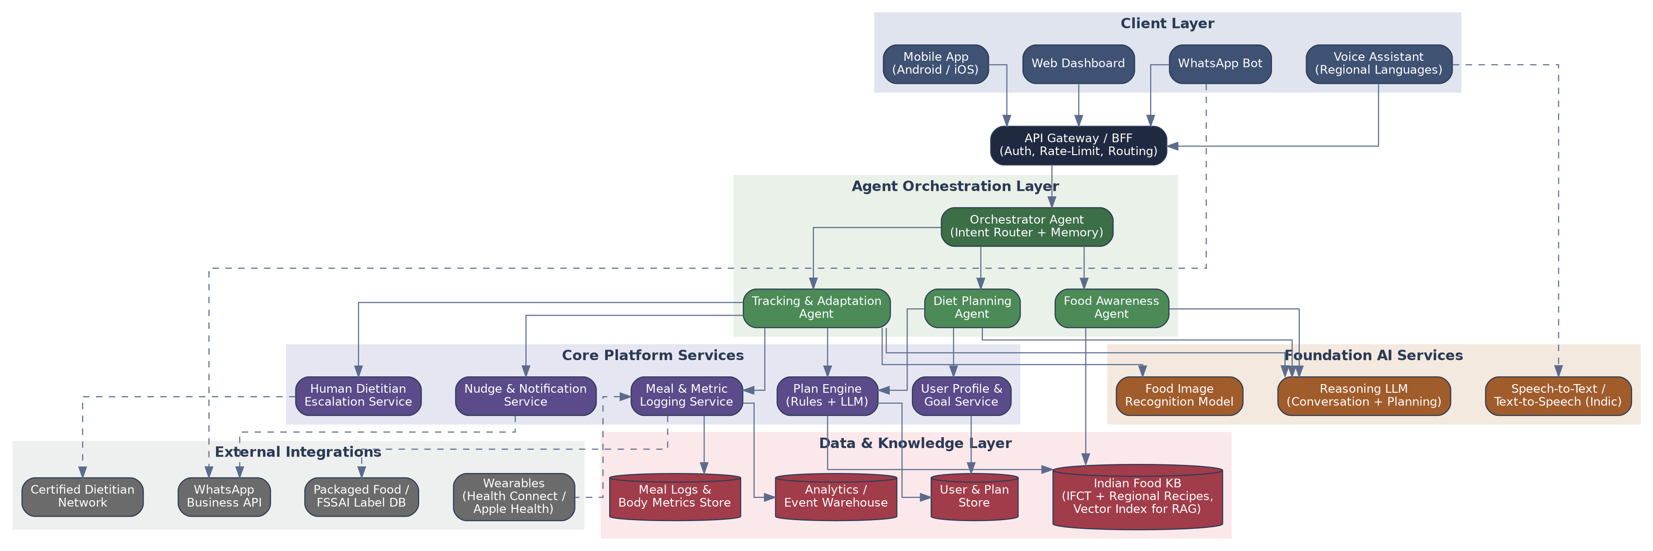
Figure 2. High-level architecture — client, agent orchestration, foundation AI, platform services, data, and external integration layers

7.1 Why an agentic, multi-agent pattern
- Each of the three product pillars has distinct reasoning needs (numerical planning vs. behavioural coaching vs. open-ended Q&A) — specialised agents with focused prompts and tools out-perform and are easier to evaluate than one monolithic prompt.
- The Orchestrator keeps short-term conversational memory and user context, so a message can move fluidly between “log this meal” and “is this okay for me?” without the user repeating themselves.
- New capabilities (e.g. a future Fitness/Activity Agent) can be added as another routed agent without disturbing the existing three.

7.2 Layer-by-layer description
Layer | Responsibility
Client layer | Mobile app, WhatsApp bot, voice assistant, and a lightweight web dashboard — all thin clients over the same API.
API Gateway / BFF | AuthN/Z, rate limiting, request shaping per client, and routing into the agent layer.
Agent orchestration layer | Orchestrator Agent (intent routing + session memory) plus the Diet Planning, Tracking & Adaptation, and Food Awareness agents, each with a scoped toolset.
Foundation AI services | Reasoning LLM for planning/conversation, a food-image recognition model for Snap logging, and Indic speech-to-text/text-to-speech for voice.
Core platform services | Profile & Goal Service, Plan Engine (deterministic calculators + LLM composition), Meal & Metric Logging Service, Nudge & Notification Service, and the Human Dietitian Escalation Service.
Data & knowledge layer | Indian Food Knowledge Base (structured IFCT-style nutrition data plus a vector index for retrieval-augmented generation), User & Plan store, Meal Log & Body Metric store, and an analytics/event warehouse.
External integrations | Wearables/health platforms (steps, heart rate), WhatsApp Business API, packaged-food/FSSAI label databases, and the certified dietitian network.

8. Data Flow
The data flow diagram traces how the five main input sources are transformed by six processing functions into the four outputs the user actually sees.
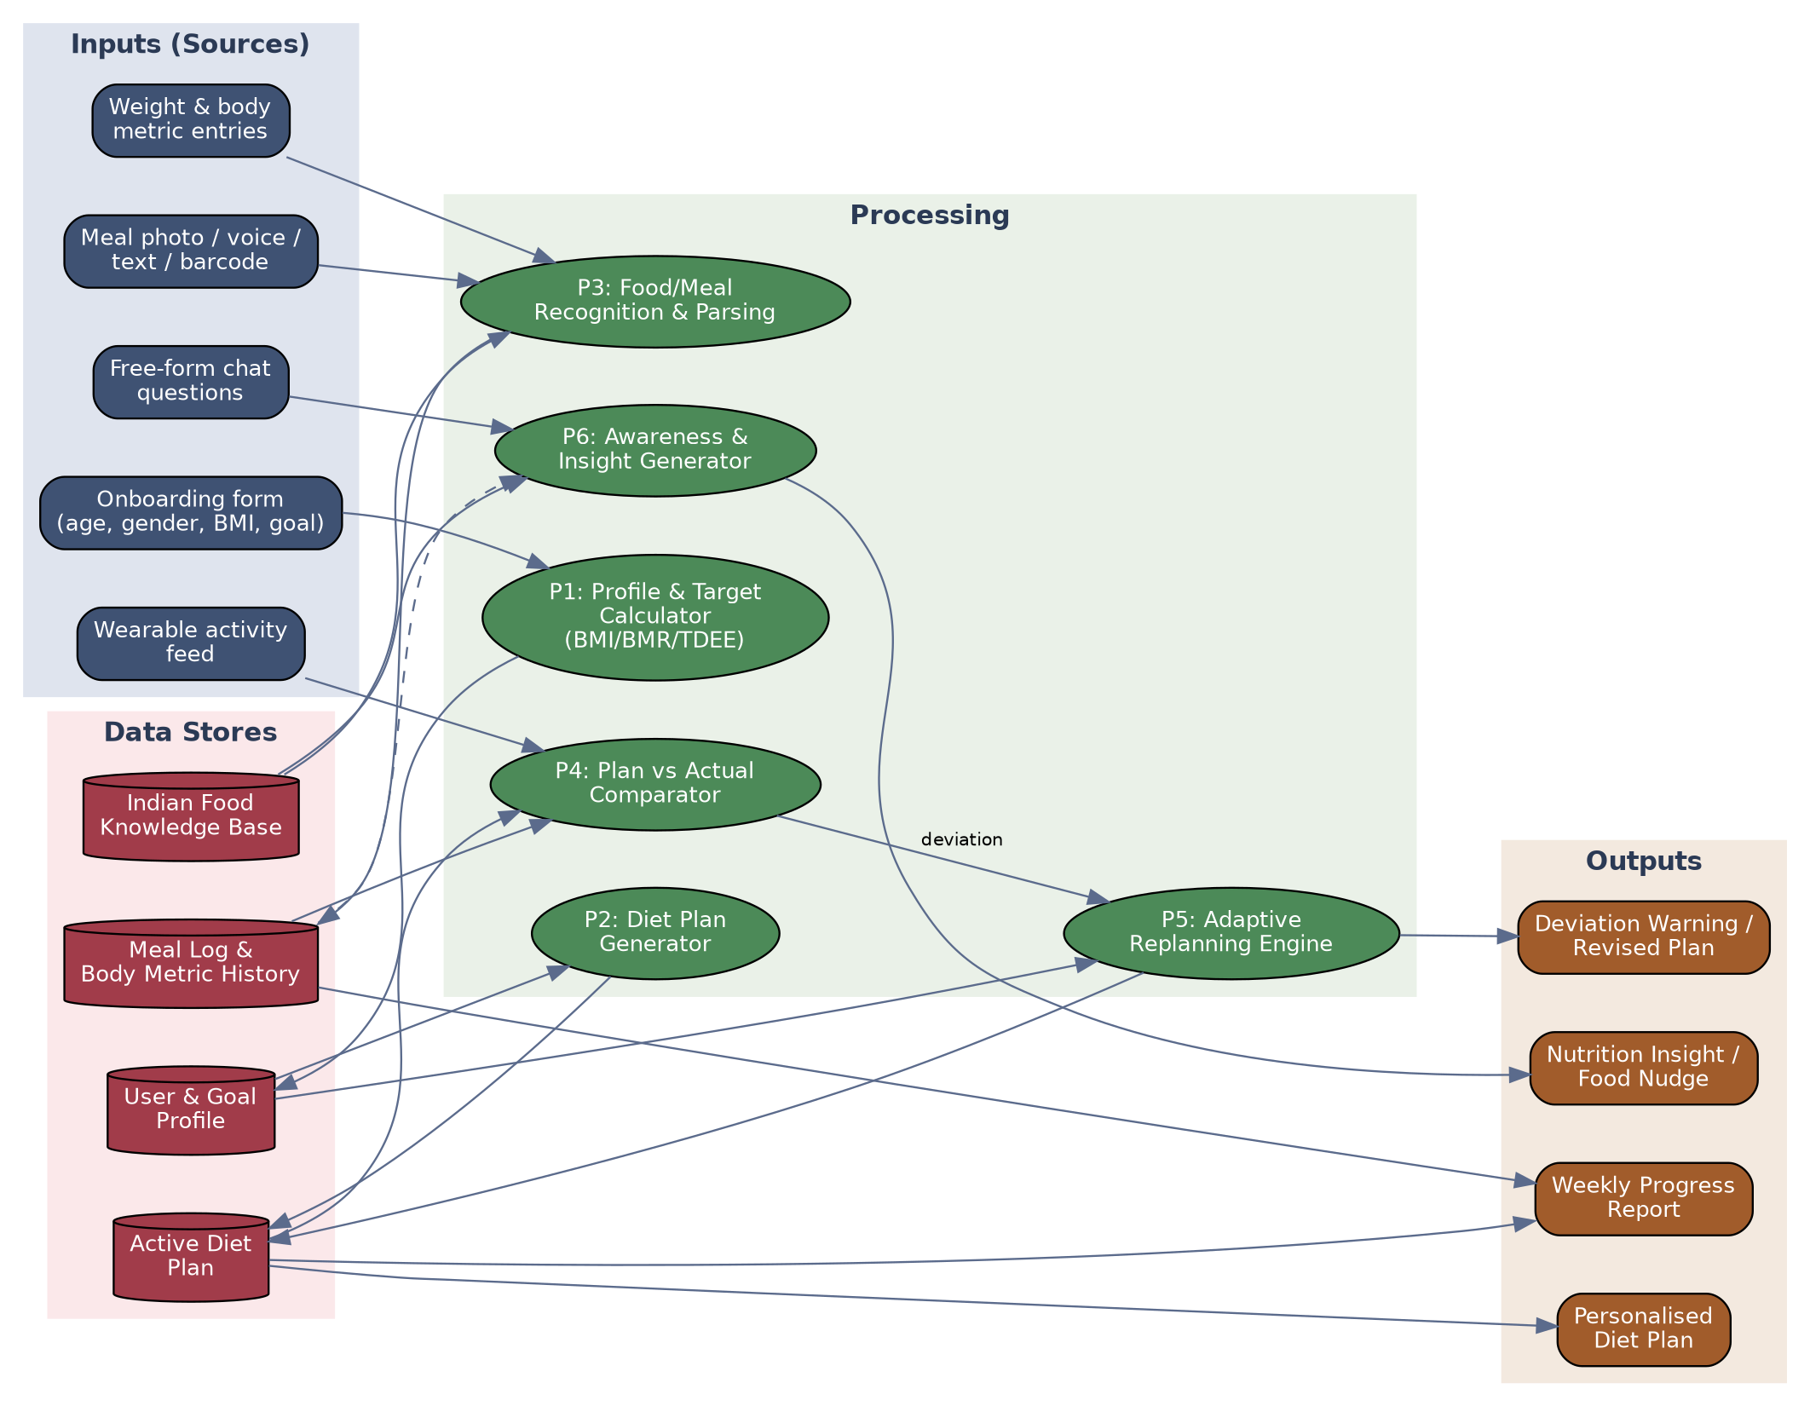
Figure 3. Data flow diagram — inputs, processing, stores, and outputs

8.1 Processing functions
Function | What it does
P1 — Profile & Target Calculator | Converts onboarding inputs into BMI classification, BMR/TDEE, and calorie/macro targets.
P2 — Diet Plan Generator | Combines targets with the user's profile and the Food Knowledge Base to compose the day-wise, milestone plan.
P3 — Food/Meal Recognition & Parsing | Turns a photo, voice note, text entry, or barcode scan into a structured meal-log entry.
P4 — Plan vs. Actual Comparator | Compares logged intake (and, where available, wearable activity) against the active plan to compute deviation.
P5 — Adaptive Replanning Engine | On meaningful deviation, produces the strict vs. flexible correction options and updates the active plan on user choice.
P6 — Awareness & Insight Generator | Answers conversational questions and produces proactive nudges, grounded in the Food Knowledge Base and, where relevant, recent logs.

9. Sequence Diagrams
The three sequences below cover the end-to-end flow for each product pillar: generating the initial plan, the daily log-deviate-adapt loop, and a conversational awareness query.

9.1 Onboarding & Personalised Diet Plan Generation
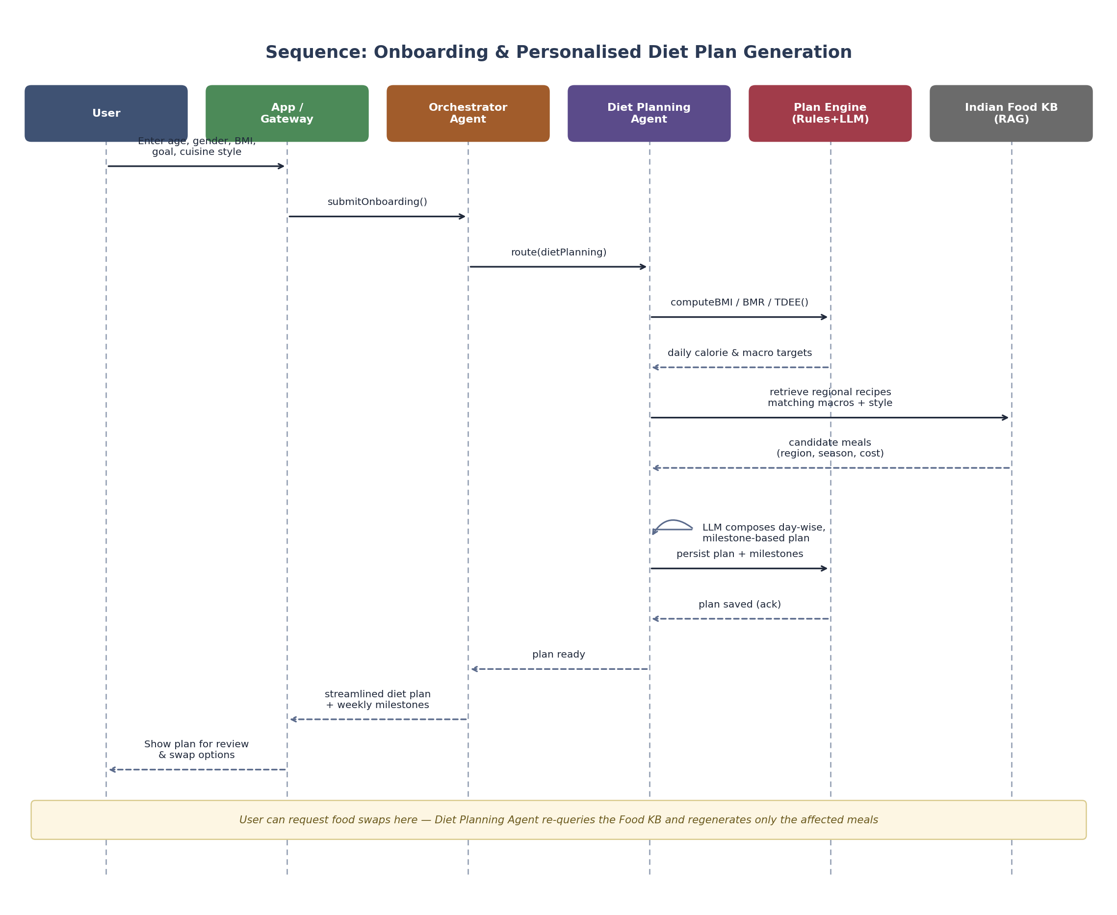
Figure 4. Sequence — from onboarding inputs to a reviewable, milestone-based diet plan
The Diet Planning Agent first gets deterministic numeric targets from the Plan Engine (BMI/BMR/TDEE and safe calorie range), then retrieves candidate regional recipes from the Food Knowledge Base that fit those targets and the user's chosen cuisine style, and only then uses the reasoning LLM to compose a coherent day-wise plan with milestones — keeping the numbers deterministic and auditable while letting the LLM handle composition and variety.

9.2 Daily Meal Logging, Deviation Warning & Adaptive Replanning
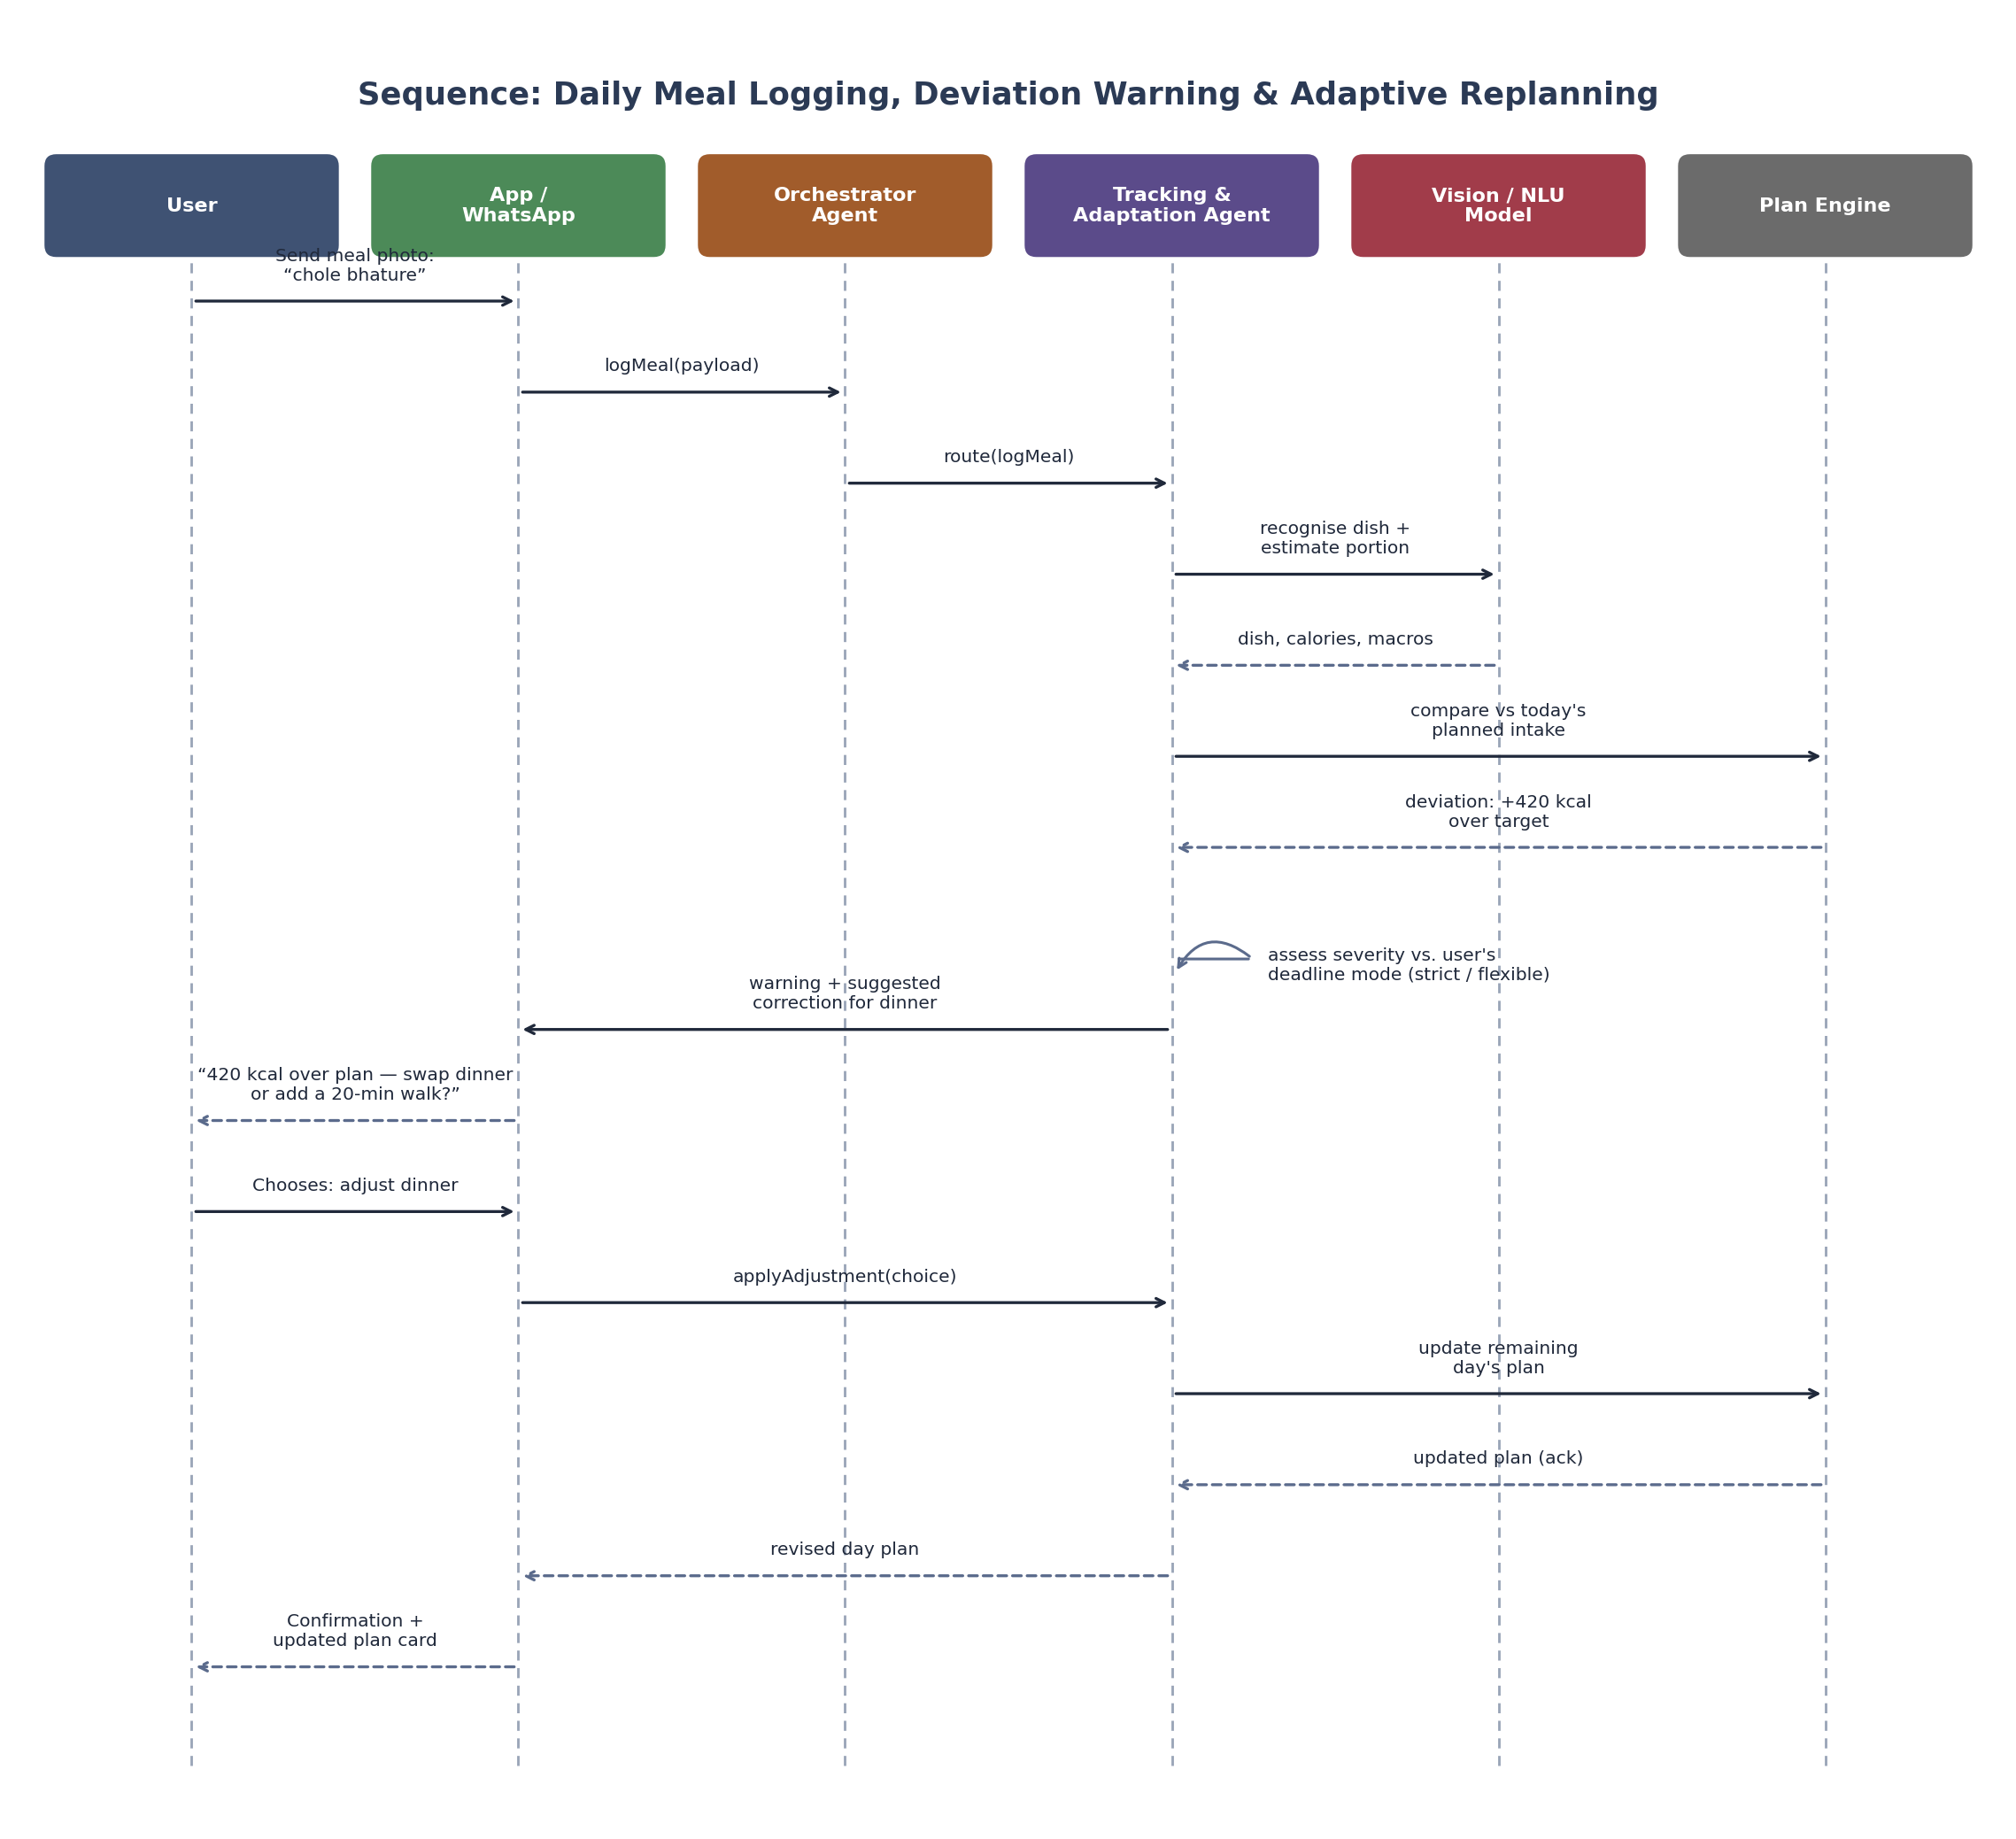
Figure 5. Sequence — logging an out-of-plan meal through to a revised day plan
Recognition (via the Vision/NLU model) and comparison against the plan (via the Plan Engine) are separated from the judgment call of what to do about a deviation, which stays with the Tracking & Adaptation Agent and, critically, with the user — the agent proposes a correction, the user chooses it, and only then is the plan actually updated.

9.3 Conversational Food Awareness & Proactive Nudges
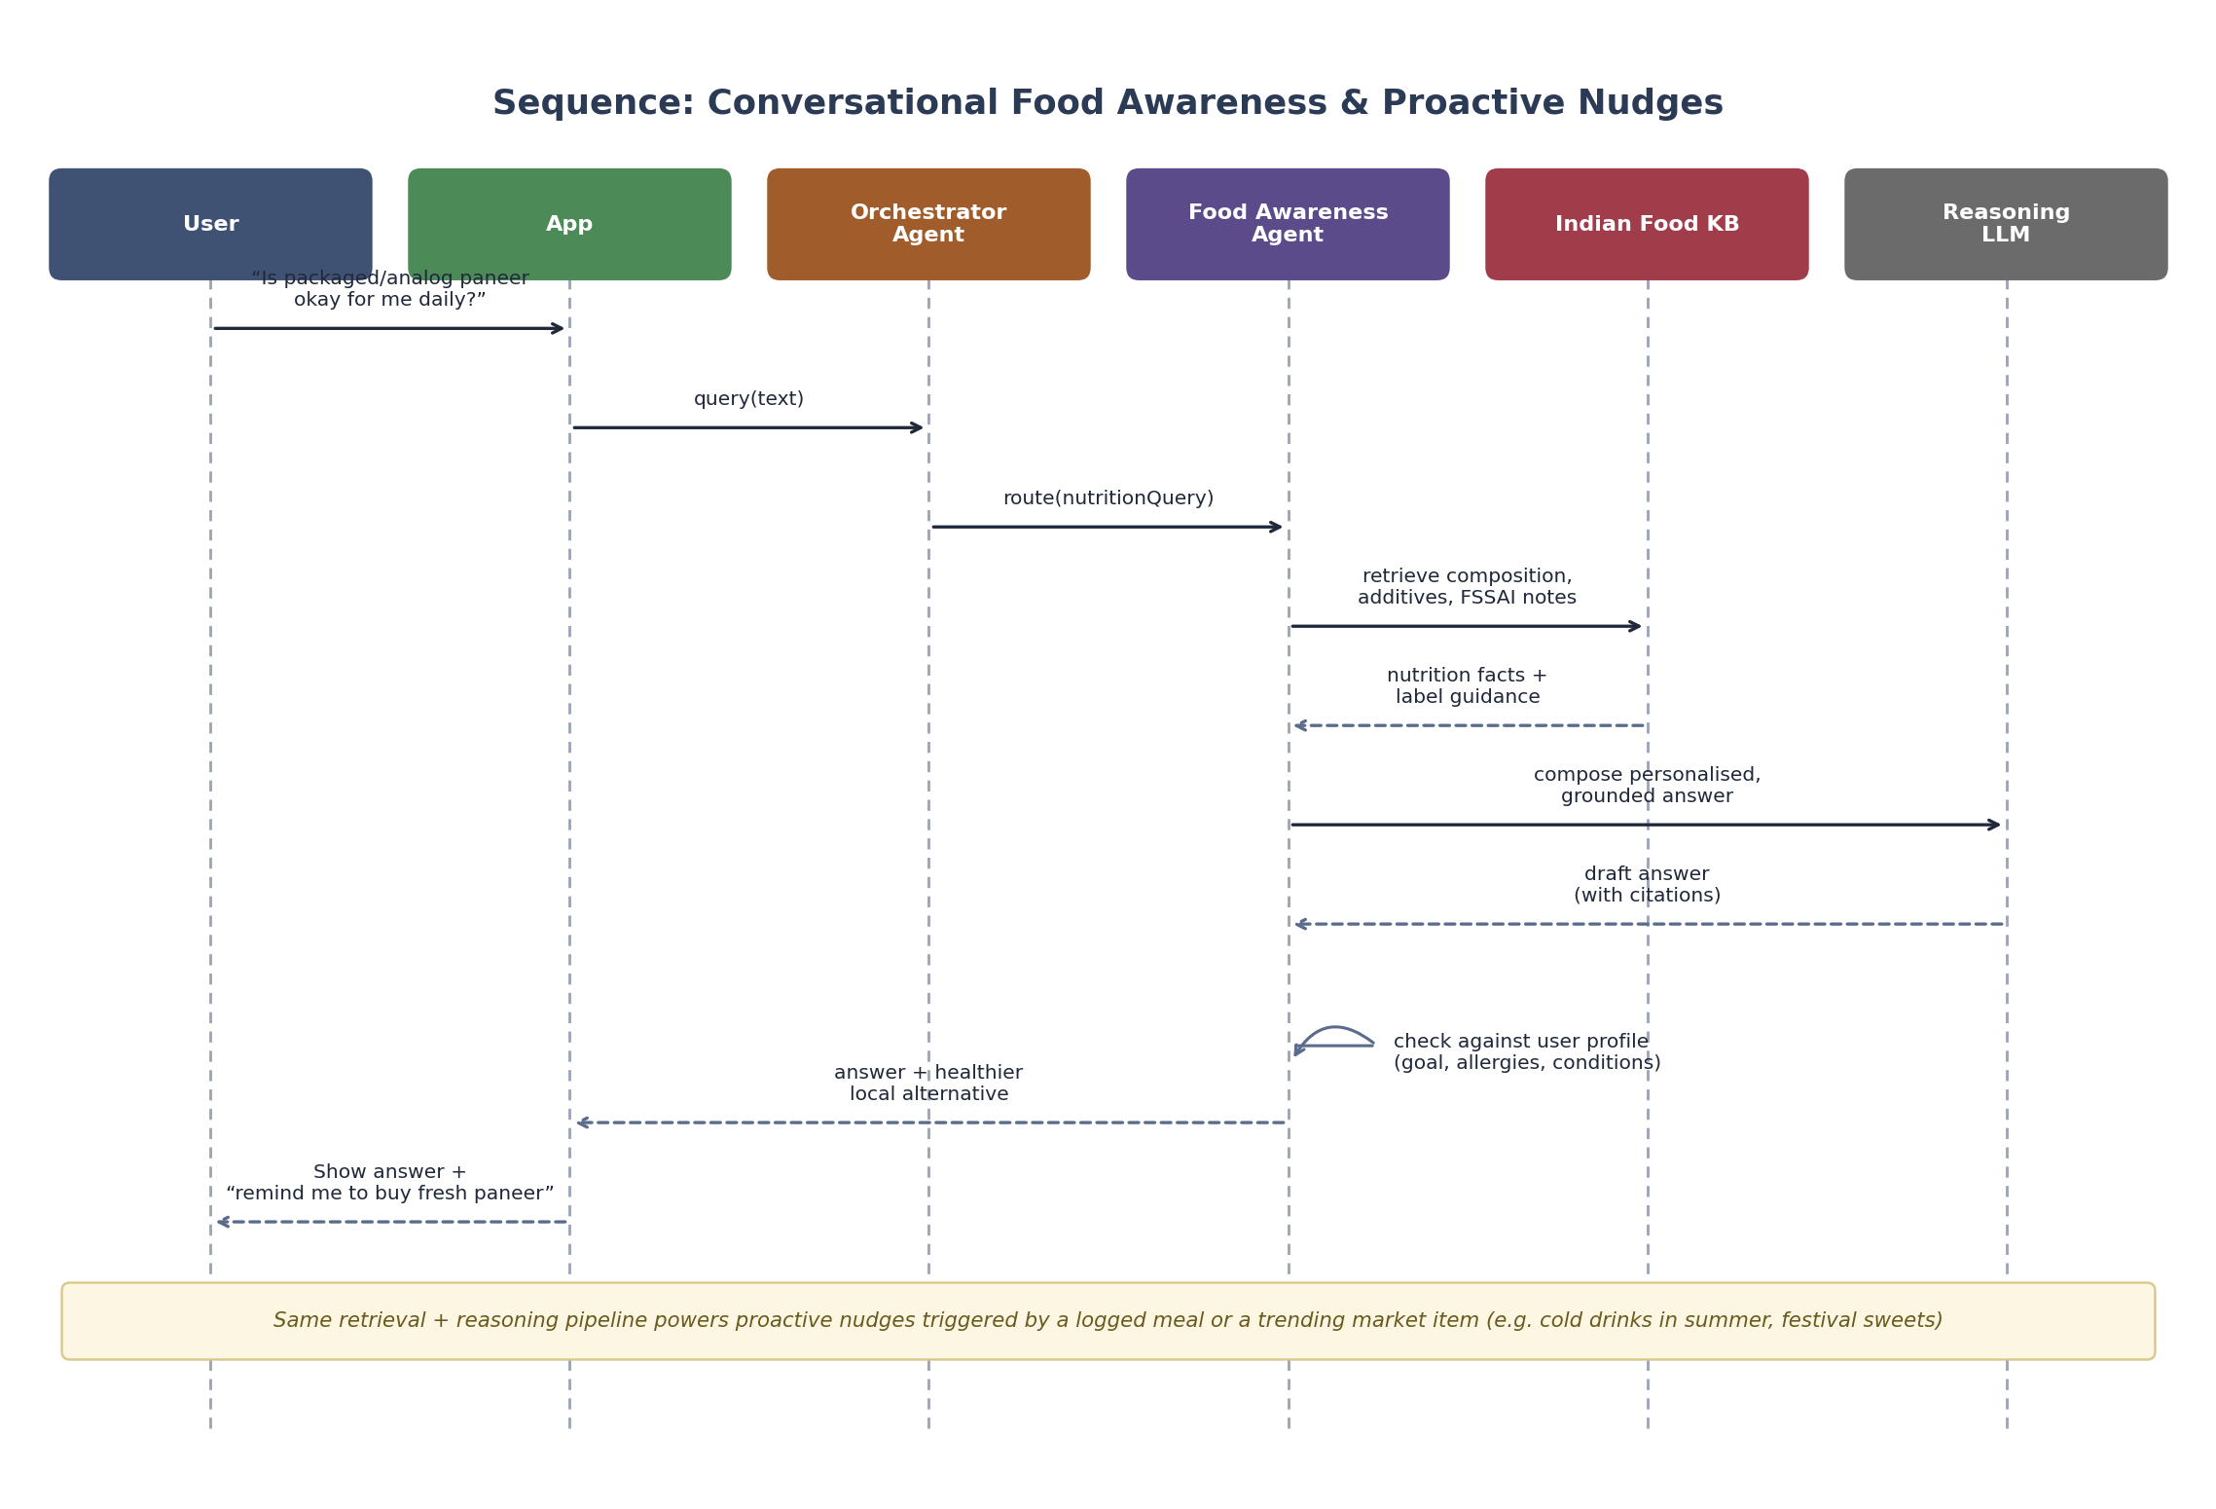
Figure 6. Sequence — a grounded, personalised answer to a food-safety question
The Food Awareness Agent always retrieves from the Food Knowledge Base before composing an answer with the LLM (retrieval-augmented generation), then checks the draft against the user's own profile (allergies, medical flags, goal) before responding — the same pipeline is reused for proactive nudges triggered by a logged meal or a scanned label.

10. High-Level Data Model
The core entities below are intentionally kept close to the product's mental model — a User has a Goal that drives a DietPlan made of PlannedMealSlots; the user's real-world eating is captured as MealLogEntry and BodyMetricEntry records; deviations may raise a NudgeEvent, which can revise the plan or raise an EscalationCase.
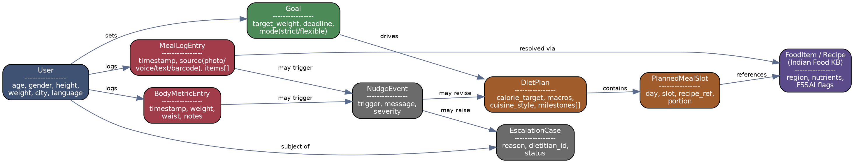
Figure 7. High-level entity relationships

10.1 Key entities
Entity | Core attributes | Notes
User | age, gender, height, weight, city, language, medical flags | One user may belong to a household.
Goal | target_weight, deadline, mode (strict/flexible) | A user can have one active goal at a time; history retained.
DietPlan | calorie_target, macro_split, cuisine_style, milestones[] | Versioned — each adaptive replan creates a new version, not an overwrite.
PlannedMealSlot | day, slot (breakfast/lunch/dinner/snack), recipe_ref, portion | References FoodItem/Recipe in the knowledge base.
MealLogEntry | timestamp, source (photo/voice/text/barcode), items[], estimated_kcal | Immutable log; corrections are appended, not overwritten.
BodyMetricEntry | timestamp, weight, waist (optional), notes | Used for trend-smoothed progress, not point-in-time alerts.
FoodItem / Recipe | region, nutrients, FSSAI flags, seasonal tags | The Indian Food Knowledge Base; sourced from IFCT plus curated regional recipes.
NudgeEvent | trigger, message, severity | May be reactive (post-log) or proactive (context-triggered).
EscalationCase | reason, dietitian_id, status | Created when a trigger crosses a clinical-safety threshold or the user asks for human help.

11. Agent Design Detail

11.1 Orchestrator pattern
The Orchestrator Agent classifies each incoming message's intent (plan / log / ask / adjust / escalate) and routes it to the relevant specialist agent, carrying forward short-term conversational memory (recent turns) and a lightweight reference to the user's current profile, active plan, and recent logs so specialist agents don't have to re-fetch context on every turn.

11.2 Tool-calling design
Each specialist agent is given a narrow, explicit toolset rather than open-ended access to the whole system — this both keeps behaviour predictable and makes the system auditable:
- Diet Planning Agent — compute_targets(), search_food_kb(), save_plan().
- Tracking & Adaptation Agent — recognise_meal(), compare_to_plan(), propose_adaptation(), apply_adaptation(), create_escalation().
- Food Awareness Agent — search_food_kb(), check_user_profile(), compose_answer().

11.3 Grounding & guardrails
- All nutrition facts are retrieved from the Indian Food Knowledge Base (retrieval-augmented generation) rather than generated freehand by the LLM, reducing hallucinated nutrition claims.
- Numeric targets (BMR/TDEE/calorie range, safe rate-of-change) are computed by deterministic rules in the Plan Engine, not by the LLM, and are the same rules an auditor or clinician can independently check.
- The agent never issues a medical diagnosis or prescribes medication changes; any medical-adjacent question is answered with general information plus a clear recommendation to consult the escalation pathway or the user's physician where appropriate.
- Every plan and every warning includes an expandable “why am I seeing this” explanation, surfacing the key inputs (e.g. “based on your TDEE of 2,100 kcal and a 500 kcal/day deficit”) so the reasoning is never a black box.

11.4 Explainability & trust
Because food and health advice touches deeply held personal and cultural beliefs, the product treats explainability as a trust feature, not a debugging feature: users can always see why a swap was suggested, why a deviation was flagged, and what changed in a replanned week.

12. Non-Functional Requirements
Category | Requirement
Performance | Meal photo recognition result in < 3s (p90); chat/awareness responses in < 4s (p90); plan generation in < 15s.
Scalability | Stateless agent and service layers behind the API Gateway; horizontally scalable to national-scale concurrent users during peak logging windows (breakfast/lunch/dinner).
Multilingual | Full text and voice support for Hindi, English, and at least 10 additional Indian languages at MVP+1.
Low-bandwidth / offline | Core plan view and logging queue work on cached data with graceful sync on reconnect, for tier-2/3 city and rural connectivity.
Privacy & compliance | DPDP Act, 2023 alignment: explicit consent per data category, data minimization, right to access/delete, encryption at rest and in transit.
Security | Health data classified as sensitive personal data; role-based access for the dietitian network; audit logging on all data access to user health records.
Accessibility | Voice-first and large-text modes for low-literacy and elderly users; WCAG-aligned mobile/web UI.
Reliability | Agent orchestration and core logging path targeted at 99.9% availability; graceful degradation to manual/text logging if photo recognition is unavailable.

13. Technology Stack Recommendation
Layer | Suggested approach
Client apps | Native/cross-platform mobile (Kotlin/Swift or React Native), WhatsApp Business API integration, lightweight React web dashboard.
API Gateway / BFF | Managed API gateway with auth, rate limiting, and per-client request shaping.
Agent orchestration | LLM tool-calling framework hosting the Orchestrator and specialist agents, each with a scoped tool/function registry.
Foundation AI | Hosted reasoning LLM (via Anthropic API or similar); fine-tuned/food-domain image recognition model; Indic ASR/TTS provider.
Core services | Containerised microservices (Profile, Plan Engine, Logging, Nudge, Escalation) on a managed Kubernetes/serverless platform.
Knowledge base | Structured nutrition DB (IFCT-derived) + vector database for RAG over recipes, labels, and awareness content.
Data stores | Managed relational DB for user/plan/profile data; document/log store for meal & metric history; event warehouse for analytics.
Integrations | Health Connect / Apple HealthKit for wearables; FSSAI-aligned packaged-food/barcode data provider; SMS/push notification provider.

14. Success Metrics
Category | Metrics
Activation | % completing onboarding → first plan generated; time-to-first-log.
Engagement | Meals logged per active user per day; % logs via photo/voice vs. manual text; weekly review open rate.
Retention | D7 / D30 / D90 retention; active-plan renewal rate at milestone checkpoints.
Adherence & outcomes | % of milestones met (within tolerance); average deviation trend over time; opt-in weight/goal progress vs. plan.
Awareness effectiveness | Nudge engagement rate; measurable shift in flagged-food logging frequency after repeated nudges.
Trust & safety | Escalation response time; % escalations resolved to user satisfaction; complaint/appeal rate on plan or nudge accuracy.
Business | Free-to-paid conversion (if freemium); household/family plan attach rate; WhatsApp-channel adoption vs. app.

15. Risks & Mitigations
Risk | Mitigation
Food-image recognition misclassifies regional/home-style dishes | Human-reviewed correction loop; always let the user confirm/edit the recognised item; continuously expand training data with regional dishes.
Aggressive plans encourage unsafe weight loss | Hard safety floors on calorie targets and rate-of-change regardless of “strict deadline” selection; automatic escalation on unsafe trend.
Over-notification causes fatigue / uninstalls | Severity-tiered nudges, user-configurable frequency, and no nudge on minor single-meal deviations.
Cultural insensitivity in food judgments (shaming traditional foods) | Editorial guidelines for the awareness content library reviewed by nutrition and cultural advisors; tone tested with target personas.
Health-data privacy breach | Encryption, strict access controls, DPDP-aligned consent and retention policy, regular security audits.
Food Knowledge Base coverage gaps for hyper-local dishes | Ongoing content-ops curation pipeline plus user-submitted dish tagging with review before publishing.
Over-reliance on AI for medical-adjacent advice | Clear scope boundaries in agent guardrails; mandatory escalation triggers for medical flags; visible disclaimers.

16. MVP Scope & Roadmap

16.1 MVP (Phase 1)
- Onboarding, target calculation, and single-user diet plan generation (Hindi + English, 2–3 major regional cuisines).
- Text and photo meal logging with deviation detection and the strict/flexible adaptive replanning choice.
- Conversational food awareness Q&A grounded in the Food Knowledge Base.
- Mobile app only; core Indian Food Knowledge Base covering major regional staples and top packaged items.

16.2 Phase 2
- WhatsApp-based logging channel; voice logging in 5+ additional Indian languages.
- Barcode/label scanning with FSSAI-aligned packaged-food database.
- Festival & fasting mode; expanded regional cuisine and swap coverage.
- Human dietitian escalation network live for medical-flagged users.

16.3 Phase 3
- Family/household multi-member plans from a shared kitchen.
- Wearable integration for activity-aware deviation comparison.
- Gamification (streaks, badges, community challenges) and proactive market-trend food nudges.
- Full 11+ language voice-first coverage and offline-tolerant logging for low-connectivity regions.

17. Appendix — Mermaid Source for the HLD Architecture Diagram
The Mermaid source below reproduces the same high-level architecture as Figure 2 and can be rendered directly in any Mermaid-compatible tool (e.g. the Mermaid Live Editor, or Markdown renderers with Mermaid support).
flowchart TB
subgraph CLIENT["Client Layer"]
Mobile["Mobile App"]
WA["WhatsApp Bot"]
Voice["Voice Assistant"]
Web["Web Dashboard"]
end
GW["API Gateway / BFF"]
subgraph AGENTS["Agent Orchestration Layer"]
Orch["Orchestrator Agent<br/>(Router + Memory)"]
Diet["Diet Planning Agent"]
Track["Tracking & Adaptation Agent"]
Aware["Food Awareness Agent"]
end
subgraph AI["Foundation AI Services"]
LLM["Reasoning LLM"]
Vision["Food Image Recognition"]
STT["Indic Speech-to-Text"]
end
subgraph PLATFORM["Core Platform Services"]
Profile["Profile & Goal Service"]
Plan["Plan Engine"]
Log["Meal & Metric Logging"]
Nudge["Nudge & Notification"]
Escalate["Dietitian Escalation"]
end
subgraph DATA["Data & Knowledge Layer"]
KB[("Indian Food KB<br/>IFCT + RAG Index")]
UserDB[("User & Plan Store")]
LogDB[("Meal Logs &<br/>Body Metrics")]
end
subgraph EXT["External Integrations"]
Wearable["Wearables"]
WABiz["WhatsApp Business API"]
Barcode["FSSAI / Barcode DB"]
Dietitian["Dietitian Network"]
end
Mobile --> GW
WA --> GW
Voice --> GW
Web --> GW
GW --> Orch
Orch --> Diet & Track & Aware
Diet --> LLM
Track --> LLM
Aware --> LLM
Track --> Vision
Voice -.-> STT
Diet --> Profile & Plan
Track --> Log & Plan & Nudge & Escalate
Aware --> KB
Plan --> KB & UserDB
Profile --> UserDB
Log --> LogDB
Nudge -.-> WABiz
Log -.-> Wearable
Log -.-> Barcode
Escalate -.-> Dietitian

