

Private Sub mnuLib_Click()

Form2.Show

Unload Me

End Sub

Private Sub mnuStd_Click()

Form10.Show

Unload Me

End Sub

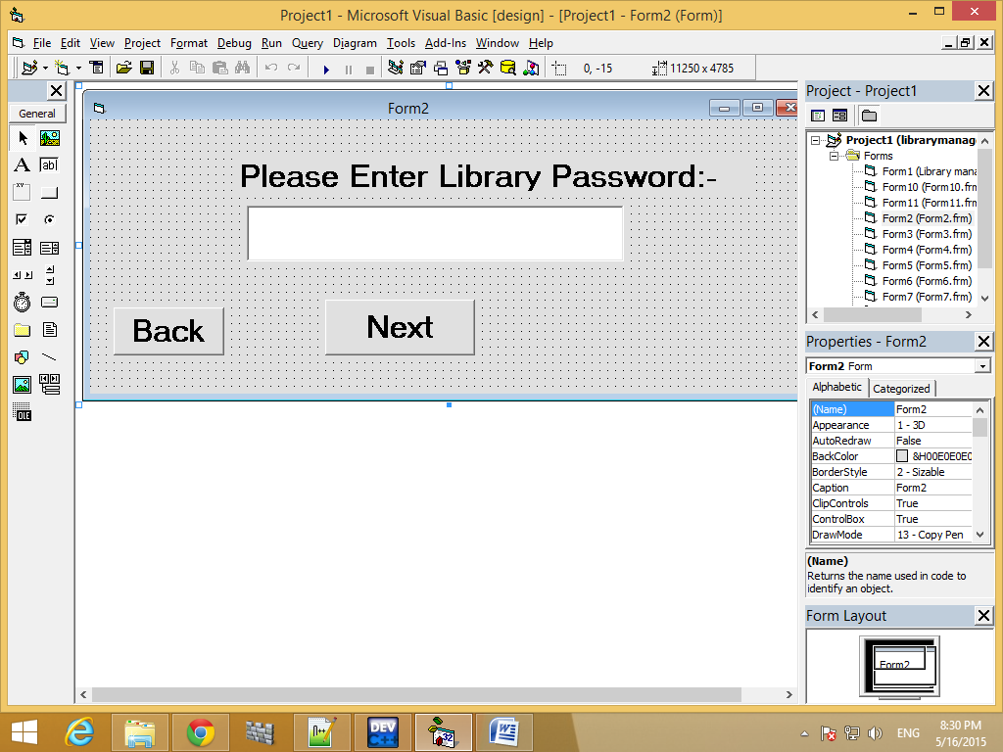

Dim p As Integer

Private Sub Command1_Click()

If Text1.Text = "" Then

MsgBox "Please enter a password"

ElseIf Val(Text1.Text) = p Then

Unload Form2

Form6.Show

Else

MsgBox "Wrong password!"

End If

End Sub

Private Sub Command2_Click()

Unload Form2

Form1.Show

End Sub

Private Sub Form_Activate()

p = 1234

End Sub

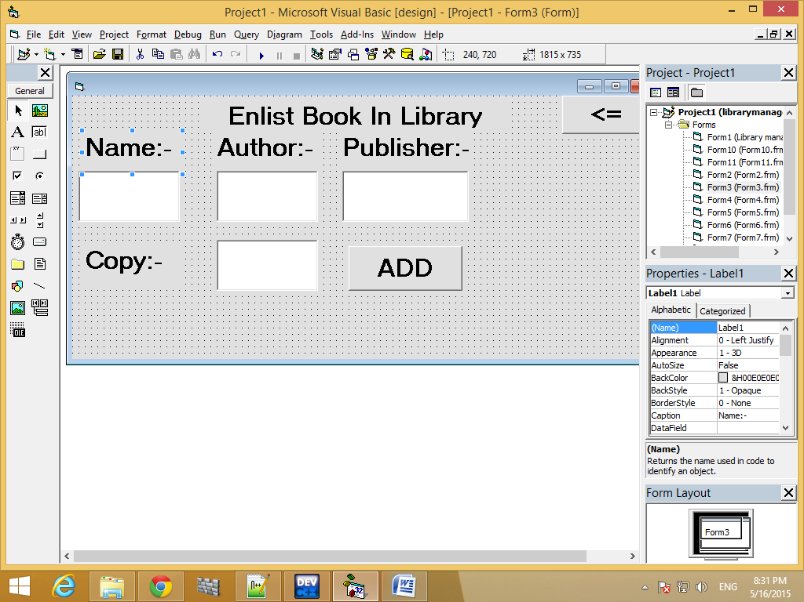

Dim p, c, d As Integer

Dim id(3) As Integer

Private Sub Command1_Click()

If Text1.Text = "" Then

MsgBox "Please enter book's name"

Text1.SetFocus

ElseIf Text2.Text = "" Then

MsgBox "Please enter author's name"

Text2.SetFocus

ElseIf Text3.Text = "" Then

MsgBox "Please enter publisher's name"

Text3.SetFocus

ElseIf Text1.Text <> "" And Text2.Text <> "" And Text3.Text <> "" Then

id(0) = Len(Text1.Text)

id(1) = Len(Text2.Text)

id(2) = Len(Text3.Text)

p = id(0)

p = p + (10 * id(1))

p = p + (100 * id(2))

Dim db As New ADODB.Connection

Dim rs As New ADODB.Recordset

Dim sql, srl, spl As String

db.Open ("Provider=Microsoft.Jet.OLEDB.4.0;Data Source=" & App.Path & "\library.mdb;Persist Security Info=False")

sql = "select *from books where id=" & p & ""

Set rs = db.Execute(sql)

If rs.BOF Or rs.EOF Then

srl = "insert into books values (" & p & ",'" & Text1.Text & "','" & Text2.Text & "','" & Text3.Text & "'," & Text4.Text & ")"

db.Execute (srl)

MsgBox "Enlistment is complete"

Text1.Text = ""

Text2.Text = ""

Text3.Text = ""

db.Close

Else

d = rs(4)

srl = "DELETE FROM books WHERE ID=" & p & ""

db.Execute (srl)

spl = "insert into books values(" & p & ",'" & Text1.Text & "','" & Text2.Text & "','" & Text3.Text & "'," & d + 1 & ")"

db.Execute (spl)

MsgBox "COPY number is increased,Enlistment is complete"

Text1.Text = ""

Text2.Text = ""

Text3.Text = ""

db.Close

End If

Set rs = Nothing

End If

End Sub

Private Sub Command2_Click()

Unload Form3

Form6.Show

End Sub

Private Sub Form_Activate()

c = 1

End Sub

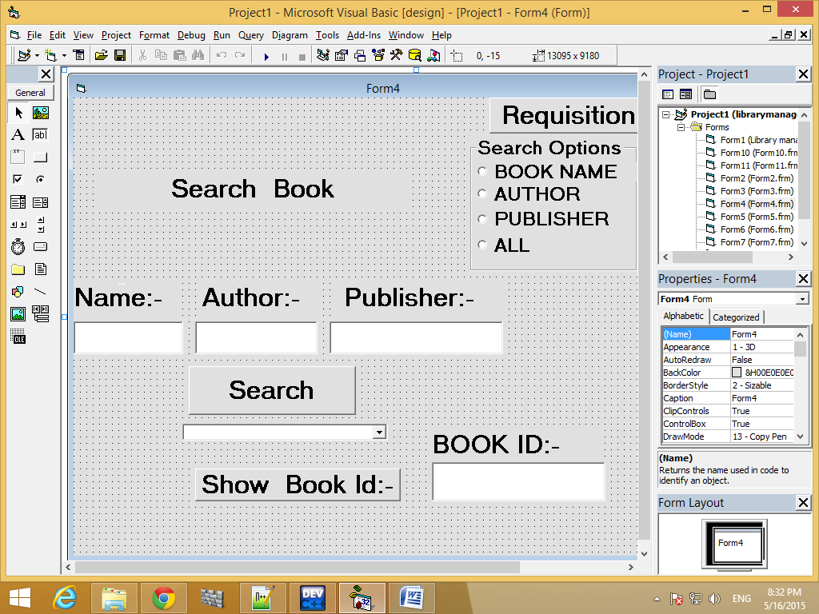

Dim id(3) As Integer

Dim p As Integer

Private Sub Command1_Click()

Combo1.Enabled = False

Combo1.Clear

If Text1.Text = "" And Text2.Text = "" And Text3.Text = "" Then

MsgBox "please fill up any of the three box"

Text1.SetFocus

ElseIf Text1.Text <> "" And Text2.Text <> "" And Text3.Text <> "" Then

Dim db As New ADODB.Connection

Dim rs, raz As New ADODB.Recordset

Dim sql, syl As String

id(0) = Len(Text1.Text)

id(1) = Len(Text2.Text)

id(2) = Len(Text3.Text)

p = id(0)

p = p + (10 * id(1))

p = p + (100 * id(2))

db.Open ("Provider=Microsoft.Jet.OLEDB.4.0;Data Source=" & App.Path & "\library.mdb;Persist Security Info=False")

sql = "select * from books where ID=" & p & ""

Set rs = db.Execute(sql)

If rs.BOF Or rs.EOF Then

MsgBox "The book is not available in library"

Text1.Text = ""

Text2.Text = ""

Text3.Text = ""

Text1.SetFocus

Text4.Text = ""

Else

Text4.Text = rs(0)

Text3.Text = ""

Text2.Text = ""

Text1.Text = ""

Set rs = Nothing

db.Close

End If

ElseIf Text1.Text <> "" And Text2.Text = "" And Text3.Text = "" Then

Dim ds As New ADODB.Connection

Dim rp As New ADODB.Recordset

Dim spl As String

Command4.Enabled = False

ds.Open ("Provider=Microsoft.Jet.OLEDB.4.0;Data Source=" & App.Path & "\library.mdb;Persist Security Info=False")

spl = "select ID from books where NAME like'" & Text1.Text & "'"

Set rp = ds.Execute(spl)

If rp.BOF Or rp.EOF Then

MsgBox "The book is not available in library"

Text1.Text = ""

Text2.Text = ""

Text3.Text = ""

Text1.SetFocus

Text4.Text = ""

Else

Text4.Text = rp(0)

Text3.Text = ""

Text2.Text = ""

Text1.Text = ""

Set rp = Nothing

ds.Close

End If

ElseIf Text1.Text = "" And Text2.Text <> "" And Text3.Text = "" Then

Dim da As New ADODB.Connection

Dim ra As New ADODB.Recordset

Dim sal As String

Combo1.Enabled = True

Command4.Enabled = True

da.Open ("Provider=Microsoft.Jet.OLEDB.4.0;Data Source=" & App.Path & "\library.mdb;Persist Security Info=False")

sal = "select NAME from books where AUTHOR like'" & Text2.Text & "'"

Set ra = da.Execute(sal)

If ra.BOF Or ra.EOF Then

MsgBox "The book is not available in library"

Text1.Text = ""

Text2.Text = ""

Text3.Text = ""

Text2.SetFocus

Text4.Text = ""

Combo1.Enabled = False

Else

Combo1.Text = "Select the book you want"

Text3.Text = ""

Text2.Text = ""

Text1.Text = ""

Do Until ra.EOF

Combo1.AddItem (ra(0))

ra.MoveNext

Loop

Set ra = Nothing

da.Close

End If

ElseIf Text1.Text = "" And Text2.Text = "" And Text3.Text <> "" Then

Dim dz As New ADODB.Connection

Dim rz As New ADODB.Recordset

Dim szl As String

Command4.Enabled = True

dz.Open ("Provider=Microsoft.Jet.OLEDB.4.0;Data Source=" & App.Path & "\library.mdb;Persist Security Info=False")

szl = "select NAME from books where PUBLISHER like'" & Text3.Text & "'"

Set rz = dz.Execute(szl)

If rz.BOF Or rz.EOF Then

MsgBox "The book is not available in library"

Text1.Text = ""

Text2.Text = ""

Text3.Text = ""

Text3.SetFocus

Text4.Text = ""

Combo1.Enabled = False

Else

Combo1.Enabled = True

Combo1.Text = "Select the book you want"

Text3.Text = ""

Text2.Text = ""

Text1.Text = ""

Do Until rz.EOF

Combo1.AddItem (rz(0))

rz.MoveNext

Loop

Set rz = Nothing

dz.Close

End If

End If

End Sub

Private Sub Command2_Click()

Unload Form4

Form5.Show

End Sub

Private Sub Command3_Click()

Unload Form4

Form1.Show

End Sub

Private Sub Command4_Click()

Dim da As New ADODB.Connection

Dim rb As New ADODB.Recordset

da.Open ("Provider=Microsoft.Jet.OLEDB.4.0;Data Source=" & App.Path & "\library.mdb;Persist Security Info=False")

Set rb = da.Execute("select ID from books where NAME='" & Combo1.Text & "'")

Text4.Text = rb(0)

End Sub

Private Sub Form_Activate()

Option4.Value = True

Option3.Value = False

Option1.Value = False

Option2.Value = False

End Sub

Private Sub Option1_Click()

Text1.Visible = True

Text2.Visible = False

Text3.Visible = False

End Sub

Private Sub Option2_Click()

Text1.Visible = False

Text2.Visible = True

Text3.Visible = False

End Sub

Private Sub Option3_Click()

Text1.Visible = False

Text2.Visible = False

Text3.Visible = True

End Sub

Private Sub Option4_Click()

Text1.Visible = True

Text2.Visible = True

Text3.Visible = True

End Sub

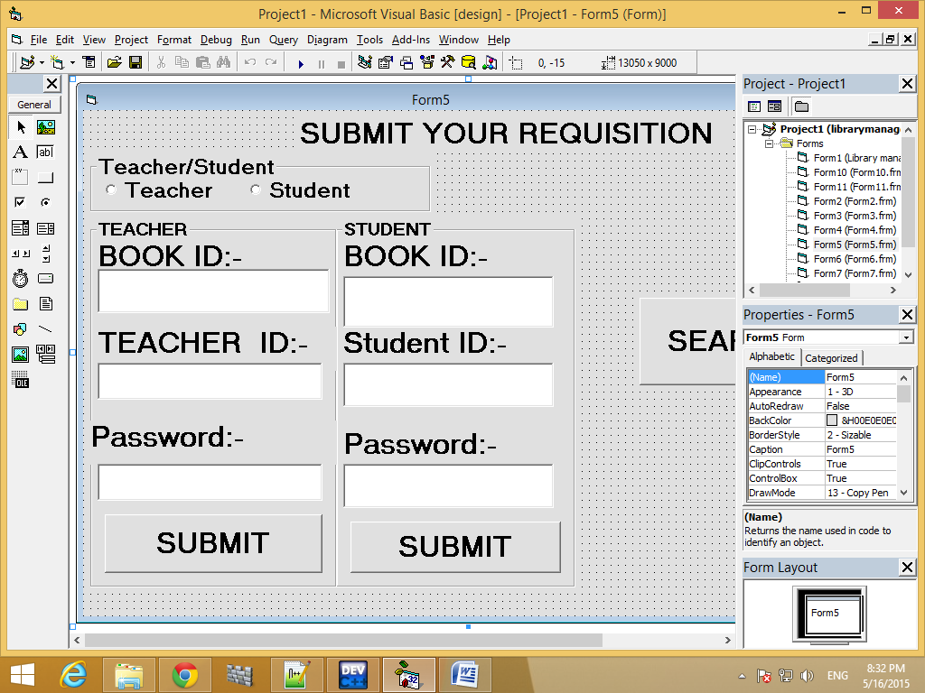

Dim t As Date

Dim s, i As String

Dim p, q As Integer

Private Sub Command1_Click()

If Text1.Text = "" Or Text2.Text = "" Then

MsgBox "Please fill up all boxes"

Else

Dim db As New ADODB.Connection

Dim rs, rb As New ADODB.Recordset

Dim sql, spl As String

db.Open ("Provider=Microsoft.Jet.OLEDB.4.0;Data Source=" & App.Path & "\library.mdb;Persist Security Info=False")

sql = "select *from books where ID=" & Val(Text1.Text) & ""

spl = "select * from student where SID=" & Val(Text2.Text) & ""

Set rs = db.Execute(sql)

Set rb = db.Execute(spl)

If rs.BOF Or rs.EOF Then

MsgBox "The BookID is invalid"

ElseIf rb.BOF Or rb.EOF Then

MsgBox "StudentID is invalid"

ElseIf rs(4) <> 0 And rb(4) = Text6.Text Then

Dim rf, rz As New ADODB.Recordset

Dim sfl, sol As String

p = rs(4)

q = p - 1

sfl = "insert into reqs values(" & rs(0) & "," & rb(0) & ",#" & t & "#,#" & t + 14 & "#)"

Set rf = db.Execute(sfl)

MsgBox "Requistion is completed, date of return is " & t + 14 & ""

sol = "update books set COPY='" & q & "'where ID = " & Text1.Text & ""

Set rz = db.Execute(sol)

Text1.Text = ""

Text2.Text = ""

Text6.Text = ""

ElseIf rs(4) = 0 Then

MsgBox "No copy of this book is avalaible now,come later"

Text1.Text = ""

Text2.Text = ""

Text6.Text = ""

Else

MsgBox "Password is incorrect"

End If

Set rz = Nothing

Set rs = Nothing

Set rb = Nothing

Set rf = Nothing

db.Close

End If

End Sub

Private Sub Command2_Click()

Unload Form5

Form4.Show

End Sub

Private Sub Command3_Click()

If Text3.Text = "" Or Text4.Text = "" Then

MsgBox "Please fill up all boxes"

Else

Dim db As New ADODB.Connection

Dim rs, rb As New ADODB.Recordset

Dim sql, spl As String

db.Open ("Provider=Microsoft.Jet.OLEDB.4.0;Data Source=" & App.Path & "\library.mdb;Persist Security Info=False")

sql = "select *from books where ID=" & Val(Text3.Text) & ""

spl = "select * from teacher where TID=" & Val(Text4.Text) & ""

Set rs = db.Execute(sql)

Set rb = db.Execute(spl)

If rs.BOF Or rs.EOF Then

MsgBox "The BookID is invalid"

ElseIf rb.BOF Or rb.EOF Then

MsgBox "TeacherID is invalid"

ElseIf rs(4) <> 0 And rb(4) = Text5.Text Then

Dim rf, rz As New ADODB.Recordset

Dim sfl, sol As String

sfl = "insert into reqt values(" & rs(0) & "," & rb(0) & ",#" & t & "#,#" & t + 14 & "#)"

Set rf = db.Execute(sfl)

MsgBox "Requistion is completed, date of return is " & t + 14 & ""

p = rs(4)

q = p - 1

sol = "update books set COPY='" & q & "'where ID = " & Text3.Text & ""

Set rz = db.Execute(sol)

Text3.Text = ""

Text4.Text = ""

Text5.Text = ""

ElseIf rs(4) = 0 Then

MsgBox "No copy of this book is avalaible now,come later"

Text3.Text = ""

Text4.Text = ""

Text5.Text = ""

Else

MsgBox "Password is incorrect"

End If

Set rz = Nothing

Set rs = Nothing

Set rb = Nothing

Set rf = Nothing

db.Close

End If

End Sub

Private Sub Command4_Click()

Unload Form5

Form1.Show

End Sub

Private Sub Form_Activate()

Frame2.Visible = False

Frame3.Visible = False

t = DateValue(Now)

End Sub

Private Sub Option1_Click()

Frame3.Visible = True

Frame2.Visible = False

End Sub

Private Sub Option2_Click()

Frame3.Visible = False

Frame2.Visible = True

End Sub

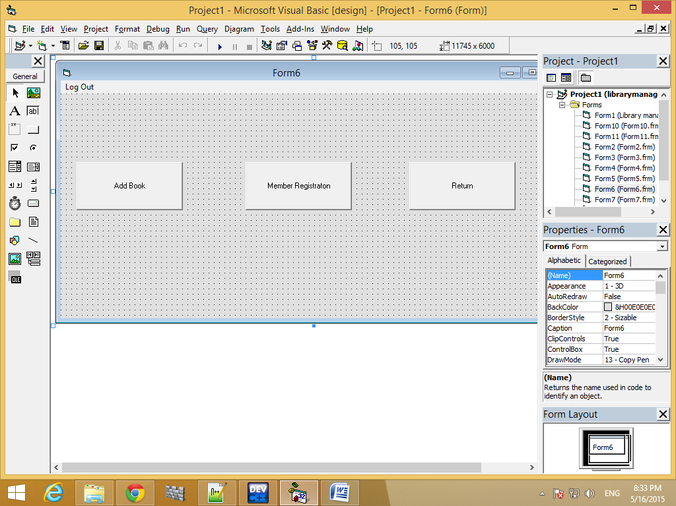

Private Sub Command1_Click()

Form3.Show

Unload Me

End Sub

Private Sub Command2_Click()

Form7.Show

Unload Me

End Sub

Private Sub Command3_Click()

Form11.Show

Unload Me

End Sub

Private Sub mnuLO_Click()

Form1.Show

Unload Me

End Sub

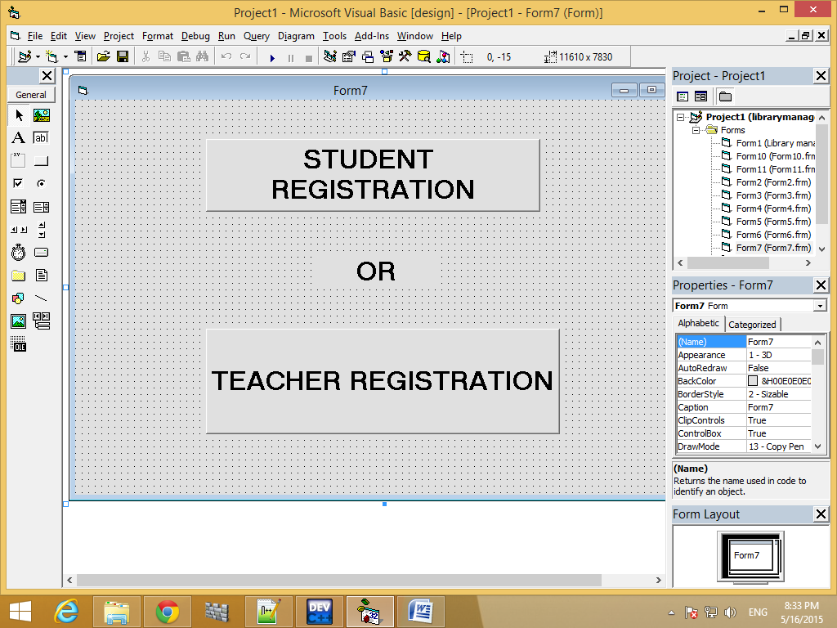

Private Sub Command1_Click()

Form8.Show

Unload Form7

End Sub

Private Sub Command2_Click()

Form9.Show

Unload Form7

End Sub

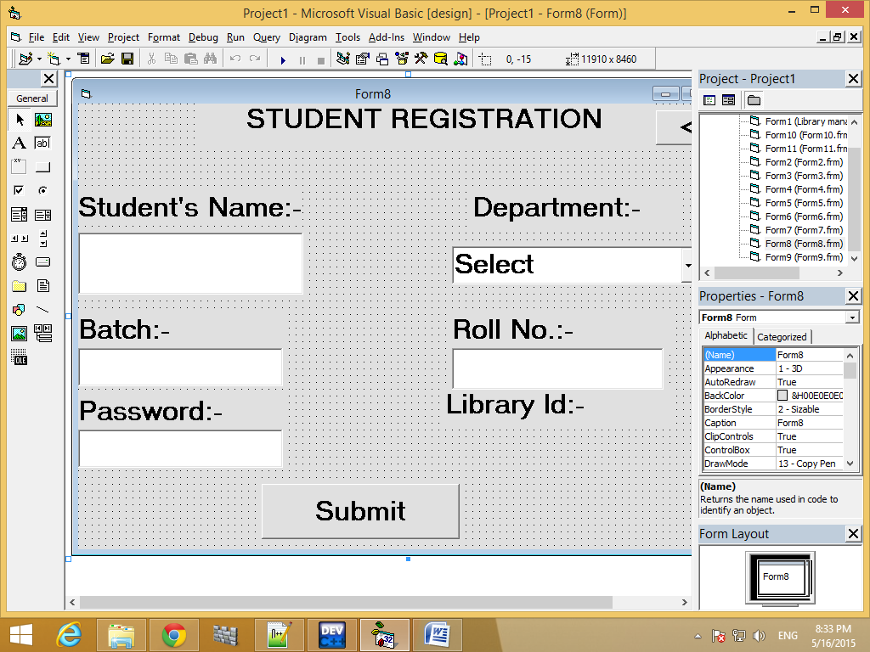

Dim p As String

Private Sub Command1_Click()

If Text1.Text = "" Or Combo1.Text = "Select" Or Text3.Text = "" Or Text5.Text = "" Then

MsgBox "Please fill up all the boxes for registration"

Else

Dim db As New ADODB.Connection

Dim rs As New ADODB.Recordset

Dim sql As String

If Combo1.Text = "CSE" Then

a = 1

ElseIf Combo1.Text = "IT" Then

a = 2

ElseIf Combo1.Text = "EE" Then

a = 3

Else

a = 4

End If

p = Val(Text3.Text) * 1000 + (a * 100) + Val(Text5.Text)

db.Open ("Provider=Microsoft.Jet.OLEDB.4.0;Data Source=" & App.Path & "\library.mdb;Persist Security Info=False")

sql = "select *from Student where SID =" & p & ""

Set rs = db.Execute(sql)

If rs.BOF Or rs.EOF Then

Dim spl As String

spl = "insert into Student values(" & p & ",'" & Text1.Text & "','" & Combo1.Text & "'," & Text3.Text & ",'" & Text4.Text & "')"

db.Execute (spl)

MsgBox "Student is registered"

Text1.Text = ""

Combo1.Text = "Select"

Text3.Text = ""

Text4.Text = ""

Text5.Text = ""

Label7.Caption = p

db.Close

Else

MsgBox "student is already registered, id=" & p & ""

Text1.Text = ""

Combo1.Text = "Select"

Text3.Text = ""

Text4.Text = ""

Text5.Text = ""

End If

Set rs = Nothing

End If

End Sub

Private Sub Command2_Click()

Unload Form8

Form6.Show

End Sub

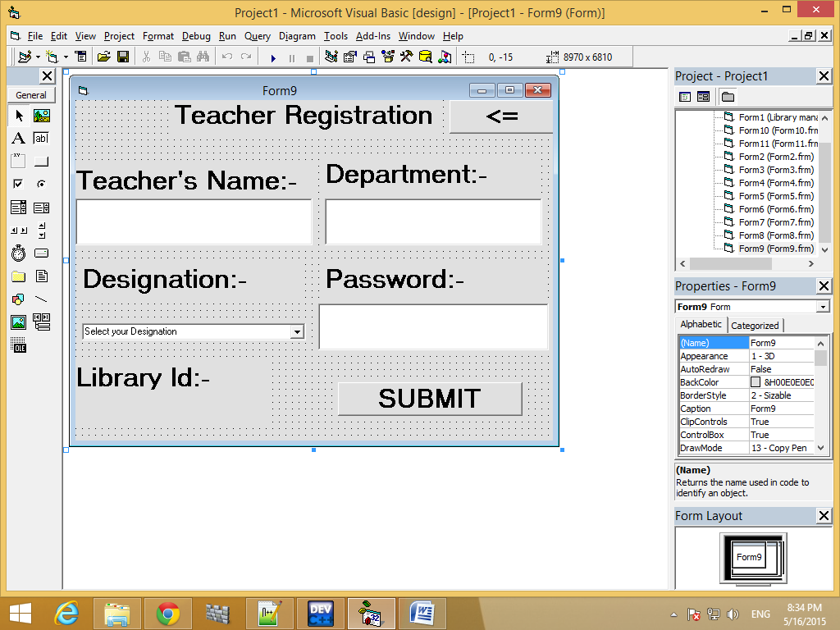

Dim p, id(3) As Integer

Private Sub Command1_Click()

If Text1.Text = "" Or Text2.Text = "" Or Text3.Text = "" Then

MsgBox "Please fill up all the boxes for registration"

Else

id(0) = Len(Text1.Text)

id(1) = Len(Text2.Text)

id(2) = Len(Text3.Text)

p = id(0) + (10 * id(1)) + (100 * id(2))

Dim db As New ADODB.Connection

Dim rs As New ADODB.Recordset

Dim sql As String

db.Open ("Provider=Microsoft.Jet.OLEDB.4.0;Data Source=" & App.Path & "\library.mdb;Persist Security Info=False")

sql = "select *from Teacher where TID=" & p & ""

Set rs = db.Execute(sql)

If (rs.BOF Or rs.EOF) Then

Dim spl As String

srl = "insert into Teacher values(" & p & ",'" & Text1.Text & "','" & Text2.Text & "','" & Text4.Text & "')"

db.Execute (srl)

MsgBox "Registration is completed"

Text1.Text = ""

Text2.Text = ""

Text3.Text = ""

Label6.Caption = p

Else

MsgBox "Teacher is aready registered, id=" & rs(0) & ""

Text1.Text = ""

Text2.Text = ""

Text3.Text = ""

Text4.Text = ""

End If

db.Close

Set rs = Nothing

End If

End Sub

Private Sub Command2_Click()

Unload Form9

Form6.Show

End Sub

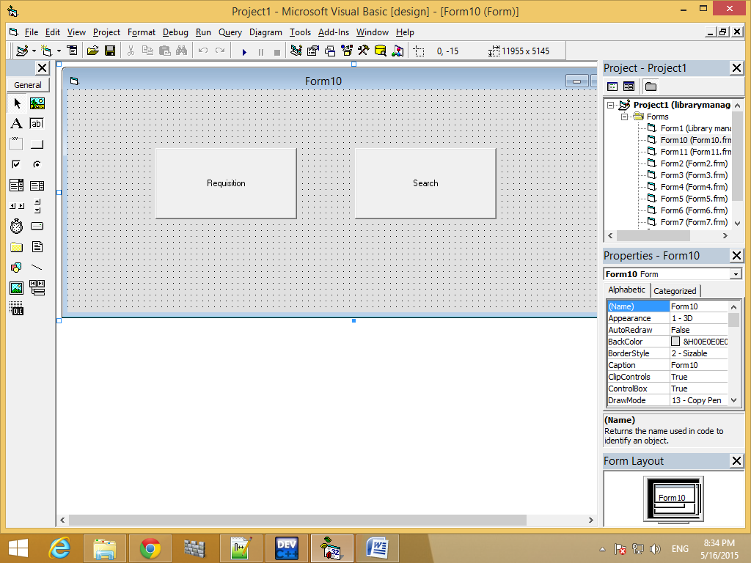

Private Sub Command1_Click()

Form5.Show

Unload Me

End Sub

Private Sub Command2_Click()

Form4.Show

Unload Me

End Sub

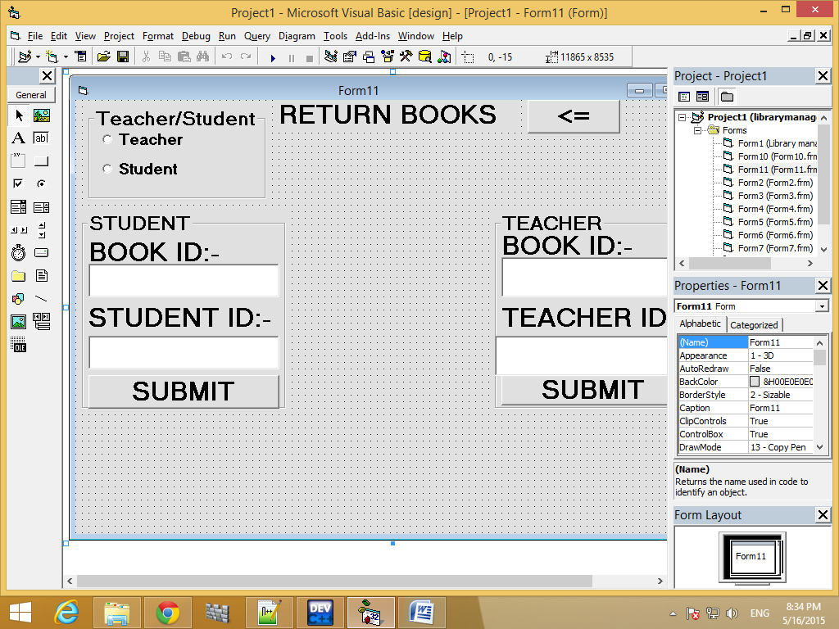

Dim l, z As Date

Dim p, q As Integer

Private Sub Command1_Click()

If Text1.Text = "" Or Text2.Text = "" Then

MsgBox "Please fill up all boxes"

Else

Dim db As New ADODB.Connection

Dim rs, rb, rv As New ADODB.Recordset

Dim sql, spl, swl As String

db.Open ("Provider=Microsoft.Jet.OLEDB.4.0;Data Source=" & App.Path & "\library.mdb;Persist Security Info=False")

sql = "select *from books where ID=" & Val(Text1.Text) & ""

spl = "select * from student where SID=" & Val(Text2.Text) & ""

Set rs = db.Execute(sql)

Set rb = db.Execute(spl)

If rs.BOF Or rs.EOF Then

MsgBox "The BookID is invalid"

ElseIf rb.BOF Or rb.EOF Then

MsgBox "StudentID is invalid"

Else

swl = "select *from Reqs where ID=" & Val(Text1.Text) & "and SID=" & Val(Text2.Text) & ""

Set rv = db.Execute(swl)

If rv.BOF Or rv.EOF Then

MsgBox "There is no such requisition "

Set rv = Nothing

db.Close

Else

Dim rf, rz, rk As New ADODB.Recordset

Dim sfl, sol, skl As String

q = rs(4) + 1

skl = "select *from Reqs where (ID=" & Val(Text1.Text) & ")and (SID=" & Val(Text2.Text) & ")"

Set rk = db.Execute(skl)

If l > rk(3) Then

z = rk(3)

l = l - z

MsgBox "You have to give " & l & "/-for late submission"

l = DateValue(Now)

sfl = "delete from reqs where ID=" & Val(Text1.Text) & "and SID=" & Val(Text2.Text) & ""

Set rf = db.Execute(sfl)

sol = "update books set COPY='" & q & "'where ID = " & Text1.Text & ""

Set rz = db.Execute(sol)

Text1.Text = ""

Text2.Text = ""

Else

Dim sbl, sil As String

sbl = "delete from reqs where ID=" & Val(Text1.Text) & "and SID=" & Val(Text2.Text) & ""

Set rf = db.Execute(sbl)

sil = "update books set COPY='" & q & "'where ID = " & Text1.Text & ""

Set rz = db.Execute(sil)

MsgBox "Submission is successful"

Text1.Text = ""

Text2.Text = ""

End If

Set rk = Nothing

Set rz = Nothing

Set rs = Nothing

Set rb = Nothing

Set rf = Nothing

db.Close

End If

End If

End If

End Sub

Private Sub Command3_Click()

Unload Form11

Form6.Show

End Sub

Private Sub Command2_Click()

If Text3.Text = "" Or Text4.Text = "" Then

MsgBox "Please fill up all boxes"

Else

Dim db As New ADODB.Connection

Dim rs, rb, rv As New ADODB.Recordset

Dim sql, spl, swl As String

db.Open ("Provider=Microsoft.Jet.OLEDB.4.0;Data Source=" & App.Path & "\library.mdb;Persist Security Info=False")

sql = "select *from books where ID=" & Val(Text3.Text) & ""

spl = "select * from teacher where TID=" & Val(Text4.Text) & ""

Set rs = db.Execute(sql)

Set rb = db.Execute(spl)

If rs.BOF Or rs.EOF Then

MsgBox "The BookID is invalid"

ElseIf rb.BOF Or rb.EOF Then

MsgBox "TeacherID is invalid"

Else

swl = "select *from Reqt where ID=" & Val(Text3.Text) & "and TID=" & Val(Text4.Text) & ""

Set rv = db.Execute(swl)

If rv.BOF Or rv.EOF Then

MsgBox "There is no such requisition "

Set rv = Nothing

db.Close

Else

Dim rf, rz, rk As New ADODB.Recordset

Dim sfl, sol, skl As String

q = rs(4) + 1

skl = "select *from Reqt where (ID=" & Val(Text3.Text) & ")and (TID=" & Val(Text4.Text) & ")"

Set rk = db.Execute(skl)

If l > rk(3) Then

z = rk(3)

l = l - z

MsgBox "You have to give " & l & "/- for late submission"

l = DateValue(Now)

sfl = "delete from Reqt where ID=" & Val(Text3.Text) & "and TID=" & Val(Text4.Text) & ""

Set rf = db.Execute(sfl)

sol = "update books set COPY='" & q & "'where ID = " & Val(Text3.Text) & ""

Set rz = db.Execute(sol)

Text3.Text = ""

Text4.Text = ""

Else

Dim sbl, sil As String

sbl = "delete from reqt where ID=" & Val(Text3.Text) & "and TID=" & Val(Text4.Text) & ""

Set rf = db.Execute(sbl)

sil = "update books set COPY='" & q & "'where ID = " & Text3.Text & ""

Set rz = db.Execute(sil)

MsgBox "Submission is successful"

Text3.Text = ""

Text4.Text = ""

End If

Set rk = Nothing

Set rz = Nothing

Set rs = Nothing

Set rb = Nothing

Set rf = Nothing

db.Close

End If

End If

End If

End Sub

Private Sub Form_Activate()

Frame2.Visible = False

Frame3.Visible = False

Option1.Value = False

Option2.Value = False

l = DateValue(Now)

End Sub

Private Sub Option1_Click()

Frame3.Visible = True

Frame2.Visible = False

End Sub

Private Sub Option2_Click()

Frame3.Visible = False

Frame2.Visible = True

End Sub