PARTE DO MAX

**Primeira parte, variação de K e T**

**K ANONIMITY (K = 3) + T-CLOSENESS(T = 0.15)**

**Supression Limit 100%**  
**Utility Measure: Loss**

**Attribute Weights: padrão (0.5 for all)**

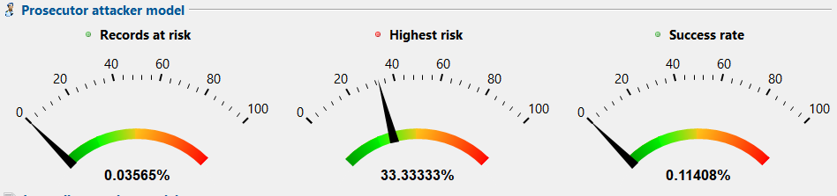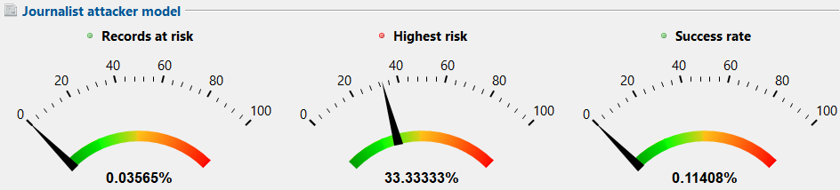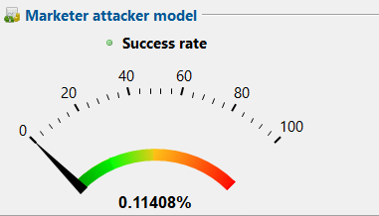

**ANALISE DE RISCOS**

|  |  |
| --- | --- |
| Medida | Valor [%] |
| Menor risco (Promotor) | 0.00623% |
| Registos afetados pelo menor risco | 57.21212% |
| Risco Médio (Promotor) | 0.11408% |
| Maior risco (Promotor) | 33.33333% |
| Registos afetados pelo maior risco | 0.02139% |
| Risco estimado (Promotor) | 33.33333% |
| Risco estimado (Jornalista) | 33.33333% |
| Risco estimado (Marketing) | 0.11408% |
| Unicidade na amostra | 0% |
| Unicidade na população | 0% |
| Modelo populacional | DANKAR |
| QIDs | Age, education, marital-status, native-country, occupation, sex, workclass |

**ANALISE DE UTILIDADE**

**Attribute-level quality:**

|  |  |  |  |  |  |  |
| --- | --- | --- | --- | --- | --- | --- |
| Atributo | Tipo de Dados | Missings | Gen. Intensity | Granularity | N. -U. entropy | Squared Error |
| sex | String | 7.00219% | 92.99781% | 92.99781% | 93.069% | 92.99781% |
| age | String | 100% | 0% | 0% | 0% | 0% |
| Marital-status | String | 100% | 0% | 0% | 0% | 0% |
| education | String | 100% | 0% | 0% | 0% | 0% |
| Native-country | String | 7.00219% | 92.99781% | 92.99781% | 64.4205% | 96.48339% |
| workclass | String | 7.00219% | 46.49891% | 66.42701% | 39.72671% | 82.31514% |
| occupation | String | 100% | 0% | 0% | 0% | 0% |

**Dataset level quality**

|  |  |
| --- | --- |
| Modelo | Qualidade |
| Gen- Intensity | 33.2135% |
| Granularity | 32.21599% |
| N. -U. entropy | 11.47625% |
| DIscerniblity | 57.73714% |
| Average Class Size | 97.09964% |
| Record-level squared error | 28.17757% |
| Attribute-level squared error | 31.12375% |
| Aggregation-specific squared error | 0% |

**K ANONIMITY (K = 5) + T-CLOSENESS(T = 0.2)**

**Supression Limit: 100%**  
**Utility Measure: Loss**

**Attribute Weights: padrão (0.5 for all)**

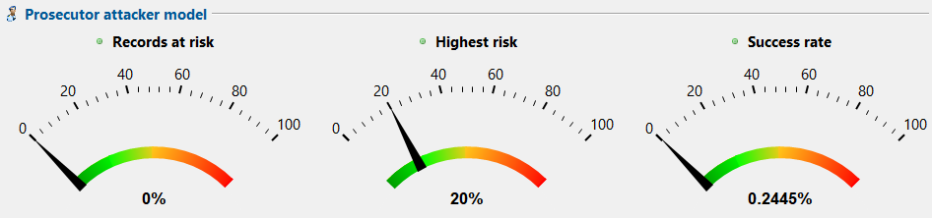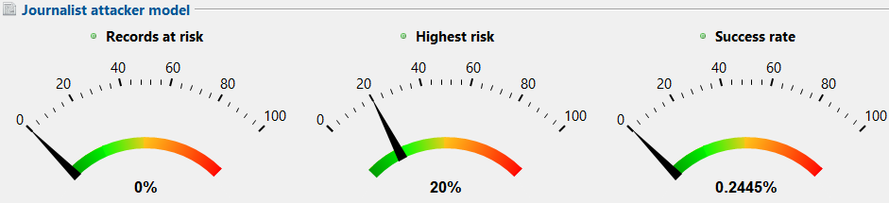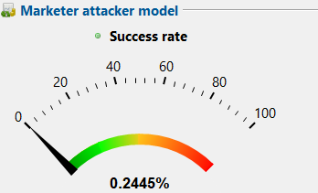

**ANALISE DE RISCOS**

|  |  |
| --- | --- |
| Medida | Valor [%] |
| Menor risco (Promotor) | 0.01795% |
| Registos afetados pelo menor risco | 21.27903% |
| Risco Médio (Promotor) | 0.2445% |
| Maior risco (Promotor) | 20% |
| Registos afetados pelo maior risco | 0.0191% |
| Risco estimado (Promotor) | 20% |
| Risco estimado (Jornalista) | 20% |
| Risco estimado (Marketing) | 0.2445% |
| Unicidade na amostra | 0% |
| Unicidade na população | 0% |
| Modelo populacional | DANKAR |
| QIDs | Age, education, marital-status, native-country, occupation, sex, workclass |

**ANALISE DE UTILIDADE**

**Attribute-level quality:**

|  |  |  |  |  |  |  |
| --- | --- | --- | --- | --- | --- | --- |
| Atributo | Tipo de Dados | Missings | Gen. Intensity | Granularity | N. -U. entropy | Squared Error |
| sex | String | 13.2153% | 86.7847% | 86.7847% | 87.33269% | 86.7847% |
| age | String | 100% | 0% | 0% | 0% | 0% |
| Marital-status | String | 100% | 0% | 0% | 0% | 0% |
| education | String | 100% | 0% | 0% | 0% | 0% |
| Native-country | String | 13.2153% | 86.7847% | 86.7847% | 45.83333% | 89.74524% |
| workclass | String | 13.2153% | 86.7847% | 86.7847% | 78.71717% | 89.88957% |
| occupation | String | 13.2153% | 43.39235% | 61.71877% | 40.39283% | 49.89006% |

**Dataset level quality**

|  |  |
| --- | --- |
| Modelo | Qualidade |
| Gen- Intensity | 43.39235% |
| Granularity | 43.09281% |
| N. -U. entropy | 21.61159% |
| DIscerniblity | 77.92549% |
| Average Class Size | 98.6499% |
| Record-level squared error | 29.95506% |
| Attribute-level squared error | 30.00089% |
| Aggregation-specific squared error | 0% |

**K ANONIMITY (K = 10) + T-CLOSENESS(T = 0.15)**

**Supression Limit: 100%**  
**Utility Measure: Loss**

**Attribute Weights: padrão (0.5 for all)**

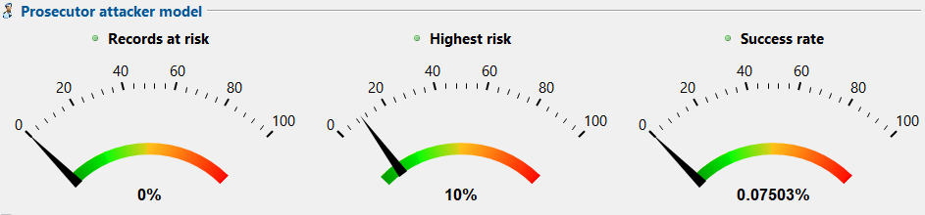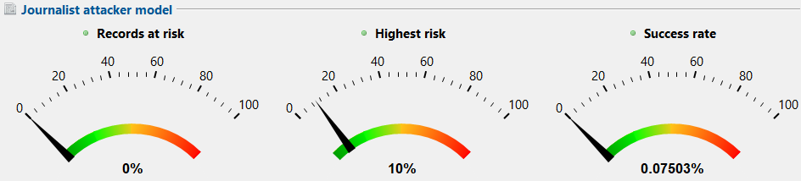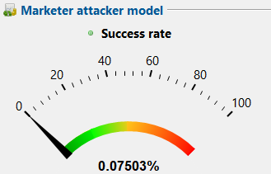

**ANALISE DE RISCOS**

|  |  |
| --- | --- |
| Medida | Valor [%] |
| Menor risco (Promotor) | 0.00623% |
| Registos afetados pelo menor risco | 57.33886% |
| Risco Médio (Promotor) | 0.07503% |
| Maior risco (Promotor) | 10% |
| Registos afetados pelo maior risco | 0.03573% |
| Risco estimado (Promotor) | 10% |
| Risco estimado (Jornalista) | 10% |
| Risco estimado (Marketing) | 0.07503% |
| Unicidade na amostra | 0% |
| Unicidade na população | 0% |
| Modelo populacional | DANKAR |
| QIDs | Age, education, marital-status, native-country, occupation, sex, workclass |

**ANALISE DE UTILIDADE**

**Attribute-level quality:**

|  |  |  |  |  |  |  |
| --- | --- | --- | --- | --- | --- | --- |
| Atributo | Tipo de Dados | Missings | Gen. Intensity | Granularity | N. -U. entropy | Squared Error |
| sex | String | 7.20774% | 92.79226% | 92.79226% | 92.79226% | 92.79226% |
| age | String | 100% | 0% | 0% | 0% | 0% |
| Marital-status | String | 100% | 0% | 0% | 0% | 0% |
| education | String | 100% | 0% | 0% | 0% | 0% |
| Native-country | String | 7.20774% | 92.79226% | 92.79226% | 62.55056% | 96.37% |
| workclass | String | 7.20774% | 46.39613% | 66.28018% | 39.56702% | 82.1597% |
| occupation | String | 100% | 0% | 0% | 0% | 0% |

**Dataset level quality**

|  |  |
| --- | --- |
| Modelo | Qualidade |
| Gen- Intensity | 33.14009% |
| Granularity | 32.14478% |
| N. -U. entropy | 11.3564% |
| DIscerniblity | 57.53159% |
| Average Class Size | 95.58705% |
| Record-level squared error | 28.1346% |
| Attribute-level squared error | 31.08676% |
| Aggregation-specific squared error | 0% |

**Segunda parte, variação de supression limit, utility measure and attribute weights com parametros especificos -> esses nao vao ser alterados!**

**K-ANONIMITY (5) + T-CLOSENESS (0.15) utility measure Discernibility, supression limit 100%**

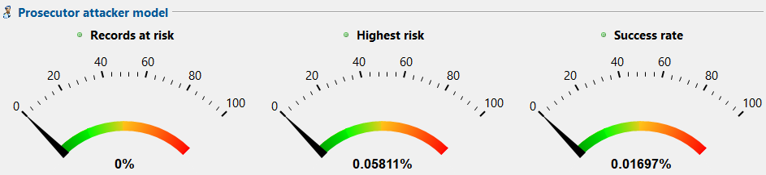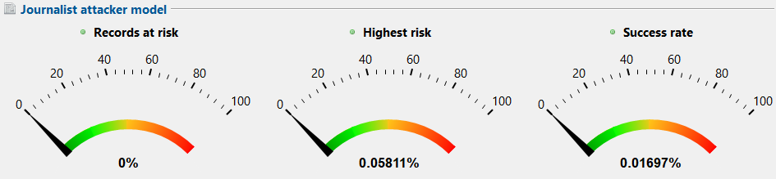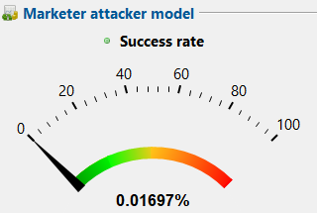

**ANALISE DE RISCOS**

|  |  |
| --- | --- |
| Medida | Valor [%] |
| Menor risco (Promotor) | 0.01084% |
| Registos afetados pelo menor risco | 31.30473% |
| Risco Médio (Promotor) | 0.01697% |
| Maior risco (Promotor) | 0.05811% |
| Registos afetados pelo maior risco | 5.84142% |
| Risco estimado (Promotor) | 0.05811% |
| Risco estimado (Jornalista) | 0.05811% |
| Risco estimado (Marketing) | 0.01697% |
| Unicidade na amostra | 0% |
| Unicidade na população | 0% |
| Modelo populacional | DANKAR |
| QIDs | Age, education, marital-status, native-country, occupation, sex, workclass |

**ANALISE DE UTILIDADE**

**Attribute-level quality:**

|  |  |  |  |  |  |  |
| --- | --- | --- | --- | --- | --- | --- |
| Atributo | Tipo de Dados | Missings | Gen. Intensity | Granularity | N. -U. entropy | Squared Error |
| sex | String | 100% | 0% | 0% | 0% | 0% |
| age | String | 100% | 0% | 0% | 0% | 0% |
| Marital-status | String | 100% | 0% | 0% | 0% | 0% |
| education | String | 100% | 0% | 0% | 0% | 0% |
| Native-country | String | 100% | 0% | 0% | 0% | 0% |
| workclass | String | 2.3208% | 48.8396% | 67.77086% | 41.97076% | 87.78506% |
| occupation | String | 2.3208% | 48.8396% | 69.37461% | 46.41364% | 55.66466% |

**Dataset level quality**

|  |  |
| --- | --- |
| Modelo | Qualidade |
| Gen- Intensity | 13.95417% |
| Granularity | 20.69136% |
| N. -U. entropy | 12.81342% |
| DIscerniblity | 72.41476% |
| Average Class Size | 80.46898% |
| Record-level squared error | 8.94323% |
| Attribute-level squared error | 1.65082% |
| Aggregation-specific squared error | 0% |

**K-ANONIMITY (5) + T-CLOSENESS (1.5) utility measure Discernibility, supression limit 50%**

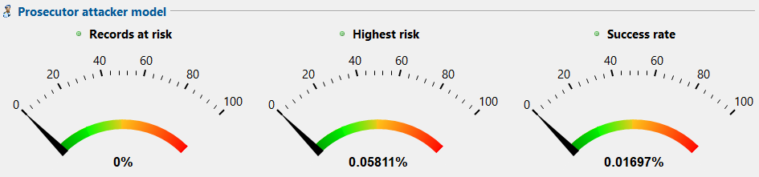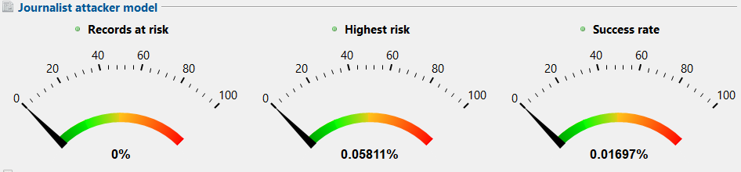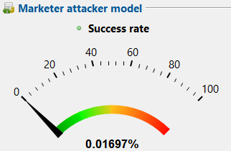

**ANALISE DE RISCOS**

|  |  |
| --- | --- |
| Medida | Valor [%] |
| Menor risco (Promotor) | 0.01084% |
| Registos afetados pelo menor risco | 31.30473% |
| Risco Médio (Promotor) | 0.01697% |
| Maior risco (Promotor) | 0.05811% |
| Registos afetados pelo maior risco | 5.84142% |
| Risco estimado (Promotor) | 0.05811% |
| Risco estimado (Jornalista) | 0.05811% |
| Risco estimado (Marketing) | 0.01697% |
| Unicidade na amostra | 0% |
| Unicidade na população | 0% |
| Modelo populacional | DANKAR |
| QIDs | Age, education, marital-status, native-country, occupation, sex, workclass |

**ANALISE DE UTILIDADE**

**Attribute-level quality:**

|  |  |  |  |  |  |  |
| --- | --- | --- | --- | --- | --- | --- |
| Atributo | Tipo de Dados | Missings | Gen. Intensity | Granularity | N. -U. entropy | Squared Error |
| sex | String | 100% | 0% | 0% | 0% | 0% |
| age | String | 100% | 0% | 0% | 0% | 0% |
| Marital-status | String | 100% | 0% | 0% | 0% | 0% |
| education | String | 100% | 0% | 0% | 0% | 0% |
| Native-country | String | 100% | 0% | 0% | 0% | 0% |
| workclass | String | 2.3208% | 48.8396% | 67.77086% | 41.97076% | 87.78506% |
| occupation | String | 2.3208% | 48.8396% | 69.37461% | 46.41364% | 55.66466% |

**Dataset level quality**

|  |  |
| --- | --- |
| Modelo | Qualidade |
| Gen- Intensity | 13.95417% |
| Granularity | 20.69136% |
| N. -U. entropy | 12.81342% |
| DIscerniblity | 72.41476% |
| Average Class Size | 80.46898% |
| Record-level squared error | 8.94323% |
| Attribute-level squared error | 1.65082% |
| Aggregation-specific squared error | 0% |

**K-ANONIMITY (5) + T-CLOSENESS (0.15) utility measure Discernibility, supression limit 10%**

Analise de riscos igual a 50% e 100%

Analise de utilidade igual a 50% e 100%

**K-ANONIMITY (5) + T-CLOSENESS (0.15) utility measure Avg equi class size, supression limit 100%**

**Uma imagem com texto, Tipo de letra, diagrama, Gráfico

Os conteúdos gerados por IA podem estar incorretos.**

**Uma imagem com texto, Tipo de letra, diagrama, Gráfico

Os conteúdos gerados por IA podem estar incorretos.**

**Uma imagem com texto, captura de ecrã, Tipo de letra, Instrumento de medição

Os conteúdos gerados por IA podem estar incorretos.**

|  |  |
| --- | --- |
| Medida | Valor [%] |
| Menor risco (Promotor) | 1.14943% |
| Registos afetados pelo menor risco | 2.19697% |
| Risco Médio (Promotor) | 6.11111% |
| Maior risco (Promotor) | 20% |
| Registos afetados pelo maior risco | 2.08333% |
| Risco estimado (Promotor) | 20% |
| Risco estimado (Jornalista) | 20% |
| Risco estimado (Marketing) | 6.11111% |
| Unicidade na amostra | 0% |
| Unicidade na população | 0% |
| Modelo populacional | DANKAR |
| QIDs | Age, education, marital-status, native-country, occupation, sex, workclass |

|  |  |  |  |  |  |  |
| --- | --- | --- | --- | --- | --- | --- |
| Atributo | Tipo de Dados | Missings | Gen. Intensity | Granularity | N. -U. entropy | Squared Error |
| sex | String | 73.74179% | 26.25821% | 26.25821% | 24.54885% | 26.25821% |
| age | String | 73.74179% | 26.25821% | 26.25821% | 25.82693% | 24.02812% |
| Marital-status | String | 100% | 0% | 0% | 0% | 0% |
| education | String | 73.74179% | 17.90947% | 20.60783% | 13.46796% | 19.20663% |
| Native-country | String | 73.74179% | 13.1291% | 19.0372% | 2.45111% | 19.20663% |
| workclass | String | 100 % | 0% | 0% | 0% | 0% |
| occupation | String | 73.74179% | 26.25821% | 26.25821% | 26.20568% | 27.87469% |

|  |  |
| --- | --- |
| Modelo | Qualidade |
| Gen- Intensity | 15.62988% |
| Granularity | 16.72213% |
| N. -U. entropy | 17.62831% |
| DIscerniblity | 26.23909% |
| Average Class Size | 99.95174% |
| Record-level squared error | 6.09655% |
| Attribute-level squared error | 17.66116% |
| Aggregation-specific squared error | 0% |

**K-ANONIMITY (5) + T-CLOSENESS (0.15) utility measure Loss, supression limit 100%**

**Uma imagem com texto, Tipo de letra, file, Gráfico

Os conteúdos gerados por IA podem estar incorretos.Uma imagem com texto, Tipo de letra, file, Gráfico

Os conteúdos gerados por IA podem estar incorretos.**

**Uma imagem com texto, captura de ecrã, Tipo de letra, número

Os conteúdos gerados por IA podem estar incorretos.**

|  |  |
| --- | --- |
| Medida | Valor [%] |
| Menor risco (Promotor) | 0.00623% |
| Registos afetados pelo menor risco | 57.23252% |
| Risco Médio (Promotor) | 0.10342% |
| Maior risco (Promotor) | 16.66667% |
| Registos afetados pelo maior risco | 0.10699% |
| Risco estimado (Promotor) | 16.6667% |
| Risco estimado (Jornalista) | 16.6667% |
| Risco estimado (Marketing) | 0.10342% |
| Unicidade na amostra | 0% |
| Unicidade na população | 0% |
| Modelo populacional | DANKAR |
| QIDs | Age, education, marital-status, native-country, occupation, sex, workclass |

|  |  |  |  |  |  |  |
| --- | --- | --- | --- | --- | --- | --- |
| Atributo | Tipo de Dados | Missings | Gen. Intensity | Granularity | N. -U. entropy | Squared Error |
| sex | String | 7.03534% | 92.96466% | 92.96466% | 93.93276 | 92.96466% |
| age | String | 100% | 0% | 0% | 0% | 0% |
| Marital-status | String | 100% | 0% | 0% | 0% | 0% |
| education | String | 100 % | 0% | 0% | 0% | 0% |
| Native-country | String | 7.03534% | 92.96466% | 92.96466% | 64.154% | 92.4692% |
| workclass | String | 7.03534 % | 46.48233% | 66.40333% | 39.67701% | 82.29841% |
| occupation | String | 100% | 0% | 0% | 0% | 0% |

|  |  |
| --- | --- |
| Modelo | Qualidade |
| Gen- Intensity | 33.20166% |
| Granularity | 32.20451% |
| N. -U. entropy | 11.45706% |
| DIscerniblity | 57.70298 % |
| Average Class Size | 96.80012% |
| Record-level squared error | 28.17212% |
| Attribute-level squared error | 31.11913% |
| Aggregation-specific squared error | 0% |

**K-ANONIMITY (5) + T-CLOSENESS (0.15) Sup limit 100% utility measure Loss Attribute Weights age 0.8, sex 0.2**

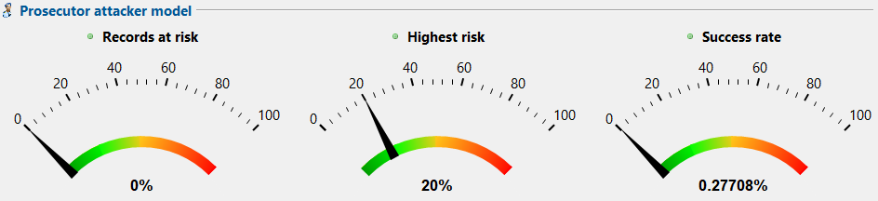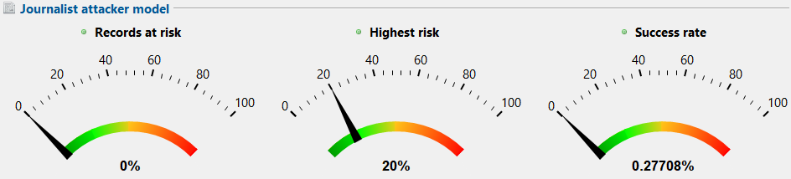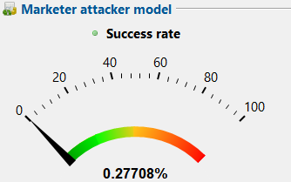

**ANALISE DE RISCOS**

|  |  |
| --- | --- |
| Medida | Valor [%] |
| Menor risco (Promotor) | 0.02236% |
| Registos afetados pelo menor risco | 22.13151% |
| Risco Médio (Promotor) | 0.27708% |
| Maior risco (Promotor) | 20% |
| Registos afetados pelo maior risco | 0.07422% |
| Risco estimado (Promotor) | 20% |
| Risco estimado (Jornalista) | 20% |
| Risco estimado (Marketing) | 0.27708% |
| Unicidade na amostra | 0% |
| Unicidade na população | 0% |
| Modelo populacional | DANKAR |
| QIDs | Age, education, marital-status, native-country, occupation, sex, workclass |

**ANALISE DE UTILIDADE**

**Attribute-level quality:**

|  |  |  |  |  |  |  |
| --- | --- | --- | --- | --- | --- | --- |
| Atributo | Tipo de Dados | Missings | Gen. Intensity | Granularity | N. -U. entropy | Squared Error |
| sex | String | 100% | 0% | 0% | 0% | 0% |
| age | String | 32.99184% | 16.75204% | 54.148% | 16.5191% | 61.17844% |
| Marital-status | String | 100% | 0% | 0% | 0% | 0% |
| education | String | 32.99184% | 67.00816% | 67.00816% | 60.79881% | 68.25362% |
| Native-country | String | 32.99184% | 67.00816% | 67.00816% | 24.17463% | 69.73388% |
| workclass | String | 32.99184% | 33.50408% | 47.86297% | 27.78455% | 59.73014% |
| occupation | String | 2.3208% | 0% | 0% | 0% | 0% |

**Dataset level quality**

|  |  |
| --- | --- |
| Modelo | Qualidade |
| Gen- Intensity | 26.32463% |
| Granularity | 36.88771% |
| N. -U. entropy | 19.47787% |
| DIscerniblity | 61.97154% |
| Average Class Size | 98.80935% |
| Record-level squared error | 33.09458% |
| Attribute-level squared error | 62.58453% |
| Aggregation-specific squared error | 0% |

**K-ANONIMITY (5) + T-CLOSENESS (0.15) Sup limit 100% utility measure Loss Attribute Weights age 0.2, sex 0.8**

**IGUAL AO LOSS PADRAO**